**Practical No. 5**

**Aim**: To create SAS data sets.

**Prerequisite:**

1. Understanding of fundamental programming constructs of Base SAS

**Outcome:** After successful completion of this experiment students will be able to

1. Use a Set command to read from an existing SAS data set.
2. Creation of a new variable using assignments statements.

(TO BE COMPLETED BY STUDENTS)

|  |  |
| --- | --- |
| Roll No. A020 | Name:Nicole Michelle Dsouza |
| Class:B.tech IT | Batch:A1 |
| Date of Practical: | Date of Submission: |
| Grade: |  |

**Assignment 1:**

Using the data set orion.customer_dim, write a DATA step to create a new data set named work.youngadult. the new data set should contain only those observations in which customers are female and their age should be between 18 to 36 years . Also the customers must have word “Gold” in their customer_Group values.

**Code of the program:**

**data** work.youngadult;

set orion.customer_dim;

where Customer_Gender = "F" and

Customer_Age > **18** and Customer_Age < **36** and Customer_Group contains"Gold";

**run**;

**proc** **print** data = work.youngadult;

**run**;

**Output of the Program:**

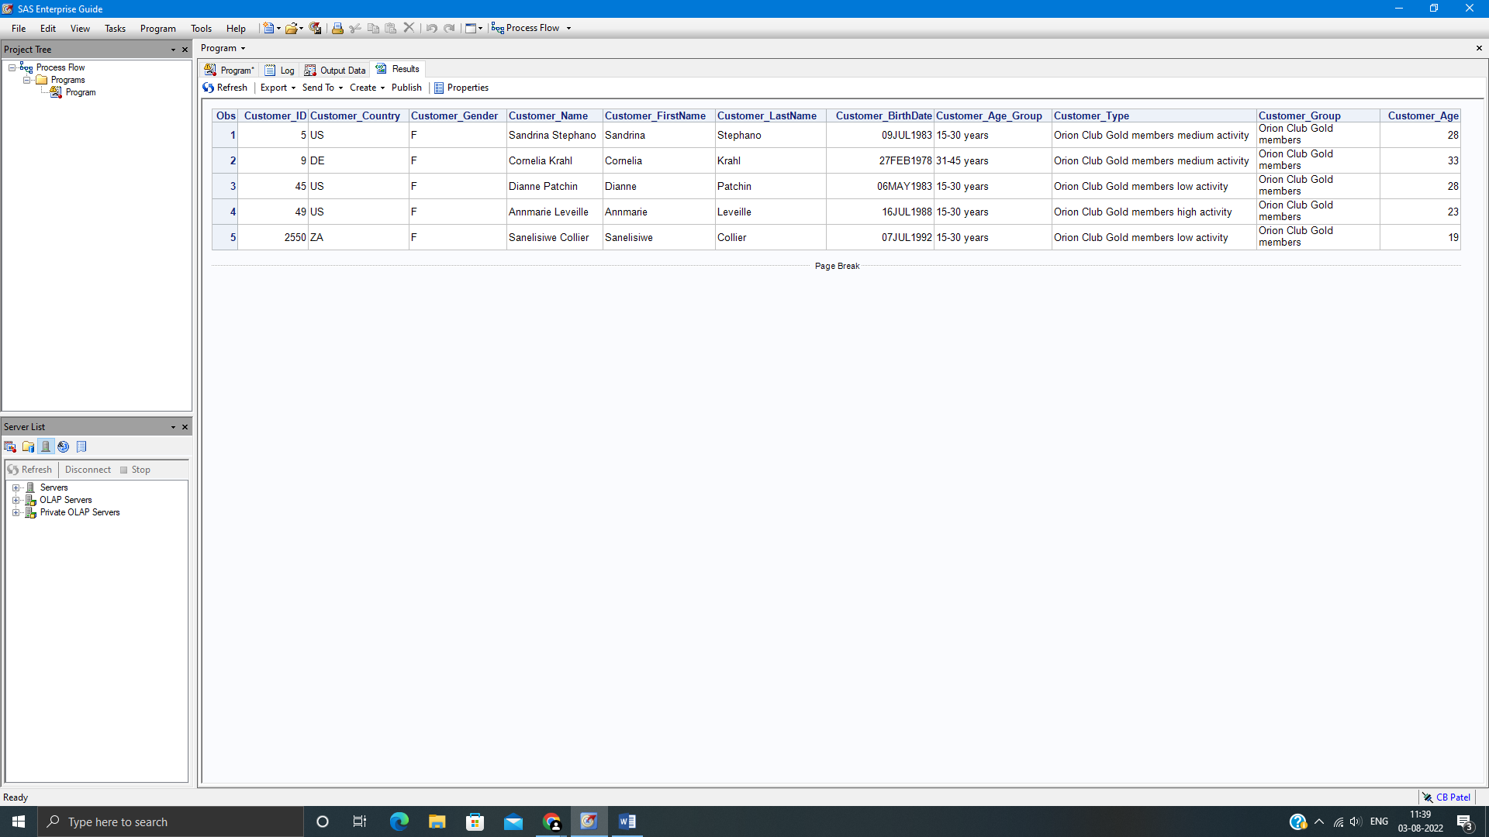

**Assignment 2:**

Using the data set orion.employees, create a new data set emp_list by subsetting records with city being ‘San Diego’ and birth date being greater than 20DEC1970.

Add a new column, salary_new to the data set which computes the salary with 10% bonus.

Sort the new data set by descending salary within descending marital status column.

Apply appropriate formats to the hire date, birth date and salary_new column. Use ID statement with employee id column and display only name, gender, hire date, birth date and salary_new column.

**Code of the program:**

**data** work.emp_list;

set orion.employees;

where City = 'San Diego' and Birth_Date >**'20DEC1970'd**;

salary_new = Salary+Salary\***.10**;

**run**;

**proc** **sort** data=work.emp_list;

by descending Marital_Status DESCENDING Salary;

**proc** **print** data=work.emp_list;

format Hire_date Birth_Date ddmmyy10.

salary_new dollar12.2;

by descending Marital_Status;

id Employee_ID;

var Name Gender Hire_date Birth_Date salary_new;

**run**;

**Output of the Program:**



