**Practical No. 6**

**Aim**: To Customize, Read SAS data sets and create permanent formats.

**Prerequisite:**

1. Understanding of fundamental programming constructs of Base SAS

**Outcome:** After successful completion of this experiment students will be able to

1. Use a Set command to read from an existing SAS data set.
2. Creation of a new variable using assignments statements.
3. Using Label and Format statements in the DATA step.

(TO BE COMPLETED BY STUDENTS)

|  |  |
| --- | --- |
| Roll No. A020 | Name: Nicole Michelle Dsouza |
| Class:B.Tech IT | Batch:A1 |
| Date of Practical: | Date of Submission: |
| Grade: |  |

**Assignment 1:**

For the following program

Proc print data=orion.au_salesforce;

Run;

Write a DATA step to create a new data set named work.assistant. use the data set orion.au_salesforce as input.

The work.assistant data set should contain observations where gender is Female

Create a new variable New_salary which is Salary multiplied by 0.10

Add the following permanent labels:

New_Salary: New Annual Salary

Salary: Employee Annual Salary

Add permanent format to display new_salary using dollar 10.2 format

Work.assistant should contain only employee_id,gender, Salary, New_salary and job_title.

**Code of the program:**

LIBNAME orion "d://PA_2021_22/Data_sets";

**data** work.assistant;

set orion.au_salesforce;

where Gender ="F";

New_Salary =Salary+Salary\***0.10**;

label New_Salary = "New Annual Salary"

Salary ="Employee Annual Salary";

format New_Salary dollar10.2;

keep Employee_ID Gender Salary New_Salary Job_Title;

**Proc** **print** data= work.assistant;

**run**;

**Output of the Program:**

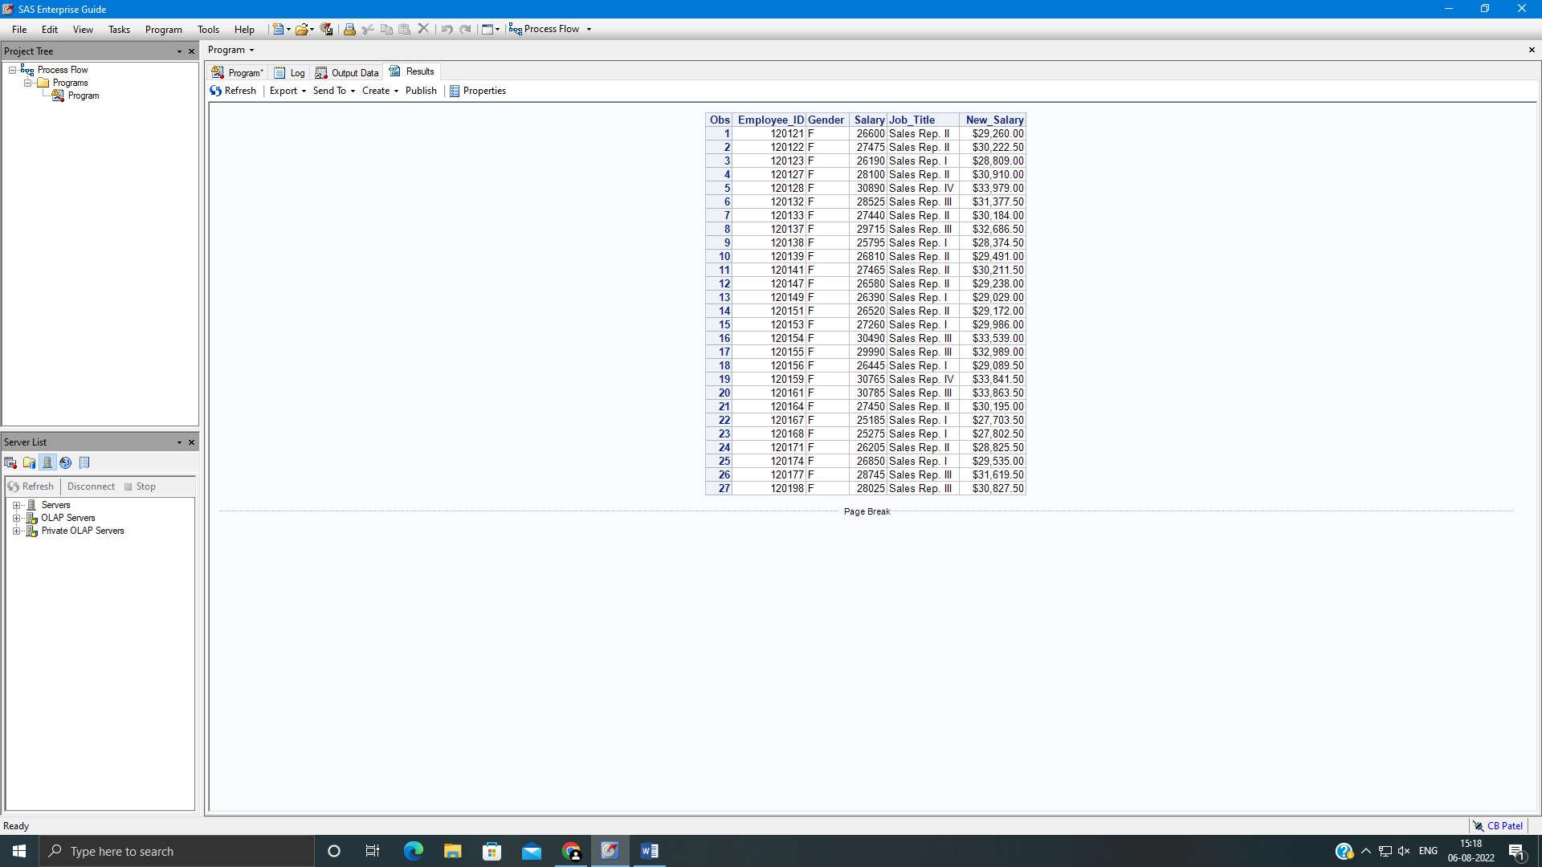

**Assignment 2:**

Write a DATA step to create work.delays. use orion.orders as input.

Create a new variable, order_month and set it to month of order_date (use MONTH function).

Use a WHERE statement and a subsetting IF statement to select observations as indicated below.

1. Delivery_date values that are more than four days beyond order_date.
2. Employee_id values that are equal to 99999999
3. Order_month values occurring in August

New data set should contain only

Add permanent labels and formats as shown below.

Order_date – Date ordered, MM/DD/YYYY

Delivery_date – Date delivered, DATE format.

Add PROC CONTENTS to display the descriptor portion of the data set.

**Code of the program:**

LIBNAME orion "d://PA_2021_22/Data_sets";

**data** work.delays;

set orion.orders;

order_month = MONTH(Order_Date);

where Delivery_Date > Order_Date + **4** and Employee_ID=**99999999**;

if order_month =**8**;

label Order_Date = "date ordered"

Delivery_Date = "date delivered";

format Order_Date mmddyy10. Delivery_Date DATE9.;

keep employee_id customer_id order_date delivery_date order_month;

**proc** **contents** data= work.delays;

**Proc** **print** data= work.delays;

**run**;

**Output of the Program:**



