# **Practical No. 8**

**Aim**: To create a SAS data set by reading data from a raw data file using Informats for fields that are nonstandard numeric.

**Prerequisite:**

1. Understanding of fundamental programming constructs of Base SAS

**Outcome:** After successful completion of this experiment students will be able to

1. Use INFILE, INPUT statements with INFORMATS to read nonstandard numeric fields in the raw data file.
2. Handle data errors using DSD and MISSOVER options.

(TO BE COMPLETED BY STUDENTS)

|  |  |
| --- | --- |
| Roll No. A020 | Name:Nicole Michelle DSouza |
| Class: B.Tech IT | Batch:A1 |
| Date of Practical: | Date of Submission: |
| Grade: |  |

**Assignment 1:**

For the following program

**data** work.salesdata;

**run**;

**proc** **print** data=work.salesdata;

**run**;

* Insert INFILE and INPUT statements to read the comma delimited raw data file named as “SalesDataN.csv”
* Read the following fields from the raw data file using informats and handle the missing data.

|  |  |
| --- | --- |
| Name | Type |
| PID | Character |
| Price | Numeric |
| Payment_Type | Character |
| Name | Character |
| City | Character |
| State | Character |
| Country | Character |
| Zipcode | Numeric |

* Create a report as shown below.

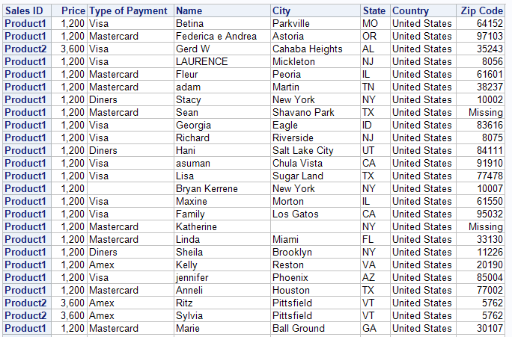

**Code of the program:**

**data** work.salesdata;

infile "d://PA_2021_22/Data_sets/SalesDataN.csv" dlm=',' dsd missover;

input PID :$20. Price :$20. Payment_Type :$20. Name :$20. City :$20. State :$20. Country :$20. Zipcode :$20.;

**run**;

**proc** **print** data=work.salesdata noobs label;

id PID;

label PID = "Sales ID";

label Payment_Type = "Type of Payment";

**run**;

**Output of the Program:**

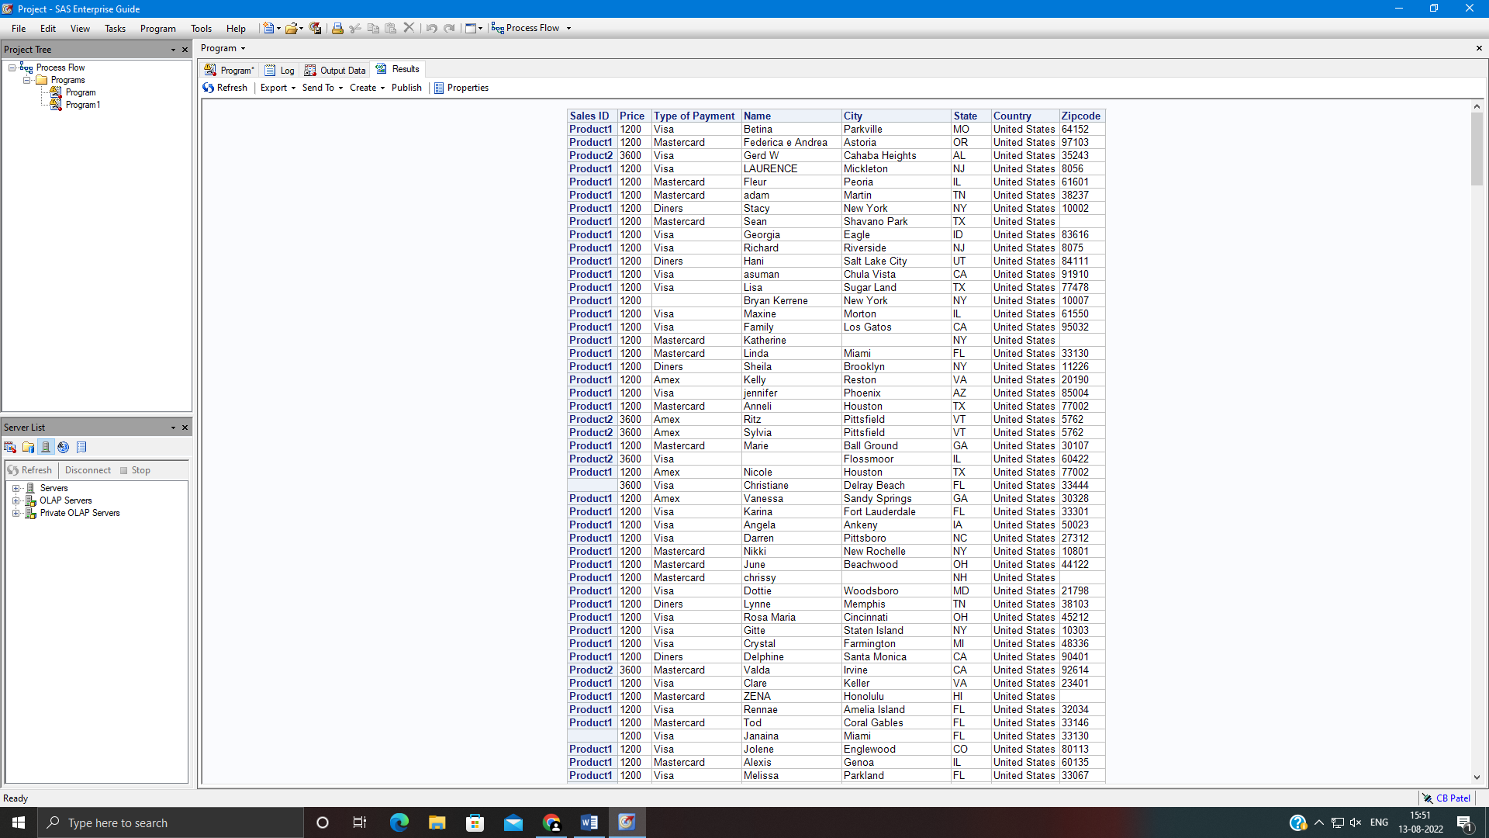

**Assignment 2:**

Create a SAS data set named work.price by reading a delimited raw data file ship02.dat using Informats. Create the report shown.

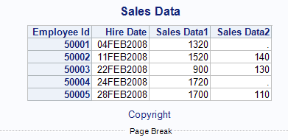

**Code of the program:**

footnote "copyright";

title "Sales Data";

**data** work.price ;

infile "d://PA_2021_22/Data_sets/ship02.dat " dlm=',' dsd missover;

input Employee_Id :$20. Hire_Date :DATE. Sales_Data1 :$20. Sales_Data2 :$20.;

**run**;

**proc** **print** data= work.price noobs;

FORMAT Hire_Date date9.;

id Employee_Id;

**run**;

**Output of the Program:**

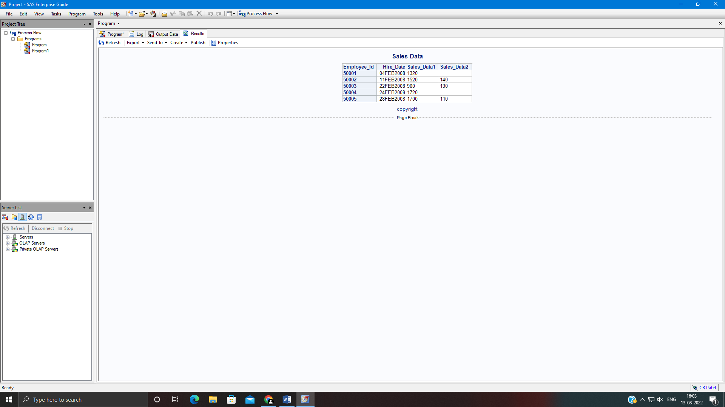

**Assignment 3:**

Create a SAS data set named work.Contacts by reading a comma-delimited raw data file phone2.csv. Add appropriate INFILE and INPUT statements to read the comma-delimited raw data file using informats. Create the report shown.

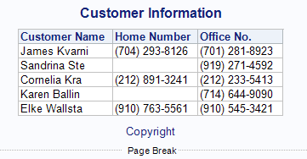

**Code of the program:**

footnote "copyright";

title "Customer Information";

**data** work.Contacts ;

infile "d://PA_2021_22/Data_sets/phone2.csv " dlm=',' dsd missover;

input Customer_Name :$20.Home_Number :$20. Office_Number :$20. ;

**run**;

**proc** **print** data=work.Contacts noobs;

**run**;

**Output of the Program:**



