**Practical No. 9**

**Aim**: To use SAS functions and conditional statements to create data values.

**Prerequisite:**

1. Understanding of fundamental programming constructs of Base SAS

**Outcome:** After successful completion of this experiment students will be able to

1. Use various DATE functions in SAS.
2. Use IF-THEN/ELSE, DO statements for conditional processing.

(TO BE COMPLETED BY STUDENTS)

|  |  |
| --- | --- |
| Roll No. A020 | Name: Nicole Michelle D’Souza |
| Class: B.Tech IT | Batch:A1 |
| Date of Practical: | Date of Submission: |
| Grade: |  |

**Assignment 1:**

* Write a DATA step that reads orion.customer_dim to create work.birthday.
* Create 3 new variables Bday2012, BdayDOW2012 and Age2012 as given below.
  + Bday2012 – combination of month of Customer_BirthDate, day of Customer_BirthDate and constant of 2012 in MDY function.
  + BdayDOW2012 – day of the week of Bday2012
  + Age2012 – (Bday2012 – Customer_BirthDate)/365.25
* Include only the following variables: Customer_Name, Customer_BirthDate, Bday2012, BdayDOW2012 and Age2102.

Format Bday2012 to appear in the form 01Jan2012(use date9.) .Age2012 should be formatted to appear with no decimal places (use 3.). for the variable BdayDOW2012 define a user defined format that displays the first 3 letters of the Day, (ex. Sun for Sunday).

* Write a PROC PRINT step to display the report.

**Code of the program:**

libname orion "d://PA_2021_22//Data_Sets";

**data** work.birthday;

set orion.customer_dim;

Bday2012 = mdy(month(Customer_BirthDate),DAY(Customer_BirthDate),**2012**);

BdayDOW2012 = weekday(Bday2012);

Age2012 = (Bday2012 - Customer_BirthDate)/**365.25**;

keep Customer_Name Customer_BirthDate Bday2012 BdayDOW2012 Age2012;

**run**;

**proc** **format**;

value dayofweek **1** = 'SUN'

**2** = 'MON'

**3** = 'TUE'

**4**= 'WED'

**5**='THU'

**6** ='FRI'

**7**='SAT';

**run**;

**proc** **print** data= work.birthday;

format Bday2012 date9.

Age2012 **3.**

BdayDOW2012 dayofweek. ;

**run**;

**Output of the Program:**

**Assignment 2:**

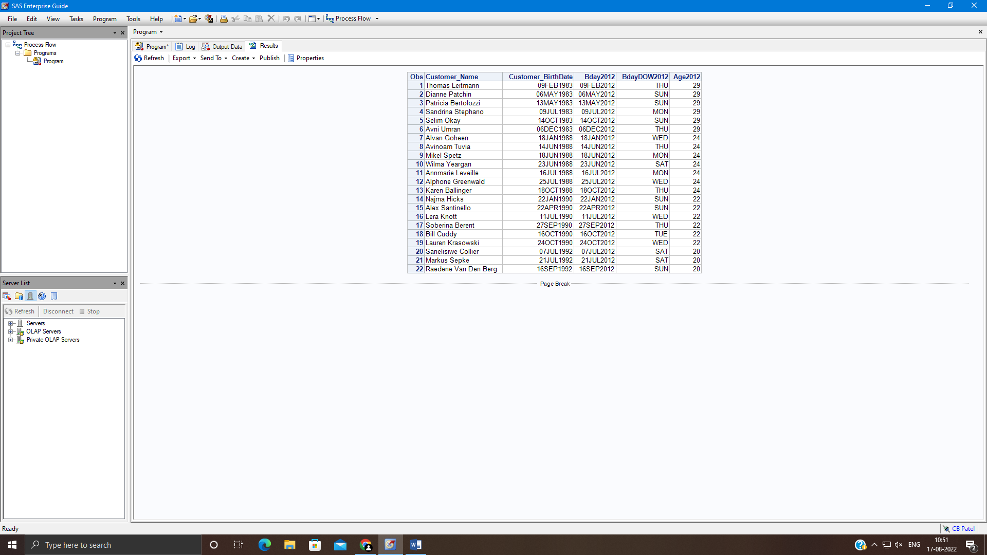

For the following program

**data** work.region;

set orion.product_dim_N;

**run**;

**proc** **print** data=work.region;

**run**;

* Modify the DATA step to create 3 new variables: discount, discounttype and region. Assign values to them based on the variable supplier_country as below.
  + If supplier country is *FR* or *US* then
    - Discount is 0.10, discounttype is “Required” and region is *north America or France*
  + For any other value
    - Discount is 0.5, discounttype is “optional” and region is *not north America*
* The new data set should include only supplier_id supplier_name, supplier_country, discount, discounttype and region.
* Display the report as shown below.

**Code of the program:**

libname orion "d://PA_2021_22//Data_Sets";

title "Supplier Information";

**data** work.region;

set orion.product_dim_N;

if supplier_country ='FR' or supplier_country = 'US' then do;

Discount = **0.10**;

Discount_Type = "Required";

Region = "North America or France";

end;

else do;

Discount = **0.5**;

Discount_Type = "Optional";

Region = " Not North America";

end;

keep supplier_id supplier_name supplier_country discount discounttype region;

**run**;

**proc** **print** data=work.region noobs;

id Supplier_ID;

**run**;

**Output of the Program:**

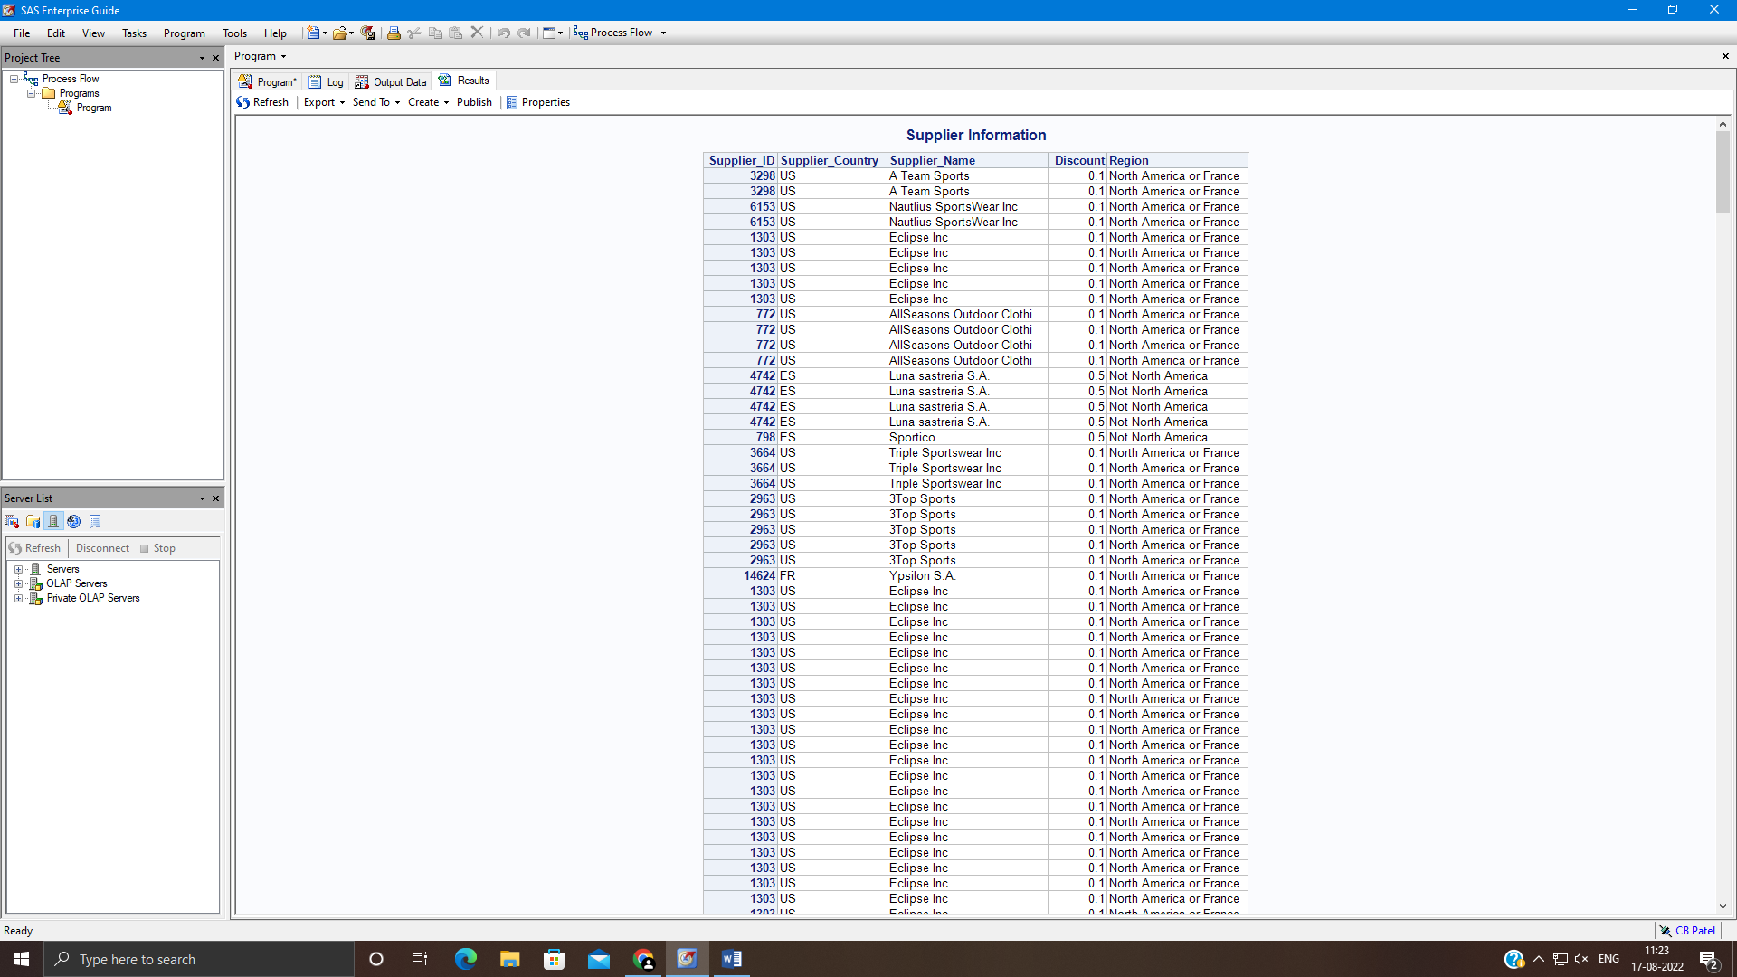

**Assignment 3:**

* Write a DATA step that reads orion.customer_dim to create work.season.
* Create 2 new variables promo and promo2 as below.
  + Promo is based on quarter in which customer was born.
    - If customer is born in first quarter, promo is equal to winter.
    - If customer is born in second quarter, promo is equal to spring
    - If customer is born in third quarter, promo is equal to summer
    - If customer is born in fourth quarter, promo is equal to fall
  + Promo2 is based on customer’s age.
    - For young adults, with age between 18 and 25, promo2 is YA.
    - For seniors, aged 65 or older, promo2 is senior.
    - For others, promo2 is NA.
* The new data set should include only the below mentioned variables: customer_firstname, customer_lastname, customer_birthdate, customer_age, promo, promo2.
* Create a report as shown below.

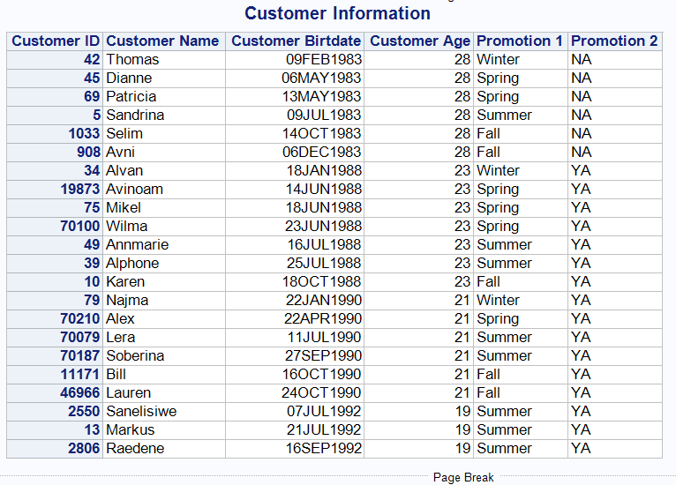

**Code of the program:**

libname orion "d://PA_2021_22//Data_Sets";

title "Customer Information";

**data** work.season;

set orion.customer_dim;

if QTR(Customer_birthdate) =**1** then do

promo = "winter";

end;

else if QTR(Customer_birthdate) =**2** then do;

promo = "spring";

end;

else if QTR(Customer_birthdate)=**3** then do;

promo = "summer";

end;

else if QTR(Customer_birthdate) =**4** then do;

promo = "fall";

end;

if Customer_Age > **18** and Customer_Age < **25** then do;

promo2 = "YA";

end;

ELSE if Customer_Age >**64** then do;

promo2 = "YA";

end;

else do;

promo2 = "NA";

end;

keep Customer_ID customer_firstname customer_lastname customer_birthdate Customer_Age promo promo2 ;

**run**;

**proc** **print** data=work.season noobs;

id customer_id;

**run**;

**Output of the Program:**



