manuscript_v1

Nicole White, Rex Parsons, David Borg, Adrian Barnett

08/07/2022

# Introduction

Despite their potential to support decision making, clinical prediction models are a growing source of research waste. Systematic reviews of diagnostic and prognostic models across several health conditions have consistently found that while new models continue to be published, most are poorly reported and unsuitable for decision-making. Initiatives such as the TRIPOD statement provide recommendations on how to report model development and validation studies, to help other researchers assess model quality. Related tools for assessing model quality have also been developed [refs]. Whilst the TRIPOD statement has been associated with modest improvements in conduct and reporting [refs], the quality of published models remains disturbingly poor. For example, a living systematic review first published in April 2020 identified 20 diagnostic and 10 prognostic models for predicting COVID-19 outcomes [refs]. All models were judged as being at high risk of bias due to issues including low sample sizes, inappropriate choice of predictors, and inadequate model assessment. By July 2022, the number of published prognostic models had increased to 606, comprising 381 newly developed models and 225 validation studies on existing models. Updated results revealed that 90% of models remained unsuitable for clinical use. These findings suggest that best practices for clinical prediction modelling are largely ignored, and decisions made during the study planning stage are major contributors to ongoing waste.

* Systematic review of published clinical prediction models have consistently highlighted poor quality, limited applicability in practice. Examples in COVID-19 (BMJ review), oncology (Dhiman 2022), others
* It is likely that many clinical prediction models are planned but never published. Source of research waste.
* One way to assess research waste from non-publication is to follow-up registered studies aiming to develop and/or validate new or already published prediction model (latter is slightly different point - flesh out later)
* Other refs: Evaluating the impact of prediction models: lessons learned, challenges, and recommendations

# Data and Methods

Clinicaltrials.gov is an online database designed to improve access to information about planned, ongoing and completed clinical studies. The database was launched in 2000 by the National Institute of Health’s National Library of Medicine, in response to United States legislation mandating the registration of funded clinical trials. Since then, over 420,000 studies have been registered, comprising both interventional and observational studies from 221 countries (<https://www.clinicaltrials.gov/>; last viewed: 8 July 2022).

Study registration is completed by a nominated study investigator using a standardised template. Compulsory fields cover the disease or condition of interest, planned commencement and end dates, study type and study design details including interventions (if any), outcomes measures and planned sample size. Additional information on participant recruitment, funding and regulatory oversight is also required. A statistical analysis plan is not required at the time of registration, but can be included as part of an optional detailed summary. Study records can be updated at any time up until project completion, including providing details of resulting publications.

For this analysis, we identified and analysed outcomes of registered studies that planned to develop or validate a clinical prediction model (data downloaded on 3 March 2022). A clinical prediction model was defined as any multivariable model designed to estimate the individual-level risk of being diagnosed with a single disease or health condition (diagnostic model) or experiencing a future health-related outcome following diagnosis (prognostic model) (Hemingway et al. (2013)). Future outcomes considered by prognostic models included both pre-defined clinical endpoints, such as treatment response and mortality, and measures of an individual’s health state following diagnosis, such as health-related quality of life.

All records classified as observational study designs were included. All other study types were excluded [need to provide rationale here for excluding RCTS]. Dependent variables could be defined as a binary, continuous or time-to-event outcome. No restrictions were placed on model data sources or choice of independent variables, provided variables were defined at the individual level and at least two variables were planned for inclusion in the proposed model. This meant that independent variables could take the form of patient-level characteristics (e.g., demographics, clinical parameters) or processed features (e.g, extracted from images).

Eligible studies proposed a clinical prediction model as the primary study objective, or as an objective within a larger study. Studies that planned to identify or validate independent risk factors associated with outcomes without mention of developing a subsequent prediction model were excluded.

All study records posted on clinicaltrials.gov until 3 March 2022 were downloaded in XML for analysis (n = xxx). Relevant studies were identified over two stages. In the first stage, we scanned study record fields for keywords reflecting approaches to clinical prediction modelling and their application to diagnosis and prognosis (Table here - search terms + fields searched). Matching studies were then manually screened for eligibility using the web application rayyan. All studies were independently reviewed by at least two study authors.

* As table: Search terms were:“machine learning”,“artificial intelligence”,“deep learning”, “prediction model”,“predictive model”,“prediction score”,“predictive score”, “warning score”,“risk score”,“risk prediction”, “prognostic model”,“diagnostic model”

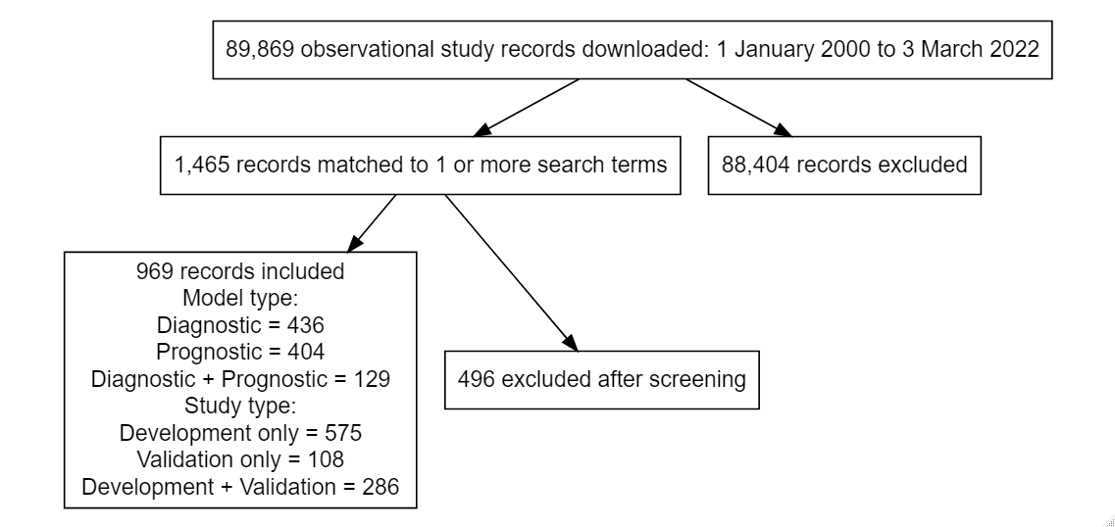

Flowchart note pretend numbers and fix typos!

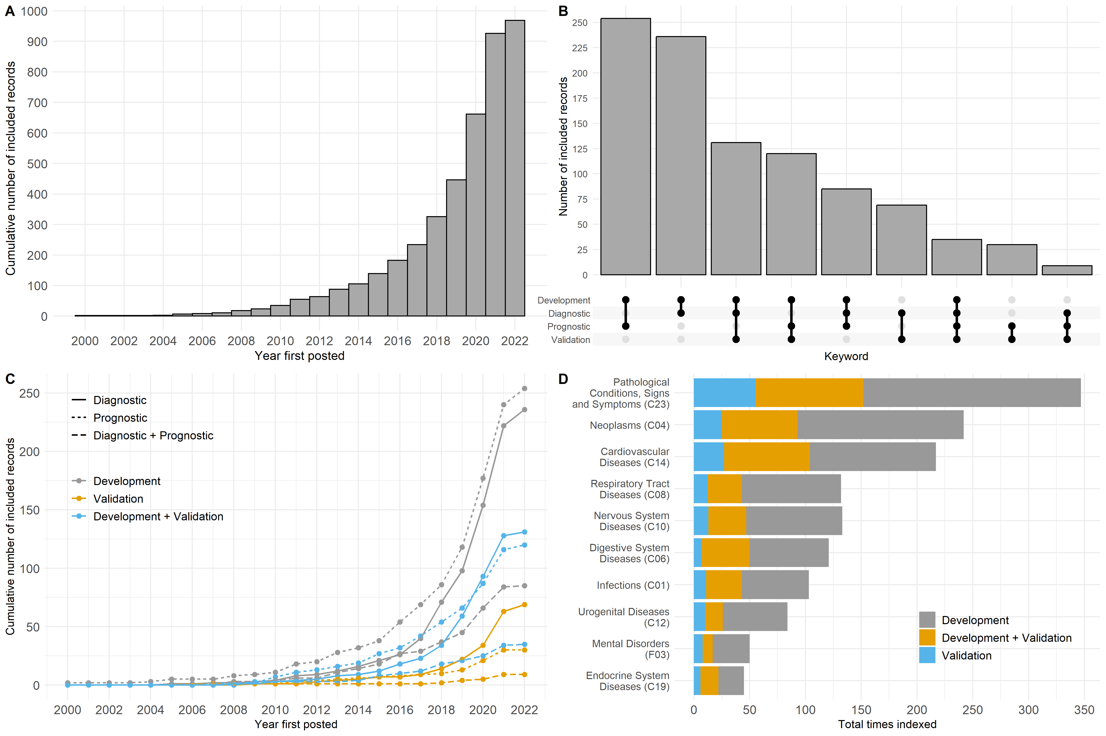 summary here

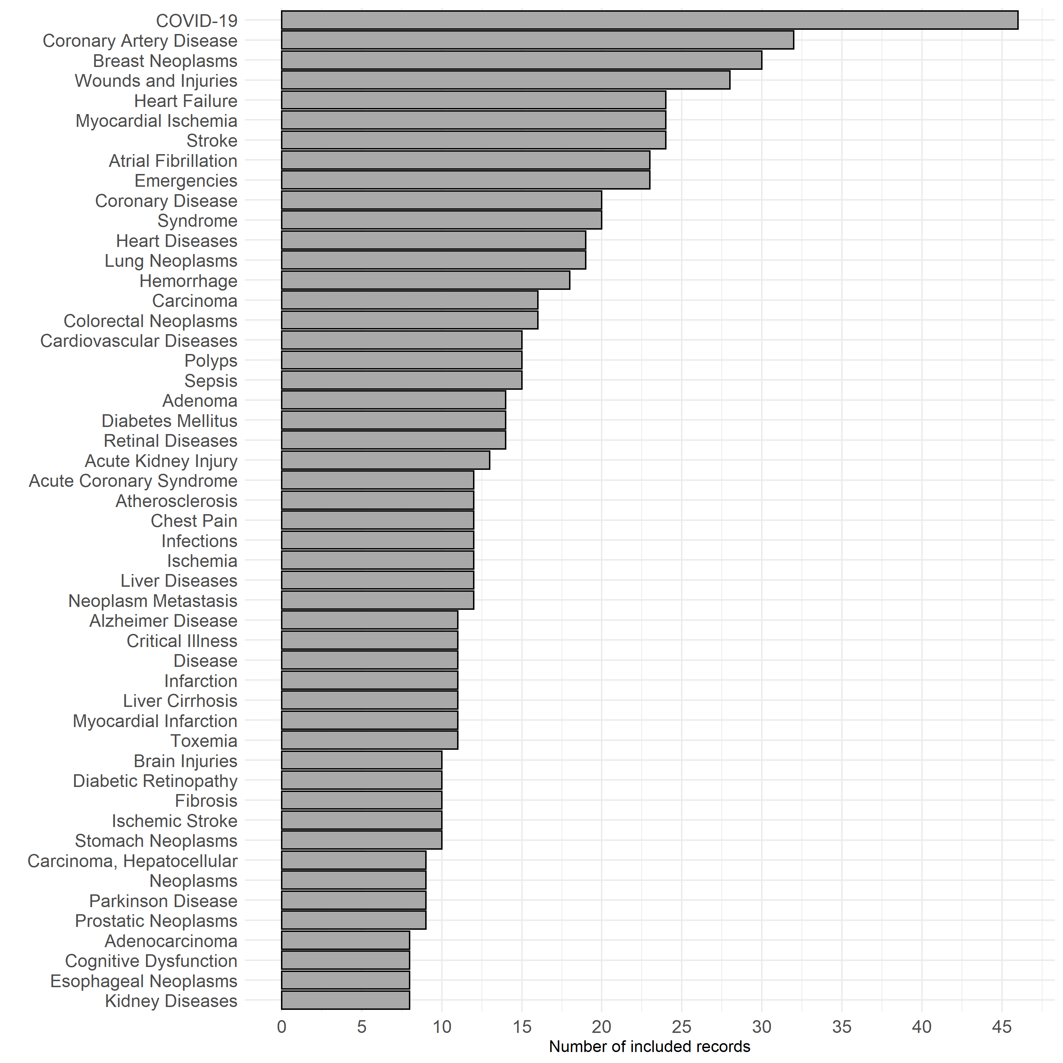

Top 50 MeSH terms

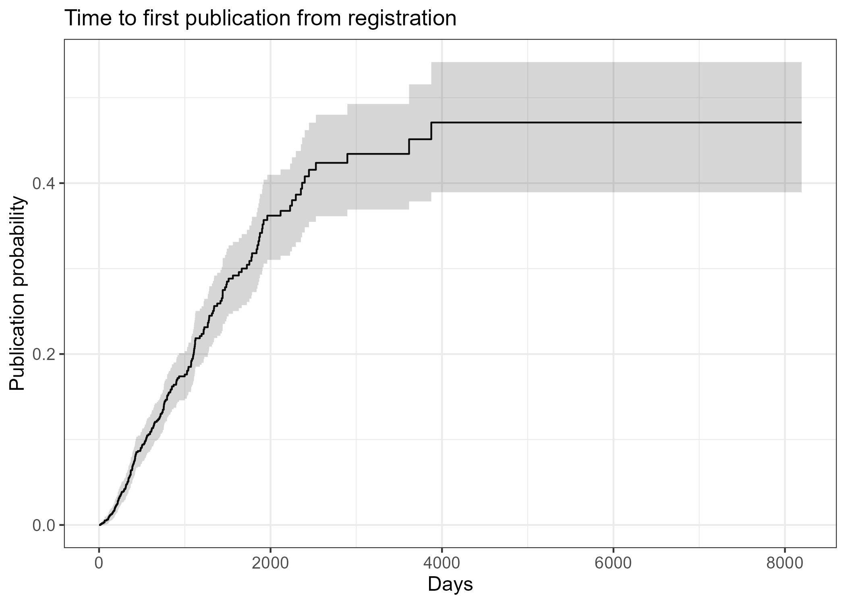

CIF: time to first publication (check caption)

## Analysis

* Study status; all identified studies, possibly compared with random sample of observational studies that don’t return match to search terms?
* Sample size history for final sample
* Frequency of targeted keywords (e.g, (.*)validation, TRIPOD)
* Links to publications using python tool (Rex to lead)

# Discussion

* need to scope existing published models for a given outcome before developing another one! [refs - riley]
* Before embarking on a prediction modelling study, its important to ensure a sufficient sample size is available and that proposed predictors/outcome data collection is of sufficient quality. Just as per any planned statistical analysis. Poor choice will likley lead to poor performance down this line (garbage in = garbage out). ref: <https://www.bmj.com/content/338/bmj.b604> (royston2009)

# References

Hemingway, Harry, Peter Croft, Pablo Perel, Jill A Hayden, Keith Abrams, Adam Timmis, Andrew Briggs, et al. 2013. “Prognosis Research Strategy (PROGRESS) 1: A Framework for Researching Clinical Outcomes.” *Bmj* 346.