Here are the instructions:

* Please Click this link: <https://njit-connect.njit.edu/givenow>
* Since the Capstone is not an option on our drop down menu, use the Giving Search function and type in Capstone.
* 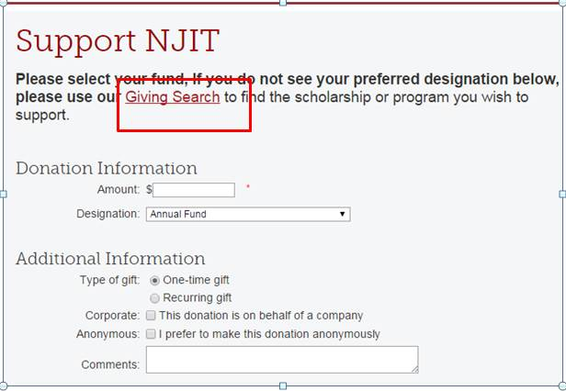
* In the search results select Capstone Program
* Select the box stating that the donation is on behalf of a company

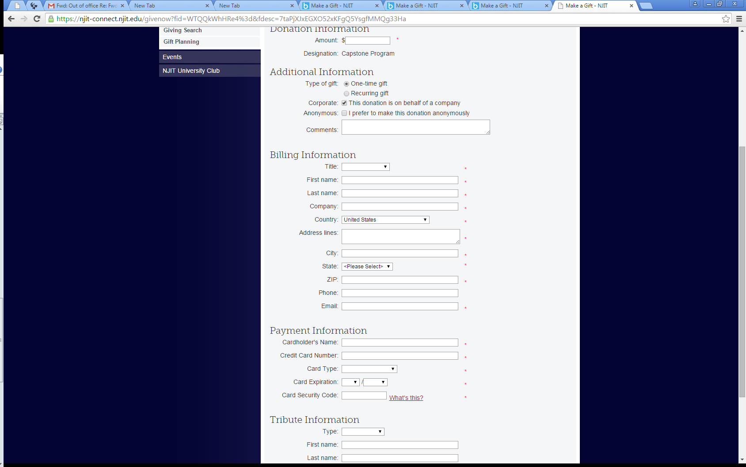

* Complete the transaction by entering the amount and billing information.