|  |
| --- |
|  |
| The Documentation |
| [Type the document subtitle] |
|  |
| **[Your Name]** |
| **[Pick the date]** |

[Type the abstract of the document here. The abstract is typically a short summary of the contents of the document. Type the abstract of the document here. The abstract is typically a short summary of the contents of the document.]

Table of Contents

[To update the table of contents, right click the message below and select Update Field (F9 on PC, ⌥⌘U on Mac).]

**No table of contents entries found.**

1. Cover Page
   1. User Interface

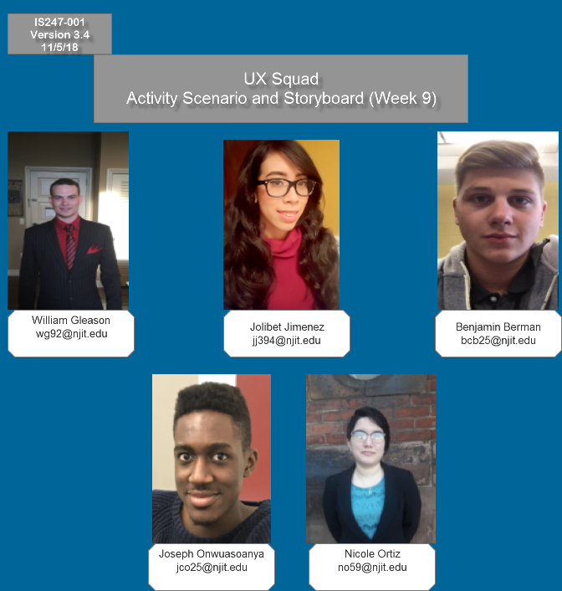

1. Motivating Problem
   1. User Interface

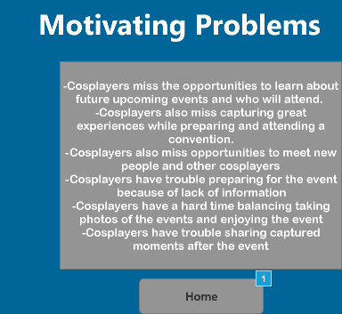

* 1. Widget Table

| Footnote | Interactions |
| --- | --- |
| 1 | OnClick:  Case 1:  Open Cover Page in Current Window |

1. Melissa Cicero
   1. User Interface

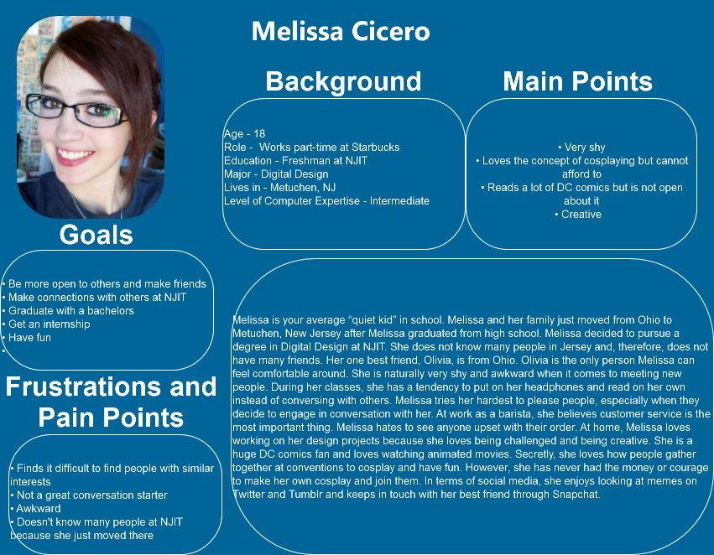

1. Problem Scenario
   1. User Interface

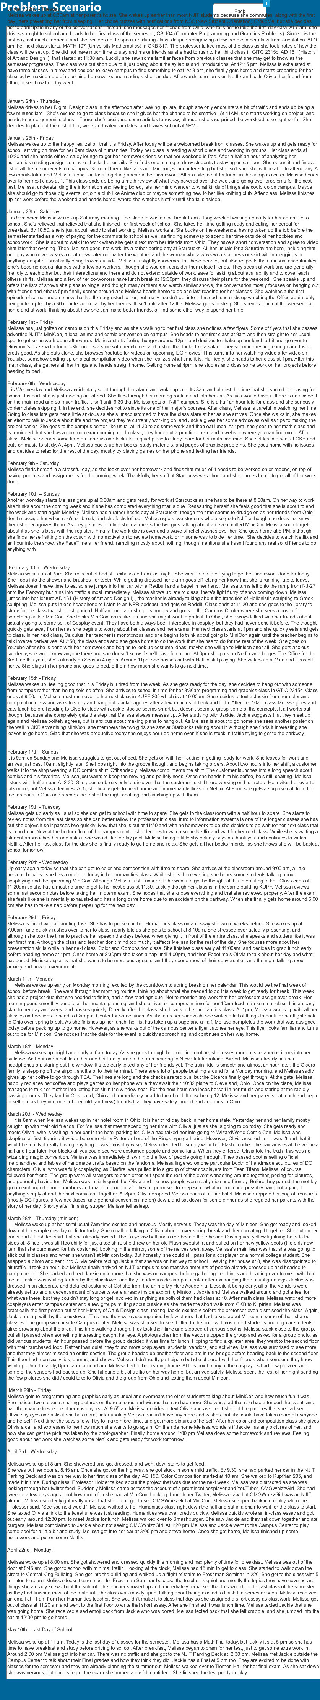

* 1. Widget Table

| Footnote | Interactions |
| --- | --- |
| 1 | OnClick:  Case 1:  Open Melissa Cicero in Current Window |

1. Problem Scenario Storyboard
   1. User Interface

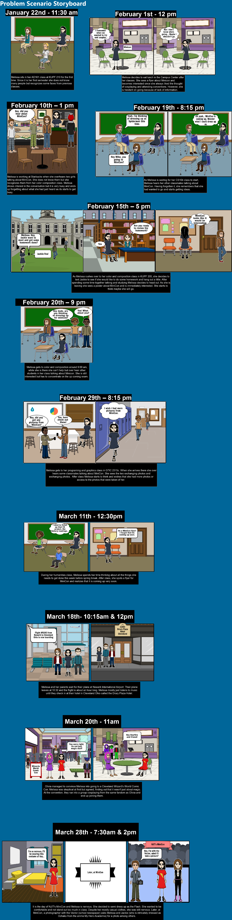

1. Claims Analysis
   1. User Interface

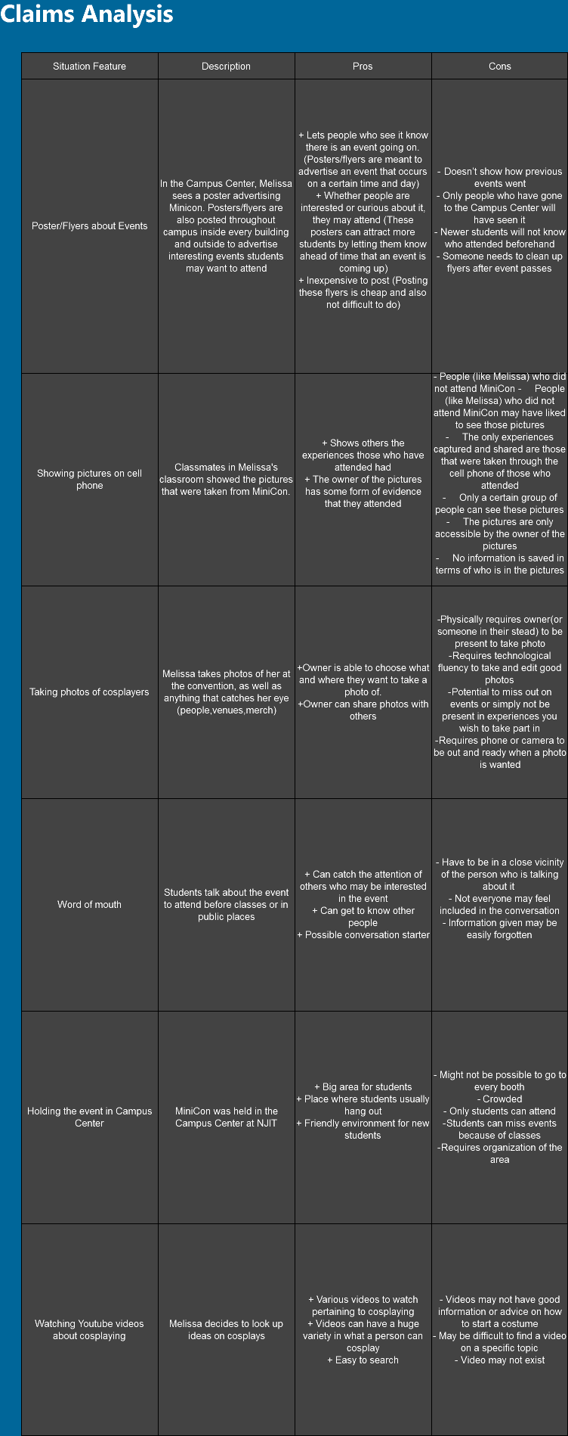

1. Activity Scenario Attempt
   1. User Interface

