|  |
| --- |
|  |
| The Documentation |
| [Type the document subtitle] |
|  |
| **[Your Name]** |
| **[Pick the date]** |

[Type the abstract of the document here. The abstract is typically a short summary of the contents of the document. Type the abstract of the document here. The abstract is typically a short summary of the contents of the document.]

Table of Contents

[To update the table of contents, right click the message below and select Update Field (F9 on PC, ⌥⌘U on Mac).]

**No table of contents entries found.**

1. Technology Audit
   1. User Interface

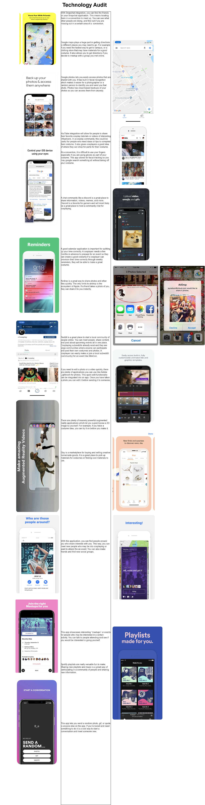

1. Claims Analysis - Realistic Activity Scenario
   1. User Interface

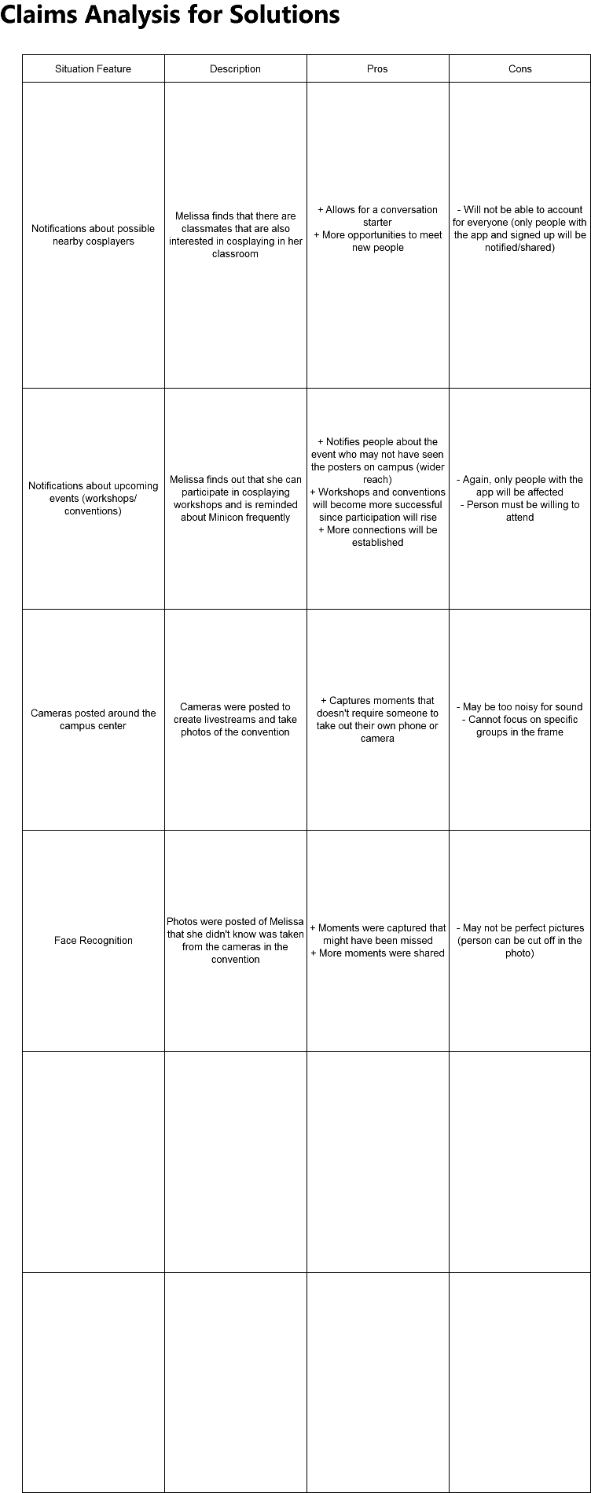

1. Claims Analysis
   1. User Interface

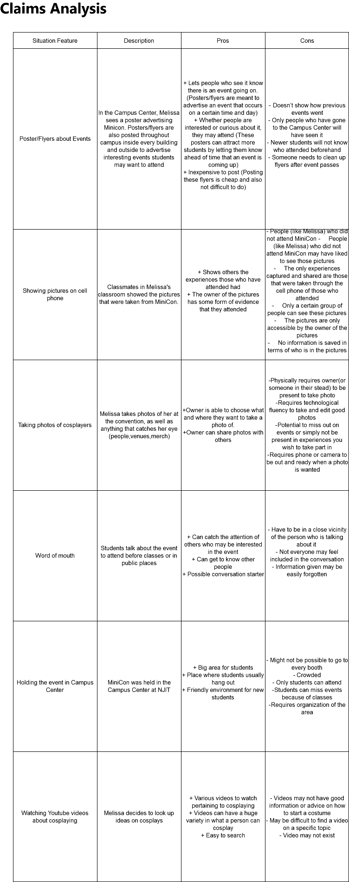

1. Key Path Main

Insert timeline on the camera slide*

Identify people in the photos with tags to their profile

* 1. User Interface

