|  |
| --- |
|  |
| The Documentation |
| [Type the document subtitle] |
|  |
| **[Your Name]** |
| **[Pick the date]** |

[Type the abstract of the document here. The abstract is typically a short summary of the contents of the document. Type the abstract of the document here. The abstract is typically a short summary of the contents of the document.]

Table of Contents

[To update the table of contents, right click the message below and select Update Field (F9 on PC, ⌥⌘U on Mac).]

**No table of contents entries found.**

1. Pages
   1. Page Tree

Home  
 Root Concept Table  
 Stakeholders  
 Demographics  
 Personas  
 Max Arnold  
 Melissa Cicero  
 Day in life  
 Story

* 1. Home
     1. User Interface

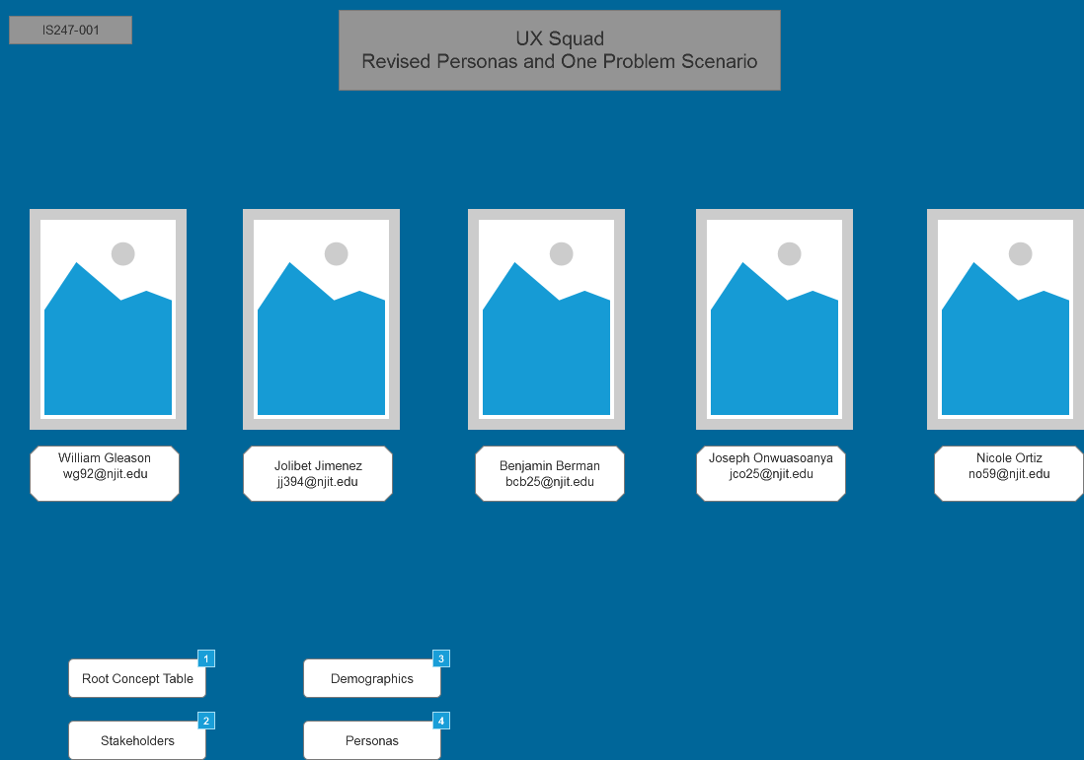

* + 1. Widget Table

| Footnote | Interactions |
| --- | --- |
| 1 | OnClick:  Case 1:  Open Root Concept Table in Current Window |
| 2 | OnClick:  Case 1:  Open Stakeholders in Current Window |
| 3 | OnClick:  Case 1:  Open Demographics in Current Window |
| 4 | OnClick:  Case 1:  Open Personas in Current Window |

* 1. Root Concept Table
     1. User Interface

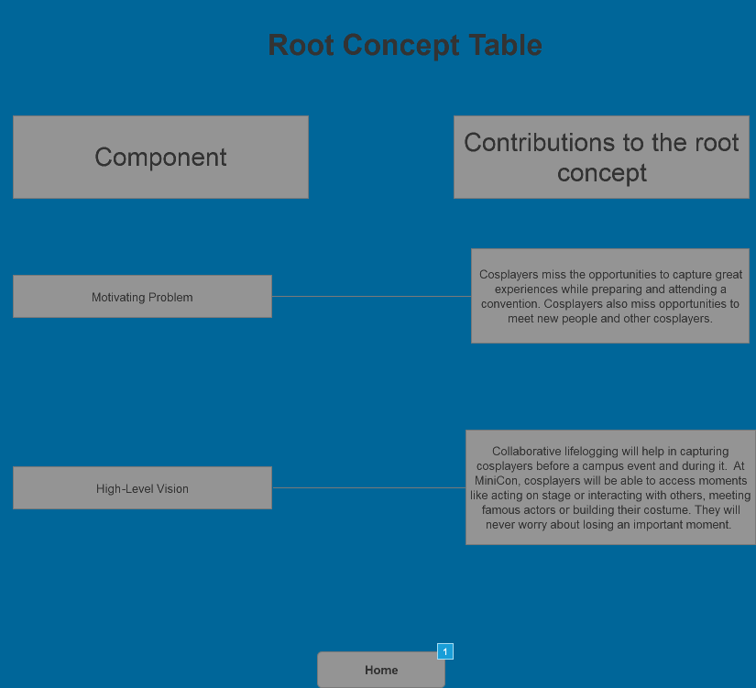

* + 1. Widget Table

| Footnote | Interactions |
| --- | --- |
| 1 | OnClick:  Case 1:  Open Home in Current Window |

* 1. Stakeholders
     1. User Interface

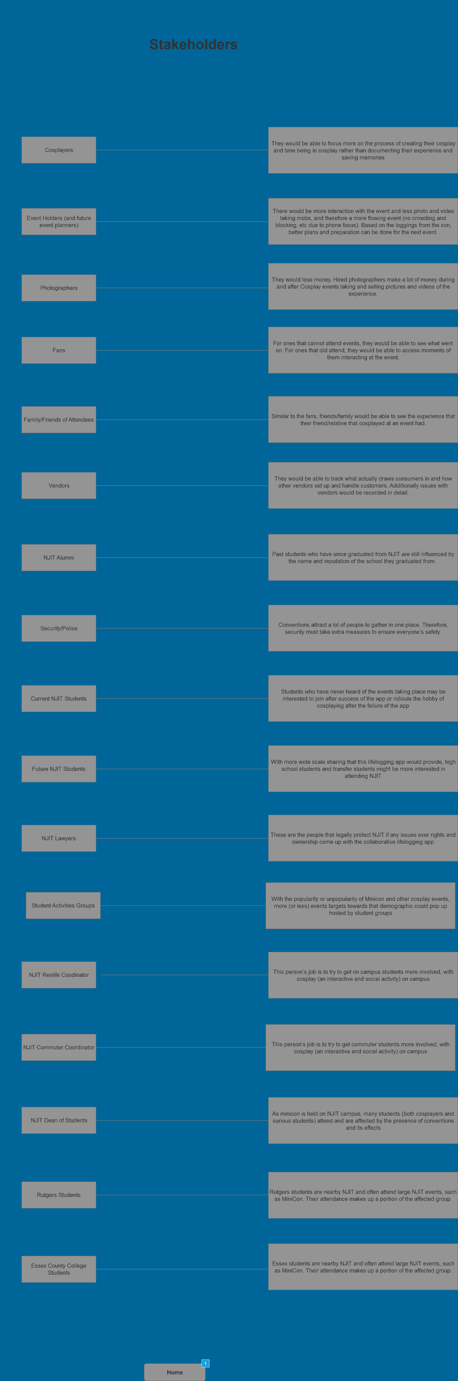

* + 1. Widget Table

| Footnote | Interactions |
| --- | --- |
| 1 | OnClick:  Case 1:  Open Home in Current Window |

* 1. Demographics
     1. User Interface

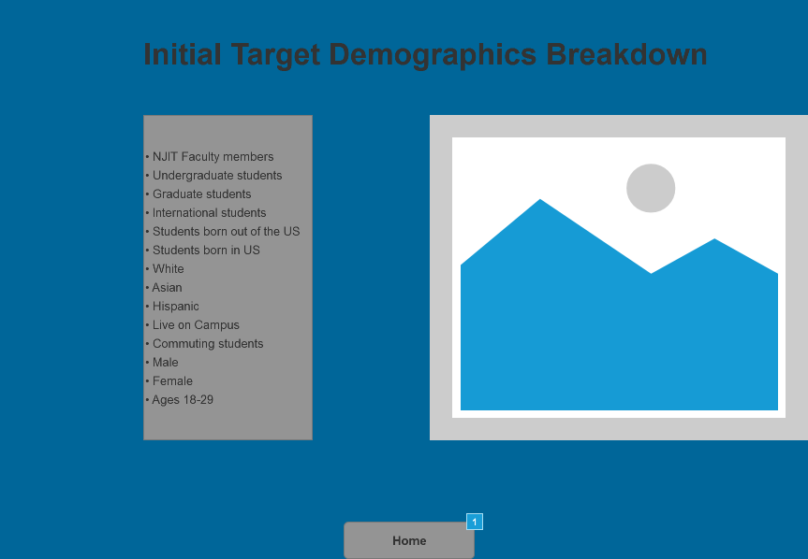

* + 1. Widget Table

| Footnote | Interactions |
| --- | --- |
| 1 | OnClick:  Case 1:  Open Home in Current Window |

* 1. Personas
     1. User Interface

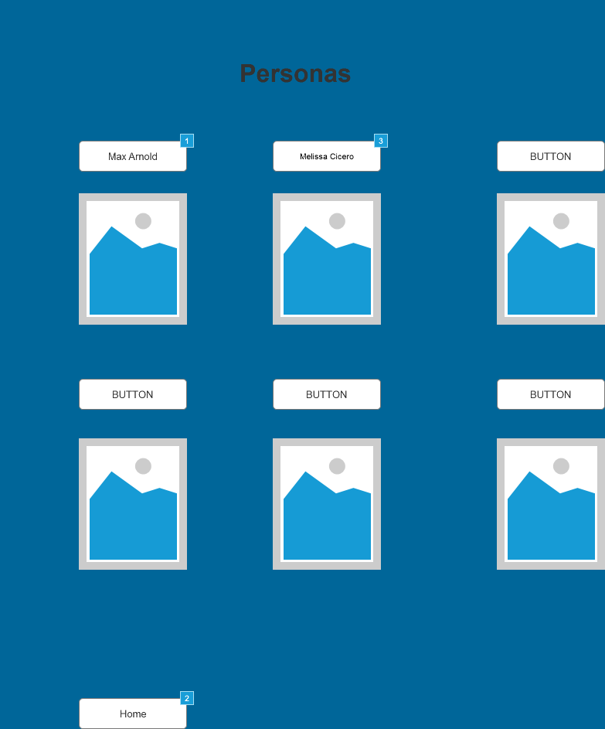

* + 1. Widget Table

| Footnote | Interactions |
| --- | --- |
| 1 | OnClick:  Case 1:  Open Max Arnold in Current Window |
| 2 | OnClick:  Case 1:  Open Home in Current Window |
| 3 | OnClick:  Case 1:  Open Melissa Cicero in Current Window |

* 1. Max Arnold
     1. User Interface

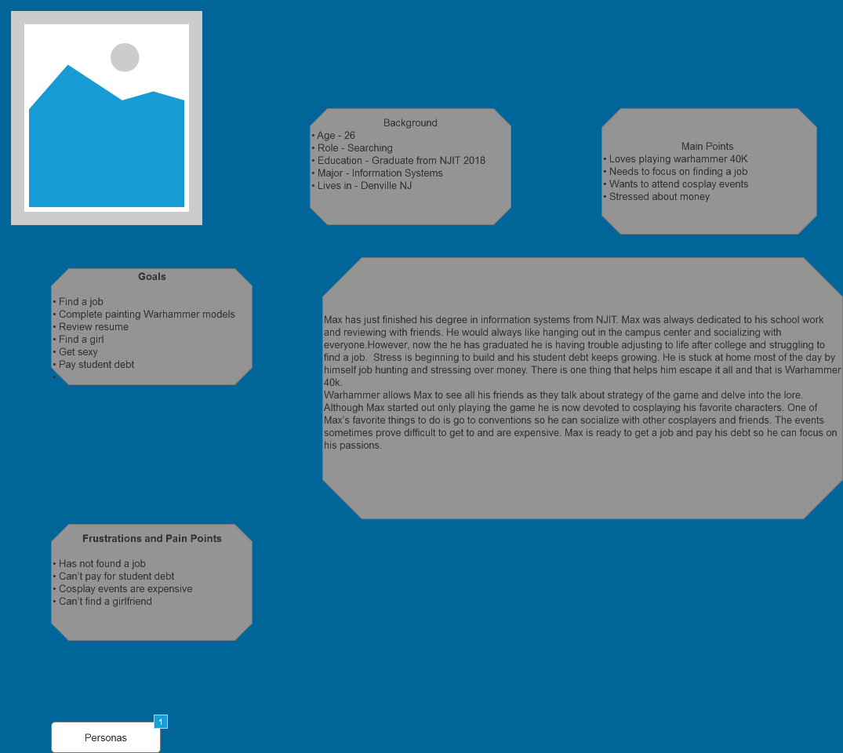

* + 1. Widget Table

| Footnote | Interactions |
| --- | --- |
| 1 | OnClick:  Case 1:  Open Personas in Current Window |

* 1. Melissa Cicero
     1. User Interface

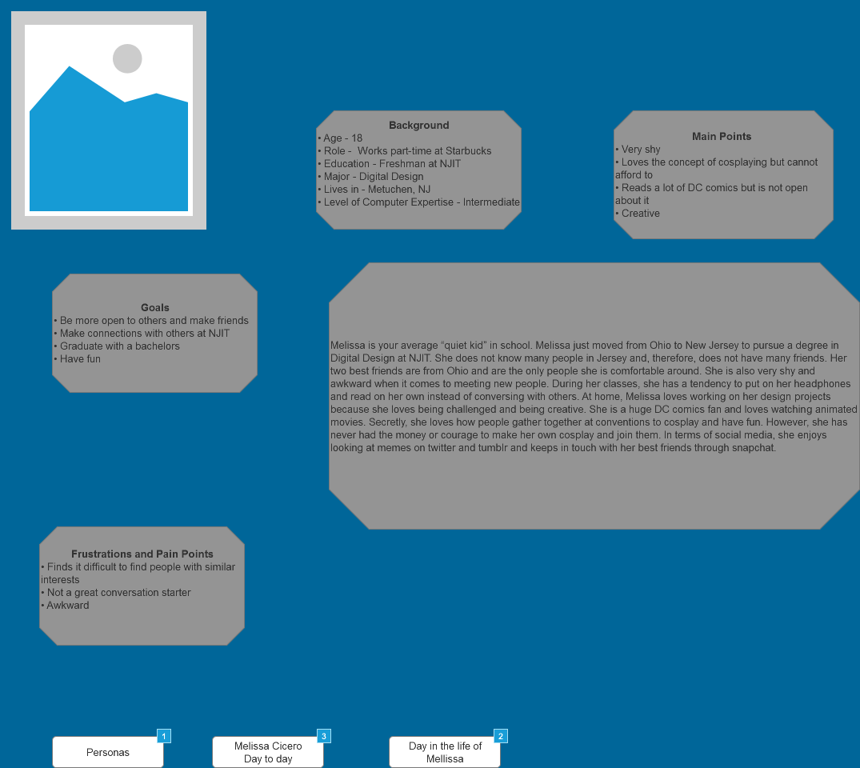

* + 1. Widget Table

| Footnote | Interactions |
| --- | --- |
| 1 | OnClick:  Case 1:  Open Personas in Current Window |
| 2 | OnClick:  Case 1:  Open Story in Current Window |
| 3 | OnClick:  Case 1:  Open Day in life in Current Window |

* 1. Day in life
     1. User Interface

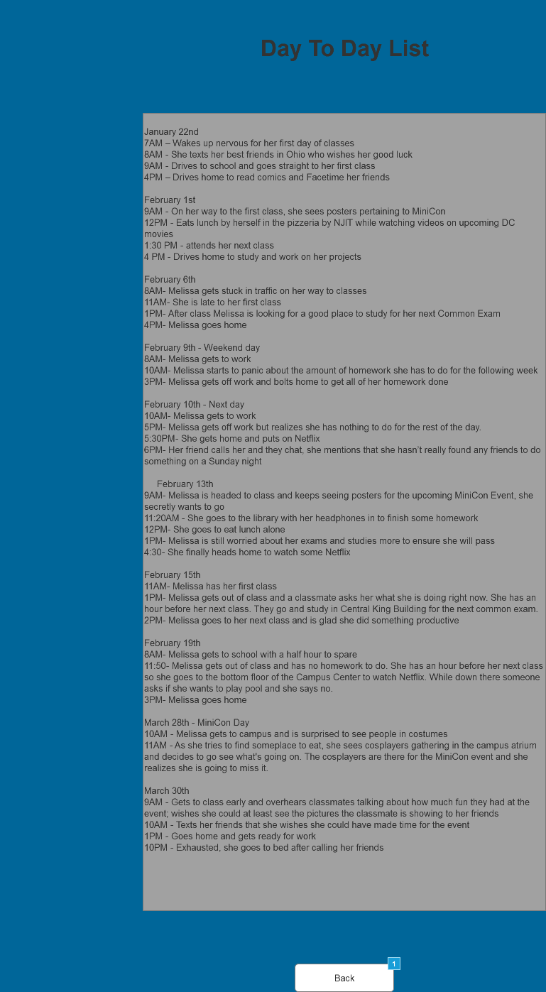

* + 1. Widget Table

| Footnote | Interactions |
| --- | --- |
| 1 | OnClick:  Case 1:  Open Melissa Cicero in Current Window |

* 1. Story
     1. User Interface

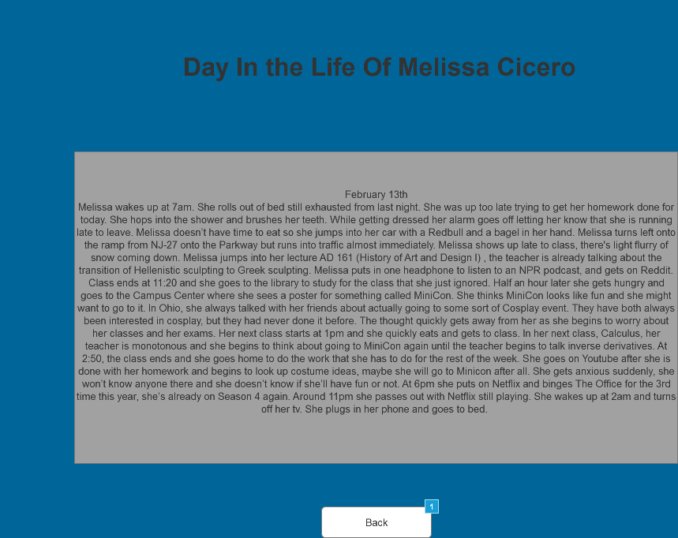

* + 1. Widget Table

| Footnote | Interactions |
| --- | --- |
| 1 | OnClick:  Case 1:  Open Melissa Cicero in Current Window |