|  |
| --- |
|  |
| The Documentation |
| [Type the document subtitle] |
|  |
| **[Your Name]** |
| **[Pick the date]** |

[Type the abstract of the document here. The abstract is typically a short summary of the contents of the document. Type the abstract of the document here. The abstract is typically a short summary of the contents of the document.]

Table of Contents

[To update the table of contents, right click the message below and select Update Field (F9 on PC, ⌥⌘U on Mac).]

**No table of contents entries found.**

1. Pages
   1. Page Tree

Cover Page  
 Table of Contents  
 Root Concept Table  
 Stakeholders  
 Initial Target Demographics  
Personas  
 Personas  
 Melissa Cicero  
 Andy Clofe  
 Anthony Joshua  
 Max Arnold  
 Harsh Patel  
Problem Scenarios  
 Problem Scenario  
 Day to Day  
 Problem Scenario Storyboard  
 Claims Analysis  
Activity Scenarios

* 1. Cover Page
     1. User Interface

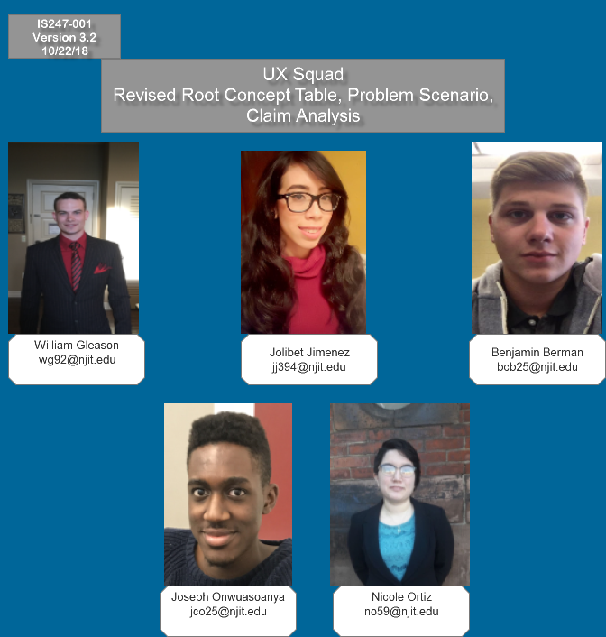

* 1. Table of Contents
     1. User Interface

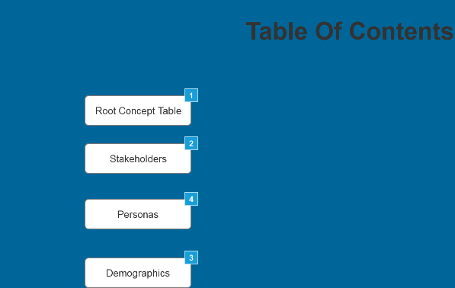

* + 1. Widget Table

| Footnote | Interactions |
| --- | --- |
| 1 | OnClick:  Case 1:  Open Root Concept Table in Current Window |
| 2 | OnClick:  Case 1:  Open Stakeholders in Current Window |
| 3 | OnClick:  Case 1:  Open Initial Target Demographics in Current Window |
| 4 | OnClick:  Case 1:  Open Personas in Current Window |

* 1. Root Concept Table
     1. User Interface

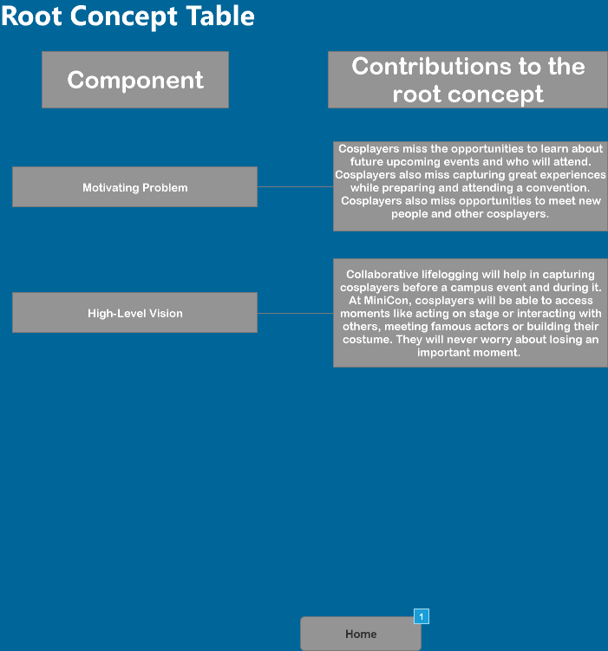

* + 1. Widget Table

| Footnote | Interactions |
| --- | --- |
| 1 | OnClick:  Case 1:  Open Cover Page in Current Window |

* 1. Stakeholders
     1. User Interface

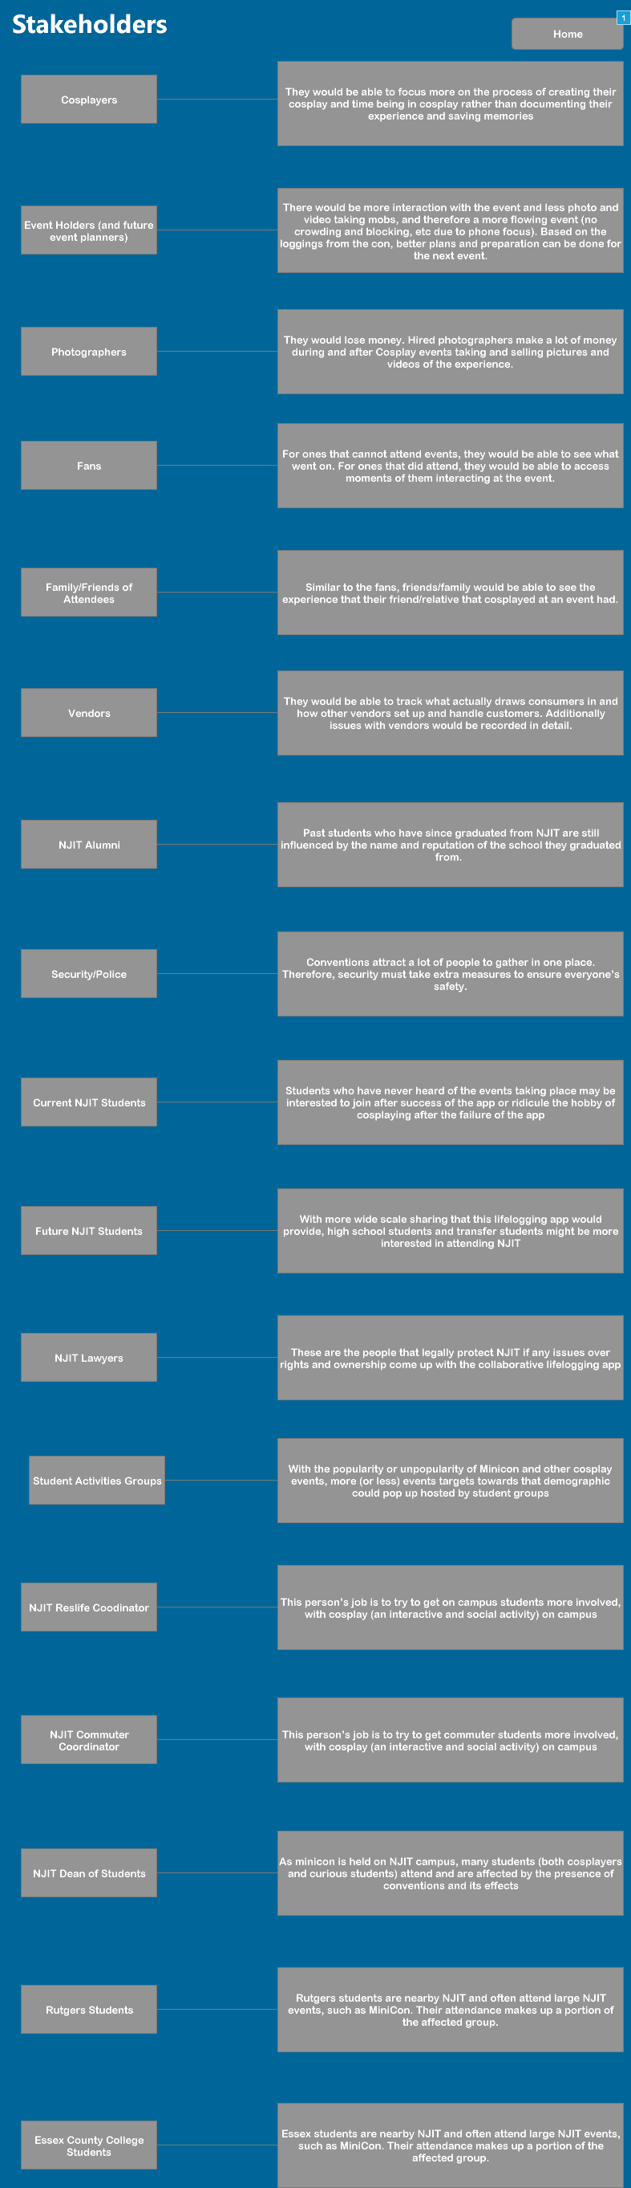

* + 1. Widget Table

| Footnote | Interactions |
| --- | --- |
| 1 | OnClick:  Case 1:  Open Cover Page in Current Window |

* 1. Initial Target Demographics
     1. User Interface

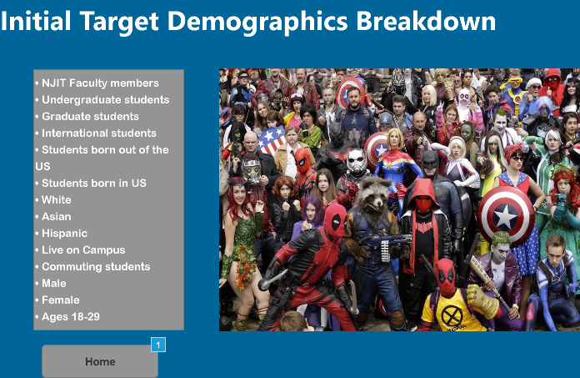

* + 1. Widget Table

| Footnote | Interactions |
| --- | --- |
| 1 | OnClick:  Case 1:  Open Cover Page in Current Window |

* 1. Personas
     1. User Interface

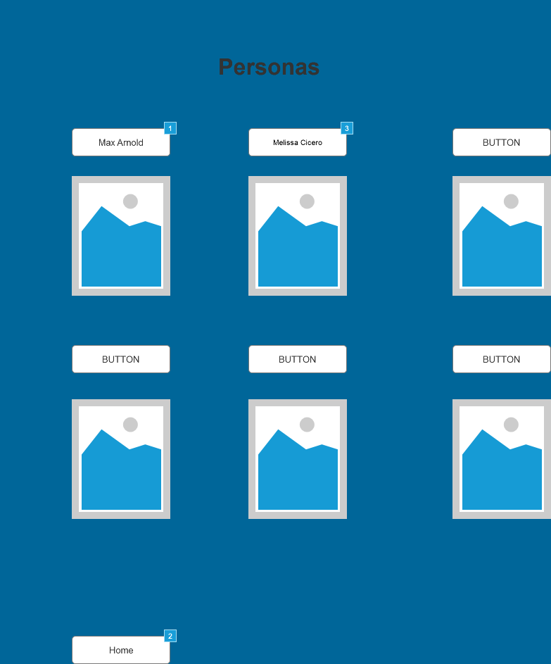

* + 1. Widget Table

| Footnote | Interactions |
| --- | --- |
| 1 | OnClick:  Case 1:  Open Link in Current Window |
| 2 | OnClick:  Case 1:  Open Cover Page in Current Window |
| 3 | OnClick:  Case 1:  Open Melissa Cicero in Current Window |

* 1. Melissa Cicero
     1. User Interface

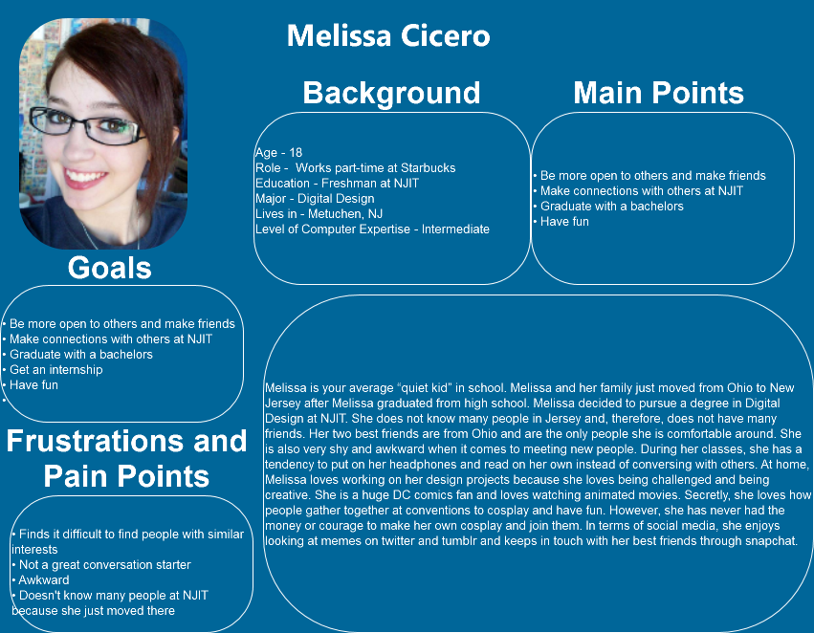

* 1. Andy Clofe
     1. User Interface

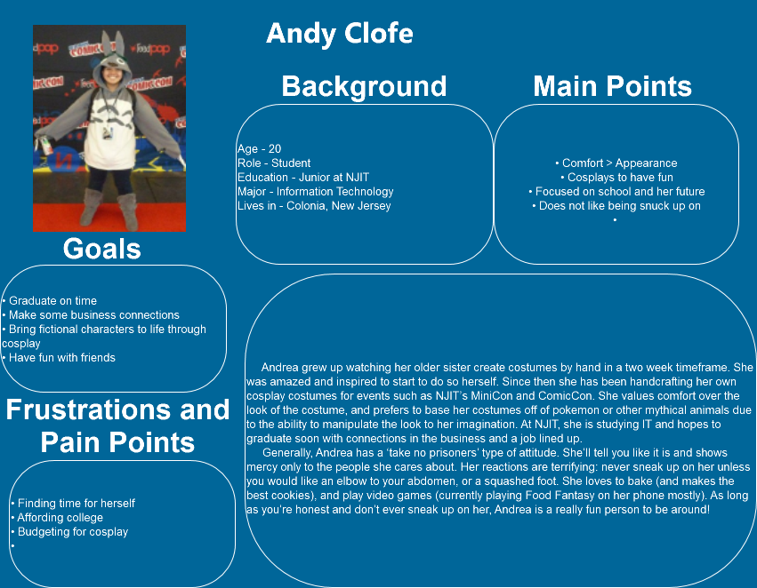

* 1. Anthony Joshua
     1. User Interface

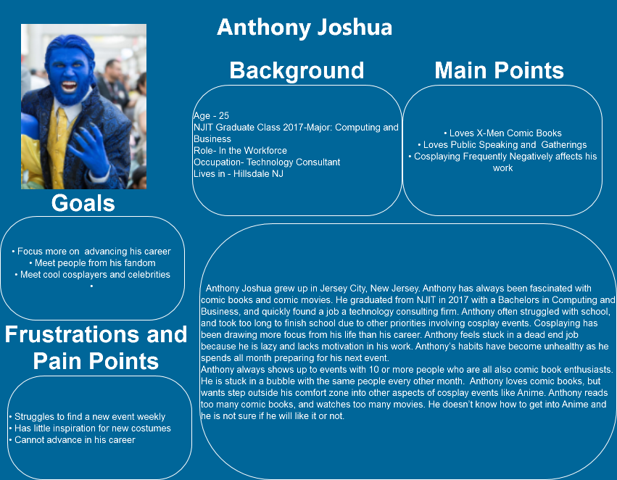

* 1. Max Arnold
     1. User Interface

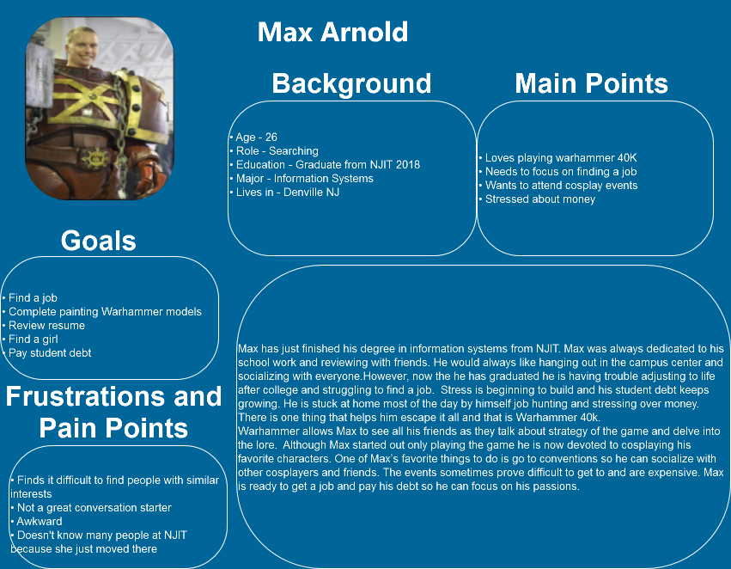

* 1. Harsh Patel
     1. User Interface

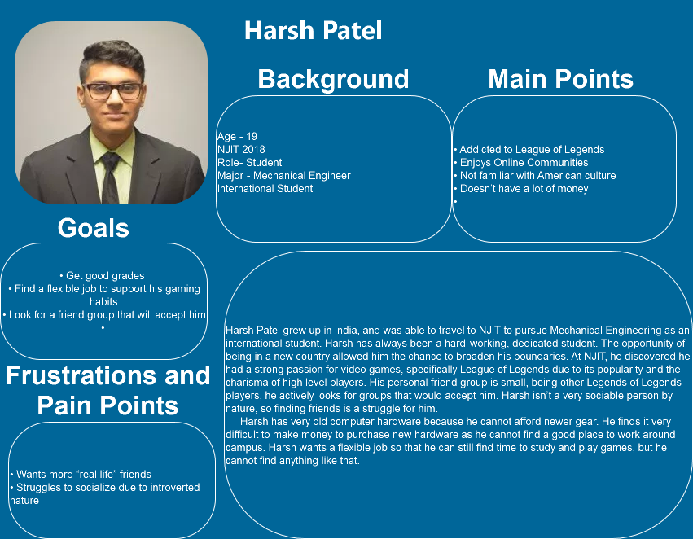

* 1. Problem Scenario
     1. User Interface

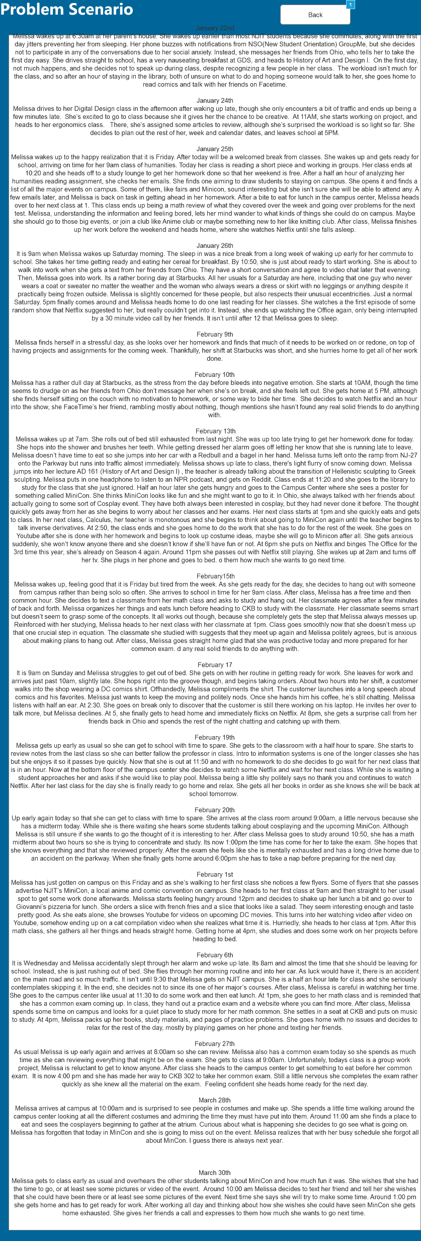

* + 1. Widget Table

| Footnote | Interactions |
| --- | --- |
| 1 | OnClick:  Case 1:  Open Melissa Cicero in Current Window |

* 1. Day to Day
     1. User Interface

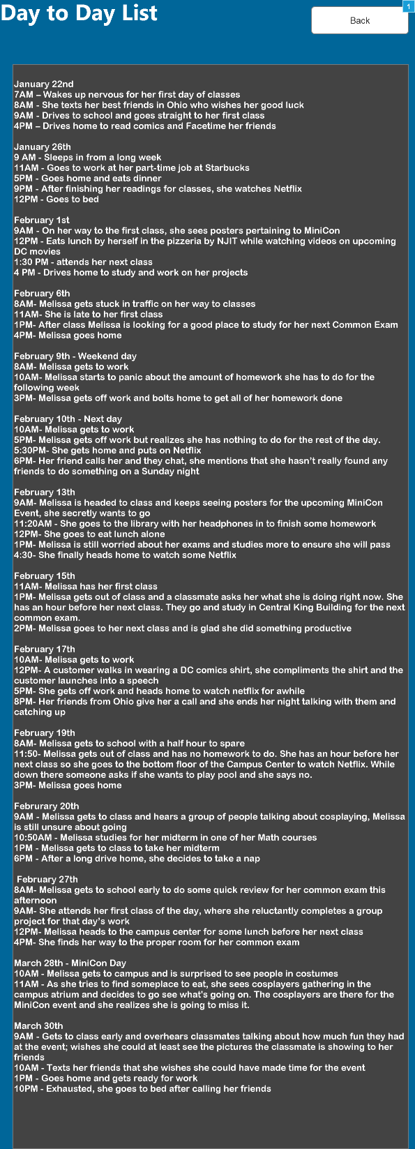

* + 1. Widget Table

| Footnote | Interactions |
| --- | --- |
| 1 | OnClick:  Case 1:  Open Melissa Cicero in Current Window |

* 1. Problem Scenario Storyboard
     1. User Interface

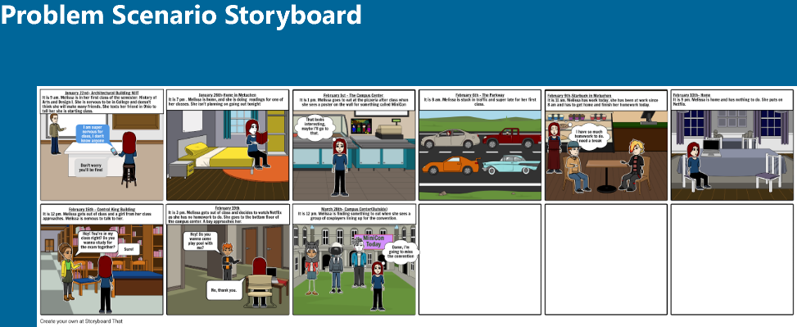

* 1. Claims Analysis
     1. User Interface

