|  |
| --- |
|  |
| The Documentation |
| [Type the document subtitle] |
|  |
| **[Your Name]** |
| **[Pick the date]** |

[Type the abstract of the document here. The abstract is typically a short summary of the contents of the document. Type the abstract of the document here. The abstract is typically a short summary of the contents of the document.]

Table of Contents

[To update the table of contents, right click the message below and select Update Field (F9 on PC, ⌥⌘U on Mac).]

**No table of contents entries found.**

1. Cover Page
   1. User Interface

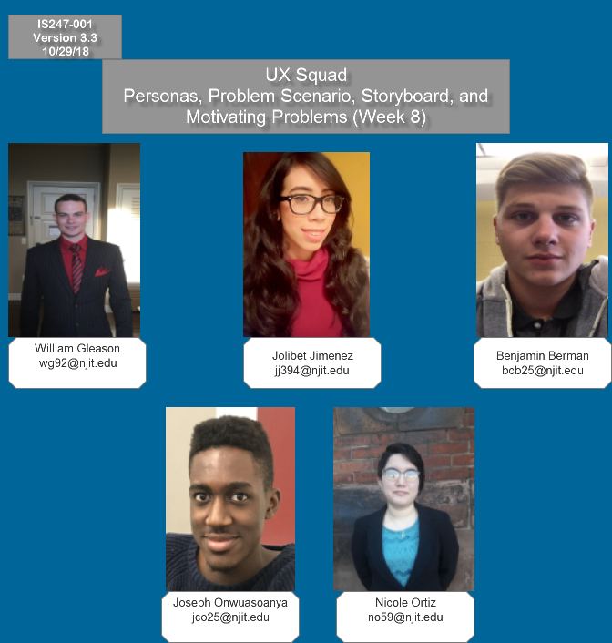

1. Motivating Problem
   1. User Interface

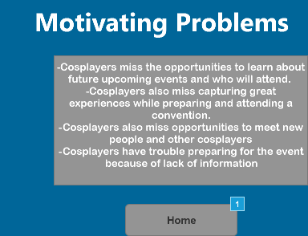

* 1. Widget Table

| Footnote | Interactions |
| --- | --- |
| 1 | OnClick:  Case 1:  Open Cover Page in Current Window |

1. Personas
   1. User Interface

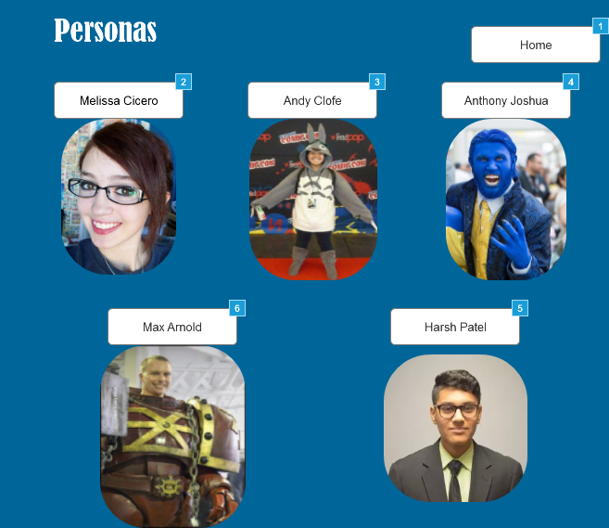

* 1. Widget Table

| Footnote | Interactions |
| --- | --- |
| 1 | OnClick:  Case 1:  Open Cover Page in Current Window |
| 2 | OnClick:  Case 1:  Open Melissa Cicero in Current Window |
| 3 | OnClick:  Case 1:  Open Andy Clofe in Current Window |
| 4 | OnClick:  Case 1:  Open Anthony Joshua in Current Window |
| 5 | OnClick:  Case 1:  Open Harsh Patel in Current Window |
| 6 | OnClick:  Case 1:  Open Max Arnold in Current Window |

1. Melissa Cicero
   1. User Interface

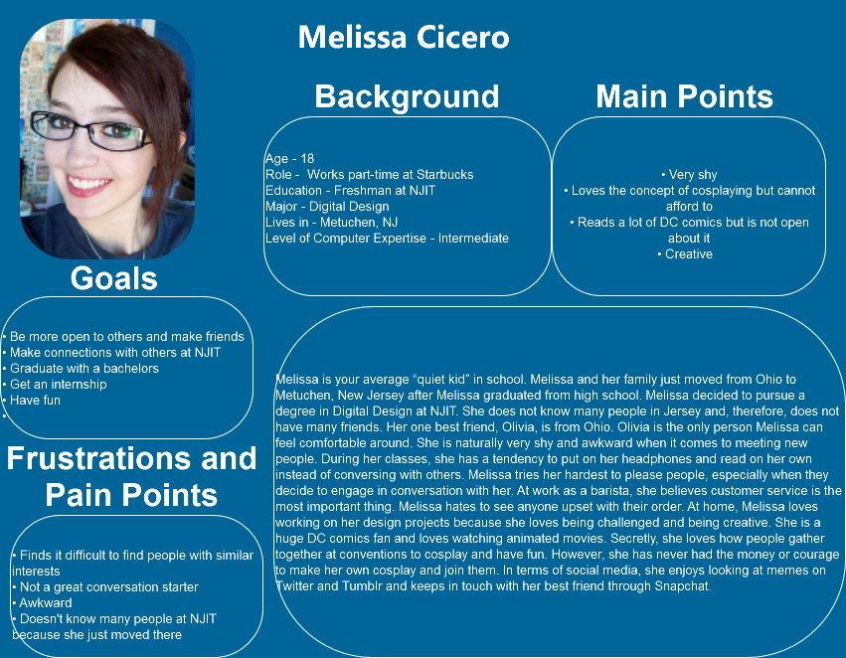

1. Andy Clofe
   1. User Interface

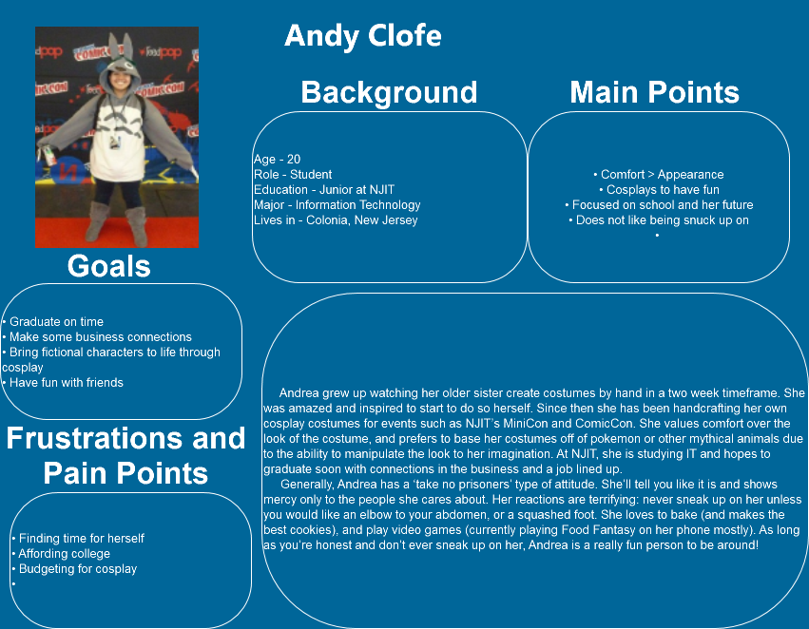

1. Anthony Joshua
   1. User Interface

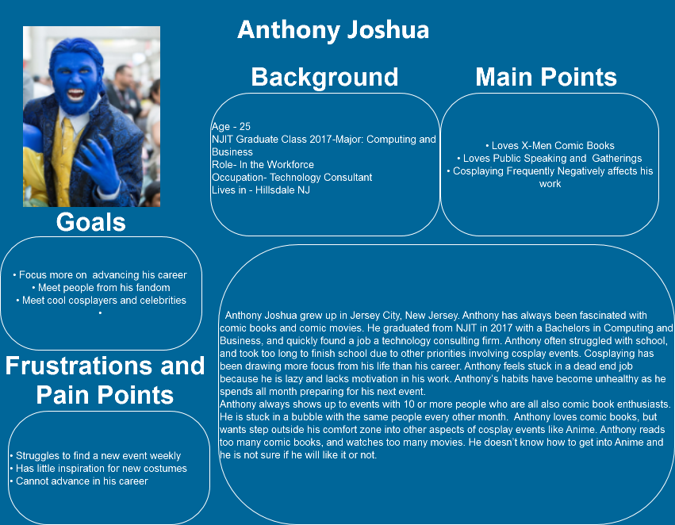

1. Max Arnold
   1. User Interface

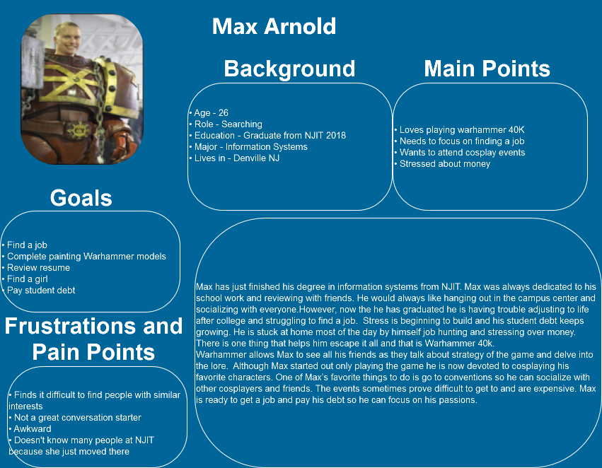

1. Harsh Patel
   1. User Interface

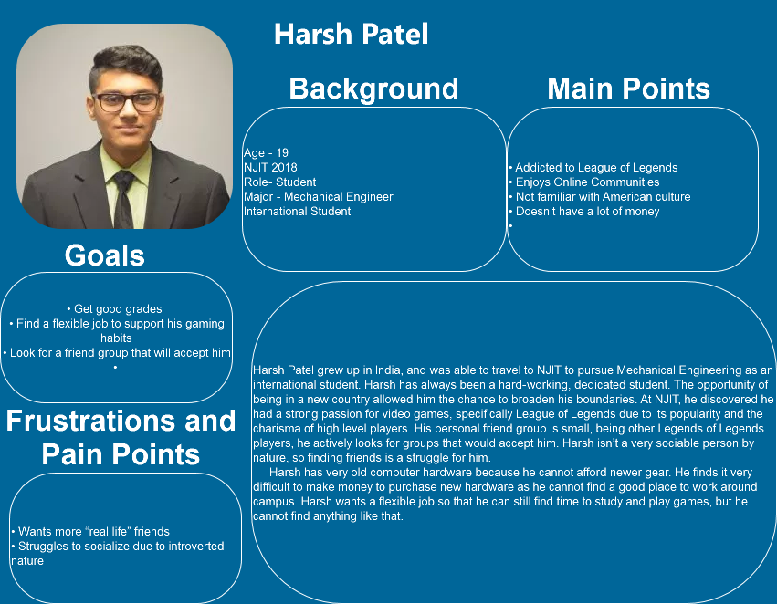

1. Problem Scenario
   1. User Interface

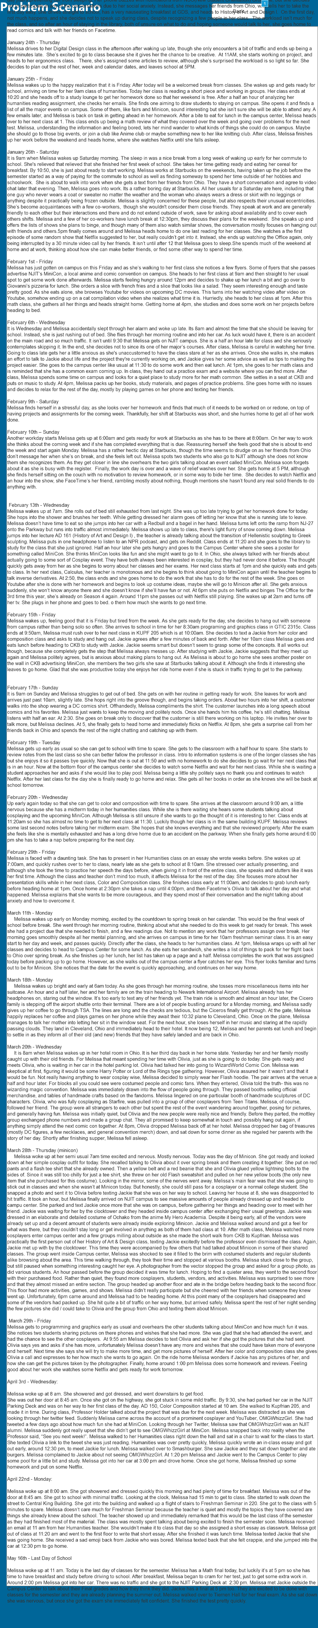

* 1. Widget Table

| Footnote | Interactions |
| --- | --- |
| 1 | OnClick:  Case 1:  Open Melissa Cicero in Current Window |

1. Problem Scenario Storyboard (1)
   1. User Interface

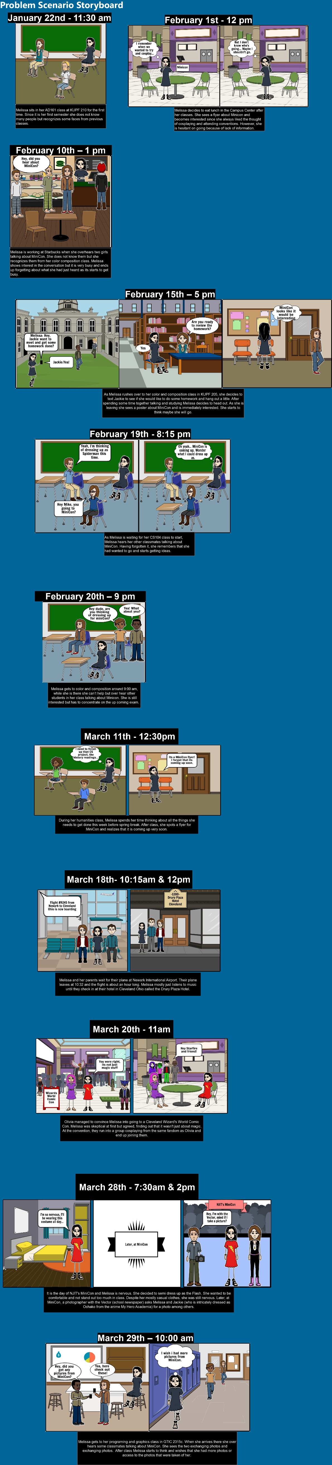

1. Claims Analysis
   1. User Interface

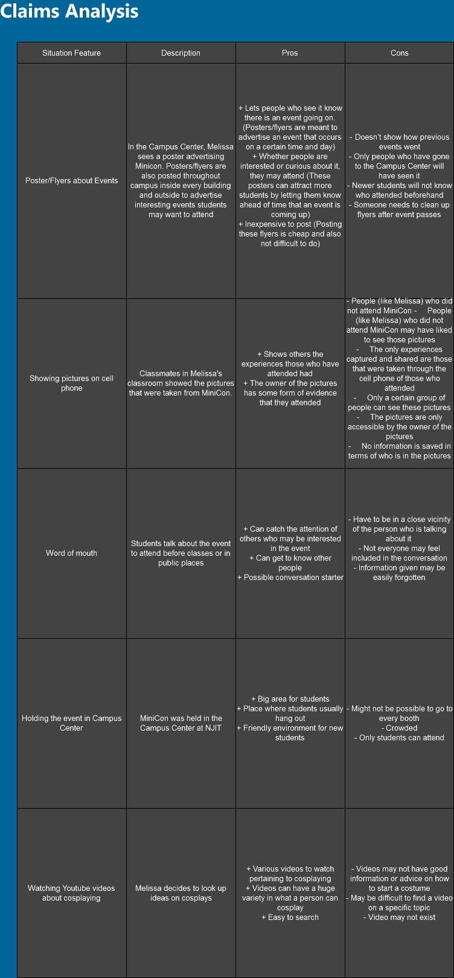

1. Activity Scenario Attempt
   1. User Interface

