

# **The Game Room**

# **CS 230 Project Software Design Template**

**Nicole Penner**

Version 1.0

## Table of Contents

**CS 230 Project Software Design Template**1

**Table of Contents**2

**Document Revision History**2

**Executive Summary**3

**Design Constraints**3

**System Architecture View**3

**Domain Model**3

**Evaluation**3

**Recommendations**5

## Document Revision History

| Version | Date | Author | Comments |
| --- | --- | --- | --- |
| 1.0 | 03/21/2021 | Nicole Penner | Initial Software Design Template |

**Instructions**

Fill in all bracketed information on page one (the cover page), in the Document Revision History table, and below each header. Under each header, remove the bracketed prompt and write your own paragraph response covering the indicated information.

## Executive Summary

The Gaming Room currently has a successful app that is currently only available for Android phones. The company is looking to expand and develop a web-based version of the gaming app that is available on multiple platforms. CTS needs to set up and the environment to create the web-based version of the gaming app to facilitate and streamline the development process.

## Design Constraints

The design constraints are as follows: select a platform to host the web-game version of the game that will serve multiple platforms easily and efficiently, create a user-interface that looks the same as the app but will function for a web-based version of it, follow the same color scheme and other design elements that resembles the mobile app, set The Gaming Room up with a plan that follows their time-frame and budget to create the web-based version of the application, create a schedule for all stages of design, and test the web version of The Gaming Room frequently to confirm it is running correctly and efficiently. All of these are constraints that need to be followed to ensure The Gaming Room can develop a web-based version of their application that will run efficiently, look like the mobile app that already exists so current and new players recognize the branding, and stay on their schedule and budget to create the best possible web-based app of their game.

## System Architecture View

Please note: There is nothing required here for these projects, but this section serves as a reminder that describing the system and subsystem architecture present in the application, including physical components or tiers, may be required for other projects. A logical topology of the communication and storage aspects is also necessary to understand the overall architecture and should be provided.

## Domain Model

Game, team, and player are all entities. This means that game, team, and player all inherit traits from entity. Therefore, game is an entity, team is an entity, and player is an entity. This shows inheritance which is one of the four principles of object-oriented programming because game, team, and player are all child classes of entity which is a parent class. Polymorphism, a second principle of object-oriented programming is shown here because Game extends Entity, Team extends Entity, and Player extends entity. Game, Team, and Player are all instances of Entity which is also shown because all three inherit traits from the parent class Entity. Encapsulation, a third principle of object-oriented programming is shown in this UML diagram as well. Some objects and methods of each class are public which is indicated by the plus sign and those that are private are indicated by the minus sign. Since use of some objects is restricted to a specific class, this shows encapsulation. Abstraction is the fourth principle of object-oriented programming. There are no abstract classes or methods here but it references the idea of only displaying essential things where other details are hidden away.

Team and player have a relationship between each other, where team has players. In other words, an instance of one class makes reference to an instance of another class. This diagram shows that GameService has a reference of Game, Game has a reference of Team, and Team has a reference of Player. A game service can have multiple games, a game can have multiple teams, and a team can have multiple players. That is the relationship for the lower part of the UML diagram. Also, ProgramDriver which contains the main part of the code uses SingletonTester, this is show in the upper left section of the UML Diagram.

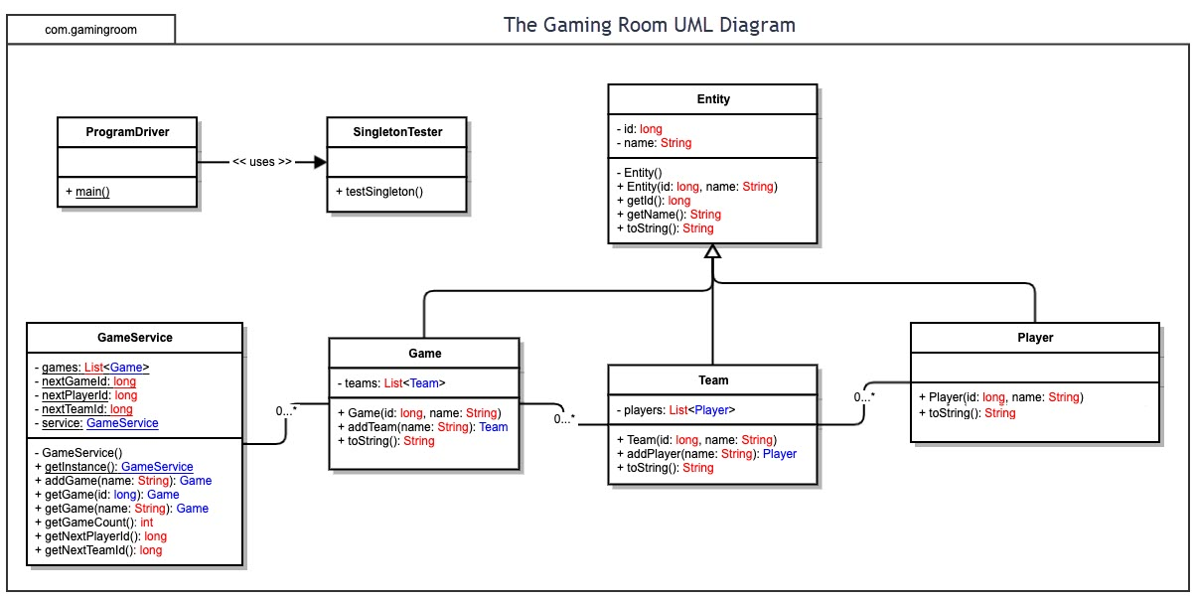

## Evaluation

Using your experience to evaluate the characteristics, advantages, and weaknesses of each operating platform (Linux, Mac, and Windows) as well as mobile devices, consider the requirements outlined below and articulate your findings for each. As you complete the table, keep in mind your client’s requirements and look at the situation holistically, as it all has to work together.

In each cell, remove the bracketed prompt and write your own paragraph response covering the indicated information.

| **Development Requirements** | **Mac** | **Linux** | **Windows** | **Mobile Devices** |
| --- | --- | --- | --- | --- |
| **Server Side** | MacOS has major advantages if Mac clients are used in the network. It is extremely easy to create apps. It offers many advantages if Mac clients are used in networks. It has easy accessibility and server configuration. It has flexible terminal commands to design the server and to access and make changes. The user interface is easy to use. There will be a cost to use a Mac hosting server. | Linux gives multiple hosting options since its open source. It is extremely flexible and provides a higher sense of manageability and automation that could save the department time and money if something in the system was to go down. The downside is if you want/need to use MS-SQL Database, ASP.NET, or .NET Core you need windows to do so. Also, no support is available if you choose to use Linux OS. There may be some difficulty navigating the platform. There is no cost to use a Linux server to host. | Windows has guaranteed long-term support for its servers, and hardware is easily installable. If there are issues, technical problems may be solved by system recovery. The server is compatible with most programs, and Microsoft specific programs. The cons are there are high licensing cost to use Microsoft, security issues may arise with their servers, and large amount of resources are required. There will be a cost to host on a Windows server as well. | You would need to code the entire thing, and develop the whole backend of a mobile app. You need to find a provider that will host your mobile application much like the Play Store on Android or App Store on Apple. Mobile device specifications vary, and may be better in some devices. |
| **Client Side** | Mac is costlier for a user than windows, and the user is forced to buy a Mac system that is built by Apple. Some programs are not compatible to MacOS as well. MacOS does offer a simpler user interface and security is increased. It requires an average amount of skill, average time to setup, and is more expensive. | An advantage to Linux is it is completely open-sourced which allows for a wide range of options for users and increased security.  The disadvantages are it is less common and support is harder to get. Linux requires maximum skill and time with minimal cost. Linux users need to be extremely proficient to support the system. | Windows is the most common OS, and are relatively affordable, or more expensive depending on the specifications you need to have. Windows is extremely easy to use, as a lot of available software, games, and utilities based on their large customer base. It is a less secure OS though. It is more expensive than Linux but requires minimum amount of expertise. | Typically, there are two categories of Mobile Devices, phones and tablets. Mobile devices offer a great deal of flexibility, efficiency, increased ability to communicate in multiple ways. Android and Apple phones are expensive, but there are other options. Users need to commit some time to support mobile devices. |
| **Development Tools** | Languages for coding include HTML, CSS, and JavaScript. Mac also supports libraries that support both the frontend and languages. IDE’s can include JavaScript, Python, PHP, and Ruby. Other development tools include PyCharm, Eclipse, Visual Studio, GitHub, Notepad++ and other online developing tools. | Languages supported include HTML, CSS, JavaScript and other libraries are supported as well. IDEs for Linux include  C, C++, Java, Python, JavaScript, PHP, and Ruby. Popular Linux development tools include GitHub, Visual Studio, PyCharm, Eclipse, and Notepad++. | Windows also supports a great deal of programming languages like HTML, CSS, and JavaScript. IDEs for Windows include Python, C++, HTML, Java, C#, C, C++, Python, and JavaScript.  Popular development tools for windows are GitHub, PyCharm, Eclipse, Visual Studio, and Notepad++. | HTML5 is great for building web-fronted apps. Other popular programming languages are JavaScript, Python, PHP, and Ruby. IDEs include HTML, php, C++, and Python. Other Developing tools include GitHub, Visual Studio, Eclipse, command prompt, PyCharm, Eclipse, and Notepad++. |

## Recommendations

Analyze the characteristics of and techniques specific to various systems architectures and make a recommendation to The Gaming Room. Specifically, address the following:

1. **Operating Platform**: The operating platform I recommend for the hosting the web-based version of The Gaming Room’s “Draw it or Lose It” application is Windows. All platforms have both their advantageous characteristics, and those that may be drawbacks. The main concern is how the web-based app it runs and if there is an issue how much support will be needed to figure out the issue. While Windows is slightly more costly, it is more friendly to those who are newer to web-based hosting and has many advantages in this regard. Windows will have the best results in this case with great software availability, the minimum expertise required compared to other servers, and it will not run into any shortage when working with IDE’s. Windows operating system is designed to run on server hardware, is widely supported by many other server roles such as web server, application server, database server, print server, and mail server.
2. **Operating Systems Architectures**: The design of Windows server operating system includes an array of ways to manage files. A user can control and manage the computer’s memory to make it as efficient as possible. Developers have the opportunity for developers to work with many programming languages. Windows has a hybrid kernel system which consists of a simple kernel, hardware abstraction layer, drivers, and a range of services collectively called “executive.”
3. **Storage Management**: Windows allows for efficient memory management on devices. When an application is downloaded it will be stored onto the main memory of the device after downloading is completed. Since it is stored to the main memory, loading will be faster since it is stored to the main memory. There is the option for cloud server storage which can exponentially increase the amount of storage.
4. **Memory Management**: The Windows operating system has many options for memory management. Such options include both virtual and physical address space, and this can be optimized so memory usage is most efficient when things are stored and when applications are running on the system efficiently.
5. **Distributed Systems and Networks**: Network based multi-user interaction systems like games that are web-based usually have a database that is shared among players on a server. Windows operating system has distributed systems and networks that simply communicate with each other, and often have different processors between many “single” workspaces. Network support usage in a distributed system is an efficient way to make use of the software for the distributed systems. It offers easy communication and direction between the two, though some issues exist in this system such as routing issues and congestion.
6. **Security**: Windows operating system offers many security options for its clients. Some options include user account control settings that can protect the data that comes into the system or data that is leaving the system. There is options to create secure VPN’s to protect their clients data, and keeping it secure. Windows also offers anti-spyware in their security to help prevent unwanted or malicious software from infiltrating their client’s system.