10/14/2014

PROPRIETARY INFORMATION

Auto Obsessions

Fluffy Unicorn

Game Design Document

Version 1.0

Contents

1 Team Personnel 2

2 Game Overview 2

2.1 Game Description 2

2.2 Genre 2

2.3 Audience 2

2.4 Platform/Hardware 2

2.5 Requirements 2

3 Plot and Setting Information 2

3.1 Story 2

3.2 Characters 2

3.3 Enemies 2

3.4 Levels 2

4 Core Gameplay 2

4.1 Levels 2

4.2 Movement 2

4.3 Upgrades 2

4.4 Beans 2

4.5 Controls 2

4.6 Artificial Intelligence 2

4.7 Power-Ups 2

5 Character Stats 2

6 Enemy Stats 2

7 Interface and Interface Usage 2

7.1 Main Menu Interface 2

7.2 Game Menu Interface 2

8 Menu and General Game Usage 2

8.1 Game Flow Diagram 2

9 Audio 2

10 Notes 2

11 Wish list 2

12 Development Technical Milestones 2

12.1 Alpha Version 2

12.2 Beta Version 2

12.3 Silver Version 2

12.4 Gold Version 2

# Team Personnel

Director and Programming Lead: Alexander Sanchez  
Visual Artist: Alexander Sanchez  
Programming Intern Teal Lead: Andrew Best  
Programming Interns: Jim Corrigan, Brandon Coulthard and Bryan Pope

# Game Overview

## Game Description

Fluffy Unicorn is a single player experience, following Fluffy the Unicorn through his adventures in converting what were once bullies into his new found friends.

## Genre

Side-scrolling shooter

## Audience

* General Audience
* Video Game Fanatics
* Ages 5 and up

## Platform/Hardware

The game will be developed using Unity’s free license. This means that there will be no costs for software used in developing the game. Since we are using Unity, we can target many platforms. However, to begin with, we will be submitting the game to the Android Play Store and the Apple App Store.

## Requirements

# Plot and Setting Information

## Story

**WORK IN PROGRESS** Fluffy is bullied and aims to convert all of the bullies into friends through the power of farting.

## Characters

**Fluffy** – Main protagonist of the game. This is who the player controls.

## Enemies

This section will contain details on individual bullies when they are created.

Enemies Base class should be created with virtual functions so that latter enemy classed derived from the base class can inherit all the basic enemy attacks and behaviours as well as aggregating his/her own special attack.

All Enemies will have a basic punch and kick. A randomized algorithm may be implemented to decide the variations of attacks that they will choose when fighting the player.

## Levels

This section will contain the story on each level, describing whether or not it is the schoolyard or the cafeteria, etc.

# Core Gameplay

## Levels

This section will contain level **functionality**

## Movement

The player will move around the levels using touch screen controls. Player movement will be approximately 5m/s, with their acceleration being 10m/s². This means that the player will reach top speed in 0.5 seconds. The player will decelerate at a speed of 20m/s², meaning it takes the player 0.25 seconds to stop from maximum speed.

## Upgrades

This section will contain details on the upgrades available to the player.

## Beans

Beans will drop from enemies killed as well as appear randomly on different parts of the levels. These are used to increase your fart gauge.

## Controls

The controls for the game utilize touch controls. Players will slide their finger up and down to move the unicorn and press buttons to activate the other controls.

## Artificial Intelligence

The Artificial Intelligence will spawn at set locations throughout the level and follow a set path in a “roam” setting. Once the player is within 20m of an enemy, the enemy will engage “seek” mode and begin to head towards the player.

The Artificial Intelligence will also try to choose the best path possible to also avoid the player’s fart cloud projectile.

## Power-Ups

There will be numerous power ups available for Fluffy to pick up. At this point in time there aren’t any ideas for them.

# Player and Enemy Stats

This section will contain an in depth look at the player’s and varying enemy stats. Note: These are base stats and do not reflect what they can be when upgraded.

## Player Stats

**Fluffy**  
Health: 3  
Damage: 1

## Enemy Stats

**Bully**Health: 1  
Damage: 1s

**Pepper-Bully**Health: 2  
Damage: 1.5

## Life Bars (HUD)

Both the player and enemy should have life bars to display health up above in game screen the game HUD player and enemy health bars play an integral role in the look and feel of the game.

# Interface and Interface Usage

## Main Menu Interface

The main menu will contain normal, key elements that your average Main Menu has. It will contain a Start and Options button.

## Game Menu Interface

The game menu is the menu that appears when the player pauses the game. This menu should have Resume, Restart, Options and Quit buttons

# Menu and General Game Usage

## Game Flow Diagram

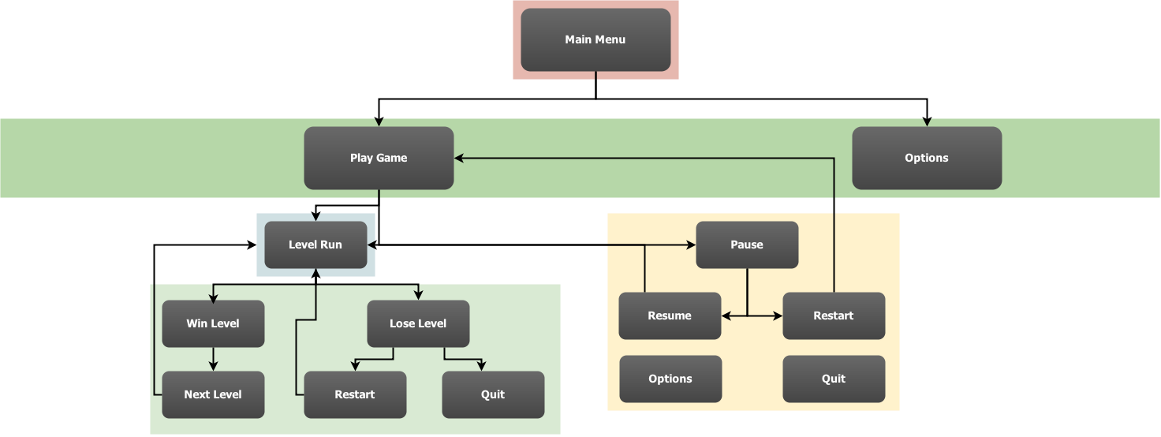

# Audio

This section will contain all audio information, in the following format:  
Song/Clip Name: 🡨 This will contain only the name of the song or the clip  
Artist (if applicable): 🡨 This will contain only the name of the artist, if not found, use **N/A**  
In Game Use: 🡨 This will contain where it is used in the game  
Credit: Yes/No 🡨 This is whether or not the artist wishes to be credited for their work, if Artist is **N/A** use **No**  
  
**Example:**  
Name: Fart Noise  
Artist: N/A  
In Game Use: On Player Attack  
Credit: No

# Notes

This section will contain any important notes, such as copyright information for any art or audio that is not suited for other places in the document.

# Wish list

Here will be the list of features we would like to have in the game, but may not be able to fit into the timeline.

* Achievements

# Development Technical Milestones

The following describes the technical goals that are required to be met during the development phases of the creation of the game along with their respective deadlines.

## Alpha Version

**Game Flow**

* Main Menu and Game State Machine, this includes the User Interface that runs the game from Main Menu to the start of the game and any other states that the game requires for user experience.
* Beans: Players are given an initial amount of coloured beans
* 3 Lives (implement the lives and display on game HUD)
* Basic Character movement
* Player class with movement and animation (touch events for touchscreen support)
* Side scrolling camera functionality with easing on player for visual elegance and games visual distinction
* Game Aspect Ratio all screens need to be scalable to all device width and heights

## Beta Version

**Character Development**

* All described in the Alpha Phase needs to be properly implemented including tidying code structures, scripts, organization and fixing any issues or bugs that may be occurring in games current state.
* Artificial Intelligence: Enemy Class implementation and enemy steering, seek player movement and behaviours, and enemy bosses.
* Player and Enemy collision
* Score
* Health Bars and Gas Bars
* Beans HUD (display the different coloured beans with a little number next to it to indicate how many are available in inventory at any given time while player is alive)
* Player Attack or Fart functionality
* Game Sounds: Atmospheric setting audio tracks for each level and in-game sound effects

## Silver Version

**Tech-Demo**

* Artificial Intelligence: Avoidance behaviour (basic behaviour to run from farts that may have different effects on the enemy’s nervous systems)
* Performance enhancements
* Load and Save Game Data
* Story Mode: Cut scenes where Fluffy advances in the game and the app narrates his adventure in between gameplay. Artwork will be required for this.
* Power-ups spawning and implementation inside areas of the games and upon character circumstances as required to sustain or extend gameplay or players chance of survival.
* Score and Gas % working and game timers
* Fart abilities or techniques should be developed as the player advances in levels he can learn new basic fart attacks or upgrade old farts
* Upgrades: Players are given an opportunity to upgrade their “Fluffy Unicorn”
* Upgrade Menu Implementation

## Gold Version

**Polish and Completion**

* Upgrade menu fully implemented
* Performance enhancements
* Load and Save Game Data
* Bug fixing
* Polish lighting effects, particle effects
* Fancy fonts for Level Intros