5/7/2015

PROPRIETARY INFORMATION

Raven Games

Animal Tales

Game Design Document

Version 1.0

Contents

1 Team Personnel 2

2 Game Overview 2

2.1 Game Description 2

2.2 Genre 2

2.3 Audience 2

2.4 Platform/Hardware 2

2.5 Requirements 2

3 Plot and Setting Information 2

3.1 Story 2

3.2 Characters 3

3.3 Setting 4

4 Core Gameplay 5

4.1 Walkthrough 5

4.2 Scoring and Points 5

4.3 Controls 5

5 Interfaces and HUD 6

5.1 Main Menu Interface 6

5.2 HUD 6

5.3 Screenshots 7

6 Menu and General Game Usage 7

6.1 Game Flow Diagram 7

7 Audio 8

8 Notes 8

9 Wish list 8

10 Development Technical Milestones 8

10.1 Milestone 1 - Alpha Version 8

10.2 Milestone 2 - Beta Version 8

10.3 Milestone 3 - Silver Version 9

10.4 Milestone 4 - Gold Version 9

# Team Personnel

Director and Programming Lead: Alexander Sanchez

Programmer: Tyler Drury  
Visual Artist: Alexander Sanchez   
Programming Interns: TBD

# Game Overview

## Game Description

Animal Tales is an educational game for children to help them learn to read. The objective is to help Mollie find her animal friends, collecting as many points as possible, and learning to spell along the way. As points are collected, you level up and the words get slightly harder to spell. Each time a mistake is made, an animal runs away and you lose points. The game is over when 5 mistakes are made.

## Genre

Educational, Family, Puzzle

## C:\Users\Nicole\AppData\Local\Microsoft\Windows\INetCache\Content.Word\e for everyone.jpgAudience

* General Audience
* Video Game Fanatics
* Ages 3 and up

## Platform/Hardware

The game will be developed using Unity’s free license. This means that there will be no costs for software used in developing the game. Since we are using Unity, we can target many platforms. However, to begin with, we will be submitting the game to Android’s Google Play Store and the Apple iTunes Store.

## Requirements

An internet connection is required to purchase/download the game, upon initial release at least.

# Plot and Setting Information

## Story

Learn to read with the help of cute animal friends such as Mollie the Monkey, Leo the Lion, Sparkles the Squirrel, and many more. Mollie will ask a question and to help find the next animal, spell the answer correctly to find them. Help Mollie find all her animal friends and learn to spell at the same time.

## Characters

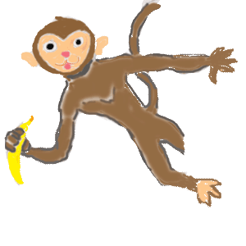

Main - Mollie the Monkey

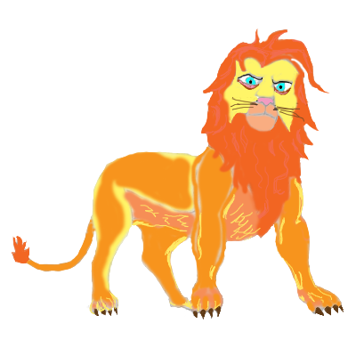

Leo the Lion



Sparkles the Squirrel



Howler the Wolf



Speedy the Turtle

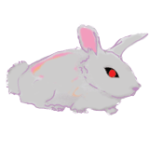

Rockso the Rabbit

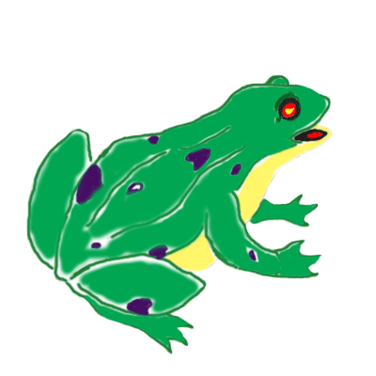

Ribbert the Frog

## Setting

This game takes place in a jungle-type setting throughout the game.



Jungle Environment

# Core Gameplay

## Walkthrough

Upon loading, you will see a splash screen for 3 seconds followed by the main menu. You see regular menu options and upon selecting start, you are transitioned to the game screen. There you can see Mollie the Monkey hanging there in her tree in the top right portion of the screen. A speech bubble appears above her and she then explains the game: “Hi, I’m Mollie. Help me find my friends! I’ll ask a question and you tap the box at the bottom to spell the answer. If you’re right, we’ll find one animal friend! Tap to continue.” A randomized 4 letter word question and answer is displayed in Mollie’s speech bubble as well as a second speech bubble. Tap the box at the bottom to bring up the device’s keyboard to spell the answer which appears in the second speech bubble. Spelled correctly, 4 points are awarded, as the answer is a 4 letter word, and Mollie says a randomized congratulations and welcomes the next animal found, also randomized. If the word is spelled wrong points are deducted according to the amount of letters in the misspelled word, scores can go into negative. The lives remaining in the top left corner is adjusted accordingly. If 5 words are spelled wrong, the game over screen appears displaying your score, the high score, and you are given the option to play again or quit.

## Scoring and Points

As each word is spelled correctly, points are awarded according to the number of letters in the word. The words start as easy 4 letter words and can progress up to 8 letter words. Every 3 words spelled right, the words get slightly more difficult as 5 letter words, every 3 more words spelled right, the words become 6 letter words, and so on until 8 letters is reached and every word from that point on is 8 letters long. Each word spelled incorrectly will deduct the number of letters the misspelled word was from your score. Points are saved and displayed as “High Score:” on the main menu.

## Controls

The controls for the game utilize touch controls. Players will tap the bottom of the screen to bring up the keyboard on their device and spell the required word. Players can tap and hold to move the animals (except Mollie) around the screen and arrange them how they want.

Screenshot with Keyboard

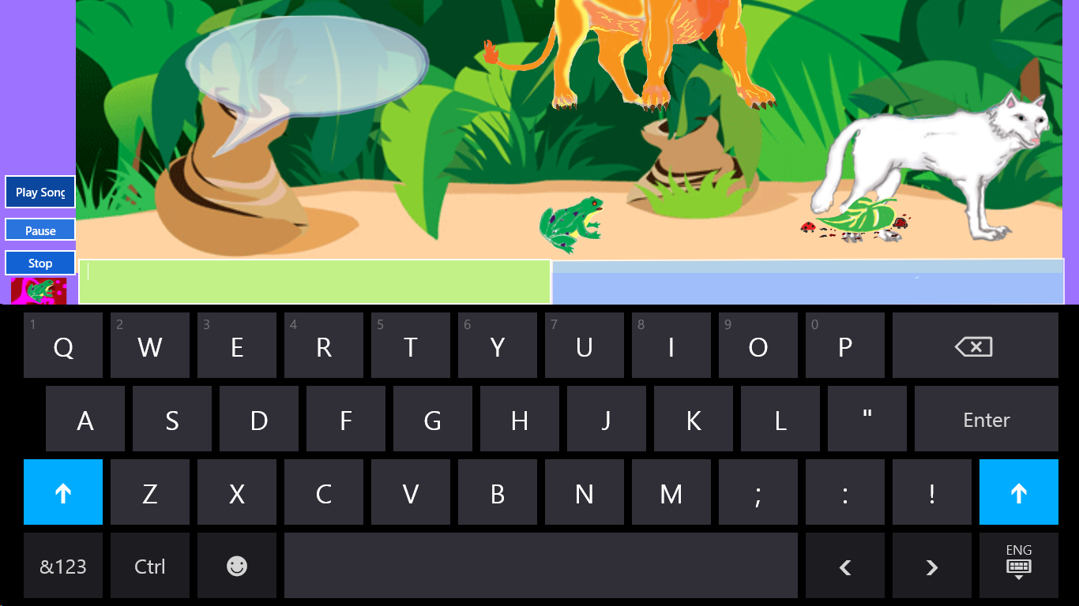

# Interfaces and HUD

## Main Menu Interface

The main menu will contain normal, key elements that your average Main Menu has. It will contain Start, Options, and Quit buttons. The main menu also contains the saved high score at the bottom of the screen in the centre. Below are examples of the Splash and Main Menu screens.

Splash Screen

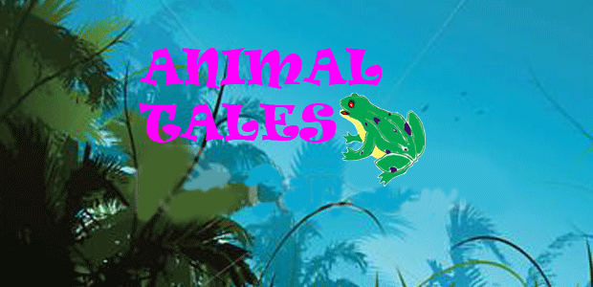

Main Menu Example

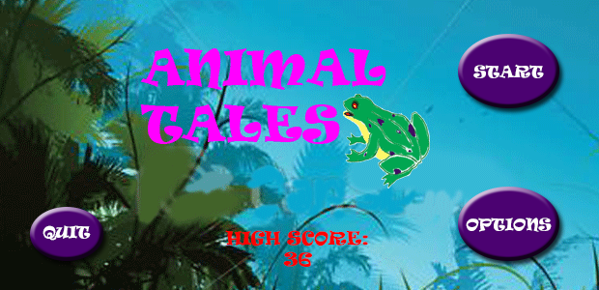

## HUD

The Head’s Up Display should contain the score clearly displayed in the top right-hand corner. The number of mistakes left you can make is displayed as lives remaining in the top left-hand corner of the screen. Music controls are displayed as buttons in the lower left corner of the screen as well.

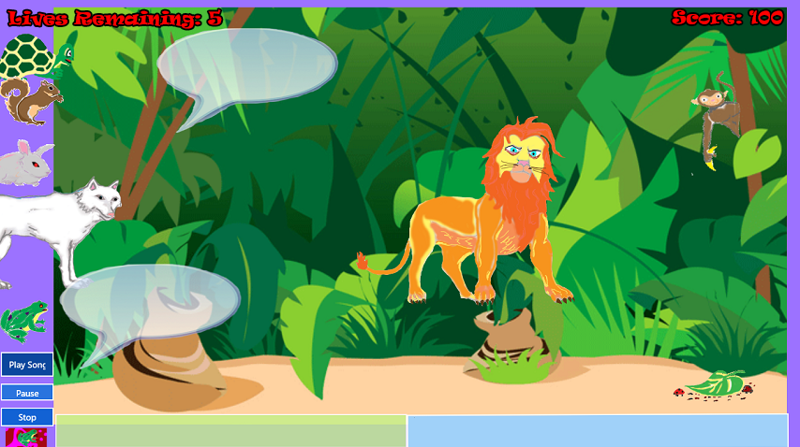

Screenshot with HUD Example

## Screenshots

Gameplay Example Screenshot #1

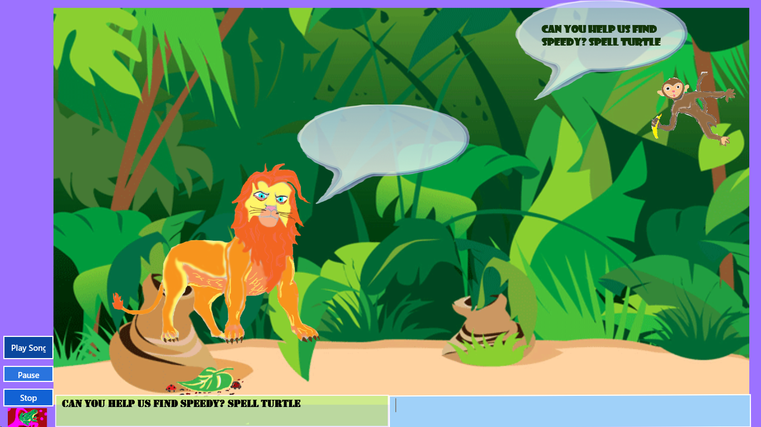

Gameplay Example Screenshot #2

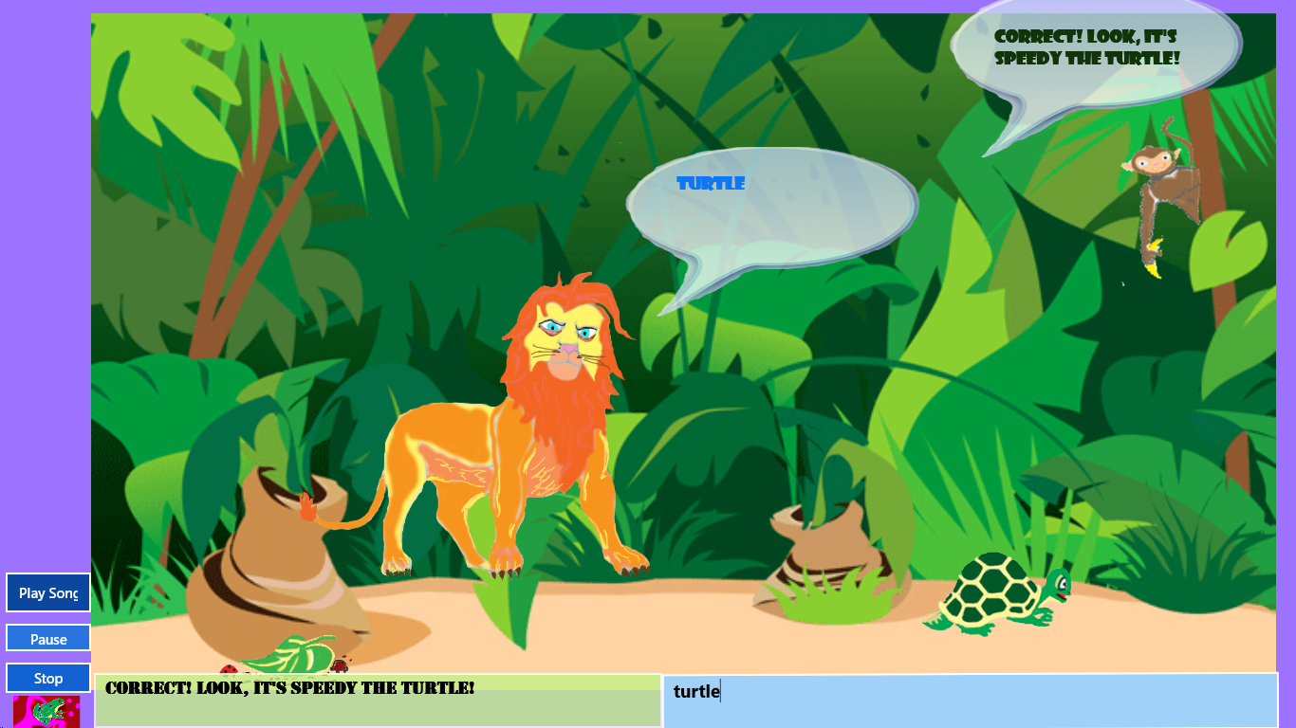

# Menu and General Game Usage

## Game Flow Diagram

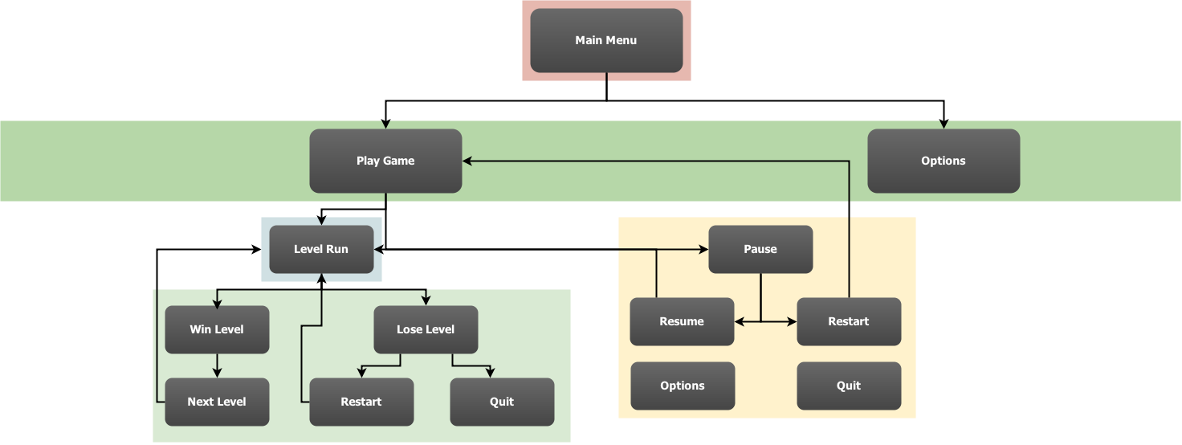

# Audio

There is an ambient track suited for this game that is on a loop playing in the background. Each animal will have its own sound effect that is triggered when the animal is clicked or tapped. There will also be a sound effect for when a word is misspelled.

# Notes

This section contains important notes that are not suited for other places in the document.

* Artwork will be all original, audio may not be (i.e. sound effects).
* Pause may not get implemented on HUD as pause can be achieved other ways on the users’ mobile device.

# Wish list

Here will be the list of features we would like to have in the game, but may not be able to fit into the timeline.

* Achievements
* Customization and/or Options Menu

# Development Technical Milestones

## Milestone 1 - Alpha Version

**Game Flow**

* Main Menu and Game State Machine, this includes the User Interface that runs the game from Main Menu to the start of the game and any other states that the game requires for user experience
* Basic drag-and-drop controls / tap & hold functionality implemented
* Game Aspect Ratio all screens need to be scalable to all device width and heights

## Milestone 2 - Beta Version

**Character Development**

* All described in the Alpha Phase needs to be properly implemented including tidying code structures, scripts, organization and fixing any issues or bugs that may be occurring in games current state
* HUD implemented – Score, Level, etc.
* Game Sounds: Arcade style audio tracks as ambient and in-game sound effects.

## Milestone 3 - Silver Version

**Tech-Demo**

* Performance enhancements
* Leveling-up implemented
* Story Mode: cut scenes/screens with congratulatory narration (possibly voice-overs which will need to be done) upon leveling-up. Artwork will also need to be done
* Load and Save Game Data implemented

## Milestone 4 - Gold Version

**Polish and Completion**

* Menus fully implemented
* Optimization
* Bugs fixed
* Polish lighting effects, particle effects
* Fancy fonts for Level Intros
* Transition effects between screens & menus