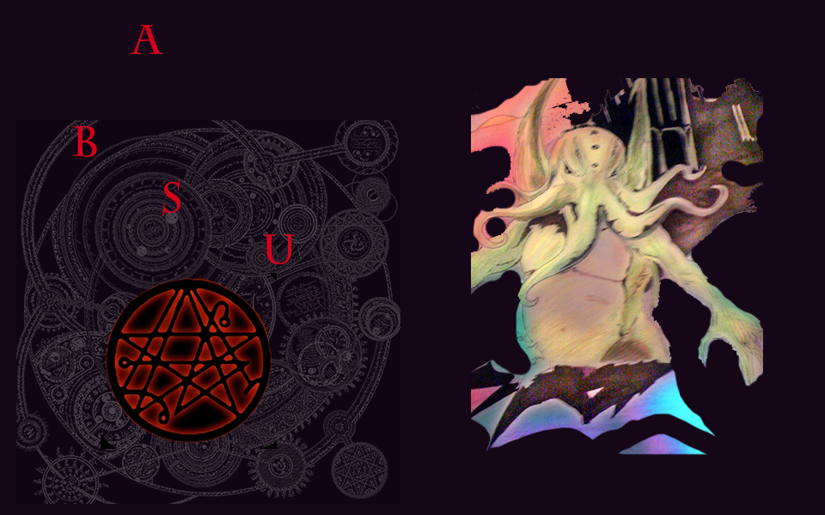

Absu

Table of Contents

Table of Contents 2

3 Target Audience

4 Visual Style 5

5 Goal of the Game 6

6 Story 7

7 Characters 8

8 Game Mechanics 9

9.1 Power Ups 9

9.1.1 Magic Power- Ups 9

9.1.2 Energy Power-Ups 9

10. Enemies 10

10.2.1Skully (reanimated skeletons) 10

10.2.2 Fenrir 10

10.2.3 Spike 10

10.2.4 Zombie 10

10.2.5 The ancient ones 10

10.2.6 Shadow Man 10

11.3 Bosses

11.3.1 Beast of Babylon

11.3.2 Dagon

11.3.3 Cuthulu

12 Game Interface 12

12.1 Controls 12

13 Levels 13

13.1 Level 1 – The Portal (Brave New World) 13

13.2 Level 2 – The Absu 13

13.3 Level 3 – Sanctum Regnum (Lair of the Unholy Cuthulu) 13

# 3. Target Audience

* General audience PG ages 12 and up.
* This game will appeal more specifically to people who enjoy the Horror genre and its themes are occult based.
* People that enjoy games that are quite easy and fast to pick up on
* Anybody who likes games in general.

4. Visual Style

Absu will be a 2D game with all original artwork based on the free of copyright HP Lovecraft novel and fun Castlevania or Streets of Rage side -scroll adventure gameplay. The style would be applicable and scalable for the web and cross platform mobile devices, along with PC. The ambience or look and feel of the game including characters and music is a bit gloomy to fit the storyline.

Players will have to make their way through 3 levels in a basic side scroll left to right style navigation fighting enemies with sword attack or magic while searching for helpful items and coins to amp characters experience, physical strength and magic to help him on his path. Once the player has reached the end of a level a boss will appear and after completing the boss fight the level ends and transitions to the next level. Once the third stage has been completed the player will be shown a credits screen and then be taken back to the title screen.

5.0.Goal of the Game

* The goal of the game is to beat all the levels in it and defeat each boss. The player must be motivated to fight enemies to gain experience and find helpful items to restore game stats he will start with 2 lives and this is not symbolic by any means this number is relative to the number of levels in the game.
* To reach the end of the third level to meet up with the main villain Cuthulu and banish him and the rest of the creatures back in to the abyss.

# 6. Story

The world has been destroyed, now all that remains are the creatures that undid the earth “The creatures of the Necronomicon” left there by their master they know only to strike fear and chaos wherever they go. Our hero is a dark mage /sorcerer of mysterious nature who was also left behind or at least his spirit and is using his magic to defeat Cuthulu and the ancient ones and send them back to their realm so that he may undo what they have done. Legend has it that many men have gone mad or missing in the attempt to confront the mysteries of this peculiar book and that its spells should never be recited because that which is done can never be undone Absu is already past that and needs to fix what is wrong so he marches on determined to write his own chapter and seal at the end of the book.

The concept is a basic side-scroller with a main character who starts the game an evil mage who is presented with the original “Book of the Dead” the infamous “Necronomicon” contained within are his spells and experience manager as he is put on a spiritual path and tackles an adventure which involves working with energy ,throughout the course of each level as the character reaches the end of each stage and there will be a typical boss character that raises the difficulty for the player from the enemies he is now used to defeating. The character fights using a sword or his magic His physical abilities “attack” is a swing of his sword and magic is an energy drain which deducts energy from his enemies, his skills both attack and magic are developed gradually as he plays more of the game and gains experience in each respective aspect as he collects items and defeats enemies his stats update and are displayed at the end of each level or mission.

# 7. Characters

Absu : Long time necromancer/black sorcerer and main character of our game, he is putting his magic to the ultimate test as he unleashes the evil that is contained in Pandoras box in to our realm by unlocking the mysteries of the Necronomicon and summoning the beasts from the nether dimensions. He possesses the power of magic and physical strength moreover he is a skilled swordsman. He plans to raise his power to the ultimate level by sending the creatures of his ancient book back to their home dimension and in doing so he will rise brand new from his quest as the most powerful wizard of our times.

Absu has a basic combination of sword attacks in his animation and as for magic he has a single a few spells which he keeps in magic book or inventory.

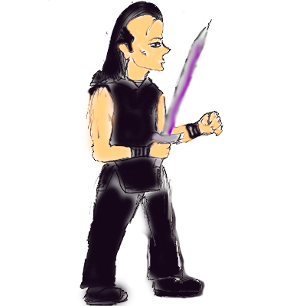

# 8. Game Mechanics

1. Absu will be given basic movement abilities, such as run, sprint, and jump
2. When jumping, Absu's position will be 2 units taller than his own height. For example if Absu’s height is 4 units, then he will be able to jump 6 units high.
3. Absu’s health will be monitored by a dynamic life-bar on the HUD. Each time he takes damage, the green part of the health-bar will decrease 2-5 percent which will be based on the type of enemy that attacks him, a Boss will make him lose a cool 10% on attack.
4. Absu will move at a speed of 2 m/s.
5. The player will have a magic bar (Mana) stat in which will be depleted when they decide to use one of the magic abilities or spells. The max stamina will be 10 but increments as player gains more experience.
6. Stamina will decrease at 1 unit/second as Absu’s uses his spells. Once he stops using the magic ability his mana begins to refill 1 unit every 2 seconds until it is full again.
7. Collision detection will be performed when the player comes in contact with an enemy attack. If Absu is to come in contact with one of these said enemy attacks he will lose 5 percent of his health-bar.
8. There will be several varieties of power ups in the game. Each of which will effect a different stat of the character. For example, there will be a power up in which the player will refresh his health bar (potion) and ether to replenish magic.
9. If Absu’s health reaches 0, then the player will be presented with a loss screen. This will ask them if they would like to retry the level, which everything will be reset (player restarts from start point of the level in which he last played). They will also be asked if they want to go to the title screen instead.
10. The player will be instructed by an arrow that appears on the screen in the background to indicate the direction he should take accompanied by a signature sound effect, similar to what they had in the retro 8 bit Double Dragon games.

# 9. Power-Ups

Absu will traverse each level of the game finding helpful pick up items to aid his quest, the gameplay is fairly simplistic and so is the difficulty so to make matters more interesting there will be just a few of these pick- up items spread out through the level waiting to be picked up and as the level increases difficulty larger items of the same type also become available in a few select places for example a large potion might be waiting for the player near a boss fight if he should be so lucky.

9.1 Potions: Potions restore player’s health bar and in form they resemble the typical lab beaker filled with potion image from most common games.

Small Potion: Small potions recover 25 percent of player’s health based on his current health.

Medium Potion: Medium potions recover 50 percent of player’s health based on his current health.

Large Potion: Large potions recover 100 percent of player’s health based on his current health.

9.2 Ether : Disclosed in a bottle which resembles drinking alcohol is the means to replenish our player’s magic power so he can perform his spells.

Ether shot : 1 oz (ounce of straight up spirits) recovers 10 percent of his magic meter.

Ether mickey : A larger amount of ether for the magical recovery process , taking a mickey recovers 25 percent if magical ability.

Ether Litro : A liter of ether has a stunning effect to razzle dazzle the magic meter as it not only puts a smile on our player’s face from ear to ear it also replenishes the magic meter by 50 percent and is the highest intake of spirits the player can handle at one instance.

# Enemies

Skully : He is the most basic enemy of the undead minion enemy class or base class model, he is an undead skeleton raised by Absu’s black-magic. Skully simply walks around with a spear or poking stick, and has one basic attack, (spear poke) which impacts 2 percent of the health meter on impact.

Fenrir : the souls of the passed ravenous hell hounds that are of a striking resemblance of the mythological Norse wolf in size and terror. They have a basic attack or charge “bite” that takes off a 3 percent of health on impact with the player.

Spike: Heavy Metal minion guy who carries a dagger and has a few attacks that impact highly on player’s health knocking 5 percent off health bar. Among his attacks he has stab, slice and knife-throw and if he loses knife in a throw he defaults to basic punch attack that removes 3 percent of health.

Zombie: Reanimated dead from the old books of voodoo put on the terrain by the necromancer Absu for practice purposes. Zombies are mindless and have no strategy or high intelligence and therefore they attack on a much slower level but can still stun the player and remove 5 percent of the health meter.

The Ancient ones: They are forever people original of that old dark dimension, they have a fish – human appearance and they are monks adept in magic who in devout servitude to Cuthulu offer sever magical attacks that remove 10 percent of the player’s health on impact.

Shadow Man: Rival black magicians who project their smoky spirit entities in the forms of these shadow men have great magical power and have a strange collection of physical attacks that are very quick and seem very unnatural that confuse and stagger the player’s health the attacks can be varied and range from 3-8 percent damage. They are difficult to defeat and they can regenerate health and cause for a much longer battle.

# Bosses

# 11.1 Beast of Babylon

The Beast of Babylon: He is a demon and keeper of the crimson skies he is a mythological hydra monster with human heads and many of them attacking at once his attacks are fierce removing 8 percent of player’s health each attack.

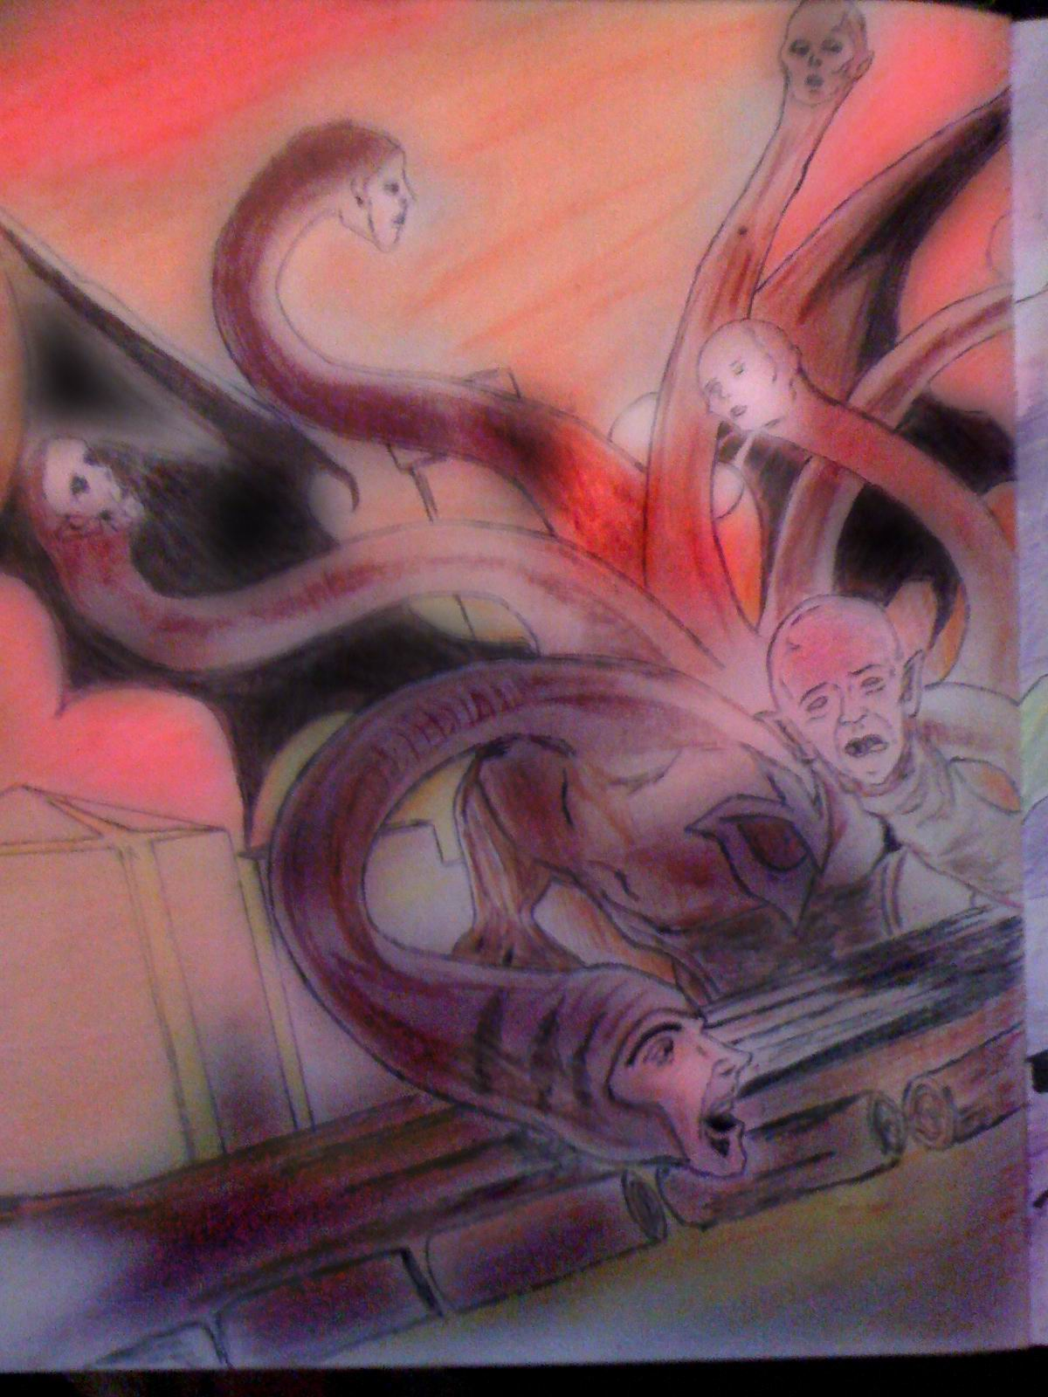

# 11.2 Dagon

Dagon: He is of many forms but in our game he appears first demon form later takes on a human form of a dark wizard and has a highly diverse magical artillery and a rage and control to match his attacks, he is directly underneath Cuthulu in the hierarchy of evil Gods and has many temple followings in this earth today. This boss is of the highest magical character type in the game and his magic attacks are piercing they remove 15 percent of health on impact.

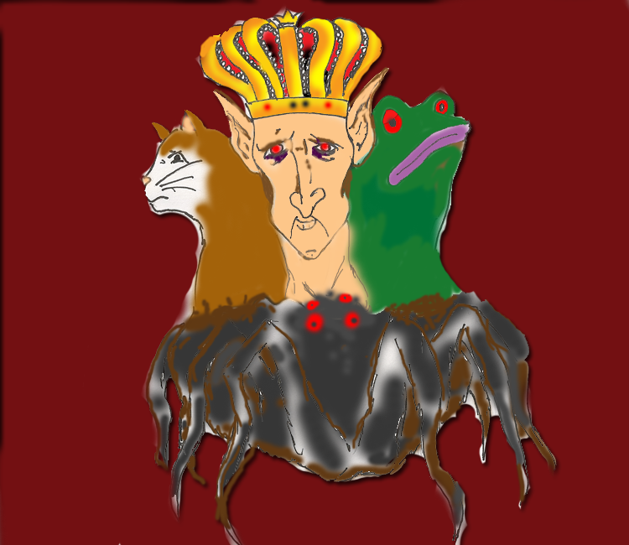

# 11.3. Cuthulu

Cuthulu : The Juggernaut God he will attack with great physical strength but can also summon the Krakken which is a hell that will shave a great deal from the players health bar in most common scenarios his attacks are fatal.

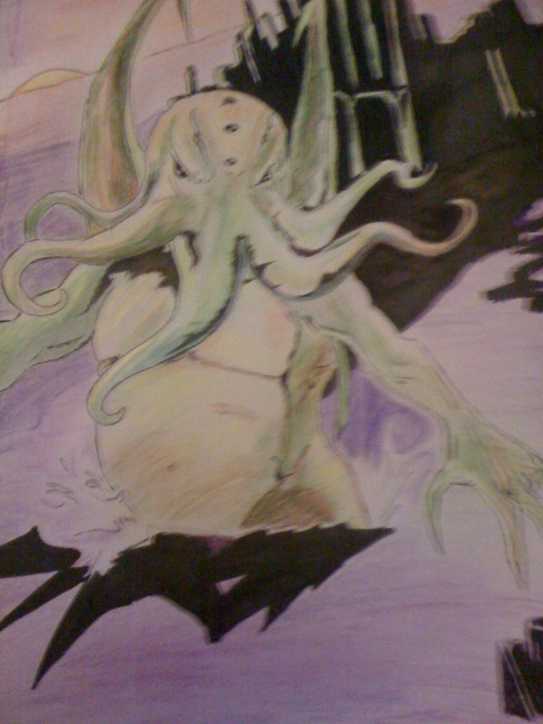

# Game Interface

The game begins with a splash screen containing a stylized drawing of gameplay. The game automatically transitions from the splash screen to the main menu after 3 seconds. At the main menu, the player can select from the following items using the mouse: 'Start Game', 'Options', 'Credits', or 'Quit'. If the player selects 'Quit', the program closes. Clicking 'Credits' brings the player to a separate screen with the names of the developers and an option to 'Return' which will bring the player back to the main menu. The 'Options' screen allows the player to adjust volume, change the game controls and return to the main menu. When the player chooses 'Start Game', the player is thrown in the game and he begins at level 1.Pausing the game while playing brings up a splash screen containing information such as the player's current health and magic remaining. From this screen, the player can choose from options with the left mouse button to either retry the level or quit and return to the main menu screen. Hitting the pause button again resumes gameplay.

Main Menu

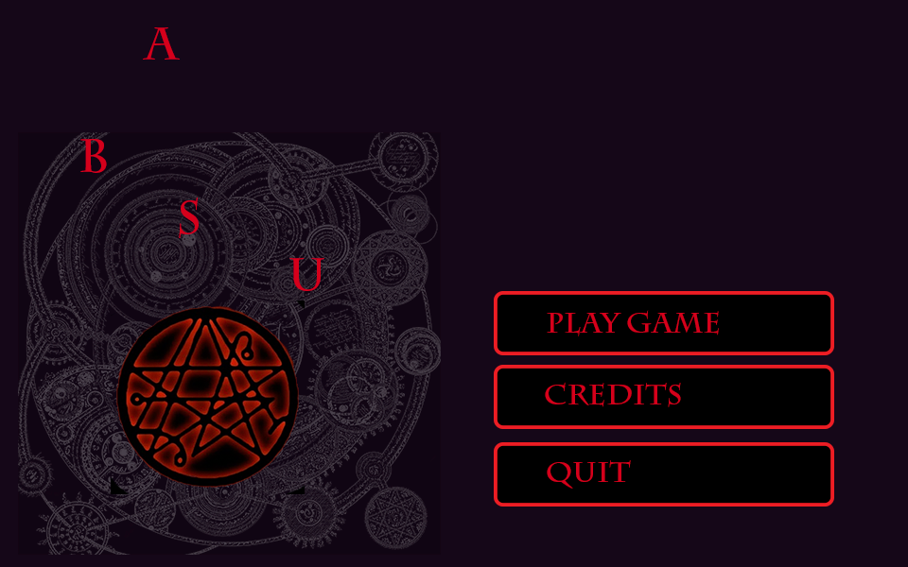

If the game grows enough before delivery date there may be an items menu

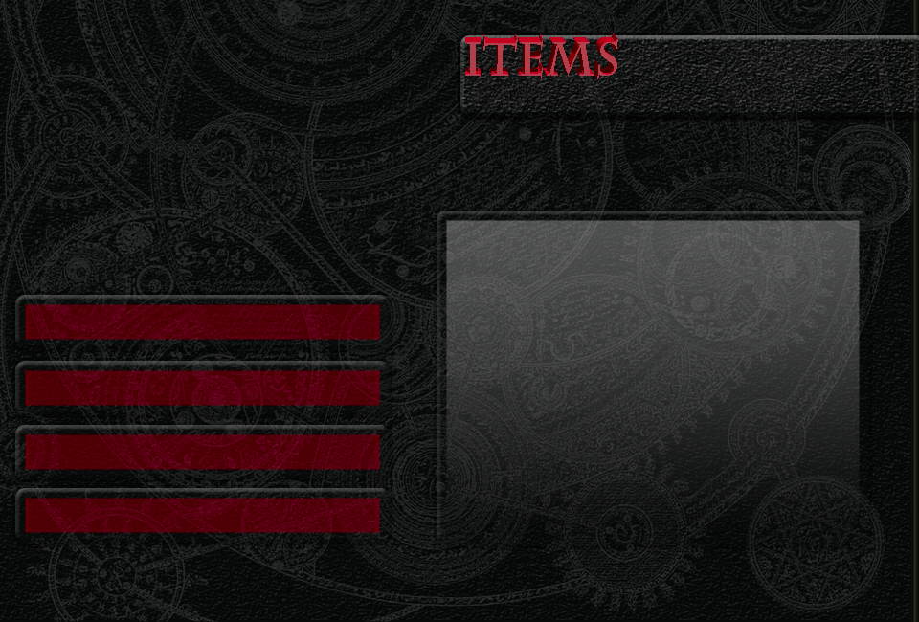

# 12.1 Controls

Keyboard Controls

-**W**: Causes the player to move forward at 50 pixels/second

-**S**: Causes the player to move backward at 50 pixels/second

-**A**: Causes the player to strafe left 50 pixels/second (this does not affect the player’s facing vector)

-**D**: Causes the player to strafe right 50 pixels/second (this does not affect the player’s facing vector)

-**SPACE BAR**: This will trigger the player to jump at 200 pixels/second

**ENTER:** Sword attack

-**SHIFT**: Magic attack

**CTRL:** Spells (Inferno, Reap )

13.Levels

# 13.1. Level 1 .The Portal (Brave New World)

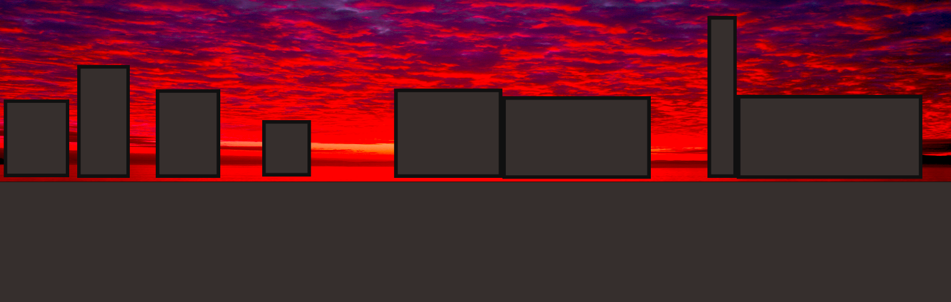

The 2D world has been destroyed, all that remains is a few buildings and all life is gone destroyed leaving the cities barren all this caused by an ancient spell only a few creatures remain and they are the hordes of hell themselves.

The Portal Brave new world level starts the player in a crimson sky atmosphere and a barren town 8 bit graphics scenery and in is an array of enemies : 8 Skully’s a few wolves and a couple of zombies . The player passes through this level to reach the Abyss or the dark forest where he will find a key to what he is looking for.

At the end of the level a horrifying boss awaits the player. It is here where his true horrors begin as he faces the relentless Beast of Babylon. The camera will change the view to leave the titan enemy boss in front view and the battle will start.

# 13.2. Level 2 .The Abyss (Enchanted Forest of Souls)

This level is a continuance of the main character’s life immediately after level one. Now the player finds himself in a murky forest full of sounds and eerie presence.

He is searching for an item which he will need to help him defeat enemies up ahead. During his journey through the forest our hero is confronted with many more adversaries. The trees have eyes and the forest is home to many goblins here he is faced with a few Skully’s in the entrance to the forest, as he goes deeper in the forest or further to the right and passed the sign there he discovers that some humans are still left alive and they are all like- minded individuals with a ravenous rage and a high appreciation for Metal music.

At this point these enemies named Spike come after the player and things begin to intensify and turn for the worst. There are some heated battles in the forest as well as there is a third phase to the forest more evil is lurking zombies and something else, somewhere even deeper in to the forest is the secret lair of the

Once the player has defeated the deadly batch of Ancient Ones he will face another major challenge as the boss here is going to require some real strategy and patience to succeed further.

The Abyss of the enchanted forest is the temple of the high priest Dagon.

# 13.3. Level 3 .Sanctum Regnum (Lair of the Unholy Cuthulu)

This level will be unique from the previous two. After the forest the player passes through the cemetery and a very dark and evil place is further ahead. Aside from new terrifying enemies there will be a set of obstacles or death traps that will stunt the player from reaching the end of the level before the timer ends.

As before mentioned this level is filled with even more danger and difficulty as our hero grows tired of fighting. Now that the player has had his first real experience with the ancient ones in a magic showdown it is time to prepare for the true battle. There is a secret enemy or enemies that possess even greater skill and magical power than the ancient ones and they are the true generals of Cuthulu and his most powerful people they are the sorcerers of the keep and they have been projecting their energy from another place and they are waiting for him in certain areas of the level.

Here in this level there is every type of enemy attacking at once.

As he gets closer to the place where Cuthulu awaits the difficulty intensifies and the battles are surely designed to have the player lose.

The end of this level unlocks a whole new level within itself as the big cheese of the game is preparing for his meal. The ancient Dark God from the Cuthulu mythos it is the man himself.

Cuthulu has 3 forms and if the player defeats his first form then he will see next more horrifying form and each time the next form is somehow more powerful.

If the player defeats all three of Cuthulus forms then he has completed the game and achieved his purpose as a powerful magician. He will have then restored the earth to what it used to be and justice will have prevailed.