Game Design Document

For

Jetpack Archer

Version 1.0

By:

Nicole Silverthorn, Ryan Feyen, Phil Bickle

**Table of Contents**

Overview --------------------------------------------------------------------------------------------------------------- 3

Plot and Setting ------------------------------------------------------------------------------------------------------- 3

Movement ------------------------------------------------------------------------------------------------------------- 4

Interface Usage (Controls, HUD, Screenshots) ---------------------------------------------------------------- 4

Menus and General Game Usage/Flow Chart ----------------------------------------------------------------- 6

**Overview**

This game is a 2D platformer with an arcade visual style with 2D, pixelated art. The objective is to survive and kill all the enemies in each level before progressing to the next. The game continues until the player’s health reaches 0. The player is equipped with a crossbow and a jetpack with limited fuel per level. Survival becomes that much more difficult when jet pack fuel runs out. This game is intended for audiences male and female above the age of 10 and therefore the desired ESRB rating would be E10+.



**Plot and Setting**

Help our hero Archer destroy all the enemies in the caves. Archer is equipped with a crossbow and a jetpack. The jetpack starts with a set amount of fuel which has to be watched as there is no refuel until the next level. Arrows for the crossbow are unlimited. The jetpack gives Archer the ability to fly up and jump higher for a 3 second period at a time. Remaining fuel is displayed in the top left corner of the screen. Arrows do 1 damage per hit to each enemy.

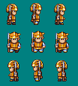**Player Character:**



**Enemies:**

* **Slimes**: Slides on the ground towards the player and explode when they touch them.



* **Bouncing Apple**: Bounces towards the player, exploding on contact.
* **Bats:** Fly towards the player, exploding on contact.

**Other:**

* **End level Object:** This object spawns when all the enemies in a stage has been killed. Picking it up will transition to the next level with simple Zelda-type scrolling.

**Movement**

**Player Movement**

* Left/Right movement: 150px/s
* Jump: Move upwards at 200px/s for 1.5 seconds
  + Fall at 50px/s
* Left/Right Dash: 600px/s
* Double Jump: 400px/s upwards

**Enemy Movement**

* *Slime*
  + Left/Right movement: 100px/s
  + Jump: 150px/s for 3 seconds
    - Fall at 100 px/s
* *Bouncing Apple*
  + Left/Right movement: 110px/s. Moves in bounding arcs
  + Jump: Upwards at 175px/s
    - Fall at 175px/s
* *Bat*
  + Left/Right/Up/Down movement: 250px/s. Moves in 400px bursts.
  + Does not jump.

**Interface Usage (Controls, HUD, Screenshots)**

**Controls**

* Left arrow: Move left
* Right arrow: Move Right
* Up arrow: jump
  + Left Shift: Engage jet pack
* Spacebar: shoot arrows

**HUD/UI Elements**

* **Health Meter**: A meter showing how much health the player has left. Placed in the top left hand corner of the screen.
* **Jetpack Meter**: A meter showing how much fuel is left in the jet pack. Placed below the health meter.

**Screenshot (example)**

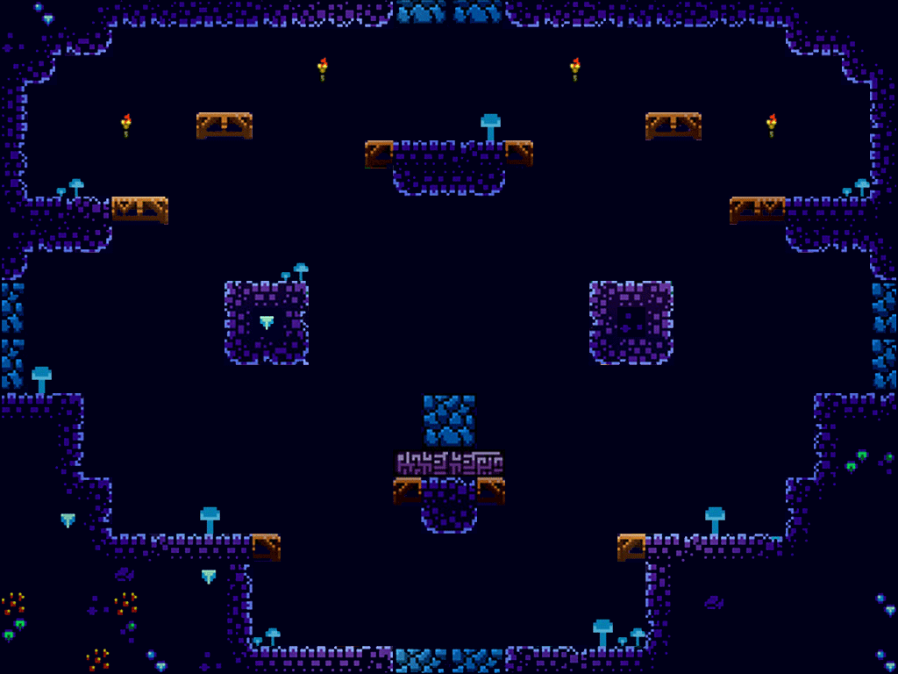

# 

**Menus and General Game Usage/Flow Chart**

