**Game Design Document**

For:

**Squirrel Crossing**

**Version 2.0**

Nicole Silverthorn

**Table of Contents**

Game Overview - - - - - - - - - - - - - - - - - - - - - - - - - - - - - - - - - - - - - - - - - - - - - - - - - - - - - - - - - 3

Plot & Setting Information - - - - - - - - - - - - - - - - - - - - - - - - - - - - - - - - - - - - - - - - - - - - - - - - -3 Core Game Play - - - - - - - - - - - - - - - - - - - - - - - - - - - - - - - - - - - - - - - - - - - - - - - - - - - - - - - - - 3

Interface Usage (Controls, HUDs/Screenshots) - - - - - - - - - - - - - - - - - - - - - - - - - - - - - - - - - 4

Menus and General Game Usage (Flow Chart, Screenshots) - - - - - - - - - - - - - - - - - - - - - - - - 5

**Game Overview**

Squirrel Crossing is Frogger-like game, made with SDL. The objective is to collect as many acorns as possible by getting the squirrel across the street, avoiding all the vehicles. The visual style is 2D/arcade style, viewed from a top-down perspective. It is intended for smaller platforms such as mobile or PC, and the desired ESRB rating would be E for Everyone.

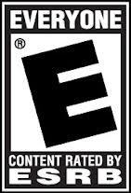

**Plot & Setting Information**

Meet Sammy Squirrel. He wants to collect as many acorns as possible. Help Sammy across the busy, 5-lane streets to collect his acorns. Collect an acorn for every street crossed without getting hit by any vehicles.

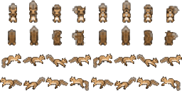

**Core Game Play**

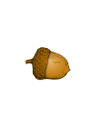 The game begins with a 4 second Squirrel Crossing splash screen, then play begins and you see Sammy Squirrel at the bottom of the screen in the centre. He can only move in 4 directions, and he jumps 64 pixels up or down and 32 pixels left or right. There are 5 lanes to cross, each lane with a different vehicle, each going a different direction, negatively or positively on the x-axis. Each vehicle has a random speed between 1 and 300 pixels per second and random spawn times between 1 and 1000 milliseconds. There is an acorn waiting for Sammy to collect at the top of the screen after getting across all 5 lanes. Sammy starts with 3 health but each car that touches him decreases his health by 1. Collect the acorn and move to the next street (start back at the starting position at the bottom of the screen) and collect the next acorn. If Sammy is hit by 3 cars, it is game over and the game over menu appears where you can chose to play again or quit.

**Interface Usage (Controls, HUDs/Screenshots)**

The only controls in this game are the movement controls. On the PC controls are up, left, down, and right, or w, a, s, d accordingly. For mobile/touch devices, tap the direction to jump on the directional pad in the bottom right corner of the screen. The health is displayed by the 3 hearts in the top left hand corner of the screen. Mobile screens will be locked in landscape orientation for this game.

PC HUD/Screenshot:

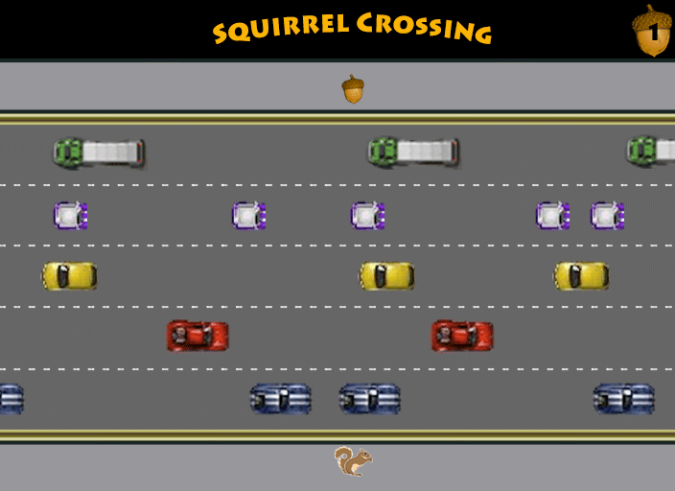

Mobile HUD/Screenshot:

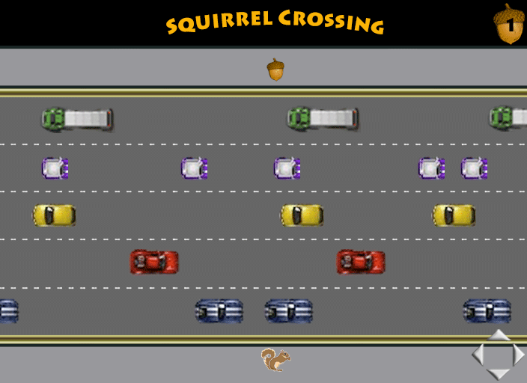



**Menus and General Game Usage (Flow Chart, Screenshots)**



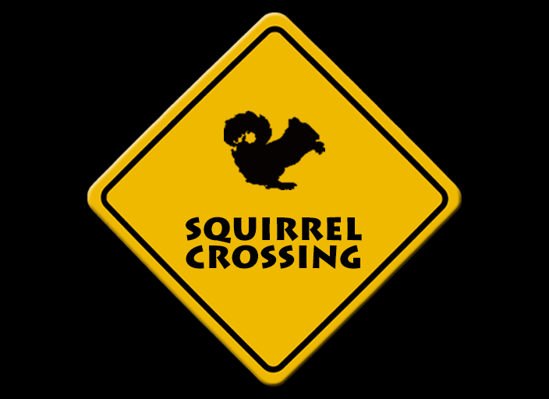Splash Screen:

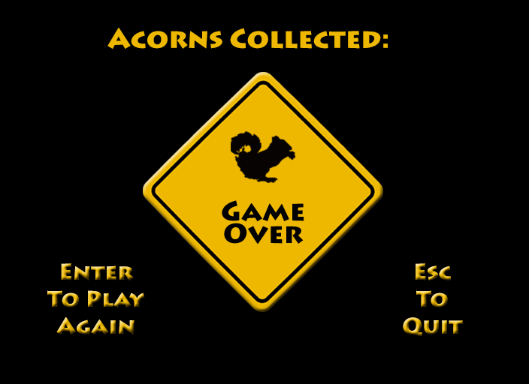Game Over Menu: