Rabid Unicorn

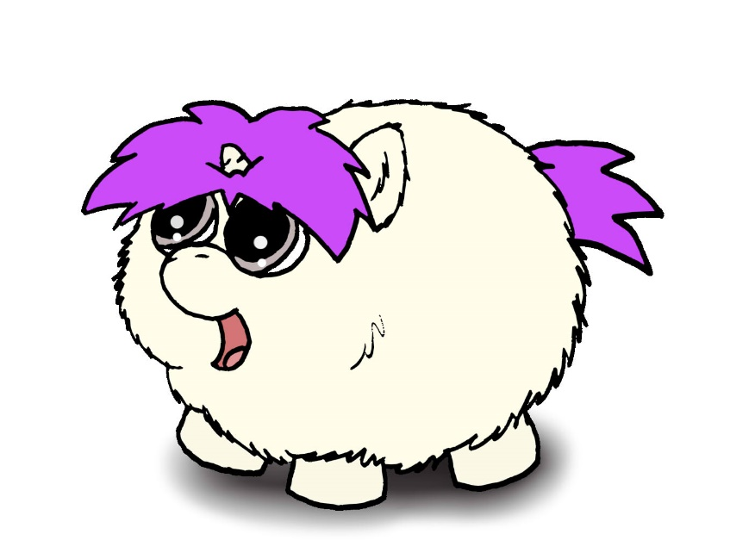

# Rabid Unicorn (Mobile App)

Side scrolling shooter game

Table of Contents

Table of Contents 1

2 Team Personnel

3 Target Audience

4 Visual Style and Game Platforms 5

5 Game Mechanics AI (Artificial Intelligence)……………………………………………………….………………………….. 6

6 Controls 7

7 User Interface ………………………………………………………………………………………………………………………………………8

8 Scalability and Mobile Awareness ……………………………………………………………………………………………………… 9

10 Creative Extras …………………………………………………………………………………………………….…………………………..11

12 Milestones …………………………………………………………………………………………………………………………………………….14

# 2. Team Personnel

Director and Programming Lead: Alexander Sanchez

Visual Artist: Alexander Sanchez

Programming intern team leader Chris LongBoats-Marsh

Programming interns: Chris Levitt

To be added soon to the project Esteban Lopez and Nielsen Leslie

# 3. Target Audience

* General audience
* Video game fanatics
* Ages 5 and up

4. Visual Style and Game Platforms

The game will be developed using Unity. It will be viewable and playable fully functional on all major mobile devices (cellphones and tablets).

# 5. Game Mechanics

This game will be available as an app and playable on all mobile devices.

Beans : Players are given an initial amount of colored beans and 3 lives.

Upgrades : Players are given an opportunity to upgrade their “Fluffy Unicorn”

***Game Play:***

The player is shown a very brief story about fluffy getting bullied. At this point players start the game. The unicorn is on the left side of the screen and can be moved up and down. Bullies enter view from the right side of the screen from various positions. The players aligns the unicorn with the bully and presses the fart but to send the rainbow fart cloud towards the bully. Once the bully is hit with the fart cloud, it converts to a friend and the player is awarded a point.

During normal game play, colored beans also appear from the right side and players must collect the beans to have enough to fart.

Players have to convert a certain number of bullies in a designated time in order to progress to the next level.

At the end of each level there is a “Boss” that needs to be dealt with.

Power ups also add to the gameplay. They can be purchased and won during normal play

Bullies would appear with a randomized thought bubble that puts down the unicorn but the message would change to a positive message once the bully has been by a fart.

# 8. Controls

The controls for the game utilize touch controls. Players would slide their finger up and down to move the unicorn and press a buttons to activate the other controls.

# 

# 9. Creative Extras

Game Power-ups or incentives.

# 10. Development Technical Milestones

The following describes the technical goals that are required to be met during the development phases of the creation of the game along with their respective deadlines.

These dates are hypothetical for now they are based on member’s skillsets and work being proficiently delegated assuming all goes well and allotting for time to fix issues along the development timelines. The reality is this game could carry on a 4-6 month term if not everyone is pulling their weight, in the industry these occurrences are not unheard of and with new members joining the party and being unaware of their individual skillsets a 4-6 month duration would infer that something like this might be happening in a group of 4 members. If all goes really well we could expect this game might only take 2-3 months of solid development especially working with an engine like Unity which sole existence is to speed up the development process.

**Beta Version: April 10, 2015**

***Game Flow***

* Main menu and game state-machine, this includes the user interface that runs the game from Main Menu to start of game and any other states that the game requires for user experience.
* Beans : Players are given an initial amount of colored beans
* 3 Lives (implement the lives and display on game HUD)
* Basic Character movement
* Player class with movement and animation (touch events for touchscreen support)
* Side scrolling camera functionality with easing on player for visual elegance and games visual distinction.
* Game Aspect Ratio all screens need to be scalable to all device width and heights

Alpha Version: **May 17, 2015**

***Character Development***

* All the described in the beta phase needs to be properly implemented including tidying code structures, scripts, organization and fixing any issues or bugs that may be occurring in games current state.
* Artificial Intelligence : Enemy Class implementation and enemy steering seek player movement and behaviors , Enemy Bosses
* Player and Enemy Collison
* Score
* Health Bars and Gas Bars
* Beans HUD (display the different colored beans with a little number next to it to indicate how many are available in inventory at any given time while player is alive.
* Player Attack or Fart functionality
* Game Sounds : Atmospheric setting audio tracks for each level and in-game sound effects

**Silver version: June 21, 2015**

***Tech-Demo***

Artificial Intelligence : Avoidance behavior (basic behavior to run from farts that may have different effects on the enemies nervous systems.

* Performance enhancements
* Load and Save Game Data
* Story Mode : Cut scenes where Fluffy advances in the game and the app narrates his adventure in between gameplay. Artwork will be required for this
* Powerups spawning and implementation inside areas of the games and upon character circumstances as required to sustain or extend gameplay or players chance of survival.
* Score , Gas %, working and game timers
* Fart abilities or techniques should be developed as the player advances in levels he can learn new basic fart attacks and or upgrade old farts.
* Upgrades : Players are given an opportunity to upgrade their “Fluffy Unicorn”.
* Upgrade Menu Implementation

Gold version : **July 15, 2015**

***Polish and Completion***

* Upgrade Menu fully implemented
* Performance enhancements
* Load and Save Game Data
* Bug fixing
* Polish lighting effects, particle effects
* Fancy fonts for Level Intros