Vampire Runner

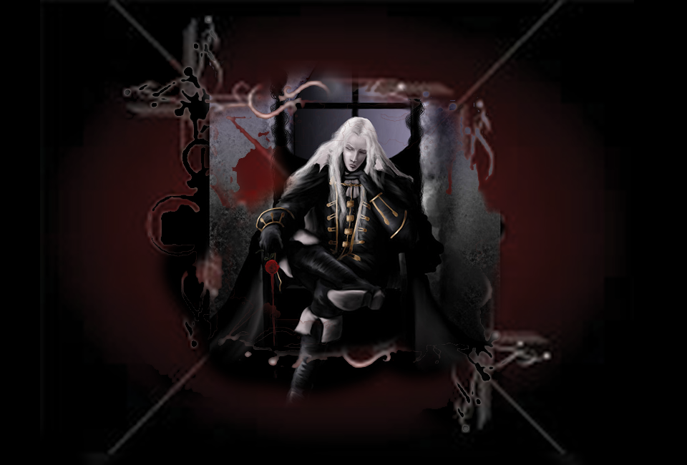

# Vampire Runner (Unity 2.5 Endless Runner Game)

Table of Contents

Table of Contents 1

2 Team Personnel

3 Target Audience

4 Visual Style 5

5 Story ……………………………………………………………………………………………………………………………………………………6

6 Endless Runner 7

7 Characters 8

8 Game Mechanics 9

9 Controls 10

10 User Interface ………………………………………………………………………………………………………………………………………11

# 2. Team Personnel

Director and Programming Lead: Alexander Sanchez

Visual Artist : Alexander Sanchez

# 3. Target Audience

* General audience
* Vampire fans and likeminded people
* Fans of endless runner games and Metal

4. Visual Style

The game will be developed as a 2.5 Dimension platform with traditional 2 Dimension side-scrolling game mechanics.

5. Story (Astral Wars)

The Astral wars are in session and the Universe’s elite astral vampires are on the prowl and you are stuck in a never ending dream state or astral paralysis and the only way Alucard (the character) can exit this perilous plight is to continue running to the very end of the journey dodging obstacles and foes along his path.

6.Endless Runner

The player is on a perpetual gut wrenching quest for survival in which he must run to meet the ends of a scene in the game. He is avidly competing not only to save his skin but to meet the highlighted marks located somewhere in the level to come closer to the end and hopefully wake up. Distance will be met or decided by the evil astral projector Carlos who has sent you this dream, each level will be slightly different in that distance met or finish marks are spaced out farther as the game grows in complexity. As the player crosses a level there will be different mechanics set out to slow him down.

# 7. Characters



“Alucard “: His name is an anagram, spelt backwards is Dracula as he is his son somehow, it is sincerely a tale too old for anyone to truly know to tell. He is a proficient occult practitioner and his most perfected skills include Astral projection, fast speed in travel and flight.



Carlos XVIII : He is the oldest living vampire who calls forth on the world’s greatest and darkest magic to aid his conquests whatever they may be at the time. He is the last remaining survivor of the old vampire coven. He will stop at nothing to lure Alucard in to joining him on his quests for complete Dominion over the world and its people.

# 8. Game Mechanics

**Atmospheric Settings**

Each level will contain one directional light and a random level generator that creates buildings, background images and running platforms that will differ in the different scenes or levels to follow the story and raise the complexity as we follow in to each astral journey and find a finish mark for the vampire to shift to the next scene, each time taking him closer to waking up.

**Music**

This game has music enchanting and dark to compliment the style of the vampire Alucard and his fellow clan members.

**Platforms/Obstacles**

Platforms in this game are of paramount importance for the player to become familiar with as they will produce different speeds that accelerate the player’s movement upon collision as he lands on each of them.

The levels also determine how much faster each of these platforms can be as the player traverses through the obstacle course. A higher level can increase each of the platforms speed boosts from the previous levels platforms as Carlos sees fit in the dream he sends each time.

**Platform Speed Scheme**

**Green Platform**

Green platforms can be a good thing at first and depending on the players skills can be very useful as they accelerate the player with great speed. The acceleration is roughly 10 pixels in game world units.

**Silver Platform**

Silver platforms maintain the current speed of the player. They serve to normalize the speeds the player can progressively build up but also help him keep a higher control of the situation by not accelerating further. The acceleration of the silver platform is 0 pixels in game world units.

**Magenta Platform**

Magenta or purple platforms are less ideal as a starting point for the player but can become a Godsend when the player is out of control due to an incredibly high velocity. These platforms work to contradict the effects of the green platforms they actually slow the players speed down by 5 pixels in game world units and help preserve the balance in the astral world. Alucard summons these with his will and every so often he is blessed if he should land here when situations become overly heated.

**Blood Vials**

Blood vials serve the player as power ups that give him extra energy or speed. They are randomly spaced out over platforms throughout the game to increase the player’s probability of successfully seeing an end to the current level. Blood vials can be stored in the player’s bloody inventory(Game HUD) until he is ready to use one. The HUD will display“Boosts” using GUIText to inform the player of any instances of blood vials and will store the amount collected in memory and dispose of one when used. The blood vial when used will increment the speed on the x and y coordinates in world space therefore they shall increment his distance and height by 10 pixels in game world units.

**Enemies**

The enemies laid out in each level are the geometry of Carlos’s evil mastermind. Using highly advanced astral projection techniques Carlos is able to spruce up these careful entities of all geometric 3Dimensional shapes to procure Alucards demise quicker. Enemies are very dangerous inside the different levels in that they can spawn in different locations, they seek and pursue the player and worst of all they can eventually collide with Alucard causing severe obstruction in his path by either getting in his way or by appearing from behind the player knocking him off his course. The player must tread carefully because even though they are only figments of the evil vampires mind and they cannot hurt the player directly they can be the most deadly obstacle the game has when they swarm all at once or when an enemy decides to knock the player off a platform it is game over.

**Position Markers**

Markers are allocated to precise points in the level to allow for a visual representation of distance traveled. They are set in the game as particle systems in the form of a colored ray shooting in an upwards direction

Level 1. Astral Projection Tutorial

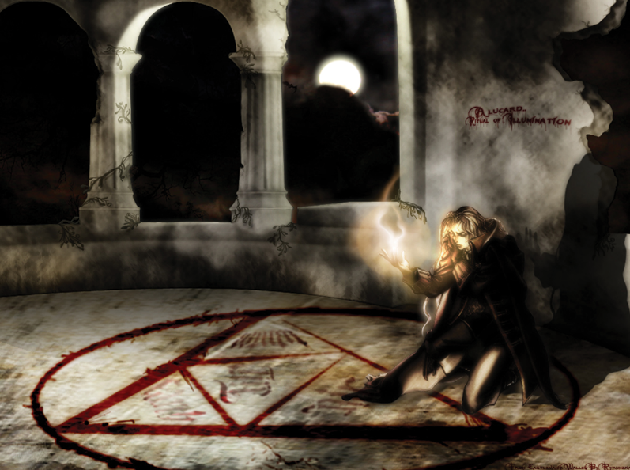

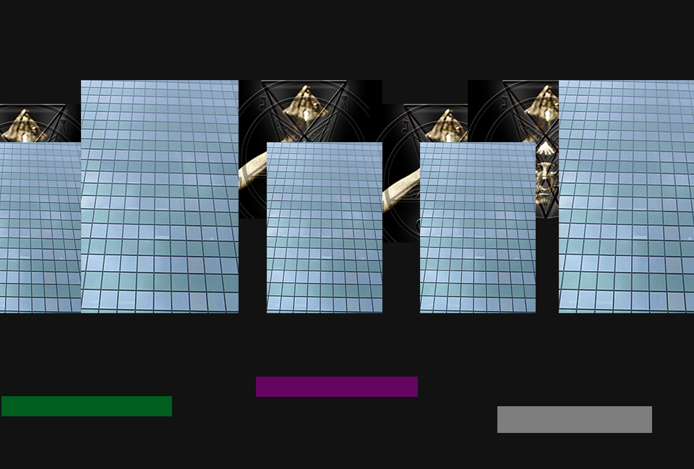

The player embarks on his first journey. He is prisoner inside his own dream and oblivious about what’s ahead. He must run to stay alive and watch carefully for obstacles all while he tries to stay alive in his dream and continue running until he has nowhere left to run.

Level One is a tutorial which instructs the player of the games mechanics which will remain the same throughout the rest of the game.

Instructions will be provided to the player in the form of instructional text or labels before he is ready to play. Once the player is ready to commence his journey he will press Start and be transported to his first astral projection.

A distance determines the end of the level. Once the player has endured a full 400 pixels in game world units the end of the level is achieved and the first mission of the game is conquered.

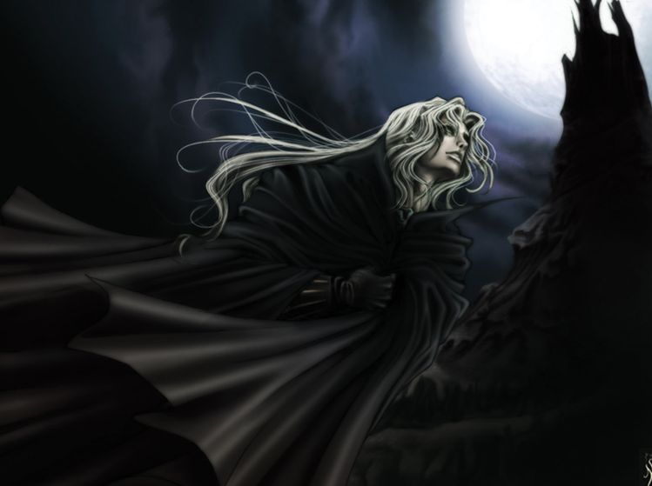



Level 2. Perplexed Dementia

Things are starting to get increasingly uglier and tougher as our hero makes it to this phase of his astral travels. This level is full of endurance tests, here the platforms become smaller and there is less room to land correctly on a platform and a higher rate for error or failure. There is a considerable raise in enemies and difficulty and everything seems to flow much quicker.

Level 2 increases platform speeds on green platforms by a multiplier of two and increases slow down on Magenta blocks by a multiplier of 1.5.

A distance determines the end of the level. Once the player has endured a full 200 pixels in game world units the end of the level is achieved and the first mission of the game is conquered.

# 9. Movement and Controls

Forward Motion (Directional key Right or forward): The player is given no initial velocity. Alucard has a forward motion of 20pixels in game world space which can accelerate the player on the x axis and can come in handy for long jumps.

Jump: As soon as he lands on a platform he can then press the space bar to Jump when he is ready for the action. The platforms are constantly pushing the player in a forward direction from left to right until the end of each course.

# 10. Main Menu and User Interface

The game initializes its vast greatness through a main menu with two buttons. The first button is the direct portal to the game and the last is a way out for the less courageous who would prefer to quit the game before attempting awesomeness.



Player HUD (Heads UP Display)

Distance Text

The distance text records the distance traveled by the vampire player.

Boosts

The boosts display is the Blood bank or “bloody inventory” in the game and it tells the player how many blood vials he currently owns in his inventory.

Time

Time elapsed playing the game.