[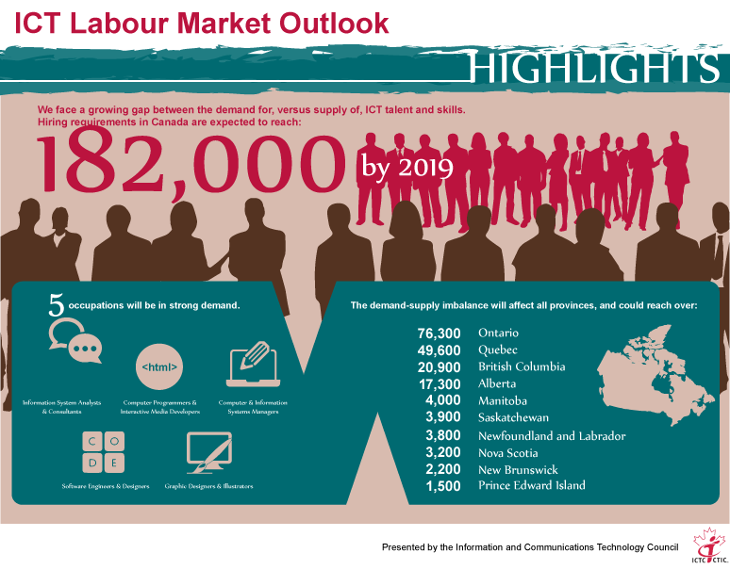](http://www.digcompass.ca/wp-content/uploads/2015/03/Outlook_finalEN-editedSAM.png)

**Canada faces a growing gap between the demand for and the supply of ICT talent and skills…**

* 811,200 ICT professionals are currently employed in Canada. Under three economic scenarios over a 5-year horizon, a combination of employment growth and replacement requirements produces estimates of total hiring requirements. Under a baseline scenario, cumulative hiring requirements in Canada for ICT talent are expected to be **182,000** by 2019. It is projected that the availability of homegrown ICT talent will not be sufficient to meet these hiring requirements.
* With the advent of numerous emerging and enabling technologies, the quest for ICT talent is heightening in all economic sectors. Closing the gap between the demand for and the supply of ICT talent and skills will help accelerate Canada’s digital advantage in an increasingly connected global environment. And therein lies the opportunities for building a robust talent supply, creating excellent career opportunities, particularly for Canada’s youth.
* Highly skilled professionals needed to innovate and apply ICTs are in high demand across Canada. Basic ICT skills needed to function effectively in today’s connected digital workplaces have expanded. Certain trends that have been prevalent in recent times – including increase in skill-intensive jobs, higher demand for better qualified workers, and significant employment growth in ICT – are set to continue.
* With many tasks becoming automated with the emergence of IOT and SMAAC, the demand is growing for information-processing and other high-level cognitive skills. In addition, ICT workers must be equipped with various “business” skills, including critical thinking, interpersonal communication, self-management, and the ability to learn. Employers’ inclination to find the right blend of technical and business skills makes the demand-supply imbalance even more challenging.

**As a result of employment growth – combined with replacement demand due to skills mismatch, retirements, and other exits, demand-supply imbalances will affect some occupations more than others…**

**High demand occupations:**

* information systems analysts and consultants
* computer and network operators and web technicians
* computer programmers and interactive media developers
* software engineers
* graphic designers and illustrators
* computer and information systems managers
* database analysts and data administrators

**Medium demand occupations:**

* electrical and electronics engineering technologists and technicians
* web designers and developers
* computer engineers
* electrical and electronics engineers
* user support technicians
* systems testing technicians

**Low demand occupations:**

* telecommunications carriers managers
* broadcast technicians

**Demand-supply imbalances will affect all provinces to some degree, with increasing demand for talent. As a result of employment growth – combined with replacement demand due to skills mismatch, retirements, and other exits:**

* **British Columbia** would have to fill 20,900 ICT positions over the next five years. By 2019, cumulative hiring requirements for ICT talent are expected to be over 15,500 in Vancouver, over 1,700 in Victoria, and over 3,600 in rest of British Columbia.
* **Alberta** would have to fill 17,300 ICT positions over the next five years. By 2019, cumulative hiring requirements for ICT talent are expected to be over 10,600 in Calgary, over 4,000 in Edmonton, and over 2,500 in rest of Alberta.
* **Saskatchewan** would need to fill 3,900 ICT positions over the next five years. By 2019, cumulative hiring requirements for ICT talent are expected to be over 1,400 in Regina, over 1,100 in Saskatoon, and over 1,300 in rest of Saskatchewan.
* **Manitoba** would need to fill 4,000 ICT positions over the next five years. By 2019, cumulative hiring requirements for ICT talent are expected to be over 3,300 in Winnipeg and over 600 in rest of Manitoba.
* **Ontario** would need to fill 76,300 ICT positions over the next five years. By 2019, cumulative hiring requirements for ICT talent are expected to be over 52,700 in the greater Toronto area, over 9,700 in Ottawa-Gatineau, over 3,800 in the Kitchener-Cambridge-Waterloo region, and over 9,900 in rest of Ontario.
* **Quebec** would need to fill 49,600 ICT positions over the next five years. By 2019, cumulative hiring requirements for ICT talent are expected to be over 35,600 in Montreal, over 9,900 in Quebec City, and over 3,900 in rest of Quebec.
* **New Brunswick** would need to fill 2,200 ICT positions over the next five years. By 2019, cumulative hiring requirements for ICT talent are expected to be over 900 in Moncton, 800 in Fredericton, 300 in Saint John, and 100 in rest of New Brunswick.
* **Nova Scotia** would need to fill 3,200 ICT positions over the next five years. By 2019, cumulative hiring requirements for ICT talent are expected to be over 2,900 in Halifax and over 300 in rest of Nova Scotia.
* **Prince Edward Island** would need to fill 1,500 ICT positions over the next five years. By 2019, cumulative hiring requirements for ICT talent are expected to be over 900 in Charlottetown and over 500 in rest of Prince Edward Island.
* **Newfoundland and Labrador** would need to fill 3,800 ICT positions over the next five years. By 2019, cumulative hiring requirements for ICT talent are expected to be over 2,400 in St. John’s and over 1,200 in rest of Newfoundland and Labrador.

**Technological trends will impact the labour market…**

* Technology trends – notably the emergence of IOT and SMAAC – will strengthen the demand for ICT skills. Availability of Canadian solutions will ensure that outsourcing and off-shoring do not increase and results in undercutting demand for ICT skills. Nevertheless, most employers will still have difficulty recruiting individuals with the right blend of technical and business skills. Unless adequately addressed, this will cause particular strife to Canada’s prosperity, as growth in Canadian workers’ productivity levels has fallen notably since 2001.

**Attracting and retaining women in ICT professions important…**

* Despite some recent improvements, gender imbalance in ICT has not much changed in the last decade. ICT professions are male-dominated, borne out by the fact that three out of four ICT professionals in Canada are men, with a solitary woman among them. The skills shortage challenge is further compounded by this chronic gender imbalance, as Canadian employers can only recruit from a limited and rather homogenous talent pool.

**Attracting youth to ICT professions critical…**

* Despite high demand and excellent opportunities, youth uptake in growing and rewarding ICT professions remains low. Only one out of every twenty ICT jobs are held by youth currently, compared to one out of every seven jobs held by youth below 25 in the overall economy. Job seeking youth – in most municipalities, provinces, and occupations – with work experience gained through co-op or internship programs will obtain employment that is commensurate with their skills and qualifications. Youth lacking industry experience, however, will find it difficult to secure gainful employment. Training young Canadians to fill the digital jobs of the future is an opportunity not to be missed, as talent is critical to growth and prosperity of the Canadian economy.

**Quest for the global talent heating up …**

* The proportion of immigrants working in ICT professions in Canada has been consistent in recent years at above a third of the workforce. This is in sharp contrast with the overall economy, where a quarter of all jobs are held by immigrants. This is further evidence of strong demand for skilled ICT workers throughout the economy. Labour market outlook, however, is not equally optimistic for all immigrants. Immigrants lacking Canadian labour market experience will have considerable difficulty in securing an ICT job that is commensurate with their qualifications. Bridging programs that combine training in Canadian workplace, business practices and communications, and a work placement component will create excellent opportunities for newcomer jobseekers to obtain employment that is commensurate with their skills and qualifications.