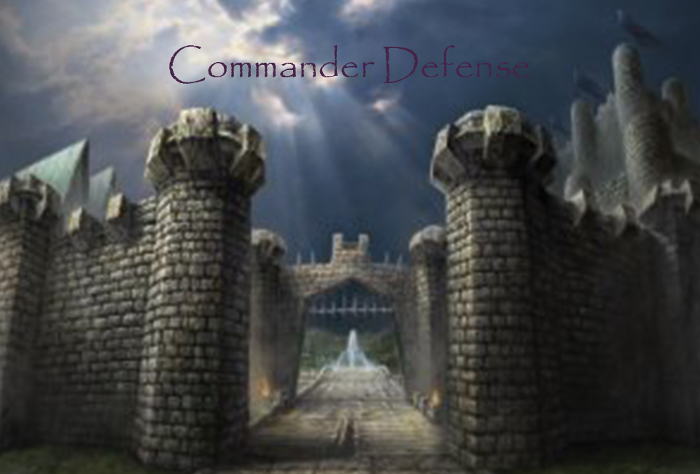

Team Personnel:

Sean Rachar………………………………………..Programmer
Aaron Taylor………………………………….Artist/Programmer
Alex Sanchez…………………………………Artist/Programmer
Jim Corrigan……………………………………….Programmer
Table of Contents

Team Personnel………………………………………….…………………………………………….…1

- Game Overview…………...………………………………………………………………………....3

2.0 Plot and Setting…………………………………...………………………………………………….3
2.1 Plot………………………...…………………………………………………………………3
2.2 Characters…………………....……………………………………………………………….3
2.3 Environment……………....………………………………………………………………….4
2.4 Artistic Style………………………………………………………………………………….4

3.0 Core Gameplay……………………...……………………………………………………………….4
3.1 Attributes……………………………………………………………………………………..4
3.2 Units………………………………………………………………………………………….6
3.3 Character Base Stats………………………………………………………………………….7
3.4 Level Changes……………………………...……………………………………………….11
3.5 Unit Commands……………………………………………………………………………..11
3.6 Items…………………………………...……………………………………………………13
3.7 Level Up System…………………………………...……………………………………….14
Equipment………………….……………………………………………………………16
Equipment Effects………………………………………………………………………17

4.0 Controls…………………………………………………………………………………………......23

5.0 Game Interface………………………………...……………………………………………………23
5.1 Splash Screen………………………………………………..……………………………...23
5.2 Start Menu…………………..………………………………………………………………24
5.3 HUD……………......……………………………………………………………………….24
5.4 Shop Menu…………………………………………………......…………………………...25

1.0 Game Overview:

Commander Defence is a 2D Tactical RPG that requires the player to command their units in battle to defeat various enemies. The game will include various melee, ranged, and magical enemies that the player will encounter. The player and enemy will take turns moving their units, and attacking the opposing forces. The victor will be declared by which player has completely destroyed their enemy's units.

2.0 Plot and Setting Information:

2.1 Plot:

The forces of evil are plotting to rule all the land. These forces consist of the Southern Orc Tribe and their leader Grawl Doomhammer, the forces of Undead under the spell of Fal'Thazar the Necromancer, and lastly, the Dark Elves under the rule of Kael'Thassad. The Orc soldiers, although less intelligent than the average human, are significantly larger. The Orc forces also consist of their powerful shamans that bend nature to their wills in order to support other Orc soldiers, or to hinder their enemies. The Orc forces ferocity and strength will prove to be difficult to surpass. The forces of the Undead consist of the recently deceased raised from the grave such as soldiers and archers. The forces also consist of lesser Necromancers under the rule of Fal'Thazar , but these enemies are not to be taken lightly. The Dark Elves consist of highly trained soldiers in the arts of magic and hand to hand combat and will make a worthy foe. The brave commander must lead his army to victory against these forces of evil in order to save the land.

2.2 Characters:

2.2.1 The Commander:


The Commander will be controlled by the player. The Commander is a seasoned strategist and leader and has seen many battles in his time. He has been chosen to lead the land's army against the newly emerged evil. The mechanics of the Commander will be described in a later section.

2.2.2 Grawl Doomhammer:
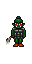

Grawl Doomhammer is the current war-chief of the Southern Orc Tribe. He is stronger and smarter than the average Orc and has seen many battles in his time. The Orcs’ will follow him into battle no matter what the circumstances. Grawl's mechanics will be described in a later section.

2.2.3 Fal'Thazar:

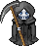
Fal'Thazar has summoned an entire undead army on his own, which continues to get stronger each and every day. No one truly knows his age or where he came from, only that he is extremely powerful. Fal'Thazar's mechanics will be described in a later section.

2.2.4 Kael'Thassad:
Kael'Thassad is the current leader of Dark Elves. He is an extremely powerful magic user and is not to be taken lightly. He has attained his leadership by usurping the throne from his predecessor who had ruled for a 1000 years previously. Kael'Thassad's mechanics will be described in a later section.

2.3 Environment:

The game will consist of one level, but will alternate from day to night between battles. This level will be 32 by 32 tiles. Each tile will be 32 pixels by 32 pixels. Also, the player's forces will start on the left side of the area, and the player's enemies will start on the right side of the area. There will be ten waves of each race. At the tenth wave of each race, their leader will enter battle. After each wave, the level attribute increases by one point.

2.4 Artistic Style:

The artistic style will be using 8-Bit style graphics and animations, similar to that of Super Mario games on the SNES.

3.0 Core Gameplay:

3.1 Attributes:

3.1.1 Health Points (Hp):

Health Points (Hp) determine whether a unit is alive or dead. If a unit's health points reach 0, that unit is dead and is no longer playable within the current battle. When a unit attacks another unit, the defending unit will lose health.

3.1.2 Mana Points (Mp):

Mana Points (Mp) determine whether a player can use a magical attack or not. Spells will cost a base amount of mana points, and if that unit does not have enough Mana Points, they may not cast that spell.

3.1.3 Attack (Atk):

Attack (Atk) determine the physical damage that a unit inflicts upon another unit when attacked. The higher the attack attribute, the more physical damage the unit will inflict.

3.1.4 Accuracy (Acc):

Accuracy (Acc) will determine the chance that a unit has to inflict physical damage to another unit. The higher the accuracy, the greater the chance that the unit will hit another unit.

3.1.5 Magic (mag):

Magic (mag) determines the magical damage that a unit inflicts upon another unit when a spell is cast. Also, the higher the Magic, the more a unit's heal will restore another unit's health.

3.1.6 Defense (Def):

Defense (Def) determines how much physical damage a target will mitigate when physical damage is inflicted.

3.1.7 Movement (Mov):

Movement (Mov) determines how far a unit may move per turn. The higher the movement attribute, the further the unit may move per turn. For example, if a unit has a movement of 5, that unit may move 5 squares each turn.

3.1.8 Speed (Spd):

Speed (Spd) determines how often a unit may move. The higher the speed attribute, the more often a unit may move. The unit's speed is added from 0. The unit with the highest speed will go first. After this unit moves, their speed is set to 0. Other units that have not moved yet will add their speed to their total again. This process repeats for each unit will they move. Also, instead of adding the speed directly, the unit's speed will be multiplied by a random number between 0.5 and 1 before being added which will produce some variation in the order of unit movement. The way speed determines movement order is shown below in an example. Each column represents a turn taken.

For example with three units. Character A has 7 Spd, Character B has 5 Spd, and Character C has 4 Spd.

CharA 7 0 7 14
CharB 5 10 0 5
CharC 4 8 12 0

3.1.9 Evasion (Eva):

Evasion (Eva) determines the chance that a unit has to dodge a physical attack. The higher the evasion attribute, the higher the chance that unit will dodge the incoming physical attack. The way evasion determines whether the hit is landed is determined by the following equation. If (Acc / Eva) is greater than or equal to (1 + (random number between 1 and 0)) then the hit will land. This allows for a physical attack to always hit if the unit has twice as much accuracy than the enemy's evasion. Also, using the random number will allow for some variation.

3.1.10 Resistance (res):

Resistance (res) determines the amount of magic damage dealt to a unit will be mitigated. There are three types of resistances: fire, ice, and lighting. The higher the resistance value, the less damage that will be dealt by that type of spell.

3.1.11 Level (lvl):

The level attribute starts at one and is increased by one after each wave. The level attribute determines how the player's enemy stats are increased.

3.2 Units:

Note: Each race has their own version of the following units.

3.2.1 Knights:

Knights are heavily armoured units that move slightly slower than other units. Knights also have the strongest melee attack, as well as the highest defence and Hp values. Knights may attack any adjacent square with their melee attack.

3.2.2 Archers:

Archers shoot enemies from a distance and have a far range at which they can attack. Archers start with a range of two squares that they may attack, but this range may be upgraded in the shop.

3.2.3 Wizards:

Wizards deal damage via ranged attack spells. They may also attack enemies with a melee attack if they are close enough. The Wizard's spells cost Mp. Wizard's melee attacks may be used on any adjacent square. Wizard's spells however have a range of two squares.

3.2.4 Priests:

Priests are the only healer classes in the game. The priests’ only offensive move is a melee attack. Also, Priest's spells cost Mp. Priest's melee attacks may be used on any adjacent square. The priest's heals however have a range of three squares.

3.3 Character Base Stats:

3.3.1 Human Units:

Attribute | Knight | Archer | Wizard | Priest | Commander
Hp | 20 | 12 | 10 | 9 | 18
Mp | 3 | 5 | 10 | 14 | 8
Atk | 7 | 5 | 1 | 1 | 6
Acc | 8 | 11 | 6 | 9 | 8
Mag | 1 | 2 | 6 | 5 | 4
Def | 6 | 2 | 2 | 3 | 5
Mov | 3 | 5 | 4 | 4 | 5
Spd | 5 | 7 | 6 | 6 | 6
Eva | 2 | 6 | 4 | 3 | 5
Fire res | 0.00% | 5.00% | 30.00% | 15.00% | 10.00%
Ice res | 0.00% | 5.00% | 30.00% | 15.00% | 10.00%
Light res | 0.00% | 5.00% | 30.00% | 15.00% | 10.00%

3.3.1.1 Human Knight:

The knight simply has a melee attack.

3.3.1.2 Human Archer:


The archer simply has a ranged attack.

3.3.1.3 Human Wizard:

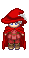
The wizard has three spells that they may use. Each spell costs 2 Mp to use. The first spell is a fireball that does 10 points of damage to a single unit. The next spell is a lighting attack that deals 5 damage to the selected target, as well as 2 damage to any target that is adjacent to the selected target. Lastly, the next spell is an ice attack that deals 8 damage to the selected unit, but also reduces the targets movement speed by 2 for that unit's next turn. Each spell may be upgraded via the shop.

3.3.1.4 Human Priest:


The priest has two healing spells that they may use. The first costs 3 Mp and is a direct heal that restores 15 hp. The second heal costs 4 Mp and restores 5 Hp to every friendly unit. The priest also has a support ability that increases a selected unit's movement for one turn by 2 and costs 2 Mp. The priest also has another support ability that increases a selected unit's defence for one turn by 4 and costs 3 Mp. Each spell may be upgraded via the shop.

3.3.1.5 Commander:

The Commander has a melee attack meaning that he may attack a unit that is adjacent to him. The Commander has a few abilities as well. The first ability is the Commander's horn blow which increases all allied unit's attributes by 1 point for each of their next turns. The horn blow costs 2 Mp. The Commander's second ability summons vines that snare enemy units until the Commander's next turn. This ability also deals 5 damage (+ Commander's mag) to each unit. This ability costs 5 Mp. The Commander also has a charge ability. This ability deals 10 (+ Commander's Atk) damage to all enemy units up to 4 tiles in front of the Commander. Once the Commander's charge is used, the Commander returns to his original position. This ability also costs 5 Mp. The Commander's last ability is earthquake. This ability costs 8 Mp and deals 10 damage (+ Commander's mag) damage to each enemy unit. The Commander's abilities may be upgraded via the shop.

3.3.2 Orc Units:

Attribute | Ogre (Knight) | Archer | Warlock (Wizard) | Shaman (Priest)
Hp | 25 | 12 | 10 | 9
Mp | 3 | 5 | 10 | 14
Atk | 8 | 5 | 1 | 1
Acc | 5 | 11 | 6 | 9
Mag | 1 | 2 | 6 | 5
Def | 5 | 2 | 2 | 3
Mov | 3 | 5 | 4 | 4
Spd | 4 | 7 | 6 | 6
Eva | 2 | 6 | 4 | 3
Level | 1 | 1 | 1 | 1
Fire res | 0.00% | 5.00% | 40.00% | 15.00%
Ice res | -20.00% | -15.00% | 0.00% | -15.00%
Light res | 0.00% | 5.00% | 30.00% | 15.00%

3.3.2.1 Orc Ogre:

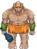
The ogre simply has a basic attack.

3.3.2.2 Orc Archer:

The archer simply has a ranged attack.

3.3.2.3 Orc Warlock:


The warlock has two abilities. The first is a fire attack that deals damage to the selected unit as well as each enemy adjacent to that unit. This spell deals 5 damage to each unit and costs 3 Mp. The next ability is also fire based and deals 8 points of damage to a selected unit. This spell also leaves a debuff on the target that deals 2 damage each turn for the next two turns. The warlock also has a melee attack.

3.3.2.4 Orc Shaman:


The shaman has two abilities. The first ability costs 5 Mp and is a direct heal that heals an ally for 15 points of health. The second ability costs 5 Mp, targets an enemy, and slows their movement by 2 points for that unit's next turn.

3.3.3 Undead Units:

Attribute | Knight | Archer | Wizard | Necromancer (Priest)
Hp | 15 | 10 | 10 | 9
Mp | 3 | 5 | 10 | 14
Atk | 8 | 5 | 1 | 1
Acc | 5 | 11 | 6 | 9
Mag | 1 | 2 | 6 | 5
Def | 6 | 2 | 2 | 3
Mov | 3 | 5 | 4 | 4
Spd | 4 | 7 | 6 | 6
Eva | 2 | 6 | 4 | 3
Level | 1 | 1 | 1 | 1
Fire res | -40.00% | -50.00% | -50.00% | -50.00%
Ice res | 5.00% | 10.00% | 40.00% | 25.00%
Light res | 0.00% | 5.00% | 30.00% | 15.00%

3.3.3.1 Undead Knight:

The knight simply has a basic attack.

3.3.3.2 Undead Archer:
The archer simply has a ranged attack.

3.3.3.3 Undead Wizard:

The wizard has two abilities. The first ability is an ice based spell that deals 8 points of damage to the selected target as well as slowing that target's movement speed by a factor of 2 for its next turn. The other ability applies a de-buff to all opposing enemies that slows their movement speed by 2 for one units turn.

3.3.3.4 Necromancer Priest:

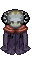
The necromancer has two healing abilities. The first spell heals a selected unit for 5 points of health and costs 4 Mp to use. The second ability heals all allied units for 2 points of health and costs 4 Mp to use. Also, the necromancer may not heal himself, only his allied units.

3.3.4 Dark Elvish Units:

Attribute | Knight | Archer | Wizard | Priest
Hp | 15 | 10 | 10 | 9
Mp | 3 | 5 | 10 | 14
Atk | 8 | 5 | 1 | 1
Acc | 5 | 11 | 6 | 9
Mag | 1 | 2 | 6 | 5
Def | 6 | 2 | 2 | 3
Mov | 3 | 5 | 4 | 4
Spd | 6 | 7 | 6 | 6
Eva | 2 | 6 | 4 | 3
Level | 1 | 1 | 1 | 1
Fire res | 0.00% | 5.00% | 30.00% | 15.00%
Ice res | 0.00% | 5.00% | 30.00% | 15.00%
Light res | -15.00% | -20.00% | -20.00% | -20.00%

3.3.4.1 Dark Elvish Knight:

The knight simply has a basic attack.

3.3.4.2 Dark Elvish Archer:

The archer simply has a ranged attack.

3.3.4.3 Dark Elvish Wizard:

The wizard has three spells that they may use. Each spell costs 3 Mp to use. The first spell is a fireball that does 8 points of damage to a single unit. The next spell is a lighting attack that deals 3 damage to the selected target, as well as 3 damage to any target that is adjacent to the selected target. Lastly, the next spell is an ice attack that deals 3 damage to the selected unit, but also reduces that targets movement by 2 for their next turn.

3.3.4.4 Dark Elvish Priest:

The priest has two healing spells that they may use. The first costs 5 Mp and is a direct heal that restores 10 hp. The second heal costs 5 Mp and restores 5 Hp to every friendly unit.

3.3.5 Bosses:

Attribute | Grawl | Fal'Thazar | Kael'Thassad
Hp | 55 | 60 | 75
Mp | 10 | 65 | 80
Atk | 35 | 20 | 30
Acc | 20 | 25 | 25
Mag | 5 | 35 | 45
Def | 20 | 25 | 30
Mov | 10 | 10 | 10
Spd | 15 | 15 | 20
Eva | 12 | 15 | 18
Fire res | 15.00% | 45.00% | 65.00%
Ice res | 15.00% | 45.00% | 65.00%
Light res | 15.00% | 45.00% | 65.00%

3.3.5.1 Grawl DoomHammer:

Grawl has a simple melee attack, but he ignores 50% of the defence of the unit he is attacking. Grawl also has a second ability that is ranged. During this ability, Grawl throws one of his axes which does half of his base attack and also ignores 50% defence of the unit he is attacking.

3.3.5.2 Fal'Thazar:

Fal'Thazar has a basic melee attack. He also has two spells that he may cast. The first spell costs 5 Mp and deals 3 damage to every enemy unit and is ice based. His last ability costs 5 Mp as well and heals each allied unit for 3 points of hp.

3.5.3 Kael'Thassad:

Kael'Thassad has a basic melee attack. He also has three spells that he may cast. Each spell that Kael'Thassad has costs 5 Mp. The first ability is fire based and deals 5 damage to each enemy unit. The next ability is a debuff that slows all target movement speed by 2 points for 1 turn. The last ability applies a de-buff that lowers all enemies accuracy by 1 point for 1 turn and deals 2 damage to each enemy unit.

3.4 Level-up Changes:

Note: Each stat is increased by the listed amount each time the level attribute is increased.

3.4.1 Orc Units:

Attribute | Ogre (Knight) | Archer | Warlock (Wizard) | Shaman (Priest)
Hp | 2 | 1 | 1 | 1
Mp | 1 | 1 | 2 | 2
Atk | 1 | 1 | 1 | 1
Acc | 1 | 2 | 1 | 1
Mag | 0 | 1 | 2 | 1
Def | 1 | 1 | 0 | 1
Mov | 0.2 | 0.2 | 0.2 | 0.2
Spd | 1 | 1 | 1 | 1
Eva | 1 | 1 | 1 | 1
Level | 1 | 1 | 1 | 1
Fire res | 1.00% | 1.00% | 2.00% | 2.00%
Ice res | 1.00% | 1.00% | 2.00% | 2.00%
Light res | 1.00% | 1.00% | 2.00% | 2.00%

3.4.2 Undead Units:

Attribute | Knight | Archer | Wizard | Necromancer (Priest)
Hp | 1 | 1 | 1 | 1
Mp | 0 | 1 | 2 | 2
Atk | 2 | 1 | 1 | 1
Acc | 1 | 1 | 1 | 1
Mag | 1 | 1 | 1 | 1
Def | 2 | 1 | 1 | 1
Mov | 0.2 | 0.2 | 0.2 | 0.2
Spd | 1 | 1 | 1 | 1
Eva | 1 | 1 | 1 | 1
Level | 1 | 1 | 1 | 1
Fire res | 1.00% | 1.00% | 2.00% | 2.00%
Ice res | 1.00% | 1.00% | 2.00% | 2.00%
Light res | 1.00% | 1.00% | 2.00% | 2.00%

3.4.3 Dark Elvish Units:

Attribute | Knight | Archer | Wizard | Priest
Hp | 1 | 1 | 1 | 1
Mp | 0 | 1 | 2 | 2
Atk | 1 | 1 | 1 | 1
Acc | 1 | 2 | 1 | 1
Mag | 0 | 1 | 1 | 1
Def | 2 | 1 | 1 | 1
Mov | 0.2 | 0.2 | 0.2 | 0.2
Spd | 1 | 1 | 1 | 1
Eva | 1 | 1 | 1 | 1
Level | 1 | 1 | 1 | 1
Fire res | 1.00% | 1.00% | 2.00% | 2.00%
Ice res | 1.00% | 1.00% | 2.00% | 2.00%
Light res | 1.00% | 1.00% | 2.00% | 2.00%

3.5 Unit Commands:

Note: The battles will be turn based. The order in which each character moves is determined by their speed as previously stated in the attributes section. Each character will be highlighted during their respective turn. The camera will be centred about the current highlighted character. During combat, each unit will have the option to Attack, use Magic, Defend, or to use Items. During the enemy turn the player controls will be disabled until the enemy turn is over. Each unit has a chance to move throughout the map, and then may use one of the four commands.

3.5.1 Attack:

When attack is selected, the attack-able squares will become highlighted. An attack animation will play depending on which character is being used. As previously stated in the attribute section, whether or not a player hits a unit will depend on accuracy and evasion. The unit that is damaged will have their health bar reflect the damage dealt. If a unit is killed in the process, a death animation will play. The amount of damage dealt to the attacked unit is determined by the following equation:

max (Attacking unit's Atk – (defending unit's Def) * (random number between 0.5 and 1.0), 1)

3.5.2 Magic:

When magic is selected, the attack-able squares will become highlighted. Magic attacks never miss and therefore do not have to check whether they hit. When casting a spell, a spell animation will play depending on which character is currently active. Similar to the Attack command, death animations will play if the unit is killed, and the unit's health bar will reflect the damage dealt. The amount of damage dealt to the attacked unit is determined by the following equation:

(Spell damage + attacking unit's mag) * (1 – defending unit's res)

Healing is also affected by magic. The following equation determines how much is actually healed.

Direct Heal = (Healing amount + unit's mag) * 0.8

Group Heal = (Healing amount + unit's mag) * 0.2

3.5.3 Defend:

Defend will result in the unit taking half damage from all attacks. Defend will last until the unit's next turn.

3.5.4 Item:

When item is selected, the squares in which the item may be used are highlighted. This allows for units to use items on nearby allies. When an item is used, it will be discarded. The highlighted squares will only be on the adjacent squares of the current unit.

3.6 Items:

3.6.1 Healing Potion:

Healing potions may be bought for 10 gold in the shop menu between battles. The healing potions will restore 10 points of health when used on a unit.

3.6.2 Mana Potion:

Mana potions may be bought for 10 gold in the shop menu between battles. The mana potions will restore 10 points of mana when used on a unit.

3.7 Levelling Up System:

Note: Each unit that the player kills will reward 10 experience per current level. Also, each enemy killed will reward the player with 20 gold per current level. Bosses however will reward the player with double the amount of gold and experience. Also, the player will be given a chance to level-up and use the shop between each battle. Gold will be used to upgrade the Commander's units. Experience will be used to upgrade the Commander.

3.7.1 Experience:

As stated, experience will be used to upgrade the Commander. The Commander may upgrade his horn blow five times. Each upgrade will increase the attribute bonus by one point. The first upgrade costs 30 experience, with each preceding upgrade costing an additional 30 experience. The Commander may also upgrade each of his attributes. For every ten points of the Commander's attributes, the cost to upgrade an attribute will increase by 10 experience points. For example, if the Commander's Attack is 8, it will cost 10 experience points. If the Commander's attack is 11, the upgrade will cost 20 experience points. Movement however, costs triple than what any other attribute costs. Accuracy and evasion cost double than any other attribute. The Commander may spend 100 experience to increase the range of his charge by one tile. After purchasing this upgrade, the Commander may spend 200 experience to upgrade the charge range another tile. The Commander may also upgrade the damage of his vines by 1 point for 30 experience. Each additional upgrade costs an additional 30 experience with a maximum of 5 upgrades. The Commander may also upgrade his earthquake ability's damage by 2 points per upgrade. The upgrade initially costs 40 experience, with each additional upgrade costing an additional 40 experience with a maximum of 5 upgrades.

3.7.2 Gold:

Gold will be used to upgrade the Commander's army units between battles. Upon selecting the “Purchase Equipment” option, the player will be able to see a menu showing the available items and upgrades. Potions can be selected for purchase by clicking the corresponding menu icon. Each class also has an equipment set consisting of five equipment slots which may be upgraded individually. After selecting something to purchase, the player must click the buy button to confirm their choice. When items are purchased, they may be accessed by any allied unit during battle via the “Item” command. When equipment is purchased, its effect is automatically applied to all allied units of the appropriate class. See equipment section (3.7.3) for more details.

3.7.3 Equipment:

3.7.3.1 Knight Equipment:

Equipment Slot | Tier1 (60g) | Tier2 (120g) | Tier3 (250g) | Tier4 (400g) | Tier5 (650g) | Tier6 (1000g) | Tier7  (1500g) | Tier8 (2100g) | Tier9 (3000g)
Weapon | Bamboo Sword | Bronze Sword | Iron Sword | Longsword | Steel Sword | Katana | Magic Sword | Blood Sword | Excalibur
Head | Wooden Helm | Bronze Helm | Iron Helm | Shell Helm | Steel Helm | Winged Helm | Magic Helm | Ancient Helm | Titan's Helm
Chest | Wooden Armour | Bronze Armour | Iron Armour | Chain  Armour | Steel Armour | Mythril Armour | Magic Armour | Diamond Armour | Adamantium Armour
Feet | Dull Greaves | Bronze Greaves | Iron Greaves | Resilient Greaves | Steel Greaves | Obsidian Greaves | Magic Greaves | Haste Greaves | Justice Greaves
Relic | String Bracers | Bronze Bracers | Iron Bracers | Elemental Bracers | Steel Bracers | Ice Bracers | Magic Bracers | Jade Bracers | Sun Bracers

3.7.3.2 Archer Equipment:

Equipment Slot | Tier1 (60g) | Tier2 (120g) | Tier3 (250g) | Tier4 (400g) | Tier5 (650g) | Tier6 (1000g) | Tier7  (1500g) | Tier8 (2100g) | Tier9 (3000g)
Weapon | Practice Bow | Short Bow | Longbow | Hunter's Bow | Great Bow | Recurve Bow | Magic Bow | Elven Bow | Artemis Bow
Head | Cloth Cap | Leather Cap | Studded-Leather Cap | Hunter's Cap | Hide Cap | Survival Cap | Magic Cap | Elven Cap | Dragonhide Cap
Chest | Cloth Vest | Leather Vest | Studded-Leather Vest | Hunter's Vest | Hide Vest | Survival Vest | Magic Vest | Elven Vest | Immortal Vest
Feet | Worn Boots | Leather Boots | Studded-Leather Boots | Hunter's Boots | Hide Boots | Survival Boots | Magic Boots | Elven Boots | Hermes Boots
Relic | Yellow Bracelet | Leather Bracelet | Studded-Leather Bracelet | Hunter's Bracelet | Hide Bracelet | Survival Bracelet | Magic Bracelet | Elven Bracelet | Moon Bracelet

3.7.3.3 Wizard Equipment:

Equipment Slot | Tier1 (60g) | Tier2 (120g) | Tier3 (250g) | Tier4 (400g) | Tier5 (650g) | Tier6 (1000g) | Tier7  (1500g) | Tier8 (2100g) | Tier9 (3000g)
Weapon | Apprentice Wand | Acolyte Wand | Fire Wand | Ice Wand | Lightning Wand | Protect Wand | Mystic Wand | Gaia Wand | Sky Wand
Head | Cloth Cowl | Pointy Cowl | Feathered Cowl | Wizard's Cowl | Red Cowl | Protect Cowl | Mystic Cowl | Archmage Cowl | Wisdom Cowl
Chest | Cloth Robe | Expensive Robe | Blue Robe | Yellow Robe | Red Robe | Protect Robe | Mystic Robe | Archmage Robe | Demigod Robe
Feet | Cloth Shoes | Expensive Shoes | Noble Shoes | Shell Shoes | Shiny Shoes | Protect Shoes | Mystic Shoes | Archmage Shoes | Wind Shoes
Relic | Old Ring | Iron Ring | Silver Ring | Gold Ring | Power Ring | Protect Ring | Mystic Ring | Archmage Ring | Energy Ring

3.7.3.4 Priest Equipment:

Equipment Slot | Tier1 (60g) | Tier2 (120g) | Tier3 (250g) | Tier4 (400g) | Tier5 (650g) | Tier6 (1000g) | Tier7  (1500g) | Tier8 (2100g) | Tier9 (3000g)
Weapon | Practice Staff | Wooden Staff | Strong Staff | Shield Staff | Healing Staff | Peacemaker Staff | Mystic Staff | Light Staff | Divinity Staff
Head | Cloth Hat | Fine Hat | Thick Hat | Sage's Hat | Healing Hat | Peacemaker Hat | Mystic Hat | Light Hat | Mercy Hat
Chest | Cloth Garb | Fine Garb | Thick Garb | Sage's Garb | Healing Garb | Peacemaker Garb | Mystic Garb | Light Garb | Justice Garb
Feet | Worn Sandals | Fine Sandals | Tough Sandals | Sage's Sandals | Healing Sandals | Peacemaker Sandals | Mystic Sandals | Light Sandals | Benevolence Sandals
Relic | Rusted Amulet | Copper Amulet | Sapphire Amulet | Opal Amulet | Healing Amulet | Peacemaker Amulet | Mystic Amulet | Light Amulet | Truth Amulet

3.7.3.5 Equipment Effects:

The following tables contain information about each piece of equipment's effect on equipped units.
Item | Effect
Bamboo Sword | +1 ATK + 1 DEF + 1 ACC + 1 EVA
Bronze Sword | +2 ATK + 2 ACC
Iron Sword | +3 ATK + 1 DEF + 1 ACC
Longsword | +3 ATK + 1 EVA + 1 SPD
Steel Sword | +3 ATK + 1 DEF + 3 ACC
Katana | +4 ATK +1 EVA + 2 SPD
Magic Sword | + 4 ATK + 3 ACC + 15 AR(all resists)
Blood Sword | +3 ATK + Gain 50% of damage as HP
Excalibur | + 10 ATK + 12 ACC + 5 DEF + 5 AR
Practice Bow | + 1 ATK + 3 ACC
Short Bow | + 2 ATK + 2 ACC
Longbow | + 2 ATK + 3 ACC
Hunter's Bow | + 2 ATK + 1 ACC + 2 EVA + 1 SPD
Great Bow | + 4 ATK
Recurve Bow | + 5 ATK + 1 ACC
Magic Bow | + 5 ATK + 3 ACC + 10AR
Elven Bow | + 4 ATK + 5 ACC + 3 EVA + 1 SPD + 1 MOV
Artemis Bow | + 7 ATK + 10 ACC + 4 EVA + 4 SPD + 1 MOV
Apprentice Wand | + 2 MAG + 4 MP + 1 ACC + 1 ATK
Acolyte Wand | + 3 MAG + 6 MP + 1 ACC + 1 ATK
Fire Wand | + 4 MAG + 3 MP + 1 ATK Fire mag. + 20%
Ice Wand | + 4 MAG + 4 MP + 1 ATK Ice mag. + 20%
Lightning Wand | + 4 MAG + 5 MP + 1 ATK Lightning mag.+ 20%
Protect Wand | + 2 MAG + 4 MP + 4 DEF + 1 ACC
Mystic Wand | + 6 MAG + 8 MP + 20 AR + 1 ACC
Gaia Wand | + 6 MAG + 10 MP + 5 DEF + 1 ACC
Sky Wand | + 10 MAG + 15 MP + 5 EVA + 2 SPD + 1 MOV
Practice Staff | + 1 MAG + 6 MP + 2 ACC + 1 ATK
Wooden Staff | + 1 MAG + 6 MP + 1 ACC + 2 ATK
Strong Staff | + 1 MAG + 5 MP + 2 ACC + 3 ATK
Shield Staff | + 2 MAG + 4 MP + 2 DEF + 1 ATK
Healing Staff | + 4 MAG + 1 MP + 2 ACC + 2 SPD
Peacemaker Staff | + 4 MAG + 6 MP + 3 DEF + 4 ATK
Mystic Staff | + 3 MAG + 11 MP + 20 AR + 2 DEF + 1 ATK
Light Staff | + 6 MAG + 12 MP + 10 AR + 1 DEF + 2 SPD
Divinity Staff | + 8 MAG + 22 MP + 15AR + 3 DEF + 3 ATK
Headgear:

Item | Effect
Wooden Helm | + 2 DEF + 4 HP
Bronze Helm | + 1 DEF + 8 HP
Iron Helm | + 1 DEF + 10 HP
Shell Helm | + 1 DEF + 9 HP + 5 AR
Steel Helm | + 2 DEF + 12 HP
Winged Helm | + 3 DEF + 12 HP
Magic Helm | + 2 DEF + 10 HP + 10 AR
Ancient Helm | + 2 DEF + 16 HP + 10 LR
Titan's Helm | + 7 ATK + 4 DEF + 20 HP
Cloth Cap | + 1 DEF + 6 HP
Leather Cap | + 1 DEF + 6 HP + 1 EVA
Studded-Leather Cap | + 2 DEF + 6 HP + 1 EVA
Hunter's Cap | + 1 DEF + 4 HP + 2 EVA + 2 SPD
Hide Cap | + 1 DEF + 12 HP + 1 SPD
Survival Cap | + 3 DEF + 8 HP + 2 EVA
Magic Cap | + 1 DEF + 8 HP + 1 EVA + 1 SPD + 10 AR
Elven Cap | + 1 DEF + 12 HP + 2 EVA + 2 SPD
Dragonhide Cap | + 4 DEF + 17 HP + 4 EVA + 2 SPD + 25FR
Cloth Cowl | + 1 DEF + 4 HP + 2 MP
Pointy Cowl | + 1 DEF + 6 HP + 2 MP
Feathered Cowl | + 1 DEF + 8 HP + 2 MP
Wizard's Cowl | + 6 HP + 6 MP + 1 MAG
Red Cowl | + 1 DEF + 8HP + 4 MP + 10 FR
Protect Cowl | + 4 DEF + 8 HP + 2 MP
Mystic Cowl | + 1 DEF + 4 HP + 8 MP + 15 AR
Archmage Cowl | + 1 DEF + 7 HP + 7 MP + 3 MAG
Wisdom Cowl | + 1 DEF + 10 HP + 16 MP + 4 MAG + 10 AR
Cloth Hat | + 1 DEF + 3 HP + 1 MP
Fine Hat | + 1 DEF + 7 HP + 1 MP
Thick Hat | + 2 DEF + 8 HP
Sage's Hat | + 7 HP + 5 MP + 5 AR
Healing Hat | + 1 DEF + 10HP + 2 MP + 1 MAG
Peacemaker Hat | + 2 DEF + 9 HP + 5 MP
Mystic Hat | + 1 DEF + 8 HP + 4 MP + 15 AR
Light Hat | + 1 DEF + 7 HP + 5 MP + 2 MAG + 1 SPD
Mercy Hat | + 3 DEF + 14 HP + 10 MP + 6 MAG

Chestpieces:

Item | Effect
Wooden Armour | + 3 DEF
Bronze Armour | + 4 DEF
Iron Armour | + 5 DEF
Chain Armour | + 4 DEF + 4 HP
Steel Armour | + 7 DEF
Mythril Armour | + 4 DEF + 2 SPD + 2 EVA
Magic Armour | + 6 DEF + 1 SPD + 10 AR
Diamond Armour | + 9 DEF + 4 HP
Adamantium Armour | + 13 DEF + 10 HP + 10 AR
Cloth Vest | + 2 DEF + 1 EVA + 2 HP
Leather Vest | + 3 DEF + 1 EVA + 2 HP
Studded-Leather Vest | + 3 DEF + 1 HP + 2 EVA
Hunter's Vest | + 3 DEF + 2 HP + 2 EVA + 1 SPD
Hide Vest | + 4 DEF + 6 HP + 1 SPD
Survival Vest | + 4 DEF + 4 HP + 3 EVA
Magic Vest | + 4 DEF + 1 EVA + 2 SPD + 10 AR
Elven Vest | + 3 DEF + 5 EVA + 3 SPD
Immortal Vest | + 7 DEF + 10 HP + 4 EVA + 4 SPD
Cloth Robe | + 2 DEF + 2 HP + 2 MP
Expensive Robe | + 2 DEF + 2 HP + 4 MP
Blue Robe | + 3 DEF + 2 HP + 4 MP + 10 IR
Yellow Robe | + 3 DEF + 2 HP + 2 MP + 10 LR
Red Robe | + 3 DEF + 2 HP + 6 MP + 10 FR
Protect Robe | + 6 DEF + 4 HP + 3 MP
Mystic Robe | + 3 DEF + 4 HP + 6 MP + 15 AR
Archmage Robe | + 4 DEF + 7 MP + 4 MAG
Demigod Robe | + 5 DEF + 8 HP + 14 MP + 5 MAG
Cloth Garb | + 2 DEF + 2 HP + 2 MP
Fine Garb | + 3 DEF + 3 HP + 1 MP
Thick Garb | + 6 DEF
Sage's Garb | + 4 DEF + 4 HP + 5 MP + 5 AR
Healing Garb | + 3 DEF + 4HP + 6 MP + 2 MAG
Peacemaker Garb | + 7 DEF + 5 HP + 5 MP
Mystic Garb | + 4 DEF + 6 HP + 6 MP + 15 AR
Light Garb | + 3 DEF + 7 HP + 7 MP + 1 MAG + 2 SPD
Justice Garb | + 4 DEF + 10 HP + 10 MP + 4 MAG + 1 SPD

Footgear:

Item | Effect
Dull Greaves | + 2 SPD + 1 DEF + 1 EVA
Bronze Greaves | + 3 SPD + 1 DEF
Iron Greaves | + 3 SPD + 1 DEF
Resilient Greaves | + 3 SPD + 1 DEF + 1 EVA
Steel Greaves | + 3 SPD + 2 DEF + 2 EVA
Obsidian Greaves | + 4 SPD + 2 DEF + 10 AR
Magic Greaves | + 4 SPD + 1 DEF + 2 EVA + 10 AR
Haste Greaves | + 6 SPD + 2 DEF + 1 MOV
Justice Greaves | + 5 SPD + 11 DEF + 3 EVA + 2 ACC
Worn Boots | + 2 SPD + 1 DEF + 1 EVA
Leather Boots | + 3 SPD + 1 DEF
Studded-Leather Boots | + 3 SPD + 1 DEF
Hunter's Boots | + 3 SPD + 1 DEF + 1 EVA
Hide Boots | + 3 SPD + 1 DEF + 3 EVA
Survival Boots | + 4 SPD + 1 DEF + 6 HP
Magic Boots | + 4 SPD + 1 DEF + 2 EVA + 10 AR
Elven Boots | + 5 SPD + 1 DEF + 5 EVA
Hermes Boots | + 11 SPD + 2 DEF + 6 EVA + 1 MOV
Cloth shoes | + 1 MAG + 2 SPD + 2 MP
Expensive shoes | + 1 MAG + 2 SPD + 1 EVA + 2 MP
Noble Shoes | + 2 MAG + 2 SPD + 1 EVA + 2 MP
Shell Shoes | + 1 MAG + 2 SPD + 1 EVA + 10 AR
Shiny Shoes | + 2 MAG + 2 SPD + 2 EVA + 2 MP
Protect Shoes | + 2 MAG + 2 SPD + 1 EVA + 3 DEF + 4 MP
Mystic Shoes | + 3 MAG + 5 MP + 10 AR + 1 SPD + 4 EVA
Archmage Shoes | + 3 MAG + 6 MP + 1 DEF + 4 SPD + 1 EVA
Wind Shoes | + 6 MAG + 8 MP + 5 EVA + 7 SPD + 1 MOV
Worn Sandals | + 1 MAG + 2 SPD + 1 DEF
Fine Sandals | + 1 MAG + 2 SPD + 1 EVA + 2 HP
Tough Sandals | + 1 MAG + 3 SPD + 1 DEF + 1 EVA + 2 HP
Sage's Sandals | + 1 MAG + 3 SPD + 1 EVA + 10 AR
Healing Sandals | + 2 MAG + 4 SPD + 2 EVA + 4 MP
Peacemaker Sandals | + 2 MAG + 4 SPD + 2 EVA + 2 DEF + 2 MP
Mystic Sandals | + 4 MAG + 4 SPD + 1 EVA + 7 MP + 10 AR
Light Sandals | + 4 MAG + 6 SPD + 3 EVA + 1 DEF + 20 LR
Benevolence Sandals | + 6 MAG + 5 SPD + 4 EVA + 3 SPD + 1 MOV

Relics:

Item | Effect
String Bracers | + 2 ACC + 1 EVA + 2 HP
Bronze Bracers | + 2 ACC + 1 EVA + 4 HP
Iron Bracers | + 3 ACC + 1 EVA + 4 HP
Elemental Bracers | + 3 ACC + 1 EVA + 10 AR
Steel Bracers | + 3 ACC + 2 EVA + 6 HP
Ice Bracers | + 4 ACC + 1 EVA + 4 HP + 20 IR
Magic Bracers | + 5 ACC + 3 EVA + 4 HP
Jade Bracers | + 6 ACC + 2 EVA + 5 HP + 15 LR
Sun Bracers | + 9 ACC + 5 EVA + 4 HP + 2 SPD + 20 FR
Yellow Bracelet | + 2 ACC + 2 HP + 10 LR
Leather Bracelet | + 2 ACC + 1 DEF + 4 HP
Studded-Leather Bracelet | + 2 ACC + 1 DEF + 6 HP
Hunter's Bracelet | + 4 ACC + 2 DEF + 2 HP
Hide Bracelet | + 3 ACC + 2 DEF + 6 HP
Survival Bracelet | + 2 ACC + 3 DEF + 8 HP
Magic Bracelet | + 3 ACC + 2 DEF + 6 HP + 2 SPD
Elven Bracelet | + 6 ACC + 1 DEF + 8 HP + 1 SPD
Moon Bracelet | + 9 ACC + 6 DEF + 6 HP + 2 SPD
Old Ring | + 4 MP + 1 EVA + 1 SPD
Iron Ring | + 6 MP + 1 DEF + 1 SPD
Silver Ring | + 6 MP + 1 DEF + 2 MAG
Gold Ring | + 8 MP + 1 DEF + 1 EVA + 1 SPD
Power Ring | + 8 MP + 1 DEF + 1 EVA + 1 SPD + 1 MAG
Protect Ring | + 4 MP + 3 DEF + 2 EVA + 4 HP
Mystic Ring | + 12 MP + 1 EVA + 1 SPD + 2 MAG
Archmage Ring | + 16 MP + 4 MAG
Energy Ring | + 18 MP + 6 DEF + 6 HP + 2 SPD
Rusted Amulet | + 4 MP + 1 EVA + 1 SPD
Copper Amulet | + 6 MP + 1 DEF + 1 SPD
Sapphire Amulet | + 5 MP + 1 DEF + 1 MAG + 15 IR
Opal Amulet | + 10 MP + 2 DEF
Healing Amulet | + 8 MP + 1 SPD + 3 MAG
Peacemaker Amulet | + 8 MP + 3 DEF + 2 SPD
Mystic Amulet | + 12 MP + 1 EVA + 1 SPD + 2 MAG
Light Amulet | + 14 MP + 1 EVA + 1 SPD + 1 MAG + 20 LR
Truth Amulet | + 18 MP + 2 DEF + 4 EVA + 6 HP + 2 SPD

4.0 Controls:

Using the “W”, “A”, “S” and “D” keys, the player can move the active character around the battlefield. This movement is limited to one square in either the up (“W”), down (“S”), left (“A”) and right (“D”) direction, with each key press. The character will only have a certain number of move points. The number of move points will be set by the value of the characters move attribute. Each move will decrement the unit's move points by 1. The movement phase will end when the player presses the “J” key. Pressing this key will begin the battle phase. Pressing the “H” key will take the player back to the movement phase. When in the battle phase, actions will be chosen using the arrow keys to highlight the corresponding buttons on screen. This action will then be confirmed by pressing the enter key.
Once an action is chosen, a sub menu will drop down and the arrow keys along with the enter key will be used to select the final action. While in a menu, be it the Main menu or the Shop menu, the mouse will be used to select and activate choices.

5.0 Game Interface

5.1 Splash Screen:

The program is initiated with an epic esoteric splash screen inspired by the game genre and magic.
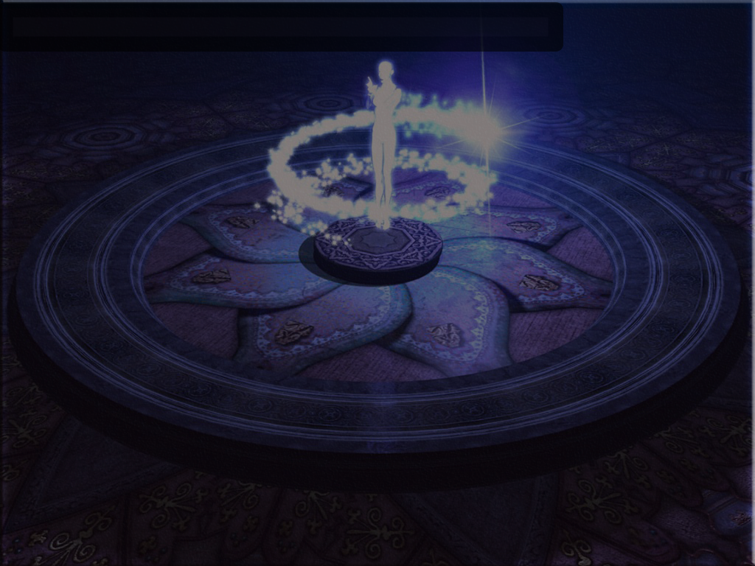

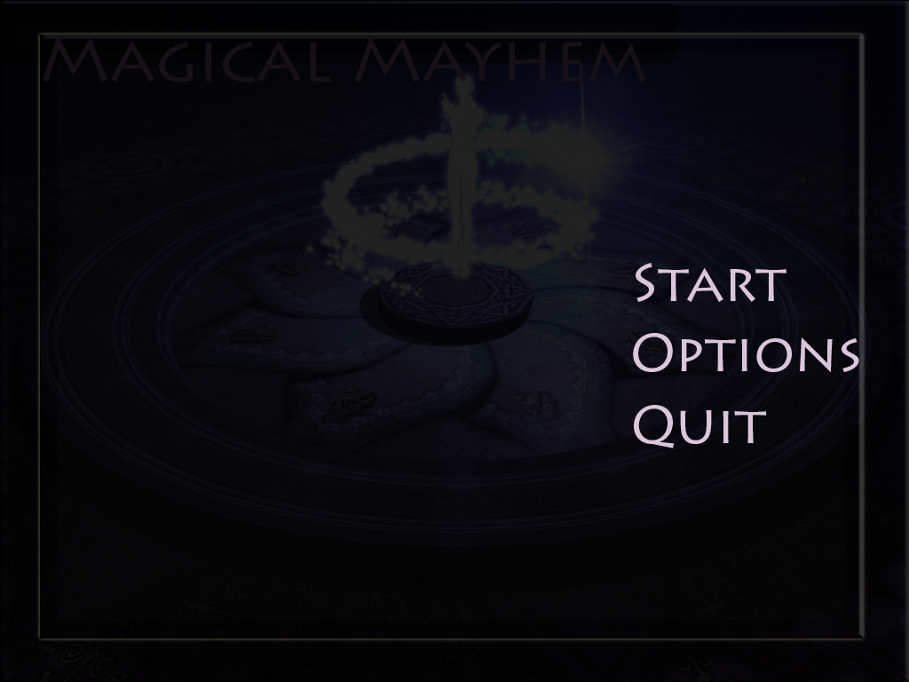

5.2 Start Menu:

A Game Menu is how the fun begins. This menu contains 3 portals to different areas of the program and they are Start, Options and Quit.

Start: Fires up the game from the first level.

Options: The player is transported to the options menu where they can change settings before gameplay such as sound on or off, difficulty and game modes.

5.3 HUD:

The player while in battle mode uses the display interface to interact with the game using the 4 action buttons in the shape of a cross as seen in many traditional RPG style games. The top button is used to attack, the left button is for using items in a fight and lastly for the remaining two, on the right is defend and the lower button is for magic attacks.

Action Buttons:

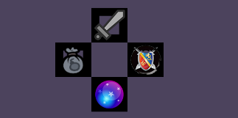

Attack: The attack button is represented above with the sword icon and when selected during battle the character uses his primary range attack.

Magic: Located at the very bottom of this cross of buttons is the icon for magic, when the player selects this button a drop-down menu for his magic attacks becomes available.

Inventory: To the left is the items button and when selected it displays a drop down menu with the items the character can use during battle.

Defend: The shield icon is used to represent that a character will take a defensive stance during battle.

5.4 Shop Menu:



At the end of each battle a menu button will appear on the top left corner of the game screen offering the player a momentary escape from the battle mode sequence to use their coins accumulated to shop for items, weapons and upgrades for the other team players.

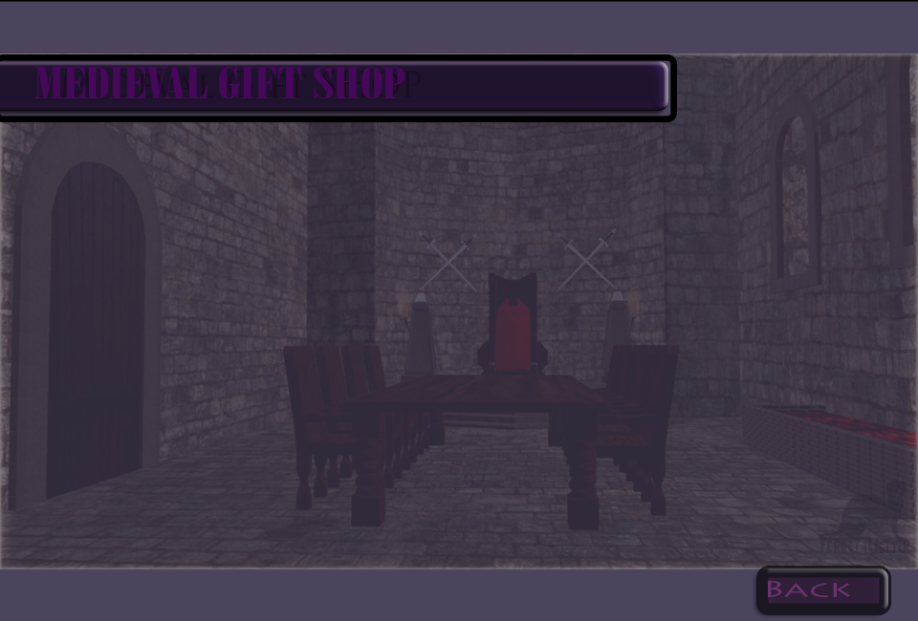

Once the player has entered the room with the shop, he or she is then welcomed and after a swift 2 second wait he is presented with a new menu that contains the options to shop for items and upgrades by character type.

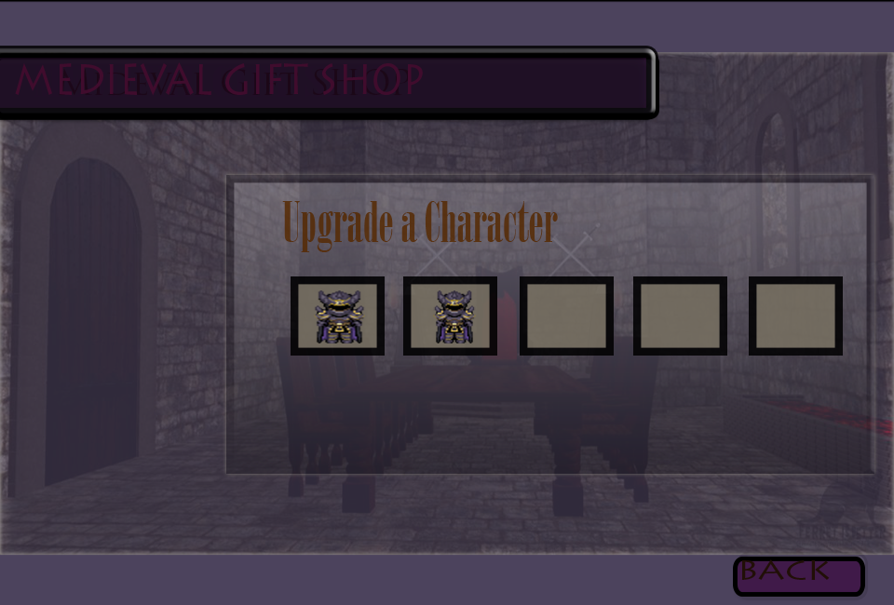

From here on the player can choose the type of character he wants to shop for or upgrade and by clicking on the character icon he crosses over to the next menu portal where the shopping for the character begins.

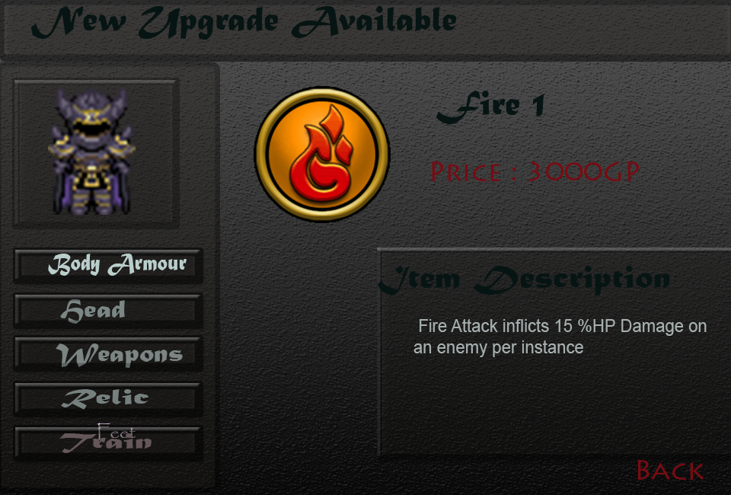

In the window above we can observe that the player has selected train to view the next available magic technique the character of the type selected can learn if purchased.

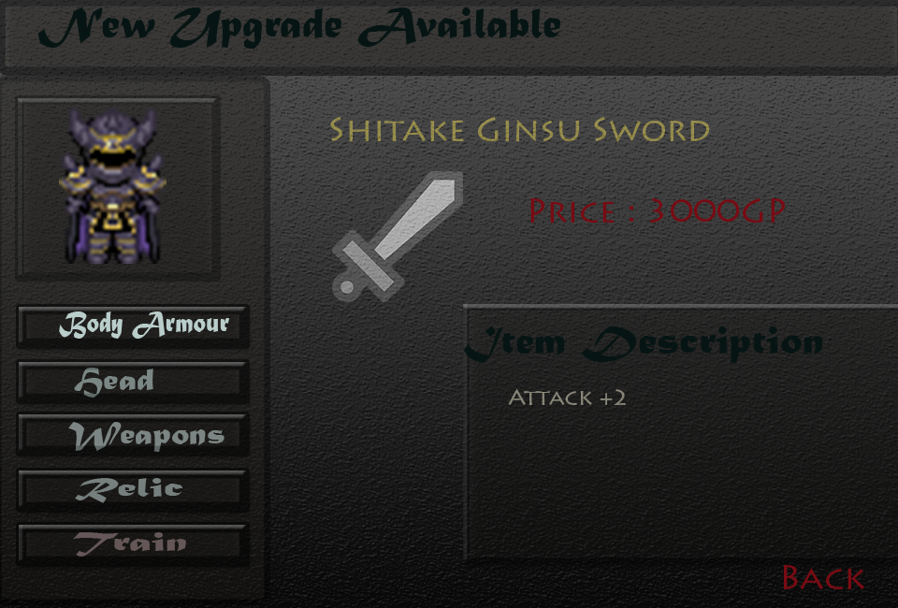

The menu objects are stored in array that includes the prices, item description and image that are generated in the screen when the respective button for the item is clicked.
Once an item is purchased by the player it is added to his inventory or equipment list and in the current screen a window will appear when an item is purchased with the details.

