1. Background

Student Number: 167184

“Zero-shot learning – A Comprehensive Evaluation of the Good, the Bad and the Ugly” is one of the most extensive works in the zero-shot learning field. It argues that although the number of methods has been increasing, it is difficult to assess the overall progress in the area due to lack of a unified evaluation protocol and flaws in the existing ones. In order to critically quantify the recent advancements, the authors of the paper have evaluated the three main aspects of zero-shot learning: methods, datasets and evaluation protocols. The paper also analyses generalized zero-shot learning since having training classes present at test time is a more realistic setting.
The different methods assessed in the paper include five linear and two nonlinear compatibility learning frameworks that learn directly a mapping from an image feature space to a semantic space, two learning independent attribute classifiers that adapt a two-stage approach of using attributes, two hybrid models which embed both the image and semantic features into another intermediate space and one generative model that represents each class as a probability distribution.
In regards to the datasets evaluated, the researchers include in their work one small and one medium coarse-grained dataset and two medium fine-grained ones that all have attributes. They also evaluate a large-scale one without attributes that contains 14 million images. In addition, they propose a new medium coarse-grained dataset that uses the same classes as the original one but in contrast, has publicly available images.
An important observation in the work is that the dataset ImageNet used to train image feature extraction networks includes some of the test classes in the rest of the datasets. Zero-shot learning requires separate train and test classes, thus, a new data split has been proposed that ensures there is no overlap.
In their experiments, the authors first provide their reproduced results of the different methods on all of the datasets and compare them to the original ones. 6 out of 13 of the methods have almost equal performances. Some of the reasons for discrepancies in the other 7 include different hyper-parameters, different methods for measuring accuracy, sensitivity to initialization and random sampling. Interestingly, the reported original accuracy for one of the methods was obtained after improving the visual features of the images.
The results after comparing the original data split with the researchers’ proposed data split show several things. Firstly, the accuracy of the methods that have overlapping train and test classes goes lower while there is no significant difference for the others. Secondly, the methods that perform the best with the proposed split all use max-margin bi-linear compatibility learning framework. In addition, the results indicate poor generalization of the methods performing well with the original split but bad with the new split.
Evaluating robustness shows that all of the methods have stable results across the fine-grained datasets with balanced number of images for different classes. In contrast, the datasets that are coarse-grained lead to worse robustness. After evaluation with three different validation splits. A linear compatibility model that uses weighted approximate ranking objective and a generative framework that models each class-conditional distribution as a multivariate Gaussian seem to be the most robust.
The work shows that the new dataset proposed by the authors is a good replacement for the original one since the results for both are similar. Moreover, all the models trained on the original one generalize well to the new one with the opposite setting also being valid.
The model that performed the best for attribute datasets did significantly worse on the large-scale dataset ImageNet which proposes that generative models need attributes as a strong embedding space. The best performing method was a hybrid model that learns a mapping between the semantic class space and the model space.
Evaluating the methods on generalized zero-shot learning leads to worse results indicating that the train classes act as a distraction to the classifiers. An important observation is that compatibility learning methods perform well on test classes meanwhile independent attribute learning methods perform well on training classes. As a consequence, the authors of the paper adopted a harmonic mean which averages the training and test accuracy.
There are three points to be addressed in conclusion. Firstly, generative and compatibility learning models seem to be better than attribute classifiers and hybrid models for classic zero-shot learning. Secondly, separate training and validation class split is obligatory for parameter optimization. Thirdly, a unified measure for generalized zero-shot learning, e.g. the harmonic mean, is necessary for accurate evaluation.

2. Outline of methods employed
In my work, I have used Direct Attribute Prediction (DAP) that is one of the two learning intermediate attributes methods evaluated in the paper above, in order to perform zero-shot learning on the Animals with Attributes 2 dataset. DAP trains probabilistic attribute classifiers and combines their scores so as to predict a class for an unseen image. I have performed classification on the data by training Support Vector Machine classifiers with binary values from the provided attribute matrix for all of the classes in the dataset.
I have trained my classifiers on random samples of the images with sizes of 25, 50, 75 and 100%. With the aim of extracting features from the images, I employed SIFT detection and SIFT extraction. I have used 50, 75 or 90% of the features extracted that were of dimension 128. In order to build a vocabulary for the images and create histograms of equal size per image, I performed K-means clustering on all of the sample data. The number of cluster center varies from 100 to 250. I have then built 85 models for each of the attributes by training SVMs on the training images. I have computed attribute probabilities for each image in the test set using the models and stored all of their scores. In consequence, I have computed the probability of each image to be of certain class by using its scores and performed classification by choosing the highest probability.
The approach that I have adopted in my work was to optimize the following three parameters: proportion of images used, proportion of features used and number of clusters for K-means.

3. Results achieved and analysis
Initially, I ran my program on 20% of the images, using all of the features and performing K-means with 128 clusters. The accuracy of my predictions was 13.43 %. Since the features used for building models are crucial for good performance, I used a selectStrongest function in order to extract only part of the interesting SURF points detected.
After implementing the function with 75% of the points, only 10% of the data and only 20 clusters, I improved my accuracy with 2.5%. That proved my theory that taking all of the features of the image would lead to the classifiers learning noise together with the actual features. That is why I decided to use the function and to try optimize the number of features.
The graph that follows the next paragraph shows the accuracy obtained with 25, 50, 75 and 100% of the images and 50% (blue), 75% (green) and 90% (red) of the features used. 200 clusters are used to perform K-means for all of the shown cases.
As it can be seen from the graph, extracting 50% of the images leads to worse performance than extracting 90%. There is no clear conclusion that can be made in regards to how much exactly is the optimal between 75% and 90%. It seems that feature extraction size may turn out to be of less importance than the proportion of images that are randomly chosen to be used. Getting 25% and 50% of the dataset shows consistently better results. It is important to note that I have not taken multiple trials of the same configuration of parameters, so the better accuracies might have been obtained due to better sampling.
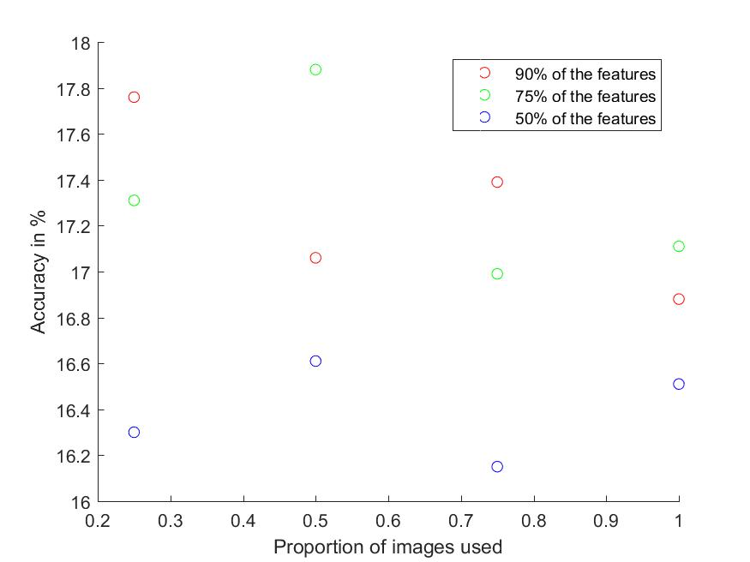
Regarding the third parameter in question – number of clusters, it appears to be of no significance when the proportion of features taken is 50%. The accuracy for models trained on 75% of the images and 50% of features is 16.15 for 200 clusters and 16.10 for 250 clusters. Nevertheless, the highest accuracy I achieved was obtained with 250 clusters on 25% of the images. It is 18.20% and is not present in the graph because of the different number of clusters used. It was also taking 95% of the features of the images which confirms the possibility that taking all of the features might not be such an issue compared to the sampling of images. Using less than 200 clusters did not seem to be optimal for most cases although for the 25% sampling of the images, using 100 clusters instead of 200 and getting 90% of the features increased the accuracy with 0.2%.

4. Conclusion
There are two important points that need to be addressed regarding my work on zero-shot learning. My approaches did not involve any pre-processing of the images which might be the reason for the low accuracy I was obtaining. What could have been done was to perform some sort of rotation of the images, and get the best features amongst the versions of the image. Moreover, I could have performed multiple tests on my best parameter configurations since sampling the data set might have led to biased results. As a whole, I think I adopted a stable workflow and was able to increase my initial accuracy to some extent. However, better feature selection would have very possibly resulted in more significant improvement of performance.

References
Xian,Y. et al. Zero-Shot Learning – A Comprehensive Evaluation of the Good, the Bad and the Ugly.(2017)

