- Approach

Student Number: 167184 & Kaggle Team Name: Dang!
High-dimensional data forms a sparse distribution in the input space and its sampling is non-uniform [1] which can present challenges for good generalization during classification. The Support Vector Machine employs the Structural Risk Minimization principle that minimizes an upper bound on the expected risk instead of minimizing the error on the training data. Thus, it has a better ability to generalize. It is also better suited for data with an extensive amount of features because it constructs a mapping into a feature space using kernel functions. Kernel functions allow operations to happen in the input space instead of the feature space which is a way to confront the high dimensionality issue.
Owing to the presented advantages of the SVM when dealing with a lot of features, I chose to adopt this approach for the ‘Do we just see snow in Brighton?’ competition for classifying snowy and not snowy images.

Methodology
  - Pre-processing
As part of the pre-processing I did for the features, I used standardization, i.e. rescaling the attributes so that they have mean value of 0 and a standard deviation of 1. I chose to standardize opposed to normalize, i.e. rescale the attributes to the range of 0 to 1, because after trying to fit the training data into different probability density distributions, I came to the conclusion that the distribution is Gaussian [2].
Regarding my attempts to measure redundancy in the features, I used both whitening and PCA (without reduction) to remove correlations and scale the data.
It is important to mention that the additional training data that was given consisted of a lot of missing values. I performed mean imputation for the GIST features and I substituted the missing values with zeros in the CNN features. I did the former owing to the fact that mean imputation is the simplest yet effective way of dealing with missing data and the latter because the CNN features consist of a lot of zero values in general. Imputing their mean would distort the distribution of the variables.
Another important characterisation of the data is the fact that it is class-imbalanced. Moreover, given the test proportions, it becomes visible that the train classes have the opposite proportions: 43% not snowy images in the train set compared to 43% snowy images in the test set. In order to combat that, I performed over-sampling, i.e. copying the instances of the under-represented class. It is important not to bias the dataset by copying only certain data points, so I did a 3:2 ratio for the snowy – not snowy images. I decided to not perform under-sampling due to the same reason.
I adopted the method mentioned above for the additional annotation confidence that was provided. In addition to the given confidence values, I used the number of missing values for each data point to create a new level of confidence: the data points that had their number of missing values above the mean for the whole set were copied only once compared to the others. I also tried removing them from the dataset.
  - Feature Selection
As a way to address the issue of high-dimensionality, I tried different techniques for feature reduction. Firstly, I tried using PCA to return only part of the features. I performed k-fold cross-validation in order to assess the train and test loss for each parameter (number of features to keep). Secondly, I adopted a feature selection technique called fast correlation-based filter that is evaluated as one of the best filtering methods for supervised feature selection [3]. It is based on calculating symmetrical uncertainty (SU). The algorithm proposed by [4] consists of two parts. In the first part, it computes the SU value for each feature (against each class outputs), selects relevant features into a new list of features based on a predefined value, and orders it in descending order. In the second part, it removes redundant features from the ordered list by calculating the SU between each pair of features, taking one as a reference at a time, and the SU of the second feature. If the former is bigger than the latter, the second feature is removed from the list. The algorithm stops when there is nothing to remove from the list.
When implementing the algorithm by using [5] for the calculation of SU, I found out that the joint SUs were always bigger than the SUs for the features themselves. This led to the algorithm removing all of the features but the first one. The features were too correlated for the method to be useful. Thus, I adopted a slightly different way of using symmetrical uncertainty. As a beginning, I did not use a threshold for features to keep, but saved all of them. Furthermore, I only used the first feature in the ordered list as a reference since the following values would be still smaller than the joint ones. Finally, I did not consequently remove features but kept all of them. I computed all of the joint SUs for each class and created a final set of features to keep by finding the features that were different for the two classes and adding an additional subset of the common features.
I also tried using another feature selection approach called two-sample t-test that chooses features based on the null hypothesis that two features come from independent random data samples.
  - Model selection
I used a number of different measurements in order to assess the performance of my models. The most general one is the test error of the trained model. I further extended my training by using 10-fold cross-validation. In this way, I could compute the train and test error of my models which could be then both compared to the error on the test data shown in Kaggle. In addition, I implemented the generation of confusion matrices that give information about the true positive and false positive rate, as well as the precision of the classifier.

Results and discussion
The first choice I did in regards to the type of SVM I was to use, was the kernel function. I compared the different types of Kernel Functions by using the Classification Learner Matlab toolbox without any pre-processing and the linear produced the highest performance. Regarding my workflow, I have not used the app but produced my own Matlab functions.
In terms of different pre-processing techniques, to begin with, I standardized the input and the output data. Normalizing only the input data produced slightly better results (0.1791 train error vs. 0.1771 test error). I also tried using the Standardization in-built in the fitting function in Matlab but it was resulting in a bigger error.
I imputed the mean values for each feature in the additional training data in order to be able to use it. I built my model with only CNN features, as well as with all of them. Using only CNN features with standardization did not improve the classification accuracy but it did when performing PCA on the data: 0.1796 train error vs. 0.1774. Owing to the fact that using CNN features only did not affect favorably my model error, I decided not to use PCA either. Imputing 0s instead of the mean in the CNN features decreased the loss with 0.005.
Trying to reduce features with PCA using 10-fold cross validation resulted in lower train set losses but did not improve the test error which showed that without the proper feature selection technique removing features can lead to overfitting:
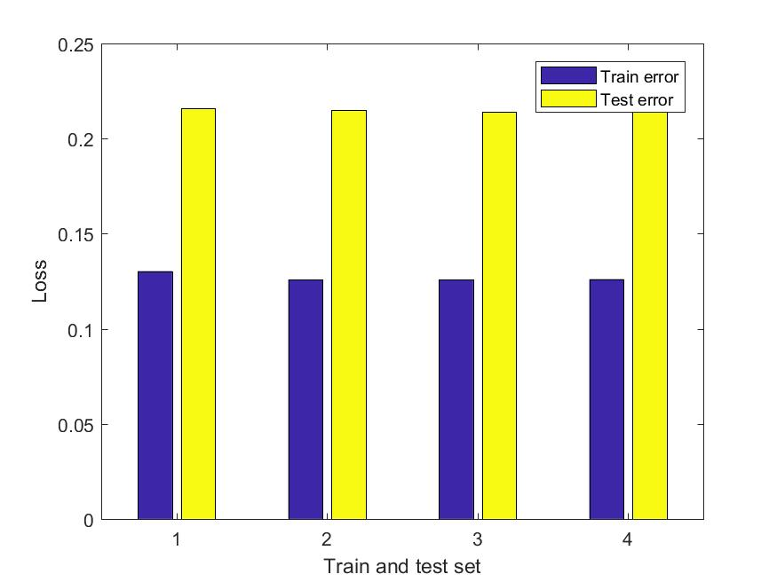

Figure 1: Overfitting after feature reduction with PCA: train data with 2000, 3000, 3500 and 4000 features respectively

Performing PCA on both the train and the test sets also led to overfitting: surprisingly, including the test features information in the training of the model did not result in better test loss as expected, but only to better train loss: 0.1796 without and 0.1264 with the test PCA.
Using 10-fold cross-validation to tune the regularization parameter, i.e. the Box Constraint in Matlab did not lead to better performance overall.
Another example for overfitting, or producing better train loss but without change in the test loss is my attempt to use the annotation confidence that was given to us. I expanded my dataset by copying data points with confidence 1 three times and the ones with confidence 0.66 twice. This led to error of 0.12 in my train set but still 0.21 in the test set. Removing data points also resulted in worse accuracy.
When I mention train and test set losses, I am referring to the test error on the training data versus the error on Kaggle (the score subtracted from 1). In addition to this point of reference, using cross-validation, I could look at both my train (validation) and test error on the training data. What is important to mention is that when the validation and test errors were more close to each other (e.g. 0.1922 and 0.1847), the Kaggle score was one of the best – 0.2056.
In order to prevent biasing towards certain data points when trying to enlarge the dataset, I changed the weights per image inside the fitting SVM function. This did not improve the test error but made the train error closer to it (hence prevented overfitting). I also fitted a Posterior Classifier in order to label the test data points by using the posterior probabilities and the test and train class priors. This was essentially another way of dealing with class imbalance. It did not result in better performance but was a good alternative to copying data points.
In regards to the oversampling approach I adopted, it led to better performance when done only with normalized data and no other processing, but led to worse results when combined with the method of expansion using annotation confidence (0.2056 vs. 0.2100). In conclusion to this, I tried avoiding expanding the dataset.
The SU feature selection method I adopted seemed to always improve slightly the performance of the model, however not significantly, but I decided to keep it. My assumption is it might lead to better performance when presented with a bigger proportion of the test data. The t-test approach led to worse results.
In conclusion, I could have trained a better model if I had adopted several additional techniques: I could have built two different classifiers for the CNN and GIST features since they are very different, and combine them. I should have tried refining the regularization parameter more. I could have also used the confusion matrices I was building for every fold of the cross-validation in order to try analyze my model better.

References
- S. Gunn. Support Vector Machines for Classification and Regression., 1998.
- J. Brownlee. How to Normalise and Standardise Your Machine Learning Data in Weka. 2016. Accessed on: May 23rd 2018
- A. Ferreira, M. Figueiredo. Efficient feature selection filters for high-dimensional data. Pattern Recognition Letters, 33(13):1794-1804
- L. Yu, H. Liu. Feature Selection for High-Dimensional Data: A Fast Correlation-Based Filter Solution. Department of Computer Science & Engineering, Arizona State University, Tempe, AZ 85287-5406
- S. Galelli. ComputeSU.m. https://github.com/stefano-galelli/Matlab-Multi-objective-Feature-Selection/blob/master/computeSU.m. Accessed on: May 20th 2018

