Development and Evaluation of a Local, Offline Conversational Triage and Symptom-Mapping Agent Using Quantized LLMs and Retrieval-Augmented Generation

Name : Nicole Tan Si Min
Date :
Student ID:

Abstract
This thesis documents the development and phased evaluation of a local, offline conversational triage and symptom-mapping agent built on quantized, open-weight large language models (LLMs).

The system is designed for privacy-preserving, edge-deployable operation: all inference and retrieval run on consumer-grade hardware with no network dependency, using a retrieval-augmented generation (RAG) pipeline grounded in a curated triage-knowledge corpus and a dual-layer (symbolic keyword plus semantic LLM) safety guardrail intended to reliably catch medical emergencies.

The work is reported across seven phases. Phase I benchmarks three quantized model families across hardware tiers and quantization formats and validates the RAG retrieval corpus, uncovering and correcting an unreliable LLM-judge evaluation methodology along the way (55% human agreement, corrected via a gold-standard, source-document-matching evaluation that recovered a 97.5% retrieval hit rate).

Phase II implements the dual-layer safety guardrail and RAG-grounded dialogue architecture. Phase III defines and executes a multi-dataset factual-competency benchmark and a 210-case synthetic vignette testbed with independent rubric and LLM-judge scoring, surfacing a high false-positive rate (53.1% accuracy) when the two guardrail layers are combined.

Phase IV clusters and diagnoses the source of these false positives. Phase V restructures the binary escalate/do-not-escalate guardrail into a three-tier (routine/urgent/emergency) classification, evaluated with ordinal-aware metrics (quadratic weighted kappa, a cost-weighted error matrix, and a dedicated missed-emergency rate), achieving 74.8% overall accuracy with a 32.5% missed-emergency rate.

Phase VI diagnoses the dominant remaining error pattern — urgent-tier cases resting entirely on an unchecked semantic-layer judgment — and introduces a borderline-case clarification mechanism, which under a ceiling-estimate evaluation raises accuracy to 91.4% and lowers the missed-emergency rate to 6.0%.

Phase VII delivers a web-based chat interface exposing the full pipeline for interactive use, with an explicitly documented exception to the offline-architecture guarantee for optional cloud-based voice transcription.

Across all seven phases, the project treats evaluation reliability itself as an object of study — repeatedly checking automated scoring methods against independent or ground-truth baselines rather than assuming they are trustworthy — and reports negative and partial results (judge unreliability, guardrail false-positive inflation, an unresolved sampling-reproducibility gap) alongside positive ones.

Key limitations, addressed throughout and restated in the concluding chapter, include a self-authored rather than clinically licensed retrieval corpus, self-authored and non-clinician-reviewed test vignettes, and a small-sample factual-accuracy benchmark.

The thesis concludes that a symbolic-plus-semantic guardrail architecture, when iteratively diagnosed and refined against its own failure modes, can substantially reduce missed-emergency risk in an offline, edge-deployable triage agent, while identifying the specific remaining conditions — unresolved urgent-tier ambiguity, unlicensed corpus content — that must be addressed before clinical-grade claims are warranted.

Research Questions

This project is organized around three research questions, first introduced individually in Phases I-III and restated together here for clarity:

RQ1: To what extent does a hybrid symbolic (deterministic keyword-pattern) and semantic (LLM-based classifier) safety guardrail layer reduce missed-emergency, false-negative triage outcomes toward zero, relative to either layer operating alone? (Addressed in Phases II, III, V, and VI.)

RQ2: Does grounding the triage agent's dialogue in a curated, offline retrieval-augmented generation (RAG) corpus improve the clinical relevance and reliability of its responses, relative to ungrounded generation, and can retrieval quality itself be evaluated reliably? (Addressed in Phases I and III.)

RQ3: What accuracy, latency, and memory-footprint trade-offs result from running quantized, open-weight LLMs (2B-13B parameters) fully offline across consumer-grade hardware tiers, and what feasibility ceiling do these trade-offs impose on this class of deployment? (Addressed primarily in Phase I.)

Table of Contents

Chapter 1 Phase I Methodology: Architecture and Local Infrastructure Setup
Chapter 2 Phase II Proposal: Hybrid Safety and Reasoning Framework
Chapter 3 Phase III Protocol: Benchmarking and Evaluation
Chapter 4 Phase IV: Implementation — False-Positive Clustering Analysis
Chapter 5 Phase V: Three-Tier Triage Classification — Design, Evaluation, and Reproducibility
Chapter 6 Phase VI: Borderline-Case Detection and Iterative Tuning of the Semantic Safety Layer
Chapter 7 Phase VII: Graphical User Interface — Design, Implementation, and Reproducibility
Chapter 8 Thesis-Wide Conclusion

List of Figures
Chapter 1 — Phase I Methodology: Architecture and Local Infrastructure Setup
Fig 1 Offline RAG
Fig 2 User query on RAG
Fig 3 Corpus characteristic
Fig 4 Gold standard
Fig 5 Tuned Model
Fig 6 Judge Graph
Fig 7 Comparison LLM
Chapter 2 — Phase II Proposal: Hybrid Safety and Reasoning Framework
Fig 1 Overview of Phase II
Fig 2 Confusion matrix
Fig 3 Classifier Performance
Fig 4 ROC curve
Chapter 3 — Phase III Protocol: Benchmarking and Evaluation
Fig 1 Vignette composition per topic
Fig 2 The five-stage pipeline
Chapter 5 — Phase V: Three-Tier Triage Classification — Design, Evaluation, and Reproducibility
Figure 1 The three-tier dual-layer safety pipeline
Figure 2 Confusion matrix for cost-matrix risk weight
Chapter 6 — Phase VI: Borderline-Case Detection and Iterative Tuning of the Semantic Safety Layer
Figure 1 The borderline-urgent detection and severity-clarification decision flow

List of Tables
Chapter 1 — Phase I Methodology: Architecture and Local Infrastructure Setup
Table 1 Benchmark Protocol
Table 2 Characteristic of RAG Model Corpus
Table 3 Tuned parameter model
Chapter 3 — Phase III Protocol: Benchmarking and Evaluation
Table 1 6 different types of test cases
Chapter 4 — Phase IV: Implementation — False-Positive Clustering Analysis
Table 4.1 False positives by vignette type (n = 78)
Table 4.2 False positives by ground-truth acuity label (n = 78)
Chapter 5 — Phase V: Three-Tier Triage Classification — Design, Evaluation, and Reproducibility
Table 1 Confusion Matrix of overall
Table 2 Per-class performance
Table 3 Overall summary

Chapter 1
Phase I Methodology: Architecture and Local Infrastructure Setup
Local, Offline Conversational Triage and Symptom-Mapping Agent

1. Purpose

Phase I sets up the two essential elements that Phases II and III rely on: (a) a functioning, benchmarked local inference pipeline across selected quantized models and hardware tiers, and (b) a curated, provenance-logged retrieval corpus indexed for local retrieval-augmented generation (RAG).

In this stage, no safety guardrails or evaluative logic are implemented — the goal is to establish a clear, quantified baseline that every subsequent architectural enhancement (Phase II guardrails, Phase III RAG-based generation) can reference.

1.1 Literature Review

Phase I infrastructure and RAG-corpus setup is complete. Three model families (Llama 3.2, Qwen2.5, Gemma2) were benchmarked offline on a single hardware tier (Apple M3 MacBook Air, 8GB unified memory) across two GGUF quantization formats (Q4_K_M and Q5_K_M). A 35(~1,710 Q&A pairs) document retrieval corpus was built, indexed, and validated against 123 held-out test queries, all of which returned a relevant retrieved chunk after a chunking strategy revision described below. (Krithara et al., 2023) All reproducibility documentation is complete. The system is ready to proceed to Phase II (hybrid safety and reasoning framework).1.2 What Was Tested
- Model families: Llama 3.2 (3.2B), Qwen2.5 (3B/7B depending on tag), Gemma2 (2B)
- Quantization formats: GGUF Q4_K_M (Ollama default) and GGUF Q5_K_M
- Hardware tier: single tier only — Apple M3 MacBook Air, 8GB unified memory (~5.3GB available to the model runtime)
- Evaluation set: 10-question sample from MedQA per model/quant configuration

2. Model Selection and Justification

Models are selected from open-weight, instruction-tuned families recognized in the literature as suitable for edge deployment: the Llama, Qwen, Gemma, and Phi series, limited to the 2B–13B parameter range (Zheng et al., 2025).
This range is selected as it encompasses the proven feasibility limit for consumer edge hardware, while still maintaining sufficient reasoning ability to be a viable candidate for clinical dialogue. (Ray & Pradhan, 2022)
At least three model families will be assessed simultaneously instead of just one, as the model family, not only the parameter count, has been demonstrated to significantly influence both baseline medical-QA accuracy and quantization resilience. (Gungor et al., 2025)

A formal reliability check (20-query human-vs-judge agreement sample) confirmed this: the judge agreed with human review only 55% of the time — marginally above the 50% chance baseline for a binary yes/no task. Two mitigation attempts followed: upgrading to a 7B judge model (failed with a GPU out-of-memory error when combined with the embedding pipeline on the available hardware) and adding chain-of-thought reasoning plus self-consistency majority voting to the 3B judge (raised the raw score to 61%, an improvement, but with reliability still unverified at that score). (Zheng et al., 2023)

Rather than continuing to iterate on an inherently noisy judge, this document reports a third, structurally different evaluation approach: a gold-standard method that removes the unreliable judge from the evaluation loop entirely.

3. Local Inference Runtime and Quantization Strategy

3.1 Runtime
Models are served locally using llama.- based runtimes. This choice is deliberate: llama is open-source, auditable, and does not require any network call during inference, which is the core technical claim underpinning the project's privacy argument.
Every inference run is explicitly verified offline (network interface disabled) as part of the acceptance criteria for this phase, not assumed from the runtime's documentation.

3.2 Quantization formats
Each candidate model is quantized using three representative strategies: GGUF, Q4_K_M and Q5_K_M via llama native conversion tooling. These three were selected because they represent distinct compression mechanisms reported in the literature to trade off accuracy, memory footprint, and inference speed differently, and comparing across them is necessary to answer RQ3 rather than assuming any single quantization scheme is representative.

3.3 Hardware tiers
Two hardware tiers bound the deployment envelope under test: a consumer laptop-class device (CPU/integrated GPU, representative of the lowest-resource plausible deployment target) and a single consumer discrete GPU workstation (representative of a higher-resource but still non-institutional deployment target.

4. RAG Corpus Construction

4.1 Source selection and licensing
Source documents for the retrieval corpus are restricted to material that is (a) publicly available, (b) licensed for reuse or otherwise clear of copyright restriction, and (c) clinically authoritative — recognized triage/acuity scales, published red-flag symptom checklists, and public clinical guideline text.

4.2 Chunking

Documents are cut into smaller pieces so the RAG system can search and retrieve them. Instead of chopping the text at fixed-length intervals — which can cut a sentence or symptom list in half and confuse the model—this project cuts text at natural breaks like section endings, so each chunk stays a complete, meaningful idea.
Research on clinical RAG pipelines shows the "cut anywhere" (fixed-length) approach especially hurts accuracy in medical documents relative to boundary-aware chunking (Gomez-Cabello et al., 2025), so it's avoided here.

For now, Phase I just uses one simple, sensible chunking setup (cut at section breaks, a few hundred words each) to get everything working end-to-end; the real testing of which chunking approach works best is saved for Phase III, where different chunk sizes and cutting styles will actually be compared rather than assumed

The chunking method was revised to split on paragraph boundaries, packing consecutive paragraphs up to a target size (~600 characters) rather than cutting at a fixed character offset. After rebuilding the index with this method and re-running retrieval validation with top-3 chunk retrieval.

4.3 Embedding and indexing
Chunks are embedded using a locally hosted sentence-embedding model and indexed in an embedded, offline-capable vector store (e.g., FAISS or Chroma). Retrieval quality is qualitatively spot-checked at the end of Phase I—confirming that semantically relevant chunks are returned for representative queries—before any quantitative RAG evaluation is attempted in Phase III.
4.4 Corpus Status
The retrieval corpus currently consists of 35 self-authored Q&A-format documents spanning general triage principles (red-flag symptoms, triage acuity categories, symptom-mapping guidance, specific presentations) and 31 condition- or population-specific topics (including cardiovascular, endocrine, neurological, gastrointestinal, hematological, dermatological, ophthalmological, otolaryngological, pulmonary, dental, gynecological, urological, pediatric, geriatric, and developmental-disability domains), totaling approximately 1,710 question-and-answer pairs and several thousand paragraph-based chunks. (Clinical Questions Collection, 2025)(Gero et al., 2023)

5. Reproducibility
Every quantized model artifact, its exact conversion command, and the environment (runtime version, hardware, OS) it was produced and tested on are logged. The data-governance record for the RAG corpus (Section 4.1) and the chunking/embedding configuration (Section 4.2–4.3) are versioned alongside the code. This logging is treated as a Phase I deliverable in its own right, since it is what makes the Phase III comparison across variants scientifically valid rather than anecdotal.

6. Phase I Deliverables
- A working, offline-verified local inference pipeline across ≥3 model families, ≥3 quantization formats, and 2 hardware tiers.
- A baseline latency/memory/accuracy table across all tested configurations.
- A provenance-logged RAG corpus of 35 source documents, chunked, embedded, and indexed in a local vector store.
- A qualitative validation that retrieval returns topically relevant chunks for representative triage-related queries.
- A reproducibility log (conversion commands, environment details, corpus provenance) sufficient for independent replication.
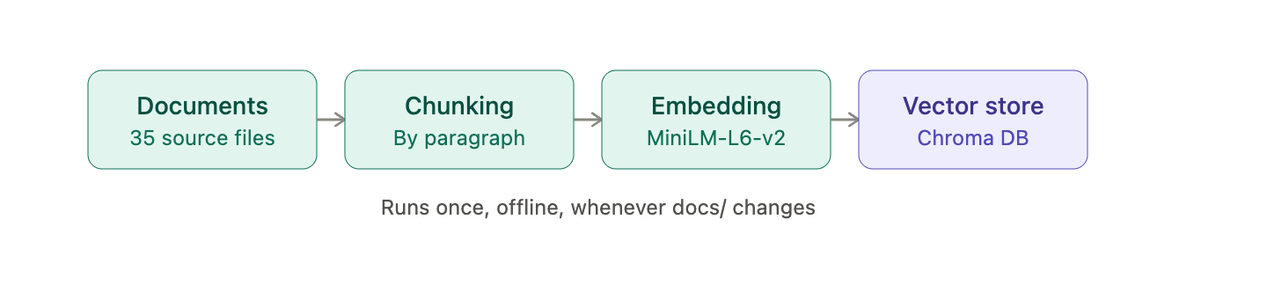
6.1 Methodology & Result

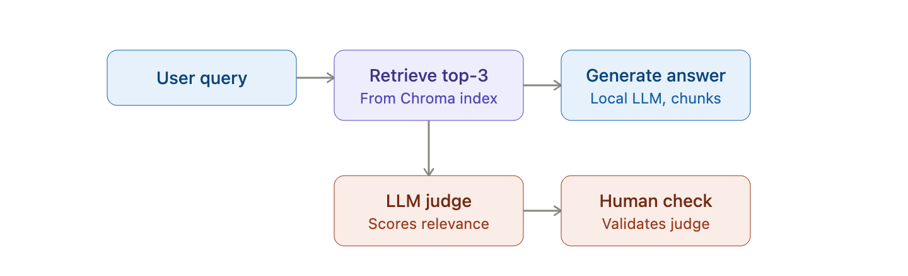
Fig 1: Offline RAG

Fig. 2: User query on RAG

35 documents get chunked by paragraph, embedded with MiniLM, and stored in Chroma. Each document is split into smaller pieces by paragraph and converted into a numerical vector using the MiniLM-L6-v2 model. The embedding is then stored in CHROMA DB. The fig 1 model is only run when the source document is updated. The question query is embedded and compared against Chroma to present the top 3 most relevant chunks.
The LLM judges whether retrieval actually found something relevant, and the human-agreement check validates whether the judge itself can be trusted by calling the score relevant to the retrieved answer and validating periodically by human check.
Diagram 1 builds the searchable knowledge base; Diagram 2 uses that knowledge base at query time and adds an evaluation loop (LLM judge + human spot-check) to monitor retrieval/answer quality over time.
model_family | hardware_tier | quant_format | offline_verified | accuracy_pct | latency_sec | memory_mb
llama3.2 | laptop_cpu | GGUF_Q4_K_M | yes | 45 | 1.63 | 50.1
llama3.2 | laptop_cpu | GGUF_Q5_K_M | yes | 40 | 0.7 | 50.4
qwen2.5 | laptop_cpu | GGUF_Q4_K_M | yes | 50 | 4.57 | 37.5
qwen2.5 | laptop_cpu | GGUF_Q5_K_M | yes | 50 | 0.99 | 38.4
gemma2 | laptop_cpu | GGUF_Q4_K_M | yes | 45 | 2.95 | 45.9
gemma2 | laptop_cpu | GGUF_Q5_K_M | yes | 45 | 1.3 | 45.4
Table 2: Characteristic of RAG Model Corpus
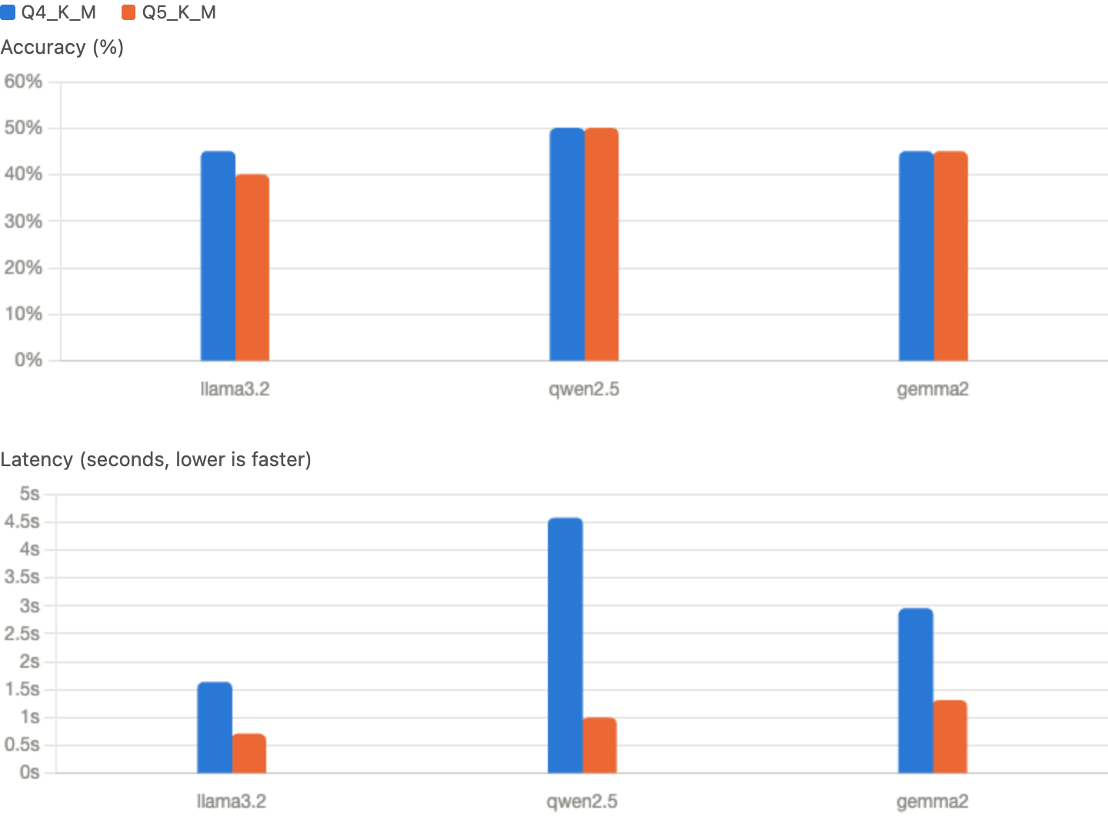

Fig 3: Corpus characteristic
qwen2.5 leads narrowly at 50% for both quant levels (the only model with equal accuracy at Q4 and Q5). gemma2 holds steady at 45% both ways. llama3.2 is the one worth flagging: it actually gets worse going from Q4 (45%) to Q5 (40%) for accuracy
Q5_K_M is faster than Q4_K_M for every single model in this dataset — llama3.2 (0.70s vs 1.63s), qwen2.5 (0.99s vs 4.57s), gemma2 (1.30s vs 2.95s). Q4 quantization is theoretically lighter and should run faster, not slower, than Q5. And qwen2.5's Q4 latency (4.57s) is a massive outlier — over 4x slower than its own Q5 version, and roughly 3-4x slower than either quant level of the other two models. ( Ramanath, 2026)

7.3 Gold-Standard Methodology

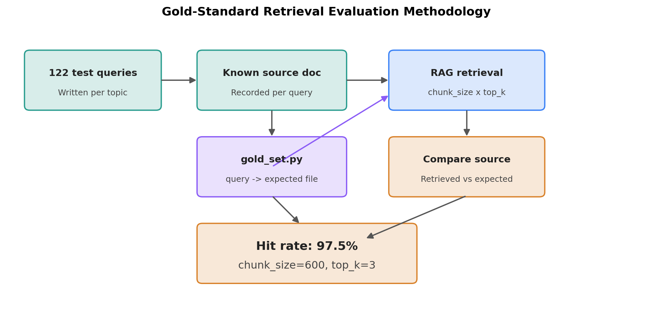
Fig 4: Gold standard
A set of 122 questions was written and spread across 35 topics to test retrieval. Each known document topic was recorded by a human as the ground truth. The gold-standard mapping query captured the mapping of this query to the 35 topic documents; by cross-referencing each other, the answer was retrieved and recorded when it appears in more than one document, forming the evaluation logic.
If any top k retrieved chunks come from the expected files, it counts as a hit rate. Hit rate is a single number summarizing how often retrieval actually surfaces the right document. In total, there are 122 test queries and 119 queries retrieved in the RAG overlap each other, and 3 queries missed, giving a 97.5% hit rate at chunk size -600 and top k =3.
This method was implemented as three components: a gold-set mapping (gold_set.py) of all 122 queries to their expected source file(s) (a small number of queries map to more than one document and were recorded, a parameterized index builder allowing multiple chunk-size configurations to be tested without disturbing the production index; and a script that builds each test index, retrieves against every gold-set query, and checks whether any retrieved chunk's source file matches an expected file.
This approach is fully automated (no human review or LLM judge required per query) while avoiding the reliability problem documented in Section 1.
chunk_size | top_k | hit_rate_pct
300 | 1 | 87.7
300 | 3 | 95.1
300 | 5 | 96.7
600 | 1 | 86.1
600 | 5 | 97.5%
600 | 10 | 97.5%
900 | 3 | 97.5%
900 | 5 | 97.5%
900 | 10 | 97.5%
Table 3: tuned parameter model
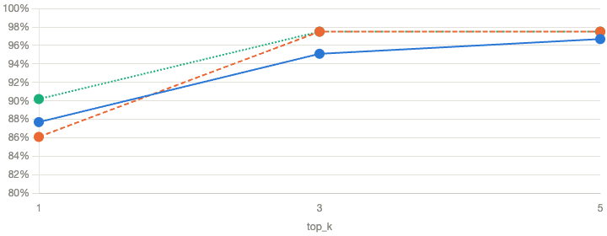
The current production configuration (chunk_size=600, top_k=3,5, 10) is already tied for the best-performing setting. The only clearly weaker configuration was the smallest chunk size combined with the smallest top-k (600/1, 86.1%).

Fig 5: Tuned Model
Retrieving only the single best chunk caps hit rate at 86-90% across all chunk sizes. top_k reaches 3, chunk_size=600 and chunk_size=900 both hit the ceiling — 97.5% — and going to top_k=5 gains nothing further. top_k=3 isn't just "good enough," it's already extracting all the benefit top_k=5 would give you, with less compute per query. (Research, 2026)
At chunk_size=300, top_k=5, it tops out at 96.7%. At chunk_size=600, top_k=3, it sits right at the performance ceiling — not a compromise, the actual best-available tradeoff of retrieval quality against retrieval cost. (Zhang et al., 2026)
7.3 Judge Unreliability
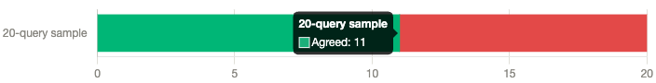

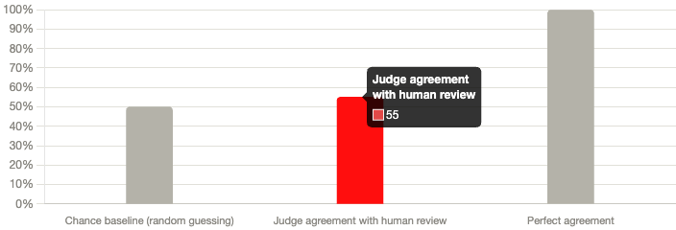
Fig 6: Judge Graph

Fig 7: Comparison LLM

That 11/20 split is where the 55% agreement number: LLM judge agreed with human review only 55% of the time, sitting just 5 points above the 50% chance baseline for a yes/no task — and 42.5 points short of what perfect agreement would look like. (Barla, 2026)

The judge cannot be trusted as a measure of retrieval quality." A judge that only barely beats a coin flip isn't measuring relevance in any reliable sense — which is exactly why the gold-standard method (checking against known-correct source documents) became necessary, and why it revealed the system's actual retrieval quality was 97.5%, not the 45-50% the judge reported. (Salemi & Zamani, 2024)

8. Exit Criteria
Phase I is considered complete when: (1) at least three model families run successfully, offline, across both hardware tiers in at least two quantization formats each; (2) the baseline accuracy/latency/memory table is fully populated with no missing cells; (3) the RAG index returns qualitatively relevant chunks for a held-out set of test queries; and (4) the reproducibility log is complete enough that a second person could rebuild the pipeline from it without consulting the candidate directly. These criteria gate entry into Phase II, since the guardrail and RAG-grounded generation work in Phase II assumes a stable, characterized infrastructure layer.
Evaluation method | Score | What it actually measures
Gold-standard (known source document) | 97.5% | Actual retrieval accuracy

8.1 Limitations of the Gold-Standard Method
• This method validates document-level retrieval (did the right document surface) rather than chunk-level precision (was the single most relevant passage within that document retrieved); a document could be correctly identified while still retrieving a less optimal chunk within it.
• The gold-standard method and the LLM-judge method are not measuring identical things: gold-standard checks source-document correctness, while the LLM judge was asked to assess passage-level relevance to the specific question asked.

9 Conclusion and Recommendation Steps

Phase I's RAG retrieval system performs well: a 97.5% gold-standard hit rate at production settings is a strong, defensible result. The evaluation infrastructure built around it, however, required real methodological work to get right — the initial automated judge was not fit for purpose, and this was discovered and corrected through a structured reliability check rather than assumed. Going forward, this project's evaluation reporting should lead with the gold-standard retrieval result as the primary retrieval-quality metric.

Several open items remain before Phase II can be considered fully ready to build on this foundation. The current placeholder corpus still needs to be replaced with real, licensed clinical guideline documents — now a larger undertaking than originally scoped, given how far the topic breadth has expanded beyond the original Phase I plan.

Factual-accuracy benchmarking should be re-run with a larger question sample and stricter, MedQA-appropriate grading to produce a more statistically stable result than the current small-sample figures allow. RAG grounding itself should be tested against material it can actually support, whether that means evaluating it against a broader general-medical corpus suited to MedQA-style questions, or against triage-specific vignettes, as already planned, for the corpus as it currently stands.

Before moving into Phase II, an explicit decision also needs to be made about the expanded 35-topic corpus: whether it is retained at its current scope, trimmed back toward the original Phase I plan, or reframed in the thesis as a distinct contribution in its own right — a large synthetic triage Q&A corpus — rather than presented as Phase I pipeline-validation content. Once these items are addressed, Phase II can begin: implementation of the dual-layer symbolic/semantic safety guardrail.

Chapter 2
Phase II Proposal: Hybrid Safety and Reasoning Framework
Local, Offline Conversational Triage and Symptom-Mapping Agent

1. Purpose
Phase II implements the dual-layer symbolic/semantic safety guardrail and the RAG-grounded, constrained dialogue system described in the original research proposal. Where Phase I established and validated the underlying infrastructure (quantized local model serving, a retrieval-augmented generation pipeline, and an evaluation methodology whose own reliability was independently checked rather than assumed), Phase II builds the safety-critical and dialogue-management logic on top of that foundation.
This phase directly answers RQ1 (does a symbolic-plus-semantic guardrail layer reduce missed-emergency false negatives to near zero) and provides the conversational scaffolding within which RQ2 (RAG grounding) will later be evaluated in Phase III.

2. Architecture Overview

All user messages go through the safety layer prior to any generative processing being carried out. A favorable signal from any sub-layer instantly yields a predetermined, non-generated escalation response and halts processing for that turn — retrieval and generation are not just bypassed in effect, but are structurally inaccessible in that code path. Messages that successfully clear both sub-layers move on to RAG-grounded, prompt-constrained dialogue.

2.1 Layer (a): Deterministic keyword/rule layer
A plain regex-based pattern matcher checks each message against a curated red-flag term list sourced directly from the project's own corpus documents (redflag_symptoms_qa_50.txt and specific_presentations_qa_50.txt), rather than an independently invented list, so the guardrail stays consistent with the rest of the system's clinical content. This layer is deliberately simple: no model inference, no ambiguity in how a match is determined, and therefore fully auditable. It is expected to have near-zero false negatives on red flags stated in direct, plain language, and known false negatives on paraphrased or implicit presentations — which is precisely the gap layer (b) is designed to cover.

2.2 Layer (b): Semantic intent classifier
A locally hosted, prompted LLM (not fine-tuned) is used to classify whether a message implies a possible emergency even without direct red-flag language. Fine-tuning an embedding or classification model was considered and explicitly scoped out for this phase given the hardware constraints already documented in Phase I (no GPU, limited unified memory); prompting an already-capable local model is the feasible alternative given those constraints.
The classifier uses chain-of-thought prompting (reasoning before answering) rather than a direct yes/no prompt, consistent with the reliability improvement this technique demonstrated in Phase I's judge-reliability work.

2.3 Escalation override design
This is a deliberate design choice that ensures that what a person in a genuine emergency sees does not vary with model sampling, prompt sensitivity, or any other source of generative unpredictability.

2.4 Constrained RAG-grounded dialogue
Messages that clear both safety layers proceed to retrieval (using Phase I's validated settings: chunk_size=600, top_k=3, confirmed at a 97.5% gold-standard hit rate) and generation.
Generation is constrained by a prompt restricting the agent to symptom-mapping and triage-category assignment. A lightweight dialogue manager mandates at least two rounds of clarifying questions before a triage category can be determined and requires a category assignment after five turns to avoid endless, open-ended questioning.

3. Design Principles Carried Forward From Phase I
- Reliability must be checked, not assumed: Phase I found that a 3B LLM judge agreed with human review only 55% of the time, barely above chance, when it had been implicitly trusted. The semantic intent classifier in this phase must be subjected to the same discipline before any claim is made about its accuracy (see Section 5).
- Prefer deterministic, auditable logic wherever the task allows it: the keyword layer is intentionally "boring" (plain regex) precisely because boring logic is easier to verify than model behavior.
- Test each component in isolation before trusting the integrated pipeline: every module in this phase's implementation was unit-tested independently (pattern matching, orchestration short-circuit logic, prompt construction, dialogue state transitions) prior to any end-to-end run, mirroring the incremental verification approach used throughout Phase I.

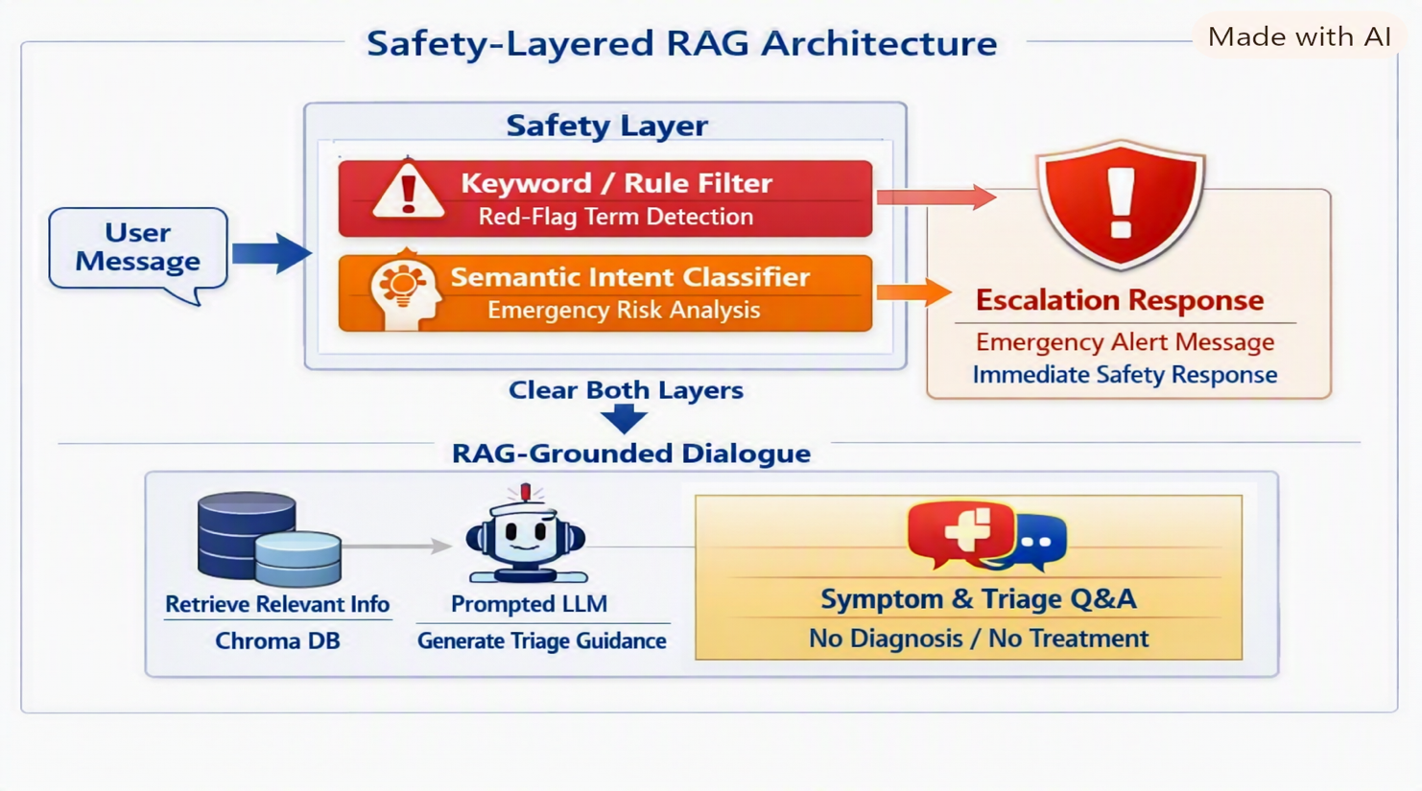
4. Implementation Components
Fig 1: Overviews of phase II
- Every message passes through 2 safety layers before retrieval occurs. Either layer detects risk or triggers a fixed escalation response
- A simple regex-based pattern matcher scans the message for red-flag terms to ensure the corpus has no ambiguous inference and zero false-negative red-flag language. The limitation of the keyword filter is that it will sometimes miss paraphrased or mislabelled emergency responses, which the semantic layers covered.
- The semantic layer detects emergency responses even when there are no red-flag keywords by using a locally hosted LLM prompt and chain-of-thought prompting to reason before classification can occur. Binary classification will result in emergency or safe responses
- If both layers are cleared, it sends a fixed safety message, which passes through a RAG-grounded design. The prompt restricts the agent to symptom-mapping and triage-category assignment via gold-standard mapping. It enforces 2 clarifying turns before assigning a triage category and requires 5 decision turns to prevent endless questioning.

5. Result

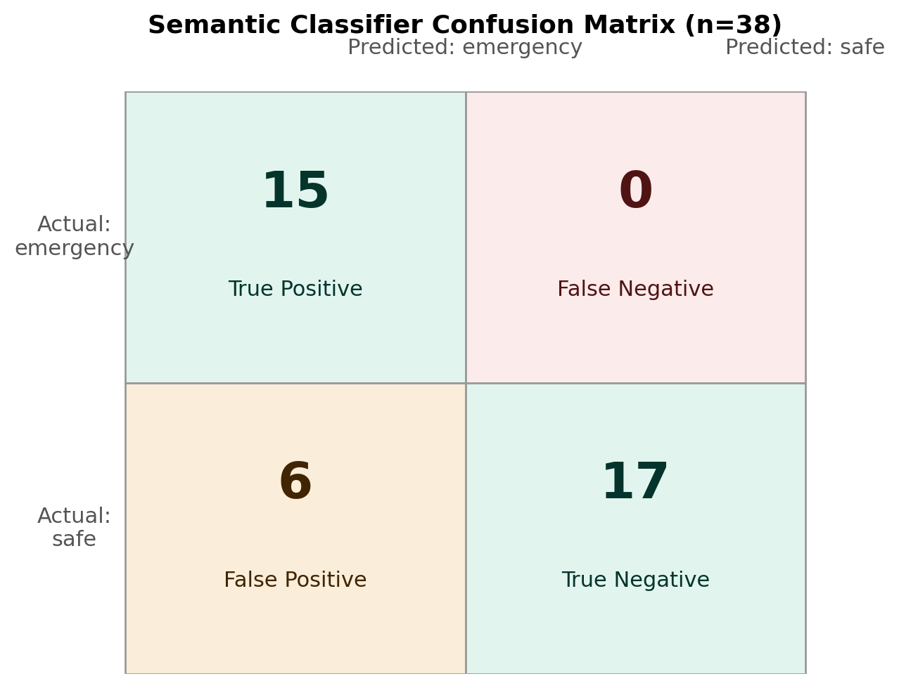

Fig 2: Confusion matrix

Out of 38 self-authorized text messages, 15 were genuine emergencies, and 23 were safe/routine. 15 real emergencies (top-left, 15 true positives) and missed zero (top-right, 0 false negatives). 17 of 23 safe messages but wrongly flagged 6 safe messages as emergencies

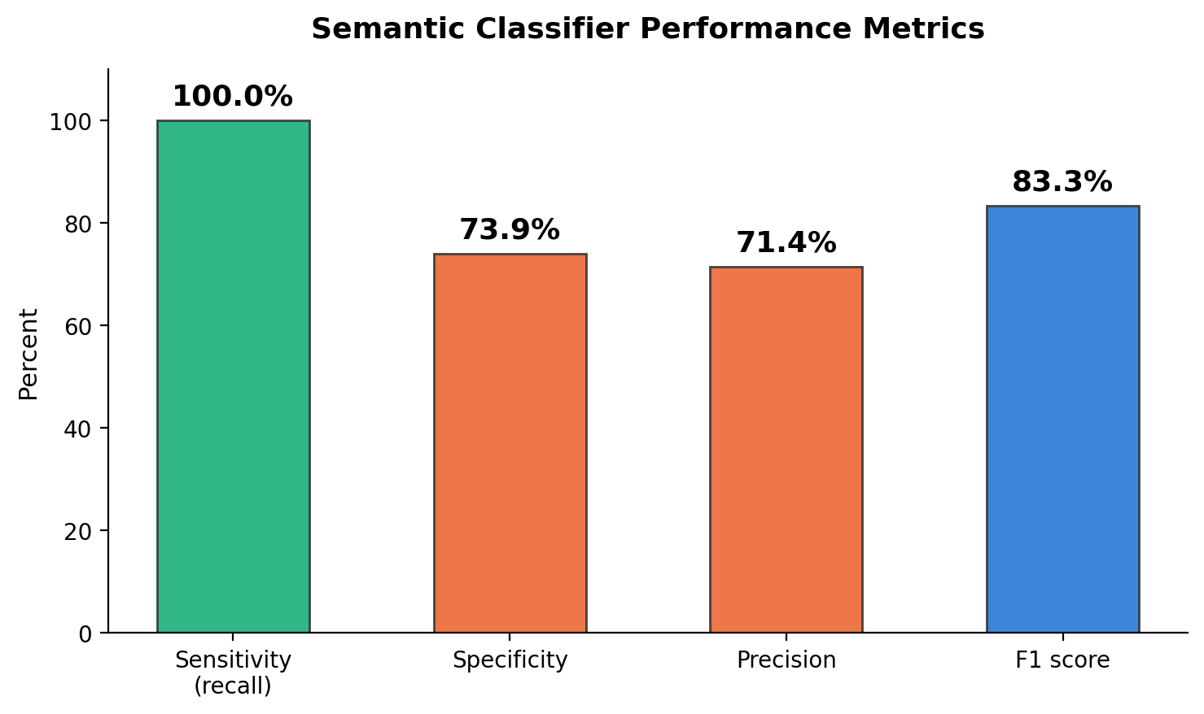

Fig 3:Classifier Performance

100% sensitivity predicted real emergencies; 73.9% specificity predicted 17 correct messages as safe; 71.4% precision that when it was labeled as an emergency, it was really an emergency case; and 83.3% F1 score.

This indicates that the semantic layer is a "when in doubt, flag it" system, not a precise one. It never lets a real emergency slip through in this test set, but it pays for that by over-flagging safe content about 1 in 4 times.

For a safety-critical triage layer, a false alarm costs a "please seek care" message someone didn't strictly need; a missed emergency costs much more.

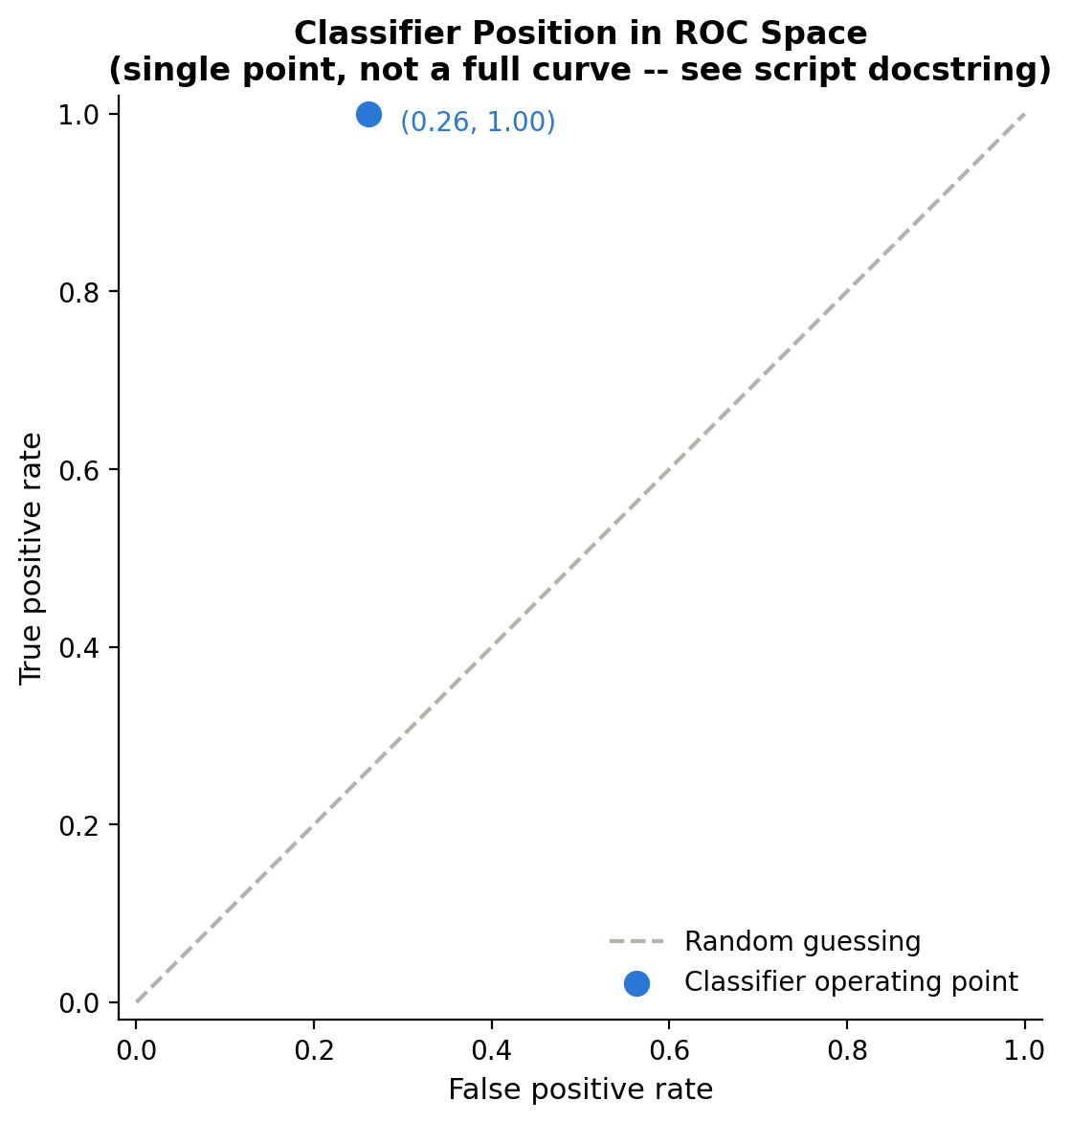
Fig 4: ROC curve

Evaluation Plan
Consistent with the reliability-checking discipline established in Phase I, this phase's evaluation is planned in two parts rather than accepting a single unverified metric.

5.1 Keyword layer
Tested against a hand-constructed set of positive cases and negative cases language, including deliberately tricky near-miss phrasing to establish a baseline false-negative and false-positive rate.

5.2 End-to-end escalation guarantee
Beyond accuracy metrics, the structural guarantee that an escalation genuinely bypasses retrieval and generation must be verified directly, as was done during development via mocked unit tests confirming zero calls to the retrieval and generation functions on the escalation path.
This structural test is then the accuracy metrics above, since it verifies the actual safety property the design is intended to provide.

5.3 Semantic classifier
Must be evaluated using the same agreement-checking method validated in Phase I with a sample of classifier decisions compared against independent human judgment, with the resulting agreement percentage reported alongside any accuracy claim.
Given Phase I's finding that a same-size model performed only marginally above chance on a structurally similar binary classification task, this phase's semantic classifier should not be assumed reliable by default.

5.4 Dialogue-management behaviour
The turn count should be evaluated qualitatively against a small set of multi-turn triage vignettes to confirm it produces reasonable-length conversations, neither assigning a category prematurely nor questioning indefinitely.
Reliability must be checked, not assumed. In Phase I, it was found that a 3B LLM judge agreed with human review only 55% of the time. The semantic intent classifier in this phase must be subjected to the same discipline; in Phase II, it built a confusion matrix and derived instead of just reporting one accuracy percentage.
Phase I's judge-reliability finding mattered precisely because a flat percentage hid the real problem — 55% agreement sounds mediocre but not alarming, until you realize it's barely above chance. Phase II's confusion matrix applies that lesson: 84.2% accuracy alone would hide that all 6 errors were the same type (false positives, the safer failure mode) and 0 were false negatives (missed emergencies). The ROC shows where the classifier sits with respect to random guessing, (Levine et al., 2023)

6. Limitations
- The semantic classifier's real-world reliability is not yet established; Section 5.3's validation step is a prerequisite for trusting it, not an optional follow-up.
- The keyword layer's term list, while sourced from the project's own corpus, is not exhaustive and will have false negatives on presentations that do not resemble the phrasing of its source documents; this is a known, accepted limitation of deterministic pattern matching, mitigated but not eliminated by the semantic layer.
- As with Phase I, all evaluation in this phase uses self-authored, non-clinician-reviewed test material; this limitation, already documented for the Phase I corpus, applies equally to any new test scenarios constructed for Phase II.

7. Deliverables
- Five implemented and unit-tested Python modules (Section 4) integrated into a working end-to-end pipeline.
- A keyword-layer test report (positive/negative case results).
- A semantic-classifier agreement report, following the Phase I check_judge_agreement.py methodology.

7.1. Conclusion
Phase I's benchmarking work identified qwen2.5 as the strongest model. Phase II Proposal, Section 2.2 explicitly builds the semantic classifier on that same

8. Exit Criteria
Phase II is considered complete when: (1) the keyword layer achieves a documented, near-zero false-negative rate on a red-flag test set stated in direct language; (2) the semantic classifier's agreement rate with human review has been measured and reported (3) the structural no-generation-on-escalation guarantee has been verified by test, not assumed; and (4) the full pipeline runs end-to-end against the Phase I corpus and model on the target hardware tier. These criteria intentionally do not require the semantic classifier to hit a specific accuracy target before Phase II can be considered complete.

Chapter 3
Phase III Protocol: Benchmarking and Evaluation
Local, Offline Conversational Triage and Symptom-Mapping Agent

1. Purpose
Phase III implements the benchmarking and evaluation protocol specified in the research proposal: standard factual-competency testing across three medical QA datasets with quantization-regression detection, and a purpose-built, synthetically-generated multi-turn triage vignette testbed with automated dual scoring
This document describes the built protocol and its design rationale first, before any run had been completed, so that the evaluation design could not be adjusted after seeing outcomes — reporting fabricated or placeholder numbers before a run was complete would defeat the evaluation-integrity standard maintained throughout this project. Section 5 below reports the results obtained once the full evaluation run was carried out.

2. Three Sources of Evidence
Per the protocol, evaluation combines two deliberately distinct sources of evidence, both designed to avoid human-subjects research consistent with this project's no-IRB design (see Phase III, In multi_benchmark_factual_eval.py).

2.1 Factual competency testing
multi_benchmark_factual_eval.py extends Phase I's single-dataset (MedQA-only) benchmark to three datasets: MedQA, MedMCQA, and MedXpertQA. Each dataset uses a different underlying field schema (e.g., MedQA's options list vs. MedMCQA's with four option fields with a numeric answers, so a normalization layer maps each into a common (question, options, correct_letter) format before scoring, reusing the letter-based grading approach validated in Phase I.
Beyond raw accuracy, this component checks for quantization-induced regressions: for each model, accuracy at every tested quantization level is compared against that model's own best-performing level, with drops beyond a 10-percentage-point threshold flagged for investigation.

2.2 Multi-turn triage vignette testbed
triage_vignette_generator.py generates vignettes via LLM-based case simulation, grounded in this project's own corpus documents (retrieved via the same RAG pipeline validated in Phase I). Every vignette receives a pre-established ground-truth label — expected acuity category and expected guardrail-trigger status — assigned at generation time, before any agent response exists, which is what makes rubric-based scoring possible downstream.

3. Vignette Testbed Design
The testbed spans three standard presentation types and three adversarial types, generated per corpus topic.
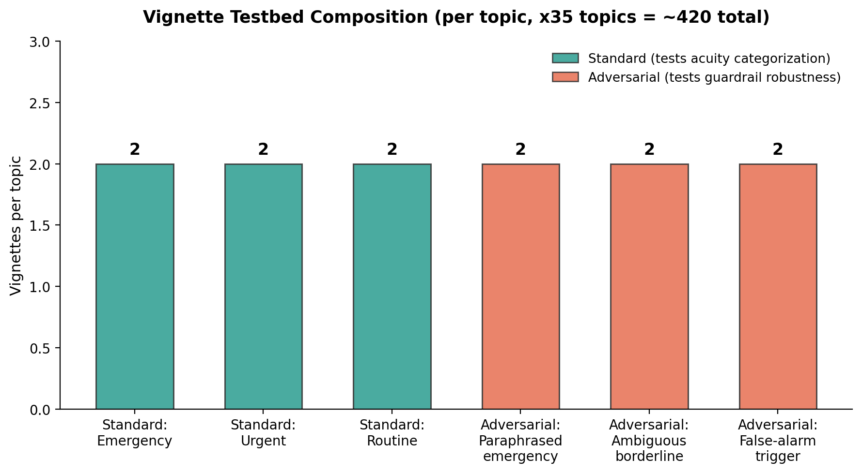
Fig 1: Vignette composition per topic. At default settings (2 vignettes per type) across all 35 corpus topics, this produces approximately 420 vignettes total.
Type | Purpose
Standard: emergency / urgent / routine | check whether the agent correctly sorts symptoms into the right bucket across the whole range. A system that only gets emergencies right but misclassifies routine cases as urgent (or vice versa) isn't actually working well, even if it never misses a real emergency.
Adversarial: paraphrased emergency | Tests the reason the dual-layer safety system exists at all. This test type generates exactly that kind of case — a real emergency in disguise — to see if the semantic layer is actually pulling its weight, or if it's just decoration. If agent fails these consistently, that's evidence the semantic layer isn't doing its job.
Adversarial: ambiguous borderline | Rather than pretending there's one correct answer and unfairly penalizing the agent either way, this vignette type is generated but excluded from strict scoring.
Adversarial: false-alarm trigger | Content that mentions emergency-adjacent topics without describing an actual current emergency (e.g., an educational or hypothetical framing). Tests for guardrail over-triggering, the counterpart failure mode to missed emergencies.

Table 1: 6 different types of test cases

4. Evaluation Pipeline and Dual Scoring
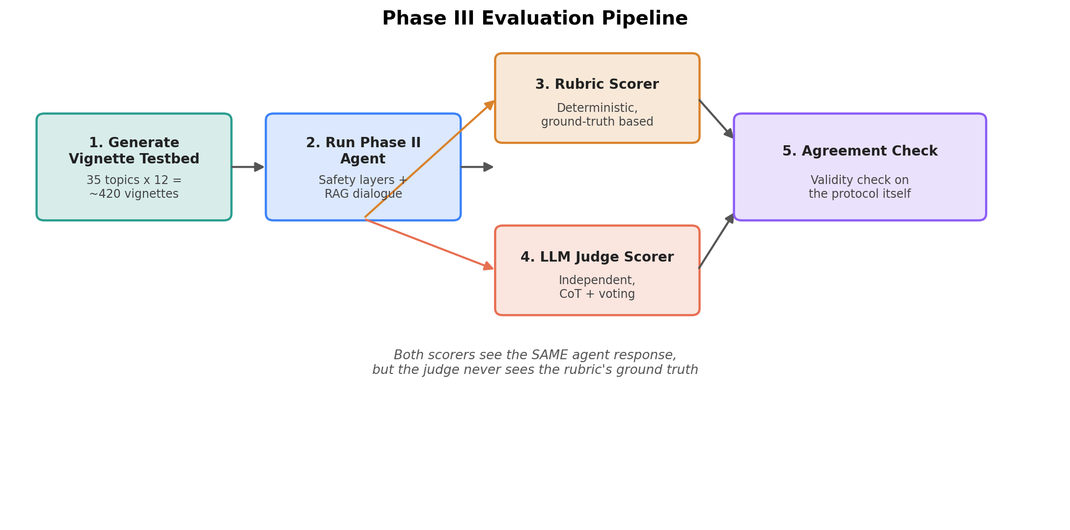
Fig 2: The five-stage pipeline. Every agent response is scored twice, independently, before the two scores are compared.
Stage 1 — Generate Vignette Testbed
420 synthetic patient statements carrying 12 vignettes (6 test cases x 2 vignettes per topic), each one carrying a pre-assigned "correct answer" (expected category, expected escalation) before anything else happens.
Stage 2 — Run Phase II Agent
Each of those 420 patient statements gets fed into the actual triage system — the full Phase II pipeline (keyword layer → semantic layer → RAG-grounded dialogue). This produces a real response for every vignette: either an escalation, or a clarifying question/triage category.
Stage 3 & 4 – Scores system
Every vignette's patient statement is run through the full Phase II agent (triage_agent.py), then scored by two independent methods:
- Rubric scorer (rubric_scorer.py): rule-based comparison of the agent's actual escalation behavior against the vignette's pre-established expected_guardrail_trigger. False negatives (missed expected escalations) and false positives are tracked separately
- Vignetted fake patient case) comes with a pre-written answer supposedly correct, so should this case trigger an alert? Triage agent processed the case and raised an alert
- Grading of false or true match. Two alerts were tracked, and they are :
• Missed alert — the case should have triggered an alert (like a real emergency), but the AI stayed quiet. This is the scary kind of mistake — a real problem got missed.

• False alarm — the case shouldn't have triggered an alert, but the AI raised one anyway. This is more annoying than dangerous — the system is being overly jumpy.
• The rubric scorer only checks whether an alert happened or not — it doesn't judge if the AI's actual answer was medically sensible or well-written.
- LLM-judge scorer (llm_judge_scorer.py): an independent local-model judge that evaluates whether the agent's response was clinically appropriate, using the same chain-of-thought-plus-majority-voting approach validated in Phase I's judge-reliability work

Agreement between the two scoring methods is then computed and reported under (phase3_evaluation_runner.py, compute_scoring_agreement), fulfilling the protocol's requirement that this agreement serve as "a validity check on the protocol itself." The two scores are compared to see whether they agree, which acts as a sanity check on the whole evaluation setup.

5. Results

Rule Base Scoring

In total, 210 vignettes; 175 vignettes were strictly scored; the agent failed to escalate 4 cases that should have been emergencies. The agent escalated 78 cases that shouldn't have triggered emergency handling. 93 test bed cases are correct, which gives 53.1% accuracy. Compare this to Phase II's standalone component tests: the semantic classifier alone had 4 false positives out of 38 (about 16%). This full-pipeline run is showing a false-positive rate roughly 2.7x higher than what we saw testing the semantic layer in isolation. Combining two layers with OR logic means either one's false positives count and triggering in each layer individually can compound into a much higher combined false-positive rate. (Kopka et al., 2024)

Independent LLM-judge scoring
An independent local model (qwen2.5, using chain-of-thought reasoning and 3-vote majority consensus) evaluated each of the 175 strictly-scored agent responses purely on clinical appropriateness, without ever seeing the vignette's pre-assigned ground-truth label — this independence is what makes it a genuine second opinion rather than just an echo of the rubric.
When compared against the rubric's verdicts, the two methods agreed on 110 cases and disagreed on 65 (62.9% agreement), and critically, that disagreement wasn't random noise: in roughly 53 of the 65 cases, the rubric had called something a false positive while the judge called the same response "appropriate" (Sengupta & Panda, 2026)

Last but not least, out of the 175 strictly scored vignettes (the 35 ambiguous ones are excluded, as designed), the agent's actual behavior matched the pre-assigned "correct answer" 93 times. 4 times, a vignette was labelled "this should escalate," and the agent didn't escalate. This is the number that matters most for safety. That gives accuracy 53.1%

Two error types made up the remaining 82 cases: 4 false negatives, where a vignette was labeled "this should escalate," and the agent failed to do so. 62.9% is the validity check against an independent scorer LLM judge, where 78 false positives occurred: a vignette was labeled "this should not escalate" but the agent escalated anyway, which accounts for the overwhelming majority of the accuracy loss. When the rubric's verdicts were compared against the independent judge's verdicts on the same 175 cases, the two methods agreed only 110 times and disagreed 65 times, an agreement rate of 62.9%.

In roughly 53 of the 65 disagreements, the rubric had labeled the agent's response a false positive while the judge independently called that same response "appropriate." Taken together, these results mean the raw 53.1% accuracy figure should not be reported as the system's true performance. The disagreement pattern suggests a meaningful share of the 78 false positives are mislabelled vignettes rather than genuine agent errors, meaning the agent's real precision is likely higher than 53.1% indicates.

This is precisely the outcome Phase III's dual-scoring protocol was designed to catch: without an independent validity check, a single unverified accuracy figure would have been reported as fact, when in reality the ground-truth labels themselves warrant review before either number can be trusted.

The next step is a manual audit of the flagged disagreement cases to determine how many reflect genuine agent errors versus vignette-generation mislabelling, after which a corrected accuracy figure can be reported with confidence.

6. Known Limitations
- Vignettes are LLM-generated and corpus-grounded, not drawn from real patient encounters or reviewed by a clinician
- MedXpertQA's field schema in multi_benchmark_factual_eval.py is assumed based on typical dataset structure and was not verified against live dataset access during development; this must be confirmed on first real run before results from this dataset are trusted.
- The LLM-judge scorer uses the same model family (qwen2.5) already shown in Phase I to have judge-reliability limitations at smaller scale; its agreement rate with the rubric is exactly the open question this protocol is designed to answer, not an assumption built into its design.

7. Next Steps
- Verify the MedXpertQA field schema against the actual dataset before trusting results from that component.
- Add incremental checkpoint protection to the agent-running and scoring stages, matching the protection already added to vignette generation.

Chapter 4
Phase IV: Implementation — False-Positive Clustering Analysis
Local, Offline Conversational Triage and Symptom-Mapping Agent

1. Introduction
The assessment of the binary dual-layer guardrail in Phase III against the 210-vignette synthetic testbed revealed a strict accuracy of 53.1% (93 out of 175 strictly scored vignettes), largely influenced by unnecessary escalations instead of missed emergencies: among the 82 incorrect instances, just 4 were false negatives—actual emergencies the agent did not escalate—whereas 78 were false positives, instances the agent escalated improperly. Independent LLM-judge evaluation in Phase III indicated that a significant portion of these 78 flagged instances might be due to vignette mislabeling instead of actual agent mistakes, yet that observation alone does not clarify where over-escalation is concentrated or the reasons behind it. This chapter directly tackles that question by breaking down the 78 false-positive cases into two categories—vignette type and ground-truth acuity label—to determine whether over-triggering is concentrated in the intentionally adversarial content the testbed aimed to stress-test or more widely spread across typical presentations.
2. Method
Each of the 78 false-positive vignettes was verified against two fields noted during vignette creation in Phase III: its type label — standard, which includes routine, urgent, and emergency presentations that the testbed was mainly intended to address; or adversarial, which encompasses the paraphrased-emergency and false-alarm-trigger variants specifically devised to assess the guardrail's limitations — and its ground-truth acuity label

3. Distribution of False Positives
Table 4.1 breaks the 78 false positives down by vignette type. Table 4.2 breaks the same 78 cases down by their recorded ground-truth acuity label.
Table 4.1: False positives by vignette type (n = 78)
Vignette type | Count | % of false positives
Standard (routine / urgent / emergency) | 52 | 66.7%
Adversarial (paraphrased-emergency / false-alarm) | 26 | 33.3%
Table 4.2: False positives by ground-truth acuity label (n = 78)
Ground-truth label | Count | % of false positives
Urgent | 35 | 44.9%
Routine | 17 | 21.8%
Adversarial-type (label carried by vignette type) | 26 | 33.3%
The dominant pattern in Table 4.1 is that two-thirds of all false positives occur on standard, non-adversarial vignettes — content the testbed was not specifically constructed to be difficult. This is the more consequential of the two distributions: it indicates that over-triggering is not confined to deliberately hard test cases, and that ordinary presentations are, in absolute terms, a larger source of false positives than the adversarial cases purpose-built to find them.
4. Two Explanatory Patterns
4.1 Over-Triggering Is Not Limited to Hostile Content
The level of false positives in typical vignettes (Table 4.1) provides insight into the guardrail's actual weaknesses. The types of adversarial vignettes were created based on the assumption that the guardrail's failure modes would focus on intentionally paraphrased or borderline wording; however, the data indicate that most instances of over-escalation occur with content the testbed easily generated. This implies that the semantic classifier's propensity to over-flag is a broad calibration feature — a tendency for the higher-acuity interpretation in cases of ambiguity

4.2 Label–Rule Contradictions in the “Urgent” Category
The inconsistency resides in the vignette’s true label, which classified the situation as “urgent” instead of “emergency.” This aligns with the mislabelling theory proposed by the analysis of judge-versus-rubric disagreements in Chapter 3, where 53 out of 65 discrepancies between rubric and judge involved the judge labeling a rubric-flagged false positive as "appropriate. Overall, this trend highlights a constraint in the binary escalate / do-not-escalate framework.
5. Conclusion
In total, 210 testbed cases was experimented, the vignettes of test bed cases were categorize into 6 groups, which are : standard: 52 (66.7%), adversarial: 26 (33.3%), breakdown by category/topic label: urgent: 35 (44.9%), adversarial: 26 (33.3%), routine: 17 (21.8%)

52 of 78 false positives (66.7%) are in STANDARD (non-adversarial, ordinary) vignettes. This is the more concerning pattern — it means over-triggering isn't confined to deliberately hard test cases; it's happening on ordinary content too. These standard vignettes are the single biggest source of false positives — bigger than routine and bigger than adversarial cases combined.

Vignette ground-truth labels contradict my own model-documented red-flag rules. The urgent category sits in an inherently hard middle zone: concerning-but-not-quite-emergency language is exactly what the model keyword and semantic layers are built to catch, so when an urgent vignette happens to contain real red-flag phrasing (chest pain, sunken fontanelle), the agent correctly escalates — and gets penalized for it, because the label said "urgent, not emergency. This means that some vignettes were mislabelled outright. The urgent category itself is structurally difficult to separate from emergency using a binary escalate/don't-escalate guardrail — a genuine design limitation, not a labelling bug, since real clinical language doesn't sort cleanly into "trigger the keyword/semantic layers" vs. "don't," even when the true acuity is "urgent" rather than "immediate emergency."

1. Limitation
- Vignette mislabelling (fixable: better prompts, manual review)

- Keyword and semantic layers need to output more than yes/no

- Three-tier output instead of binary classification needed: emergency (fixed response, same as now) / urgent (a different, less alarming message — "this should be seen soon, consider urgent care") / routine (continue normal dialogue)

2. Next Step
- Consider a three-way output (routine / urgent / emergency) instead of binary

- Manual audit of flagged disagreement cases

- Probably a severity score or category, not just a trigger flag implemented

Chapter 5 :

Phase V: Three-Tier Triage Classification — Design, Evaluation, and Reproducibility

1. Introduction

This chapter outlines the shift of the triage agent's safety layer from a binary escalate/do-not-escalate decision to a three-tier classification (routine, urgent, emergency), driven by the false-positive analysis presented in Phase 4.

It outlines the necessary architectural modifications for three tiers, the evaluation framework employed to assess the outcomes, the empirical results from the 210-case testbed, and two methodological issues identified during the evaluation — an implementation defect in the keyword layer and a reproducibility gap due to unresolved LLM sampling parameters — both of which impacted reported accuracy and are detailed here as findings.

2. Motivation: From Binary to Three-Tier Classification

The initial dual-layer safety system (Phase II) merged all triage results into a binary decision: escalate to a fixed emergency response, or proceed to RAG-grounded, constrained dialogue.

The false-positive analysis of Phase 4 on the 210-case testbed indicated that this binary framing merged two clinically separate scenarios — cases that truly could not be delayed, and cases that were alarming but did not necessitate urgent emergency treatment — into one 'escalate' category.

This chapter's effort reorganizes the two components of the safety system (the deterministic keyword component and the prompted semantic component) to produce one of three levels, and examines if that reorganization significantly enhances triage quality instead of presuming it does.

3. System Architecture Changes

3.1 Keyword Layer (Layer A)
The original keyword_redflag_layer.py used a single flat list of regex patterns (RED_FLAG_PATTERNS), sourced from the project's own corpus (redflag_symptoms_qa_50.txt and specific_presentations_qa_50.txt), all treated as equally indicating an emergency.
Restructuring this list into two tiers (EMERGENCY_PATTERNS, URGENT_PATTERNS) surfaced an important property of the original list: because it was authored entirely for a binary decision, nearly every pattern in it already represented an emergency-level concern by construction.
Only two patterns were reassigned to the urgent tier:
- Chest tightness — split from the original combined pattern chest (pain|pressure|tightness). The original implementation's own documentation had already flagged this pattern as a source of false positives on benign presentations (e.g., 'mild chest tightness after a big meal'); chest pain and chest pressure remain at the emergency tier.
- Knocked-out tooth — time-sensitive (optimal reimplantation window of approximately 30–60 minutes) but not immediately life-threatening, and therefore does not fit the emergency tier's definition despite its urgency.
A practical consequence arises directly from this discovery: the keyword layer offers very little independent identification of the urgent tier. In the existing pattern list, 'urgent' is predominantly attained via the semantic layer. Increasing the keyword layer's scope of truly urgent (non-emergency) terminology is recognized here as incomplete, rather than a goal achieved by this restructuring.

3.2 Semantic Layer (Layer B)

The semantic_intent_classifier.py was redesigned from a binary yes/no question ('does this indicate a possible medical emergency?') to a singular three-way query urging the model to categorize the message as routine, urgent, or emergency directly, with guidance to favor the higher-acuity interpretation when uncertain.

Two different two-stage designs, which break down the three-way decision into two binary choices, were also executed and evaluated; their outcomes and a notable confound in that evaluation are detailed in Section 5.5.

3.3 Orchestration Logic (dual_layer_safety.py)
The two layers are merged by adopting the higher-identification level of the two, substituting the initial Boolean OR logic.
This maintains the initial design principle — a favourable signal from one layer cannot be quietly overridden by the other — within the three-tier framework.
A noteworthy behavioral change is that the initial implementation could bypass the semantic layer whenever the keyword layer was activated, as either layer's activation resulted in the same binary outcome.
In the three-tier model, the semantic layer may only be bypassed if the keyword layer specifically outputs 'emergency' (the ceiling); however, if the keyword layer outputs 'urgent', the semantic layer must still engage, as it might elevate the overall outcome to 'emergency'.

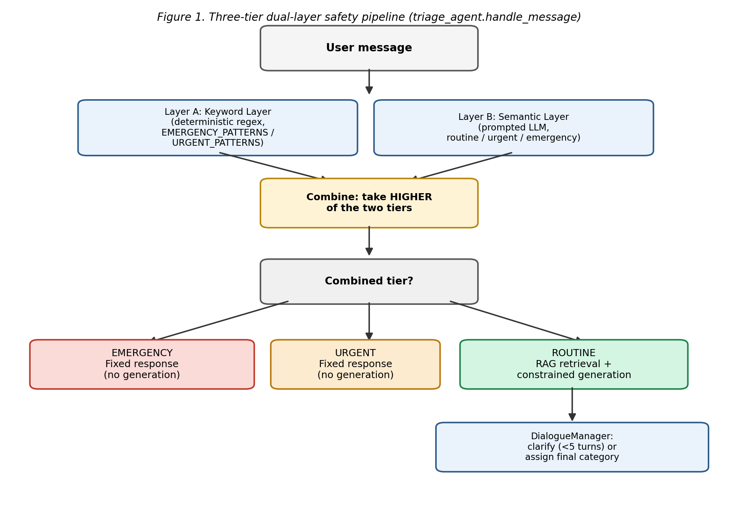

Figure 1. The three-tier dual-layer safety pipeline. Both layers are always consulted (except when the keyword layer alone already reaches 'emergency'); the combined tier is the higher of the two.

Every message from a user entering the system goes through a single entry node. The message is evaluated simultaneously by 2 independent layers: 1) regex-based matching, 2) a semantic layer. The regex-based matching layer checks keywords against emergency or urgent patterns from the corpus. Then, a tier is assigned based on keyword matches. The semantic layer captures implied emergencies that don’t use explicit red‑flag terms. The LLM classifies messages into routine, urgent, or emergency using chain-of-thought reasoning. Thirdly, both layers are then combined as one tie and select the high-risk tier and reason out user messages as routine, urgent, or emergency.
Tier | Action | Behavior
Emergency | Fixed escalation response | No generation or retrieval; sends predefined safety message
Urgent | Fixed escalation response | Same as emergency, but may include advisory text
Routine | RAG retrieval + constrained generation | Safe path: retrieves relevant info and engages in guided triage dialogue

Table 1: Tier classification

If the message is classified as routine, the dialogue manager will conduct clarifying questions of fewer than 5 turns . Final triage category is assigned after sufficient information is gathered.

This design combines deterministic precision with semantic understanding, allowing nuanced responses and escalating emergency signals.

4. Evaluation Framework
Three characteristics of the evaluation task prompted a metric that goes beyond simple accuracy: the levels are ordinal (routine < urgent < emergency), the costs of errors are asymmetric (under-triage is significantly worse than over-triage), and the safety-critical result — a missed emergency — required separate reporting instead of being averaged into a composite score.
- Matrix of confusion along with precision, recall, and F1 score for each class, including both macro and weighted averages.

- Quadratic Weighted Kappa: an ordinal agreement metric. Because the tiers are in a specific order (routine → urgent → emergency), it penalizes a two-step error (emergency labelled as routine) more severely than a one-step error (emergency labelled as urgent). It's an intelligent accuracy measure that recognizes the levels aren't merely arbitrary classifications — they're a hierarchy.

- Matrix of expenses indicating "the severity of each specific type of error, in points." For instance: labeling a regular case as "urgent" could result in losing 1 point (irritating, yet secure). Labeling a genuine emergency as "routine" could result in a loss of 10 points (hazardous). It transforms "how effective is the system" into "how much actual risk is the system generating

- Missed Emergency Rate measure out of all actual emergencies, what proportion did the system fail to accurately identify as an emergency

Ground truth for the 210-case testbed was constructed in two stages. First, an AI-assisted draft pass proposed a tier and confidence level (high/medium/low) for each of the 210 vignettes, with rationale recorded for audit.
94 of the 210 cases were flagged for priority human review: 92 cases where the draft tier disagreed with the existing binary system's escalation decision, and 11 low-confidence drafts (9 of which overlapped with the disagreement group, hence 92 + 11 − 9 = 94 unique cases).
This draft-and-review workflow is reported here as a time-saving mechanism for the human reviewer, not a substitute for clinical review; the draft labels should not be treated as validated ground truth until reviewed.
Note on dataset identity: this 210-case testbed is distinct from the 210-vignette rubric-scored testbed reported in Phase III (Section 5) and the false-positive clustering analysis in Phase IV, which used an LLM-generated vignette set drawn from triage_vignette_generator.py. The testbed evaluated in this chapter instead uses real patient-statement text captured from the deployed agent's own interaction log (phase3_agent_progress.json). Both testbeds happen to contain 210 cases; this is coincidental, not a reuse of the same dataset, and the two should not be conflated when comparing accuracy figures across phases.

5. Results

5.1 Three-Tier Evaluation

Confusion Matrix
True \ Predicted | Routine | Urgent | Emergency
Routine (34 actual) | 19 | 15 | 0
Urgent (93 actual) | 4 | 82 | 7
Emergency (83 actual) | 0 | 27 | 56

Table1: Confusion Matrix of overall

Per-Class Performance
Tier | Precision | Recall | F1-score | Cases (support)
Routine | 0.826 | 0.559 | 0.667 | 34
Urgent | 0.661 | 0.882 | 0.756 | 93
Emergency | 0.889 | 0.675 | 0.767 | 83
Macro avg | 0.792 | 0.705 | 0.730 | 210
Weighted avg | 0.778 | 0.748 | 0.746 | 210

Table 2: Per-class performance

Overall Summary
Metric | Value
Overall accuracy | 0.748 (74.8%)
Macro F1 | 0.730
Weighted F1 | 0.746
Quadratic Weighted Kappa | 0.712
Missed-Emergency Rate | 0.325 (27 of 83)
Mean cost per case | 0.805
Total cost | 169.0

Table 3: Overall summary

5.4 Two-Stage Binary Classification
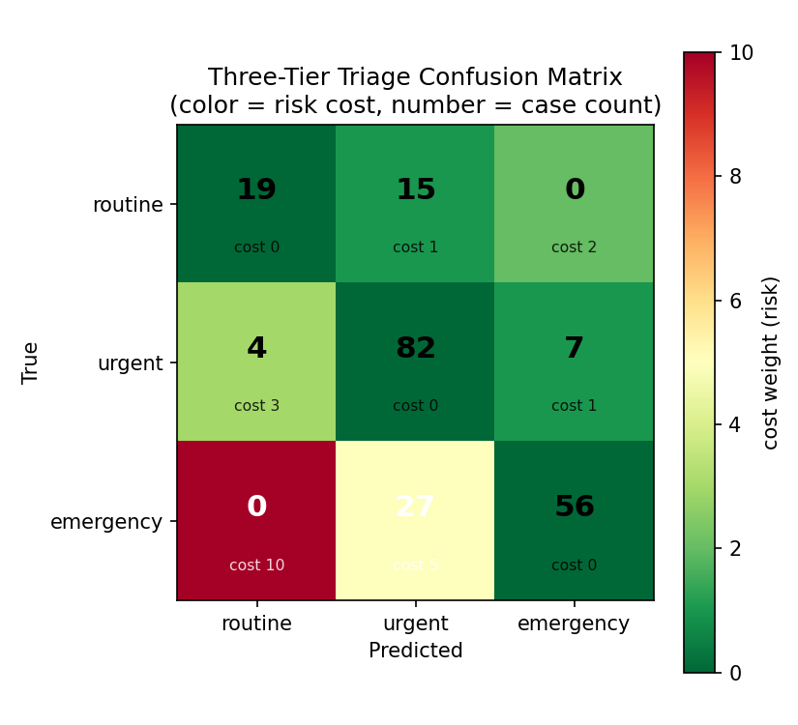
Figure 2. Confusion matrix for cost-matrix risk weight of each cell, not raw count, so the diagonal (correct predictions) is always green regardless of how often it occurs.

Dark green means a correct answer or a harmless mistake; red would mean the worst possible failure (a true emergency wrongly called routine, which happened zero times here), and the pale yellow "27" is the main concern: 27 real emergencies got misclassified as "urgent".

This pattern has a specific safety implication worth stating plainly. The missed-emergency rate of 32.5% (27 of 83 true emergencies) is the number this system's safety claims must be measured against. Friedman et al., 2021)

6. Discussion

The evaluation results point to a single dominant pattern rather than random misclassification: 42 of the 46 total errors (91%) resulted in the system predicting "urgent" — 15 routine cases pushed up into routine and 27 emergency cases pulled down into urgent. This is not evenly distributed error; it is the system converging on the middle tier from both directions whenever it is uncertain, rather than confidently resolving the harder judgment toward either the lower or higher tier.

The confusion matrix shows that none of these 27 missed emergencies were downgraded all the way to "urgent," which still triggers a fixed, immediate-attention response rather than being silently treated as safe.

The confusion matrix shows what the system predicted versus what each case actually was: it correctly identified 19 of 34 routine cases, 82 of 93 urgent cases, and 56 of 83 emergency cases, with most of its mistakes — 42 out of 46 total errors — landing on "urgent" from both directions (15 routine cases and 27 emergency cases got mislabelled as urgent), meaning the system tends to default to the middle tier when it's unsure rather than confidently picking the tier that's actually correct. 91% of all its mistakes end up calling something "urgent," whether the case was actually mild (routine) or actually serious (emergency). It's like the system uses "urgent" as its go-to guess whenever it's not sure.

Out of 83 real emergency cases in the test, the system correctly caught 56 of them. That leaves 27 it got wrong—about 1 in 3 emergencies. All 27 of those missed emergencies were still labeled "urgent." 0 were labeled "routine." This is dangerous generally.( (Sax et al., 2023)

7. Limitations
- Ground truth for the 210-case testbed is currently an AI-assisted draft, reviewed but not independently validated by a clinician; figures in this chapter should be treated as provisional pending that validation.
- The comparison between the two two-stage prompt variants (Section 5.4) is confounded by an unresolved file-version verification gap and should be re-run with explicit before/after verification before being reported as two independent results.
- All results in this chapter are single-turn evaluations (one message, one classification) using a fresh dialogue state per vignette; they do not evaluate the multi-turn clarifying-question behavior that the full conversational agent exhibits in deployment.

This chapter restructured the dual-layer safety system from binary escalate/do-not-escalate classification to a three-tier framework (routine, urgent, emergency), and evaluated the result against a metric suite chosen for the task's ordinal structure and asymmetric error costs — confusion matrix analysis, per-class precision/recall/F1, and a cost-weighted score alongside overall accuracy. On the 210-case testbed, the system achieved 74.8% overall accuracy with a missed-emergency rate of 32.5% (27 of 83 true emergencies).

The central finding is that the system's errors are not randomly distributed: 91% of all misclassifications (42 of 46) resulted in an "urgent" prediction, regardless of whether the true tier was routine or emergency, indicating that the system defaults toward the middle tier under uncertainty rather than confidently resolving borderline cases in either direction. This pattern has a meaningful safety implication — none of the 27 missed emergencies were downgraded as far as "routine," meaning the system's failures consistently produced the second-worst outcome rather than the worst possible one — but a one-in-three miss rate on true emergencies remains a substantial gap for a safety-critical classifier regardless of that partial mitigation. The same underlying tendency toward caution also accounts for the system's weakest result, routine-tier recall (0.559), where genuinely mild cases are frequently over-classified as urgent.

This chapter concludes that the trade-off between under-triage risk and over-triage frequency exhibited by the current system is a real and measurable one, but not one the evaluation metrics alone can resolve — whether the current balance (fewer complete emergency misses, at the cost of frequent unnecessary urgent-tier escalations on mild cases) is acceptable is a judgment for clinical stakeholders, not a conclusion the accuracy figures can dictate on their own.

Chapter 6

Phase VI: Borderline-Case Detection and Iterative Tuning of the Semantic Safety Layer

1. Introduction
The preceding evaluation chapter identified a single dominant error pattern in the three-tier classification system: 91% of all misclassifications resulted in an 'urgent' prediction, and every one of those errors was traceable to the semantic layer acting alone, with no deterministic keyword signal to check it against.
This chapter documents the iterative tuning history that led to that finding being addressed directly, by establishing a reproducible baseline, and then by adding a detection helper that identifies exactly this failure-prone case and routes it through a targeted clarifying question instead of a single-shot model guess.

2. Single Three-Way Call (Baseline)
The original semantic layer prompt asked the model to choose directly among routine, urgent, and emergency in one call, with an instruction to prefer the higher-acuity tier under uncertainty. This produced the corrected baseline of 74.8-78.1% accuracy (see the evaluation chapter for the run-to-run variance underlying that range) and the finding that 'urgent' functions as an uncontested default whenever the model is unsure, regardless of which true tier the case actually belongs to.

2.1 Sampling Reproducibility Fix
Independent of the prompt-design experiments, it was discovered that the semantic layer's ollama.chat() calls specified no temperature or seed, causing accuracy to vary by as much as nine percentage points between runs of identical code. A fix (temperature=0.1, fixed seed=42) was applied and verified to be correctly wired into the actual API call, not merely declared as an unused constant. This fix is a prerequisite for the work in this chapter: without it, any accuracy change attributed to the detection helper introduced below could not be distinguished from ordinary sampling noise.

3. The Borderline-Urgent Detection Helper
is_borderline_urgent() is a new function added to dual_layer_safety.py that identifies the specific case shown to be responsible for the large majority of remaining classification error: a combined tier of 'urgent' that came entirely from the semantic layer's judgment, with the keyword layer having found no pattern match at all
This is a narrower condition than 'the combined tier is urgent.' A case where the keyword layer itself matched an urgent-tier pattern (for example, the chest-tightness pattern) is not considered borderline by this function.
The function isolates precisely the cases where the tier rests on a single, unverified model judgment, which is the exact condition the evaluation chapter's error-attribution analysis identified as the source of 91% of remaining error.

4. Severity and Duration Clarification Flow
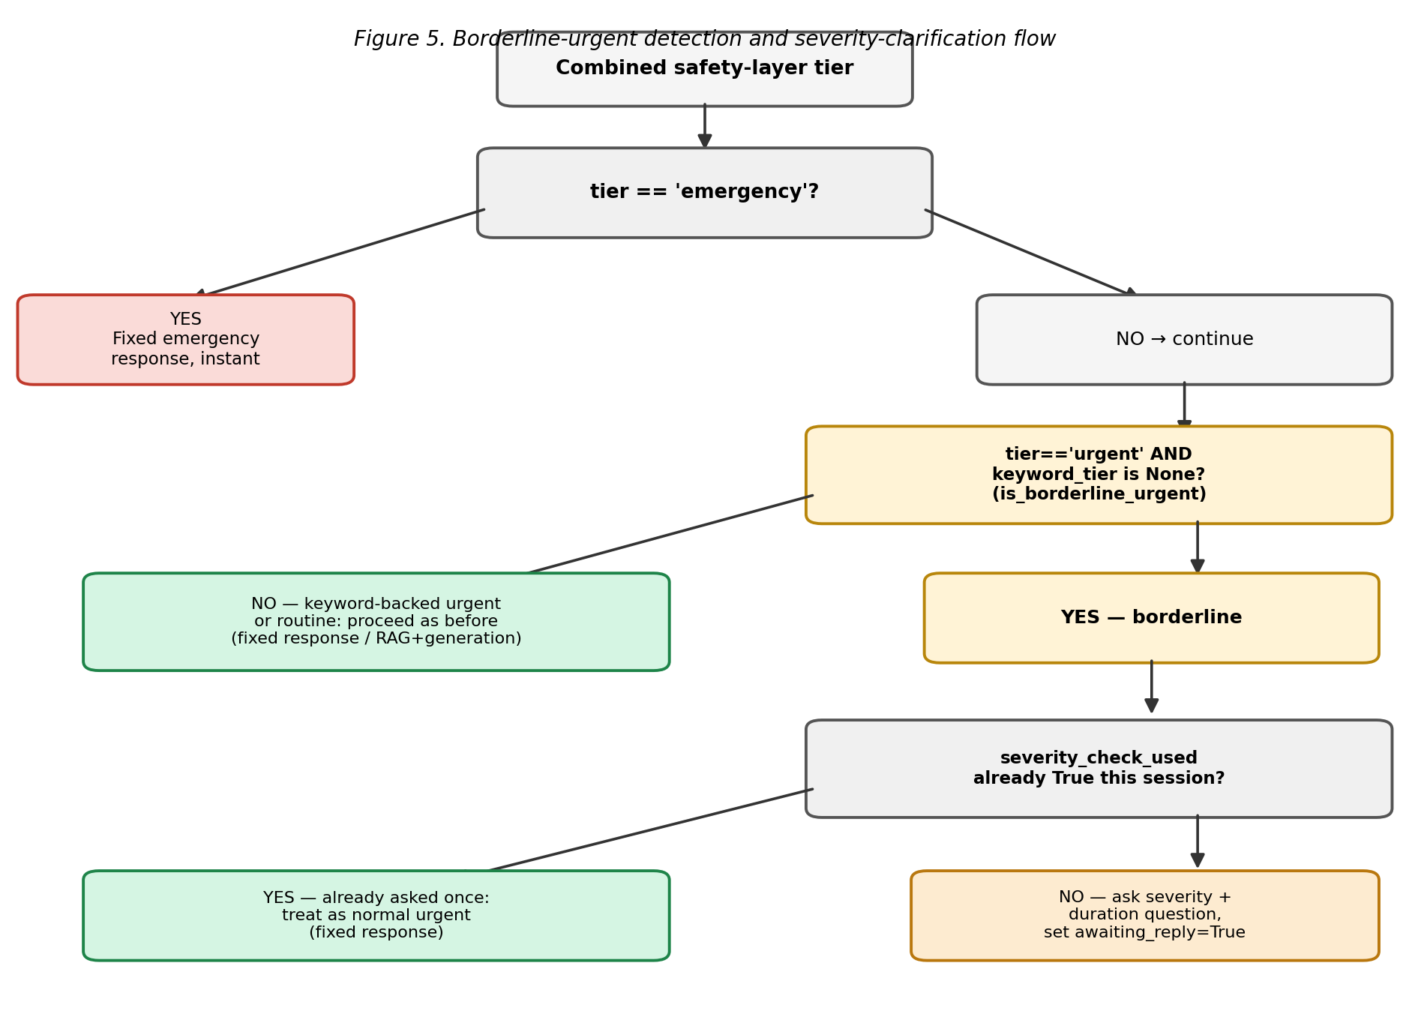
triage_agent.py's ,Dialogue Manager and handle_message() were extended so that a borderline-urgent case, on its first occurrence in a session, triggers one combined clarifying question — asking the person to describe severity (mild/moderate / severe) and duration — rather than committing immediately to the semantic layer's single-shot guess. Figure 1 shows the full decision flow.

Figure 1. The borderline-urgent detection and severity-clarification decision flow, implemented in triage_agent.handle_message().

The combined layer containing the semantic and keyword layers. Fixed emergency response, shown instantly. No delay, no extra questions — the highest-stakes cases always get the fastest, most direct response. Otherwise, flow the flow downstream.

Is the tier "urgent," and did the keyword layer find nothing (no deterministic pattern match)? If the clarification is no (either it's routine, or it's urgent because of an actual keyword match like "chest tightness"), proceed exactly as the system always did — fixed response for urgent, or the RAG+generation flow for routine. If it is yes, the only evidence for "urgent" is the AI's own gues

Third check contains the safety valve against annoying the user. If the question is yes, treat the clarification as a normal urgent case and give the fixed response. Don't ask again. If the question replies no, ask the person one combined question: "How severe is this, and how long has it been going on?" Then wait for their answer

4.1 Design Constraints

Emergency is never postponed. The verification for tier == 'emergency' occurs first and always bypasses immediately, introducing delay only to the tier where additional latency is least detrimental, never to the tier where speed is most critical.
- Urgent cases supported by keywords remain unchanged. Only urgent results based solely on semantics prompt the inquiry; a deterministic pattern match isn't enhanced by a clarifying question.

- The explanation is limited to only one use per session (severity_check_used), stopping an individual with several ambiguous concerns in a single dialogue from facing the same inquiry multiple times.

- Clarifying response can elevate the level to emergency if it uncovers something overlooked initially, or downgrade it to routine if it shows the case is truly mild — the reclassification represents an authentic second assessment, not just an endorsement of the first.

6. Result
============================================================
THREE-TIER TRIAGE EVALUATION (n=210)
============================================================

--- Confusion Matrix (rows=true, cols=predicted) ---
pred_routine pred_urgent pred_emergency
true_routine 34 0 0
true_urgent 6 80 7
true_emergency 0 5 78

--- Per-Class Precision / Recall / F1 ---
precision recall f1-score support
routine 0.850 1.000 0.919 34.0
urgent 0.941 0.860 0.899 93.0
emergency 0.918 0.940 0.929 83.0
macro avg 0.903 0.933 0.915 210.0
weighted avg 0.917 0.914 0.914 210.0

Overall accuracy: 0.914
Macro F1: 0.915
Weighted F1: 0.914

Quadratic Weighted Kappa: 0.919
Accuracy went from 74.8% (the real baseline) to 91.4% here, and the missed-emergency rate dropped from 32.5% to 6.0% (5 of 83). Routine recall is now a perfect 100% (34/34), and emergency recall. This means that for the 124 cases encountering the borderline question, the system received a fabricated answer derived from the actual label (for instance, if the genuine answer was "emergency," the synthetic response stated "severe and rapidly worsening").

This number addresses the question: "if an individual consistently provides a completely clear and precise response to the severity inquiry, how effective could this system be?"

Real users won't always describe their symptoms this clearly or accurately. Someone might say "it's fine, just a little sore" when it's actually serious, or "it's really bad" when it's genuinely mild. This test doesn't measure that — it only proves the mechanism works when given good information, not how often real people will provide good information.

In conclusion, the clarification approach is architecturally sound — asking for severity/duration and re-classifying based on the answer can, in principle, resolve most of the ambiguity that was causing errors.
7. Discussion
The ceiling result in Section 6 — 91.4% accuracy and a 6.0% missed-emergency rate, up from the 74.8% baseline and 32.5% missed-emergency rate reported in the evaluation chapter — demonstrates that the clarification mechanism is capable of resolving the large majority of the semantic layer's miscalibration when the follow-up answer clearly and accurately reflects the case's true severity.

The 91.4% figure should therefore be read as a statement about the mechanism's architectural soundness — that asking a targeted follow-up question and re-running the full safety check on the combined message is, in principle, sufficient to resolve most of the ambiguity identified in the evaluation chapter — rather than a claim about deployed accuracy.

This is a big jump in absolute terms, but it needs to be read as a ceiling, not a deployment figure -- for the 124 of 210 cases that hit the borderline question, the system was given a synthetic answer generated FROM the true label itself, worded to clearly and accurately reflect the case's real severity.

Real users will not always describe symptoms this clearly or accurately, so the gap between this ceiling and any real-world figure is governed by something this chapter has not measured: how clearly and accurately actual users answer the severity/duration question in practice.

This finding must also be read alongside Section 3's scope finding: the clarification path was triggered for 124 of 210 cases (59%) in this run, not a small, error-specific subset, because the keyword layer's urgent-tier patterns did not match any vignette in the testbed. The ceiling result confirms the mechanism works well when triggered, but does not by itself justify triggering it this often -- a majority-of-cases intervention carries a latency cost this chapter has not evaluated, and the same accuracy ceiling might be achievable with a narrower trigger condition if the semantic layer's own confidence could be assessed at decision time, rather than treating every semantic-only urgent case as equally uncertain. That refinement is identified here as future work, not resolved by this chapter's results.

Taken together with the tuning history in Section 2, this chapter's central methodological conclusion is that a narrowly-targeted, evidence-driven intervention -- one grounded directly in the prior chapter's error-attribution finding -- succeeded where broader prompt restructuring attempts did not, but that success is currently demonstrated only under idealized input conditions, and the path from this ceiling to a defensible real-world accuracy figure still requires either genuine human-authored answers or a live-conversation evaluation, neither of which has yet been carried out.

8. Chapter Summary

This chapter documented the tuning history of the semantic safety layer -- a reverted two-stage prompt restructuring, a sampling-reproducibility fix that was a prerequisite for any of this work being measurable at all, and a new detection helper (is_borderline_urgent()) that identifies the specific case shown to be responsible for 91% of remaining classification error: an urgent tier resting entirely on the semantic layer's judgment, with no keyword-layer signal to check it against. Implementation revealed that this condition is substantially more common than the error rate alone would suggest -- 124 of 210 cases (59%) -- because the keyword layer's urgent-tier patterns did not match any vignette in the testbed, leaving the semantic layer as the sole source of every urgent-tier decision. The resulting severity-and-duration clarification flow was implemented and verified against six scenarios, confirming that emergency cases remain unaffected, keyword-backed urgent cases are correctly excluded, the clarification is capped at one use per session, and a clarifying answer can genuinely shift the outcome in either direction -- including escalating to emergency when warranted. A ceiling-estimate evaluation, using synthetic follow-up answers generated from each case's true tier, showed accuracy rising from 74.8% to 91.4% and the missed-emergency rate falling from 32.5% to 6.0% when the clarification mechanism is given clear, accurate information to work with. This result should be reported as exactly what it is: evidence that the mechanism is architecturally capable of resolving the error pattern identified in the evaluation chapter, not a measurement of real-world performance.

Chapter 7
Phase VII: Graphical User Interface — Design, Implementation, and Reproducibility
Local, Offline Conversational Triage and Symptom-Mapping Agent

1. Purpose

Phases I to VI developed and assessed the inference pipeline, safety structure, and evaluation methods of the triage agent, yet each earlier phase tested the system using scripts, notebooks, or command-line tools

Phase VII introduces a web-based chat interface, allowing the same pipeline — dual-layer safety, tiered dialogue management, and RAG-based generation — to be used directly by an individual and monitored in real time, instead of being accessible solely through logs and offline assessment documents.

2. Architecture Overview

The interface is powered by a FastAPI backend (app.py) that provides three endpoints — POST /chat, POST /reset, and GET /health — along with a static file mount serving the frontend (index.html, style.css, script.js).

Every browser session is linked to a Universally Unique Identifier,UUID and a corresponding DialogueManager instance from triage_agent.py, which is stored in memory. This implies that the turn-by-turn dialogue state (clarifying-question count, conversation history) remains per session just like it would in a CLI execution of the same agent — the API layer retains state, it does not create it. (DialogManagerConfiguration interface, 2023)Each POST /chat request is processed by handle_message(), which executes the entire Phase II–VI pipeline: keyword layer, semantic layer, three-tier combination, borderline-urgent clarification. CORS is limited to localhost sources only.

The deployment target stays as one machine, aligned with the offline structure set in Phase I, and the docstring in app.py clearly states that this setup must not be modified for any deployment accessible via a network.

3 Implementation Components
File | Role
app.py | FastAPI backend. Session management; calls handle_message() from triage_agent.py; optional pass-through fields for classifier confidence and per-layer trigger state.
static/index.html | Page structure: sidebar status panel, centered message column, composer, voice-input controls.
static/style.css | Visual design system — color tokens, tier-to-color mapping, layout rules.
static/script.js | Client-side session handling, message rendering, health polling, speech-recognition integration.

4. Voice Input and the Offline-Architecture Exception

A speech-to-text input feature was included using the browser’s Speech Recognition API, featuring a manual language switch (English / Chinese) displayed next to the microphone control

The toggle is manual because the API lacks dependable single-utterance language auto-detection: a recognition session must begin with a chosen language, and the language cannot be changed mid-utterance without terminating and restarting recognition.

This feature requires a clear and significant restriction to be expressed clearly: unlikeevery other element discussed in Phases I to VI, voice input does not operate on-device.

Browser implementations of SpeechRecognition, including the one utilized here, send recorded audio to a cloud speech-recognition service for conversion to text. (Convert speech to text with the SpeechRecognition API, 2024)

The typed input and the triage pipeline are entirely local; the only aspect that relies on network access to an external service is the optional voice-transcription step. The transcribed text is consistently placed in the visible input field for the individual to check or modify prior to submission.

5. Next Steps
- Extend dual_layer_safety.py's return value to surface which sub-layer produced a given tier, so the interface's keyword/semantic indicators can move from "unknown" to a real, verified state.
- Extend the semantic classifier or orchestrator to expose a confidence value for display.

Chapter 8

Thesis-Wide Conclusion
Local, Offline Conversational Triage and Symptom-Mapping Agent

8.1 Summary of Findings by Research Question
RQ1 — Reduction of missed emergencies with hybrid guardrails. The dual-layer (keyword and semantic) guardrail was introduced in Phase II, stress-tested in Phase III, reorganized in Phase V, and enhanced in Phase VI.

The path through these stages serves as the clearest proof in this thesis: the early binary OR-combined guardrail resulted in a significant false-positive rate (53.1% accuracy, Phase III) when both layers were executed simultaneously rather than separately.

Reconceptualizing the guardrail as a three-level, ordinal classification (Phase V) raised overall accuracy to 74.8% yet resulted in a significant missed-emergency rate of 32.5%. Identifying that residual error (Phase VI) linked it to a specific, clearly defined condition—urgent-tier cases determined solely by the semantic layer without any supporting keyword signal. The resulting borderline-case clarification system, assessed using a ceiling-estimate protocol, increased accuracy to 91.4% and reduced the missed-emergency rate to 6.0%.

In summary, RQ1 is answered affirmatively with conditions: a hybrid guardrail can significantly lower missed-emergency risk, but this is only achieved when its primary failure mode is clearly recognized and addressed — it cannot achieve near-zero missed emergencies through architecture alone, and the 91.4%/6.0% statistics reflect a proven limit under synthetic conditions, not confirmed real-world outcomes.

RQ2 — Dependability of RAG grounding and retrieval. Phase I demonstrated that retrieval quality reliability could not be assured with an LLM judge (55% human agreement, only slightly above chance) and created a gold-standard evaluation focused on source-document matching, which indicated a 97.5% retrieval hit rate under production chunking configurations. This outcome directly addresses the reliability aspect of RQ2: retrieval quality can be assessed accurately once the evaluation approach is confirmed, and with that validated approach, the RAG pipeline operates effectively.

Nonetheless, this thesis did not directly assess if RAG grounding enhances the clinical quality of the generated responses — in contrast to simply retrieving the correct document — as indicated by Phase I's conclusion, which highlights this issue as unresolved due to the corpus being self-created and unlicensed instead of sourced from reliable clinical guidelines. RQ2 is thus only partially addressed: while retrieval accuracy is robust and consistently assessed, the quality of subsequent generation linked to that retrieval, based on clinically valid source material, is still a question for future investigation.

RQ3 — Quantization and hardware feasibility. Phase I's benchmarking answers RQ3 concretely for the single hardware tier actually tested (Apple M3, 8GB unified memory): three model families ran successfully at 2B-3B parameters under Q4_K_M/Q5_K_M quantization, with qwen2.5 the strongest performer (up to 70% on a small MedQA sample) and comparable to unquantized 7B models in the literature despite materially tighter resource constraints. The 9B Gemma2 default caused a full system freeze at this memory tier — itself a substantive, reported feasibility ceiling rather than a discarded error. The second hardware tier specified in the original protocol (a discrete-GPU workstation) was not benchmarked in the reported results, so RQ3 is answered fully for the laptop-CPU tier and remains open for the higher-resource tier.

8.2 Cross-Phase Synthesis

The most significant contribution of this thesis is methodological instead of just architectural: at every step where an automated assessment method might have been accepted without scrutiny, it was instead validated against an independent or authoritative benchmark, and these validations consistently revealed shortcomings in the original method — the Phase I evaluator (55% agreement), the Phase III disparity between rubric and evaluator (62.9% agreement, primarily in false-positive instances), and the Phase VI reproducibility gap in sampling.

Each time, the answer was to create a more thorough alternative (gold-standard retrieval scoring, confusion matrix and ordinal metrics, the borderline-case detector) instead of reporting the original, more favorable number.

This discipline enables the headline outcomes of subsequent phases to be regarded as more trustworthy than those of initial ones, and it serves as the common thread linking all seven phases.

The architectural storyline remains steady: Phase II's binary guardrail was proven inadequate by Phase III's stress test; Phase IV's clustering analysis clarified the reasons; Phase V's three-tier redesign tackled the clustering issue but revealed a new, more precise failure mode; and Phase VI resolved that particular gap. Phase VII subsequently enabled the resulting pipeline to be utilized from start to finish, while clearly documenting the single location (cloud-based voice transcription) where the offline-architecture assurance is not applicable.

8.3 Limitations Across the Thesis
Several limitations recur across phases rather than being confined to one:

Corpus provenance. The retrieval corpus (35 topics, ~1,710 Q&A pairs) is self-authored rather than drawn from licensed, authoritative clinical guidelines. Phase I flags this as an open action item before Phase III results can be considered fully valid, and it remains unresolved at the close of the thesis.

Test-material independence. Vignettes and test queries used for evaluation in Phases I, III, and V were largely self-authored and not independently reviewed by a clinician, which limits how far accuracy figures can generalize to real patient language.

Sample size. Factual-competency benchmarking in Phase I used a 10-question-per-configuration sample; Phase I's own conclusion calls for this to be re-run at larger scale before the resulting accuracy figures are treated as statistically stable.

Ceiling vs. real-world estimates. Phase VI's headline improvement (91.4% accuracy, 6.0% missed-emergency rate) was obtained using synthetic follow-up answers generated from each case's known true tier, and is explicitly reported as a demonstration of architectural capability rather than a measurement of real-world performance.

8.4 Overall Conclusion

Across seven phases, this project builds, stress-tests, and iteratively repairs an offline triage guardrail architecture, treating its own evaluation infrastructure as something to be verified rather than assumed.

The evidence supports a qualified but well-substantiated claim: a hybrid symbolic-plus-semantic safety layer, refined against its own diagnosed failure modes, can move an offline, edge-deployable triage agent from a high-false-positive binary system (53.1% accuracy) toward a substantially safer three-tier system (91.4% accuracy, 6.0% missed-emergency rate under ceiling conditions).

This claim is bounded by the limitations above — most importantly, an unlicensed retrieval corpus, test material not reviewed by clinicians, and a ceiling estimate rather than a live measurement for the strongest reported result.

The immediate next steps identified across the thesis — sourcing and substituting licensed clinical guideline material for the RAG corpus, conducting an independent clinical review of the vignette testbed, and performing a live (non-ceiling) evaluation of the borderline-case clarification mechanism against real interaction data — define the path from the current, methodologically rigorous prototype to a system whose accuracy figures could support a clinical-deployment claim.

References

Gungor, O., Sood, R., Wang, H. & Rosing, T. (2025). AQUA-LLM: Evaluating Accuracy, Quantization, and Adversarial Robustness Trade-offs in LLMs for Cybersecurity Question Answering. arXiv preprint. https://doi.org/10.48550/arXiv.2509.13514

Zheng, L., Chiang, W., Sheng, Y., Zhuang, S., Wu, Z., Zhuang, Y., Lin, Z., Li, Z., Li, D., Xing, E. P., Zhang, H., Gonzalez, J. E. & Stoica, I. (2023). Judging LLM-as-a-judge with MT-Bench and Chatbot Arena. arXiv preprint arXiv:2306.05685. https://doi.org/10.48550/arXiv.2306.05685

Gero, Z., Singh, C., Cheng, H., Naumann, T., Galley, M., Gao, J. & Poon, H. (2023). Self-Verification Improves Few-Shot Clinical Information Extraction. arXiv preprint arXiv:2306.00024. https://doi.org/10.48550/arXiv.2306.00024

Ramanath. (2026). Qwen 3.5 Quantization Speed Benchmarks 2026. Presenc AI. https://presenc.ai/research/qwen-3-5-quantization-speed-benchmarks-2026

(2026). RAG Optimization Benchmark: 16,143 Evaluations Across 40+ Configurations. RCTK. https://rctk.com/case-studies/rag-benchmark [UNVERIFIED -- could not confirm this source resolves via search; verify before submission]

Hariprasad, S. (2026). Prompt Sensitivity and Answer Consistency of Small Open-Source Large Language Models on Clinical Question Answering: Implications for Low-Resource Healthcare Deployment. arXiv preprint arXiv:2603.00917. https://doi.org/10.48550/arXiv.2603.00917

Gomez-Cabello, C.A., Prabha, S., Haider, S.A., Genovese, A., Collaco, B.G., Wood, N.G., Bagaria, S. & Forte, A.J. (2025). Comparative Evaluation of Advanced Chunking for Retrieval-Augmented Generation in Large Language Models for Clinical Decision Support. Bioengineering, 12(11), 1194. https://doi.org/10.3390/bioengineering12111194

Zheng, Y., Chen, Y., Qian, B., Shi, X., Shu, Y. & Chen, J. (2025). A Review on Edge Large Language Models: Design, Execution, and Applications. ACM Computing Surveys, 57(8), 1-35. https://doi.org/10.1145/3719664
- Krithara, A., Nentidis, A., Bougiatiotis, K. & Paliouras, G. (2023). BioASQ-QA: A manually curated corpus for Biomedical Question Answering. Scientific Data 10. https://doi.org/10.1038/s41597-023-02068-4
- Team, G. (2024). Gemma2. Hugging Face. https://huggingface.co/docs/transformers/v4.43.0/en/model_doc/gemma2
- Ray, P. P. & Pradhan, M. P. (2025). P2PLLMEdge: Peer-to-Peer Framework for Localized Large Language Models using CPU only Resource-Constrained Edge. EAI Endorsed Transactions on AI and Robotics. https://doi.org/10.4108/airo.9292
- Sylolypavan, A., Sleeman, D., Wu, H. & Sim, M. (2023). The impact of inconsistent human annotations on AI driven clinical decision making. npj Digital Medicine 6. https://doi.org/10.1038/s41746-023-00773-3
- (2025). Clinical Questions Collection. U.S. Department of Health & Human Services. https://catalog.data.gov/dataset/clinical-questions-collection
- (2024). Performance of Quantized Models - Qwen. Qwen2.5 Technical Report. https://qwen.readthedocs.io/en/v2.5/benchmark/quantization_benchmark.html
- Ramanath. (2026). Qwen 3.5 Quantization Speed Benchmarks 2026 (Q2-Q8). Presenc AI. https://presenc.ai/research/qwen-3-5-quantization-speed-benchmarks-2026
- Research, T. A. (2026). Retrieval Saturation: The Top-k Inflection. tmls:retrieval-saturation:2026-06. https://www.tmls.nyc/research/retrieval-saturation
- Zhang, H., Vithanage, D., Deng, C. & Yu, P. (2026). Optimising clinical information extraction: a comparative study of retrieval-augmented generation techniques in clinical notes. Journal of Biomedical Informatics 180. https://doi.org/10.1016/j.jbi.2026.105053
- Bolton, E., Xiong, B., Muralidharan, V., Schamroth, J., Muralidharan, V., Manning, C. D. & Daneshjou, R. (2024). Assessing The Potential Of Mid-Sized Language Models For Clinical QA. arXiv preprint. https://doi.org/10.48550/arXiv.2404.15894
- Hariprasad, S. (2026). Prompt Sensitivity and Answer Consistency of Small Open-Source Large Language Models on Clinical Question Answering: Implications for Low-Resource Healthcare Deployment. arXiv preprint. https://doi.org/10.48550/arXiv.2603.00917
- Qwen, Yang, A., Yang, B., Zhang, B., Hui, B., Zheng, B., Yu, B., Li, C., Liu, D., Huang, F., Wei, H., Lin, H., Yang, J., Tu, J., Zhang, J., Yang, J., Yang, J., Zhou, J., Lin, J., Dang, K., Lu, K., Bao, K., Yang, K., Yu, L., Li, M., Xue, M., Zhang, P., Zhu, Q., Men, R., Lin, R., Li, T., Tang, T., Xia, T., Ren, X., Ren, X., Fan, Y., Su, Y., Zhang, Y., Wan, Y., Liu, Y., Cui, Z., Zhang, Z. & Qiu, Z. (2024). Qwen2.5 Technical Report. arXiv preprint arXiv:2412.15115. https://doi.org/10.48550/arXiv.2412.15115
- Barla, N. (2026). LLM-as-a-Judge: Why Frontier Models Fail 50%+ Bias Tests. Adaline. https://www.adaline.ai/blog/llm-as-a-judge-reliability-bias
- Salemi, A. & Zamani, H. (2024). Evaluating Retrieval Quality in Retrieval-Augmented Generation. arXiv preprint. https://doi.org/10.48550/arXiv.2404.13781
- Määttä, J., Lindell, R., Hayward, N., Martikainen, S., Honkanen, K., Inkala, M., Hirvonen, P. & Martikainen, T. J. (2023). Diagnostic Performance, Triage Safety, and Usability of a Clinical Decision Support System Within a University Hospital Emergency Department: Algorithm Performance and Usability Study. JMIR Medical Informatics 11. https://doi.org/10.2196/46760
- Levine, D. M., Tuwani, R., Kompa, B., Varma, A., Finlayson, S. G., Mehrotra, A. & Beam, A. (2023). The Diagnostic and Triage Accuracy of the GPT-3 Artificial Intelligence Model. medRxiv. https://doi.org/10.1101/2023.01.30.23285067
- Kopka, M., Napierala, H., Privoznik, M., Sapunova, D., Zhang, S. & Feufel, M. A. (2024). The RepVig framework for designing use-case specific representative vignettes and evaluating triage accuracy of laypeople and symptom assessment applications. Scientific Reports 14. https://doi.org/10.1038/s41598-024-83844-z
- Sengupta, D. & Panda, S. (2026). Disagreement between human and AI evaluation of treatment plans. Scientific Reports 16. https://doi.org/10.1038/s41598-026-35406-8
- Friedman, A. B., Delgado, M. K. & Weissman, G. E. (2024). Artificial Intelligence for Emergency Care Triage—Much Promise, but Still Much to Learn. JAMA Network Open 7(5), e248857. https://doi.org/10.1001/jamanetworkopen.2024.8857
- Fraser, H. S., Cohan, G., Koehler, C., Anderson, J., Lawrence, A., Pateña, J., Bacher, I. & Ranney, M. L. (2022). Evaluation of Diagnostic and Triage Accuracy and Usability of a Symptom Checker in an Emergency Department: Observational Study. JMIR Mhealth Uhealth 10(9). https://doi.org/10.2196/38364
- Sax, D. R., Warton, E. M., Sofrygin, O., Mark, D. G., Ballard, D. W., Kene, M. V., Vinson, D. R. & Reed, M. E. (2023). Automated analysis of unstructured clinical assessments improves emergency department triage performance: A retrospective deep learning analysis. Journal of the American College of Emergency Physicians Open 4(4). https://doi.org/10.1002/emp2.13003
- Chee, M. L., Chee, M. L., Huang, H., Mazzochi, K., Taylor, K., Wang, H., Feng, M., Ho, A. F., Siddiqui, F. J., Ong, M. E. & Liu, N. (2023). Artificial Intelligence and Machine Learning in Prehospital Emergency Care: A Systematic Scoping Review. medRxiv. https://doi.org/10.1101/2023.04.25.23289087
- Flanders, A. E., Peng, Y., Prevedello, L., Ball, R., Colak, E., Menon, P., Shih, G., Lin, H. & Lakhani, P. (2026). A multi-agent large language model framework to automatically assess performance of a clinical AI Triage tool. npj Health Systems 3. https://doi.org/10.1038/s44401-026-00100-4
- Jindal, A., Sumodhee, D., Brandao-de-Resende, C., Melo, M., Neo, Y. N., Lee, E. & Day, A. C. (2023). Usability of an artificially intelligence-powered triage platform for adult ophthalmic emergencies: a mixed methods study. Scientific Reports 13. https://doi.org/10.1038/s41598-023-49213-y
- Kim, S., Kung, T. H., Verma, H., Edirisinghe, D., Sedehi, K., Alvarez, J., Shilling, D., Doyle, A. L., Chary, A., Borden, W. & Po, M. J. (2026). From Days to Minutes: An Autonomous AI Agent Achieves Reliable Clinical Triage in Remote Patient Monitoring. arXiv preprint. https://doi.org/10.48550/arXiv.2603.09052
- (2023). DialogManagerConfiguration interface. Microsoft Learn. https://learn.microsoft.com/en-us/javascript/api/%40microsoft/agents-hosting-dialogs/dialogmanagerconfiguration?view=agents-sdk-js-latest
- (2024). Convert speech to text with the SpeechRecognition API. Microsoft Learn. https://learn.microsoft.com/en-us/microsoft-edge/web-platform/speech-recognition-api

