CAD-Results:

Scheduler-> 0.1

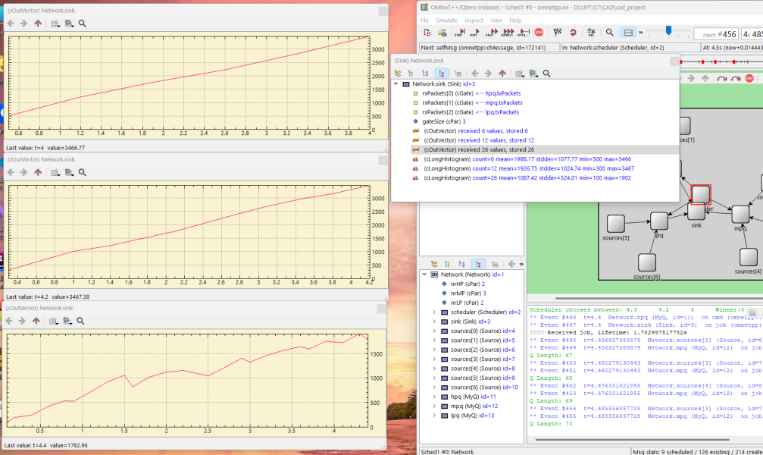

Scheduler->0.05

