Excercise-vectors

1. **Write a function to create vector A, for example, A = (2,4,5,7) and, return a vector with the sum of each value with the previous value. In this example, the result is: Res = (2,6,9,12).**

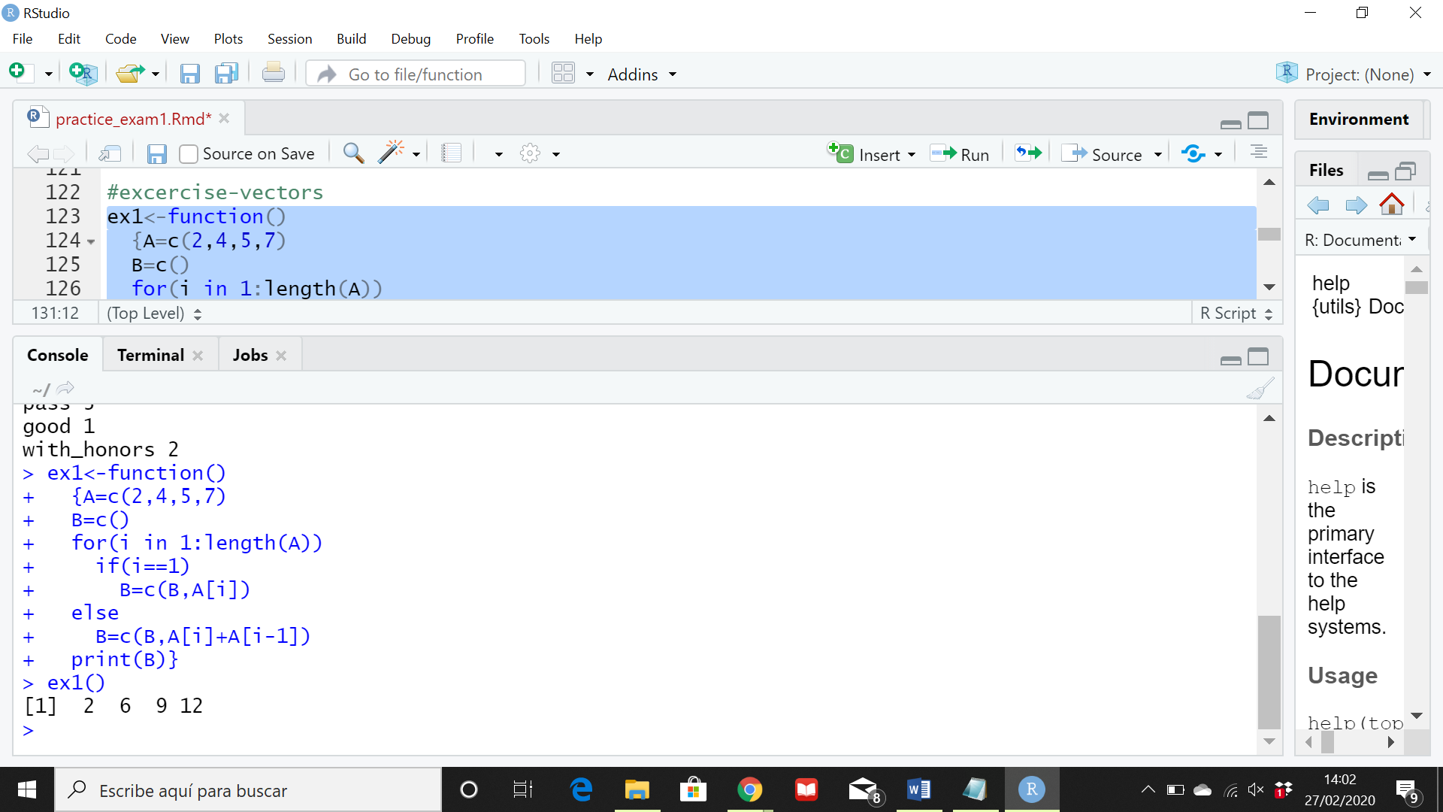

**2.-** **Write a function to create vector A = (2,4,5,7) and, return a vector with the sum of each value with the next value.**

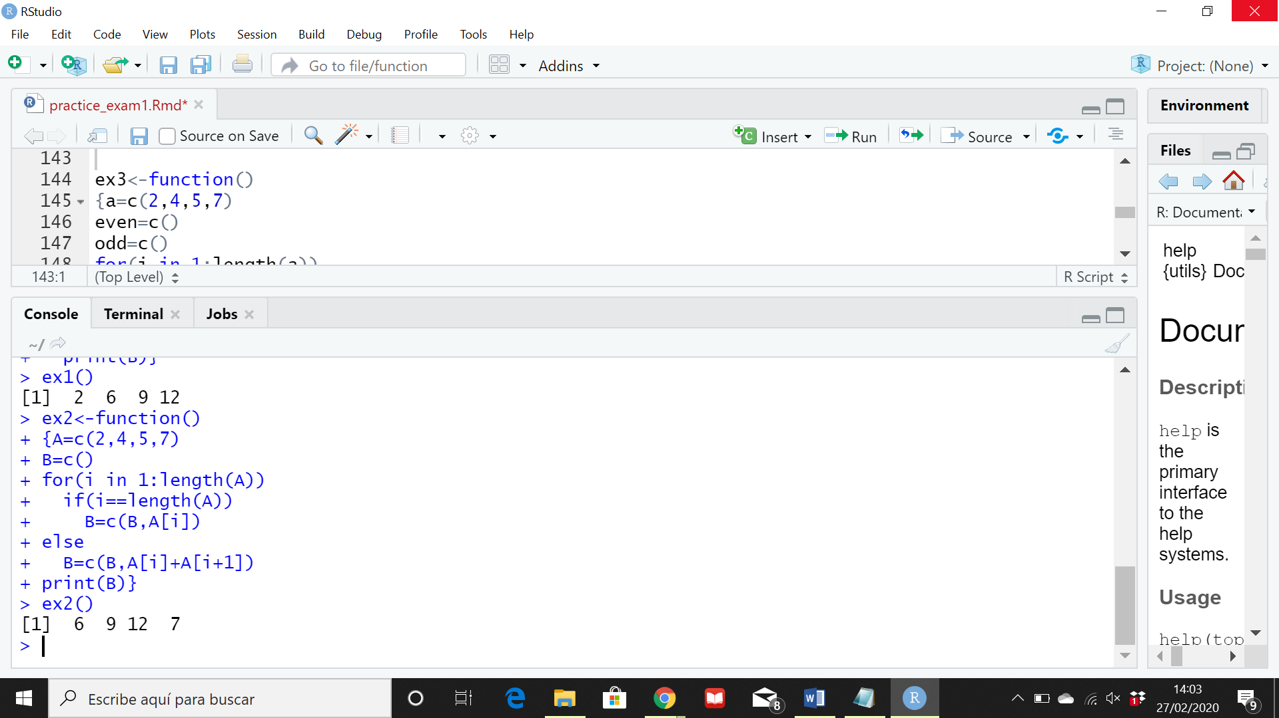

**3. Write a function to create vector A = (2,4,5,7) and, return a vector with even numbers and another with odd numbers.**

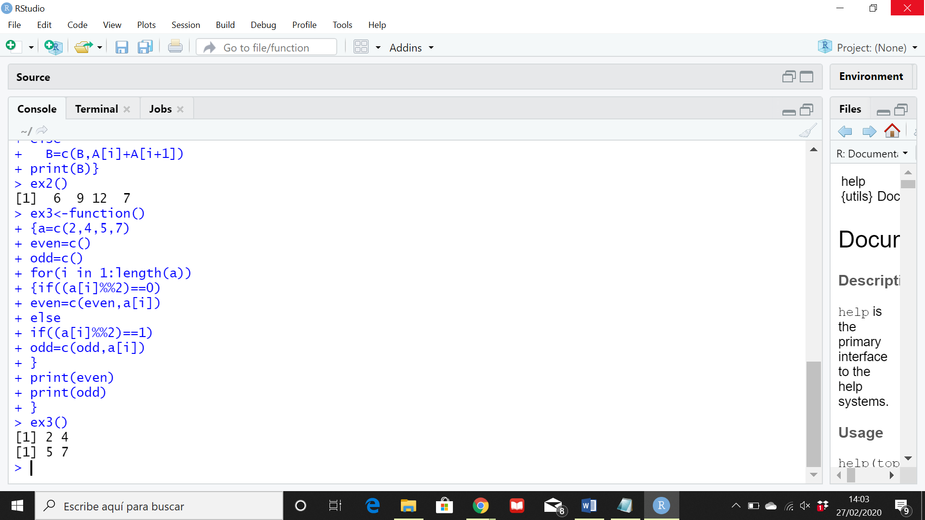

**4. Write a function to ask a user for a grade using the keyboard. The code has to classify the grade: fail or pass**

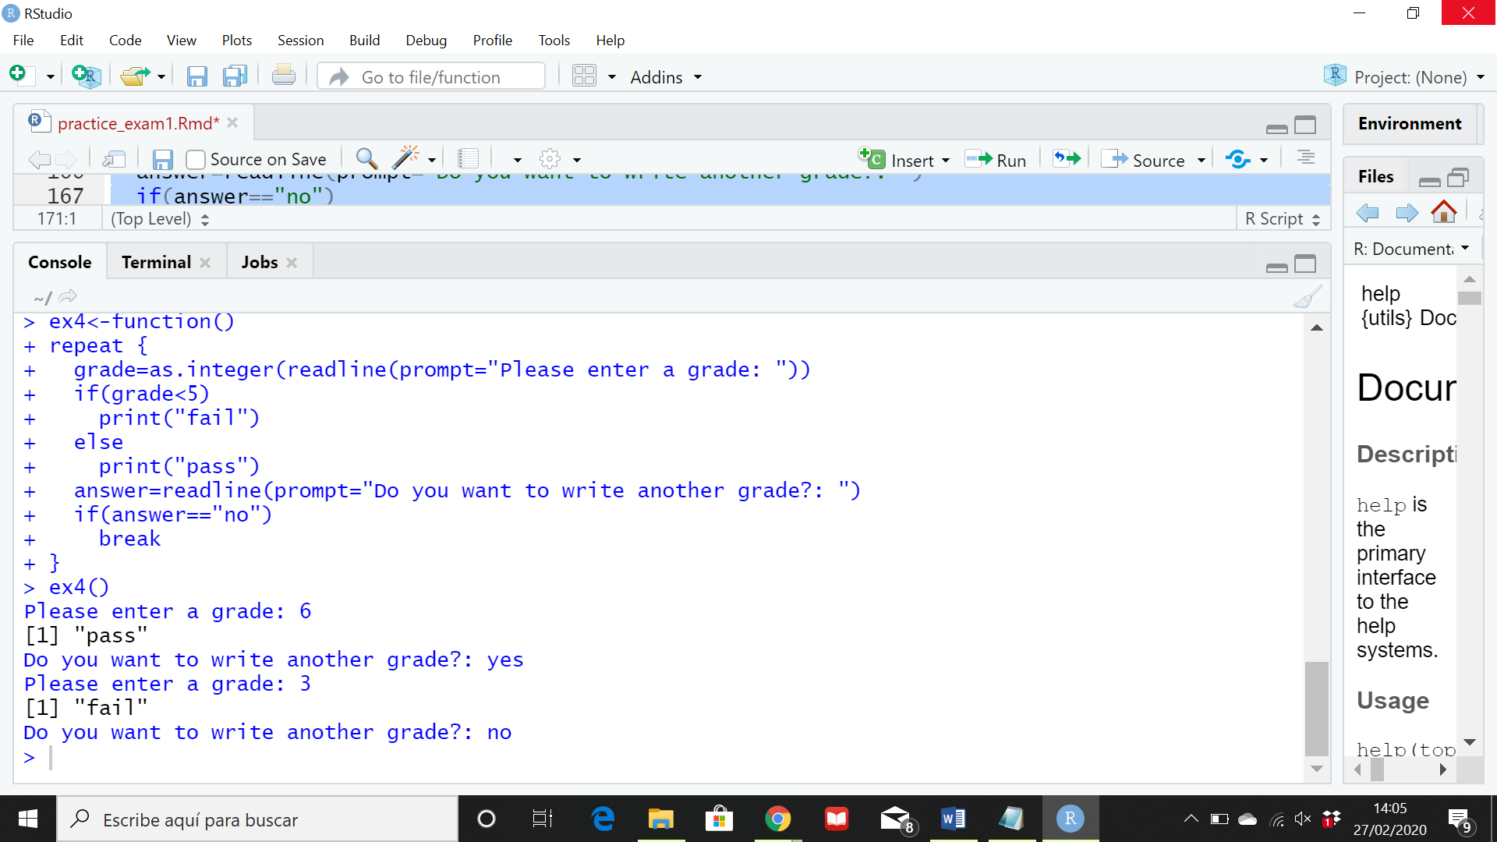

**5. Write a function to ask a user or a grade using the keyboard. The code has to classify the grade: fail, pass, good, with honors**

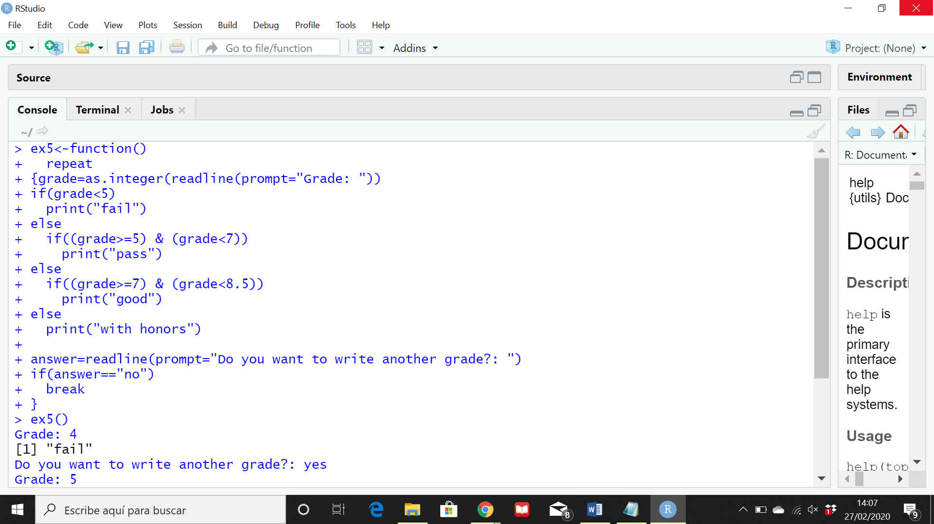

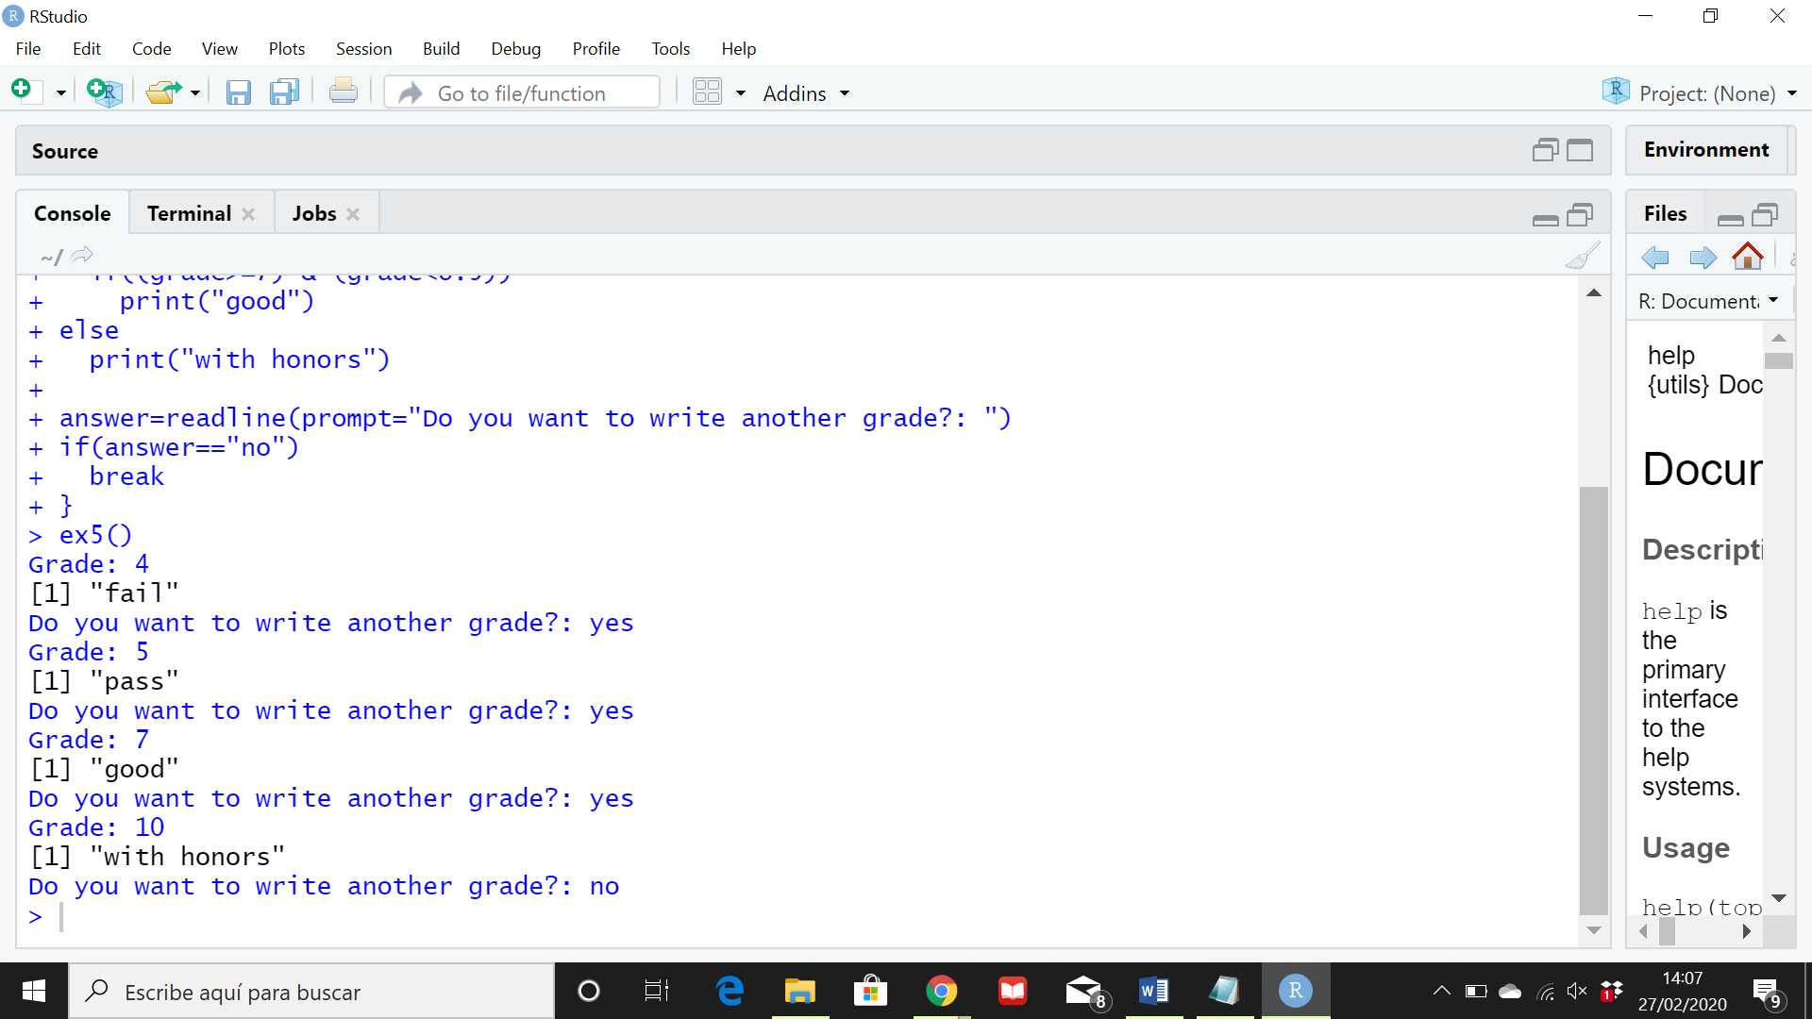

**6. Write a function to ask a user for 5 grades using the keyboard. The code has to classify the grade: fail or pass**

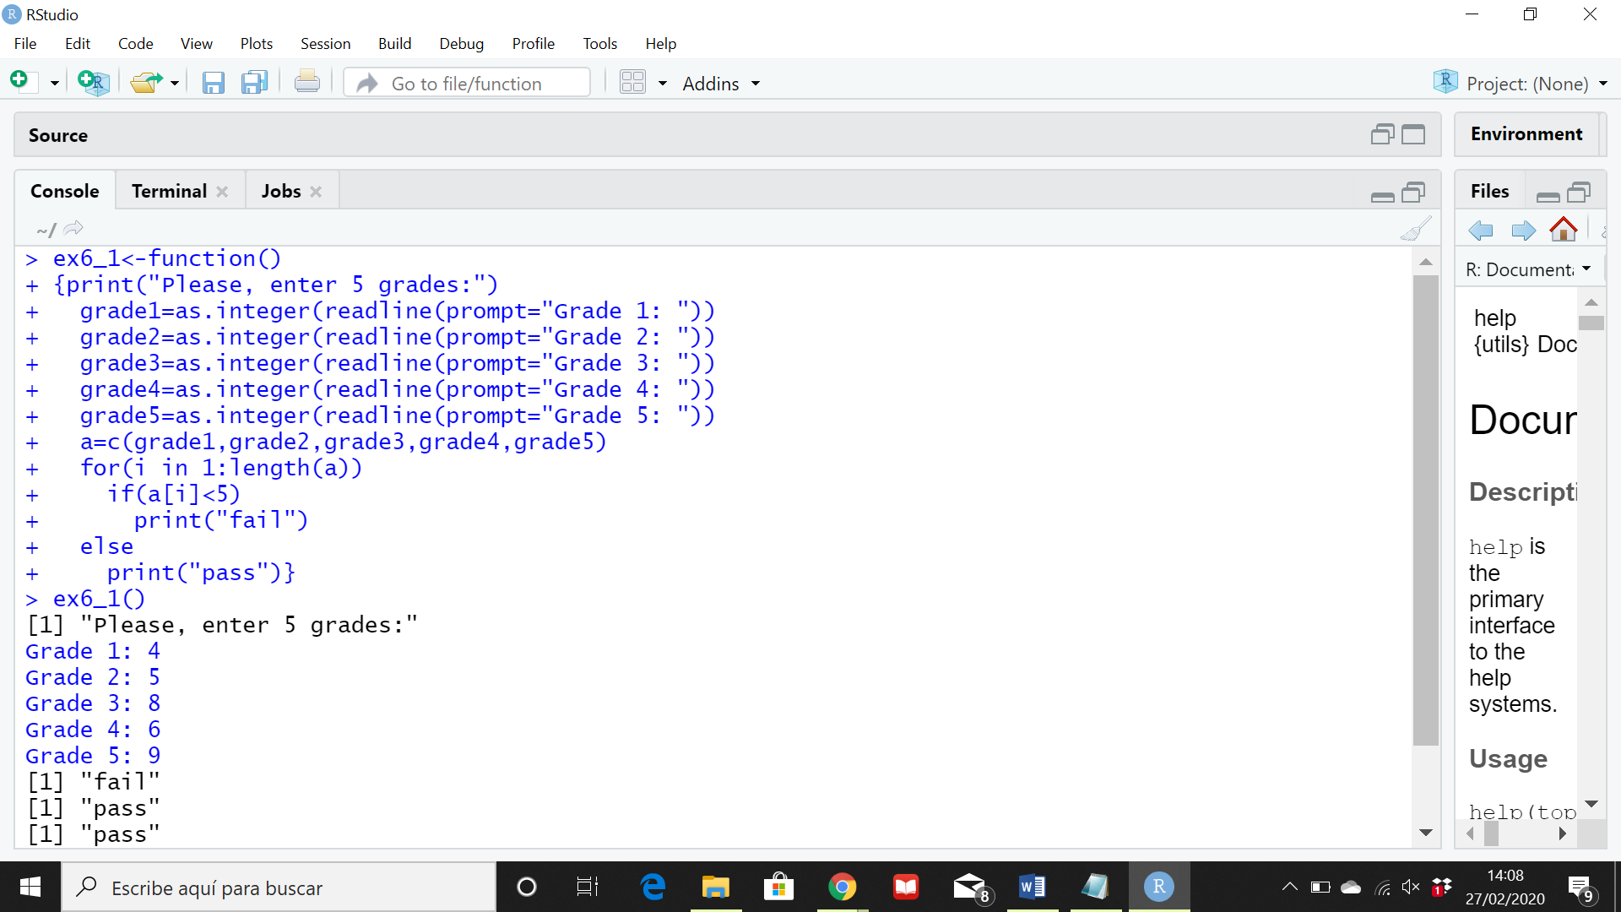

**7. Given a vector which contains the grades of 10 students, write a function that count the number of passes and fails** 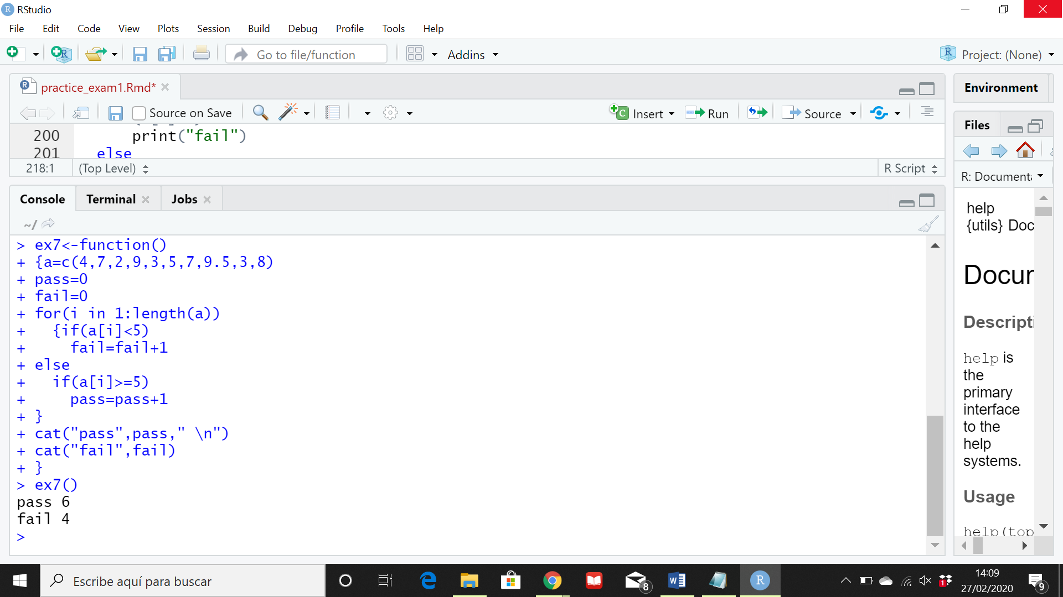

**7.a. Count number of fail, pass, good and with honors**

