Shared Trip

1.Правим таблички

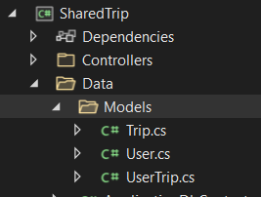

1.1 User

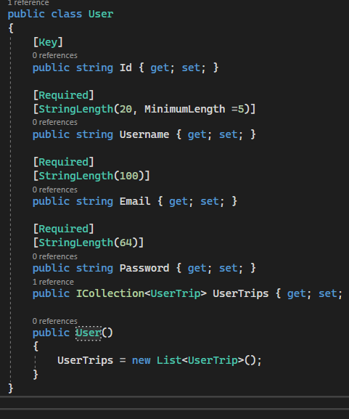

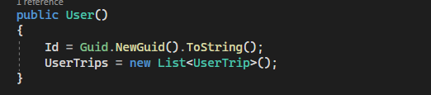

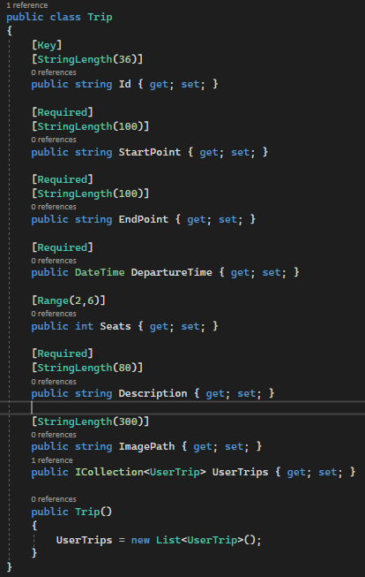1.2 Trip

1.3 UserTrip

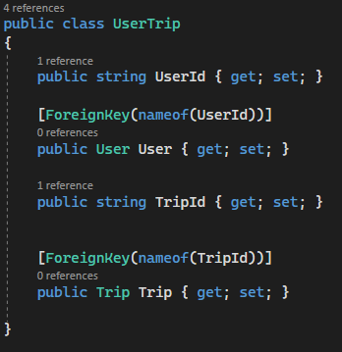

1.4 В ApplicationDbContext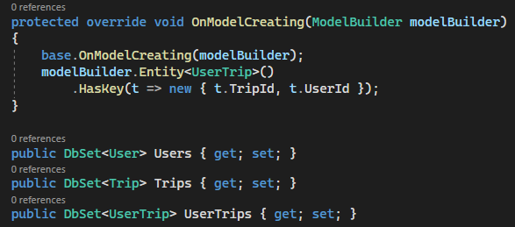

1.5 Правим някакви Имиграции в Package Manager Console

add-migration InitialMigration

update-database

2.

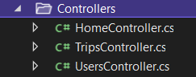

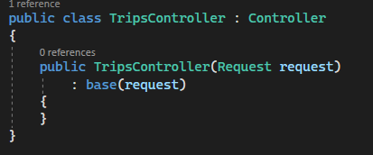

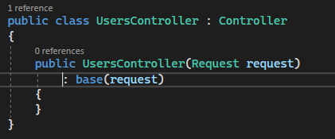

2.1 Purvo pravim dvata Get metoda, koito da vrushtat Login I Register, vrushtame se v UsersController I pravim dva publichni metoda koito vrushtat Response

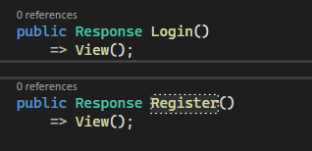

2.2 pochvame da pravim Post. Tova koeto tryabva da napravim e da si vdignem edin Service

Nova papka SharedTrip -> Contracts i Services

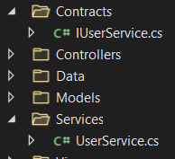

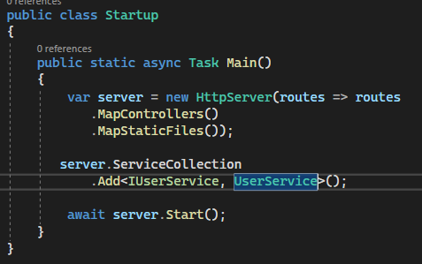

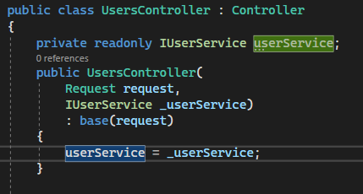  
2.3 sledvashtoto neshto koeto trabva da napravim e registraciyata na potrebitelite, s tova tryabva da zapochnem zashtoto vsichko drugo go imame v momenta. Imame stranichkata za neregistrirani potrebiteli I suotvetno tryabva da napravim stranichkata za registrirani potrebiteli

Models -> papka Users -> class RegisterViewModel

Gledame ot Views -> Users -> Register.cshtml

Controllers -> UsersController

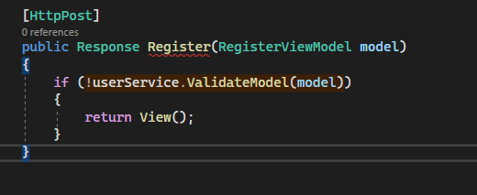

Dobavyame v Models oshe edin class

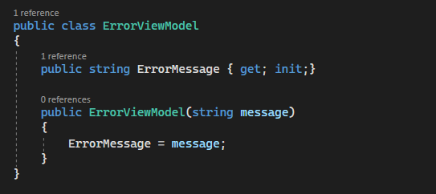

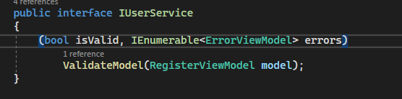

Pochvame da pravim proverkite v UserService

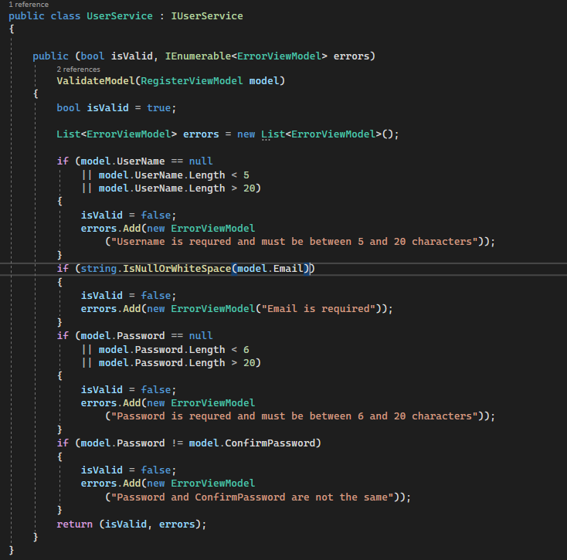

Sluchaya v koito ne uspeem da se registrirame

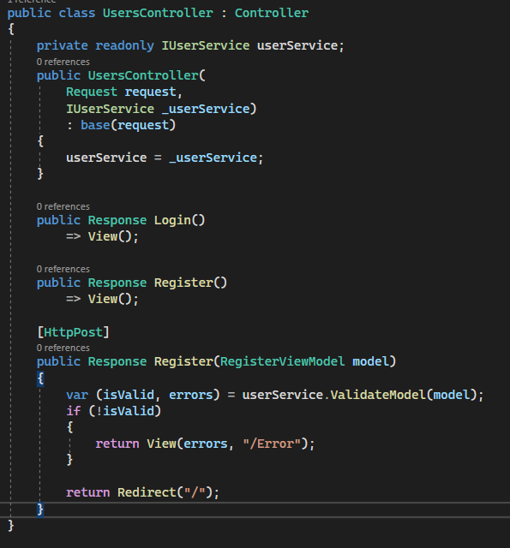

Sluchaya v koito uspeem:

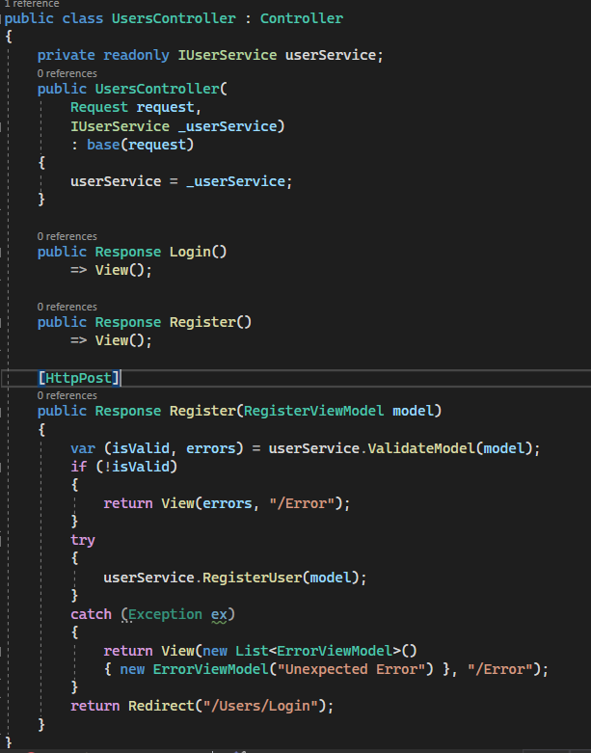

Implementirame interface-a v UserService

V RegisterUser shte tryabva da zapishem v bazata,toest shte ni tryabva neshto s koeto da rabotim s bazata

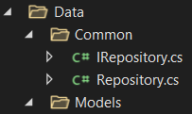

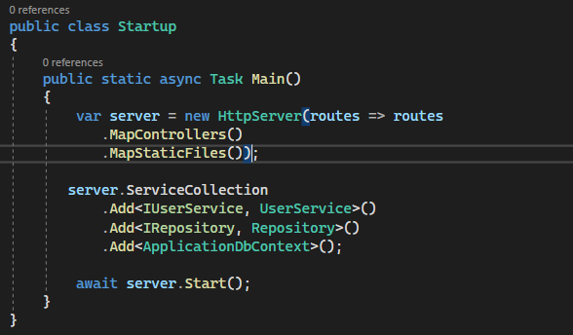

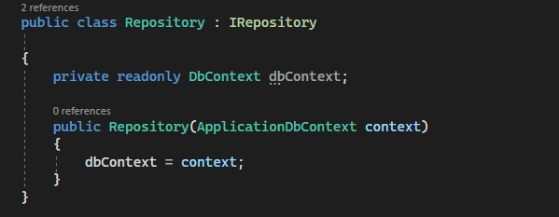

🡨Po tozi nachin shte si injektirame nashiyat db context I ot tuk natatuk shte mojem da rabotim s nego

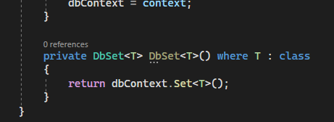

<- po tozi nachin mojem da si vzemem tablicata ot bazata danni koyato ni e neobhodima

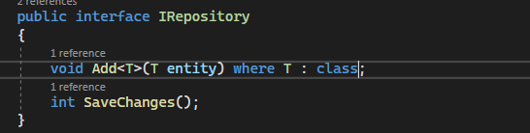

V Repository ->

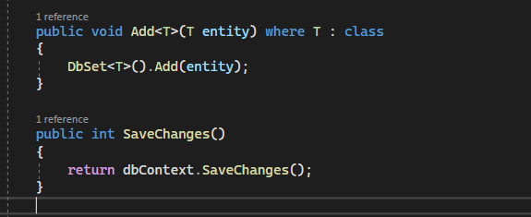

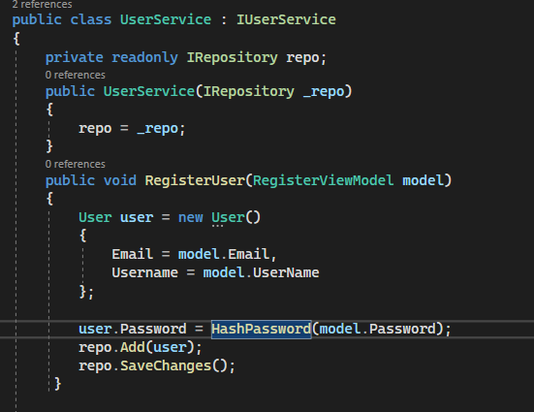

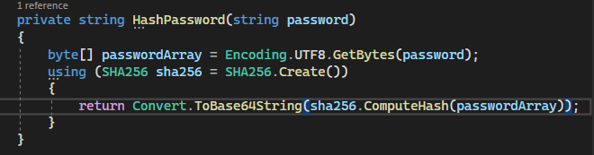

Imame Register, sega pochvame Login

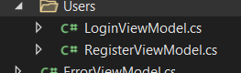

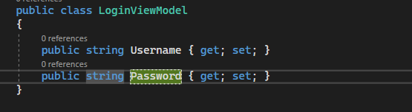

V UsersController

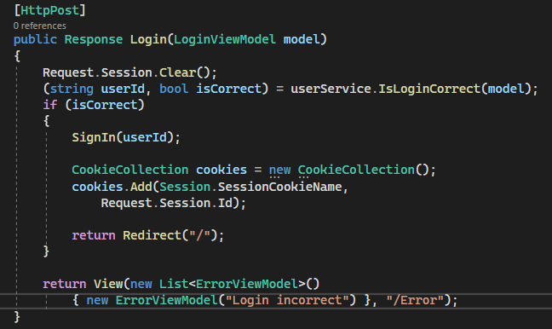

Implementirame metoda v UserService. Imame Login modela, tryabva da prochetem ot bazata , no nie oshte nqmame metod s koito da prochetem ot bazata

Otivame v IRepository

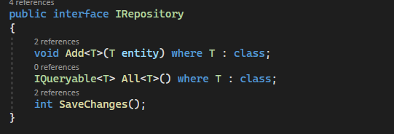

Tozi metod ni e napulno dostatuchen za da prochetem vsichko ot bazata

V Repository->

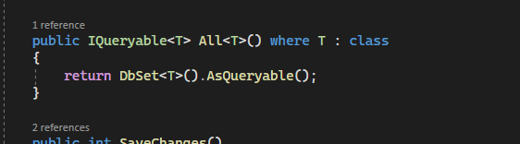

V UserService

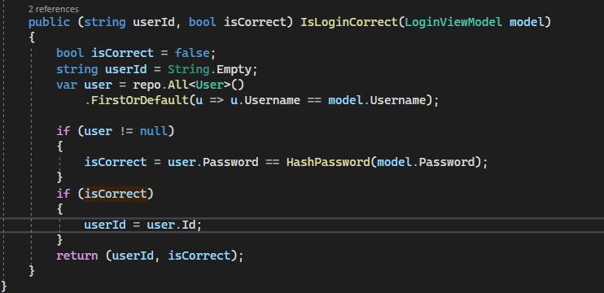

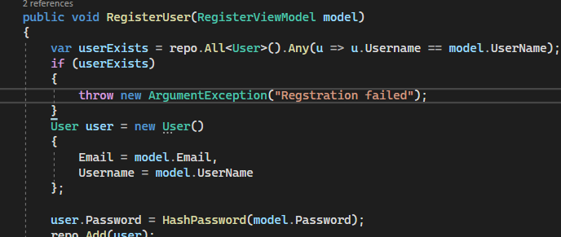

V UsersController

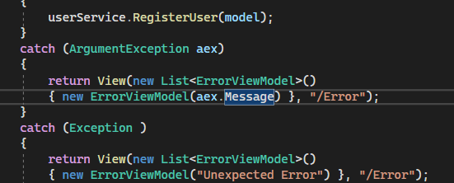

Pravim metod v UserServise

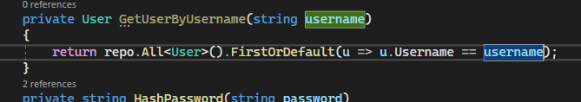

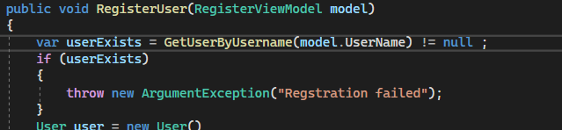

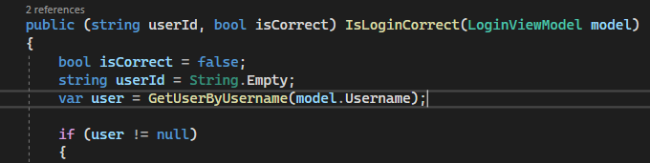

V UserController pravim Logout

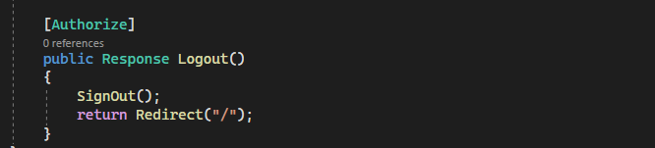

Pochvame s Add Trip

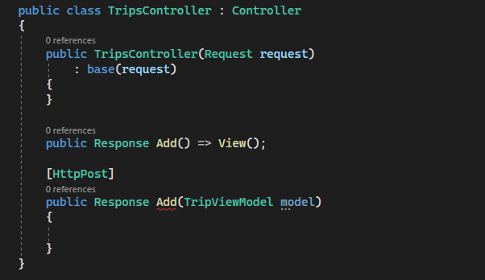

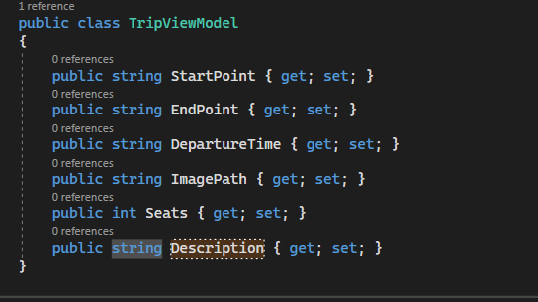

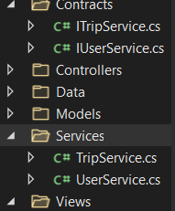

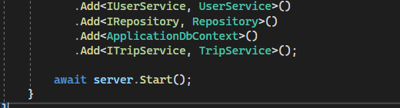

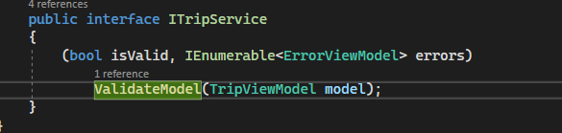

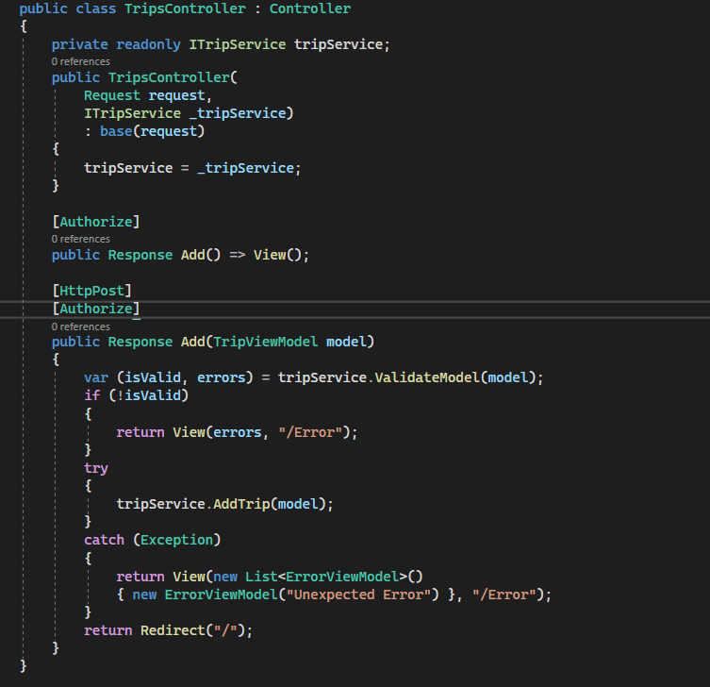

V TripService validirame

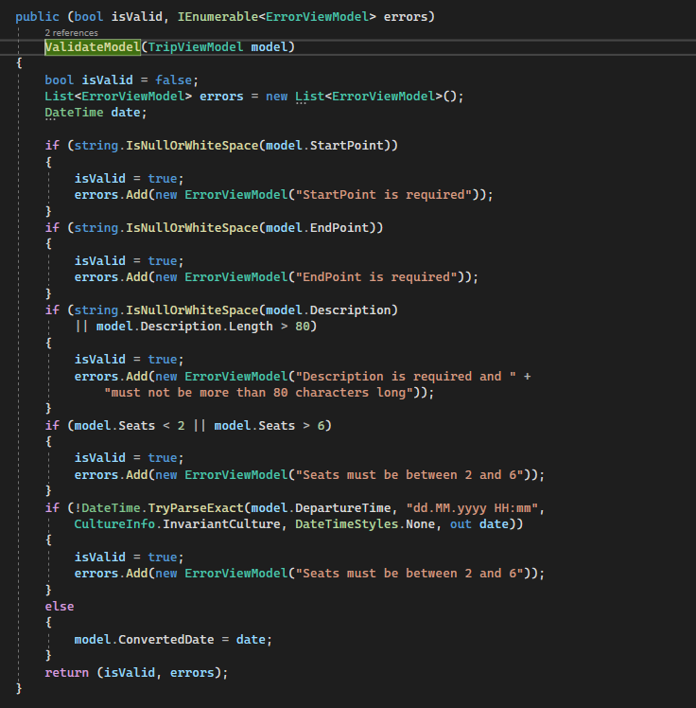

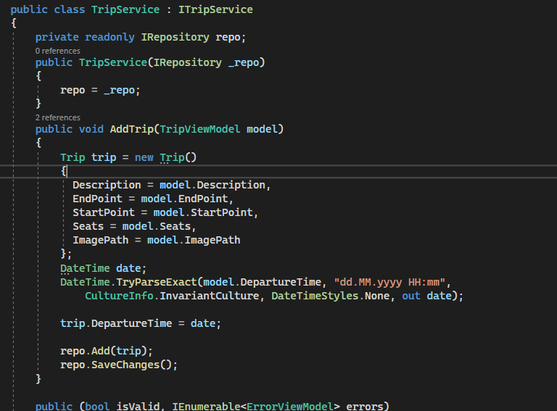

V Trip

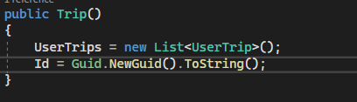

Suzdavame v Model TripListViewModel

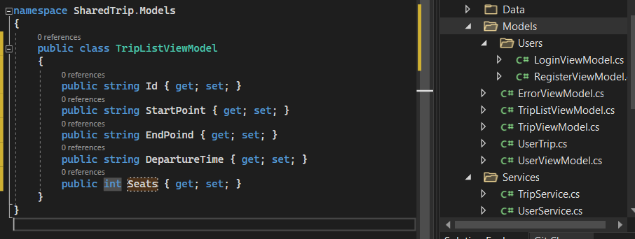

V TripsController ->

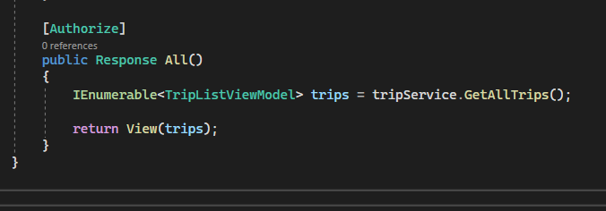

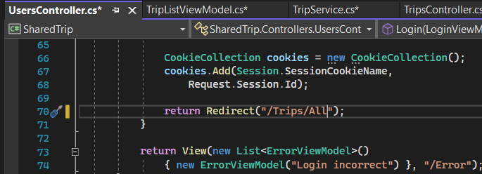

Implementirame metoda v TripService

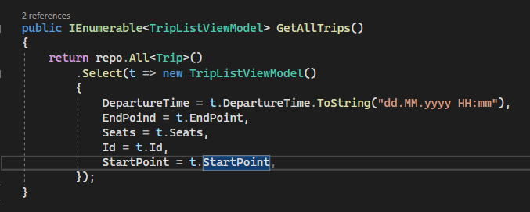

V Model suzdavame ->

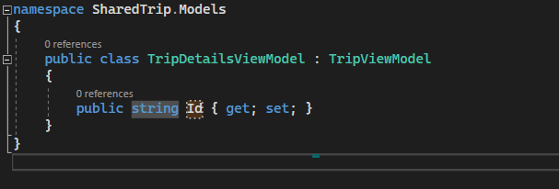

V tripscontroller

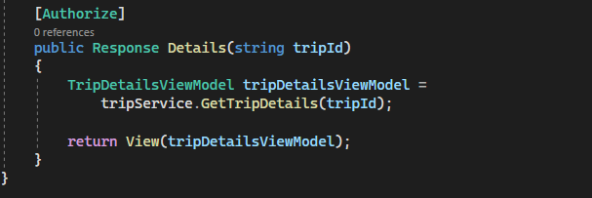

V tripserver

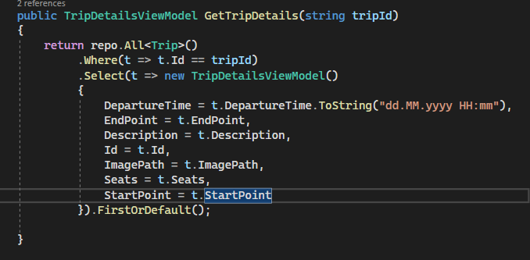

Add User to trip

TripsController

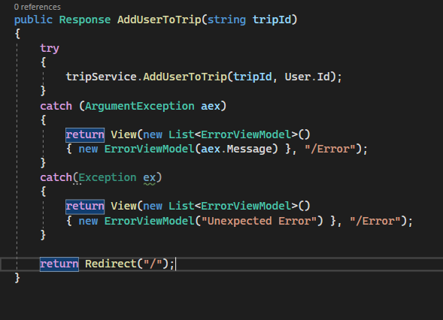

Implementirame metoda v TripService

