***List of commands to play in the cli***

* **‘play assistant card’**: Allows you to play an assistant card by entering the order number of the card.
* **‘play character card’**: Allows you to play a character card by entering the index of the card in the deck.
* **‘move student to island’:** Moves a student to a selected island by entering the position of the student in the hall and the index of the island.
* **‘move student to classroom’:** Moves a student to the respective color row in classroom by entering the position of the student in the hall.
* **‘move mn’:** Move Mother Nature to the selected island.
* **‘choose cc’:** Allows to choose one cloud card after moving mother nature.

***List of commands to visualize info and objects in the cli***

* **‘islands’:** allows you to view all the islands in the game with the students drawn above, the size, the presence of mother nature and the number of towers there are

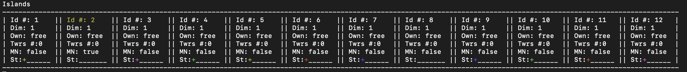

*Legend:*

* Dim: Is the number of islands connected.
* Own: is the player who owns the island.
* Twrs: Is the number of towers on the island.
* MN: Tells if Mother nature is on island (true) or if is not (false).
* St: ‘+’ represents a student in the respective color.
* **‘dashboard’:** allows you to view all the dashboards of the players in the game with the students in the hall and possibly in the classroom, the professors and the towers

without students in classroom or teacher in teacher’s table.

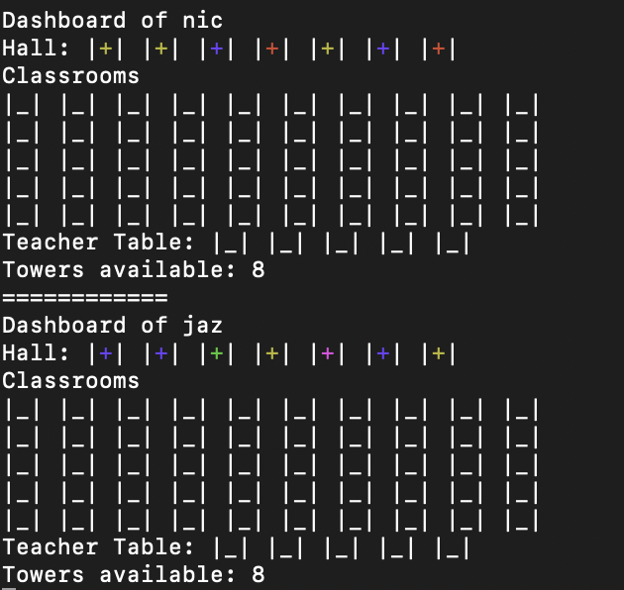

With a student in the classroom and a professor in teacher’s table.

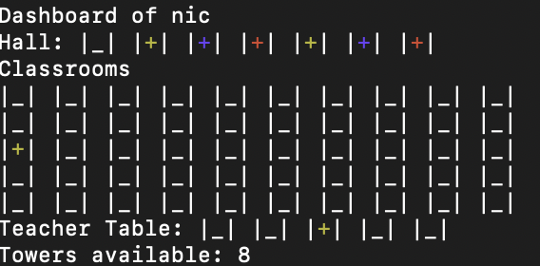

*Legend:*

* + Each ‘+’ represents a student or a teacher If the ‘+’ is in teacher table, in the respective color.
  + Each ‘|_|’ represents a box of the class
* **‘cloud cards’:** Allows you to view all the cloud cards in the game with the students above

*Legend:*

* + Each ‘+’ represents a student in the respective color.
* **‘player’:** Shows the info of the player: username, moves of Mn and wallet.



* **‘gameInfo’:** shows the actual player, the round number and the current phase

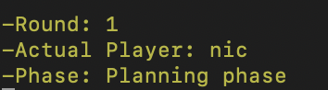

* **‘cardsPlayed’:** shows the list of assistant cards that you have played.

After the player have played the card with order 1:

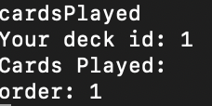

***Game tutorial (CLI version)***

To play Eryantis with the cli you have to type one of the commands described above from the command line of your terminal.

* First, the game notifies you by telling you which phase of the game is taking place (planning phase or action phase)
* Then the game notifies you when your turn has started by saying “Your turn started”
* If the current phase of the game is “planning phase” you have to play an assistant card that will determine the order of play for you in the next turn and in the action phase and also the moves you can do with mother nature
* If the current phase of the game is “action phase” you have to move your students to the islands or to your classroom.
* In the action phase, after moving the students, you must also move mother nature to an island of your choice that respects the moves of mother nature you obtained by playing the assistant card in the previous phase.
* Lastly, you have to choose a cloud card.

***Mode to launch server, client and GUI from the command line:***

***Write in the command line of the terminal:***

* + Launch server: java -jar ‘jar path’ -server (optional -p: select the port)
  + Launch cli: java -jar ‘jar path’ -cli (optional -p: select the port

optional -ip: select the ip address)

* + Launch gui: java -jar ‘jar path’