IST 263

# Lab 04

## This lab covers:

* Tables
* Forms

## tables Setup

1. This week we will be working on two different pages. Start your lab by creating a new page with the required HTML tags. If you forgot how to do this, refer to lab 1. The title of your page should be "Skills".
2. Save it in a new folder called lab04 in your Github repository on your computer as skills.html.

## tables

To work on HTML tables, we are going to create a table for our portfolio site that lists your technical skills and competency with each. Here's a screen shot of a few rows of mine.

Tables are coded in HTML one row at a time with each cell in the table marked with a td tag. Your browser will figure out how to render all the data in neat columns.

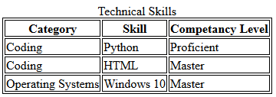

**Captions**

Let's talk about a couple of features of this table. First there's a title centered over the top of the table. This is done with the <caption> element. Caption tags appear right after the <table> tag like this:



**Borders**

There are lines around all the cells in this table. To do this I'm going to show you a preview of Cascading Style Sheets. CSS is a way to set up the layout and appearance of your website.

One way to tell the web browser how you want an item to appear is to put CSS code between your <head></head> element at the top of the page. CSS requires <style> tags and then you describe the HTML element you are changing using CSS rules. Here's what the top of the page looks like for my table borders.

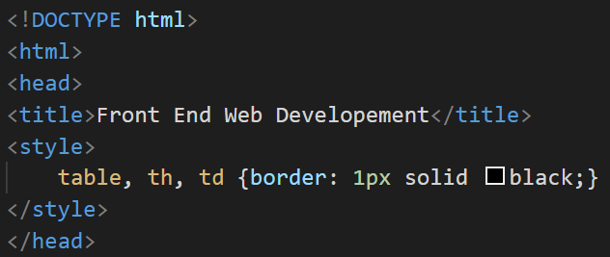

The <style> tag and everything inside of it is a rule to tell the web browser to draw borders around the table, table headers and table data cells.

Before you begin the question below, refresh your memory about table parts and format at w3school.com here: <https://www.w3schools.com/html/html_tables.asp> or check out the code from lecture in blackboard.

1. Create your own personalized skills table. Yours can have completely different headings then mine but it must meet the following requirements:
   1. Table must have a caption
   2. Table must have a border
   3. Table must have at least 3 columns
   4. Table must have at least 10 rows including headers

## Forms Setup

1. In either the Finder or File Explorer, copy the contact.html file from the lab03 folder to your lab04 folder.

## Forms

In this part of the lab we are going to add a form to the bottom of our contact page. That page is starting to look like a hot mess with a ton of different parts to it, but we will fix the layout during the CSS unit so don't worry about that.

Contact form  
Take a moment to look over the [w3schools.com reference page](https://www.w3schools.com/html/html_forms.asp) on forms. Here are a few things to pay attention to:

* The form tag has a begin and end and all the form field tags must go inside it.   
  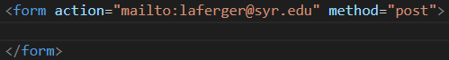  
  Recall that the action attribute describes how the form is going to be sent. In our case with a mailto link that has the email address you want to send the form responses to. We also have a method attribute with a value of post.
* Look through the [form elements documentation](https://www.w3schools.com/html/html_form_elements.asp). I went over a few of the most common in lecture. A few things to recall about form elements:
  + All form elements need labels. To associate the label with the field the label should have a for attribute that matches the name of the id attribute in the form element. 
* Tip: Feel free to copy code from my lecture video examples or the W3Schools website to get started on your form fields.

1. Create a form at the bottom of all the other content on your contact page with the following:
   1. A text field
   2. a radio button, checkbox or select
   3. a textarea
   4. a submit button
   5. that mails the results to you

Note: Your form can ask for anything from the user that would be useful for this page. It can contain extra fields if you need them.

## Validation and checking your work

1. Before you finish you must validate you HTML. Go to the <https://html5.validator.nu/> and correct any errors that appear in validating.

## What will You hand IN?

Create a word document, pdf or use the "write submission" option in blackboard to provide the following:

1. Submit the GitHub URL for the skills page.
2. Submit the link to the validation for the skills page.
3. Submit the GitHub URL for the contact page.
4. Submit the link to the validation for the contact page.
5. Submit answers to the following:
   1. What questions did you have about the lab?
   2. What was the hardest part of the lab?
   3. Rate your comfort level with this week's topics.  
      1 ==> I can do this on my own and explain how to do it.  
      2 ==> I can do this on my own without any help.  
      3 ==> I can do this with help or guidance from others.   
       If you choose this level, please indicate HOW this person helped you.  
      4 ==> I don't understand this at all yet and need extra help.