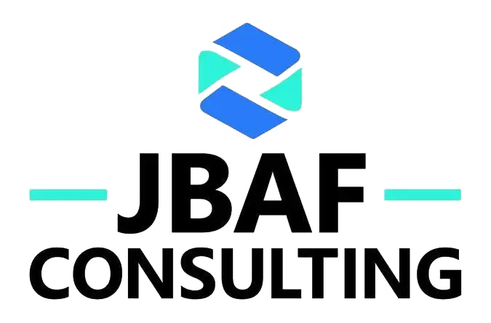

Legal Notice / Imprint
Last updated: January 2026

1. Site Operator / Company Details
Company Name:
JBAF CONSULTING LTD
Legal Form:
Private Limited Company incorporated in England and Wales
Company Registration Number:
12081906
Registered Office Address:
JBAF CONSULTING LTD
100 Church Street
Brighton, East Sussex
BN1 1UJ, United Kingdom

2. Contact Information
Email:
Joseph@jbafconsult.com
Website:
https://jbafconsult.com

3. Governing Law and Jurisdiction
This website and all legal relationships arising from its use are governed by the laws of England and Wales. The courts of England and Wales shall have exclusive jurisdiction over any disputes arising from or in connection with this website, unless mandatory statutory provisions dictate otherwise.
As a UK-based company, JBAF CONSULTING LTD operates in compliance with UK laws and regulations, including the UK General Data Protection Regulation (UK GDPR) and the Data Protection Act 2018.

4. Regulatory Information
JBAF CONSULTING LTD is registered with Companies House. You can verify our company registration details at: https://find-and-update.company-information.service.gov.uk

5. Responsible for Content
Responsible for editorial content pursuant to applicable laws:
JBAF CONSULTING LTD
Email: Joseph@jbafconsult.com

6. Disclaimer

6.1 Content Accuracy
The information provided on this website has been compiled with care. However, JBAF CONSULTING LTD cannot guarantee the accuracy, completeness, or timeliness of the information. The company reserves the right to modify or update content at any time without prior notice.

6.2 External Links
This website may contain links to external third-party websites. JBAF CONSULTING LTD has no control over the content of these external sites and therefore cannot accept any liability for their content. The respective provider or operator of linked pages is always responsible for their content. Linked pages were checked for possible legal violations at the time of linking; no illegal content was identifiable at that time.

6.3 Liability Limitations
JBAF CONSULTING LTD shall not be liable for any damages, whether direct, indirect, incidental, or consequential, arising from the use or inability to use this website or its content, except in cases of intentional misconduct or gross negligence. Nothing in this disclaimer excludes or limits liability for death or personal injury arising from negligence, fraud or fraudulent misrepresentation, or any other liability that cannot be excluded or limited by English law.

7. Copyright and Intellectual Property
All content on this website, including but not limited to text, images, graphics, logos, videos, and documents, is protected by copyright and other intellectual property laws. The content is owned by JBAF CONSULTING LTD or used with permission from rights holders. Any reproduction, distribution, modification, or use of the content beyond the scope of copyright law requires prior written consent from JBAF CONSULTING LTD.

8. Online Dispute Resolution
The European Commission provides a platform for online dispute resolution (ODR): https://ec.europa.eu/consumers/odr
JBAF CONSULTING LTD is neither obligated nor willing to participate in dispute resolution proceedings before a consumer arbitration board.
© 2026 JBAF CONSULTING LTD. All rights reserved.

