General notes

Contents

Purchases 1

Arduino MKR 1010 config 2

Initial Config 2

Tutorials 2

Connect to WiFi mobile net, send to ThingSpeak 2

Arduino IDE 3

Sensors 3

Matlab/Simulink 3

Packages 3

Connection with Arduino 3

Data visualization 4

Thingspeak data in Unity 4

Telegram bot 5

ThingSpeak visualization 6

Interest links 6

Things to improve 6

# Purchases

Arduino MKR 1010 Wifi (<https://www.amazon.es/gp/product/B07FYFF5YZ/ref=ppx_yo_dt_b_asin_title_o05_s00?ie=UTF8&psc=1>): 33,76€

Sensors:

* Rain (<https://www.amazon.es/gp/product/B07V5QWXNS/ref=ppx_yo_dt_b_asin_title_o04_s00?ie=UTF8&psc=1>): 5u 7,99€
* Light (<https://www.amazon.es/gp/product/B07DJ4LHTR/ref=ppx_yo_dt_b_asin_title_o03_s00?ie=UTF8&psc=1>): 5u 5,99€
* Temperature (<https://www.amazon.es/gp/product/B07VB25GS5/ref=ppx_yo_dt_b_asin_title_o03_s00?ie=UTF8&psc=1>): 5u 7,99€
* Soil moisture (ml/cubic centimetre) (<https://www.amazon.es/gp/product/B07V6M5C4H/ref=ppx_yo_dt_b_asin_title_o02_s00?ie=UTF8&psc=1>): 5u 14,29€

Arduino kit (<https://www.amazon.es/gp/product/B07CGD2HLD/ref=ppx_yo_dt_b_asin_title_o01_s00?ie=UTF8&psc=1>): 13,99€

Arduino batteries (<https://www.amazon.es/gp/product/B078HM9L7X/ref=ppx_yo_dt_b_asin_title_o00_s00?ie=UTF8&psc=1>): 2u 9,99€

## Arduino MKR 1010 config

### Initial Config

First Arduino IDE installation, add Arduino SAMD Core, add drivers and finish config (<https://www.arduino.cc/en/Guide/MKRWiFi1010/>)

### Tutorials

* Connecting MKR WiFi 1010 to a Wi-Fi network DONE (<https://www.arduino.cc/en/Guide/MKRWiFi1010/connecting-to-wifi-network/>)
* Powering MKR WiFi 1010 with batteries (<https://www.arduino.cc/en/Guide/MKRWiFi1010/powering-with-batteries/>)
* Host a web server on the MKR WiFi 1010 (<https://www.arduino.cc/en/Guide/MKRWiFi1010/hosting-a-webserver/>)
* How to connect sensors to the MKR WiFi 1010 (<https://www.arduino.cc/en/Guide/MKRWiFi1010/connecting-sensors/>)
* How to detect MAC address for Arduino (<https://www.arduino.cc/en/Reference/WiFiNINAScanNetworks>)
* Give static IP address to the board (<https://www.arduino.cc/en/Reference/WiFiConfig>)
* Getting started with Arduino hardware in Simulink (<https://es.mathworks.com/help/supportpkg/arduino/ref/getting-started-with-arduino-hardware.html>)
* Arduino based watering plants (<https://es.mathworks.com/help/supportpkg/arduino/ref/arduino-based-smart-watering-of-plants.html>)

### Connect to WiFi mobile net, send to ThingSpeak

Configure MatLab for recognizing this specific board in USB mode. Simluation -> Model Settings -> Hardware (Select board, and configure WiFi)

Set ThingSpeak channel

Sdlrtkernet -setup

Configure Analog out (soil moisture) to ThingSpeak write (standard Thingspeak write is working but cannot be integrated in Arduino, just simulation, Arduino specific Thingspeak write is sending 0 always as the value <https://es.mathworks.com/help/supportpkg/arduino/ref/wifithingspeakwrite.html> even that they have the same values)

Finally using a library (<https://github.com/mathworks/thingspeak-arduino>) created by MathWorks that permits writing and reading from ThingSpeak through the Arduino IDE I get a program that publish there correctly. After installing ThingSpeak library in the IDE.

Now I’m publishing correctly in the channel, but if the board is running on batteries, it’s not working, so I’m in the same situation as before but with a more complicated code than Simulink.

Modified part of the code, now is running on batteries correctly.

## Arduino IDE

Using the ThingsSpeak library (<https://github.com/mathworks/thingspeak-arduino>) for Arduino IDE (1.8.13) I send data from my soil moisture analogic sensor to my ThingSpeak channel, channel 1 (Soil moisture).

It works fine, so Matlab/Simulink is discarded for the moment.

### Sensors

#### Soil moisture sensor

As it’s an analogic sensor it should produce values between 0 and 1023, but we should map these values as a percentage of soil moisture from 0% to 100%. Using this examples I do it (<https://www.instructables.com/How-to-Use-the-Soil-Hygrometer-Module-Arduino-Tuto/> , <https://create.arduino.cc/projecthub/asmodeus_eous/using-a-soil-hygrometer-sensor-with-arduino-fad704?ref=part&ref_id=8233&offset=43>)

My sensor range goes from 675 when inside water to 1023 completely dried, so I map it from 0 to 1023 and send this data to Thingspeak.

#### Light sensor

As there is no info from the vendor about this sensor, following the indications on it I connect it to the Arduino.

<https://arduinogetstarted.com/tutorials/arduino-light-sensor>

When trying to upload both values to my thingspeak channel, the second one is not working as expected.

It has to be first using setField for each of the values you want to upload and then writeFields for writing together all (<https://github.com/mathworks/thingspeak-arduino#documentation>)

#### Temperature sensor

My sensor it’s a DS18B20 (Dallas) model, so it needs a library in order to work with Arduino (<https://www.geekfactory.mx/tutoriales/tutoriales-arduino/ds18b20-con-arduino-tutorial-de-sensor-de-temperatura-digital/>) Implementing the first example, we get the temperature reading in ºC.

Then adapt this code to my Arduino program.

Thermometer in order to check if measurement is correct (<https://pay.ebay.es/rxo?action=success&sessionid=1571075684017>)

#### Rain sensor

Connect the sensor according to the vendor’s information.

#### Sensor’s installation

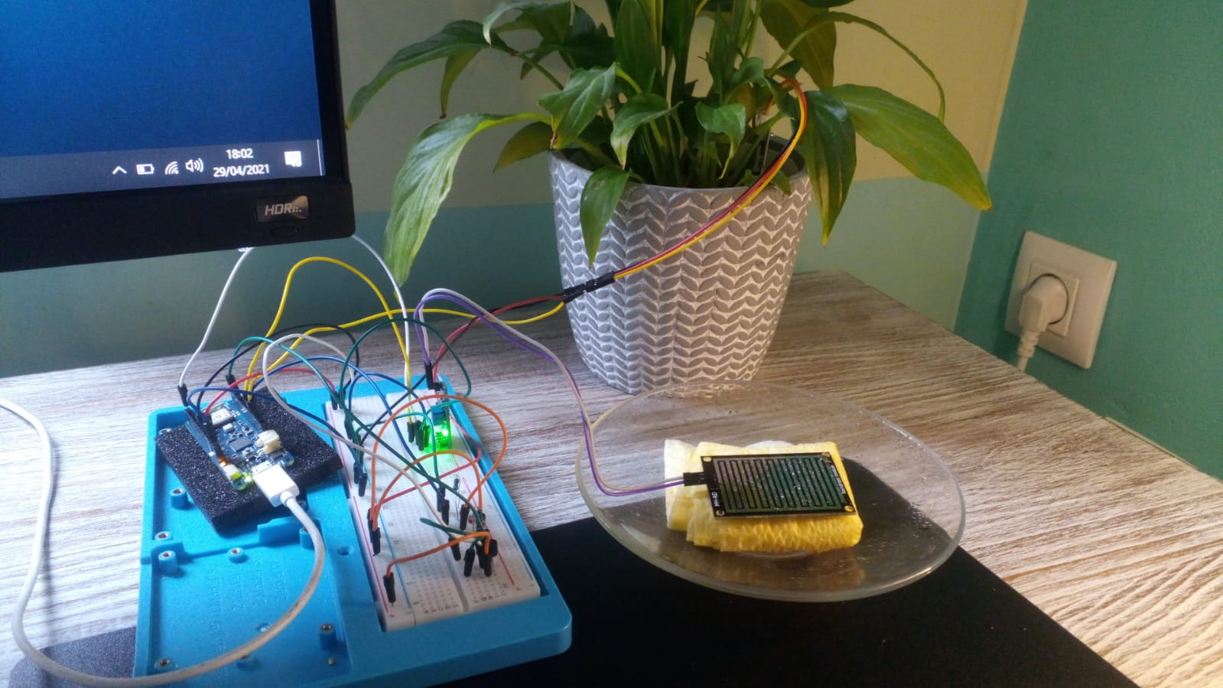

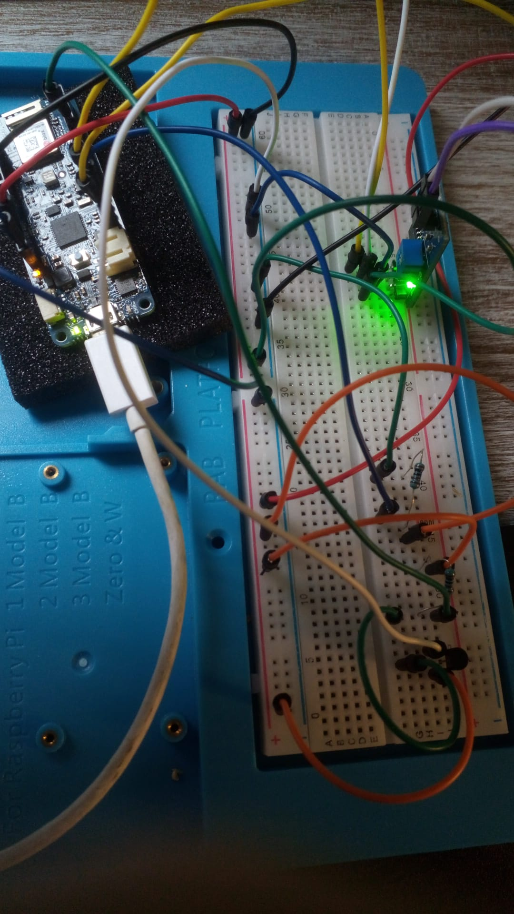

## Matlab/Simulink

### Packages

* Installation including all simulink components.
* MinGW (C/C++ compiler)
* Support Package for Arduino
* Simulink Support Package for Arduino Hardware

### Connection with Arduino

## Data visualization

### Thingspeak data in Unity

#### Python in Unity

Starting with the first demo following what Victor tought us about a simple app displaying a cube that I already had, I start investigating about how to run a Python script in Unity.

* 4 ways of running Python in Unity (<https://docs.unity3d.com/Packages/com.unity.scripting.python@2.0/manual/inProcessAPI.html>)
* Python script Editor – Simplest way of running Python directly (<https://docs.unity3d.com/Packages/com.unity.scripting.python@2.0/manual/PythonScriptEditor.html>)

I decided to use the Python Script Editor, but upgrade to version 2.0.1 is required. I upgrade to the last stable release 2020.3.0f1 with Android Build included in the installation.

Follow both guides mentioned before that Victor provided to us.

There is a problem if these guidelines are followed:

* Daydream support was removed in 2020.1. Google released an open source cardboard plugin for 2020.1+ which they recommend using as a replacement: <https://developers.google.com/cardboard/develop/unity/quickstart>  
    
  See google's suggestions here: <https://developers.google.com/vr/develop/unity/get-started-android>

Here is written how to use the new cardboard plugin (<https://developers.google.com/cardboard/develop/unity/quickstart>), we cannot use Google VR for Unity as defined in the guide.

Mixed reality library for Unity and Google Cardboard (<https://assetstore.unity.com/packages/templates/systems/ar-vr-mr-camera-mixed-reality-with-google-cardboard-xr-plugin-ar-179433?aid=1100lGft&utm_source=aff>)

Import Hello Cardboad from the Package Manager

Tutorial for integrating Python Script Editor in Unity with small example (<https://www.youtube.com/watch?v=3UOlN8FcNbE&ab_channel=Indie-Pixel>)

Guide for installing Python in Unity (<https://docs.unity3d.com/Packages/com.unity.scripting.python@2.1/manual/installation.html>)

Python for Unity does not work with Python 3, only Python 2. I use Python 2.7.16, remember to add it to the PATH.

Install pip from this site (<https://bootstrap.pypa.io/pip/2.7/get-pip.py>) in order to work with Python 2.7. In order to work, add it to the PATH (<https://appuals.com/fix-pip-is-not-recognized-as-an-internal-or-external-command>) C:\Python27\Scripts

We should add the dependency manually to VAR_AUB\Packages\manifest.json

Python editor in Unity is just an editor for the moment, not for runtime executions. **I discard this idea.**

#### C# in Unity

##### C# script prototype

In Visual Studio Community, C# package.

First a demo of C# program that get’s thingspeak data to the console.

Then get the data from Thingspeak in JSON using their API (<https://community.thingspeak.com/documentation%20.../api/>)

This as an example (<https://stackoverflow.com/questions/33224357/how-to-parse-json-to-c-sharp-and-read-values>)

We need to use the Newtonsoft.Json library (using Newtonsoft.Json.Linq) in order to process JSON data in Unity (<https://www.nuget.org/packages/Newtonsoft.Json>)

##### Implement this script associated to a Unity object

First, I create a progress bar in Unity.

I had an idea to make it work for VR, I create 2 cylinders, one coloured in blue wider than the other coloured in white. Controlling the Y position of the blue one It seems like a bar in VR.

For adapting the C# script in Unity I install the NuGetUnityPackage (<https://github.com/GlitchEnzo/NuGetForUnity/releases>) and (<https://github.com/GlitchEnzo/NuGetForUnity>).

In order to reference the object I want to move (<https://answers.unity.com/questions/699464/how-do-i-have-reference-to-gameobject.html>)

To move the object (<https://answers.unity.com/questions/1470684/how-to-change-position-of-gameobject.html>)

For translating the values obtained from ThingSpeak (0-100) to values needed for modifying the position in Unity (0-2) I create a map function (<https://stackoverflow.com/questions/14353485/how-do-i-map-numbers-in-c-sharp-like-with-map-in-arduino>)

Object from ThingSpeak to int (<https://www.tutorialsteacher.com/articles/convert-string-to-int>).

Plant for prototype (<https://assetstore.unity.com/packages/3d/vegetation/plants/plants-150261>)

Git large files management (<https://git-lfs.github.com/>)

For adding the rest of the sensors, I create 3 more cylinders, for displaying the rest of the measurements.

Also adapt the C# code for reading Thingspeak values following the same procedure.

In order to show if it’s highly raining, a raining cloud is programmed to appear above the plant.

I encountered some problems, when the script manages all 4 indicators, none of them work.

Converting the values obtained to float for them to work in the vector that modifies the height of the cylinder indicating the values readded from the sensors.

The script in charge of reading the values and modifying the indicators is used in the object containing these indicators.

When trying to get the temperature from Thingspeak the float parsing destroys the decimal point, so the number is gotten incorrectly. When the number is converted to float using System.Globalization.CultureInfo.InvariantCulture comma separator is used instead of point (<https://www.codeproject.com/Questions/188004/Decimal-Seperator-change-in-c>)

Setting the system to accept dot as the number decimal separator as default (<https://stackoverflow.com/questions/9160059/set-up-dot-instead-of-comma-in-numeric-values>)

In order to simulate if it’s raining or not, a game object that simulates rain in the scene is activated or deactivated using the setActive() function according to the value obtained from the sensor (<https://answers.unity.com/questions/372531/how-to-disable-gameobjects-in-code.html>) (<https://docs.unity3d.com/ScriptReference/GameObject.SetActive.html>)

### Editable measurements through user interface

Starting with this tutorial (<https://learn.unity.com/tutorial/creating-a-vr-menu-2019-2#6036dc27edbc2a50f848a6fc>). As it’s for a controller I just create the menu.

I make it smaller and only appearing when a button near the measure value,

## Telegram bot

I’m going to create a telegram bot that answers with the possible fields stored in ThingSpeak in buttons form and then when one is pressed answer with the latest value and date.

In order to do it I create a bot using BotFather (<https://t.me/botfather>), create the bot, give it a name “VAR_AUB”. Change photo and description.

Then using telepot python library (<https://telepot.readthedocs.io/en/latest/>) in order to make the communication easier with the bot.

Lastly using the thingspeak python library (<https://thingspeak.readthedocs.io/en/latest/>) in order to get data from my channel as JSON and then process it to get the asked values.

When it’s running, talk to VAR_AUB_bot ([t.me/var_aub_bot](tg://resolve?domain=var_aub_bot)) in telegram and it will answer with the possible options.

## ThingSpeak visualization

## Interest links

* <https://nothans.com/thingspeak-tutorials/netduino/create-your-own-web-of-things-using-the-netduino-plus-and-thingspeak>

# Things to improve

* Adjust some sensors with resistances, use new light sensors and test if it’s better 3.3V or 5V.

# Retake on the proyect

First, I must change the building of the app to ios, due to now I’m using an iPhone as my phone. I’m developing in Windows, then compile the output in a mac with xcode, connect my phone to execute it on it.

I later decided to build again in Android for another phone, being much simpler to do for every modification.

## Unity proyect upgrades

For the visualization of you plants from abroad I plan on do the next modifications:

* Better bars for a more elegant visualization of the values of each of the variables measured
* Upgrade graphics of the plant
* Now when the sensors detect rain, rains in the visualization, I want to include the following:
  + Desert graphics when soil moisture low, forest graphics when in normal levels
  + Bright light when lighting is normal, dark when is in low conditions
  + Fire or snow when temperature very high or low
* Ask Víctor if more than one plant should be shown / should be editable depending on each user

When this part is finished, I will start with the second visualization, based on walk through your garden in AR.

### Upgrade bars

I’ll use a plugin called Minimalist Bar System (<https://assetstore.unity.com/packages/3d/gui/minimalist-bar-system-210257?_ga=2.209021141.674523672.1651167969-455725227.1650924997>)

After importing I’m getting errors.

In order to get It working It should be executed in 2020.3.30+, but I’m in 2020.3.0, so I upgrade the version to 2020.3.33f1 being the closest to the required with a LTS.

Now the import is correct.

### New bars

I decided to make more pleasant the ones that I did better than using this plugin. Make them smaller and better designed.

I decided to change the design to be similar to this one <https://www.mdpi.com/applsci/applsci-09-03897/article_deploy/html/images/applsci-09-03897-g018.png>

### Upgrade graphics of the plant

Using the package ‘Plants pack’ <https://assetstore.unity.com/packages/3d/vegetation/plants-pack-177792?_ga=2.97717208.674523672.1651167969-455725227.1650924997>

Modifying the prefabs I get the plant I wanted to have.

### Greenhouse

Being the plant inside a greenhouse, the stats displayed in the walls <https://assetstore.unity.com/packages/3d/props/exterior/greenhouse-114631>

Using the prefab, materials not loading correctly (hidden/internal Error Shader) -> change shader to standard. Plus a 3D plane for the ground inside. Adding material and modifying the parameters I get what I want.

### Final scene

Finally, I going to create a terrain (<https://learn.unity.com/tutorial/texturize-terrains-with-materials>) that changes depending on the atmospheric conditions and display the values in a stone near the plant.

First create the terrain base material with something intermediate form grass and sand. Also create some elevations in the terrain to limit the borders.

Lighting tutorials to make the scene realistic:

* Area light : <https://www.youtube.com/watch?v=-cJCTsvRxB4&ab_channel=Chidre%27sTechTutorials>
* Create sun: <https://www.youtube.com/watch?v=BUi2PpR4u6o&ab_channel=Chanfort>

How to decide the first position the camera is going to be in? Where player/main camera is but rotation is not taken into account. Leave main camera in 0,0,0 and only move player object. And don’t move it anymore. (<https://github.com/googlevr/gvr-unity-sdk/issues/785>)

To display the temperature, I’m going to use a TextMeshPro object that shows in a numeric way the exact degrees measured. First, I start with a stone totem, just a rectangular object with a stone texture, create 2 text objects, read the number, and display it in the second object.

Tutorials for changing textmeshpro text:

* <https://www.youtube.com/watch?v=WCgd_HY1F14&ab_channel=TKGgames>

Finally, I’m using a normal text for displaying the degrees.

Then I implemented that if the temperature is below 10C, the value will appear in blue, if it’s more than 30C, it will be red. Info in changing color (<https://forum.unity.com/threads/change-text-color.484117/>) (<https://docs.unity3d.com/ScriptReference/Color.html>)