Nico Miguel Assignment 1

COMP3829 Subject 3

Test Cases

Test Case 2

Current Age > School Age

**Test Code**

// Generated by Selenium IDE

import org.junit.Test;

import org.junit.Before;

import org.junit.After;

import static org.junit.Assert.*;

import static org.hamcrest.CoreMatchers.is;

import static org.hamcrest.core.IsNot.not;

import org.openqa.selenium.By;

import org.openqa.selenium.WebDriver;

import org.openqa.selenium.firefox.FirefoxDriver;

import org.openqa.selenium.chrome.ChromeDriver;

import org.openqa.selenium.remote.RemoteWebDriver;

import org.openqa.selenium.remote.DesiredCapabilities;

import org.openqa.selenium.Dimension;

import org.openqa.selenium.WebElement;

import org.openqa.selenium.interactions.Actions;

import org.openqa.selenium.support.ui.ExpectedConditions;

import org.openqa.selenium.support.ui.WebDriverWait;

import org.openqa.selenium.JavascriptExecutor;

import org.openqa.selenium.Alert;

import org.openqa.selenium.Keys;

import java.util.*;

import java.net.MalformedURLException;

import java.net.URL;

public class AgeschoolageTest {

private WebDriver driver;

private Map<String, Object> vars;

JavascriptExecutor js;

@Before

public void setUp() {

driver = new FirefoxDriver();

js = (JavascriptExecutor) driver;

vars = new HashMap<String, Object>();

}

@After

public void tearDown() {

driver.quit();

}

@Test

public void ageschoolage() {

driver.get("https://www.envisionfinancial.ca/tools-calculators/calculators/resp-calculator");

driver.manage().window().setSize(new Dimension(707, 697));

driver.switchTo().frame(0);

driver.findElement(By.id("calcJSChildAge")).click();

driver.findElement(By.id("calcJSChildAge")).sendKeys("21");

driver.findElement(By.id("ageStartSchool")).click();

driver.findElement(By.id("calcJS-errorMesgTitle")).click();

driver.findElement(By.id("calcTopError")).click();

assertThat(driver.findElement(By.id("calcJS-errorMesgTitle")).getText(), is("The age must be younger than when the child will begin post-secondary education."));

}

}

Test Screenshot

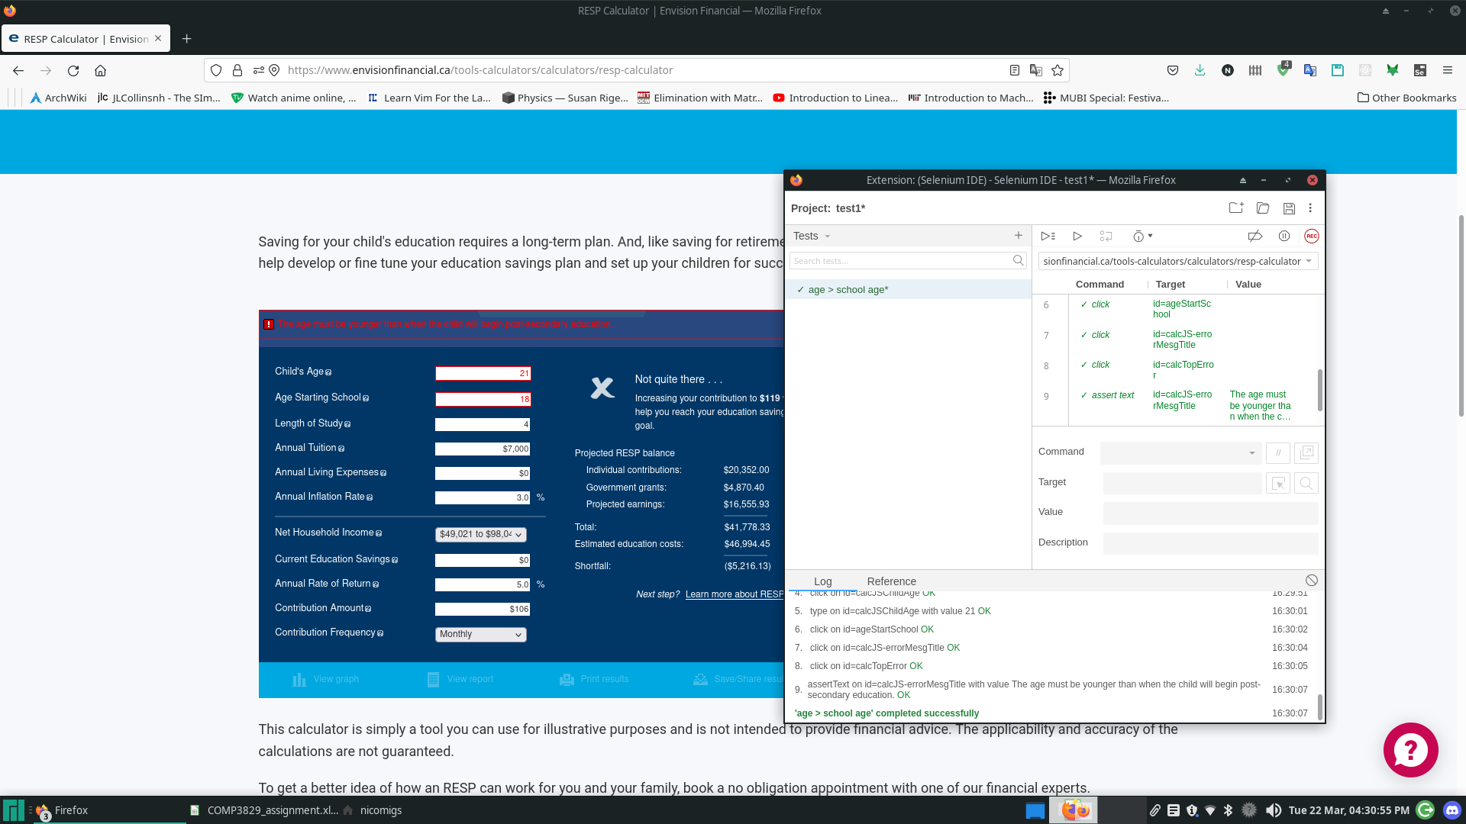

Test Case 3

Long Study

Test Code

// Generated by Selenium IDE

import org.junit.Test;

import org.junit.Before;

import org.junit.After;

import static org.junit.Assert.*;

import static org.hamcrest.CoreMatchers.is;

import static org.hamcrest.core.IsNot.not;

import org.openqa.selenium.By;

import org.openqa.selenium.WebDriver;

import org.openqa.selenium.firefox.FirefoxDriver;

import org.openqa.selenium.chrome.ChromeDriver;

import org.openqa.selenium.remote.RemoteWebDriver;

import org.openqa.selenium.remote.DesiredCapabilities;

import org.openqa.selenium.Dimension;

import org.openqa.selenium.WebElement;

import org.openqa.selenium.interactions.Actions;

import org.openqa.selenium.support.ui.ExpectedConditions;

import org.openqa.selenium.support.ui.WebDriverWait;

import org.openqa.selenium.JavascriptExecutor;

import org.openqa.selenium.Alert;

import org.openqa.selenium.Keys;

import java.util.*;

import java.net.MalformedURLException;

import java.net.URL;

public class LongstudyTest {

private WebDriver driver;

private Map<String, Object> vars;

JavascriptExecutor js;

@Before

public void setUp() {

driver = new FirefoxDriver();

js = (JavascriptExecutor) driver;

vars = new HashMap<String, Object>();

}

@After

public void tearDown() {

driver.quit();

}

@Test

public void longstudy() {

driver.get("https://www.envisionfinancial.ca/tools-calculators/calculators/resp-calculator");

driver.manage().window().setSize(new Dimension(1920, 1015));

driver.switchTo().frame(0);

driver.findElement(By.id("yearsAtSchool")).click();

driver.findElement(By.id("yearsAtSchool")).sendKeys("11");

driver.findElement(By.id("roomAndBoard")).click();

driver.findElement(By.id("calcJS-errorMesgTitle")).click();

driver.findElement(By.id("calcTopError")).click();

assertThat(driver.findElement(By.id("calcJS-errorMesgTitle")).getText(), is("Length of study must be between 1 and 10 years."));

}

}

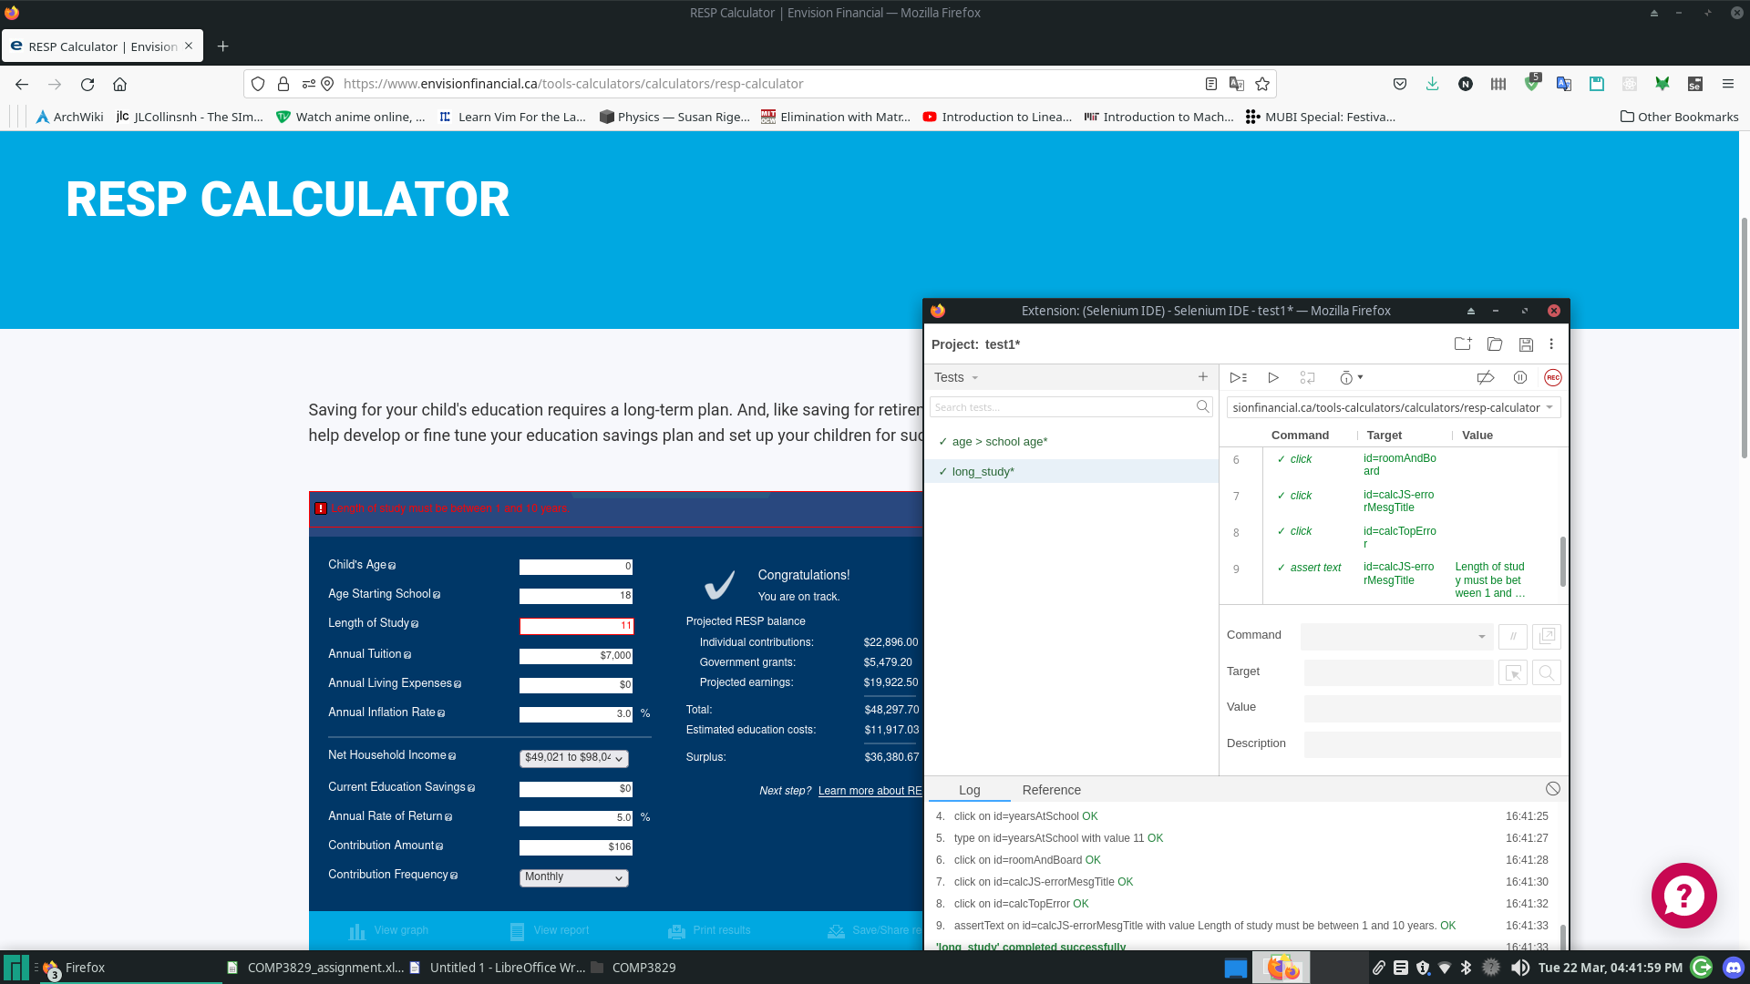

Test Case 1

Positive Test Case

// Generated by Selenium IDE

import org.junit.Test;

import org.junit.Before;

import org.junit.After;

import static org.junit.Assert.*;

import static org.hamcrest.CoreMatchers.is;

import static org.hamcrest.core.IsNot.not;

import org.openqa.selenium.By;

import org.openqa.selenium.WebDriver;

import org.openqa.selenium.firefox.FirefoxDriver;

import org.openqa.selenium.chrome.ChromeDriver;

import org.openqa.selenium.remote.RemoteWebDriver;

import org.openqa.selenium.remote.DesiredCapabilities;

import org.openqa.selenium.Dimension;

import org.openqa.selenium.WebElement;

import org.openqa.selenium.interactions.Actions;

import org.openqa.selenium.support.ui.ExpectedConditions;

import org.openqa.selenium.support.ui.WebDriverWait;

import org.openqa.selenium.JavascriptExecutor;

import org.openqa.selenium.Alert;

import org.openqa.selenium.Keys;

import java.util.*;

import java.net.MalformedURLException;

import java.net.URL;

public class PositivetestTest {

private WebDriver driver;

private Map<String, Object> vars;

JavascriptExecutor js;

@Before

public void setUp() {

driver = new FirefoxDriver();

js = (JavascriptExecutor) driver;

vars = new HashMap<String, Object>();

}

@After

public void tearDown() {

driver.quit();

}

@Test

public void positivetest() {

driver.get("https://www.envisionfinancial.ca/tools-calculators/calculators/resp-calculator");

driver.manage().window().setSize(new Dimension(1920, 1015));

driver.switchTo().frame(0);

driver.findElement(By.id("calcJSChildAge")).click();

driver.findElement(By.id("calcJSChildAge")).sendKeys("2");

driver.findElement(By.id("ageStartSchool")).click();

driver.findElement(By.id("yearsAtSchool")).click();

driver.findElement(By.id("calcJSTuition")).click();

driver.findElement(By.id("calcJSTuition")).click();

driver.findElement(By.id("calcJSTuition")).sendKeys("$10,000");

driver.findElement(By.id("calcJSTuition")).click();

driver.findElement(By.id("roomAndBoard")).click();

driver.findElement(By.id("roomAndBoard")).sendKeys("$10,000");

driver.findElement(By.id("calcJSInflation")).click();

driver.findElement(By.id("calcJSInflation")).sendKeys("2.1");

driver.findElement(By.id("netFamilyIncome")).click();

driver.findElement(By.cssSelector("#netFamilyIncome > option:nth-child(2)")).click();

driver.findElement(By.id("currentEduSavings")).click();

driver.findElement(By.id("annualRateOfReturn")).click();

driver.findElement(By.id("contributionAmount")).click();

driver.findElement(By.id("contributionAmount")).sendKeys("$350");

driver.findElement(By.id("contributionFrequency")).click();

driver.findElement(By.cssSelector("#contributionFrequency > option:nth-child(1)")).click();

assertThat(driver.findElement(By.id("respSurplus")).getText(), is("$11,192.32"));

}

}

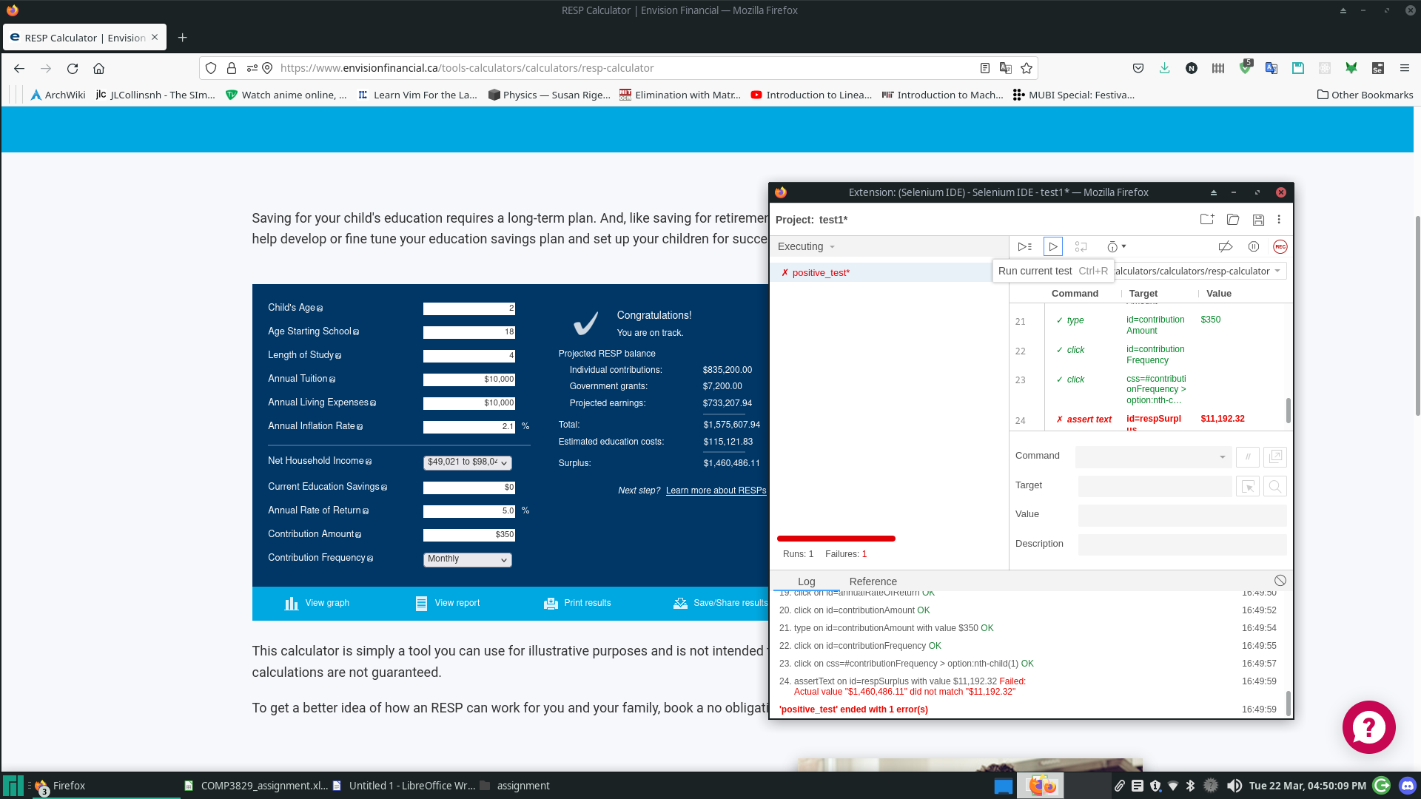

Bug Report in Excel