**List of changes to the EasySpin Code in order to run it on Octave**

Nicolás I. Neuman

June 1st 2021

This document, as well as the code , is provided without any warranty whatsoever.

On running ‘easyspin’, the first warning is on verLessThan, called from chkmlver, from easyspininfo, which checks the Matlab version. These checks have to be commented everywhere on the code.

First important change:

Comment

error(chkmlver);

everywhere.

The following error is in:

easyspincompile at line 34 column 4

This error occurs because the function

mex.getCompilerConfigurations ('C','Installed');

which checks that there is a compiler installed, is not understood. The function mex cannot be indexed with a dot in Octave.

Solution: Comment lines 34-39. But we have to make sure that Octave has access to the proper C-compiler, so that the mex-files will be compiled.

After commenting this line, compilation of 9 files is peformed. In my installation, there is one file that fails:

(4/9) mdhmm_lbfgsb_wrapper.c

The full trace is the following:

>> easyspin

EasySpin not yet compiled for this platform (0/9 files). Attempting to compile.

EasySpin compilation

directory: C:\Users\User\Documents\Intec\Investigacion\EPR Simulation\EasySpin-1jun2021\easyspin\private

version: 6.2.0

mex extension: mex, 32-bit

compiling 9 c-files...

(1/9) chili_lm.c complete

(2/9) cubicsolve.c complete

(3/9) lisum1i.c complete

(4/9) mdhmm_lbfgsb_wrapper.c mdhmm_lbfgsb_wrapper.c:111:1: error: unknown type name 'mxLogical'; did you mean 'logical'?

111 | mxLogical isInt( const mxArray *pm ) {

| ^~~~~~~~~

| logical

mdhmm_lbfgsb_wrapper.c:111:24: error: unknown type name 'mxArray'

111 | mxLogical isInt( const mxArray *pm ) {

| ^~~~~~~

mdhmm_lbfgsb_wrapper.c: In function 'isInt':

mdhmm_lbfgsb_wrapper.c:126:20: warning: implicit declaration of function 'mxIsInt16' [-Wimplicit-function-declaration]

126 | return mxIsInt16(pm);

| ^~~~~~~~~

mdhmm_lbfgsb_wrapper.c:128:20: warning: implicit declaration of function 'mxIsInt32' [-Wimplicit-function-declaration]

128 | return mxIsInt32(pm);

| ^~~~~~~~~

mdhmm_lbfgsb_wrapper.c:130:20: warning: implicit declaration of function 'mxIsInt64' [-Wimplicit-function-declaration]

130 | return mxIsInt64(pm);

| ^~~~~~~~~

mdhmm_lbfgsb_wrapper.c:132:13: warning: implicit declaration of function 'mexErrMsgTxt' [-Wimplicit-function-declaration]

132 | mexErrMsgTxt("You have a weird computer that I don't know how to support");

| ^~~~~~~~~~~~

mdhmm_lbfgsb_wrapper.c:133:20: error: 'false' undeclared (first use in this function); did you mean 'fclose'?

133 | return false;

| ^~~~~

| fclose

mdhmm_lbfgsb_wrapper.c:133:20: note: each undeclared identifier is reported only once for each function it appears in

mdhmm_lbfgsb_wrapper.c: At top level:

mdhmm_lbfgsb_wrapper.c:139:29: error: unknown type name 'mxArray'

139 | void mexFunction( int nlhs, mxArray *plhs[], int nrhs, const mxArray*prhs[] ) {

| ^~~~~~~

mdhmm_lbfgsb_wrapper.c:139:62: error: unknown type name 'mxArray'

139 | void mexFunction( int nlhs, mxArray *plhs[], int nrhs, const mxArray*prhs[] ) {

| ^~~~~~~

warning: mkoctfile: building exited with failure status

failed

mex: building exited with failure status

(5/9) multimatmult_.c complete

(6/9) multinucstick.c complete

(7/9) projecttriangles.c complete

(8/9) projectzones.c complete

(9/9) sf_peaks.c complete

EasySpin compilation unsuccessful.

==================================================================

Release: $ReleaseID$ ($ReleaseDate$)

Expiry date: $ExpiryDate$

Folder: C:\Users\User\Documents\Intec\Investigacion\EPR Simulation\EasySpin-1jun2021\easyspin

MATLAB version: 6.2.0

Platform: Microsoft Windows [Version 10.0.19042.985]

mex-files: mex, 0.111111/

System date: 01-Jun-2021 10:12:07

Temp dir: C:\Users\User\AppData\Local\Temp\

==================================================================

Solution: For now, ignore this problem, as this file is necessary to implement the L-BFGS-B algorithm, that probably is used within the esfit function.

Then I will run an example, which calls the function pepper.

chkmlver at line 15 column 1

pepper at line 61 column 1

Solution:

Comment

error(chkmlver);

everywhere.

After this, pepper gives warnings:

warning: implicit conversion from matrix to sq_string

pepper at line 113 column 1

pepper at line 158 column 33

Solution:

Change

error(err) -> error(strvcat(err));

everywhere

Within pepper, the validatespinsys function is called, which runs easyspincompile. Presumably as this compilation has failed for one file, it is not validated and tries to compile again.

So in the validatespinsys file we should comment lines 36-42.

Other warnings and errors in pepper

warning: implicit conversion from matrix to sq_string

warning: called from

pepper at line 528 column 3

pepper at line 158 column 33

HSCo_pepper at line 34 column 12

warning: implicit conversion from matrix to sq_string

warning: called from

parseoption at line 25 column 3

pepper at line 561 column 24

pepper at line 158 column 33

HSCo_pepper at line 34 column 12

error: verLessThan: package "matlab" is not installed

error: called from

verLessThan at line 72 column 5

chkmlver at line 15 column 1

resfields at line 45 column 1

pepper at line 643 column 38

pepper at line 158 column 33

HSCo_pepper at line 34 column 12 resfields at line 45 column 1

Solution:

Everywhere in pepper, parseoption:

Change

Error(err)

by

error(strvcat(err)); %Matlab->Octave

In resfields (and to save time, also on resfields_perturb), comment error(chkmlver) and also fix error(err);

After fixing all these things, the following example passed:

HSCo_pepper_onlySym.m

clear all, close all

Bmin = 0; %in mT

Bmax = 500;

Freq = 9.456; %Frecuencia en Hz

g1 = [5.197 0 0;0 4.134 0;0 0 3.4];

Sys.S = 0.5;

Sys.g = g1;

Sys.Nucs = '59Co';

Sys.A = [500 0 0;0 400 0;0 0 300]; %MHz

Sys.lwpp = [0 2]; %mT

Vary.g = [0.2 0 0;0 0.2 0;0 0 0.2];

Vary.A = [50 0 0;0 50 0;0 0 50];

Exp.Range = [Bmin Bmax];

Exp.nPoints = 8192;

Exp.mwFreq = Freq;

[B,SimSpc] = pepper(Sys,Exp);

plot(B,SimSpc/max(SimSpc),'-r');

Produces the following simulation.

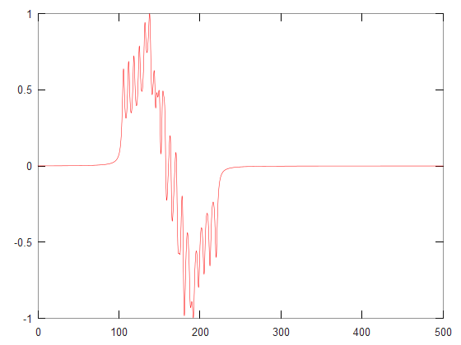

Another example which uses least-squares fiting (esfit) is the following (a small modification of basicfit.m)

% Basic example of spectral fitting using EasySpin

%====================================================================

clear

% Since we don't have any experimental data available, let's create some mock

% data by simulating a spectrum and adding some noise. If you use this example

% as a basis for your fittings, replace this code by code that loads your

% experimental data.

Sys.g = [2 2.1 2.2];

Sys.Nucs = '1H';

Sys.A = [120 50 78];

Sys.lwpp = 1;

Exp.mwFreq = 10;

Exp.Range = [300 380];

[B,spc] = pepper(Sys,Exp);

spc = addnoise(spc,150,'n');

% Now we set up the least-squares fitting. First comes a starting set of

% parameters (which we obtain by copying the spin system from the simulation

% and changing a few values).

Sys0 = Sys;

Sys0.A = [100 50 78];

Sys0.g(1) = 1.98;

% Next, we specify which parameter we want to be fitted and by how much the

% fitting algorithm can vary it approximately.

Vary.g = [0.1 0 0];

Vary.A = [30 0 0];

% We also can provide options for the simulation function.

SimOpt.Method = 'perturb';

% Finally, we specify the fitting algorithm and what should be fitted.

FitOpt.Method = 'simplex int'; % simplex algorithm, integrals of spectra

[bestsys,bestspc] = esfit(@pepper,spc,Sys0,Vary,Exp,SimOpt,FitOpt);

plot(B,spc/max(spc),'-k',B,bestspc/max(bestspc)-0.1,'-r');

% If the fitting algorithm doesn't find the correct minimum, you can change

% the algorithm, target function, and starting point in the UI. For example,

% run Monte Carlo for a bit, save the best fit, and then use that as the

% starting point with Nelder/Mead to close in on the correct fit.

This produces the following output.

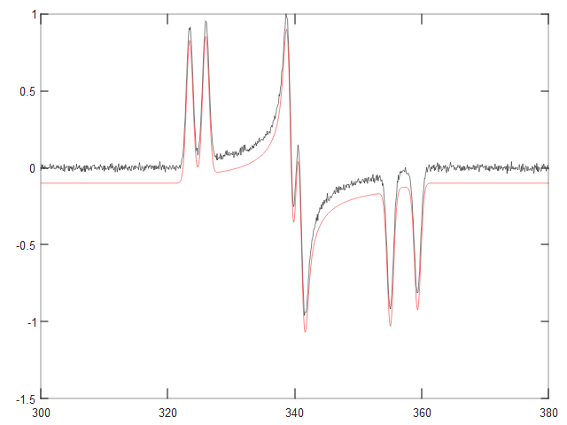

>> bestsys

bestsys =

scalar structure containing the fields:

g =

1.9999 2.1000 2.2000

Nucs = 1H

A =

119.924 50.000 78.000

lwpp = 1

weight = 1