**Unit 1 User manuals and instructions**

1. **Basic qualities of technical communication**

Interactive and adaptable

Reader centered

Reliant on teamwork

Visual

Bound ethically，legally and politically

International and transcultural

1. **Writing definitions: three types of definitions**

Parenthetical Definitions

Sentence Definitions

Extended Definitions

1. **Guidelines for writing descriptions**

mechanism and object descriptions

elements contained in instructions

a title (good title)

general introduction (how to draft introductions)

step-by-step instructions (tips)

a conclusion (how to draft conclusions; troubleshooting guide)

1. **Diagrammatic features**
2. **Ways to improve the appearance**

**Unit 2 Email**

1. **How communication flows in an organization**

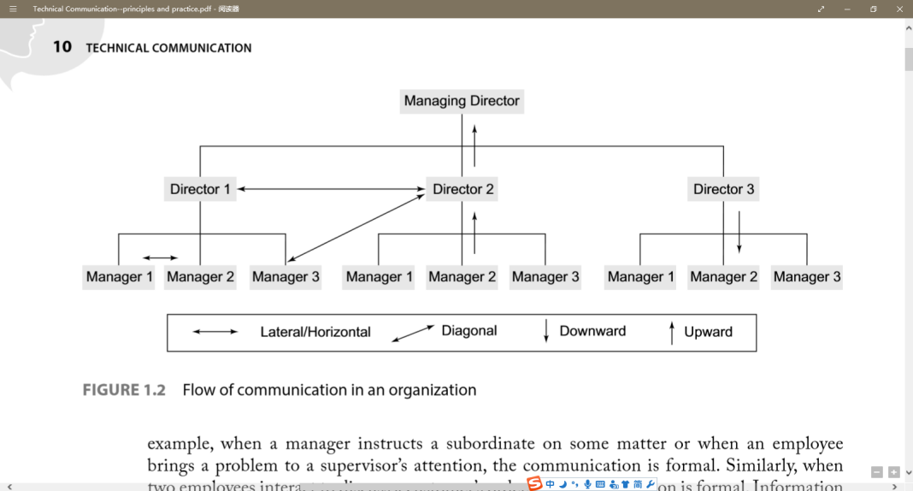

horizontal/lateral communication: Communication between peers

vertical communication: Communication between superiors and subordinates

diagonal communication: Communication between superiors and subordinates without going through the hierarchical set-up inside the organization

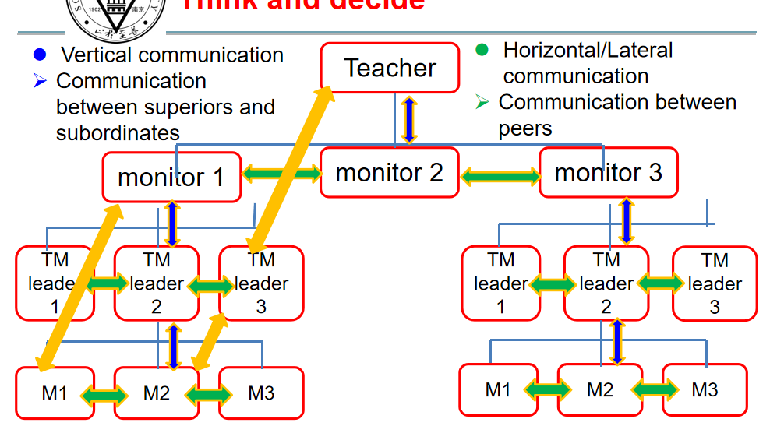

1. **Format and basic elements of an email**

From

To

CC=courtesy copy：抄送

BC or BCC=blind courtesy copy：密件抄送

Sent

Subject

Attachment

Format Elements: Header, Message and Signature

1. **“you-attitude”**

correspondence must convey a courteous, positive tone.The key to accomplishing this task is using the "youattitude”-that is, looking at the situation from the reader's point of view and adjusting the content, structure,and tone to meet his or her needs.

Put yourself in your reader's shoes

Try to imagine what your reader will feelabout what you write

Reflect and emphasize your reader'sneeds, interests and concerns

Protect your reader's ego

**Unit 3 Memo**

1. **Channels of communication at workplace**

Face-to-face communication

Communication over telephone

Communication through email

Communication through an inter-office memo

1. **Audience & purposes/functions**

Purposes:

To request for action or information

请求采取行动或提供信息

Compared with an oral request, a written request in the form of a memo is more difficult for the reader to forget or ignore

与口头请求相比，备忘录形式的书面请求更难让读者忘记或忽略

To explain to the reader something that is not understood.

向读者解释一些不被理解的东西。

To announce or to give formal notice to readers, publicly informing them about new procedures, new products, or anything that needs to be publicly known.

向读者发布或发出正式通知，公开告知他们有关新程序、新产品或任何需要公开的信息。

To confirm the details of a meeting, conversation, or telephone call.

确认会议、谈话或电话的细节。

To suggest solutions to business problems, to offer one’s services or those of the department, or to bring up new ideas or methods of doing things.

提出解决业务问题的建议，提供自己或部门的服务，或提出新的想法或做事方法。

To report the details of a project at regular intervals as a way of helping the organization keep track of progress and problems.

定期报告项目的详细信息，以帮助组织跟踪进度和问题。

Functions:

facilitate communication about various operations

促进各种操作的沟通

help arrive at some quick decisions

帮助做出一些快速的决定

help solve problems

帮助解决问题

by informing the reader about new information, such as policy changes, price increases. (informative)

通过告知读者新信息，如政策变化、价格上涨

by persuading the reader to take an action, such as attend a meeting, use less paper, change a current production procedure. (persuasive)

通过说服读者采取行动，例如参加会议、减少用纸、改变当前的制作流程

enable the information to flow in 3 types of communication:

vertical (upward & downward), horizontal and diagonal

help bridge the communication gap among the various sections of an organization

serve as permanent record of information

使信息以3种通信方式流动：

垂直（向上和向下）、水平和对角

帮助弥合组织各部门之间的沟通差距

作为信息的永久记录

1. **Components and format of a memo**
2. Heading

Subject Line: taken the four key words from the main message. Underline those words in the body of the memo.

1. Opening

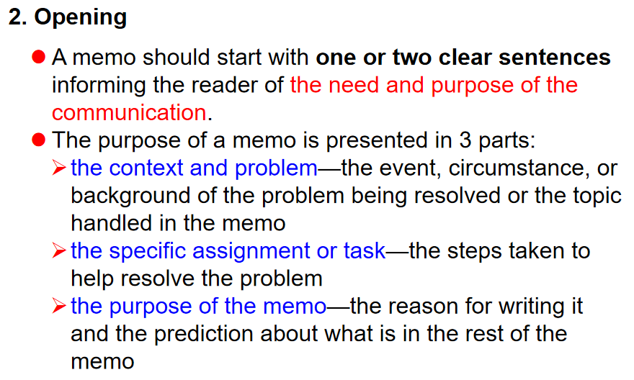

1. Discussion

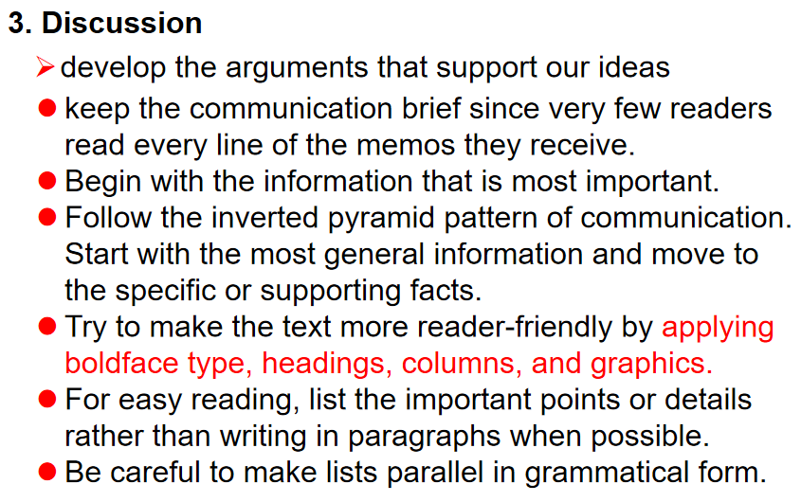

1. Closing

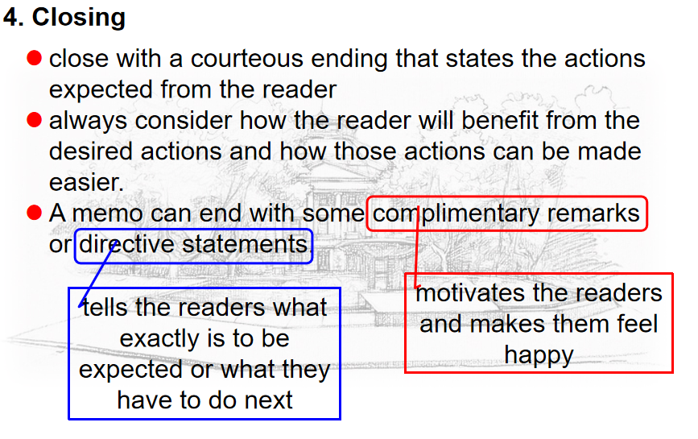

1. **Writing skills**

Subject writing skills

Closing writing skills

**Unit 4 Job application**

1. **Background knowledge of a résumé**
2. **Type, components, format of a résumé**

Type:

Chronological résumé

Functional/skills résumé

Hybrid/combination résumé

Components:

dentifying information (personal/contact information)

objectives or summary of qualifications (Career/professional objective)

education (Educational/academic qualifications)

employment history (Work experience /Professional and technical skills)

Interests and activities (Extracurricular activities and achievements/special interests, aptitudes, memberships /Awards and honours)

References

1. **Difference between a résumé and a CV**

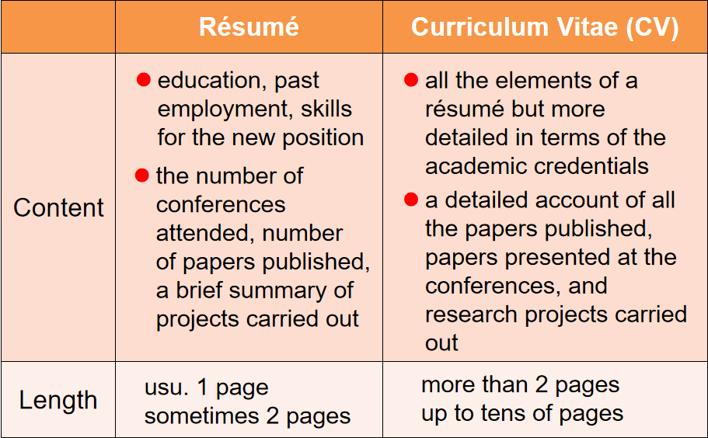

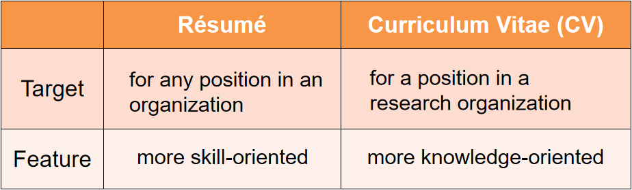

1. **Writing skills**

Starting with power verbs

Achievement (résumé) writing skills

Cover letter writing skills

**Unit 1 Presentation skills**

1. **Advantages and disadvantages of visual aids**

Advantages:

Portray instantly and vividly things that are impossible to convey verbally.

Save time.

Create interest.

Bring variety.

Add impact.

Remain in memory longer than words.

Disadvantages:

Reduce flexibility.

Expensive.

Can divert attention from what is being said.

Confusion and humiliation if they go wrong.

1. **Good ways to open a presentation**

Grab attention

Explain “what is in it for them”

Build up your authority

Go through the structure of the presentation

1. **Good ways to end a presentation**

In conclusion/Before we stop for coffee…

Restate “Take Home message”

Handle questions if necessary

1. **Techniques for handling questions**

Listen to the question

Pause – give yourself valuable thinking time

Show understanding– seek point for agreement initially

Control your audience with eye contact

Brevity – keep your answer short and succinct

1. **Functions of body language**

Body language can also cancel or reinforce what we are saying verbally and it is essential that the two sets of messages agree.

1. **Functions of pitch, pace and pause in a presentation**

Pitch(说话的音符):

This simply means the note at which you speak. Just as a musical instrument would be very dull if it was played using two or three notes so is the voice if a speaker has a restricted range.

Pace:

Pace is the rate at which you speak. It is important to vary the rate at which you speak in order to add colour and variety to your voice.

Pause:

Pauses are very necessary in speech for a number of reasons and these are:

1. Gives the speaker time to think

2. Gives the audience time to absorb information

3. Makes the speaker appear in control, authoritative and confident

4. Useful for dramatic effect

**Unit 2 Welcome/Opening speech**

**1、Elements of a welcome speech and its features**

greeting and appreciation

background of the event

purposes/questions to be discussed

agenda

good wishes

1. **Purposes of a welcome speech**

extending welcome and appreciation

setting the tone

informing the attendees of the theme and agenda

declaring the opening

1. **General linguistic patterns for each purpose in a welcome speech**
2. **Language: useful expressions**

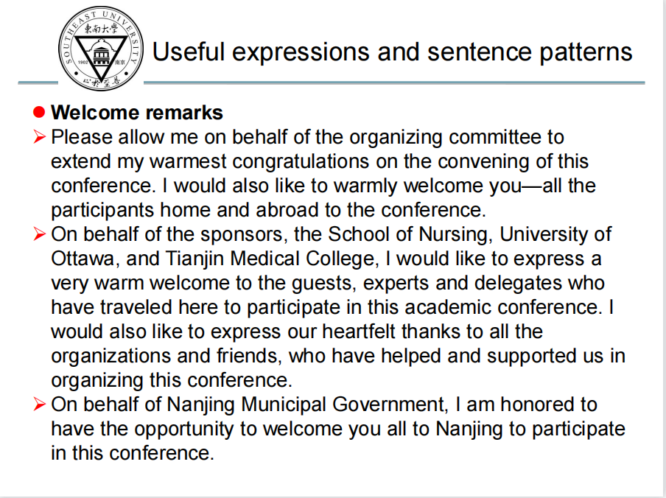

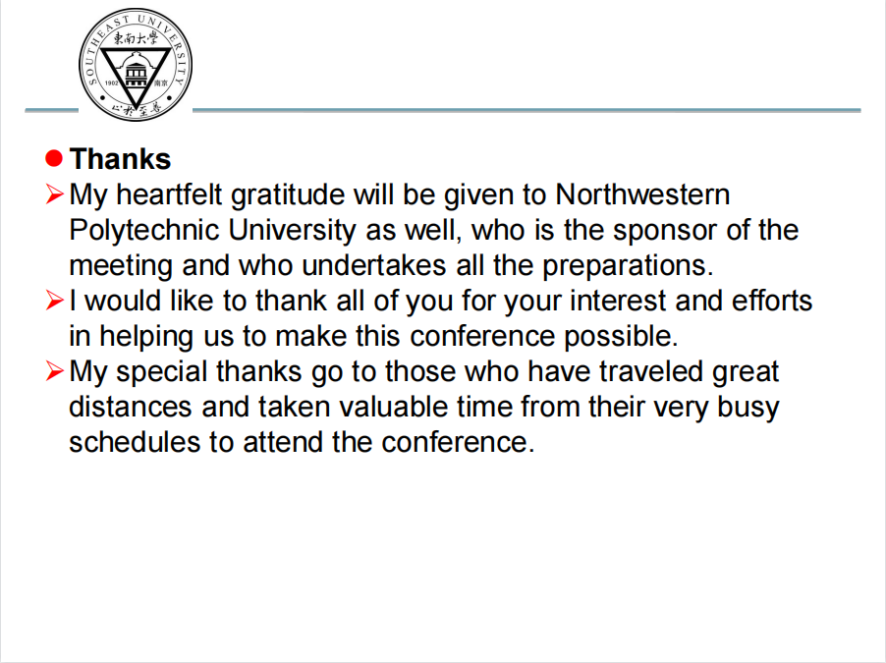

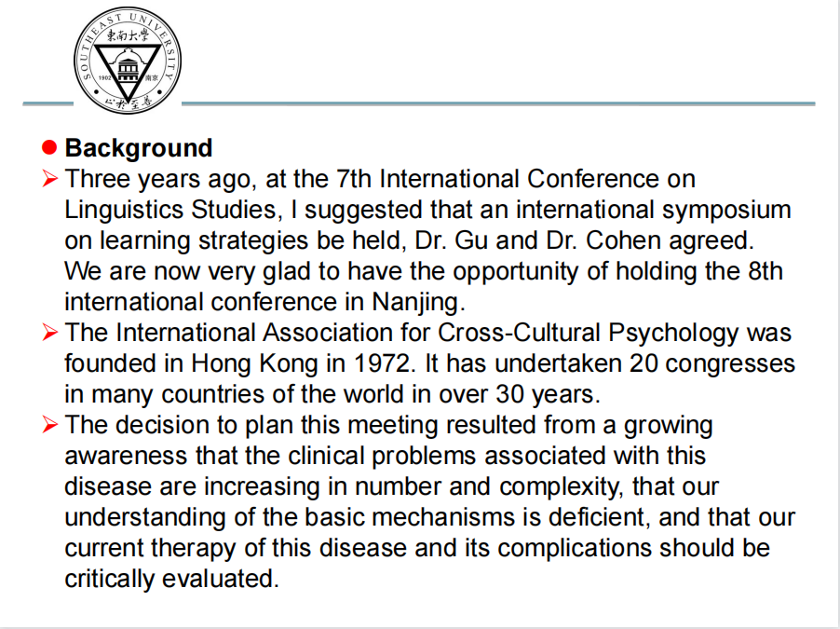

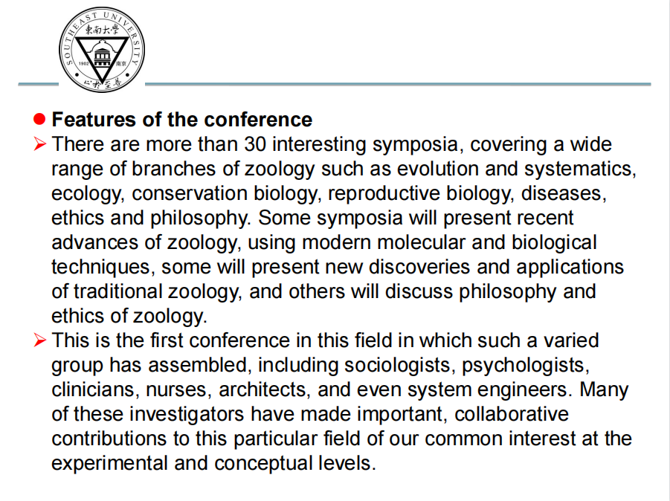

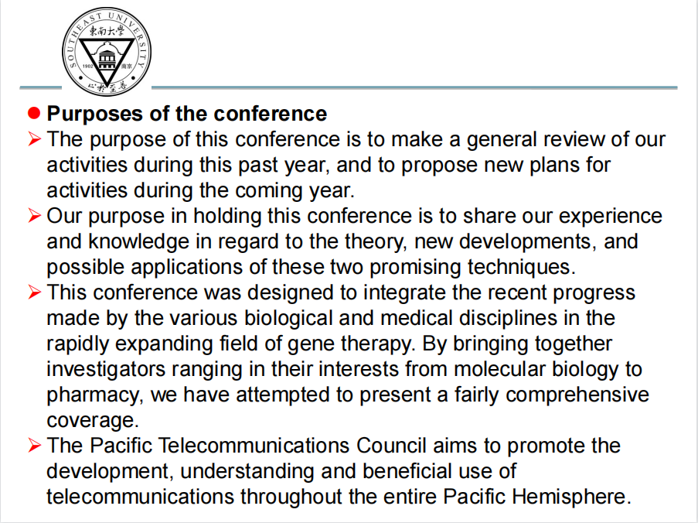

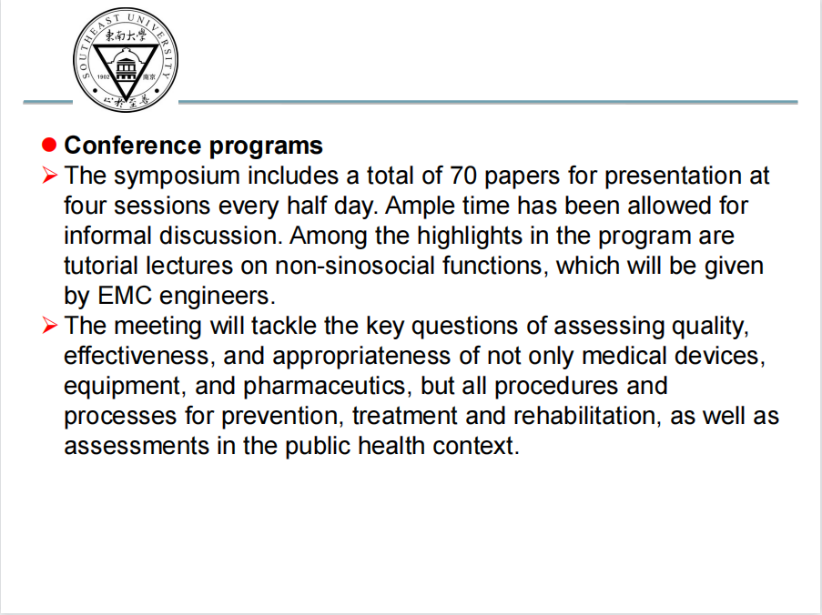

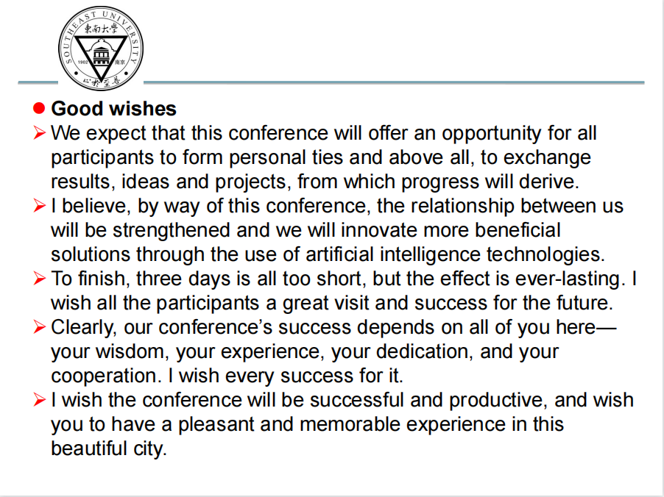

**Unit 3 Introducing speakers**

1. **How to make preparation for speaker introduction**
2. Ask the speaker what they’d like you to say.
3. Find out what subject the speaker will cover.
4. Look up biographical information on the speaker.
5. Avoid using sensitive or embarrassing information without approval.
6. Find other speeches the speaker has given.
7. Include a surprising detail if it fits in your intro.
8. Master pronouncing the speaker’s name.
9. Check for any special titles the speaker has.
10. **Contents of speaker introduction**

Academic achievements

Speech experiences

Awards and honors

1. **Dos and don’ts in a speaker introduction**

Don’t make the remarks too effusive or hyperbolic

The introduction should not last longer than three minutes or some two hundred words

Introduce the speakers in a comfortable and professional manner

1. **What to do after the introduction**
2. **Language: useful expressions**

**Unit 4 Keynote speech**

1. **Definition of keynote speech**

The keynote of a speech is the main theme of a speech or the part that is emphasized the most.

1. **Definition of keynote Speaker**

a very distinguished speaker introducing the meeting or its subject

1. **Structure of keynote speech**

a speech setting forth the keynote, containing a central or the most important idea

1. **Organization of the body of the speech**
2. **Techniques of delivering a keynote speech**

Present your main points one by one in logical order.

Pause at the end of each point (give people time to take notes, or time to think about what you are saying).

Make it absolutely clear when you move to another point.

1. **Language: useful expressions**

**Unit 5 Q & A**

1. **The time for the Q &A Session**

It starts the moment the keynote speaker finishes his or her speech.

（If there are several keynote speakers, it is very likely that the Q&A session happens after all the speeches are over.）

1. **Announcing the Q &A Session**

One is the chairperson，who gives the audience the timetable or the agenda before the conference actually starts.

The other is the keynote speaker himself/herself.

1. **Timing the Q & A Session**

No matter who is in charge of this session, the chairperson or the speaker, he or she should control the time, especially at the last one or two minute. For example, we have only two minutes left, one more question.

1. **Possible question types**

·Ask the speaker to further elaborate on the particular concept he or she made in the speech.

·Ask the speaker to give you some suggestions on your professional development.

·Ask the speaker to repeat the point you failed to understand.

·Air your own opinion different from the speaker 's (not suggested).

·Follow up another listener 's question.

·Any questions centering around the topic the speaker has made.

1. **Tips for answering questions**

·Don't raise a question without permission, even without a microphone.

·Don't speak, both speaker and listener, until the whole audiences are quiet.

·Don't introduce yourself too much.

·Don't ask more than two questions at one time. Leave opportunities to others.

·Don't forget to say “Thank you” at the end of your speech, either speaker or listener.

**6、Language: useful expressions**

**Unit 6 Closing speech**

1. **Functions of a closing speech**

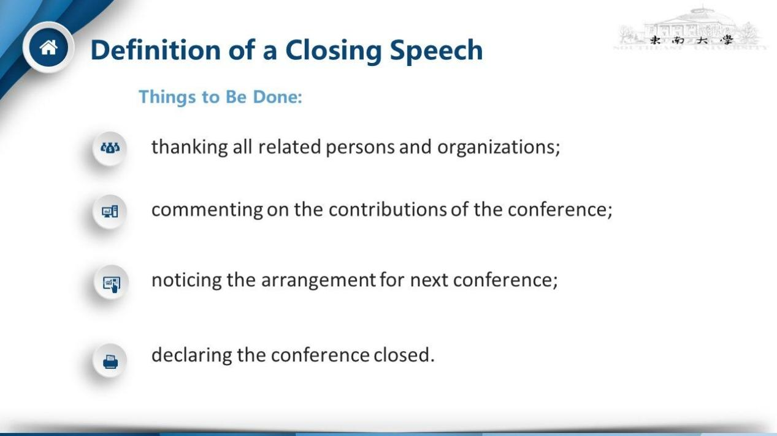

1. **Elements of a closing speech**

Appreciation、summary、evaluation、expectation、invitation、closing

1. **Similarity and difference between an opening speech and a closing speech**

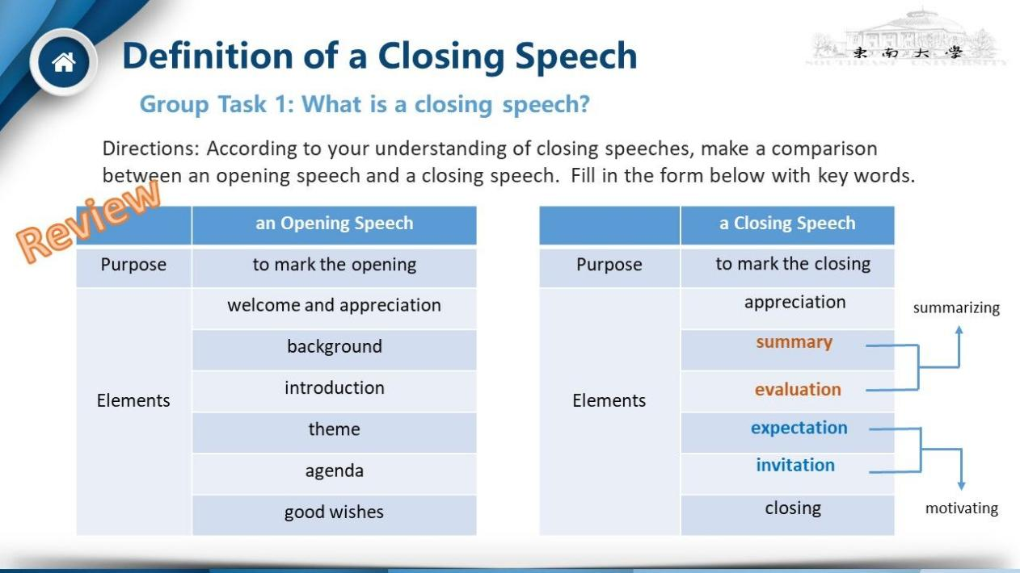

1. **Linguistic features of a closing speech**
2. **Language: useful expressions**