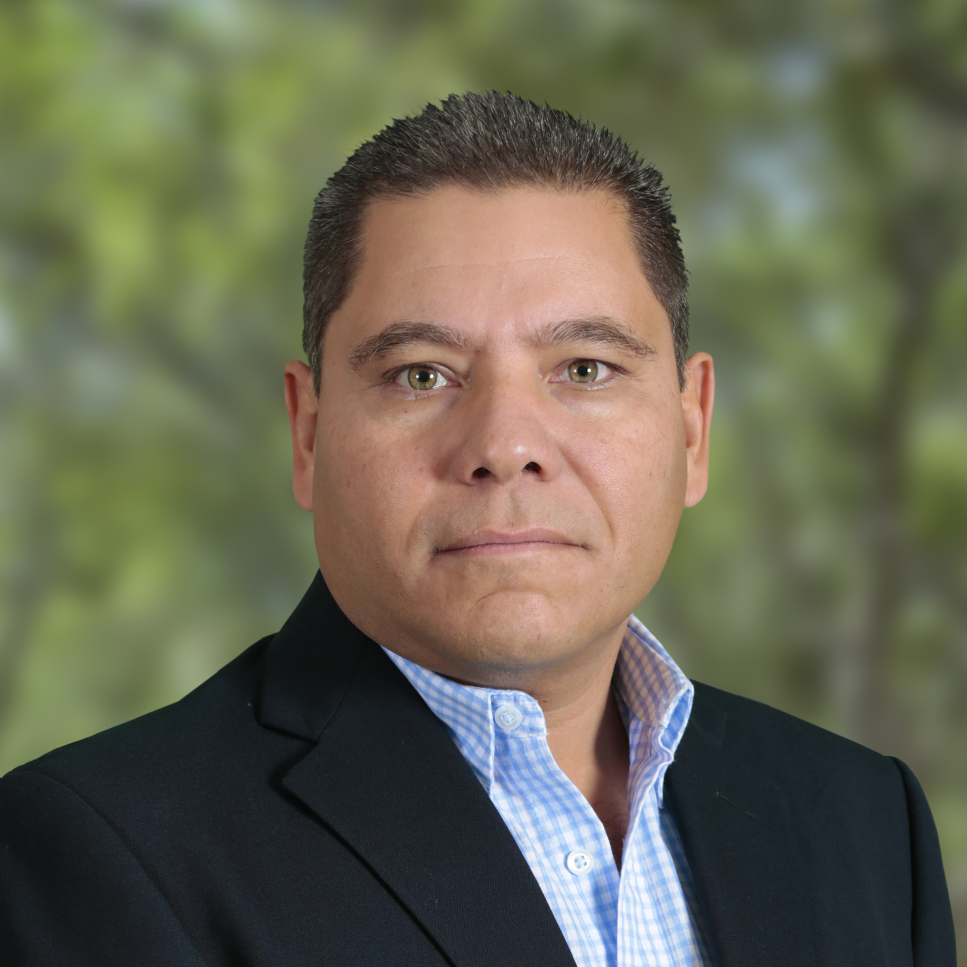

José Manuel Rosales Barrera

Paseo Lira 30

Fracc. Pontevedra

Guadalajara, Jal.

Mexico

Mobile phone: 52+(33) 15 66 54 24

Home phone: 52+(33) 16 47 68 01

E-mail:

[rosales01sin@gmail.com](mailto:rosales01sin@gmail.com)

Skype: jose.manuel.rosales.barrera

**WORK EXPERIENCE**

Company: HINES INTERESTS MEXICO

Post: Construction Manager

Date: March 2016 - current

Responsibilities: Engineering and design coordination, estimating, construction startup and progress control, contractors hiring, quality control, staff hiring, permits processing, client support in previous overall activities, marketing and project management support for tenants prospects.

Achievements: On time engineering, estimating and permits delivery; progress construction on time for Parque Industrial Tecnológico 4 ($ 60 USD million), in a 330,000 m2 area. Today construction progress 50%. Complete tenant’s satisfaction with quality and time delivery.

Company: Alberici Constructors Inc.

Post: Preconstruction Manager

Date: December 2014 – March 2016

Responsibilities: Engineering and design coordination, estimating, startup project construction, contractors hiring, staff hiring, permits processing, client support in previous overall activities.

Achievements: On time engineering and estimating delivery to achieve the projects; client’s satisfaction about service and quality; costs saving through the daily review of the needs of projects: Tokyo Roki ($ 10 USD million), Stanley Electric ($ 42 USD million), Chiyoda Integre ($ 5 USD million)

Company: M+W GROUP

Post: Construction Manager

Date: January 2014 – October 2014

Responsibilities: Engineering and works quality control for BDF (NIVEA) facilities construction; contractors activities control; quotations and works authorization; cost estimating for new CO’s; engineering team integration (Project value $120’000,000.00 USD)

Achievements: On time engineering and construction deliveries to get the project substantial completion; client’s satisfaction about quality and time deliveries; costs saving through the daily review of the needs of projects.

Company: Freelance

Post: Project advisor

Date: August 2013 – December 2013

Responsibilities: Technical advising for industrial and infrastructure projects. Basic engineering and scope of work management.

Achievements: Technical and financial definition for jobs start; engineering quality control to get the best cost for the projects.

Company: FERROCARRIL MEXICANO S.A. DE C.V.

Post: Construction Manager

Date: May 2012 – August 2013

Responsibilities: Railway and special facilities projects management in the largest rail road system in Mexico. Activities include engineering and construction management; daily, weekly and monthly oversight, schedule, general status reports: construction, quality control, finance schedule. (Projects value for more than $100’000,000.00 USD)

Achievements: On time construction projects deliveries, ensuring the operation needs for the commercial and sales departments; costs saving through the daily review of the needs of projects

Company: Freelancer

Post: Freelance Estimator

Date: December 2011 – April 2012

Responsibilities: Estimating services for many companies for multiple projects in the public and private field.

Achievements: Achieving 2 contracts ($2´000,000 USD) from 4 estimated.

Company: UMBRAL CAPITAL SAPI DE C.V.

Post: Technical Manager

Date: November 2009 – November 2011

Responsibilities: Multiple housing projects management along Mexico. Activities include Engineering and construction management; daily, weekly and monthly oversight, schedule, general status reports: sales, construction, quality control, finance schedule. (Projectsvalue for more than $650’000,000.00 pesos)

Achievements: Building and operational costs savings through a detailed analysis of the needs of the current and new projects; company business decisions supporting the technical field.

Company: URBI Construcciones del Pacífico-Plaza Irapuato

Post: Preconstruction Manager

Date: June 2008 – November 2009

Responsibilities: General management of San Roque housing project at Irapuato, Gto.; land acquisition, executive project procurement (architecture, engineering, estimating), permits procurement. Project value $950’000,000.00 pesos.

Achievements: Engineering and costs delivered on time to start construction activities.

Company: HINES INTERESTS MEXICO

Post: Construction Manager

Date: June 2007 – May 2008

Responsibilities: Project management construction for COOPER STANDARD workshop expansion 15,000 m² .Project value $5, 000,000.00USD

Achievements: Project delivered on time, and the total satisfaction of the client.

Company: FINCAMEX S.A. DE C.V.

Post: Quality control manager

Date: October 2006 – May 2007

Responsibilities: Control Quality improvement for the construction procedure methods in housing construction in 13 developments in North East Mexico. Projects value $430, 000,000.00 pesos

Achievements: Construction savingsfor 5% and costumers total satisfaction when delivering houses.

Company: FUJITA CORPORATION MEXICO

Post: Project Manager

Date: January 2005 – September 2006

Responsibilities: EPC (Engineering, Procurement and Construction) projects management in the automobile industry. The main customer was NISSAN MEXICANA and the suppliers industries that NISSAN moves, including JATCO, NICOMETAL, AHRESTY, SANS, UNIPRESS, SANHO, and other minor suppliers.

Achievements: $3’000,000.USD profit.

Company: CONSORCIO ARA

Post: Project Leader

Date: May 2003 – June 2004

Responsibilities: Control Quality improvement for the construction procedure methods in housing construction in 6 developments in North Mexico (Projects value $100,000,000.00USD)

Achievements: Construction savings for 3% and costumers total satisfaction when delivering houses.

Company: PRADI CONSTRUCCIONES

Post: Construction Manager

Date: March 2002 – May 2003

Responsibilities: EPC projects management for federal and municipal authorities.

Achievements: $20’000,000.00 pesos profit.

Company: PRODEMEX S.A. DE C.V.

Post: Estimating Manager

Date: February 2001 – March 2002

Responsibilities: Construction budgets and schedules procurement for the construction of a 116 rooms hotel in Loreto, México.

Achievements: $35’000,000.00 pesos profit.

Company: CONSTRUCCIONES ICAR S.A. DE C.V.

Post: Job site manager

Date: September 1999 – February 2001

Responsibilities: Technical an administrative management in the construction of a custom post at Agua Prieta, Sonora and a Tax Collection Office at Durango.

Achievements: $5’000,000.00 pesos profit.

Company: CONSTRUCTORA DE EQUIPOS DE COMPRESION S.A. DE C.V.

Post: Structural Works Control Manager

Date: September 1998 – September 1999

Responsibilities: Managing (engineering, procurement and construction) structural Works for the fabrication of a gas compression marine platform named Akal-GC, at Tuxpan, Veracruz. Important to say that it was a joint venture project between West Coast Energy, Global Industries, Marubeni Co., Dragados S.A. and Consorcio Constructor de Campeche to produce natural gas from a well located in the Gulf of Mexico.

Achievements: Time delivery reduction (about one month before the engaged delivery date)and 3% construction savings (Project value $350’000,000.00 USD)

Company: Fabela y Asociados S.A. DE C.V.

Post: Job site manager

Date: September 1997 – September 1998

Responsibilities: Management in the construction of a 10,000 m² industrial workshop SAN-S Mexicana at Aguascalientes, and Mc Donald’s restaurant at Cd. del Carmen, Camp.

Achievements: Time delivery reductionwith a $500,000.00 USD profit (in both projects).

**EDUCATION**

Civil Engineer – Bachelor degree (Licensed in Mexico)

Universidad Autónoma Metropolitana (Metropolitan University, Mexico City)

**OTHER KNOWLEDGE**

Accounting and finances for engineers (Mexican Construction Chamber)

Industrial Floors Construction (American Concrete Institute)

Tilt Up Buildings Construction (American Concrete Institute)

Quality management (FINCAMEX)

Neurolinguistics programming (FINCAMEX)

Business negotiation (FINCAMEX)

**SOFTWARE**

MS Office Word, Excel, Power Point, Project

OPUS, NEODATA (Rate analysis and control software)

AutoCAD

SAP, ERP

Prolog

**LANGUAGES**

Spanish (Native)

English (proficient)

French (fluent)