

Departamento de Computación
Introducción a los sistemas distribuidos (75.43)

Trabajo práctico grupal

2° cuatrimestre de 2013
Grupo N°2
Integrantes:

Padrón | Nombre
84634 | Ignacio Angrigiani
81862 | Gabriel Fainstein
85373 | Diego Malchinsky
90649 | Leandro Miguenz
83752 | Nicolás Suárez

Índice de contenido
1. Subredes 3
2. Asignación de direcciones IP 5
3. Tablas de ruteo 7
4. Ruteo dinámico 15
5. Redundancia (VRRP) 16
6. Redes Frame Relay 17
7. DNS 18
8. Tuneles GRE - Simulación de Internet 23
9. OpenVPN 25
10. Topología para la simulación 26

1. Subredes
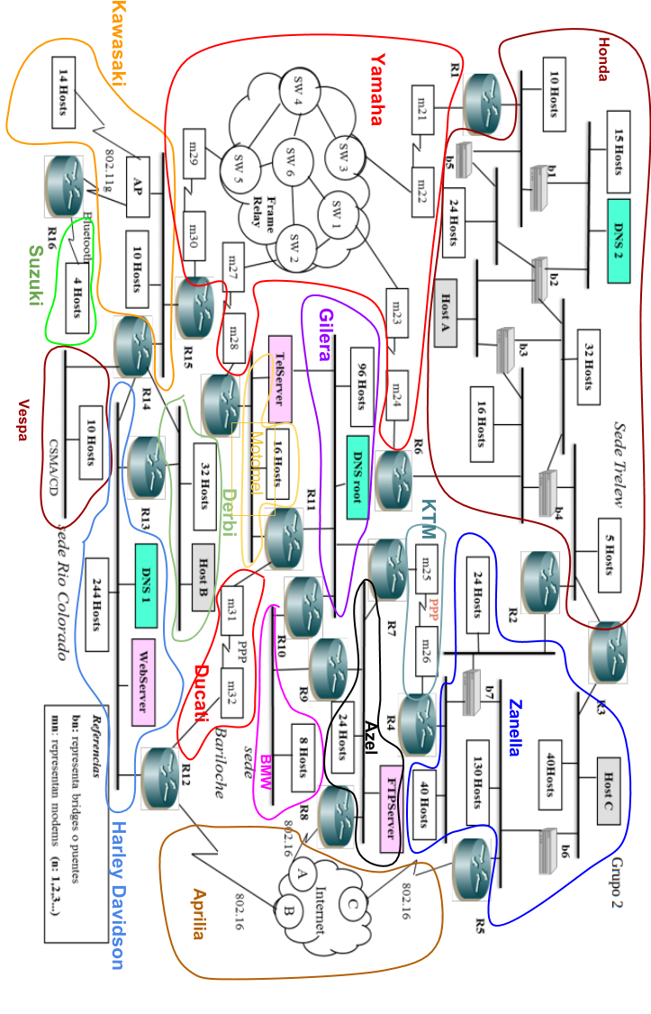

A partir de la topología definida en el gráfico mostrado en la página anterior, teniendo en cuenta las direcciones de red disponibles, se efectuó el subnetting de la red, aplicando los conceptos establecidos por la RFC 950. A continuación se muestran los resultados obtenidos, dividiendo la topología en 3 sedes (Trelew, Río Colorado, Bariloche) y los enlaces entre las mismas.

Sede Trelew
Sede Rio Colorado
Sede Bariloche
Enlaces entre sedes

Nombre | Restriccion | Hosts | VRRP | Routers | Direccion de red y Broadcast | Total | Total del bloque | Direccion de Red | Máscara
Honda |  | 104 | 1 | 4 | 2 | 111 | 128 | 10.24.3.128/25 | 255.255.255.128
Yamaha | Frame Relay |  |  |  |  | 24 | 32 | 172.43.0.64 /27 | 255.255.255.224
Kawasaki |  | 25 |  | 3 | 2 | 30 | 32 | 10.24.3.32 /27 | 255.255.255.224
Suzuki |  | 4 |  | 1 | 2 | 7 | 8 | 10.24.3.8 /29 | 255.255.255.248
Vespa |  | 10 |  | 1 | 2 | 13 | 16 | 10.24.3.16 /28 | 255.255.255.240
Harley Davidson | Apache | 246 | 1 | 3 | 2 | 252 | 256 | 192.168.8.0 /24 | 255.255.255.0
Ducati |  | 0 |  | 2 | 2 | 4 | 4 | 10.24.3.4 /30 | 255.255.255.252
Derbi |  | 33 | 1 | 2 | 2 | 38 | 64 | 10.24.3.64 /26 | 255.255.255.192
Gilera | Telnet | 98 |  | 3 | 2 | 103 | 128 | 10.24.1.0 /25 | 255.255.255.128
MotoMel | Telnet | 17 |  | 2 | 2 | 21 | 32 | 10.24.1.128 /27 | 255.255.255.224
BMW |  | 8 |  | 2 | 2 | 12 | 16 | 10.92.27.32 /28 | 255.255.255.240
Aprilia | Internet | 0 |  | 3 | 2 | 5 | 8 | 133.43.1.0 /29 | 255.255.255.248
Azel | FTP | 25 |  | 3 | 2 | 30 | 32 | 10.92.27.0 /27 | 255.255.255.224
KTM |  | 0 |  | 2 | 2 | 4 | 4 | 10.24.3.0 /30 | 255.255.255.252
Zanella |  | 235 | 1 | 4 | 2 | 242 | 256 | 10.10.5.0 /24 | 255.255.255.0
 |  |  |  |  |  |  | 1016 | Total

2. Asignación de direcciones IP

Una vez asignadas las direcciones de cada subred, se determinaron las direcciones IP de los hosts de prueba (A, B y C), los servidores Web, Telnet y FTP, los servidores DNS Root, y DNS secundario 1 y 2 y las interfaces de los routers. A continuación se detallan las direcciones de red disponibles y las asignaciones de direcciones IP realizadas.

Direccion | Clase | Cantidad de Direcciones
192.168.8.0 | C | 256 | Apache
10.92.27.0 | A | 256 | FTP
133.43.1.0 | B | 256 | INTERNET
172.43.0.64 | B | 64 | Frame Relay
10.24.1.0 | A | 256 | Telnet
10.24.3.0 | A | 256
10.10.5.0 | A | 256
 |  | 1600 | Total

Router | Direcciones
R1 | 10.24.3.129 (Honda) | 172.43.0.65 (Yamaha)
R2 | 10.24.3.130 (Honda) | 10.10.5.1 (Zanella)
VRRP R2-R3 | 10.24.3.133 (Honda) | 10.10.5.5 (Zanella)
R3 | 10.24.3.131 (Honda) | 10.10.5.2 (Zanella)
R4 | 10.24.3.1 (KTM) | 10.10.5.3 (Zanella)
R5 | 133.43.1.1 (Aprilia) | 10.10.5.4 (Zanella) | 192.168.2.5 (Tunnel10) | 192.168.2.9 (Tunnel20)
R6 | 10.24.3.132 (Honda) | 172.43.0.66 (Yamaha)
R7 | 10.24.1.1 (Gilera) | 10.92.27.4 (Azel) | 10.24.3.2 (KTM)
R8 | 133.43.1.5 (Aprilia) | 10.92.27.3 (Azel) | 192.168.2.6 (Tunnel10) | 192.168.2.13 (Tunnel30)
R9 | 10.92.27.33 (BMW) | 10.92.27.2 (Azel)
R10 | 10.24.1.2 (Gilera) | 10.92.27.34 (BMW)
R11 | 10.24.3.5 (Ducati) | 10.24.1.3 (Gilera) | 10.24.1.130 (Motomel)
R12 | 192.168.8.1 (Harley) | 10.24.3.6 (Ducati) | 133.43.1.9 (Aprilia) | 192.168.2.10 (Tunnel20) | 192.168.2.14 (Tunnel30)
R13 | 192.168.8.2 (Harley) | 10.24.3.65 (Derbi)
VRRP R13-R14 | 192.168.8.4 (Harley) | 10.24.3.67 (Derbi)
R14 | 10.24.3.33 (Kawasaki) | 10.24.3.17 (Vespa) | 192.168.8.3 (Harley) | 10.24.3.66 (Derbi)
R15 | 172.43.0.67 (Yamaha) | 10.24.3.34 (Kawasaki)
R16 | 10.24.3.35 (Kawasaki) | 10.24.3.9 (Suzuki)
R17 | 10.24.1.4 (Gilera) | 10.24.1.131 (Motomel)

3. Tablas de ruteo

A continuación se muestran las tablas de ruteo que se han configurado en forma estática en cada una de las subredes. Se puede apreciar que en algunos routers se resalta si es un router perteneciente al borde de la subred que utiliza el protocolo de ruteo dinámico RIPv2, ya que estos routers no indican rutas que estén dirigidas hacia adentro de esta red, las rutas establecidas direccionan hacia afuera.

Se configuraron también saltos alternativos para contemplar situaciones en las que algún enlace no esté disponible, de manera tal de tener diversas posibilidades para poder rutear en forma efectiva paquetes hacia otras redes,

Los comandos que se utilizaron para configurar cada router son los siguientes:

Router > enable
Router# conf t
Router(config)# ip route network-ip mask next-hop-ip

Sede Trelew
Sede Rio Colorado
Sede Bariloche
Enlaces entre sedes

R1 | Dinamico Border
A red | IP RED | MASCARA | SALTO
Kawasaki | 10.24.3.32 /27 | 255.255.255.224 | 172.43.0.74
Suzuki | 10.24.3.8 /29 | 255.255.255.248 | 172.43.0.74
Vespa | 10.24.3.16 /28 | 255.255.255.240 | 172.43.0.74
Harley Davidson | 192.168.8.0 /24 | 255.255.255.0 | 172.43.0.74
Ducati | 10.24.3.4 /30 | 255.255.255.252 | 172.43.0.70
Derbi | 10.24.3.64 /26 | 255.255.255.192 | 172.43.0.74
Gilera | 10.24.1.0 /25 | 255.255.255.128 | 172.43.0.70
MotoMel | 10.24.1.128 /27 | 255.255.255.224 | 172.43.0.70

R4 | Dinamico Border
A red | IP RED | MASCARA | SALTO
Vespa | 10.24.3.16 /28 | 255.255.255.240 | 10.24.3.2(R7)
Harley Davidson | 192.168.8.0 /24 | 255.255.255.0 | 10.24.3.2(R7)
Ducati | 10.24.3.4 /30 | 255.255.255.252 | 10.24.3.2(R7)
Derbi | 10.24.3.64 /26 | 255.255.255.192 | 10.24.3.2(R7)
Gilera | 10.24.1.0 /25 | 255.255.255.128 | 10.24.3.2(R7)
MotoMel | 10.24.1.128 /27 | 255.255.255.224 | 10.24.3.2(R7)
BMW | 10.92.27.32 /28 | 255.255.255.240 | 10.24.3.2(R7)
Azel | 10.92.27.0 /27 | 255.255.255.224 | 10.24.3.2(R7)

R5 | Dinamico Border
A red | IP RED | MASCARA | SALTO | SALTO SEC
Honda | 10.24.3.128/25 | 255.255.255.128 | 10.10.5.5 | Tunnel10 192.168.2.6
Yamaha | 172.43.0.64 /27 | 255.255.255.224 | 10.10.5.5 | Tunnel20 192.168.2.10
Kawasaki | 10.24.3.32 /27 | 255.255.255.224 | 10.10.5.5 | Tunnel20 192.168.2.10
Suzuki | 10.24.3.8 /29 | 255.255.255.248 | 10.10.5.5 | Tunnel20 192.168.2.10
Vespa | 10.24.3.16 /28 | 255.255.255.240 | 10.10.5.5 | Tunnel20 192.168.2.10
Harley Davidson | 192.168.8.0 /24 | 255.255.255.0 | Tunnel20 192.168.2.10 | 10.10.5.5
Ducati | 10.24.3.4 /30 | 255.255.255.252 | 10.10.5.5 | Tunnel20 192.168.2.10
Derbi | 10.24.3.64 /26 | 255.255.255.192 | 10.10.5.5 | Tunnel20 192.168.2.10
Gilera | 10.24.1.0 /25 | 255.255.255.128 | 10.10.5.5 | Tunnel20 192.168.2.10
MotoMel | 10.24.1.128 /27 | 255.255.255.224 | 10.10.5.5 | Tunnel10 192.168.2.6
BMW | 10.92.27.32 /28 | 255.255.255.240 | 10.10.5.5 | Tunnel10 192.168.2.6
Azel | 10.92.27.0 /27 | 255.255.255.224 | Tunnel10 192.168.2.6 | 10.10.5.5
KTM | 10.24.3.0 /30 | 255.255.255.252 | 10.10.5.5 | Tunnel10 192.168.2.6

R6 | Dinamico Border
A red | IP RED | MASCARA | SALTO
Kawasaki | 10.24.3.32 /27 | 255.255.255.224 | 172.43.0.82 (R15)
Suzuki | 10.24.3.8 /29 | 255.255.255.248 | 172.43.0.82 (R15)
Vespa | 10.24.3.16 /28 | 255.255.255.240 | 172.43.0.82 (R15)
Harley Davidson | 192.168.8.0 /24 | 255.255.255.0 | 172.43.0.82 (R15)
Ducati | 10.24.3.4 /30 | 255.255.255.252 | 172.43.0.78 (R17)
Derbi | 10.24.3.64 /26 | 255.255.255.192 | 172.43.0.78 (R17)
Gilera | 10.24.1.0 /25 | 255.255.255.128 | 172.43.0.78 (R17)
MotoMel | 10.24.1.128 /27 | 255.255.255.224 | 172.43.0.78 (R17)

R7
A red | IP RED | MASCARA | SALTO | SALTO SEC
Honda | 10.24.3.128/25 | 255.255.255.128 | 10.24.3.1(R4) | 10.24.1.3(r11)
Yamaha | 172.43.0.64 /27 | 255.255.255.224 | 10.24.1.3(r11) | 10.24.3.1(R4)
Kawasaki | 10.24.3.32 /27 | 255.255.255.224 | 10.24.1.3(r11) | 10.24.3.1(R4)
Suzuki | 10.24.3.8 /29 | 255.255.255.248 | 10.24.1.3(r11) | 10.24.3.1(R4)
Vespa | 10.24.3.16 /28 | 255.255.255.240 | 10.24.1.3(r11) | 10.24.3.1(R4)
Harley Davidson | 192.168.8.0 /24 | 255.255.255.0 | 10.24.1.3(r11) | 10.92.27.3 (R8)
Ducati | 10.24.3.4 /30 | 255.255.255.252 | 10.24.1.3(r11) | 10.92.27.3 (R8)
Derbi | 10.24.3.64 /26 | 255.255.255.192 | 10.24.1.3(r11) | 10.92.27.3 (R8)
Gilera | 10.24.1.0 /25 | 255.255.255.128 | - | -
MotoMel | 10.24.1.128 /27 | 255.255.255.224 | 10.24.1.3(r11) | 10.92.27.2(r9)
BMW | 10.92.27.32 /28 | 255.255.255.240 | 10.24.1.3(r11) | 10.92.27.2(r9)
Aprilia | 133.43.1.0 /29 | 255.255.255.248 | 10.92.27.3 (R8) | 10.24.1.3(r11)
Azel | 10.92.27.0 /27 | 255.255.255.224 | - | -
KTM | 10.24.3.0 /30 | 255.255.255.252 | - | -
Zanella | 10.10.5.0 /24 | 255.255.255.0 | 10.24.3.1(R4) | 10.92.27.3 (R8)

R8
A red | IP RED | MASCARA | SALTO | SALTO SEC
Honda | 10.24.3.128/25 | 255.255.255.128 | 10.92.27.4 (R7) | 192.168.2.5 (Tunel 10)
Yamaha | 172.43.0.64 /27 | 255.255.255.224 | 10.92.27.4 (R7) | 192.168.2.5 (Tunel 10)
Kawasaki | 10.24.3.32 /27 | 255.255.255.224 | 192.168.2.14 (Tunel 30) | 10.92.27.4 (R7)
Suzuki | 10.24.3.8 /29 | 255.255.255.248 | 192.168.2.14 (Tunel 30) | 10.92.27.4 (R7)
Vespa | 10.24.3.16 /28 | 255.255.255.240 | 192.168.2.14 (Tunel 30) | 10.92.27.4 (R7)
Harley Davidson | 192.168.8.0 /24 | 255.255.255.0 | 192.168.2.14 (Tunel 30) | 10.92.27.4 (R7)
Ducati | 10.24.3.4 /30 | 255.255.255.252 | 192.168.2.14 (Tunel 30) | 10.92.27.4 (R7)
Derbi | 10.24.3.64 /26 | 255.255.255.192 | 192.168.2.14 (Tunel 30) | 10.92.27.4 (R7)
Gilera | 10.24.1.0 /25 | 255.255.255.128 | 10.92.27.4 (R7) | 10.92.27.2 (R9)
MotoMel | 10.24.1.128 /27 | 255.255.255.224 | 10.92.27.4 (R7) | 192.168.2.14 (Tunel 30)
BMW | 10.92.27.32 /28 | 255.255.255.240 | 10.92.27.2 (R9) | 10.92.27.4 (R7)
Aprilia | 133.43.1.0 /29 | 255.255.255.248 | - | -
Azel | 10.92.27.0 /27 | 255.255.255.224 | - | -
KTM | 10.24.3.0 /30 | 255.255.255.252 | 10.92.27.4 (R7) | 10.92.27.2 (R9)
Zanella | 10.10.5.0 /24 | 255.255.255.0 | 192.168.2.5 (Tunel 10) | 10.92.27.4 (R7)

R9
A red | IP RED | MASCARA | SALTO | SALTO SEC
Honda | 10.24.3.128/25 | 255.255.255.128 | 10.92.27.4(R7) | 10.92.27.34(R10)
Yamaha | 172.43.0.64 /27 | 255.255.255.224 | 10.92.27.4(R7) | 10.92.27.34(R10)
Kawasaki | 10.24.3.32 /27 | 255.255.255.224 | 10.92.27.4(R7) | 10.92.27.34(R10)
Suzuki | 10.24.3.8 /29 | 255.255.255.248 | 10.92.27.4(R7) | 10.92.27.34(R10)
Vespa | 10.24.3.16 /28 | 255.255.255.240 | 10.92.27.4(R7) | 10.92.27.34(R10)
Harley Davidson | 192.168.8.0 /24 | 255.255.255.0 | 10.92.27.4(R7) | 10.92.27.34(R10)
Ducati | 10.24.3.4 /30 | 255.255.255.252 | 10.92.27.4(R7) | 10.92.27.34(R10)
Derbi | 10.24.3.64 /26 | 255.255.255.192 | 10.92.27.4(R7) | 10.92.27.34(R10)
Gilera | 10.24.1.0 /25 | 255.255.255.128 | 10.92.27.4(R7) | 10.92.27.34(R10)
MotoMel | 10.24.1.128 /27 | 255.255.255.224 | 10.92.27.4(R7) | 10.92.27.34(R10)
BMW | 10.92.27.32 /28 | 255.255.255.240 | - | -
Aprilia | 133.43.1.0 /29 | 255.255.255.248 | 10.92.27.3(R8) | 10.92.27.34(R10)
Azel | 10.92.27.0 /27 | 255.255.255.224 | - | -
KTM | 10.24.3.0 /30 | 255.255.255.252 | 10.92.27.4(R7) | 10.92.27.34(R10)
Zanella | 10.10.5.0 /24 | 255.255.255.0 | 10.92.27.4(R7) | 10.92.27.34(R10)

R10
A red | IP RED | MASCARA | SALTO | SALTO SEC
Honda | 10.24.3.128/25 | 255.255.255.128 | 10.24.1.1 (R7) | 10.92.27.33 (R9)
Yamaha | 172.43.0.64 /27 | 255.255.255.224 | 10.24.1.1 (R7) | 10.92.27.33 (R9)
Kawasaki | 10.24.3.32 /27 | 255.255.255.224 | 10.24.1.3 (R11) | 10.92.27.33 (R9)
Suzuki | 10.24.3.8 /29 | 255.255.255.248 | 10.24.1.3 (R11) | 10.92.27.33 (R9)
Vespa | 10.24.3.16 /28 | 255.255.255.240 | 10.24.1.3 (R11) | 10.92.27.33 (R9)
Harley Davidson | 192.168.8.0 /24 | 255.255.255.0 | 10.24.1.3 (R11) | 10.92.27.33 (R9)
Ducati | 10.24.3.4 /30 | 255.255.255.252 | 10.24.1.3 (R11) | 10.92.27.33 (R9)
Derbi | 10.24.3.64 /26 | 255.255.255.192 | 10.24.1.3 (R11) | 10.92.27.33 (R9)
Gilera | 10.24.1.0 /25 | 255.255.255.128 | - | -
MotoMel | 10.24.1.128 /27 | 255.255.255.224 | 10.24.1.3 (R11) | 10.92.27.33 (R9)
BMW | 10.92.27.32 /28 | 255.255.255.240 | - | -
Aprilia | 133.43.1.0 /29 | 255.255.255.248 | 10.24.1.1 (R7) | 10.92.27.33 (R9)
Azel | 10.92.27.0 /27 | 255.255.255.224 | 10.24.1.1 (R7) | 10.92.27.33 (R9)
KTM | 10.24.3.0 /30 | 255.255.255.252 | 10.24.1.1 (R7) | 10.92.27.33 (R9)
Zanella | 10.10.5.0 /24 | 255.255.255.0 | 10.24.1.1 (R7) | 10.92.27.33 (R9)

R11
A red | IP RED | MASCARA | SALTO | SALTO SEC
Honda | 10.24.3.128/25 | 255.255.255.128 | 10.24.1.131 (R17) | 10.24.1.1 (R7)
Yamaha | 172.43.0.64 /27 | 255.255.255.224 | 10.24.1.131 (R17) | 10.24.3.6 (R12)
Kawasaki | 10.24.3.32 /27 | 255.255.255.224 | 10.24.1.131 (R17) | 10.24.3.6 (R12)
Suzuki | 10.24.3.8 /29 | 255.255.255.248 | 10.24.1.131 (R17) | 10.24.3.6 (R12)
Vespa | 10.24.3.16 /28 | 255.255.255.240 | 10.24.3.6 (R12) | 10.24.1.131 (R17)
Harley Davidson | 192.168.8.0 /24 | 255.255.255.0 | 10.24.3.6 (R12) | 10.24.1.131 (R17)
Ducati | 10.24.3.4 /30 | 255.255.255.252 | - | -
Derbi | 10.24.3.64 /26 | 255.255.255.192 | 10.24.3.6 (R12) | 10.24.1.131 (R17)
Gilera | 10.24.1.0 /25 | 255.255.255.128 | - | -
MotoMel | 10.24.1.128 /27 | 255.255.255.224 | - | -
BMW | 10.92.27.32 /28 | 255.255.255.240 | 10.24.1.2 (R10) | 10.24.3.6 (R12)
Aprilia | 133.43.1.0 /29 | 255.255.255.248 | 10.24.3.6 (R12) | 10.24.1.2 (R10)
Azel | 10.92.27.0 /27 | 255.255.255.224 | 10.24.1.1 (R7) | 10.24.3.6 (R12)
KTM | 10.24.3.0 /30 | 255.255.255.252 | 10.24.1.1 (R7) | 10.24.3.6 (R12)
Zanella | 10.10.5.0 /24 | 255.255.255.0 | 10.24.1.1 (R7) | 10.24.3.6 (R12)

R12
A red | IP RED | MASCARA | SALTO | SALTO SEC
Honda | 10.24.3.128/25 | 255.255.255.128 | Tunel 20 (R5-R12) | 192.168.8.3 (R14)
Yamaha | 172.43.0.64 /27 | 255.255.255.224 | 192.168.8.3 (R14) | 10.24.3.5 (R11)
Kawasaki | 10.24.3.32 /27 | 255.255.255.224 | 192.168.8.3 (R14) | 10.24.3.5 (R11)
Suzuki | 10.24.3.8 /29 | 255.255.255.248 | 192.168.8.3 (R14) | 10.24.3.5 (R11)
Vespa | 10.24.3.16 /28 | 255.255.255.240 | 192.168.8.3 (R14) | 10.24.3.5 (R11)
Harley Davidson | 192.168.8.0 /24 | 255.255.255.0 | - | -
Ducati | 10.24.3.4 /30 | 255.255.255.252 | - | -
Derbi | 10.24.3.64 /26 | 255.255.255.192 | 192.168.8.4 (Vrrp) | 10.24.3.5 (R11)
Gilera | 10.24.1.0 /25 | 255.255.255.128 | 10.24.3.5 (R11) | 192.168.8.3 (R14)
MotoMel | 10.24.1.128 /27 | 255.255.255.224 | 10.24.3.5 (R11) | 192.168.8.3 (R14)
BMW | 10.92.27.32 /28 | 255.255.255.240 | 10.24.3.5 (R11) | Tunel 30
Aprilia | 133.43.1.0 /29 | 255.255.255.248 | - | -
Azel | 10.92.27.0 /27 | 255.255.255.224 | Tunel 30 | 10.24.3.5 (R11)
KTM | 10.24.3.0 /30 | 255.255.255.252 | 10.24.3.5 (R11) | Tunel 20
Zanella | 10.10.5.0 /24 | 255.255.255.0 | Tunel 20 | 10.24.3.5 (R11)

R13
A red | IP RED | MASCARA | SALTO | SALTO SEC
Honda | 10.24.3.128/25 | 255.255.255.128 | 10.24.3.66 (R14) | 192.168.8.1 (R12)
Yamaha | 172.43.0.64 /27 | 255.255.255.224 | 10.24.3.66 (R14) | 192.168.8.1 (R12)
Kawasaki | 10.24.3.32 /27 | 255.255.255.224 | 10.24.3.66 (R14) | 192.168.8.1 (R12)
Suzuki | 10.24.3.8 /29 | 255.255.255.248 | 10.24.3.66 (R14) | 192.168.8.1 (R12)
Vespa | 10.24.3.16 /28 | 255.255.255.240 | 10.24.3.66 (R14) | 192.168.8.1 (R12)
Harley Davidson | 192.168.8.0 /24 | 255.255.255.0 | - | -
Ducati | 10.24.3.4 /30 | 255.255.255.252 | 192.168.8.1 (R12) | 10.24.3.66 (R14)
Derbi | 10.24.3.64 /26 | 255.255.255.192 | - | -
Gilera | 10.24.1.0 /25 | 255.255.255.128 | 192.168.8.1 (R12) | 10.24.3.66 (R14)
MotoMel | 10.24.1.128 /27 | 255.255.255.224 | 192.168.8.1 (R12) | 10.24.3.66 (R14)
BMW | 10.92.27.32 /28 | 255.255.255.240 | 192.168.8.1 (R12) | 10.24.3.66 (R14)
Aprilia | 133.43.1.0 /29 | 255.255.255.248 | 192.168.8.1 (R12) | 10.24.3.66 (R14)
Azel | 10.92.27.0 /27 | 255.255.255.224 | 192.168.8.1 (R12) | 10.24.3.66 (R14)
KTM | 10.24.3.0 /30 | 255.255.255.252 | 192.168.8.1 (R12) | 10.24.3.66 (R14)
Zanella | 10.10.5.0 /24 | 255.255.255.0 | 192.168.8.1 (R12) | 10.24.3.66 (R14)

R14
A red | IP RED | MASCARA | SALTO | SALTO SEC
Honda | 10.24.3.128/25 | 255.255.255.128 | 10.24.3.34 (R15) | 192.168.8.1 (R12)
Yamaha | 172.43.0.64 /27 | 255.255.255.224 | 10.24.3.34 (R15) | 192.168.8.1 (R12)
Kawasaki | 10.24.3.32 /27 | 255.255.255.224 | - | -
Suzuki | 10.24.3.8 /29 | 255.255.255.248 | 10.24.3.35 (R16) | 10.24.3.34 (R15)
Vespa | 10.24.3.16 /28 | 255.255.255.240 | - | -
Harley Davidson | 192.168.8.0 /24 | 255.255.255.0 | - | -
Ducati | 10.24.3.4 /30 | 255.255.255.252 | 192.168.8.1 (R12) | 10.24.3.34 (R15)
Derbi | 10.24.3.64 /26 | 255.255.255.192 | - | -
Gilera | 10.24.1.0 /25 | 255.255.255.128 | 10.24.3.34 (R15) | 192.168.8.1 (R12)
MotoMel | 10.24.1.128 /27 | 255.255.255.224 | 10.24.3.34 (R15) | 192.168.8.1 (R12)
BMW | 10.92.27.32 /28 | 255.255.255.240 | 192.168.8.1 (R12) | 10.24.3.34 (R15)
Aprilia | 133.43.1.0 /29 | 255.255.255.248 | 192.168.8.1 (R12) | 10.24.3.34 (R15)
Azel | 10.92.27.0 /27 | 255.255.255.224 | 192.168.8.1 (R12) | 10.24.3.34 (R15)
KTM | 10.24.3.0 /30 | 255.255.255.252 | 192.168.8.1 (R12) | 10.24.3.34 (R15)
Zanella | 10.10.5.0 /24 | 255.255.255.0 | 10.24.3.34 (R15) | 192.168.8.1 (R12)

R15
A red | IP RED | MASCARA | SALTO | SALTO SEC
Honda | 10.24.3.128/25 | 255.255.255.128 | 172.43.0.81 (R6) | 10.24.3.33 (R14)
Yamaha | 172.43.0.64 /27 | 255.255.255.224 | - | -
Kawasaki | 10.24.3.32 /27 | 255.255.255.224 | - | -
Suzuki | 10.24.3.8 /29 | 255.255.255.248 | 10.24.3.35 (R16) | 172.43.0.86 (R17)
Vespa | 10.24.3.16 /28 | 255.255.255.240 | 10.24.3.33 (R14) | 172.43.0.86 (R17)
Harley Davidson | 192.168.8.0 /24 | 255.255.255.0 | 10.24.3.33 (R14) | 172.43.0.86 (R17)
Ducati | 10.24.3.4 /30 | 255.255.255.252 | 10.24.3.33 (R14) | 172.43.0.86 (R17)
Derbi | 10.24.3.64 /26 | 255.255.255.192 | 10.24.3.33 (R14) | 172.43.0.86 (R17)
Gilera | 10.24.1.0 /25 | 255.255.255.128 | 172.43.0.86 (R17) | 10.24.3.33 (R14)
MotoMel | 10.24.1.128 /27 | 255.255.255.224 | 172.43.0.86 (R17) | 10.24.3.33 (R14)
BMW | 10.92.27.32 /28 | 255.255.255.240 | 172.43.0.86 (R17) | 10.24.3.33 (R14)
Aprilia | 133.43.1.0 /29 | 255.255.255.248 | 10.24.3.33 (R14) | 172.43.0.86 (R17)
Azel | 10.92.27.0 /27 | 255.255.255.224 | 172.43.0.86 (R17) | 10.24.3.33 (R14)
KTM | 10.24.3.0 /30 | 255.255.255.252 | 172.43.0.81 (R6) | 10.24.3.33 (R14)
Zanella | 10.10.5.0 /24 | 255.255.255.0 | 172.43.0.81 (R6) | 10.24.3.33 (R14)

R16
A red | IP RED | MASCARA | SALTO | SALTO SEC
Honda | 10.24.3.128/25 | 255.255.255.128 | 10.24.3.34 (R15) | 10.24.3.33 (R14)
Yamaha | 172.43.0.64 /27 | 255.255.255.224 | 10.24.3.34 (R15) | 10.24.3.33 (R14)
Kawasaki | 10.24.3.32 /27 | 255.255.255.224 | - | -
Suzuki | 10.24.3.8 /29 | 255.255.255.248 | - | -
Vespa | 10.24.3.16 /28 | 255.255.255.240 | 10.24.3.33 (R14) | 10.24.3.34 (R15)
Harley Davidson | 192.168.8.0 /24 | 255.255.255.0 | 10.24.3.33 (R14) | 10.24.3.34 (R15)
Ducati | 10.24.3.4 /30 | 255.255.255.252 | 10.24.3.33 (R14) | 10.24.3.34 (R15)
Derbi | 10.24.3.64 /26 | 255.255.255.192 | 10.24.3.34 (R15) | 10.24.3.33 (R14)
Gilera | 10.24.1.0 /25 | 255.255.255.128 | 10.24.3.34 (R15) | 10.24.3.33 (R14)
MotoMel | 10.24.1.128 /27 | 255.255.255.224 | 10.24.3.34 (R15) | 10.24.3.33 (R14)
BMW | 10.92.27.32 /28 | 255.255.255.240 | 10.24.3.33 (R14) | 10.24.3.34 (R15)
Aprilia | 133.43.1.0 /29 | 255.255.255.248 | 10.24.3.33 (R14) | 10.24.3.34 (R15)
Azel | 10.92.27.0 /27 | 255.255.255.224 | 10.24.3.34 (R15) | 10.24.3.33 (R14)
KTM | 10.24.3.0 /30 | 255.255.255.252 | 10.24.3.34 (R15) | 10.24.3.33 (R14)
Zanella | 10.10.5.0 /24 | 255.255.255.0 | 10.24.3.34 (R15) | 10.24.3.33 (R14)

R17
A red | IP RED | MASCARA | SALTO | SALTO SEC
Honda | 10.24.3.128/25 | 255.255.255.128 | 172.43.0.77 (R6) | 10.24.1.130 (R11)
Yamaha | 172.43.0.64 /27 | 255.255.255.224 | - | -
Kawasaki | 10.24.3.32 /27 | 255.255.255.224 | 172.43.0.85 (R15) | 10.24.1.130 (R11)
Suzuki | 10.24.3.8 /29 | 255.255.255.248 | 172.43.0.85 (R15) | 10.24.1.130 (R11)
Vespa | 10.24.3.16 /28 | 255.255.255.240 | 172.43.0.85 (R15) | 10.24.1.130 (R11)
Harley Davidson | 192.168.8.0 /24 | 255.255.255.0 | 172.43.0.85 (R15) | 10.24.1.130 (R11)
Ducati | 10.24.3.4 /30 | 255.255.255.252 | 10.24.1.130 (R11) | 172.43.0.85 (R15)
Derbi | 10.24.3.64 /26 | 255.255.255.192 | 172.43.0.85 (R15) | 10.24.1.130 (R11)
Gilera | 10.24.1.0 /25 | 255.255.255.128 | 10.24.1.130 (R11) | 172.43.0.85 (R15)
MotoMel | 10.24.1.128 /27 | 255.255.255.224 | - | -
BMW | 10.92.27.32 /28 | 255.255.255.240 | 10.24.1.130 (R11) | 172.43.0.85 (R15)
Aprilia | 133.43.1.0 /29 | 255.255.255.248 | 10.24.1.130 (R11) | 172.43.0.85 (R15)
Azel | 10.92.27.0 /27 | 255.255.255.224 | 10.24.1.130 (R11) | 172.43.0.77 (R6)
KTM | 10.24.3.0 /30 | 255.255.255.252 | 172.43.0.77 (R6) | 10.24.1.130 (R11)
Zanella | 10.10.5.0 /24 | 255.255.255.0 | 172.43.0.77 (R6) | 10.24.1.130 (R11)

4. Ruteo dinámico

Todos los routers de la sede Trelew utilizan el protocolo RIPv2. Los routers de frontera tienen pasivadas las interfaces que comunican al exterior para no distribuir mensajes RIP hacia fuera de la sede.

En todos los casos se desactivó la sumarización automática (“no auto-summary”) para prevenir problemas de ruteo, y se estableció que los routers distribuyan las redes a las que están conectados así como sus rutas estáticas (routers de frontera).

Router | Redes |  | Interfaz pasiva
R1 | Honda (10.24.3.128) |  | Serial1/0 (Yamaha)
R2 | Honda | Zanella (10.10.5.0)
R3 | Honda | Zanella
R4 | Zanella |  | Ethernet0/1 (KTM)
R5 | Zanella |  | Ethernet0/1 (Aprilia)
R6 | Honda |  | Serial1/0 (Yamaha)

5. Redundancia (VRRP)

Se aplicó redundancia entre los pares de routers R2-R3 y R13-R14, hacia ambos lados, como se representa en las siguientes imágenes:
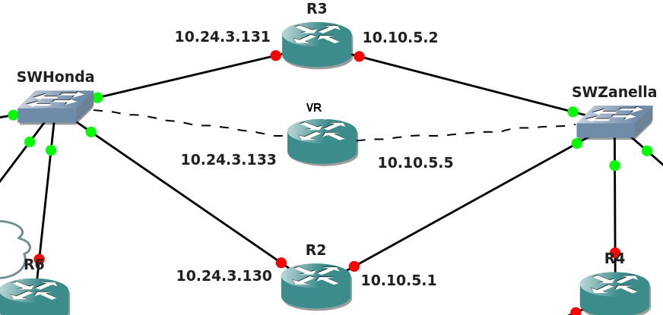

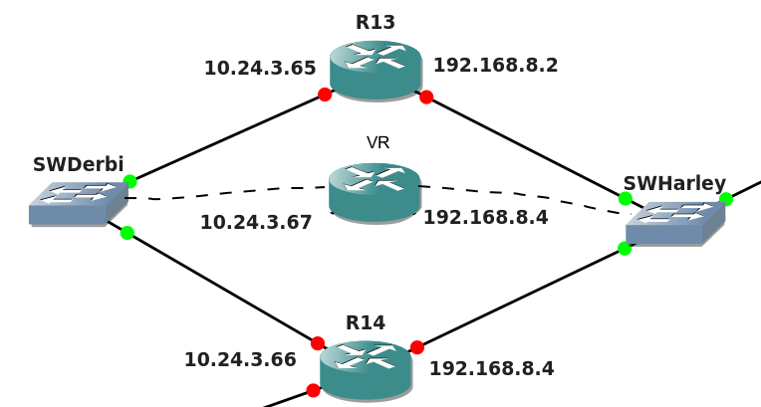

6. Redes Frame Relay

En este trabajo práctico se simuló la red frame-relay utilizando un único router c3640, con interfaces NM-4T.
Para cada par de routers conectados a través de la red frame-relay, se les asignó a sus interfaces sobre dicha red una dirección dentro de una subred punto a punto (barra 30), como se observa en la siguiente tabla.

La columna “DLCIs” indica el DLCI con el que viajan los paquetes desde el router origen al frame-relay, y el DLCI con el que viajan los que van desde el frame-relay hasta el router destino, respectivamente.

Nombre | Dir. de red | Máscara | Routers | Tamaño de bloque | Routers involucrados | DLCIs
M1 | 172.43.0.64 | /30 | 2 | 4 | R1 (172.43.0.65) - R6 (172.43.0.66) | 401 -104
M2 | 172.43.0.68 | /30 | 2 | 4 | R1(172.43.0.73) - R15 (172.43.0.74) | 403 - 304
M3 | 172.43.0.72 | /30 | 2 | 4 | R1 (172.43.0.69) - R17 (172.43.0.70) | 402 - 204
M4 | 172.43.0.76 | /30 | 2 | 4 | R6 (172.43.0.81) - R15 (172.43.0.82) | 502 - 205
M5 | 172.43.0.80 | /30 | 2 | 4 | R6 (172.43.0.77) - R17 (172.43.0.78) | 501- 105
M6 | 172.43.0.84 | /30 | 2 | 4 | R15 (172.43.0.85) - R17 (172.43.0.86) | 106 - 601

7. DNS

Dominio de la empresa: chubut.dc.fi.uba.ar

Se dispone de 3 servidores DNS, uno instalado en cada sede (Trelew, Bariloche, Río Colorado). El DNS ubicado en la sede Río Colorado (DNS1, en la red Harley Davidson) se encarga de resolver los nombres de la sede Río Colorado exclusivamente. El DNS ubicado en la sede Trelew (DNS2, en la red Honda) resuelve los nombres de las sedes Trelew y Bariloche. El DNS Root ubicado en la sede Bariloche (en la red Gilera), es de nivel 1, delega la autoridad en los DNS 1 y 2 mencionados anteriormente.

RED Honda
 | Nombre DNS | IP
R1 | r1.honda1.trelew.chubut.dc.com.ar | 10.24.3.129
R6 | r6.honda2.trelew.chubut.dc.com.ar | 10.24.3.132
R2 | r2.honda3.trelew.chubut.dc.com.ar | 10.24.3.130
R3 | r3.honda4.trelew.chubut.dc.com.ar | 10.24.3.131
VRRP R2-R3 | vrrp-r2r3.honda5.trelew.chubut.dc.com.ar | 10.24.3.133
DNS 2 | dns2.honda6.trelew.chubut.dc.com.ar | 10.24.3.134
Host A | hosta.honda7.trelew.chubut.dc.com.ar | 10.24.3.135

RED Zanella
 | Nombre DNS | IP
R2 | r2.zanella1.trelew.chubut.dc.com.ar | 10.10.5.1
R3 | r3.zanella2.trelew.chubut.dc.com.ar | 10.10.5.2
R4 | r4.zanella3.trelew.chubut.dc.com.ar | 10.10.5.3
R5 | r5.zanella4.trelew.chubut.dc.com.ar | 10.10.5.4
VRRP R2-R3 | vrrp-r2r3.zanella5.trelew.chubut.dc.com.ar | 10.10.5.5
Host C | hostc.zanella6.trelew.chubut.dc.com.ar | 10.10.5.6

RED KTM
 | Nombre DNS | IP
R4 | r4.ktm1.chubut.dc.com.ar | 10.24.3.1
R7 | r7.ktm2.chubut.dc.com.ar | 10.24.3.2

RED Azel
 | Nombre DNS | IP
R7 | r7.azel1.bariloche.chubut.dc.com.ar | 10.92.27.4
R8 | r8.azel2.bariloche.chubut.dc.com.ar | 10.92.27.3
R9 | r9.azel3.bariloche.chubut.dc.com.ar | 10.92.27.2
FTP Server | ftpserver.azel4.bariloche.chubut.dc.com.ar | 10.92.27.1

RED Aprilia
 | Nombre DNS | IP
R5 | r5.aprilia1.chubut.dc.com.ar | 133.43.1.1
R8 | r8.aprilia2.chubut.dc.com.ar | 133.43.1.2
R12 | r12.aprilia3.chubut.dc.com.ar | 133.43.1.3

RED BMW
 | Nombre DNS | IP
R9 | r9.bmw1.bariloche.chubut.dc.com.ar | 10.92.27.33
R10 | r10.bmw2.bariloche.chubut.dc.com.ar | 10.92.27.34

RED Ducati
 | Nombre DNS | IP
R11 | r11.ducati1.chubut.dc.com.ar | 10.24.3.5
R12 | r12.ducati2.chubut.dc.com.ar | 10.24.3.6

RED H. Davidson
 | Nombre DNS | IP
R12 | r12.hdavidson1.riocolorado.chubut.dc.com.ar | 192.168.8.1
R13 | r13.hdavidson2.riocolorado.chubut.dc.com.ar | 192.168.8.2
R14 | r14.hdavidson3.riocolorado.chubut.dc.com.ar | 192.168.8.3
VRRP R13-R14 | vrrp-r13r14.hdavidson4.riocolorado.chubut.dc.com.ar | 192.168.8.4
DNS 1 | dns1.hdavidson5.riocolorado.chubut.dc.com.ar | 192.168.8.5
Apache Web Server | apache.hdavidson6.riocolorado.chubut.dc.com.ar | 192.168.8.71

RED Derbi
 | Nombre DNS | IP
R13 | r13.derbi1.riocolorado.chubut.dc.com.ar | 10.24.3.65
R14 | r14.derbi2.riocolorado.chubut.dc.com.ar | 10.24.3.66
VRRP R13-R14 | vrrp-r13r14.derbi3.riocolorado.chubut.dc.com.ar | 10.24.3.67
Host B | hostb.derbi4.riocolorado.chubut.dc.com.ar | 10.24.3.68

RED Motomel
 | Nombre DNS | IP
R11 | r11.motomel1.bariloche.chubut.dc.com.ar | 10.24.1.130
R17 | r17.motomel2.bariloche.chubut.dc.com.ar | 10.24.1.129
Telnet | telnet.motomel3.bariloche.chubut.dc.com.ar | 10.24.1.65

RED Gilera
 | Nombre DNS | IP
R7 | r7.gilera1.bariloche.chubut.dc.com.ar | 10.24.1.1
R10 | r10.gilera2.bariloche.chubut.dc.com.ar | 10.24.1.2
R11 | r11.gilera3.bariloche.chubut.dc.com.ar | 10.24.1.3
Telnet | telnet.gilera4.bariloche.chubut.dc.com.ar | 10.24.1.129
DNS Root | dnsroot.gilera5.bariloche.chubut.dc.com.ar | 10.24.1.4

RED Yamaha
 | Nombre DNS | IP
R1 | r1.yamaha1.chubut.dc.com.ar | 172.43.0.65
R6 | r6.yamaha2.chubut.dc.com.ar | 172.43.0.66
R15 | r15.yamaha3.chubut.dc.com.ar | 172.43.0.67
R17 | r17.yamaha4.chubut.dc.com.ar | 172.43.0.68

RED Kawasaki
 | Nombre DNS | IP
R14 | r14.kawasaki1.riocolorado.chubut.dc.com.ar | 10.24.3.33
R15 | r15.kawasaki2.riocolorado.chubut.dc.com.ar | 10.24.3.34
R16 | r16.kawasaki3.riocolorado.chubut.dc.com.ar | 10.24.3.35

RED Suzuki
 | Nombre DNS | IP
R16 | r16.suzuki1.riocolorado.chubut.dc.com.ar | 10.24.3.9

RED Vespa
 | Nombre DNS | IP
R14 | r14.vespa1.riocolorado.chubut.dc.com.ar | 10.24.3.17

Las figuras 7.1 y 7.2 muestran los árboles de los servidores DNS1 y DNS2 respectivamente.
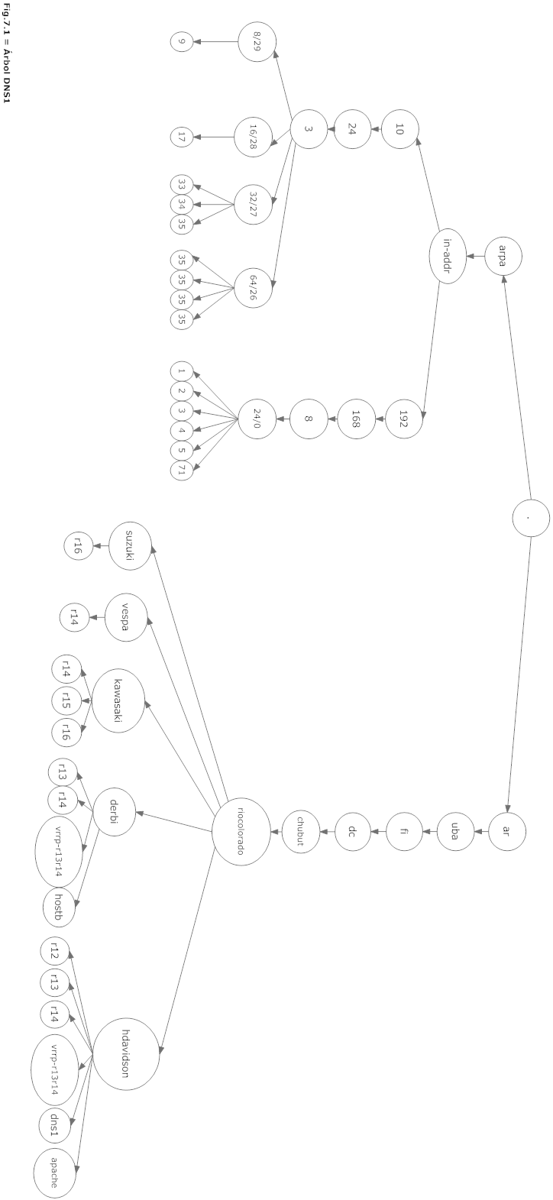
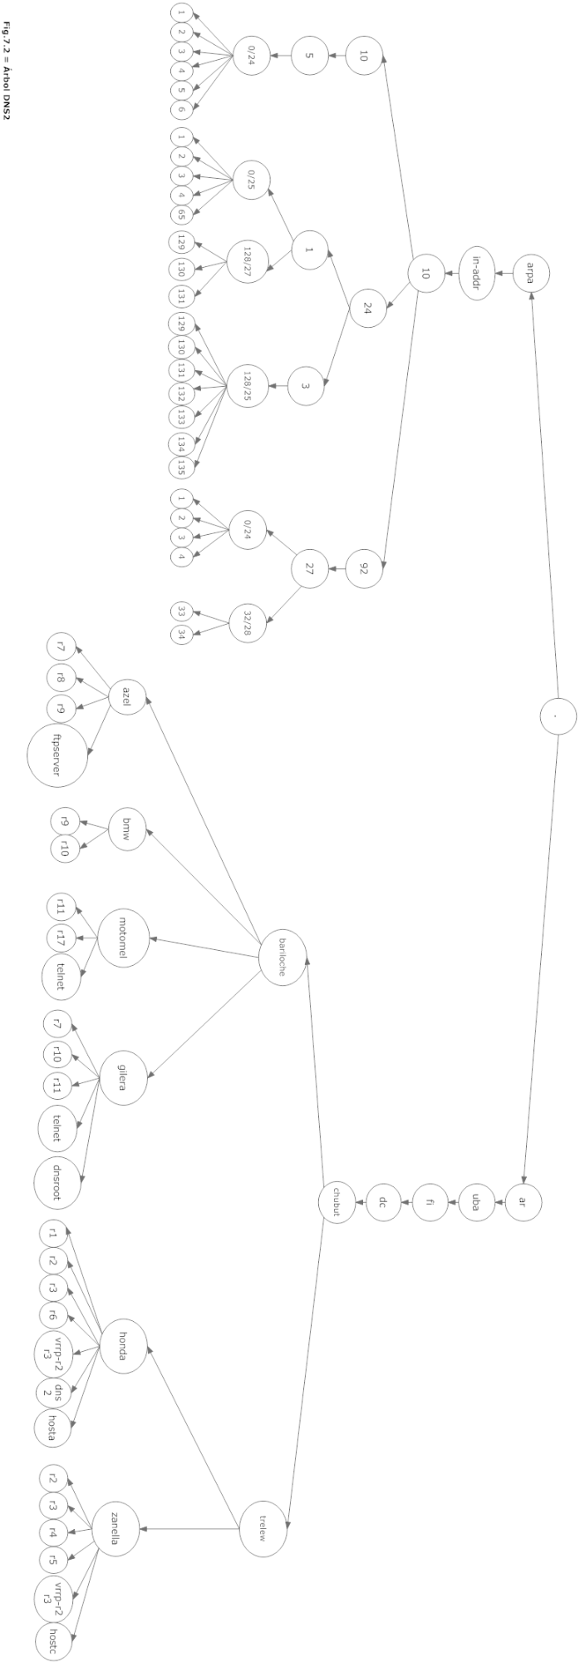

8. Tuneles GRE - Simulación de Internet

Para encapsular las comunicación entre las redes Zanella, Azel y Harley Davidson a través de Internet se configuraron 3 túneles GRE (Tunnel10 entre R5 perteneciente a Zanella y R8 perteneciente a Azel, Tunnel20 entre R5 perteneciente a Zanella y R12 perteneciente a Harley Davidson, y Tunnel30 entre R5 y R8 para comunicar Harley Davidson con Azel).

A continuación se muestra como han quedado configurados los túneles en forma gráfica y luego como se realizó la configuración por consola.
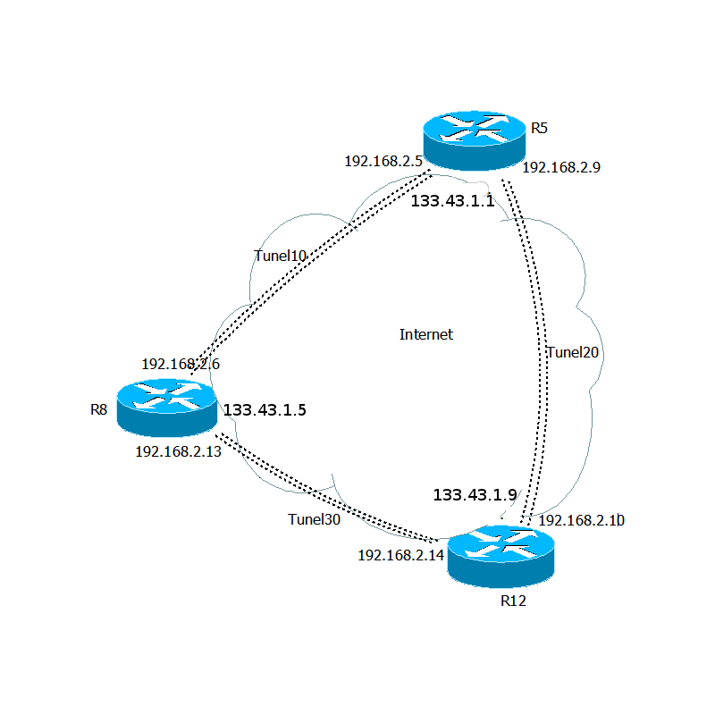

R5
interface Tunnel10
ip address 192.168.2.5 255.255.255.252
tunnel source 133.43.1.1
tunnel destination 133.43.1.5
!
interface Tunnel20
ip address 192.168.2.9 255.255.255.252
tunnel source 133.43.1.1
tunnel destination 133.43.1.9

R8
interface Tunnel10
ip address 192.168.2.6 255.255.255.252
tunnel source 133.43.1.5
tunnel destination 133.43.1.1
!
interface Tunnel30
ip address 192.168.2.13 255.255.255.252
tunnel source 133.43.1.5
tunnel destination 133.43.1.3

R12
interface Tunnel20
ip address 192.168.2.10 255.255.255.252
tunnel source 133.43.1.9
tunnel destination 133.43.1.1
!
interface Tunnel30
ip address 192.168.2.14 255.255.255.252
tunnel source 133.43.1.9
tunnel destination 133.43.1.5

9. OpenVPN

Para simular el comportamiento de algunos hosts dentro de la topología, fue necesario establecer un enlace virtual entre los equipos físicos y el programa GNS3. Para lograr esto utilizamos los servicios de conexión a través de una red privada virtual que provee openvpn.

En la máquina donde se ejecuta la topología, se crearon dispositivos tap con números fijos para cada una de las terminales necesarias (Web Server, Host A, DNS1, etc). Una vez creados los tap, en la topología se utilizó un dispositivo Cloud que representase a cada terminal y se le asignó a cada uno el tap correspondiente.

La configuración del lado de las terminales es mucho más simple, puesto que sólo es necesario que exista un único tap creado por vez, de acuerdo al servicio o host que se esté simulando en el momento. Para conectar dicha terminal con la topología solo basta crear un dispositivo tap al cual se le indica la dirección IP de la computadora corriendo la topología y el número de puerto al que se debe conectar, así como también la dirección IP y máscara que dicho dispositivo debe tener en la red simulada.

Terminal | Dispositivo | Puerto
DNS 1 | tap 1 | 1195
DNS 2 | tap 2 | 1196
DNS Root | tap 3 | 1197
FTP Server | tap 4 | 1198
Web Server | tap 5 | 1199
Telnet Server 1 | tap 6 | 1200
Telnet Server 2 | tap 7 | 1201
Host A | tap 8 | 1202
Host B | tap 9 | 1203
Host C | tap 0 | 1204

10. Topología para la simulación

En la siguiente figura se observa como ha sido configurada la topología con el software de simulación GNS3.

