REVIEW ARTICLE
Somatic Distress as a Drug Target: The GDF-15–GFRAL Axis in Cancer Cachexia
From a divergent TGF-β superfamily cytokine to a brainstem-restricted receptor and the first positive phase 2 trial in cachexia
Prepared 11 September 2026 · Weekly Science Review series

Abstract
Cancer cachexia — the progressive, involuntary loss of skeletal muscle and adipose tissue that cannot be reversed by feeding — affects a large fraction of patients with advanced solid tumours and independently predicts poor tolerance of anticancer therapy and shortened survival. For four decades the field pursued appetite stimulants, anabolic steroids and nutritional support, with almost no durable success, largely because the molecular drivers of the syndrome remained obscure. That situation changed in 2017, when four independent groups converged on GDNF-family receptor α-like (GFRAL), an orphan receptor expressed almost exclusively in the area postrema and nucleus tractus solitarius of the hindbrain, as the receptor for growth differentiation factor 15 (GDF-15, also called MIC-1) — a divergent TGF-β superfamily cytokine that had been known for twenty years as one of the most reliable circulating biomarkers of ‘something is wrong’ in human disease. GDF-15 is transcribed downstream of the integrated stress response, is secreted in large amounts by many tumours, and is among the strongest single-analyte correlates of weight loss and mortality in cancer. Its receptor sits in a circumventricular organ outside the blood–brain barrier and feeds a canonical aversive circuit (parabrachial nucleus → central amygdala) rather than the hypothalamic homeostatic machinery — which is why GDF-15 produces not merely reduced eating but nausea, conditioned taste aversion and, in animals, sympathetically driven adipose lipolysis that proceeds even under forced caloric intake. This review synthesises the molecular biology of GDF-15 production, the structure and neuroanatomy of the GFRAL–RET signalling complex, the dual anorectic and anorexia-independent effector arms through which the axis drives tissue wasting, and the therapeutic programmes that have emerged: ligand-neutralising antibodies (ponsegromab, AV-380, visugromab) and receptor antagonists (3P10). In the randomised phase 2 PROACC-1 trial, twelve weeks of ponsegromab produced a dose-dependent median weight gain of up to 2.81 kg over placebo in biomarker-selected patients, the first convincingly positive result of its kind. We close by examining what remains unresolved: whether the weight gained is functional lean mass, whether blockade improves survival, how a system that also governs pregnancy nausea, chemotherapy tolerance and antitumour immunity behaves under chronic inhibition, and why a parallel heart-failure programme with the same antibody was discontinued.
Keywords: GDF-15 · MIC-1 · GFRAL · RET · cancer cachexia · area postrema · integrated stress response · ponsegromab · anorexia · adipose lipolysis

1. Introduction

1.1 Cachexia is a distinct syndrome, not simply starvation
An international consensus panel in 2011 defined cancer cachexia as “a multifactorial syndrome defined by an ongoing loss of skeletal muscle mass (with or without loss of fat mass) that cannot be fully reversed by conventional nutritional support and leads to progressive functional impairment.”¹ The operational diagnostic threshold agreed by that panel — more than 5% unintentional weight loss over six months, or more than 2% in someone already depleted (body-mass index below 20 kg/m² or established sarcopenia) — remains the entry criterion for essentially every interventional trial in the field, and the panel's staging scheme (precachexia → cachexia → refractory cachexia) still frames how clinicians think about the trajectory.¹
The clinically decisive phrase in that definition is “cannot be fully reversed by conventional nutritional support.” Simple starvation is an energy-deficit state that resolves when calories are restored, and it preferentially spares lean tissue. Cachexia does neither. Its pathophysiology, as the consensus statement put it, reflects a negative protein and energy balance driven by a variable combination of reduced food intake and abnormal metabolism.¹ That second term — abnormal metabolism — is where the mechanistic action lies, and for most of the syndrome's history it was a placeholder for processes nobody could name. The practical consequence is a therapeutic graveyard: megestrol acetate, corticosteroids, cannabinoids, ghrelin agonists and ω-3 supplementation have all been tested, and while several increase appetite or weight, none has reliably improved muscle mass, physical function and survival together.

1.2 A biomarker that turned out to be a mediator
Growth differentiation factor 15 was first described in 1997 by Bootcov and colleagues, who cloned it from activated macrophages under the name macrophage inhibitory cytokine-1 (MIC-1) and recognised immediately that it was structurally a TGF-β superfamily member but had “no strong homology to existing families,” making it a divergent founder of a new branch. That first paper already described the key biochemistry: expression of MIC-1 in CHO cells produced proteolytic cleavage of a propeptide and secretion of a cysteine-rich dimeric protein of 25 kDa.²
Over the following two decades GDF-15 accumulated an unusual epidemiological profile. Barely detectable in most healthy somatic tissue but abundant in placenta, it rises in inflammation, myocardial ischaemia, renal disease, mitochondrial disorders and, above all, cancer, and elevated levels track with weight loss and mortality across a remarkable range of conditions.³˒⁵˒²² This made it one of the most reliable prognostic analytes in clinical medicine, but its ubiquity also made it look epiphenomenal — a smoke detector rather than the fire. The decisive question could not be answered without knowing where GDF-15 acted, and for twenty years its receptor was unknown.³
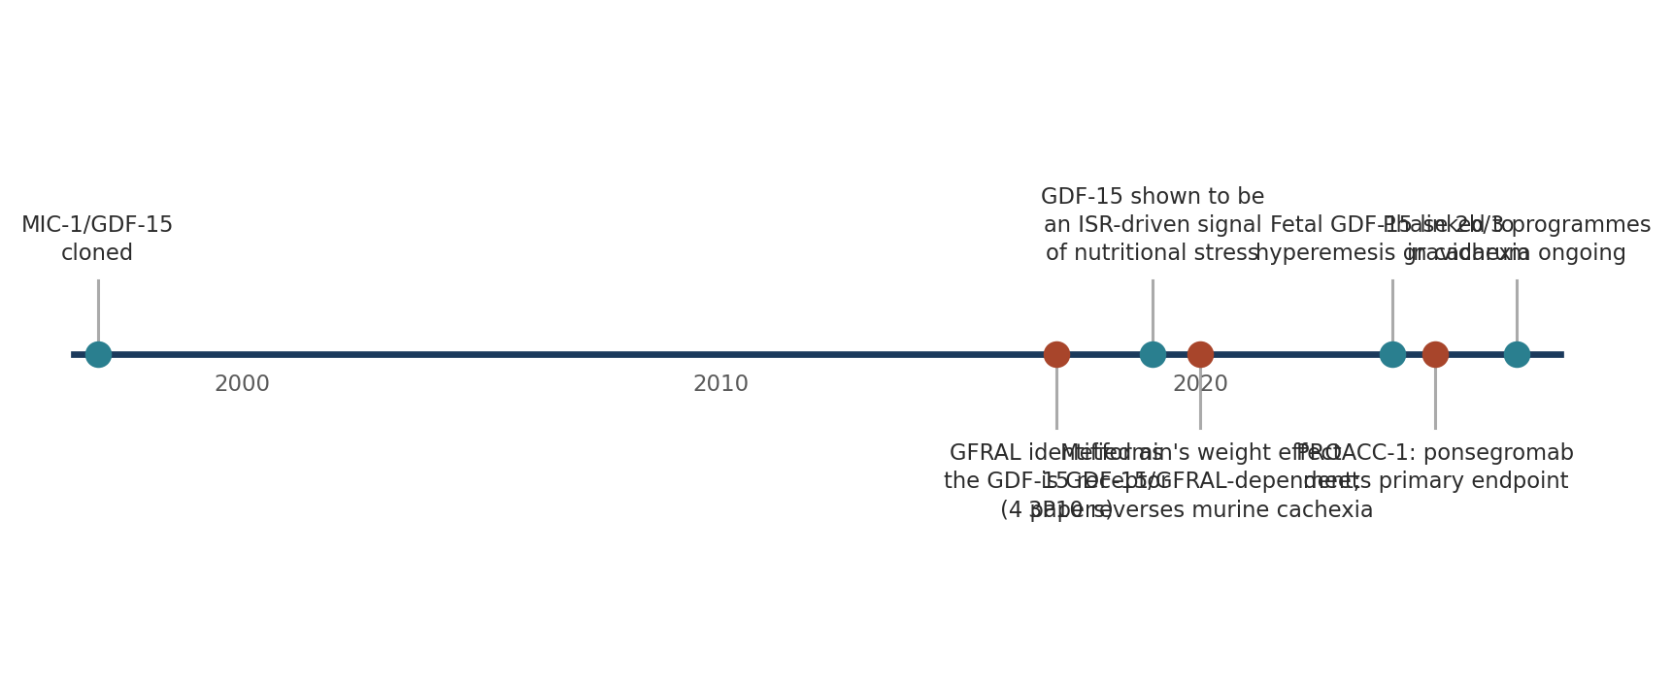
Figure 1. Principal milestones in GDF-15 biology, from the cloning of MIC-1 to the current phase 2b/3 cachexia programmes. Compiled by the author from the primary sources cited throughout this review (refs. 2, 6, 9–15, 18) and from ClinicalTrials.gov registration records (ref. 25).

2. GDF-15: biosynthesis and transcriptional control

2.1 A divergent cytokine with an unusual latency problem
GDF-15 is synthesised as a pre-pro-protein. Following signal-peptide removal, the propeptide is cleaved by furin-like convertases and the mature C-terminal domain assembles into a disulfide-linked homodimer of roughly 25 kDa, which is the circulating and biologically active species.²˒³ A distinctive feature of GDF-15 biology is that the propeptide can retain the mature dimer in a latent, matrix-associated form, so that tissue stores and circulating concentrations are not always in equilibrium — a point of considerable practical importance for assay interpretation and for antibody pharmacology, since therapeutic antibodies bind the free, mature dimer.³˒⁴
Unlike classical TGF-β family ligands, GDF-15 does not signal through the type I/type II serine–threonine kinase receptor pairs that define the superfamily. This anomaly — a TGF-β fold without TGF-β receptor engagement — was one reason the receptor search took so long, and it is also why the axis is mechanistically insulated from the many other TGF-β signals operating in the tumour microenvironment.⁴˒⁵

2.2 Transcription downstream of the integrated stress response
The gene is induced, rather than constitutively expressed, and the inducing signals converge on cellular stress. In tumours, p53 and EGR1 drive GDF15 transcription; more generally, the integrated stress response (ISR) is the dominant upstream controller. When mitochondrial dysfunction, endoplasmic reticulum stress, amino-acid imbalance or oxidative injury activate eIF2α kinases, the resulting ATF4–CHOP transcriptional programme includes GDF15 among its output genes.⁶˒⁷
Patel and colleagues established this link in an elegant series of human and mouse experiments. They found that circulating GDF-15 shows only very modest changes in response to moderate caloric surplus or deficit — clearly distinguishing it from classical intestinally derived satiety hormones and from leptin — but rises markedly after sustained high-fat feeding or dietary amino-acid imbalance. They then demonstrated directly that GDF15 expression is regulated by the integrated stress response and induced in selected tissues in these settings, and that pharmacological GDF-15 administration can trigger conditioned taste aversion in mice.⁶ That last observation reframed the hormone: this is not a satiety signal reporting that enough has been eaten, but an aversion signal reporting that something ingested or something internal is wrong.
The same ISR logic explains GDF-15's behaviour in non-oncological disease. It is a principal secreted output of mitochondrial stress, which is why it is elevated in primary mitochondrial myopathies and in sepsis,⁷ and why it and FGF21 are frequently co-regulated as a stress-cytokine pair in models of mitochondrial perturbation.⁸ In cancer, both the tumour and stressed host tissues contribute, and the resulting plasma concentrations — typically well above the ~0.2–1.2 ng/mL seen in health — can reach levels that in a healthy volunteer would be considered pathological.
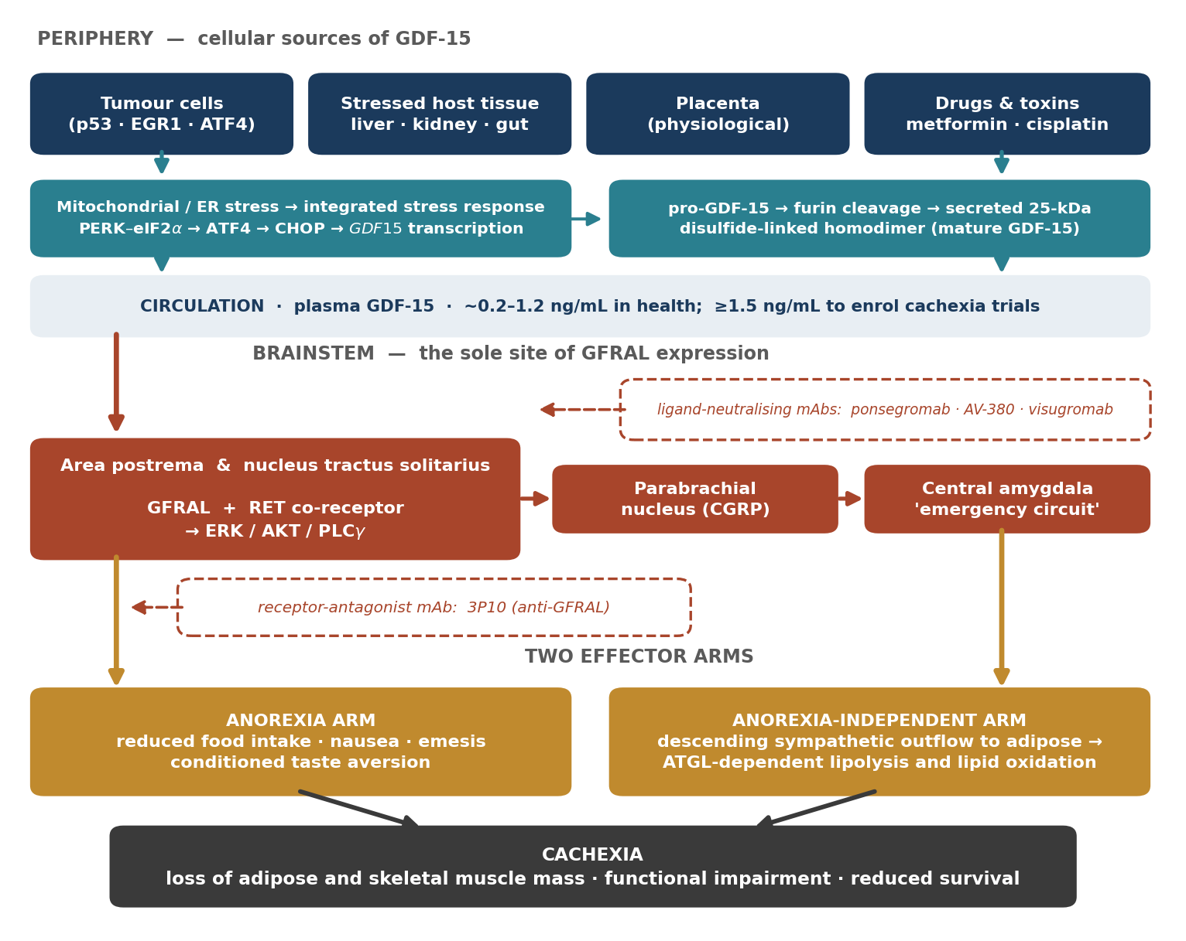
Figure 2. Integrated schematic of the GDF-15–GFRAL axis in cancer cachexia. Original figure drawn by the author from mechanisms and quantitative thresholds reported in refs. 2–6, 9–13 and 18; the enrolment threshold of ≥1500 pg/mL is that used in the PROACC-1 trial (ref. 18). Dashed boxes mark the two pharmacological intervention points that have entered clinical development: neutralisation of the circulating ligand and antagonism of the receptor.

3. GFRAL–RET: an anatomically restricted receptor

3.1 Four laboratories, one receptor, one year
In 2017 four groups — working independently at NGM Biopharmaceuticals, Janssen, Novo Nordisk and Eli Lilly — published within weeks of each other that the receptor for GDF-15 is GDNF-family receptor α-like (GFRAL), a distant relative of the GDNF receptor family.⁹˒¹² The convergence of four pharmaceutical discovery programmes on the same answer, using orthogonal methods, gave the result unusual immediate credibility. Table 1 summarises what each contributed.
Study | Principal approach | Key finding
Hsu et al., Nature 2017⁹ | Expression cloning; Gfral-knockout mice | GFRAL is expressed exclusively in the area postrema and nucleus tractus solitarius; Gfral–/– mice are hyperphagic under stress and resistant to chemotherapy-induced anorexia and weight loss. GDF-15 activates downstream parabrachial and central amygdala neurons — part of the ‘emergency circuit’ shaping feeding under threat.
Mullican et al., Nat Med 2017¹⁰ | Affinity purification; primate dosing | GDF-15 induces weight loss in high-fat-fed mice and in nonhuman primates with spontaneous obesity; binds GFRAL with high affinity; receptor deletion abolishes the effect and worsens diet-induced obesity and insulin resistance. Signalling requires RET as co-receptor.
Yang et al., Nat Med 2017¹¹ | Binding screens; surface plasmon resonance | GDF-15 binds GFRAL specifically and with high affinity; GFRAL requires association with RET to elicit intracellular signalling; anti-obesity effects abolished in Gfral-knockouts; GFRAL expression confined to hindbrain neurons with none in peripheral tissues. Energy expenditure was not increased, implicating reduced intake as the primary mechanism.
Emmerson et al., Nat Med 2017¹² | Orphan-receptor deorphanisation | Independently identified GFRAL as the mediator of the metabolic effects of GDF-15, confirming the hindbrain localisation and the requirement for the receptor in GDF-15-induced weight loss.
Table 1. The four independent 2017 reports that identified GFRAL as the receptor for GDF-15. Content summarised from the abstracts and reported findings of refs. 9–12.

3.2 Receptor architecture and proximal signalling
The functional receptor is a complex rather than a single chain. GFRAL is a GPI-anchored-like binding subunit with no intrinsic catalytic activity; signal transduction requires recruitment of the receptor tyrosine kinase RET, the same co-receptor used by the GDNF family ligands.¹⁰˒¹¹ The GDF-15 homodimer engages two GFRAL molecules, and the resulting assembly brings two RET molecules into proximity for trans-autophosphorylation, activating the canonical RET outputs: ERK/MAPK, PI3K–AKT and PLCγ.⁴˒²⁴
This architecture has direct therapeutic consequences. Because ligand binding and kinase activity reside in different proteins, the complex can be broken at either end. The monoclonal antibody 3P10 exploits precisely this: it targets GFRAL and inhibits RET signalling by preventing the GDF-15-driven interaction of RET with GFRAL at the cell surface, rather than by blocking ligand binding outright.¹³ Ligand-neutralising antibodies such as ponsegromab act at the other end, sequestering circulating GDF-15 before it reaches the brainstem.¹⁶

3.3 Neuroanatomy: a circumventricular gate onto an aversive circuit
The restriction of GFRAL to the area postrema and nucleus tractus solitarius is the single most consequential fact about this axis.⁹˒¹¹ The area postrema is a circumventricular organ — it lacks a complete blood–brain barrier — and it is the brain's chemoreceptor trigger zone, the structure that detects circulating toxins and initiates emesis. A hormone whose only receptor is located there is, by anatomy, a toxin-sensing signal.
Hsu and colleagues traced the downstream circuit: GDF-15 activates GFRAL-expressing neurons in the area postrema and nucleus tractus solitarius, which in turn activate neurons in the parabrachial nucleus and central amygdala — structures that together constitute part of the emergency circuit that shapes feeding responses to stressful conditions.⁹ This is not the arcuate–paraventricular hypothalamic machinery that adjusts intake to energy stores; it is the pathway that makes an animal stop eating because eating seems dangerous. The authors framed GDF-15 accordingly as a mechanistic basis for the non-homeostatic regulation of neural circuitry by a peripheral signal associated with tissue damage and stress.⁹
Two behavioural consequences follow and have both been observed. First, exogenous GDF-15 produces conditioned taste aversion in rodents, meaning animals learn to avoid a flavour paired with the hormone — the signature of a malaise signal rather than a satiety signal.⁶ Second, loss of the receptor confers resistance to chemotherapy-induced anorexia and weight loss,⁹ which places GDF-15 squarely within the biology of treatment tolerance as well as of the tumour itself.

4. How the axis produces cachexia

4.1 The anorectic arm
The first and best-characterised effector arm is reduced food intake. Across mouse, rat and nonhuman primate models, GDF-15 administration lowers intake and body weight, and both effects are abolished by deletion of GFRAL.⁹˒¹²˒²¹ Yang and colleagues noted that GDF-15 did not increase energy expenditure in treated obese mice, concluding that the anti-obesity action of the cytokine is driven primarily by reduced intake.¹¹ In the cancer setting this arm manifests clinically as the anorexia, early satiety, nausea and altered taste that patients report, and it is measurable with instruments such as the Functional Assessment of Anorexia-Cachexia Therapy subscale used in the ponsegromab programme.¹⁷

4.2 The anorexia-independent arm: a sympathetic route to adipose lipolysis
Had anorexia been the whole story, GDF-15 blockade would amount to an expensive appetite stimulant, and the history of appetite stimulants in cachexia is discouraging. The critical experiment came from Suriben and colleagues, who developed the antagonistic anti-GFRAL antibody 3P10 and tested it in tumour-bearing mice.¹³
Three of their findings matter most. First, 3P10 treatment reversed excessive lipid oxidation in tumour-bearing mice and prevented cancer cachexia even under calorie-restricted conditions — that is, the protection persisted when the animals were not permitted to eat more, proving that a substantial part of the effect is not mediated by intake. Second, activation of the GFRAL–RET pathway induced expression of lipid-metabolism genes in adipose tissue. Third, and mechanistically decisive, both peripheral chemical sympathectomy and loss of adipose triglyceride lipase (ATGL) protected mice from GDF-15-induced weight loss.¹³
Together these define a descending efferent limb: hindbrain GFRAL activation drives sympathetic outflow to adipose tissue, where ATGL-dependent lipolysis mobilises triglyceride and raises whole-body lipid oxidation, producing loss of adipose and, secondarily, of muscle mass and function. The authors described this as a peripheral sympathetic axis by which GDF-15 elicits a lipolytic response in adipose tissue independently of anorexia.¹³ This is the mechanistic result that justifies treating GDF-15 as a cachexia driver rather than a cachexia marker.

4.3 Skeletal muscle: the least resolved compartment
Muscle is what determines function and survival in cachexia, and it is where the mechanism is thinnest. GFRAL is not expressed in skeletal muscle — all four discovery papers agree that expression is confined to hindbrain neurons, with none detected in peripheral tissues.⁹˒¹¹ Any GDF-15 effect on myofibres must therefore be indirect: via reduced protein and energy intake, via sympathetically driven catabolism and substrate diversion, or via systemic consequences of the lipolytic state.¹³˒²³ Whether an additional GFRAL-independent action of GDF-15 on muscle exists remains contested, and it is not settled by the available genetic evidence. This uncertainty is the reason that a dedicated phase 1b study of ponsegromab using skeletal muscle mass and physical function as its readouts has been registered in non-small-cell lung cancer-associated cachexia.²⁵

4.4 Human physiology validates the axis from three independent directions
Three lines of human evidence, none of them derived from cancer, converge on the same conclusion: this pathway genuinely controls body weight and nausea in people.
Metformin. Coll and colleagues showed in two independent randomised controlled trials that metformin raises circulating GDF-15, and then demonstrated in mice that metformin prevents high-fat-diet-induced weight gain in wild-type animals but not in mice lacking GDF15 or GFRAL. In obese mice, the weight-lowering effect of metformin was reversed by a GFRAL-antagonist antibody, while its glucose-lowering effect persisted in the absence of GDF-15 activity.¹⁴ The world's most prescribed antidiabetic drug thus loses its weight effect, but not its glycaemic effect, when this axis is removed — a clean pharmacological dissociation.
Pregnancy and hyperemesis gravidarum. Fejzo and colleagues used mass spectrometry with a naturally labelled GDF-15 variant to show that the vast majority of GDF-15 in maternal plasma derives from the feto-placental unit, and that higher maternal levels associate with vomiting in pregnancy and with hyperemesis gravidarum. Strikingly, the risk is governed by maternal sensitivity as much as by fetal production: women with genetically low pre-pregnancy GDF-15 are at increased risk, whereas women with β-thalassaemia, in whom GDF-15 is chronically high, report very low levels of nausea and vomiting of pregnancy. In mice, the acute food-intake response to a GDF-15 bolus was influenced bidirectionally by prior circulating levels, in a manner suggesting desensitisation.¹⁵
Chemotherapy tolerance. Gfral-knockout mice are resistant to chemotherapy-induced anorexia and body-weight loss,⁹ which implies that part of what patients experience as the systemic misery of cytotoxic therapy is GDF-15 signalling through a specific brainstem receptor rather than a diffuse toxic malaise.
The desensitisation finding deserves emphasis, because it is the most important pharmacological caveat in the entire field: a system in which prior exposure sets responsiveness is a system in which chronic blockade may be met by resensitisation, and in which chronic agonism (the obesity indication) may lose efficacy.¹⁵

5. Therapeutic targeting of the axis

5.1 Two pharmacological strategies
Because ligand and receptor are separable, two antibody strategies exist. Ligand neutralisation uses monoclonal antibodies against circulating GDF-15: ponsegromab (Pfizer), AV-380 (AVEO) and visugromab/CTL-002 (CatalYm). Receptor antagonism uses antibodies against GFRAL, of which 3P10 is the best-characterised preclinical agent; it works by preventing GDF-15-driven recruitment of RET to GFRAL.¹³ Ligand neutralisation has advanced furthest clinically, in part because plasma GDF-15 is directly measurable and therefore serves simultaneously as an enrichment biomarker and a pharmacodynamic readout.

5.2 Ponsegromab: first-in-patient pharmacology
Crawford and colleagues reported the first-in-patient (phase 1b) study: ten adults with advanced cancer, cachexia and elevated GDF-15 received open-label ponsegromab 200 mg subcutaneously every three weeks for twelve weeks alongside standard anticancer care.¹⁶ Median serum unbound GDF-15 at baseline was 2.269 ng/mL; after the first dose, median unbound concentrations fell below the lower limit of quantification (0.0424 ng/mL) from three hours post-dose through week 15 — essentially complete and durable target engagement. A least-squares mean weight increase of 4.63 kg (SE 1.98) was observed at week 12, approximately 6.6% above baseline, with improvements in actigraphy-based physical activity and in appetite-related quality of life. No treatment-related treatment-emergent adverse events or injection-site reactions attributable to ponsegromab were identified.¹⁶ With ten patients and no control arm the efficacy signal was hypothesis-generating only, but the pharmacology was unambiguous.

5.3 PROACC-1: the first positive randomised trial
PROACC-1 (NCT05546476) was designed as a double-blind, placebo-controlled phase 2 study in adults with non-small-cell lung, pancreatic or colorectal cancer who had cachexia and elevated GDF-15, randomised 1:1:1:1 to ponsegromab 100, 200 or 400 mg or placebo subcutaneously every four weeks for twelve weeks, with change in body weight at week 12 as the primary endpoint and physical activity, physical function, actigraphy, appetite, nausea and fatigue as secondary endpoints.¹⁷
A total of 187 patients were randomised; 40% had non-small-cell lung cancer, 32% pancreatic cancer and 29% colorectal cancer, and enrolment required serum GDF-15 of at least 1500 pg/mL. All three ponsegromab doses produced significantly greater weight gain than placebo at 12 weeks, with a clear dose–response, and improvements across appetite, cachexia symptoms and physical activity were seen in the 400-mg group relative to placebo. Adverse events of any cause occurred in 70% of ponsegromab-treated patients versus 80% of those given placebo.¹⁸
Group | Median difference vs placebo in 12-week weight change | 95% credible interval | Other reported outcomes
Ponsegromab 100 mg | +1.22 kg | 0.37 to 2.25 | Weight gain significantly greater than placebo
Ponsegromab 200 mg | +1.92 kg | 0.92 to 2.97 | Weight gain significantly greater than placebo
Ponsegromab 400 mg | +2.81 kg | 1.55 to 4.08 | Improvements in appetite, cachexia symptoms and physical activity vs placebo
Placebo | reference | — | Adverse events of any cause in 80% (vs 70% on ponsegromab)
Table 2. Primary and selected secondary results of the PROACC-1 phase 2 trial of ponsegromab in cancer cachexia (n = 187; NCT05546476). Values reproduced from the results reported by Groarke et al., N Engl J Med 2024 (ref. 18).
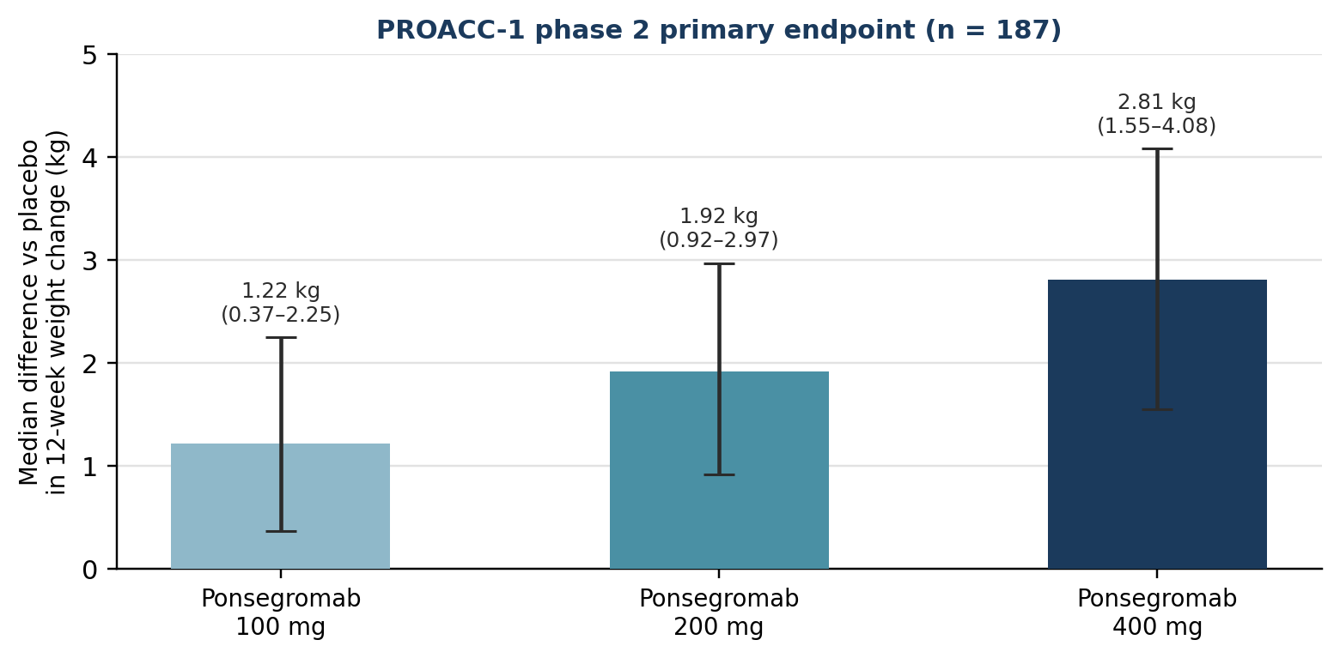
Figure 3. Dose–response for the PROACC-1 primary endpoint. Bars show the median between-group difference in 12-week body-weight change versus placebo; whiskers show 95% credible intervals. Chart constructed by the author from the numerical results reported in ref. 18.

5.4 The wider clinical landscape
The GDF-15 axis is now being pursued in two distinct therapeutic contexts. The cachexia programmes aim to neutralise the ligand to preserve body mass and function. The immuno-oncology programmes aim to neutralise the same ligand for an entirely different reason: GDF-15 has been proposed to act as an immune checkpoint that impedes T-cell infiltration of tumours.²⁰ In the phase 1–2a GDFATHER trial, patients with advanced cancers refractory to anti-PD-1 or anti-PD-L1 therapy received visugromab with nivolumab; durable and deep responses occurred in some patients with non-squamous non-small-cell lung cancer and urothelial cancer, accompanied by increased tumour infiltration, proliferation, interferon-γ-related signalling and granzyme B expression by cytotoxic T cells.¹⁹ That the same antibody class is now entering a randomised phase 2/3 cachexia trial illustrates how tightly the metabolic and immunological faces of this cytokine are linked. Table 3 summarises the registered programmes.
Trial (NCT) | Agent / sponsor | Phase | Status | Setting and size
NCT05546476 (PROACC-1) | Ponsegromab · Pfizer | 2 | Completed | Cancer cachexia, NSCLC/pancreatic/colorectal; n = 187
NCT06989437 | Ponsegromab · Pfizer | 2b/3 | Recruiting | Cachexia with metastatic pancreatic ductal adenocarcinoma, on first-line chemotherapy; n = 982
NCT07663630 | Ponsegromab · Pfizer | 1b | Not yet recruiting | NSCLC-associated cachexia; endpoints are skeletal muscle mass and physical function; n = 80
NCT05492500 | Ponsegromab · Pfizer | 2 | Terminated | Heart failure; n = 455
NCT07112196 | Visugromab · CatalYm | 2/3 | Recruiting | Cancer-associated cachexia; n = 518
NCT04725474 (GDFATHER-1/2a) | Visugromab + nivolumab · CatalYm | 1/2 | Active, not recruiting | Advanced solid tumours refractory to anti-PD-1/PD-L1; n = 199
NCT07098988 / NCT07246863 | Visugromab · CatalYm | 2 | Recruiting | First- and second-line metastatic non-squamous NSCLC; n = 107 and 131
NCT05865535 | AV-380 · AVEO | 1b | Recruiting | Metastatic cancer with cachexia and elevated GDF-15, with standard chemotherapy; n = 30
Table 3. Registered clinical programmes targeting the GDF-15 axis, as recorded on ClinicalTrials.gov and retrieved for this review (ref. 25). Enrolment figures are target or actual enrolment as registered. The heart-failure study of ponsegromab (NCT05492500) is listed as terminated.

6. Discussion: what is established and what is not

6.1 Causality is established; clinical benefit is not yet
The argument that GDF-15 is causal in cachexia now rests on three independent pillars: receptor deletion protects mice from stress- and chemotherapy-induced weight loss;⁹ antibody blockade of the receptor prevents murine cancer cachexia even under caloric restriction;¹³ and, in humans, biomarker-selected patients given a ligand-neutralising antibody gained weight in a dose-dependent, placebo-controlled fashion.¹⁸ The trial investigators were entitled to conclude that their findings confirmed the role of GDF-15 as a driver of cachexia.¹⁸
What has not been shown is that any of this lengthens or improves life. A 2.81 kg median advantage over twelve weeks is a real pharmacological effect, but PROACC-1 was not powered or designed for survival, and its follow-up was short relative to the natural history of advanced pancreatic or lung cancer.¹⁸ The field has been misled before by weight as a surrogate: megestrol acetate reliably produces weight gain, much of it fat and fluid, without corresponding functional benefit. The ongoing phase 2b/3 study in metastatic pancreatic cancer (n = 982) and the dedicated muscle-and-function phase 1b study are the trials that will settle this.²⁵

6.2 Body composition is the central open question
Because GFRAL is absent from muscle,⁹˒¹¹ and because the best-defined anorexia-independent mechanism runs through adipose triglyceride lipase,¹³ the most parsimonious prediction is that GDF-15 blockade preserves fat mass more readily than lean mass. PROACC-1 included lumbar skeletal muscle index among its exploratory objectives,¹⁷ and the registration of a phase 1b study whose primary readouts are skeletal muscle mass and physical function is a candid acknowledgement that this question is unanswered.²⁵ If the weight gained proves to be predominantly adipose, GDF-15 blockade will be a useful component of cachexia therapy rather than a solution to it, and combination with an anabolic or anti-myostatin/activin-receptor strategy becomes the logical next step.

6.3 The costs of blocking a stress signal
GDF-15 is not a pathological molecule that evolution failed to delete. It is the efferent limb of a surveillance system, and blocking it carries at least three theoretical costs. First, the same signal that drives cachexia also drives protective food aversion during toxin exposure; blunting it could conceivably permit continued intake of something harmful, though no such signal has emerged clinically.⁹˒¹⁵ Second, GDF-15 has been characterised as an immune checkpoint restraining antitumour immunity,²⁰ which cuts in the therapeutic direction for cancer but complicates any assumption that the cytokine is simply a bystander. Third, GDF-15 is abundant in normal pregnancy and appears to be physiologically important there,¹⁵ making it an agent that will require careful handling in patients of reproductive potential.
The discontinued heart-failure programme is instructive in this regard. Ponsegromab was taken into a 455-patient phase 2 study in heart failure, a condition in which GDF-15 is among the strongest prognostic biomarkers; that study is recorded as terminated.²⁵ The registry record does not state the reason, and it would be unwarranted to infer a safety finding from the status alone — programmes are stopped for portfolio, futility and enrolment reasons at least as often. But the episode makes the general point that a biomarker's prognostic strength in a disease is not evidence that neutralising it will help that disease. Cachexia is, so far, the indication where the causal chain has actually been demonstrated.

6.4 Patient selection, desensitisation and redundancy
Three further issues will shape how this class is used. Patient selection is already built in: both ponsegromab trials required elevated GDF-15 for entry, with PROACC-1 using a 1500 pg/mL threshold,¹⁷˒¹⁸ which means the phase 2 result applies to a biomarker-defined subgroup and not to cachexia generally. Desensitisation is a genuine pharmacological risk, given direct evidence that prior GDF-15 exposure sets subsequent responsiveness bidirectionally.¹⁵ And redundancy is likely: cachexia is a multifactorial syndrome by definition,¹ with IL-6, TNF-α and activin/myostatin signalling all implicated, so complete GDF-15 neutralisation would not be expected to abolish wasting in patients whose dominant driver lies elsewhere — which is precisely what the partial effect sizes in PROACC-1 suggest.

6.5 Priorities for the next five years
Four questions seem most tractable and most consequential. Does GDF-15 blockade preserve skeletal muscle and physical function, or principally adipose mass? Does it affect survival, or tolerance of the anticancer therapy that patients are receiving concurrently? Does neutralising GDF-15 in an unselected or lower-biomarker population confer any benefit, or is the biomarker threshold essential? And can the metabolic and immunological rationales be combined — that is, can a single anti-GDF-15 antibody simultaneously restore body mass and lift a checkpoint on antitumour immunity, as the parallel visugromab programmes in cachexia and in checkpoint-refractory solid tumours implicitly propose?¹⁹˒²⁵

7. Conclusion
The GDF-15–GFRAL axis is the clearest example in recent metabolic medicine of a biomarker becoming a target. For twenty years GDF-15 was a number that predicted bad outcomes without explaining them. The 2017 identification of GFRAL supplied the missing mechanism and, crucially, located it in a specific and anatomically peculiar place: a circumventricular chemoreceptive zone wired into an aversive rather than a homeostatic circuit. That single anatomical fact accounts for most of the syndrome's clinical texture — the nausea, the food aversion, the failure of feeding to help — and the subsequent demonstration that the pathway also drives sympathetically mediated adipose lipolysis independently of intake explains why cachexia is not simply starvation.
The translation has been unusually fast: receptor identified in 2017, murine proof of reversibility in 2020, first-in-patient pharmacology in 2024, and a positive randomised phase 2 trial in the same year, with phase 2b/3 programmes from two sponsors now enrolling. Whether ponsegromab and its class become the first approved treatments for cancer cachexia depends on a question that the weight endpoint cannot answer: whether the tissue regained is the tissue that matters. The trials now running were designed to find out, and the answers should arrive before the end of this decade.

References
1. Fearon K, Strasser F, Anker SD, et al. Definition and classification of cancer cachexia: an international consensus. Lancet Oncol. 2011;12(5):489–95. doi:10.1016/S1470-2045(10)70218-7 (PMID 21296615)
2. Bootcov MR, Bauskin AR, Valenzuela SM, et al. MIC-1, a novel macrophage inhibitory cytokine, is a divergent member of the TGF-beta superfamily. Proc Natl Acad Sci USA. 1997;94(21):11514–9. doi:10.1073/pnas.94.21.11514 (PMID 9326641)
3. Lockhart SM, Saudek V, O'Rahilly S. GDF15: a hormone conveying somatic distress to the brain. Endocr Rev. 2020;41(4):bnaa007. doi:10.1210/endrev/bnaa007 (PMID 32310257)
4. Breit SN, Brown DA, Tsai VW-W. The GDF15–GFRAL pathway in health and metabolic disease: friend or foe? Annu Rev Physiol. 2021;83:127–51. doi:10.1146/annurev-physiol-022020-045449 (PMID 33228454)
5. Wang D, Day EA, Townsend LK, Djordjevic D, et al. GDF15: emerging biology and therapeutic applications for obesity and cardiometabolic disease. Nat Rev Endocrinol. 2021;17(10):592–607. doi:10.1038/s41574-021-00529-7 (PMID 34381196)
6. Patel S, Alvarez-Guaita A, Melvin A, et al. GDF15 provides an endocrine signal of nutritional stress in mice and humans. Cell Metab. 2019;29(3):707–718.e8. doi:10.1016/j.cmet.2018.12.016 (PMID 30639358)
7. Fujita Y, Ito M, Ohsawa I. Mitochondrial stress and GDF15 in the pathophysiology of sepsis. Arch Biochem Biophys. 2020;696:108668. doi:10.1016/j.abb.2020.108668 (PMID 33188737)
8. Keipert S, Ost M. Stress-induced FGF21 and GDF15 in obesity and obesity resistance. Trends Endocrinol Metab. 2021;32(11):904–15. doi:10.1016/j.tem.2021.08.008 (PMID 34526227)
9. Hsu J-Y, Crawley S, Chen M, et al. Non-homeostatic body weight regulation through a brainstem-restricted receptor for GDF15. Nature. 2017;550(7675):255–9. doi:10.1038/nature24042 (PMID 28953886)
10. Mullican SE, Lin-Schmidt X, Chin C-N, et al. GFRAL is the receptor for GDF15 and the ligand promotes weight loss in mice and nonhuman primates. Nat Med. 2017;23(10):1150–7. doi:10.1038/nm.4392 (PMID 28846097)
11. Yang L, Chang C-C, Sun Z, et al. GFRAL is the receptor for GDF15 and is required for the anti-obesity effects of the ligand. Nat Med. 2017;23(10):1158–66. doi:10.1038/nm.4394 (PMID 28846099)
12. Emmerson PJ, Wang F, Du Y, et al. The metabolic effects of GDF15 are mediated by the orphan receptor GFRAL. Nat Med. 2017;23(10):1215–9. doi:10.1038/nm.4393 (PMID 28846098)
13. Suriben R, Chen M, Higbee J, et al. Antibody-mediated inhibition of GDF15–GFRAL activity reverses cancer cachexia in mice. Nat Med. 2020;26(8):1264–70. doi:10.1038/s41591-020-0945-x (PMID 32661391)
14. Coll AP, Chen M, Taskar P, et al. GDF15 mediates the effects of metformin on body weight and energy balance. Nature. 2020;578(7795):444–8. doi:10.1038/s41586-019-1911-y (PMID 31875646)
15. Fejzo M, Rocha N, Cimino I, et al. GDF15 linked to maternal risk of nausea and vomiting during pregnancy. Nature. 2024;625(7996):760–7. doi:10.1038/s41586-023-06921-9 (PMID 38092039)
16. Crawford J, Calle RA, Collins SM, et al. A phase Ib first-in-patient study assessing the safety, tolerability, pharmacokinetics, and pharmacodynamics of ponsegromab in participants with cancer and cachexia. Clin Cancer Res. 2024;30(3):489–97. doi:10.1158/1078-0432.CCR-23-1631 (PMID 37982848)
17. Groarke JD, Crawford J, Collins SM, et al. Phase 2 study of the efficacy and safety of ponsegromab in patients with cancer cachexia: PROACC-1 study design. J Cachexia Sarcopenia Muscle. 2024;15(3):1054–61. doi:10.1002/jcsm.13435 (PMID 38500292)
18. Groarke JD, Crawford J, Collins SM, et al. Ponsegromab for the treatment of cancer cachexia. N Engl J Med. 2024;391(24):2291–303. doi:10.1056/NEJMoa2409515 (PMID 39282907)
19. Melero I, de Miguel Luken M, de Velasco G, et al. Neutralizing GDF-15 can overcome anti-PD-1 and anti-PD-L1 resistance in solid tumours. Nature. 2025;637(8048):1218–27. doi:10.1038/s41586-024-08305-z (PMID 39663448)
20. Wischhusen J, Melero I, Fridman WH. Growth/differentiation factor-15 (GDF-15): from biomarker to novel targetable immune checkpoint. Front Immunol. 2020;11:951. doi:10.3389/fimmu.2020.00951 (PMID 32508832)
21. Tsai VWW, Husaini Y, Sainsbury A, Brown DA, Breit SN. The MIC-1/GDF15–GFRAL pathway in energy homeostasis: implications for obesity, cachexia, and other associated diseases. Cell Metab. 2018;28(3):353–68. doi:10.1016/j.cmet.2018.07.018 (PMID 30184485)
22. Siddiqui JA, Pothuraju R, Khan P, et al. Pathophysiological role of growth differentiation factor 15 (GDF15) in obesity, cancer, and cachexia. Cytokine Growth Factor Rev. 2021;64:71–83. doi:10.1016/j.cytogfr.2021.11.002 (PMID 34836750)
23. Ling T, Zhang J, Ding F, Ma L. Role of growth differentiation factor 15 in cancer cachexia (Review). Oncol Lett. 2023. Retrieved via Consensus: https://consensus.app/papers/details/2858436c3c27580db15a82ad4dfe8d41/
24. Rochette L, Zeller M, Cottin Y, Vergely C. Insights into mechanisms of GDF15 and receptor GFRAL: therapeutic targets. Trends Endocrinol Metab. 2020;31(12):939–51. doi:10.1016/j.tem.2020.10.004 (PMID 33172749)
25. ClinicalTrials.gov (US National Library of Medicine). Registration records NCT05546476, NCT06989437, NCT07663630, NCT05492500, NCT07112196, NCT04725474, NCT07098988, NCT07246863, NCT05865535. Retrieved 11 September 2026.
Sources. Bibliographic records for references 1–22 and 24 were retrieved from PubMed; reference 23 was retrieved via Consensus; reference 25 from ClinicalTrials.gov. All figures and tables in this review were constructed by the author from data reported in the cited sources; no copyrighted figure has been reproduced.

