WEEKLY REVIEW IN THE BIOLOGICAL SCIENCES
Bacteriophage Therapy for Multidrug-Resistant Bacterial Infection: Molecular Mechanism, the Coevolutionary Arms Race, and the Gap Between Compassionate Use and Randomised Evidence
A structured literature review
Compiled 17 August 2026
Subfield: microbiology / infectious disease therapeutics
ABSTRACT
Antimicrobial resistance (AMR) was associated with an estimated 4.71 million deaths worldwide in 2021, of which 1.14 million were directly attributable to a resistant phenotype; reference forecasts place the associated figure at 8.22 million by 2050. Against this backdrop, therapeutic bacteriophages — obligately lytic viruses that kill a narrow range of bacterial hosts — have re-entered mainstream translational research after a century at the margins of Western medicine. This review synthesises the current mechanistic and clinical literature. Phage killing proceeds through receptor-mediated adsorption, genome injection, host takeover, virion assembly, and holin–endolysin lysis; because the agent replicates on its target, its pharmacology is non-linear and dose–response is governed by inundation thresholds rather than by a fixed concentration. Bacteria resist through a layered arsenal spanning adsorption blockade, restriction–modification and CRISPR–Cas nucleic-acid interference, and abortive-infection systems (CBASS, Thoeris, RADAR, immune ATP nucleosidases) that destroy the infected cell's own metabolic currency; phages in turn encode sponge and glycosidase proteins that sequester or degrade the nucleotide second messengers on which those systems depend. Clinically, the evidence base is sharply bimodal. Personalised, phagogram-guided treatment of 100 consecutive difficult-to-treat infections produced clinical improvement in 77.2% and eradication of the targeted organism in 61.3% of evaluable cases, with eradication 70% less probable when no concomitant antibiotic was given (odds ratio 0.3, 95% CI 0.127–0.749). By contrast, all three published randomised placebo-controlled trials of fixed, non-personalised cocktails — PhagoBurn in burn wounds, intravesical Pyophage after transurethral prostate resection, and topical TP-102 in diabetic foot ulcers — failed to demonstrate superiority, each for identifiable reasons of dose, product characterisation, or statistical power. We argue that this apparent paradox is not evidence against phage therapy but a specification of the conditions under which it can work: adequately titred, susceptibility-matched preparations delivered to the infection site alongside antibiotics. We close by identifying the open questions most likely to determine whether phage therapy becomes a licensed modality or remains a salvage practice.
Keywords: bacteriophage therapy; antimicrobial resistance; anti-phage defence; CBASS; phage–antibiotic synergy; phagogram; personalised medicine; ESKAPE pathogens

1. Introduction

1.1 The resistance gap
Antibacterial chemotherapy rests on a small number of molecular scaffolds discovered largely between 1940 and 1970, and bacterial populations have had eight decades to explore escape routes from each of them. The most recent comprehensive accounting of that erosion, produced by the Global Research on Antimicrobial Resistance collaboration, estimated that in 2021 bacterial AMR was associated with 4.71 million deaths (95% uncertainty interval 4.23–5.19 million) and directly attributable to 1.14 million (1.00–1.28 million). The trajectory is not uniform. Between 1990 and 2021, AMR mortality in children under five fell by more than half — a genuine public-health achievement driven by vaccination and infection prevention — while mortality in adults aged seventy and above rose by more than 80%. Two phenotypes account for a disproportionate share of the increase: methicillin-resistant Staphylococcus aureus, whose associated deaths grew from 261,000 to 550,000, and carbapenem resistance among Gram-negative organisms, which grew from 619,000 to 1.03 million associated deaths over the same interval.
The reference forecast to 2050 projects 8.22 million associated and 1.91 million attributable deaths per year. Notably, the same modelling exercise found that a scenario of improved care and access to existing antibiotics would avert roughly eight times as many deaths as a scenario in which a new Gram-negative drug pipeline materialises (92.0 million versus 11.1 million cumulative deaths averted between 2025 and 2050). This is an important framing for any discussion of novel antibacterials: new agents matter, but they matter most for the subset of patients for whom no adequate conventional option exists. That subset — not community-acquired infection at large — is where phage therapy has accumulated its evidence.
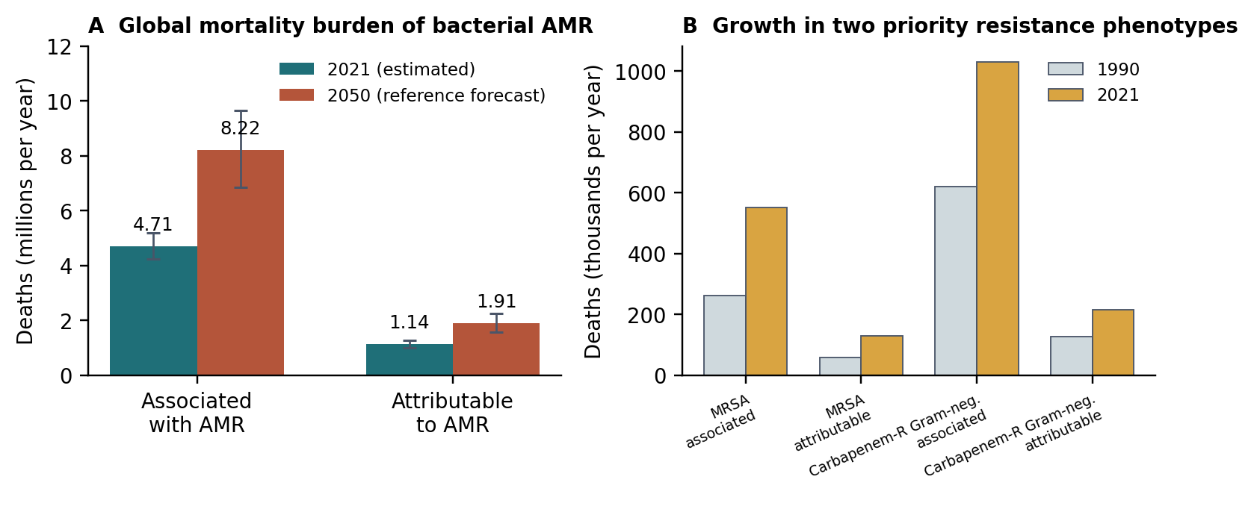
Figure 1. The mortality burden of bacterial antimicrobial resistance. (A) Global deaths associated with, and attributable to, bacterial AMR in 2021 with 95% uncertainty intervals, alongside the 2050 reference-scenario forecast. (B) Growth between 1990 and 2021 in deaths linked to two priority resistance phenotypes. Chart constructed by the authors from the estimates reported by the GBD 2021 Antimicrobial Resistance Collaborators, Lancet 2024;404:1199–1226 (reference 1); no figure was reproduced from the source article.

1.2 A century-old idea, revisited
Bacteriophages were described independently by Twort and d'Hérelle in the second decade of the twentieth century and were used therapeutically almost immediately. Western pharmaceutical interest collapsed with the arrival of sulphonamides and penicillin, but clinical practice continued largely uninterrupted in Georgia, Poland, and the Soviet Union — which is why the Eliava Institute in Tbilisi remains a source of both phage banks and clinical experience today. The modern revival dates from a small number of highly publicised salvage cases in the late 2010s, and has since produced institutional infrastructure: national magistral (compounding) frameworks, curated phage banks, susceptibility assays analogous to antibiograms, and a first generation of registered clinical trials.
A bibliometric analysis found that annual publications on therapeutic phages rose from 212 in 2011 to 739 in 2022, yet the same systematic search identified only seven randomised controlled trials, together enrolling 418 participants, across indications as heterogeneous as bacterial diarrhoea, urinary tract infection, infected burn wounds, chronic otitis, venous leg ulcers, and chronic rhinosinusitis. The mismatch between publication volume and controlled evidence is the central problem this review addresses.

2. Biological background: what a phage is and how it kills

2.1 Lytic and temperate lifestyles
Bacteriophages are viruses of bacteria. Structurally most therapeutic candidates are tailed, double-stranded DNA viruses: an icosahedral capsid containing the genome, a contractile or non-contractile tail, and distal fibres bearing receptor-binding proteins (RBPs). Functionally, the distinction that matters for therapy is between obligately lytic (virulent) phages, which always kill the cell they infect, and temperate phages, which can integrate as prophages and replicate passively with the host chromosome.
Only obligately lytic phages are acceptable as therapeutics, for two reasons. First, a lysogenic phage does not reliably kill. Second, integrated prophages are a principal vehicle of horizontal gene transfer, including of virulence factors and resistance determinants — the very traffic that generated the problem being treated. Contemporary manufacturing standards therefore require whole-genome sequencing of every therapeutic phage to confirm the absence of integrase and repressor genes and of any recognised virulence or AMR determinant. In the largest published personalised-therapy cohort, the Belgian consortium documented that phage genomes 'contained no genetic determinants known to confer lysogeny' and that endotoxin content was held below the pyrogenic threshold of 5.0 endotoxin units per kilogram body mass per hour for intravenous routes.

2.2 The lytic cycle
Infection proceeds through five stages. (i) Adsorption: an RBP on the tail fibre binds a specific, exposed macromolecule on the bacterial surface. (ii) Genome entry: the tail penetrates or channels through the envelope and the genome is injected into the cytoplasm. (iii) Host takeover: early phage genes shut down or redirect host transcription and translation. (iv) Assembly: structural proteins self-assemble and genomes are packaged into capsids. (v) Lysis: a holin permeabilises the inner membrane, allowing an endolysin to reach and hydrolyse the peptidoglycan sacculus; the cell bursts, releasing progeny. Burst sizes are typically tens of virions per infected cell, and latent periods can be very short — a Klebsiella aerogenes phage characterised in 2026 showed a 15-minute latent period at an optimal multiplicity of infection of 0.01.
This last point is the source of both the promise and the difficulty of phage therapy. An effective phage is a self-amplifying drug: its concentration at the infection site can rise by orders of magnitude without further dosing, provided susceptible hosts remain. Equally, its concentration collapses when they do not.
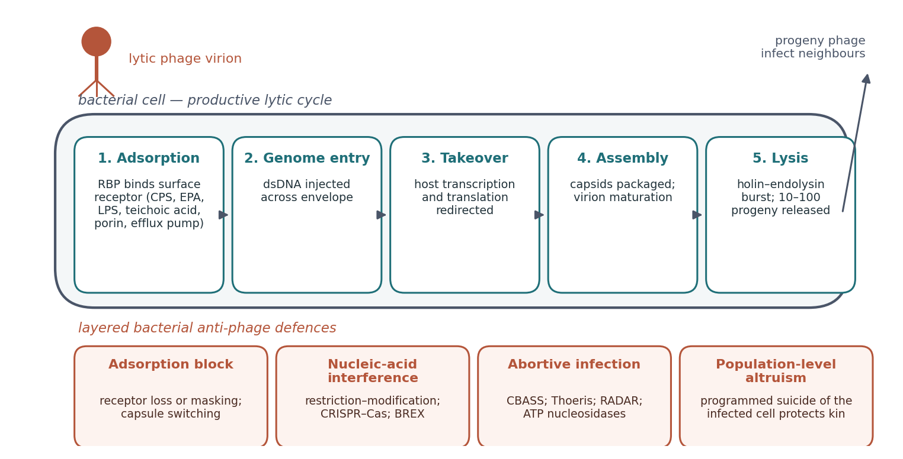
Figure 2. Schematic of the productive lytic cycle (upper panel) and the four functional tiers of bacterial anti-phage defence that can interrupt it (lower panel). Original schematic drawn by the authors; the mechanistic content synthesises references 4, 5, 11, 12, 13, 14, 21 and 23. RBP, receptor-binding protein; CPS, capsular polysaccharide; EPA, enterococcal polysaccharide antigen; LPS, lipopolysaccharide; BREX, bacteriophage exclusion; CBASS, cyclic-oligonucleotide-based antiphage signalling system.

2.3 Receptor specificity sets the host range — and the failure mode
A phage can only infect a cell whose surface displays its receptor. Recent characterisation work makes the point concretely. Four newly isolated Enterococcus faecium phages, each with a genome of approximately 19 kilobases, showed a narrow spectrum of activity; when resistant mutants were selected in vitro, they carried mutations in the enterococcal polysaccharide antigen (epa) and capsular polysaccharide (cps) loci, and the phages proved able to infect only those clinical isolates bearing similar epa loci — implicating that surface polysaccharide as the receptor. In Klebsiella pneumoniae, tropism is likewise mediated principally through recognition of capsular polysaccharide and, secondarily, lipopolysaccharide by phage-encoded RBPs.
The therapeutic consequence is that host range must be measured, not assumed. The assay for doing so — a 'phagogram', by analogy with the antibiogram — tests a patient's own isolate against a panel of banked phages. Its yield can be low. In the largest mycobacterial series, isolates from 200 culture-positive patients were screened and one or more lytic phages could be found for only 55 of them; 20 patients were ultimately treated (Figure 4).

2.4 A drug that replicates: non-linear pharmacology
Conventional pharmacokinetic–pharmacodynamic models assume that drug concentration declines monotonically from a dose according to clearance. Phages violate this assumption in both directions: they amplify where targets are abundant, and they are cleared by the reticuloendothelial system, principally in liver and spleen. Reviews of paediatric phage pharmacology consequently argue for non-linear, dynamic models that couple phage and bacterial population equations together with host immune clearance.
A 2026 in vitro study of three anti-staphylococcal phages against two S. aureus strains quantified what this means for dosing. Phage–bacteria interaction followed a predator–prey pattern with rapid initial bacterial collapse, but regrowth occurred in some experiments and was associated with the initial multiplicity of infection. All resistant clones carried mutations in teichoic acid biosynthesis genes and showed growth defects. Critically, the phage binding rate of resistant bacteria was 35- to 250-fold lower than that of susceptible bacteria, giving them proliferation 45- to 310-fold higher and inundation thresholds 34- to 190-fold higher. Model-based simulation led to a clean clinical inference: suppressing resistance requires an initial phage dose exceeding the inundation threshold of the resistant subpopulation as well as the susceptible one. Underdosing does not merely fail; it selects.

3. The coevolutionary arms race

3.1 A layered bacterial defence arsenal
Bacteria have been under phage predation for billions of years and their genomes are correspondingly dense with defence systems. These fall into functional tiers. The outermost is adsorption blockade: loss, mutation, or masking of the surface receptor, as in the epa and cps mutants and teichoic acid mutants described above. Inside the cell, restriction–modification enzymes and CRISPR–Cas systems discriminate self from foreign DNA and cleave the latter. The most rapidly expanding category is abortive infection: systems that sense infection and then destroy something the phage needs, accepting the death of the infected cell as the price of protecting its clonal neighbours.
The molecular logic of abortive infection has been substantially clarified since 2023 and is worth stating precisely, because it is now the frontier of phage engineering. Cyclic-oligonucleotide-based antiphage signalling systems (CBASS) synthesise cyclic dinucleotides such as 3'3'-cGAMP upon infection; Thoeris systems convert NAD⁺ into the cyclic ADP-ribose isomers 2'cADPR and 3'cADPR. In both cases a small nucleotide second messenger activates a downstream effector. A conserved effector family identified in 2023 turned out to be an ATP nucleosidase: on infection it cleaves the N-glycosidic bond of cellular ATP and dATP, degrading the cell's energy currency and halting phage propagation. These domains occur across CBASS operons, prokaryotic Argonautes, and NLR-like proteins, and homologous domains in eukaryotic proteins retain the same enzymatic activity — evidence that nucleotide-depletion immunity is conserved across the tree of life. The RADAR system offers a structural counterpoint: cryo-electron microscopy showed RdrA and RdrB assembling into a complex of up to 10 megadaltons, in which a dodecameric RdrB deaminates ATP mononucleotides to ITP, causing massive inosine mononucleotide accumulation during infection.

3.2 Phage counter-defences: sponges and glycosidases
Phages evade these systems, and the mechanisms are instructive because they are all directed at the nucleotide signal rather than at the effector. A biochemical screen of 57 diverse phages identified Acb4 from the phage SPO1 as the founding member of a family of more than 1,300 immune-evasion proteins; a 2.1 Å crystal structure in complex with 3'3'-cGAMP showed a tetrameric assembly that acts as a molecular sponge, sequestering CBASS second messengers so that immune activation never occurs. Sequestration, however, is reversible and stoichiometric. A 2026 forward biochemical screen went further and identified RyDEP, a mycobacteriophage glycosidase that cleaves the ribose–ribose linkage of 2'cADPR and 3'cADPR — the first mechanism shown to destroy these exceptionally stable Thoeris signals outright. The crystal structure of the post-cleavage RyDEP–3'cADPR complex revealed unexpected homology with the Repeat12 domain of animal ryanodine receptors, and the reaction has a second benefit for the phage: it directly regenerates NAD⁺.
For therapy, the practical reading of this literature is that phage resistance is not a single obstacle to be engineered around once. It is a multi-layered, evolvable system, and any given therapeutic phage carries only a subset of the counter-measures needed.
Table 1. Functional tiers of bacterial anti-phage defence and the phage counter-measures characterised to date. Compiled by the authors from the cited primary literature; no table was reproduced from a source article.
Tier | Representative systems | Molecular action | Documented phage counter-measure
Adsorption blockade | epa / cps locus variation (E. faecium); capsular polysaccharide switching (K. pneumoniae); teichoic acid biosynthesis mutation (S. aureus) | Receptor is lost, altered, or masked, so the receptor-binding protein cannot dock | Host-range expansion by cocktail formulation, RBP engineering, or pre-adaptation of the phage to the patient isolate (refs 2, 4, 5, 21)
Nucleic-acid interference | Restriction–modification; CRISPR–Cas; BREX | Incoming phage genome is recognised as non-self and cleaved | Genome modification and anti-CRISPR proteins; conversely, CRISPR–Cas can be weaponised and delivered by engineered phage (ref 22)
Abortive infection — nucleotide signalling | CBASS (3'3'-cGAMP); Thoeris (2'cADPR, 3'cADPR) | Infection-triggered synthesis of a cyclic nucleotide messenger activates a lethal effector | Acb4-family sponge proteins sequester CBASS signals (>1,300 homologues; 2.1 Å structure, ref 13); RyDEP glycosidases cleave 2'/3'cADPR and regenerate NAD⁺ (ref 14)
Abortive infection — metabolic destruction | Immune ATP nucleosidases; RADAR (RdrAB, up to 10 MDa) | Cellular ATP/dATP is cleaved at the N-glycosidic bond, or deaminated to ITP, starving the phage of substrate | Not yet characterised; a principal open question for rational phage selection (refs 11, 12)

3.3 Resistance that costs the bacterium: phage steering
The most therapeutically interesting property of phage resistance is that it is frequently expensive. Because many phage receptors are also virulence or resistance apparatus, a mutant that escapes the phage often surrenders something else. The best-characterised example is the Pseudomonas aeruginosa phage OMKO1, which binds an outer-membrane component of a multidrug efflux system. Selection for OMKO1 resistance therefore selects against efflux-mediated antibiotic resistance — an approach termed 'phage steering'. A controlled test across three antibiotics found that OMKO1 reduced antibiotic resistance in P. aeruginosa PAO1 even in the presence of antibiotic, that the effect persisted after roughly 70 bacterial generations of continuous coculture, and that in a Galleria mellonella larval model the phage both extended survival and increased erythromycin sensitivity, whether or not antibiotic was present.
The same logic has since been documented for carbapenem-resistant Acinetobacter baumannii. Resistance to the phage pB23 arose through a stop-gain mutation in the gtr9 glycosyltransferase gene; the mutants produced less capsular polysaccharide, formed poorer biofilms, grew more slowly, were attenuated in a zebrafish infection model, and — decisively — were more sensitive to meropenem. The trade-off was stable across continuous passage, and phage–meropenem combination retained synergy across different matrices. In the 100-case Belgian cohort the same phenomenon was observed clinically: a combination of antibiotic re-sensitisation and reduced virulence in phage-resistant isolates that emerged during treatment.
Phage steering reframes the resistance problem. If the escape mutant is less fit and more drug-susceptible than its parent, then phage and antibiotic are not merely additive but mutually reinforcing, and the emergence of phage resistance during therapy is not automatically a treatment failure.

4. The host immune system as a third player
Therapeutic phages are not immunologically inert particles. Phage capsids, phage nucleic acids, bacterial lysis products, and manufacturing impurities all interact with innate and adaptive immunity, and those interactions cut both ways. Complement activation, phagocyte uptake, and pattern-recognition receptor signalling can restrict phage bioavailability, while neutrophil-mediated killing can cooperate with phage lysis to clear the pathogen. On repeated or systemic administration, anti-phage antibodies and serum neutralisation become relevant.
The clinical data on neutralisation are more nuanced than often assumed. In the 20-patient mycobacterial series, neutralising antibodies appeared in serum after initiation of intravenous phage in eight patients and potentially contributed to non-response in four — but were not consistently associated with unfavourable outcome in the others. In the 100-case cohort, immune neutralisation was detected in 5 of 13 screened patients (38.5%). Antibody development is therefore a monitoring parameter rather than a reliable predictor of failure, and this asymmetry is one of the strongest arguments for routine immune monitoring in phage trials.
Two further observations from the mycobacterial series deserve emphasis, because they run counter to intuition. First, no adverse reaction was attributed to therapy in any of the 20 patients, regardless of pathogen, phage, or route — intravenous, aerosolised, or both. Second, of the eleven patients treated with a single phage rather than a cocktail, none developed phage resistance. Whatever limits mycobacterial phage therapy, it is the scarcity of usable phages and the immune response to them, not the evolution of resistance in the pathogen.

5. Clinical evidence

5.1 The salvage case that restarted the field
In 2017 a 68-year-old patient with diabetes and necrotising pancreatitis complicated by a multidrug-resistant Acinetobacter baumannii infection of a pancreatic pseudocyst deteriorated over four months despite multiple antibiotic courses and percutaneous drainage. Two laboratories screened for lytic activity against the patient's own isolate and identified nine phages. Administration intravenously and percutaneously into the abscess cavities was associated with reversal of his clinical trajectory, clearance of the infection, and recovery. The case is a single observation and the authors framed it as such, but it established the operational template that essentially all subsequent personalised phage therapy has followed: isolate the pathogen, screen a bank, compound a bespoke preparation, deliver it to the site, and continue antibiotics.

5.2 What large observational cohorts show
The most informative dataset in the field is a retrospective observational analysis of the first 100 consecutive cases of personalised phage therapy facilitated by a Belgian consortium between January 2008 and April 2022, spanning 35 hospitals in 29 cities across 12 countries. The commonest indications were lower respiratory tract infection (25.4% of 114 targeted infections), skin and soft tissue infection (22.8%), bone infection (14.0%), and upper respiratory tract infection (11.4%). Treatment used combinations of 26 individual phages and six defined cocktails, individually selected and in some cases pre-adapted to the causative strain; in 69.3% of targeted infections phages were applied locally at the infection site.
Clinical improvement was reported in 77.2% (88/114) of targeted infections and eradication of the targeted organism in 61.3% (65/106) of infections with adequate bacteriological follow-up. Three findings from the regression analysis carry more weight than the headline rates. First, eradication was 70% less probable when no concomitant antibiotic was used (odds ratio 0.3, 95% CI 0.127–0.749); concomitant antibiotic use was the single most informative variable in the reduced dataset. Second, in vitro phage–antibiotic synergy was demonstrated in 9 of 10 evaluable patients. Third, in vivo selection of phage resistance was documented in 7 of 16 evaluated patients (43.8%), but eradication failed in 43% of patients with resistance selection and in 22% of those without — a difference, but not a categorical one. Fifteen adverse events were reported, including seven non-serious suspected adverse drug reactions.
The dissociation between clinical and microbiological endpoints in this cohort is itself informative: 18 of 106 monitored infections (17.0%) improved clinically without bacterial eradication, and in two patients eradication occurred without clinical improvement. Five patients showed neither, and died of septic shock, cardiogenic shock, or related causes. The authors are explicit that the uncontrolled design, physician-assessed endpoints, and absence of prespecified clinical metrics limit inference — a caveat that should be carried forward into any reading of the percentages above.
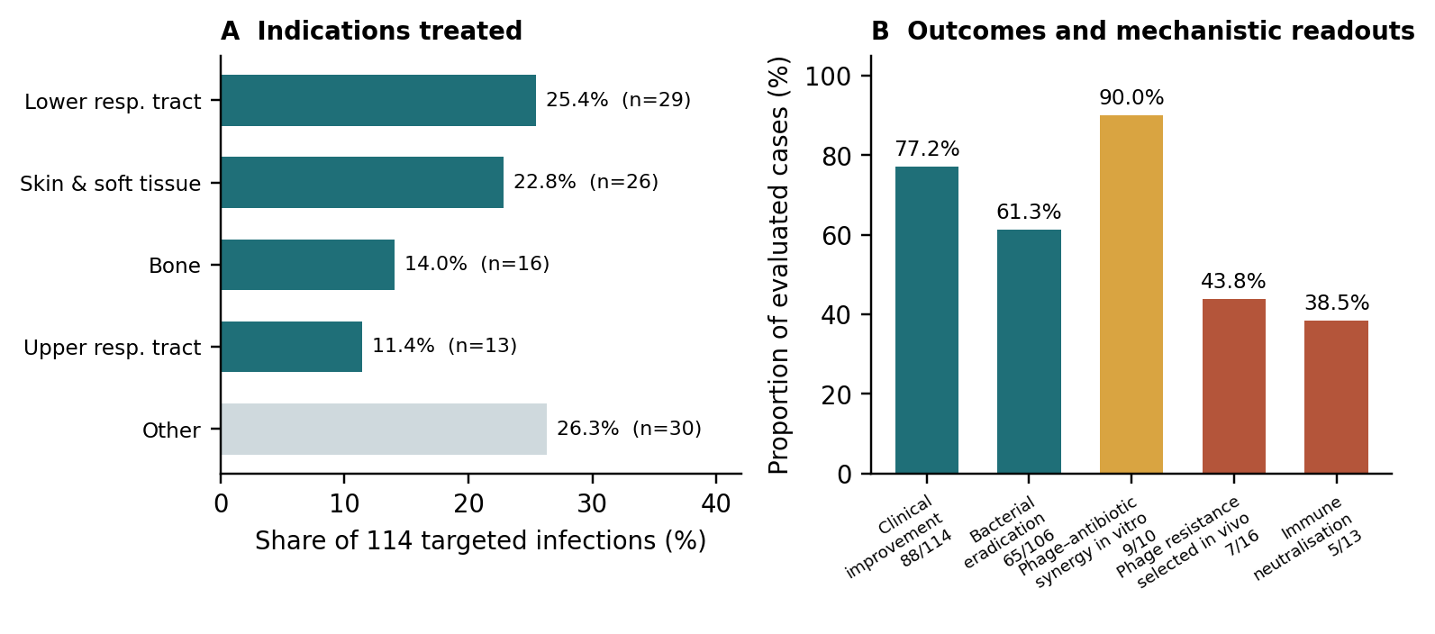
Figure 3. Personalised bacteriophage therapy in 100 consecutive real-world cases. (A) Distribution of the 114 targeted infections by anatomical indication. (B) Clinical and microbiological outcomes together with three mechanistic readouts. Chart constructed by the authors from the counts and proportions reported by Pirnay et al., Nature Microbiology 2024;9:1434–1453 (reference 2); no figure was reproduced from the source article. 'Other' in panel A aggregates the remaining indications reported in the source.
The mycobacterial experience provides a complementary, and sobering, view of feasibility. Non-tuberculous mycobacteria — particularly Mycobacterium abscessus in cystic fibrosis and bronchiectasis — are intrinsically antibiotic-resistant and represent one of the hardest problems in clinical mycobacteriology. Screening isolates from 200 culture-positive symptomatic patients yielded at least one lytic phage for only 55; 20 patients were treated on a compassionate-use basis; and favourable clinical or microbiological responses were seen in 11. Subsequent synthesis has attributed the heterogeneity of outcome chiefly to antibody-mediated neutralisation during intravenous delivery and to morphotype-dependent susceptibility, with smooth colony variants resistant to currently available phages.
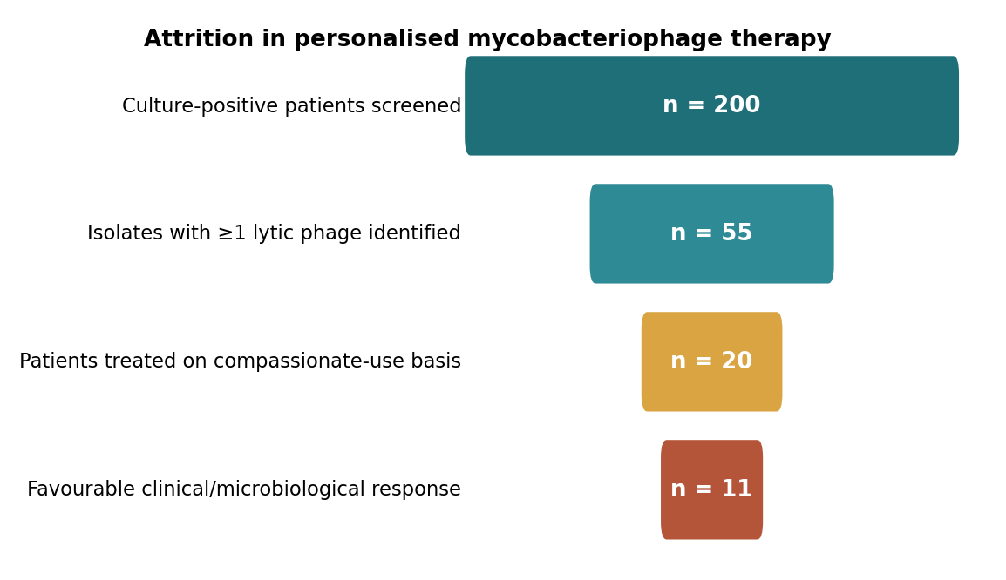
Figure 4. Feasibility attrition in personalised mycobacteriophage therapy: from patients screened to favourable response. Chart constructed by the authors from the counts reported by Dedrick et al., Clinical Infectious Diseases 2023;76:103–112 (reference 3); no figure was reproduced from the source article.

5.3 The randomised trials, and why they read as failures
Three randomised, placebo- or standard-of-care-controlled trials of phage therapy have been published in full, and none demonstrated superiority. Read carefully, however, each carries a distinct and largely technical explanation.
PhagoBurn randomised 27 patients across nine burn centres in France and Belgium to a twelve-phage anti-Pseudomonas cocktail (PP1131) or 1% silver sulfadiazine, applied topically for seven days. It was stopped early for insufficient efficacy: the primary endpoint of sustained two-quadrant reduction in bacterial burden was reached at a median of 144 hours with PP1131 versus 47 hours with standard of care (hazard ratio 0.29, 95% CI 0.10–0.79; p = 0.018). The reason is stated plainly in the report: the cocktail's titre decayed after manufacture, so participants received a substantially lower concentration of phages per daily dose than the protocol specified. The ancillary analysis found that bacteria isolated from treatment failures were resistant to low phage doses. In the language of Section 2.4, the delivered dose sat below the inundation threshold. The authors' own conclusion was that further studies with increased phage concentrations and phagogram guidance are warranted.
The intravesical UTI trial randomised men scheduled for transurethral resection of the prostate to a commercial Pyo bacteriophage cocktail, placebo bladder irrigation, or sensitivity-guided systemic antibiotics for seven days. Urine culture normalised in 5/28 (18%) with Pyophage, 9/32 (28%) with placebo, and 13/37 (35%) with antibiotics. Phage therapy was non-inferior to antibiotics but not superior to placebo; adverse events were numerically fewest in the phage arm (21% versus 41% with placebo). The trial is methodologically the most rigorous in the field and its negative result is real — but the intervention was an off-the-shelf, periodically adapted commercial cocktail rather than a phagogram-matched preparation, and bladder irrigation with saline is a non-trivial comparator.
The most recent trial randomised 19 participants with diabetic foot ulcers, of whom 13 received the TP-102 cocktail topically at 10⁹ PFU/mL/cm³ after susceptibility testing. No treatment-related adverse events occurred. Microbiological reduction of target bacteria was seen in 80% of TP-102 recipients versus 50% of placebo recipients, and 5/7 (71.4%) versus 1/3 (33.3%) reached 50% wound closure — but with p = 1.000 and p = 0.500 respectively, the study was, as its authors state, underpowered to determine superiority. It is a safety and feasibility result, not an efficacy result.
Table 2. Published randomised controlled trials of bacteriophage therapy. All figures are as reported in the primary publications; the table was compiled by the authors and not reproduced from any source.
Trial (year) | Indication / pathogen | Design and n | Primary result | Interpretation
PhagoBurn (2019) | Infected burn wound; P. aeruginosa | Randomised, controlled, double-blind phase 1/2; 27 randomised (13 phage, 14 standard of care); 9 centres, France and Belgium | Median time to sustained 2-quadrant bacterial reduction 144 h (PP1131) vs 47 h (silver sulfadiazine); HR 0.29 (95% CI 0.10–0.79), p = 0.018; stopped early | Titre decayed after manufacture, so the delivered daily dose was far below the intended concentration; failures' isolates were resistant to low phage doses. A dosing failure, not a mechanism failure.
Intravesical Pyophage (2021) | UTI in men undergoing transurethral prostate resection | Randomised, placebo-controlled, double-blind, with open-label antibiotic comparator; 97 treated (28 / 32 / 37) | Urine culture normalisation 5/28 (18%) phage vs 9/32 (28%) placebo (OR 1.60, 95% CI 0.45–5.71) vs 13/37 (35%) antibiotic (OR 2.66, 0.79–8.82) | Non-inferior to antibiotics, not superior to placebo. Favourable safety (21% vs 41% adverse events). Used an off-the-shelf commercial cocktail, not a phagogram-matched product.
TP-102 (2025) | Diabetic foot ulcer; S. aureus, P. aeruginosa and/or A. baumannii | Randomised, double-blind safety and tolerability study; 19 randomised, 13 received TP-102; Israel | No treatment-related adverse events. Microbiological reduction 80% vs 50% (p = 1.000); 50% wound closure 5/7 (71.4%) vs 1/3 (33.3%) (p = 0.500) | Explicitly underpowered for superiority. Supports safety and tolerability of susceptibility-matched topical phage; efficacy untested.

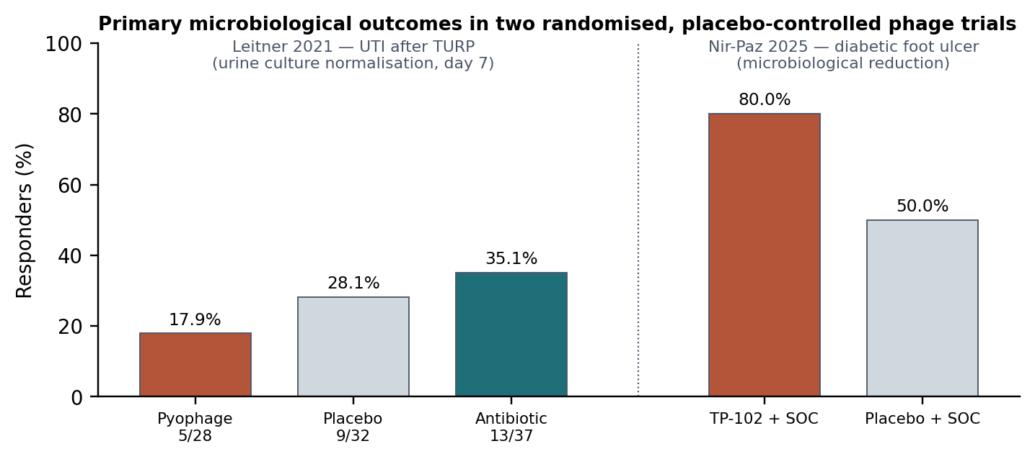
Figure 5. Primary microbiological outcomes in two randomised, placebo-controlled phage trials. Left, urine culture normalisation at day 7 in the intravesical Pyophage trial (reference 6). Right, microbiological reduction of target bacteria in the TP-102 diabetic foot ulcer trial (reference 7); denominators were not reported for this endpoint in the source publication and are therefore omitted. Chart constructed by the authors from reported values; no figure was reproduced from either source article. SOC, standard of care.

5.4 The current trial pipeline
A search of ClinicalTrials.gov for interventional phase 1–3 studies of bacteriophage interventions returned 66 registered records at the time of writing. The composition of that pipeline is revealing in two ways. First, it has shifted decisively toward defined, sponsor-manufactured products — including recombinant cocktails — rather than adapted bank preparations. Second, it retains a high attrition rate at the sponsor level: several prosthetic joint infection programmes were withdrawn before enrolling a single patient.
Table 3. Selected interventional phage trials registered on ClinicalTrials.gov, illustrating the shape of the current pipeline. Retrieved 17 August 2026; status and enrolment as recorded in the registry.
Registry ID | Product / indication | Phase and status | Enrolment | Notable design feature
NCT05488340 (ELIMINATE) | LBP-EC01, recombinant E. coli phage cocktail; acute uncomplicated UTI caused by drug-resistant E. coli | Phase 2; recruiting | 318 planned (30 open-label PK lead-in, 288 randomised) | The largest randomised phage trial to date; dose regimen selected in a PK lead-in, then phage plus trimethoprim/sulfamethoxazole versus placebo plus antibiotic
NCT05453578 | WRAIR-PAM-CF1; P. aeruginosa colonisation in cystic fibrosis | Phase 1b/2; completed | 73 | NIAID-sponsored, 19 sites, single dose, placebo-controlled
NCT04596319 | AP-PA02 inhaled multi-phage therapeutic; chronic pulmonary P. aeruginosa in cystic fibrosis | Phase 1b/2a; completed | 29 | Single and multiple ascending inhaled doses
NCT04684641 (CYPHY) | YPT-01; P. aeruginosa in adults with cystic fibrosis | Phase 1/2; completed | 8 | Single site, randomised, double-blind, placebo-controlled
NCT06605651 | PP1493 and PP1815 anti-S. aureus phages; hip or knee prosthetic joint infection | Phase 2; not yet recruiting | 100 planned | Intra-articular injection adjunctive to debridement, antibiotics and implant retention (DAIR)
NCT06409819 | Personalised phage therapy; recurrent UTI in kidney transplant recipients | Phase 1/2; recruiting | 32 planned | Personalised selection in an immunosuppressed population
NCT05269134 | PhageBank phage therapy adjunctive to DAIR; chronic prosthetic joint infection | Phase 2; withdrawn | 0 (10 sites opened) | Illustrates programme-level attrition: withdrawn without enrolling
POSTSTAMP (protocol published) | Mycobacteriophage therapy; refractory pulmonary M. abscessus in cystic fibrosis | Prospective multi-site protocol under FDA compassionate-use IND | 10 planned | One or two phages intravenously twice daily for 52 weeks; participants without a phage match followed on guideline-based therapy as comparison group

6. Reconciling the paradox
The field's central empirical tension is that uncontrolled personalised therapy reports success rates in the 60–80% range while controlled trials of fixed products report no benefit. Four differences between the two settings account for most of the gap, and each is a testable design variable rather than an irreducible difference of opinion.
- Dose adequacy. PhagoBurn delivered substantially less phage than intended, and its failures were demonstrably low-dose failures. In vitro PK/PD modelling indicates that resistant subpopulations have inundation thresholds 34- to 190-fold above those of susceptible cells, so a dose adequate to suppress the wild type may still select the mutant.
- Susceptibility matching. Personalised protocols screen the patient's own isolate against a bank and sometimes pre-adapt the phage to it. Fixed cocktails cannot do this. The narrow, receptor-determined host range documented for E. faecium and K. pneumoniae phages means that an unmatched product will simply miss a substantial fraction of enrolled patients.
- Concomitant antibiotics. Every published randomised trial has evaluated phage as a stand-alone therapy or against an antibiotic comparator, whereas essentially all successful personalised cases combined phage with standard-of-care antibiotics. This is the single strongest statistical signal in the observational data — eradication was 70% less likely without concomitant antibiotic — and it is precisely the condition the trials did not test.
- Route and access. In the 100-case cohort, 69.3% of targeted infections were treated with phage applied directly to the infection site. Systemic delivery introduces reticuloendothelial clearance and antibody neutralisation as additional barriers, and the practical feasibility of local delivery varies enormously by indication.
Set against these, the observational literature has its own systematic biases, which should not be minimised. Outcomes were assessed by treating physicians without prespecified metrics or blinding; eradication was not evaluated prospectively or systematically; follow-up intervals varied at physician discretion; and patients who received compassionate-use phage were self-selected for having survived long enough on failing therapy to be referred. Publication and reporting pressures in a field with strong prior enthusiasm push in one direction. The honest reading is that the observational data establish plausibility, safety, and a set of design requirements — not efficacy.

7. Open questions and emerging directions

Dose, and how to know it
The inundation threshold is currently an in vitro construct fitted to time-kill data in defined media. Translating it into a bedside dosing rule requires knowing the target bacterial burden, the accessible phage concentration at the infection site, and the local clearance rate — none of which is routinely measurable. Until a validated PK/PD framework exists, phage dosing remains empirical, and the field should expect further dose-driven trial failures.

Engineered and CRISPR-armed phages
Two engineering strategies are converging. Host-range engineering swaps or diversifies receptor-binding proteins to broaden tropism. Separately, phages can be used as delivery vehicles for CRISPR–Cas payloads that cut resistance genes, virulence determinants, or the mobile genetic elements that disseminate them. Current reviews argue that the combination offers more targeted delivery and lower probability of resistance emergence than either component alone, while acknowledging unresolved barriers: narrow host range, bacterial escape, off-target CRISPR activity, anti-CRISPR proteins, host immune responses, and — not least — manufacturing and regulatory pathways for a genetically modified self-replicating agent.

Phage-derived enzymes as an alternative to whole phage
Endolysins and depolymerases sidestep replication, resistance evolution, and much of the immunogenicity problem, at the cost of losing self-amplification. A recombinant chimeric bacteriophage endolysin (HY-133) has entered a randomised, placebo-controlled first-in-human study in Staphylococcus aureus, with an extended phase evaluating effects on the nasal microbiome (ClinicalTrials.gov NCT06290557), and depolymerase activity is already being read out phenotypically in phage characterisation — the halo surrounding plaques of the Klebsiella phage KA_SGEB_01 is such a signal.

Formulation and delivery
Because phages are protein–nucleic acid assemblies, they lose titre in biological matrices, at extremes of pH, and during storage — the PhagoBurn manufacturing failure is the cautionary case. Encapsulation approaches are addressing this directly: alginate hydrogels loaded with KA_SGEB_01 preserved viability above 10⁹ PFU/mL for 14 days, released approximately 67% of payload over 72 hours, and produced significant biofilm inhibition, with around 60% reduction in crystal-violet-stained biomass and disruption visible by scanning electron microscopy. Liposomal encapsulation and hydrogel delivery are also being pursued to improve pulmonary bioavailability in mycobacterial disease.

Regulation: the magistral route versus the licensing route
Personalised phage therapy is structurally incompatible with conventional medicinal product licensing, which presumes a fixed, characterised molecule tested in a defined population. The Belgian consortium's response was a two-tiered magistral framework in which a national institute certifies phage active pharmaceutical ingredients for use in pharmacy compounding, and the authors are explicit that full GMP certification, preclinical testing, and randomised trials for each bespoke preparation form 'an insurmountable' barrier for a phage therapy centre. Whether regulators elsewhere adopt analogous pathways is arguably a stronger determinant of patient access over the next five years than any laboratory advance. A parallel signal comes from veterinary medicine, where an EU approval of a phage feed additive for poultry represents a first regulatory milestone.

Which questions would change practice
- Does phage added to standard-of-care antibiotics improve outcome in a randomised comparison? No published trial has tested the combination that the observational data identify as effective.
- Can a phagogram predict clinical response prospectively? Susceptibility matching is the field's core assumption and remains formally unvalidated as a predictive test.
- Does a dose exceeding the modelled inundation threshold of resistant subpopulations prevent on-treatment resistance in patients, as simulation predicts?
- Can anti-phage defence genotype be read from a clinical isolate's genome to guide phage selection? Sequencing for CBASS, Thoeris, RADAR and ATP-nucleosidase loci is now technically straightforward; its predictive value is untested.
- How should immune neutralisation be managed — by phage rotation, route change, or dose escalation — given that antibody development does not uniformly predict failure?

8. Conclusion
Phage therapy occupies an unusual epistemic position: a hundred years of clinical use, a rigorous and rapidly advancing molecular literature, and almost no controlled evidence of efficacy. The mechanistic picture is now genuinely detailed. We understand how phages recognise and lyse their hosts, we have structural and enzymatic accounts of the nucleotide-signalling immune systems bacteria deploy against them and of the sponges and glycosidases phages use to subvert those systems, and we have quantitative models showing that dose below an inundation threshold selects for resistance rather than suppressing it. We also understand, from a large real-world cohort, that phage therapy works best in combination with antibiotics, applied to the infection site, against an isolate that has been tested for susceptibility.
What the field lacks is a trial that embodies those conditions. The three published randomised trials each violated at least one of them — by a hundredfold underdose, by using an unmatched off-the-shelf cocktail, or by enrolling nineteen patients — and their negative results have been widely, and in our view incorrectly, read as evidence against the modality. The most consequential development in the pipeline is therefore not a new engineering platform but a design choice: the ELIMINATE trial's 318-patient evaluation of a recombinant phage cocktail given alongside an antibiotic, with the dose regimen selected in a pharmacokinetic lead-in rather than assumed. Phage therapy's near-term future will be settled less by molecular biology than by whether trials of that shape are run, and whether regulators can accommodate a therapeutic that is, by design, different for every patient.
For now the defensible clinical position is narrow and worth stating without inflation: in patients with difficult-to-treat infection for whom no adequate antibiotic option remains, susceptibility-matched phage added to best available antibiotic therapy has an encouraging safety record and biologically coherent rationale, and is reasonable to pursue under protocol with rigorous monitoring. It is not yet a proven therapy, and the burden of demonstrating that it is falls on trials the field has not yet completed.

References
All references below were retrieved from PubMed, bioRxiv, or ClinicalTrials.gov during preparation of this review. According to PubMed, the bibliographic details and abstract content summarised in this article are as recorded in the entries cited.
1. GBD 2021 Antimicrobial Resistance Collaborators. Global burden of bacterial antimicrobial resistance 1990–2021: a systematic analysis with forecasts to 2050. Lancet. 2024;404(10459):1199–1226. PMID: 39299261. doi:10.1016/S0140-6736(24)01867-1
2. Pirnay JP, Djebara S, Steurs G, Griselain J, Cochez C, De Soir S, et al. Personalized bacteriophage therapy outcomes for 100 consecutive cases: a multicentre, multinational, retrospective observational study. Nat Microbiol. 2024;9(6):1434–1453. PMID: 38834776. doi:10.1038/s41564-024-01705-x
3. Dedrick RM, Smith BE, Cristinziano M, Freeman KG, Jacobs-Sera D, Belessis Y, et al. Phage therapy of Mycobacterium infections: compassionate use of phages in 20 patients with drug-resistant mycobacterial disease. Clin Infect Dis. 2023;76(1):103–112. PMID: 35676823. doi:10.1093/cid/ciac453
4. Royet K, Blazere L, Helluin E, Coignet L, Plumet L, Bonhomme M, et al. Unravelling resistance and thresholds in phage therapy using in vitro Staphylococcus aureus experiments and pharmacokinetic/pharmacodynamic models. J Infect Dis. 2026. PMID: 42575518. doi:10.1093/infdis/jiag407
5. Evans E, Ojima S, Yamashita W, Kiga K, Van Tyne D. Characterization of Enterococcus faecium-targeting bacteriophages. PHAGE (New Rochelle). 2026;7(2):147–155. PMID: 42583535. doi:10.1177/26416549251413133
6. Leitner L, Ujmajuridze A, Chanishvili N, Goderdzishvili M, Chkonia I, Rigvava S, et al. Intravesical bacteriophages for treating urinary tract infections in patients undergoing transurethral resection of the prostate: a randomised, placebo-controlled, double-blind clinical trial. Lancet Infect Dis. 2021;21(3):427–436. PMID: 32949500. doi:10.1016/S1473-3099(20)30330-3
7. Nir-Paz R, Onallah H, Dekel M, Gellman YN, Haze A, Ben-Ami R, et al. Randomized double-blind study on safety and tolerability of TP-102 phage cocktail in patients with infected and non-infected diabetic foot ulcers. Med. 2025;6(5):100565. PMID: 39740667. doi:10.1016/j.medj.2024.11.018
8. Jault P, Leclerc T, Jennes S, Pirnay JP, Que YA, Resch G, et al. Efficacy and tolerability of a cocktail of bacteriophages to treat burn wounds infected by Pseudomonas aeruginosa (PhagoBurn): a randomised, controlled, double-blind phase 1/2 trial. Lancet Infect Dis. 2019;19(1):35–45. PMID: 30292481. doi:10.1016/S1473-3099(18)30482-1
9. Schooley RT, Biswas B, Gill JJ, Hernandez-Morales A, Lancaster J, Lessor L, et al. Development and use of personalized bacteriophage-based therapeutic cocktails to treat a patient with a disseminated resistant Acinetobacter baumannii infection. Antimicrob Agents Chemother. 2017;61(10):e00954-17. PMID: 28807909. doi:10.1128/AAC.00954-17
10. Abdo Ahmad TA, Kabbara D, Shokor Z, Saba ES. Harnessing phages in the age of antibiotic resistance: immunological perspectives. Front Immunol. 2026;17:1866625. PMID: 42597638. doi:10.3389/fimmu.2026.1866625
11. Rousset F, Yirmiya E, Nesher S, Brandis A, Mehlman T, Itkin M, et al. A conserved family of immune effectors cleaves cellular ATP upon viral infection. Cell. 2023;186(17):3619–3631.e13. PMID: 37595565. doi:10.1016/j.cell.2023.07.020
12. Duncan-Lowey B, Tal N, Johnson AG, Rawson S, Mayer ML, Doron S, et al. Cryo-EM structure of the RADAR supramolecular anti-phage defense complex. Cell. 2023;186(5):987–998.e15. PMID: 36764290. doi:10.1016/j.cell.2023.01.012
13. Chang RB, Toyoda HC, Hobbs SJ, Richmond-Buccola D, Wein T, Burger N, et al. A widespread family of viral sponge proteins reveals specific inhibition of nucleotide signals in anti-phage defense. bioRxiv. 2024 (preprint, not peer reviewed). PMID: 39803557. doi:10.1101/2024.12.30.630793
14. López Rivera M, Chang RB, Lewis CM, Hadary R, Kovalski JM, Freeman KG, et al. Phage RyR-domain proteins degrade ADPR-based immune signals and fuel NAD⁺ synthesis. bioRxiv. 2026 (preprint, not peer reviewed). PMID: 42244614. doi:10.64898/2026.05.28.727677
15. Gurney J, Pradier L, Griffin JS, Gougat-Barbera C, Chan BK, Turner PE, et al. Phage steering of antibiotic-resistance evolution in the bacterial pathogen, Pseudomonas aeruginosa. Evol Med Public Health. 2020;2020(1):148–157. PMID: 34254028. doi:10.1093/emph/eoaa026
16. Luo J, Liu M, Ai W, Zheng X, Han L, Huang K, et al. gtr9 mutation trades phage resistance for carbapenem sensitivity to potentiate phage–meropenem therapy against carbapenem-resistant Acinetobacter baumannii. Antimicrob Agents Chemother. 2026;70(2):e0135525. PMID: 41467804. doi:10.1128/aac.01355-25
17. Le J, Bradley JS, Ramchandar N. Pharmacology of bacteriophage therapy in children: a re-emerging paradigm in antibacterial therapy. J Pediatr Pharmacol Ther. 2026;31(4):483–492. PMID: 42577996. doi:10.5863/JPPT-25-00151
18. Walter N, Mirzaei M, Deng L, Willy C, Alt V, Rupp M. The potential of bacteriophage therapy as an alternative treatment approach for antibiotic-resistant infections. Med Princ Pract. 2024;33(1):1–9. PMID: 37879316. doi:10.1159/000534717
19. Ash A, Moon C, Jang J. Clinical and translational perspectives on bacteriophage therapy for nontuberculous mycobacterial diseases. J Microbiol Biotechnol. 2025;35:e2509030. PMID: 41466100. doi:10.4014/jmb.2509.09030
20. Nick JA, Martiniano SL, Lovell VK, Vestal B, Poch K, Caceres SM, et al. Trial design of bacteriophage therapy for nontuberculous mycobacteria pulmonary disease in cystic fibrosis: the POSTSTAMP study. J Cyst Fibros. 2025;24(4):684–690. PMID: 40222858. doi:10.1016/j.jcf.2025.03.669
21. Hu YW, Zhang Y, Ren Y, Qin H, Zhao H. Advances in phage therapy for pneumonia caused by Klebsiella pneumoniae. Zhonghua Jie He He Hu Xi Za Zhi. 2026;49(8):902–907. PMID: 42557080. doi:10.3760/cma.j.cn112147-20251012-00632
22. Musini A, Yata VK, Bukke SPN, Akhila K, Shivani T, Narapureddy BR, et al. Phage and CRISPR based precision antimicrobials: a dual strategy against multidrug-resistant bacteria. Mol Biol Rep. 2026;53(1). PMID: 42599326. doi:10.1007/s11033-026-12544-w
23. Zaeem I, Mondal SI, Niloy RK, Jewel NA, Mahin MR, Bhatta R, et al. Isolation, characterization, and alginate hydrogel delivery of a Klebsiella aerogenes bacteriophage and its impact on biofilm degradation. Curr Res Microb Sci. 2026;11:100652. PMID: 42571327. doi:10.1016/j.crmicr.2026.100652
24. Muneeb M, Khan AY, Shaukat A, Qu Y. Bacteriophage cocktails for combating multidrug-resistant Staphylococcus aureus infections in animals: a comprehensive review across pets, livestock, and wildlife. Microb Pathog. 2026;219:108774. PMID: 42595022. doi:10.1016/j.micpath.2026.108774
25. Locus Biosciences. A phase 2, double-blind, randomized, active-controlled evaluation of the safety, tolerability, pharmacokinetics and efficacy of LBP-EC01 in the treatment of acute uncomplicated urinary tract infection caused by drug-resistant E. coli (ELIMINATE). ClinicalTrials.gov identifier NCT05488340. Retrieved 17 August 2026.
26. ClinicalTrials.gov. Interventional phase 1–3 studies of bacteriophage interventions (66 records): NCT05453578, NCT04596319, NCT04684641, NCT06605651, NCT06409819, NCT05269134, NCT04191148, NCT06290557, NCT02116010 and others. Retrieved 17 August 2026.
Note on sources and figures
Every quantitative claim in this review traces to one of the 26 sources listed above, all of which were retrieved directly from PubMed, bioRxiv, or ClinicalTrials.gov. All five figures and all three tables were constructed by the authors from numeric values reported in those sources; no figure, image, or table was reproduced from a source publication. Where a source reported a proportion without denominators, the proportion is presented without invented counts. References 13 and 14 are preprints that have not completed peer review and are identified as such in the reference list and in the text. Reference 21 is an English-abstract record of a Chinese-language review; only content stated in the indexed abstract is relied upon.

