The Malignant Synapse: Neuron-to-Glioma Synaptic Communication as a Driver of Brain Tumour Progression
A review of the cancer-neuroscience literature on electrochemical integration of diffuse gliomas into neural circuits
Automated weekly literature review · 19 October 2026 · Sources retrieved from PubMed/PubMed Central and ClinicalTrials.gov

Abstract
Diffuse gliomas were long regarded as autonomous masses that merely displace and destroy the brain they grow in. Work over the past decade has overturned that view. Malignant glioma cells are now known to receive genuine synaptic input from neurons, to depolarise in response to it, and to convert that depolarisation into proliferation and invasion. Two independent groups reported in 2019 that neurons form ultrastructurally and electrophysiologically bona fide glutamatergic synapses onto glioma cells, with postsynaptic currents carried by AMPA-type glutamate receptors. These malignant synapses sit on tumour microtubes, the ultra-long membrane protrusions that also interconnect glioma cells into a gap-junction-coupled, radioresistant network. The circuit is not passive: gliomas secrete neuroligin-3, brain-derived neurotrophic factor and thrombospondin-1, increase the excitability of the surrounding cortex, and so amplify the very neuronal activity that feeds them. Subsequent work has extended the principle beyond glutamate, identifying depolarising GABAergic synapses specific to H3K27M-altered diffuse midline glioma and muscarinic cholinergic signalling onto midline tumours, and has shown that malignant synapses undergo BDNF-TrkB-dependent plasticity analogous to long-term potentiation. In patients, the degree of functional connectivity between tumour and brain predicts both language performance and survival. This review sets out the molecular and cellular anatomy of the neuron-to-glioma synapse, the downstream signalling it engages, its consequences for growth, invasion, therapy resistance and epilepsy, and the early-phase clinical trials now testing whether interrupting the circuit — with AMPA receptor antagonists, glutamate-release inhibitors, gap-junction blockers or potassium-channel inhibitors — can be turned into treatment. It closes with the open questions that most limit translation: the small and variable fraction of tumour cells that are synaptically connected, the near-complete reliance on immunodeficient xenograft models, and the uncomfortable discovery that some drugs routinely given to these patients may accelerate their tumours.
Keywords: cancer neuroscience; glioblastoma; diffuse midline glioma; AMPA receptor; neuroligin-3; tumour microtubes; neuronal activity; perampanel; brain tumour-related epilepsy

1. Introduction
High-grade gliomas remain the leading cause of brain tumour-related death in both children and adults [2,16]. Diffuse midline glioma (DMG), the H3K27M-altered tumour of the pons, thalamus and spinal cord that affects children, still carries a median survival of only 11–13 months [12]. Decades of therapeutic effort directed at cell-intrinsic oncogenic programmes — growth-factor receptor signalling, cell-cycle checkpoints, DNA repair — have produced disappointingly little, and the reason is increasingly understood to be that the tumour is not an isolated biological unit. It is embedded in, and functionally continuous with, the most electrically active tissue in the body.
The discipline that studies this relationship, cancer neuroscience, rests on a simple observation first made rigorously in 2015: when cortical neurons are made to fire by optogenetic stimulation, patient-derived glioma xenografts grow faster [1]. The mitogen responsible turned out to be neuroligin-3 (NLGN3), a synaptic adhesion molecule shed from neuronal membranes in an activity-dependent manner [1,2]. That paracrine mechanism, however, could not fully account for the magnitude of the effect, and in September 2019 two papers published back-to-back in Nature reported the mechanism that could: neurons form real synapses onto glioma cells [3,4].
This review describes what is now known about those synapses — how they are built, what currents they carry, what signalling they trigger inside the malignant cell, and what they do to the brain in return. It focuses on diffuse glioma, where the evidence is deepest, and draws throughout on primary experimental literature retrieved from PubMed and on trial records from ClinicalTrials.gov. Where findings come from preprints that have not completed peer review, this is stated explicitly.

2. Biological background

2.1 Gliomas and their likely cell of origin
Diffuse gliomas are classified by molecular features — IDH mutation status, 1p/19q codeletion, H3 K27 and G34 alterations — rather than by histology alone. Despite this heterogeneity, single-cell transcriptomic studies repeatedly recover a common architecture: a hierarchy in which a proportion of malignant cells resemble oligodendrocyte precursor cells (OPCs) or neural progenitor cells, with more differentiated astrocyte-like and mesenchymal-like states alongside [8,11]. The OPC resemblance is the critical clue for this review, because OPCs are the one glial cell type in the healthy brain that is known to receive direct synaptic input from neurons [3,17,26].

2.2 The normal neuron-to-precursor synapse
In the developing and adult brain, neuronal activity regulates OPC proliferation, oligodendrogenesis and myelin structure — the phenomenon of adaptive, or activity-dependent, myelination [17]. Part of that regulation is paracrine, but part is synaptic: axons form presynaptic specialisations onto OPC processes, releasing glutamate onto AMPA-type ionotropic receptors. Because gliomas retain the transcriptional programme of their precursor counterparts, the hypothesis that they might also retain the synaptic machinery was a natural one, and it is the hypothesis that the 2019 experiments confirmed [3,17].
Three features of the normal synapse matter for what follows. First, the AMPA receptor is a tetramer whose calcium permeability is determined by the GluA2 subunit: when the Q/R site of GluA2 is edited (the normal adult state), the channel excludes calcium; when editing is incomplete, calcium flows in. Second, the direction of chloride flux through GABA-A receptors, and therefore whether GABA is inhibitory or excitatory, depends on the balance of the chloride importer NKCC1 and the exporter KCC2 — immature cells with high NKCC1 activity depolarise in response to GABA. Third, synaptic strength is not fixed: activity-regulated BDNF signalling through the TrkB receptor drives AMPA receptor insertion into the postsynaptic membrane, the molecular substrate of potentiation [10,17].

2.3 The glioma network: tumour microtubes and gap junctions
In 2015 Osswald and colleagues showed that astrocytic glioma cells extend ultra-long (tens to hundreds of micrometres) membrane protrusions, which they named tumour microtubes (TMs), and use them both to invade brain parenchyma and to interconnect with one another through TM-associated gap junctions [5]. The resulting syncytium behaves as a single functional unit: calcium signals propagate through it, damage to the network is repaired through TM outgrowth, and — critically — connected cells survive radiotherapy that kills unconnected ones [5]. The neuronal growth-associated protein GAP-43 is required for TM formation [5], and a second TM regulator, Tweety-homolog 1 (TTYH1), was identified from correlative expression and imaging analysis as a driver of brain colonisation [7]. Oligodendroglial tumours, notably, are relatively deficient in this mechanism [5]. TMs also convey resistance to surgical lesions and to chemotherapy, with an "excessive healing response" repopulating a surgical cavity over weeks [6].
This matters for the synapse because the neuron-to-glioma synapse is, anatomically, located on tumour microtubes [4]. The same structure that makes the tumour invasive and treatment-resistant is the structure that receives neuronal input.
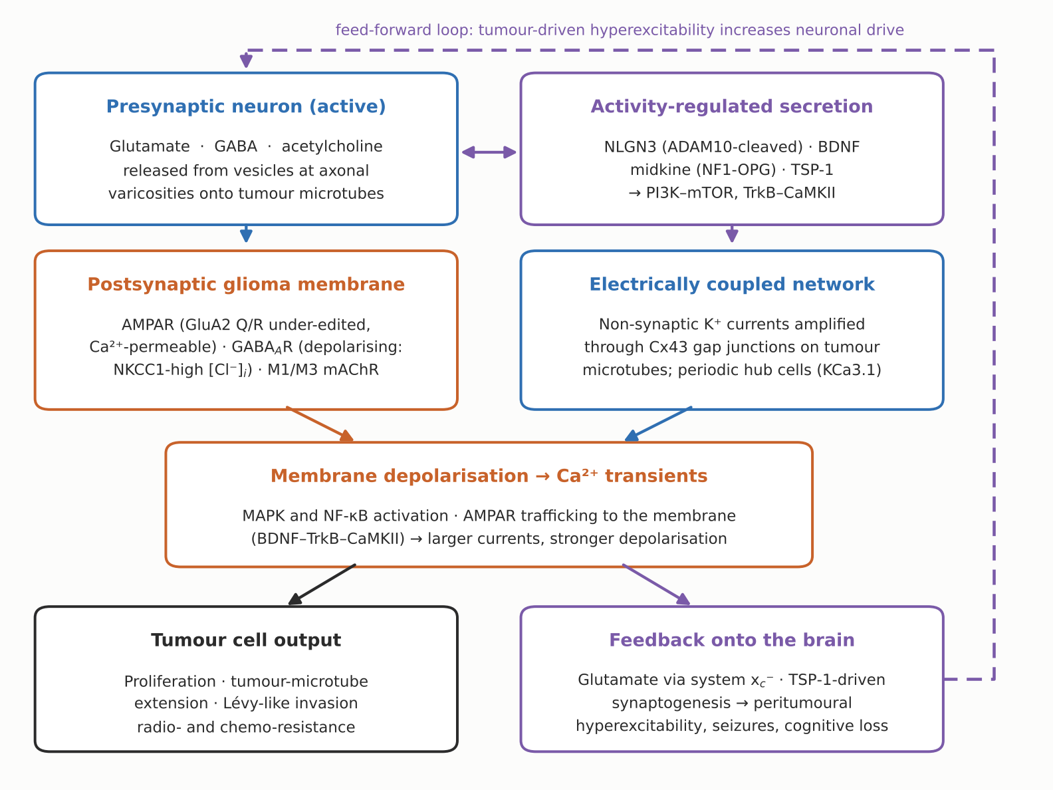
Figure 1. The neuron-to-glioma circuit. Schematic drawn for this review, synthesising the mechanisms reported in refs. [1–5, 8–14]. Neuronal activity acts on glioma cells through two parallel routes: activity-regulated secretion of NLGN3, BDNF, midkine and thrombospondin-1, and direct synaptic transmission onto AMPA, GABA-A and muscarinic receptors on tumour microtubes. Both converge on membrane depolarisation and calcium transients, which are amplified across a Cx43 gap-junction-coupled network and converted into proliferation, microtube extension and invasion. The tumour feeds back onto the brain through system xc(-)-mediated glutamate release and TSP-1-driven synaptogenesis, raising peritumoural excitability and so closing a feed-forward loop.

3. The neuron-to-glioma synapse

3.1 The paracrine prologue: neuroligin-3
Using optogenetic control of cortical neuronal activity in mice bearing patient-derived paediatric glioblastoma xenografts, Venkatesh and colleagues demonstrated that active neurons promote high-grade glioma proliferation and growth in vivo, and that conditioned medium from optogenetically stimulated cortical slices reproduced the effect — establishing that a secreted, activity-regulated mitogen was responsible [1]. That mitogen was identified as soluble NLGN3, which was both sufficient and necessary for robust proliferation, acted through the PI3K-mTOR pathway, and induced feedforward expression of NLGN3 in the glioma cells themselves. NLGN3 expression in human high-grade glioma correlated negatively with overall survival [1].
A follow-up study established the dependency and the proteolytic mechanism: NLGN3 is cleaved from both neurons and oligodendrocyte precursor cells by the ADAM10 sheddase, and ADAM10 inhibitors prevented its release into the tumour microenvironment and robustly blocked xenograft growth. Strikingly, patient-derived orthotopic xenografts of paediatric glioblastoma, DIPG and adult glioblastoma failed to grow at all in Nlgn3-knockout mice, and NLGN3 was shown to stimulate early focal adhesion kinase activation upstream of PI3K-mTOR [2]. NLGN3 exposure induced a broad synaptic gene expression programme in glioma cells [2,3] — the observation that directly motivated the search for malignant synapses.

3.2 Structural and functional evidence for bona fide synapses
Two groups, working independently and with different model systems, reported the synapse in the same issue of Nature. Venkataramani and colleagues described functional chemical synapses between presynaptic neurons and postsynaptic glioma cells, showing typical synaptic ultrastructure on electron microscopy, located on tumour microtubes, and generating postsynaptic currents mediated by AMPA-subtype glutamate receptors [4]. Venkatesh and colleagues reported the same core finding in paediatric and adult models, identifying glioma cells on the postsynaptic side of synaptic structures by immuno-electron microscopy, with synapses on approximately 10% of GFP-positive glioma processes [3].
The electrophysiological signature is that of a genuine AMPA receptor-mediated synapse: the current-voltage relationship reverses near 0 mV, and glioma excitatory postsynaptic currents (EPSCs) show paired-pulse facilitation [3]. Importantly, GluA2 in these tumours is under-edited at the Q/R site (roughly 50–70% edited in paediatric glioma), which renders a substantial proportion of the receptors calcium-permeable [3].
Causality was established genetically and pharmacologically. Mice bearing xenografts overexpressing wild-type GluA2 survived a shorter time than controls, whereas xenografts expressing a dominant-negative GluA2 construct showed reduced tumour burden and improved survival; in a competition experiment seeding 80% dominant-negative cells, the tumours that formed at endpoint consisted almost entirely of non-expressing cells [3]. Glioma-cell-specific perturbation of AMPA receptors likewise reduced calcium-dependent invasiveness and tumour growth [4]. Treatment with the clinically licensed AMPA receptor antagonist perampanel produced approximately a 50% decrease in paediatric glioma proliferation relative to vehicle [3], and reduced growth in the parallel study [4].

3.3 Potassium currents and the electrically coupled network
Synaptic currents are not the whole story. Neuronal activity also evokes non-synaptic, activity-dependent potassium currents in glioma cells, and these are amplified by gap-junction-mediated interconnection to form an electrically coupled network [3]. Across 643 paediatric glioma cells examined, roughly 5–10% exhibited synaptic EPSCs while approximately 40% showed the prolonged potassium-mediated response [3] (Figure 2). In other words, only a minority of malignant cells are directly wired, but a much larger fraction senses neuronal activity through the shared network — a design that distributes a sparse input across many cells.
Direct optogenetic depolarisation of the glioma membrane in vivo promoted proliferation, whereas blocking electrochemical signalling pharmacologically or genetically inhibited xenograft growth and extended survival [3]. Neuronal activity, including under epileptic conditions, generates synchronised calcium transients throughout TM-connected glioma networks [4].
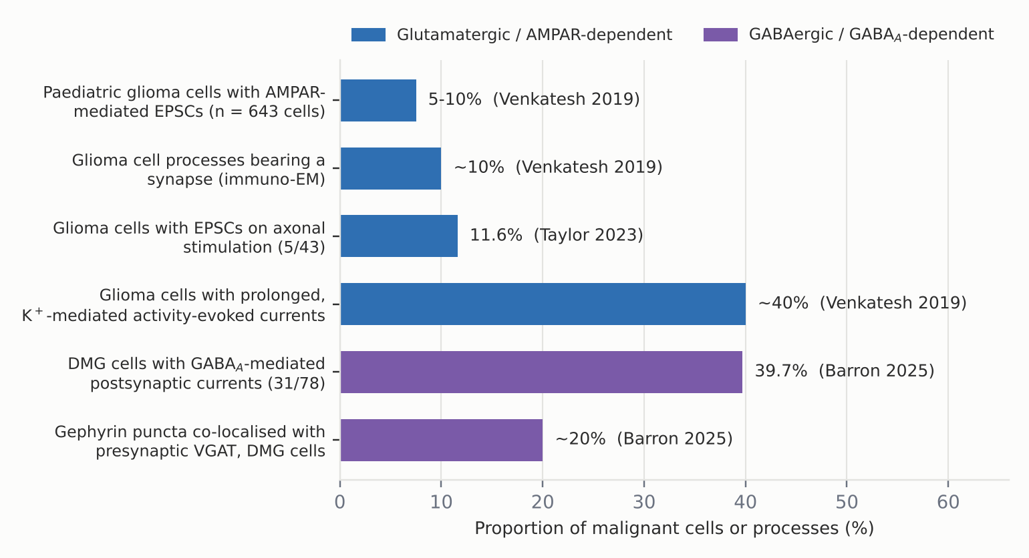
Figure 2. How much of the tumour is actually wired? Proportions of malignant cells or processes showing each form of neuron-to-glioma communication, compiled for this review from values reported in Venkatesh et al. 2019 [3], Taylor et al. 2023 [10] and Barron et al. 2025 [12]. Values are those stated in the source papers; where a paper reported a range or an approximate figure, that is indicated. Glutamatergic and GABAergic measurements come from different tumour types (paediatric and adult high-grade glioma versus H3K27M-altered diffuse midline glioma) and are not directly comparable with one another.

3.4 Depolarising GABAergic synapses in diffuse midline glioma
For several years the malignant synapse was understood as a glutamatergic phenomenon. In 2025 Barron and colleagues reported functional, tumour-promoting GABAergic neuron-to-glioma synapses in H3K27M-altered diffuse midline glioma [12]. Using whole-cell patch-clamp recording in the presence of the AMPA receptor antagonist NBQX, local stimulation evoked an inward GABA-A receptor-mediated current in approximately 40% (31 of 78) of DMG cells across patient-derived xenograft models; roughly 20% of glioma gephyrin puncta co-localised with presynaptic VGAT, the anatomical correlate [12].
The pharmacologically important point is the direction of the current. Because DMG cells express the chloride importer NKCC1 and so maintain a high intracellular chloride concentration, GABA depolarises them. Inhibiting NKCC1 with bumetanide shifted the reversal potential from −25.0 ± 3.7 mV to −57.2 ± 7.4 mV, a value close to that of H3/IDH wild-type paediatric cortical glioblastoma cells [12]. Since depolarisation drives proliferation, GABAergic interneuron activity promotes DMG growth: optogenetic stimulation of GABAergic interneurons increased xenograft proliferation and glioma Fos expression in vivo [12].
The clinical implication is uncomfortable. The benzodiazepine lorazepam, a positive allosteric modulator of GABA-A receptors in routine use for sedation, seizures and chemotherapy-associated nausea, increased the amplitude of GABAergic postsynaptic currents in DMG cells, exerted a dose-dependent proliferative effect in three independent patient-derived xenograft models, and shortened survival [12]. By contrast, only minimal depolarising GABAergic currents were found in hemispheric high-grade glioma, and lorazepam did not alter the growth of hemispheric glioblastoma xenografts — a tumour-subtype-specific effect [12].
Property | Glutamatergic neuron-to-glioma synapse | GABAergic neuron-to-glioma synapse
Tumour context | Paediatric and adult high-grade glioma, including DIPG and hemispheric GBM [3,4] | Demonstrated in H3K27M-altered diffuse midline glioma; minimal in hemispheric HGG [12]
Receptor | AMPA-type ionotropic glutamate receptor; GluA2 Q/R site under-edited (~50–70% edited) [3] | GABA-A receptor; postsynaptic gephyrin scaffold [12]
Proportion of cells responding | ~5–10% with synaptic EPSCs; ~40% with prolonged K+ currents (n = 643 cells) [3] | ~40% with GABA-A-mediated currents (31/78 cells) [12]
Effect on membrane potential | Depolarising; reversal near 0 mV; paired-pulse facilitation [3] | Depolarising because of NKCC1-driven high intracellular chloride (reversal −25.0 ± 3.7 mV) [12]
Anatomical location | On tumour microtubes; synaptic ultrastructure on EM [3,4] | Gephyrin puncta co-localised with presynaptic VGAT (~20%) [12]
Pharmacological lever | Perampanel, NBQX; dominant-negative GluA2 reduces growth and extends survival [3,4] | Bumetanide shifts reversal potential to −57.2 ± 7.4 mV; benzodiazepines accelerate growth [12]
Table 1. Two classes of malignant synapse compared. Values are as reported in the cited primary studies; the two columns describe different tumour types studied with different protocols and should not be read as a head-to-head comparison.

3.5 Cholinergic and other modulatory inputs
Work extending the principle to neuromodulatory systems is at an earlier stage. In a preprint that has not completed peer review, Drexler and colleagues report that optogenetic stimulation of cholinergic midbrain nuclei promotes DMG proliferation in a circuit-specific manner — stimulation of the pedunculopontine nucleus promoting growth in the pons and of the laterodorsal tegmentum in the thalamus, matching the respective projection patterns — and that acetylcholine acts directly on tumour cells through M1 and M3 muscarinic receptors, which are enriched in the OPC-like subpopulation [13]. A second preprint proposes that neuronal acid-sensing ion channel 1a modulates the formation and function of neuron-to-glioma synapses, with Asic1a-knockout neurons evoking smaller AMPA receptor-dependent EPSCs in glioma cells [21]. Both findings are biologically plausible and mechanistically specific, but should be treated as provisional until peer-reviewed.
On the question of how these synapses are assembled, a 2025 study implicates glioma-derived SPARCL1 (hevin) in promoting the formation of peritumoral neuron-glioma synapses, validated in clinical samples and neuron-glioma co-culture [20]. Synaptogenic factors secreted by the tumour are thus emerging as a druggable upstream node, a theme taken further in Section 4.5.

3.6 Plasticity at the malignant synapse
If the malignant synapse were a static conduit, its therapeutic significance would be limited. It is not. Taylor and colleagues showed that glioma synapses recruit the same BDNF-dependent plasticity that strengthens healthy synapses [10]. Signalling through TrkB to CaMKII, BDNF promotes AMPA receptor trafficking to the glioma cell membrane, increasing the amplitude of glutamate-evoked currents. Graded optogenetic control of glioma membrane potential then linked the two: larger depolarising currents produce more tumour growth [10].
The co-culture data quantify how much of the neuronal effect runs through this axis. Recombinant BDNF alone raised DIPG proliferation from roughly 20% to roughly 30%; co-culture with hippocampal neurons raised it to roughly 60%; and deleting TrkB in the glioma cells reduced the neuron-induced rate back to roughly 30% [10] (Figure 3). Axonal stimulation produced EPSCs in about 10% of xenografted glioma cells (5 of 43), consistent with earlier estimates [10]. Plasticity therefore amplifies a sparse synaptic input into a substantial growth signal, and it does so through a receptor, TrkB, for which inhibitors already exist.
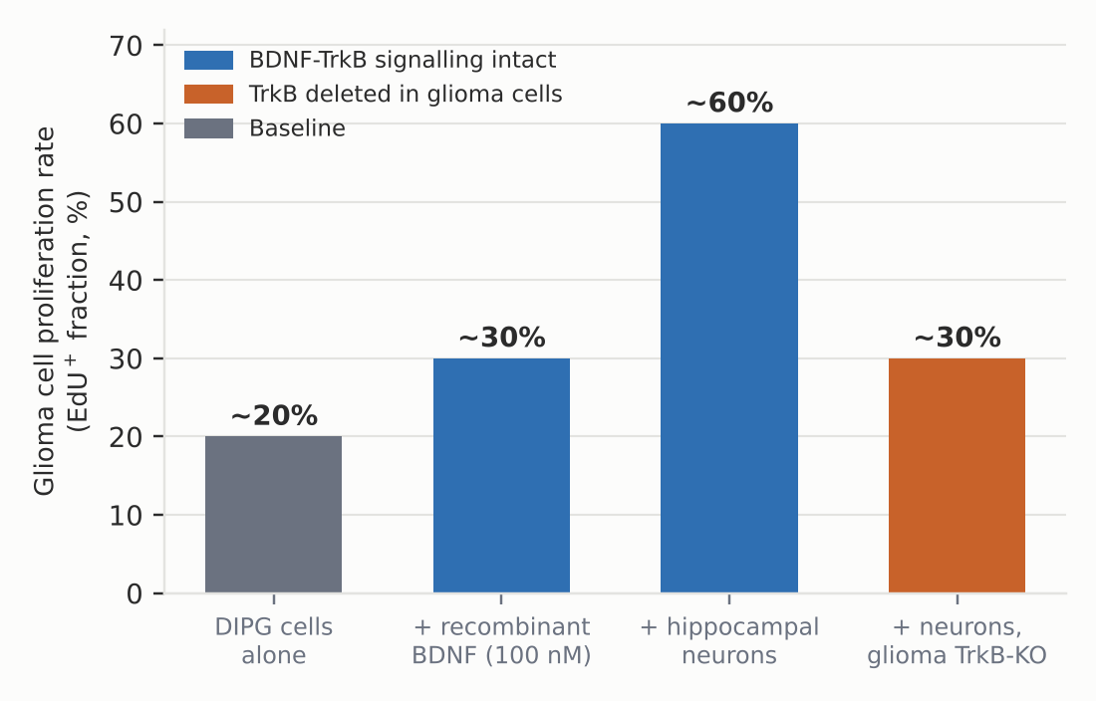
Figure 3. The BDNF-TrkB axis carries much of the neuronal growth signal. Glioma cell proliferation rates in co-culture, redrawn for this review from the approximate values reported by Taylor et al. 2023 [10]. Bars show EdU-positive fractions described in the text of that paper as "around" the plotted values; they are not re-measured data and no error bars are implied.

3.7 Autonomous rhythmic activity: the network as pacemaker
Glioma networks are not merely driven from outside. Hausmann and colleagues described a small, plastic population of highly connected glioblastoma cells displaying rhythmic, autonomous calcium oscillations whose transients precede those of the cells they are connected to, activating the frequency-dependent MAPK and NF-κB pathways [9]. Mathematical analysis showed that glioblastoma network topology is scale-free and small-world, with these "periodic" cells frequently occupying network hubs — an architecture that resists random damage but is vulnerable to targeted loss of hubs.
Targeting the rhythmic activity, either by physically ablating periodic tumour cells or by genetic or pharmacological interference with the calcium-activated potassium channel KCa3.1 (KCNN4), strongly compromised global network communication, reduced tumour cell viability across the network, slowed growth in mice and extended survival [9]. KCa3.1 inhibition is therefore a network-level, rather than synapse-level, intervention against the same underlying electrophysiology.

4. Pathophysiological consequences

4.1 Proliferation
The through-line from synapse to growth is membrane potential. Optogenetic depolarisation of glioma membranes promotes proliferation; blocking electrochemical signalling inhibits it [3]. Graded depolarisation produces graded growth [10]. Depolarisation in DMG can be achieved by glutamate or, because of NKCC1-driven chloride loading, by GABA [12]. Downstream, calcium entry through under-edited AMPA receptors and through network-propagated transients engages MAPK and NF-κB [9], while the paracrine arm engages PI3K-mTOR via NLGN3 [1] and TrkB-CaMKII via BDNF [10].

4.2 Invasion
Venkataramani and colleagues subsequently showed that whole-brain colonisation is driven by a distinct subpopulation: glioma cells that lack connections to other tumour cells and astrocytes but do receive synaptic input from neurons [8]. These cells correspond to neuronal and neural-progenitor-like transcriptomic states in both mouse models and human tumours. Their migration resembles neuronal migration and follows a Lévy-like movement pattern of environmental probing; neuronal activity induces complex calcium signals in them, followed by de novo tumour microtube formation and increased invasion speed [8]. Cellular heterogeneity and dissemination are thus two faces of the same neuronal mechanism.

4.3 Treatment resistance
TM-connected astrocytoma cells, but not unconnected ones, are protected from radiotherapy-induced cell death [5], and TMs also convey resistance to surgical lesioning and to chemotherapy, repopulating a cavity through an excessive healing response [6]. Because the connected network and the synaptically innervated compartment are structurally the same system, electrochemical signalling and treatment resistance are not separate therapeutic problems.

4.4 Peritumoural hyperexcitability and epilepsy
Seizures affect a large proportion of glioma patients — up to roughly three-quarters in some series [25]. A principal driver is glutamate. Buckingham and colleagues showed that glioma xenografts release glutamate through the system xc(-) cystine-glutamate antiporter (SLC7A11), producing glutamatergic epileptiform hyperexcitability that spreads into adjacent brain; blocking the transporter with the licensed drug sulfasalazine reduced epileptic event frequency at clinically achievable concentrations [14]. Human intraoperative electrocorticography has since demonstrated increased cortical excitability in the glioma-infiltrated cortex [3].
This closes the feed-forward loop drawn in Figure 1: tumour-derived glutamate raises neuronal activity, and neuronal activity drives tumour growth. A recent clinical correlate comes from the Dana-Farber perampanel pilot, in which peritumoural glutamate concentrations measured by mass spectrometry in surface biopsies correlated positively with high-frequency oscillation rates on intraoperative electrocorticography [22].

4.5 Circuit remodelling, cognition and survival
The most direct human evidence comes from Krishna and colleagues, who combined intracranial recordings during lexical retrieval tasks in awake patients with site-directed biopsies [11]. Glioblastoma remodels functional circuitry so that task-relevant neural responses activate tumour-infiltrated cortex well beyond the regions normally recruited. Biopsies from regions of high functional connectivity (HFC) between tumour and brain were enriched for a glioblastoma subpopulation with a synaptogenic and neuronotrophic phenotype, secreting thrombospondin-1 (TSP-1); HFC regions showed increased presynaptic synapsin-1 puncta, increased postsynaptic PSD95 density and increased synapsin-PSD95 co-localisation relative to low-connectivity regions [11].
Two translational findings followed. Pharmacological inhibition of TSP-1 with the licensed drug gabapentin decreased glioblastoma proliferation [11]. And the degree of functional connectivity negatively affected both patient survival and performance on language tasks — in a recursive-partitioning survival analysis, the best-outcome group comprised patients younger than 62 years with greater than 97% extent of resection and absence of functional connectivity in the tumour [11]. Functional integration into circuits is thus not an epiphenomenon but an independent prognostic feature, and one that is in principle modifiable.

5. Therapeutic implications
Because the circuit is assembled from well-characterised neuronal machinery, most candidate interventions are existing neurological drugs. Figure 4 maps the points of interruption; Table 2 summarises the preclinical evidence and the trials registered to date.
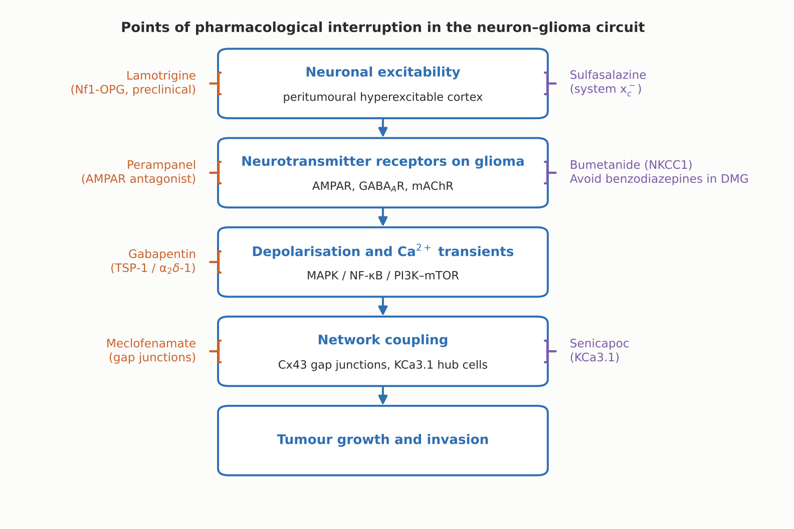
Figure 4. Points of pharmacological interruption in the neuron-glioma circuit. Schematic drawn for this review from the mechanisms and agents reported in refs. [3,4,9,11,12,14,15,22]. Bar-ended connectors denote inhibition. Benzodiazepines appear as a caution rather than a target: by potentiating depolarising GABA-A currents they accelerate H3K27M-altered DMG growth in xenograft models [12].
Agent (target) | Rationale and preclinical evidence | Clinical status
Perampanel (AMPA receptor) | ~50% reduction in paediatric glioma proliferation in xenografts [3]; reduced growth and AMPAR-dependent invasion [4]; reduced proliferation and glutamate release in patient-derived glioblastoma lines in vitro [23]; abolished spontaneous epileptiform discharges in C6 glioma slices, without effect on tumour progression in that model [24] | Completed pilot trial in newly diagnosed high-grade glioma (NCT04497142; 12 enrolled, terminated early at interim analysis): HFO rates similar to levetiracetam; 14% of perampanel-treated vs 50% of standard-of-care patients had seizures over a median 281 days; survival similar to a glioblastoma reference cohort [22,27]. Prospective real-world add-on series (n = 14) reported seizure and quality-of-life outcomes [25]
Senicapoc (KCa3.1) + perampanel | KCa3.1 interference disrupts autonomous rhythmic hub activity, reduces network viability and tumour growth, and extends survival in mice [9] | Phase 0/1 randomised trial of mono- and combination therapy in newly diagnosed glioblastoma (NCT07284069; 36 participants, recruiting) [29]
Gabapentin (thrombospondin-1 / α2δ-1) | TSP-1 secreted by high-connectivity glioblastoma cells drives synaptogenesis and circuit remodelling; gabapentin inhibition of TSP-1 decreased glioblastoma proliferation [11] | Included with sulfasalazine and memantine in a phase Ib/II drug-repurposing trial of glutamate-signalling inhibitors with chemoradiotherapy in newly diagnosed glioblastoma (NCT05664464; 120 participants, recruiting) [28]
Sulfasalazine (system xc(-) / SLC7A11) | Blocks tumour glutamate release; reduced epileptic event frequency in glioma-bearing mice at concentrations equivalent to human Crohn’s disease dosing [14] | Combination arm of NCT05664464 [28]
Meclofenamate (gap junctions) | Network interconnection through TM-associated gap junctions confers radio-, chemo- and surgical resistance [5,6]; disconnection is the stated therapeutic aim [5] | Pilot trial in recurrent or progressive brain metastases (NCT02429570; 30 participants, active, not recruiting) [30]; no registered glioma trial retrieved
Lamotrigine (neuronal excitability) | In Nf1-mutant optic pathway glioma, neuronal hyperexcitability drives midkine production; lamotrigine suppressed neuronal midkine, prevented progression and suppressed growth of existing tumours for months after cessation, at paediatric epilepsy dosing [15] | Preclinical; proposed as chemoprevention or chemotherapy for NF1-associated optic pathway glioma [15]
Bumetanide (NKCC1) | Shifts the GABA reversal potential in H3K27M DMG cells from −25.0 ± 3.7 mV to −57.2 ± 7.4 mV, removing the depolarising drive [12] | Preclinical concept; no registered DMG trial retrieved
Benzodiazepines — caution | Lorazepam increased GABAergic currents, produced dose-dependent proliferation in three DMG xenograft models and shortened survival; no effect on hemispheric glioblastoma xenografts [12] | Not a target: a prompt to re-examine sedative and anti-emetic practice in H3K27M-altered DMG [12]
Table 2. Agents that interrupt the neuron-glioma circuit, with preclinical evidence and registered trials. Trial details retrieved from ClinicalTrials.gov; enrolment figures are target or actual enrolment as registered. No agent in this table has demonstrated a survival benefit in a randomised glioma trial.
The perampanel pilot is instructive about how hard this translation will be [22]. It met its feasibility objectives but was terminated early at a planned interim analysis, and its primary electrophysiological endpoint — high-frequency oscillation rates on intraoperative electrocorticography — was no better than with levetiracetam. The seizure-freedom signal (14% versus 50% of patients with seizures) is encouraging but rests on 11 analysable patients. The study nevertheless produced the correlative finding that peritumoural glutamate concentration tracks cortical hyperexcitability, which is exactly the kind of pharmacodynamic biomarker later trials will need [22].

6. Open questions and limitations
Only a minority of tumour cells are synaptically connected. Across the largest published sample, roughly 5–10% of paediatric glioma cells showed synaptic EPSCs [3]; axonal stimulation evoked EPSCs in about 10% of cells in a later study [10]. If so few cells are wired, why does blocking the synapse have such large effects on growth? The leading explanation is the network: non-synaptic potassium currents amplified through gap junctions distribute the signal to perhaps 40% of cells [3], and periodic hub cells propagate rhythmic activity through a scale-free topology [9]. But the quantitative relationship between synaptic input, network propagation and proliferation across a whole tumour has not been established, and it is the parameter that determines how much of a tumour a synapse-directed drug can reach.
Almost everything described here comes from orthotopic xenografts in immunodeficient mice. That model removes the adaptive immune system, which is itself regulated by the nervous system and is a major determinant of glioma behaviour [16]. Survival experiments in these systems typically use three to five mice per group, powered to detect effect sizes of around 20% [3,10,12]; they establish mechanism rather than effect magnitude.
Heterogeneity is a second limitation. The GABAergic synapse is a property of H3K27M-altered DMG and is largely absent from hemispheric high-grade glioma [12]; oligodendroglial tumours are relatively deficient in tumour microtubes [5]. Mechanisms demonstrated in one molecular subtype should not be assumed in another, and the lorazepam finding shows that the clinical consequence of getting this wrong can be to accelerate a tumour.
Several further questions remain substantially open. Do neuron-to-glioma synapses turn over, and can they be re-formed after pharmacological blockade, as the TM-mediated healing response suggests for the network [6]? How do cholinergic, serotonergic and noradrenergic inputs contribute outside the midline, given that the existing cholinergic data remain in preprint [13]? Can functional connectivity measured non-invasively — rather than by intraoperative recording — serve as a stratification biomarker, given that it predicts survival and language performance [11]? And can any of this be separated from seizure control, since the drugs available are anti-epileptic drugs and improved seizure control alone improves quality of life and may confound survival analyses [25]?

7. Conclusion
The neuron-to-glioma synapse has moved in a decade from an unexpected observation to a well-characterised piece of pathophysiology, supported by electron microscopy, patch-clamp electrophysiology, optogenetics, single-cell transcriptomics and human intracranial recording. Its elements are now specific enough to name: AMPA receptors with under-edited GluA2 on tumour microtubes; depolarising GABA-A currents sustained by NKCC1 in H3K27M-altered midline tumours; BDNF-TrkB-CaMKII-dependent receptor trafficking that potentiates the malignant synapse; a Cx43-coupled network with rhythmic hub cells that distributes the signal; and a secreted repertoire — NLGN3, BDNF, TSP-1, midkine, SPARCL1 — that makes the surrounding brain more active and more synaptogenic in return.
What has not yet arrived is a treatment. The first trials are small, early-phase and mostly repurposing drugs chosen for a receptor rather than for a tumour, and the one completed pilot missed its electrophysiological endpoint. The most immediately actionable finding may in fact be a negative one: that benzodiazepines accelerate the growth of H3K27M-altered diffuse midline glioma in preclinical models [12], a result that, if it holds in patients, changes supportive care tomorrow rather than in a decade. The broader lesson of cancer neuroscience is that a brain tumour cannot be understood, or treated, in isolation from the circuits it has joined.

References
1. Venkatesh HS, Johung TB, Caretti V, Noll A, Tang Y, Nagaraja S, et al. Neuronal activity promotes glioma growth through neuroligin-3 secretion. Cell. 2015;161(4):803–816. PMID: 25913192. doi:10.1016/j.cell.2015.04.012
2. Venkatesh HS, Tam LT, Woo PJ, Lennon J, Nagaraja S, Gillespie SM, et al. Targeting neuronal activity-regulated neuroligin-3 dependency in high-grade glioma. Nature. 2017;549(7673):533–537. PMID: 28959975. doi:10.1038/nature24014
3. Venkatesh HS, Morishita W, Geraghty AC, Silverbush D, Gillespie SM, Arzt M, et al. Electrical and synaptic integration of glioma into neural circuits. Nature. 2019;573(7775):539–545. PMID: 31534222. doi:10.1038/s41586-019-1563-y
4. Venkataramani V, Tanev DI, Strahle C, Studier-Fischer A, Fankhauser L, Kessler T, et al. Glutamatergic synaptic input to glioma cells drives brain tumour progression. Nature. 2019;573(7775):532–538. PMID: 31534219. doi:10.1038/s41586-019-1564-x
5. Osswald M, Jung E, Sahm F, Solecki G, Venkataramani V, Blaes J, et al. Brain tumour cells interconnect to a functional and resistant network. Nature. 2015;528(7580):93–98. PMID: 26536111. doi:10.1038/nature16071
6. Weil S, Osswald M, Solecki G, Grosch J, Jung E, Lemke D, et al. Tumor microtubes convey resistance to surgical lesions and chemotherapy in gliomas. Neuro Oncol. 2017;19(10):1316–1326. PMID: 28419303. doi:10.1093/neuonc/nox070
7. Jung E, Osswald M, Blaes J, Wiestler B, Sahm F, Schmenger T, et al. Tweety-homolog 1 drives brain colonization of gliomas. J Neurosci. 2017;37(29):6837–6850. PMID: 28607172. doi:10.1523/JNEUROSCI.3532-16.2017
8. Venkataramani V, Yang Y, Schubert MC, Reyhan E, Tetzlaff SK, Wißmann N, et al. Glioblastoma hijacks neuronal mechanisms for brain invasion. Cell. 2022;185(16):2899–2917.e31. PMID: 35914528. doi:10.1016/j.cell.2022.06.054
9. Hausmann D, Hoffmann DC, Venkataramani V, Jung E, Horschitz S, Tetzlaff SK, et al. Autonomous rhythmic activity in glioma networks drives brain tumour growth. Nature. 2023;613(7942):179–186. PMID: 36517594. doi:10.1038/s41586-022-05520-4
10. Taylor KR, Barron T, Hui A, Spitzer A, Yalçin B, Ivec AE, et al. Glioma synapses recruit mechanisms of adaptive plasticity. Nature. 2023;623(7986):366–374. PMID: 37914930. doi:10.1038/s41586-023-06678-1
11. Krishna S, Choudhury A, Keough MB, Seo K, Ni L, Kakaizada S, et al. Glioblastoma remodelling of human neural circuits decreases survival. Nature. 2023;617(7961):599–607. PMID: 37138086. doi:10.1038/s41586-023-06036-1
12. Barron T, Yalçın B, Su M, Byun YG, Gavish A, Shamardani K, et al. GABAergic neuron-to-glioma synapses in diffuse midline gliomas. Nature. 2025;639(8056):1060–1068. PMID: 39972132. doi:10.1038/s41586-024-08579-3
13. Drexler R, Drinnenberg A, Gavish A, Yalcin B, Shamardani K, Rogers A, et al. Cholinergic neuronal activity promotes diffuse midline glioma growth through muscarinic signaling. bioRxiv [preprint]. 2024:2024.09.21.614235. PMID: 39386427. doi:10.1101/2024.09.21.614235
14. Buckingham SC, Campbell SL, Haas BR, Montana V, Robel S, Ogunrinu T, Sontheimer H. Glutamate release by primary brain tumors induces epileptic activity. Nat Med. 2011;17(10):1269–1274. PMID: 21909104. doi:10.1038/nm.2453
15. Anastasaki C, Chatterjee J, Koleske JP, Gao Y, Bozeman SL, Kernan CM, et al. NF1 mutation-driven neuronal hyperexcitability sets a threshold for tumorigenesis and therapeutic targeting of murine optic glioma. Neuro Oncol. 2024;26(8):1496–1508. PMID: 38607967. doi:10.1093/neuonc/noae054
16. Winkler F, Venkatesh HS, Amit M, Batchelor T, Demir IE, Deneen B, et al. Cancer neuroscience: state of the field, emerging directions. Cell. 2023;186(8):1689–1707. PMID: 37059069. doi:10.1016/j.cell.2023.02.002
17. Taylor KR, Monje M. Neuron-oligodendroglial interactions in health and malignant disease. Nat Rev Neurosci. 2023;24(12):733–746. PMID: 37857838. doi:10.1038/s41583-023-00744-3
18. Yang Y, Schubert MC, Kuner T, Wick W, Winkler F, Venkataramani V. Brain tumor networks in diffuse glioma. Neurotherapeutics. 2022;19(6):1832–1843. PMID: 36357661. doi:10.1007/s13311-022-01320-w
19. Cueto-Ureña C, Ramírez-Expósito MJ, Martínez-Martos JM. Neuron-glioma synapses in tumor progression. Biomedicines. 2025;14(1):72. PMID: 41595608. doi:10.3390/biomedicines14010072
20. Li Y, Wang Y, Han X, Xu J, Liu E, Cheng J, et al. Glioma-derived SPARCL1 promotes the formation of peritumoral neuron-glioma synapses. J Neurooncol. 2025;173(3):515–526. PMID: 40227556. doi:10.1007/s11060-025-05007-y
21. Park G, Jin Z, Ge Q, Pan Y, Du J. Neuronal acid-sensing ion channel 1a regulates neuron-to-glioma synapses. bioRxiv [preprint]. 2023:2023.08.31.555794. PMID: 37693494. doi:10.1101/2023.08.31.555794
22. Tobochnik S, Regan MS, Dorotan MKC, Reich D, Lapinskas E, Hossain MA, et al. Pilot trial of perampanel on peritumoral hyperexcitability in newly diagnosed high-grade glioma. Clin Cancer Res. 2024;30(23):5365–5373. PMID: 39499201. doi:10.1158/1078-0432.CCR-24-1849
23. Lange F, Weßlau K, Porath K, Hörnschemeyer MF, Bergner C, Krause BJ, et al. AMPA receptor antagonist perampanel affects glioblastoma cell growth and glutamate release in vitro. PLoS One. 2019;14(2):e0211644. PMID: 30716120. doi:10.1371/journal.pone.0211644
24. Mayer J, Kirschstein T, Resch T, Porath K, Krause BJ, Köhling R, Lange F. Perampanel attenuates epileptiform phenotype in C6 glioma. Neurosci Lett. 2019;715:134629. PMID: 31734290. doi:10.1016/j.neulet.2019.134629
25. Impellizzeri M, Paone P, Pauletto G, Nilo A, Beretta S, Salmaggi A, et al. Perampanel as add-on in high-grade glioma-related epilepsy: seizure control and QoL in a prospective, multicenter, real-world 6-month follow-up study. Epilepsia Open. 2026;11(4):1137–1148. PMID: 42237784. doi:10.1002/epi4.70274
26. Pan Y, Monje M. Neuron-glial interactions in health and brain cancer. Adv Biol (Weinh). 2022;6(9):e2200122. PMID: 35957525. doi:10.1002/adbi.202200122
27. ClinicalTrials.gov. Pilot study of perampanel on peritumoral hyperexcitability and seizure control in newly diagnosed high grade glioma. NCT04497142. Dana-Farber Cancer Institute; 2020–2023.
28. ClinicalTrials.gov. A phase Ib/II randomized, open label drug repurposing trial of glutamate signaling inhibitors in combination with chemoradiotherapy in patients with newly diagnosed glioblastoma. NCT05664464. University of Zurich; recruiting.
29. ClinicalTrials.gov. Phase 0/1 randomized clinical trial of senicapoc and perampanel mono- and combination therapy of newly diagnosed glioblastoma. NCT07284069. Aarhus University Hospital; recruiting.
30. ClinicalTrials.gov. Pilot study of meclofenamate in subjects with recurrent or progressive brain metastasis from solid tumor primary. NCT02429570. Memorial Sloan Kettering Cancer Center; active, not recruiting.
Bibliographic records in references 1–26 were retrieved from PubMed and PubMed Central; references 27–30 are trial records retrieved from ClinicalTrials.gov. DOIs are given as reported by PubMed. References 13 and 21 are preprints that have not completed peer review.

