Organelles on the Move: Intercellular Mitochondrial Transfer in Tissue Homeostasis, Cancer and Cell Therapy
A review of mechanisms, pathological consequences and therapeutic exploitation

Review article · 21 September 2026 · Prepared from peer-reviewed literature retrieved via PubMed and ClinicalTrials.gov

Abstract
Mitochondria have traditionally been treated as strictly vertically inherited organelles, passed from mother cell to daughter cell and never crossing the boundary between one cell lineage and another. That assumption has been overturned. Over the past two decades a substantial experimental literature has established that mitochondria move horizontally between developmentally unrelated cells, travelling through actin-based tunnelling nanotubes, gap-junction-anchored microvesicles, free extracellular particles and receptor-dependent uptake pathways. Intercellular mitochondrial transfer is now recognised as a physiological mechanism that restores bioenergetics in injured epithelium, supports neuronal survival after ischaemia, and regulates adipose-tissue metabolic homeostasis. It is also a pathological mechanism: bone-marrow stroma donates mitochondria to leukaemic blasts and confers chemoresistance; cancer cells physically steal mitochondria from lymphocytes; and tumour-derived mitochondria carrying mitochondrial DNA (mtDNA) mutations invade tumour-infiltrating lymphocytes, replace the host mitochondrial genome and drive immune evasion. The same biology is being deliberately reversed for therapeutic benefit, with autologous mitochondrial transplantation tested in children with post-ischaemic cardiogenic shock, mitochondrial augmentation of haematopoietic stem cells in single large-scale mtDNA deletion syndromes, and nanotube-mediated mitochondrial loading of CD8+ T cells to overcome exhaustion in adoptive cell therapy. This review summarises the molecular machinery of transfer, the evidence for its physiological and pathological roles, the state of clinical translation, and the methodological and conceptual questions that remain open — including how transferred mitochondria are quantified, how long donor organelles and donor mtDNA persist, and whether transfer can be selectively blocked in tumours without disrupting its homeostatic functions.
Keywords: mitochondrial transfer; tunnelling nanotubes; MIRO1; connexin 43; mitochondrial transplantation; tumour microenvironment; T-cell exhaustion; mitochondrial DNA; organelle medicine

1. Introduction
The endosymbiotic origin of mitochondria is one of the foundational narratives of cell biology: an ancestral proteobacterium was captured by a host cell roughly 1.5 billion years ago and was gradually domesticated into the organelle that now supplies most of the ATP consumed by eukaryotic cells. A corollary of that narrative — rarely stated explicitly, because it seemed self-evident — was that mitochondria, once inside a lineage, stay inside it. Mitochondria segregate during mitosis, and both the organelle and its 16.6-kilobase circular genome are inherited vertically from parent cell to daughter cell.
That corollary is now known to be incomplete. Beginning with the description of thin, actin-containing membrane conduits between cultured cells that permitted the selective transfer of vesicles and organelles, and continuing with the demonstration that such transfer could restore aerobic respiration to cells whose own mitochondrial genome had been destroyed, a body of work has established that mitochondria routinely move between developmentally unrelated cells. Borcherding and Brestoff, reviewing the field in Nature, described this phenomenon as intercellular mitochondria transfer and argued that it regulates the physiology of multiple organ systems in both health and disease.
The importance of this idea lies in what it implies for metabolic organisation at the tissue level. If a cell's respiratory capacity can be supplemented — or depleted — by its neighbours, then bioenergetics is not a purely cell-autonomous property. Tissues become metabolic collectives in which mitochondrial content is a negotiable, tradeable resource. That reframing has consequences for how we think about injury and repair, about the metabolic competition between tumours and the immune system, and about a new therapeutic modality in which the organelle itself is the drug.
This review is organised around four questions. How do mitochondria physically move between cells, and what molecular machinery is required? Where does this happen in normal physiology? How is it subverted in disease, particularly in cancer? And how far has the deliberate therapeutic manipulation of mitochondrial transfer progressed towards the clinic?

2. Biological background

2.1 Mitochondrial structure, genetics and quality control
Mitochondria are double-membraned organelles. The outer mitochondrial membrane is permeable to small solutes through porins; the inner membrane is highly selective, deeply folded into cristae, and houses the five complexes of the oxidative phosphorylation (OXPHOS) system. Electron flow through complexes I–IV pumps protons into the intermembrane space, generating an electrochemical gradient — the mitochondrial membrane potential — that complex V (ATP synthase) uses to phosphorylate ADP. The tricarboxylic acid cycle, fatty-acid β-oxidation, parts of the urea cycle, iron–sulfur cluster biogenesis and the intrinsic apoptotic pathway are all housed in or controlled from the mitochondrion.
Each mitochondrion contains multiple copies of mtDNA, which encodes 13 OXPHOS subunits together with the transfer and ribosomal RNAs needed to translate them. Because a cell carries hundreds to thousands of mtDNA copies, a pathogenic mutation may be present in only a fraction of them — a state termed heteroplasmy. Clinical disease typically appears only when mutant load exceeds a tissue-specific threshold, which is why heteroplasmy level, rather than mutation presence alone, is the relevant quantitative variable in mitochondrial medicine. When all copies carry the same sequence, the state is homoplasmic.
Mitochondrial quality is maintained by continuous fission and fusion, which mixes matrix contents and allows damaged segments to be isolated, and by mitophagy, the selective autophagic degradation of dysfunctional organelles. Reactive oxygen species (ROS) generated by the respiratory chain both signal and damage; in T cells, ROS ordinarily targets defective mitochondria for mitophagic clearance. As section 4 describes, the ability of transferred organelles to evade this clearance machinery turns out to be central to one mechanism of tumour immune evasion.

2.2 Routes of intercellular transfer
Four broad routes have been characterised, each with distinct molecular requirements (Figure 1, Table 1).
Tunnelling nanotubes (TNTs). Rustom and colleagues described highly sensitive nanotubular structures formed de novo between cultured cells, containing F-actin and permitting the selective transfer of membrane vesicles and organelles while apparently impeding the flow of small molecules. They proposed these conduits as a distinct biological principle of cell-to-cell interaction based on membrane continuity. TNTs remain the best-studied route for mitochondrial transfer and are the route most consistently implicated in the tumour microenvironment.
Gap-junction-anchored microvesicles. In a mouse model of lipopolysaccharide-induced acute lung injury, Islam and colleagues showed that instilled bone-marrow-derived stromal cells (BMSCs) formed connexin-43 (Cx43)-containing gap junctional channels with alveolar epithelium and released mitochondria-containing microvesicles that the epithelial cells engulfed. Crucially, gap-junction-incompetent BMSCs and BMSCs with dysfunctional mitochondria failed to protect, establishing that the transfer itself — not a generic paracrine effect — was responsible.
Free extracellular mitochondria. Hayakawa and colleagues demonstrated that astrocytes release functional mitochondrial particles into the extracellular space by a calcium-dependent mechanism involving CD38 and cyclic ADP-ribose signalling, and that these particles enter adjacent neurons. After transient focal cerebral ischaemia in mice, astrocytic mitochondria entered neurons and amplified cell survival signals; suppressing CD38 by short interfering RNA reduced transfer and worsened neurological outcomes.
Receptor-dependent uptake. Working in white adipose tissue, Brestoff and colleagues used a genome-wide CRISPR–Cas9 knockout screen to show that macrophage uptake of adipocyte-derived mitochondria depends on heparan sulfates. Deleting the heparan sulfate biosynthetic gene Ext1 in myeloid cells reduced uptake, increased adipose mass, lowered energy expenditure and worsened diet-induced obesity — linking the uptake machinery directly to organismal metabolic phenotype.
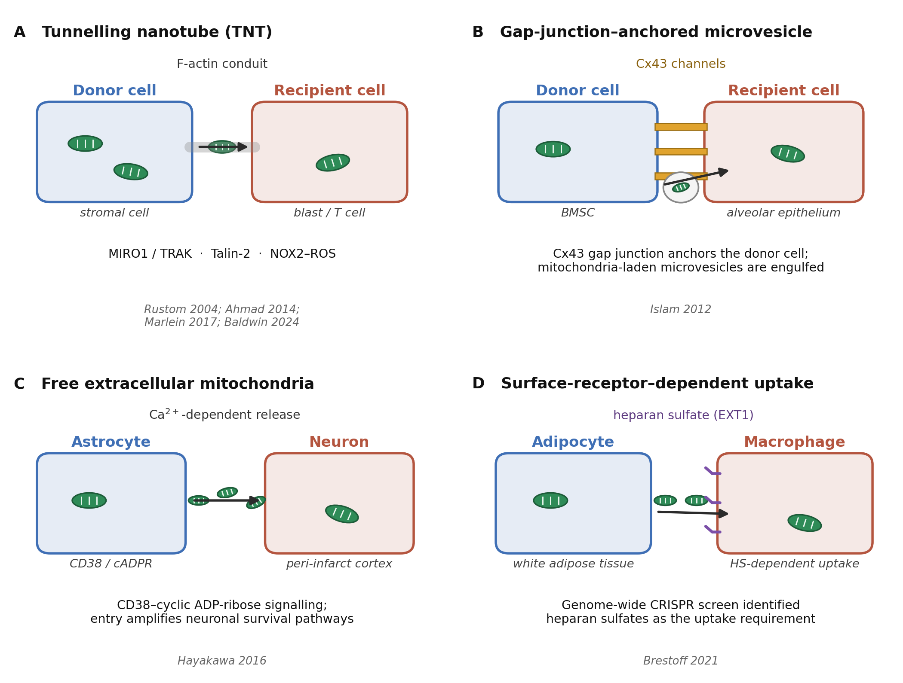
Figure 1. Four characterised routes of intercellular mitochondrial transfer and their molecular requirements. (A) Actin-based tunnelling nanotubes carry mitochondria between donor and recipient; MIRO1/TRAK adaptors, M-Sec, Talin-2 and NOX2-derived reactive oxygen species have each been shown to regulate this route. (B) Connexin-43 gap junctional channels anchor bone-marrow stromal cells to alveolar epithelium, which then engulfs mitochondria-containing microvesicles. (C) Astrocytes release free mitochondrial particles by a calcium-dependent, CD38/cyclic-ADP-ribose-dependent mechanism; the particles enter neighbouring neurons. (D) Macrophage uptake of adipocyte mitochondria requires cell-surface heparan sulfates, identified in a genome-wide CRISPR–Cas9 knockout screen. Original schematic drawn by the authors of this review; mechanisms and molecular mediators as reported in Rustom et al. 2004, Islam et al. 2012, Ahmad et al. 2014, Hayakawa et al. 2016, Marlein et al. 2017, Brestoff et al. 2021 and Baldwin et al. 2024.
Table 1. Routes of intercellular mitochondrial transfer, their molecular requirements and the experimental systems in which each was characterised. Compiled from the primary sources listed in the final column.
Route | Key molecular mediators | Experimental system | Principal functional consequence | Source
Tunnelling nanotube (F-actin conduit) | MIRO1/RHOT1; Talin-2; NOX2-derived superoxide | PC12 and other cultured cells; bone-marrow stroma with AML blasts; stroma with CD8+ T cells | Selective transfer of vesicles and organelles; metabolic support of recipient | Rustom 2004; Ahmad 2014; Marlein 2017; Baldwin 2024
Gap-junction-anchored microvesicle | Connexin 43 (Cx43) | Mouse LPS-induced acute lung injury; BMSC to alveolar epithelium | Increased alveolar ATP; protection against acute lung injury | Islam 2012
Free extracellular mitochondrial particles | CD38; cyclic ADP-ribose; Ca2+ signalling | Mouse transient focal cerebral ischaemia; astrocyte to neuron | Amplified neuronal survival signalling; improved neurological outcome | Hayakawa 2016
Receptor-dependent uptake | Heparan sulfates (EXT1-dependent biosynthesis) | Mouse white adipose tissue; adipocyte to macrophage | Regulation of adipose mass and energy expenditure; impaired in obesity | Brestoff 2021
Endocytic uptake after contact | Contact-dependent; enhanced by chemotherapy | Niche-like coculture of AML blasts with bone-marrow stroma | +14% mitochondrial mass; ~1.5-fold ATP; chemoresistance | Moschoi 2016

2.3 Molecular regulators of transfer
Several molecules have emerged as rate-limiting for transfer rather than merely permissive. MIRO1 (also called RHOT1), a mitochondrial Rho-GTPase that adapts mitochondria to the kinesin motor machinery for intracellular trafficking, also governs intercellular movement. Ahmad and colleagues showed that overexpressing MIRO1 in mesenchymal stem cells increased mitochondrial donation to epithelial cells and improved therapeutic efficacy in rotenone-induced airway injury and in three separate allergen-induced asthma models, whereas MIRO1 knockdown abolished the benefit. Importantly, the anti-inflammatory secretome of the stem cells — nitric oxide, TGF-β, IL-10, PGE2 — was unchanged by MIRO1 overexpression, excluding a non-specific paracrine explanation.
Oxidative stress acts as a trigger. Marlein and colleagues showed that in human acute myeloid leukaemia (AML), NADPH oxidase-2 (NOX2) generates superoxide that stimulates BMSC-to-blast mitochondrial transfer through AML-derived tunnelling nanotubes. NOX2 inhibition prevented transfer, increased AML apoptosis and improved survival in a xenograft model, while leaving non-malignant CD34+ cell survival unaffected — a therapeutically attractive selectivity.
Adhesion machinery is also required. In the engineered-transfer setting described by Baldwin and colleagues, optimal mitochondrial transfer from bone-marrow stromal cells into CD8+ T cells required Talin-2 on both donor and recipient cells, identifying a shared adhesion requirement at both ends of the nanotube.

3. Intercellular mitochondrial transfer in normal physiology
Three lines of evidence establish that transfer is not merely a tissue-culture artefact but a physiological process with measurable organismal consequences.
Rescue of respiratory-deficient cells. Spees and colleagues used cells lacking functional mitochondria and showed that active transfer from adult stem cells and somatic cells restored aerobic respiration, with the acquisition of donor mtDNA confirmed by restriction-fragment and single-nucleotide polymorphism analysis. This established the essential proof of principle: transferred mitochondria are functional in the recipient, and the mitochondrial genome itself moves.
Protection of injured epithelium. The acute lung injury work described above showed that BMSC-derived mitochondria raised alveolar ATP concentrations and markedly abrogated the alveolar leukocytosis, protein leak, impaired surfactant secretion and mortality caused by lipopolysaccharide instillation. Human mtDNA was detectable in mouse lungs after instillation of human BMSCs, providing an unambiguous species-specific marker of transfer in vivo.
Metabolic and neurological homeostasis. The adipocyte-to-macrophage axis links transfer to whole-body energy expenditure, and its impairment in obesity suggests that loss of transfer capacity may contribute to metabolic disease rather than merely accompanying it. In the brain, astrocyte-to-neuron transfer after stroke appears to be an endogenous neuroprotective and neurorecovery mechanism, suggesting that neuroglial crosstalk includes the exchange of whole organelles.
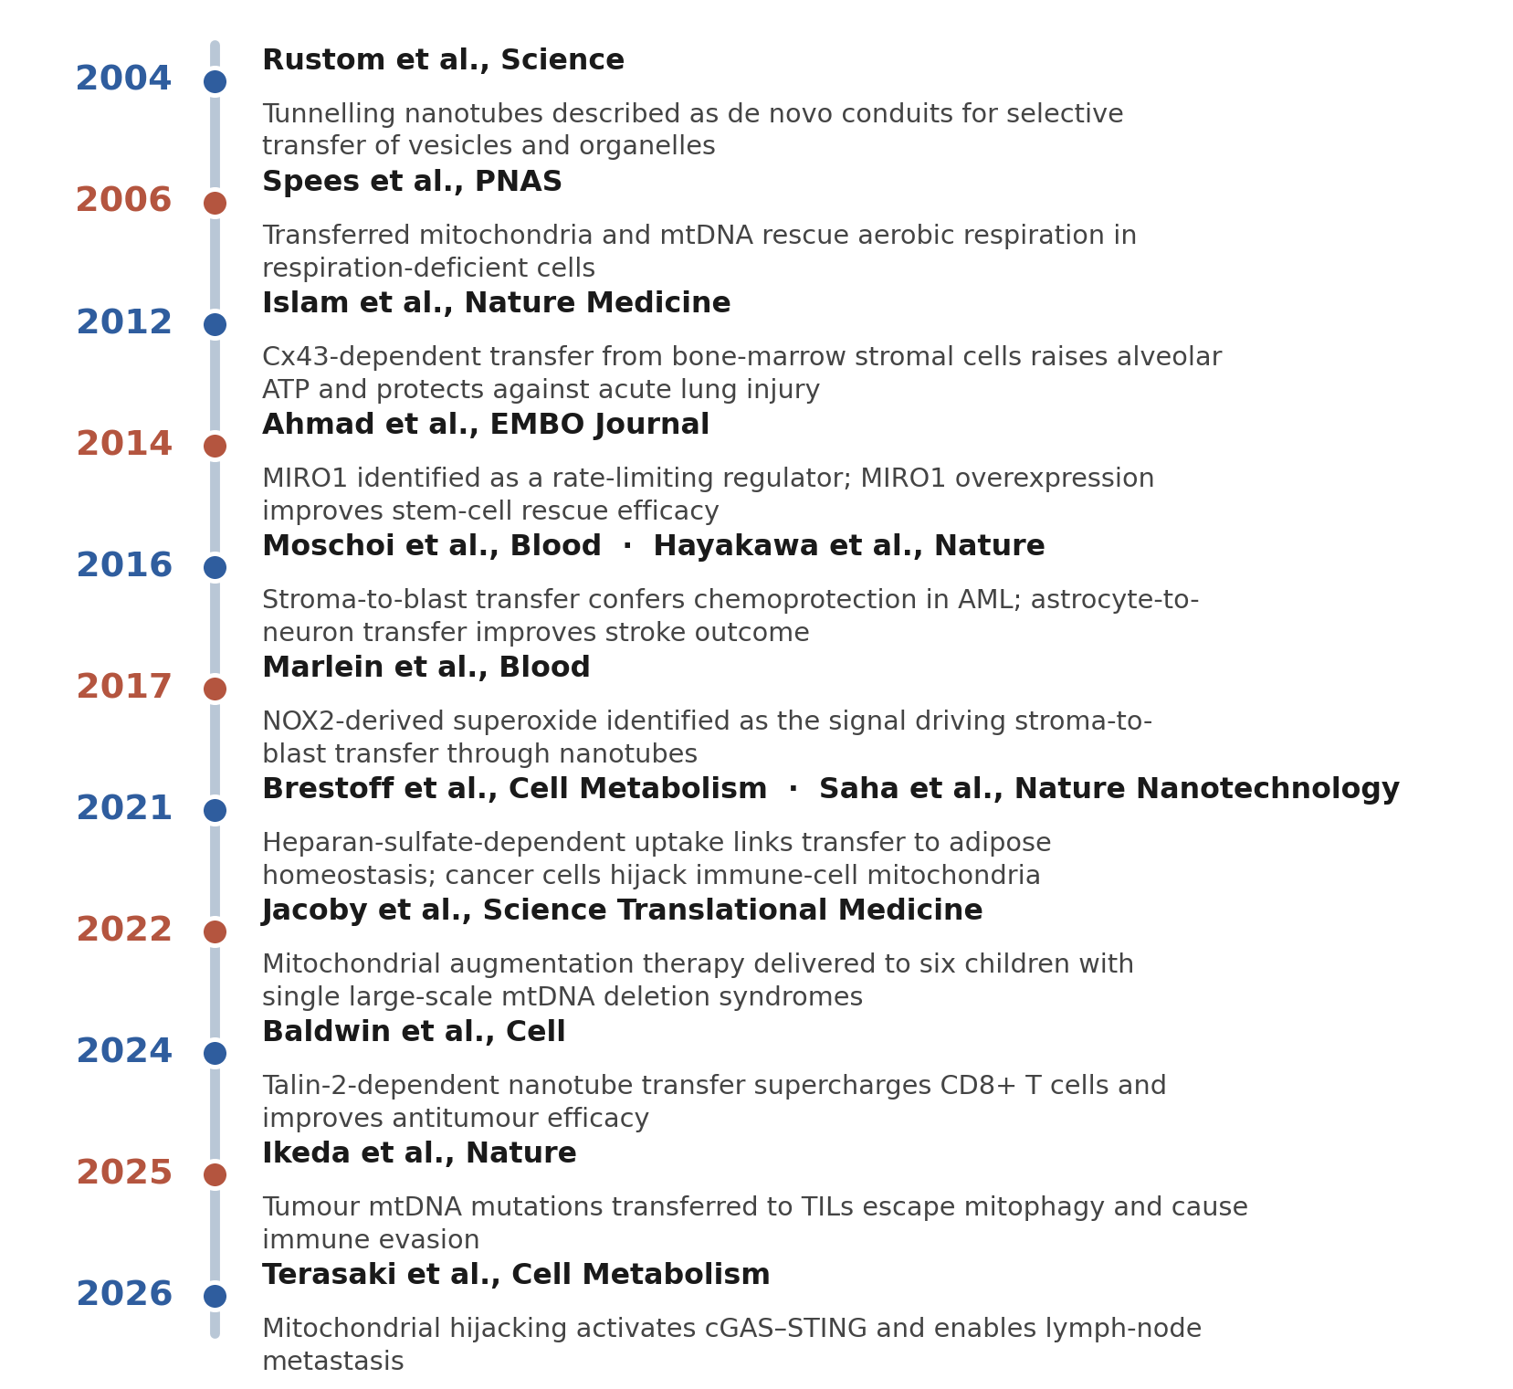
Figure 2. Two decades of intercellular mitochondrial transfer research, from the description of tunnelling nanotubes to the demonstration that mitochondrial hijacking enables lymph-node metastasis. Each entry corresponds to a primary publication listed in the reference list. Original figure compiled by the authors of this review from the cited primary literature.

4. Pathological exploitation: mitochondrial traffic in cancer
In the tumour microenvironment, mitochondrial traffic runs in several directions simultaneously, and each direction has a different consequence (Figure 3, Table 2).
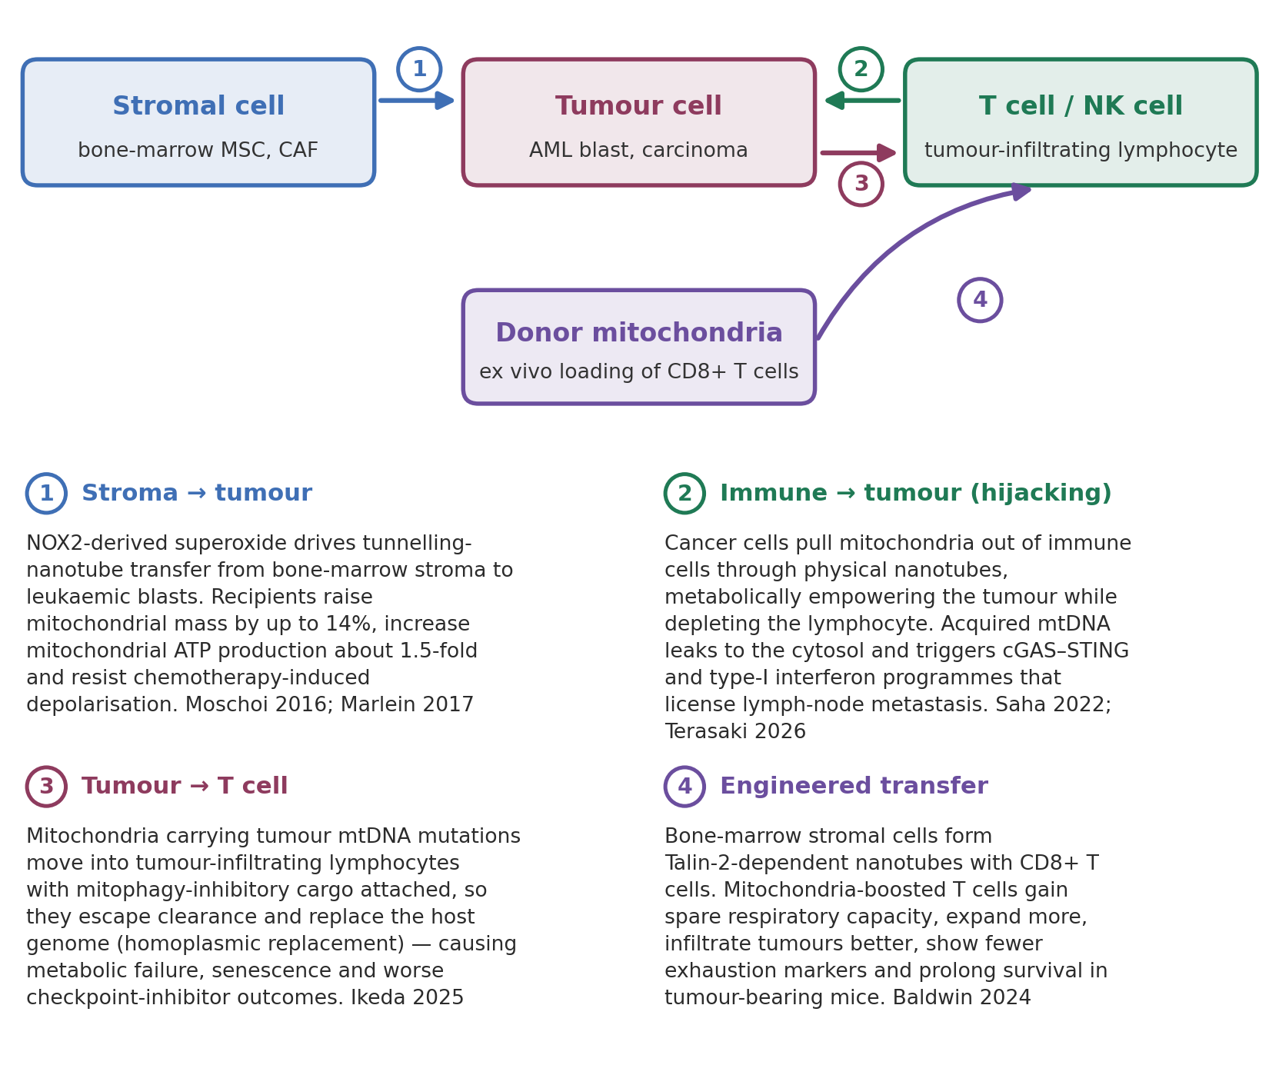
Figure 3. Bidirectional mitochondrial traffic in the tumour microenvironment. Stromal cells donate mitochondria to tumour cells and confer chemoresistance (1); tumour cells steal mitochondria from lymphocytes, disarming them and acquiring a cGAS–STING-dependent metastatic programme (2); tumour cells push mutation-bearing mitochondria into tumour-infiltrating lymphocytes, where they escape mitophagy and replace the host mitochondrial genome (3); and the same nanotube route can be engineered to load CD8+ T cells with healthy stromal mitochondria for adoptive therapy (4). Original schematic drawn by the authors of this review; findings and quantitative values as reported in Moschoi et al. 2016, Marlein et al. 2017, Saha et al. 2022, Baldwin et al. 2024, Ikeda et al. 2025 and Terasaki et al. 2026.
Table 2. Quantitative findings on mitochondrial transfer in cancer, as reported in the source publications. Values are those stated by the authors of each study; effect sizes are not directly comparable across different models and assays.
Direction of transfer | Model | Reported finding | Source
Stroma → AML blast | Niche-like coculture; NSG xenograft | Mitochondrial mass increased by up to 14%; 1.5-fold increase in mitochondrial ATP production; reduced depolarisation after chemotherapy; higher survival; greater in blasts than in cord-blood CD34+ cells | Moschoi et al., Blood 2016
Stroma → AML blast | Primary human AML; NSG mice | NOX2-generated superoxide stimulates transfer through AML-derived tunnelling nanotubes; NOX2 inhibition prevented transfer, increased AML apoptosis and improved mouse survival without detectable effect on non-malignant CD34+ cells | Marlein et al., Blood 2017
Stroma → AML blast (pharmacological block) | Human AML with mesenchymal stromal cells | Daratumumab (anti-CD38) inhibited AML metabolic capacity by blocking mitochondrial transfer from mesenchymal stromal cells | Mistry et al., Haematologica 2021
Immune cell → cancer cell | Immunocompetent breast cancer model | Nanotube-mediated transfer metabolically empowered cancer cells and depleted immune cells; L-778123 plus PD-1 blockade improved antitumour outcomes | Saha et al., Nat Nanotechnol 2022
Cancer cell → TIL | Human melanoma and NSCLC specimens; mouse models | mtDNA mutations shared between cancer cells and TILs; transferred mitochondria escape mitophagy via co-transferred inhibitory molecules, causing homoplasmic replacement, senescence and impaired effector and memory function; tumour mtDNA mutation was a poor prognostic factor for checkpoint inhibitors | Ikeda et al., Nature 2025
Immune cell → cancer cell | Lymph-node metastasis models | Acquired mitochondria fuse with the endogenous network, leak mtDNA to the cytosol and activate cGAS/STING and type-I interferon programmes; blocking cGAS, STING or type-I interferon reduced lymph-node metastasis | Terasaki et al., Cell Metab 2026
Stroma → CD8+ T cell (therapeutic) | Mouse tumour-bearing hosts | Talin-2-dependent nanotube transfer increased mitochondrial respiration and spare respiratory capacity; boosted T cells expanded more, infiltrated tumours better, showed fewer exhaustion signs and prolonged survival | Baldwin et al., Cell 2024

4.1 Stroma to tumour: fuelling chemoresistance
Contrary to a simple reading of the Warburg effect, AML blasts depend substantially on oxidative phosphorylation for ATP. Moschoi and colleagues showed in a niche-like coculture system that both primary and cultured AML cells take up functional mitochondria from murine or human bone-marrow stromal cells, increasing their mitochondrial mass by up to 14%. Recipient cells showed a 1.5-fold increase in mitochondrial ATP production, were less prone to mitochondrial depolarisation after chemotherapy, and survived better. The transfer was unidirectional, required cell–cell contact, proceeded through an endocytic pathway, was enhanced by some chemotherapeutic agents, and was greater in AML blasts than in normal cord-blood CD34+ cells. It was reproduced in an immunodeficient mouse xenograft model and observed in human leukaemia-initiating cells.
The NOX2 work extended this by identifying the signal that drives the transfer, and the therapeutic logic was subsequently tested pharmacologically: Mistry and colleagues reported that daratumumab, an anti-CD38 monoclonal antibody already licensed in myeloma, inhibits AML metabolic capacity by blocking mitochondrial transfer from mesenchymal stromal cells.

4.2 Immune to tumour: organelle theft
Saha and colleagues reported that cancer cells can hijack mitochondria from immune cells through physical nanotubes. Using field-emission scanning electron microscopy, fluorophore-tagged mitochondrial tracing and metabolic quantification, they showed that nanotube-mediated transfer from immune cells to cancer cells metabolically empowers the cancer cell while depleting the immune cell. Inhibiting the nanotube assembly machinery reduced transfer and prevented immune-cell depletion; combining the farnesyltransferase and geranylgeranyltransferase-1 inhibitor L-778123, which partially inhibits nanotube formation, with a PD-1 checkpoint inhibitor improved antitumour outcomes in an aggressive immunocompetent breast cancer model.
The consequences of theft extend beyond local metabolic competition. In work published in Cell Metabolism in January 2026, Terasaki and colleagues reported that tumour cells hijack mitochondria from a wide array of immune cells as a common attribute; mitochondrial loss reduced antigen presentation and co-stimulatory machinery in the donor immune cells and impaired the activation and cytotoxic capacity of natural killer and CD8+ T cells. In the recipient cancer cells, the acquired mitochondria fused with the endogenous network, leaked mtDNA into the cytosol and stimulated cGAS/STING, activating type-I-interferon-mediated immune evasion programmes. Blocking the transfer machinery — cGAS, STING, or type-I interferon — reduced lymph-node metastasis, positioning mitochondrial hijacking as a mechanism by which tumours colonise immune-populated tissue.

4.3 Tumour to T cell: transferring a broken genome
The most mechanistically striking direction was reported by Ikeda and colleagues in Nature in 2025. Analysing clinical specimens, they identified mtDNA mutations in tumour-infiltrating lymphocytes (TILs) that were shared with the cancer cells, and showed that mitochondria carrying those mutations transfer from cancer cells to TILs.
The key twist concerns quality control. Mitochondria in TILs ordinarily undergo ROS-driven mitophagy; mitochondria transferred from cancer cells do not, because mitophagy-inhibitory molecules attach to them and are co-transferred. The result is homoplasmic replacement — the mutant genome displaces the T cell's own. T cells that acquire mtDNA mutations from cancer cells show metabolic abnormalities and senescence, with defects in effector function and memory formation, and impaired antitumour immunity in vitro and in vivo. Consistent with a clinically meaningful effect, the presence of an mtDNA mutation in tumour tissue was a poor prognostic factor for immune checkpoint inhibitor therapy in patients with melanoma or non-small-cell lung cancer.
A related line of evidence, from conplastic mice carrying different naturally occurring mtDNA lineages on an identical nuclear background, shows that host mtDNA variation alone can determine tumour growth through T-cell reactive oxygen signalling, with regulatory T-cell function normalised by a mitochondrially targeted catalytic antioxidant. Together these findings indicate that the mitochondrial genotype of a lymphocyte — whether inherited or acquired — is a determinant of antitumour immunity.

5. Therapeutic exploitation
Three distinct therapeutic strategies follow from the biology above: blocking pathological transfer, supplying healthy mitochondria to damaged tissue, and engineering mitochondrial content into cell therapy products (Table 3).

5.1 Blocking transfer in cancer
NOX2 inhibition, anti-CD38 antibody therapy and nanotube-assembly inhibition have each been shown to reduce transfer and improve outcomes in preclinical models. The attraction of this approach is the apparent selectivity: NOX2 inhibition prevented transfer to AML blasts without detectable effect on non-malignant CD34+ cell survival. The obvious caution is that the same machinery serves homeostatic functions in lung, brain and adipose tissue, so the therapeutic window will depend on whether tumour-associated transfer uses molecularly distinguishable machinery or merely uses the same machinery more intensively.

5.2 Mitochondrial transplantation for ischaemia–reperfusion injury
Autologous mitochondrial transplantation — isolating mitochondria from a patient's own skeletal muscle and delivering them to ischaemic myocardium — has advanced furthest in paediatric cardiac surgery. Guariento and colleagues reported a single-centre pilot study of children requiring postcardiotomy extracorporeal membrane oxygenation (ECMO) for severe refractory cardiogenic shock after ischaemia–reperfusion injury, comparing ten patients who received mitochondrial transplantation after revascularisation with fourteen who received revascularisation alone (Figure 4).
Successful separation from ECMO, defined as freedom from ECMO reinstitution within one week of initial separation, was achieved in 8 of 10 treated patients (80%) versus 4 of 14 controls (29%; P = .02). Median circumferential strain immediately after separation was better in the treated group (−23.0%, range −20.0% to −28.8%) than in controls (−16.8%, range −13.0% to −18.4%; P = .03). Median time to functional recovery after revascularisation was 2 days versus 9 days (P = .02), and cardiovascular events occurred in 20% versus 79% (P < .01), with a Cox regression hazard ratio of 4.6 (95% CI 1.0–20.9; P = .04) for the control group. Markers of systemic inflammatory response and organ function measured before and after revascularisation did not differ between groups.
These are encouraging results, but they should be read with the design in mind: this was a retrospective, single-centre, non-randomised comparison in 24 patients accumulated over sixteen years, and the authors present it as a pilot. A prospective study at the same institution (NCT02851758) remains in progress, and an endovascular autologous mitochondrial transplantation study in cerebral ischaemia is recruiting at the University of Washington (NCT04998357).
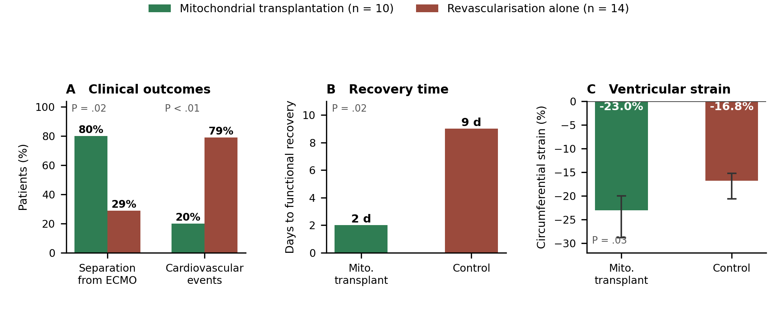
Figure 4. Outcomes of autologous mitochondrial transplantation in children requiring postcardiotomy ECMO for refractory cardiogenic shock after ischaemia–reperfusion injury. (A) Successful separation from ECMO and incidence of cardiovascular events. (B) Median time to functional recovery after revascularisation. (C) Median circumferential strain immediately after ECMO separation (more negative values indicate better function); whiskers show the ranges reported by the authors. Chart constructed by the authors of this review from the numerical results reported in Guariento et al., J Thorac Cardiovasc Surg 2021;162(3):992–1001. Retrospective, single-centre, non-randomised pilot comparison (n = 24).

5.3 Mitochondrial augmentation in primary mitochondrial disease
Jacoby and colleagues developed a method to enrich haematopoietic cells with exogenous mitochondria and treated six children with single large-scale mtDNA deletion syndromes (SLSMDs) — presenting as Pearson syndrome in early childhood or Kearns–Sayre syndrome later — through a compassionate-use programme. Autologous CD34+ haematopoietic cells were augmented with maternally derived healthy mitochondria, a technology the authors term mitochondrial augmentation therapy (MAT).
The procedure was well tolerated; all study-related severe adverse events were either leukapheresis-related or attributable to the baseline disorder. Heteroplasmy decreased in peripheral blood in four of six patients, and mtDNA content in peripheral blood cells increased in all six at 6–12 months relative to baseline. The authors report some clinical improvement in aerobic function measured by sit-to-stand or six-minute-walk testing in two patients, weight gain in five of six who had very low body weight at baseline, and improvement in some quality-of-life and physical examination parameters. With six patients, no control group and heterogeneous baseline disease, these data establish feasibility and safety signals rather than efficacy — which is how the authors frame them.

5.4 Organelle medicine for adoptive cell therapy
Mitochondrial loss and dysfunction drive T-cell exhaustion, a principal barrier to T-cell-based immunotherapy. Baldwin and colleagues turned the tumour's own trick around. They found that bone-marrow stromal cells establish nanotubular connections with T cells and use them to transplant stromal mitochondria into CD8+ T cells, with optimal transfer requiring Talin-2 on both donor and recipient.
CD8+ T cells that received donated mitochondria displayed enhanced mitochondrial respiration and increased spare respiratory capacity. Transferred into tumour-bearing hosts, these cells expanded more robustly, infiltrated tumours more efficiently and showed fewer signs of exhaustion than T cells that had not taken up mitochondria; they mediated superior antitumour responses and prolonged animal survival. The authors describe the approach as a prototype of organelle medicine — an apt description of a modality in which neither a small molecule nor a gene but an organelle is the therapeutic agent.
Table 3. Clinical translation of mitochondrial transfer and transplantation: selected registered studies and published human experience. Registry data retrieved from ClinicalTrials.gov; published outcomes from the cited publications. Status as recorded at the time of retrieval.
Programme / identifier | Indication | Design and status | Outcome reported
Autologous mitochondrial transplantation (Boston Children's Hospital); published pilot series | Paediatric postcardiotomy cardiogenic shock after ischaemia–reperfusion injury | Retrospective single-centre comparison, n = 24 (10 treated, 14 control), 2002–2018 | 80% vs 29% successful ECMO separation (P = .02); strain −23.0% vs −16.8% (P = .03); recovery 2 vs 9 days (P = .02); cardiovascular events 20% vs 79% (P < .01). Guariento et al. 2021
NCT02851758 (Boston Children's Hospital) | Ischaemia–reperfusion injury in patients on ECMO support | Interventional, n = 16, recruiting; primary completion 2027 | Prospective study of autologous mitochondria transplantation; results not yet reported
NCT04998357 (University of Washington) | Cerebral ischaemia | Interventional, n = 20, recruiting; primary completion 2026 | Endovascular autologous mitochondrial transplantation; results not yet reported
Mitochondrial augmentation therapy, MNV-BM-BLD (Minovia Therapeutics); NCT03384420 | Pearson syndrome and other single large-scale mtDNA deletion syndromes | Phase 1/2, n = 7 (registry); published compassionate-use series of 6 children | Well tolerated; heteroplasmy decreased in 4/6; mtDNA content increased in all 6 at 6–12 months; weight gain in 5/6; some improvement in aerobic function and quality of life. Jacoby et al. 2022
PN-101 (Paean Biotechnology); NCT04976140 | Refractory polymyositis and dermatomyositis | Phase 1/2a dose escalation, n = 9, completed | Safety, tolerability and exploratory efficacy of a mitochondria-based product; registry record only
Preclinical: engineered mitochondrial loading of CD8+ T cells | Adoptive T-cell therapy for solid tumours | Mouse models; no registered human study identified | Enhanced respiration and spare respiratory capacity, better tumour infiltration, fewer exhaustion markers, prolonged survival. Baldwin et al. 2024

6. Discussion: open questions

6.1 Quantification and attribution
Much of the field rests on fluorescence-based tracing of labelled mitochondria between cells. Dye transfer, membrane exchange without organelle transfer, and the engulfment of dying donor cells can all produce signals that resemble transfer. The most persuasive studies address this with orthogonal evidence — species-specific mtDNA detection, restriction-fragment and SNP analysis of the recipient genome, electron microscopy, and functional rescue of respiration-deficient cells. Studies reporting transfer purely on the basis of fluorescence colocalisation should be read with more caution, and the field would benefit from standardised reporting of which orthogonal controls were applied.

6.2 Persistence and fate of donor mitochondria
How long do transferred mitochondria survive in the recipient, and what happens to their genomes? The homoplasmic replacement reported in TILs implies that, under some conditions, donor mtDNA can displace host mtDNA entirely. At the other extreme, mtDNA in the cytosol is an inflammatory signal through cGAS–STING, and mtDNA fragments can integrate into the nuclear genome as nuclear mitochondrial DNA segments (NUMTs) — elements once dismissed as genomic noise but now argued to accumulate with age and to intersect with hallmarks of ageing. The long-term genomic consequences of deliberately introducing foreign mitochondria into a patient's cells have not been characterised, and this is a gap that any durable therapeutic programme will need to close.

6.3 Selectivity of therapeutic blockade
Because the same routes serve protective and pathological ends, systemic inhibition of mitochondrial transfer is a blunt instrument. NOX2-driven transfer in the AML niche and CD38-dependent astrocyte-to-neuron transfer after stroke are mechanistically distinct enough to be separable in principle; whether nanotube assembly inhibitors of the kind used with L-778123 can achieve tumour selectivity in patients is unresolved. Conversely, therapeutic mitochondrial delivery must avoid inadvertently supplying tumour cells, which are demonstrably avid recipients.

6.4 Sourcing, dosing and manufacturing
The clinical programmes surveyed here use very different sources — autologous skeletal muscle, maternally derived mitochondria, allogeneic stromal cells — and there is no agreed potency assay, dose metric or release specification for a mitochondrial product. A registry search of ClinicalTrials.gov returns 72 records matching mitochondrial transplantation or transfer interventions, but the genuinely relevant interventional programmes remain small: single-centre studies with enrolments in the single or low double digits. Until dosing and potency are standardised, cross-study comparison will remain difficult.

7. Conclusion
Intercellular mitochondrial transfer has moved in twenty years from a curiosity of cultured cells to a mechanism with demonstrated consequences for lung injury, stroke outcome, adipose-tissue metabolism, leukaemic chemoresistance, tumour metastasis and the success or failure of cancer immunotherapy. The most consequential recent findings concern the immune system: that tumours steal mitochondria from lymphocytes to fuel themselves and disarm their attackers; that they push defective mitochondrial genomes into T cells in a form that escapes quality control; and that the same conduit can be run in reverse to build metabolically supercharged T cells for adoptive therapy.
What began as a challenge to the assumption of strict vertical inheritance has become a practical proposition: that the organelle can be moved deliberately, and that moving it changes outcomes. Whether the early clinical signals in paediatric cardiogenic shock and mitochondrial deletion syndromes translate into controlled evidence of benefit, and whether transfer can be blocked selectively in tumours, are the questions on which the next phase of this field will turn.

References
All references were retrieved from PubMed; digital object identifiers (DOIs) and PubMed identifiers (PMIDs) are given for each. Clinical trial records were retrieved from ClinicalTrials.gov.
1. Rustom A, Saffrich R, Markovic I, Walther P, Gerdes HH. Nanotubular highways for intercellular organelle transport. Science. 2004;303(5660):1007–1010. doi:10.1126/science.1093133. PMID: 14963329.
2. Spees JL, Olson SD, Whitney MJ, Prockop DJ. Mitochondrial transfer between cells can rescue aerobic respiration. Proc Natl Acad Sci U S A. 2006;103(5):1283–1288. doi:10.1073/pnas.0510511103. PMID: 16432190.
3. Islam MN, Das SR, Emin MT, Wei M, Sun L, Westphalen K, Rowlands DJ, Quadri SK, Bhattacharya S, Bhattacharya J. Mitochondrial transfer from bone-marrow-derived stromal cells to pulmonary alveoli protects against acute lung injury. Nat Med. 2012;18(5):759–765. doi:10.1038/nm.2736. PMID: 22504485.
4. Ahmad T, Mukherjee S, Pattnaik B, Kumar M, Singh S, Kumar M, Rehman R, Tiwari BK, Jha KA, Barhanpurkar AP, Wani MR, Roy SS, Mabalirajan U, Ghosh B, Agrawal A. Miro1 regulates intercellular mitochondrial transport and enhances mesenchymal stem cell rescue efficacy. EMBO J. 2014;33(9):994–1010. doi:10.1002/embj.201386030. PMID: 24431222.
5. Moschoi R, Imbert V, Nebout M, Chiche J, Mary D, Prebet T, Saland E, Castellano R, Pouyet L, Collette Y, Vey N, Chabannon C, Recher C, Sarry JE, Alcor D, Peyron JF, Griessinger E. Protective mitochondrial transfer from bone marrow stromal cells to acute myeloid leukemic cells during chemotherapy. Blood. 2016;128(2):253–264. doi:10.1182/blood-2015-07-655860. PMID: 27257182.
6. Hayakawa K, Esposito E, Wang X, Terasaki Y, Liu Y, Xing C, Ji X, Lo EH. Transfer of mitochondria from astrocytes to neurons after stroke. Nature. 2016;535(7613):551–555. doi:10.1038/nature18928. PMID: 27466127.
7. Marlein CR, Zaitseva L, Piddock RE, Robinson SD, Edwards DR, Shafat MS, Zhou Z, Lawes M, Bowles KM, Rushworth SA. NADPH oxidase-2 derived superoxide drives mitochondrial transfer from bone marrow stromal cells to leukemic blasts. Blood. 2017;130(14):1649–1660. doi:10.1182/blood-2017-03-772939. PMID: 28733324.
8. Brestoff JR, Wilen CB, Moley JR, Li Y, Zou W, Malvin NP, Rowen MN, Saunders BT, Ma H, Mack MR, Hykes BL, Balce DR, Orvedahl A, Williams JW, Rohatgi N, Wang X, McAllaster MR, Handley SA, Kim BS, Doench JG, Zinselmeyer BH, Diamond MS, Virgin HW, Gelman AE, Teitelbaum SL. Intercellular mitochondria transfer to macrophages regulates white adipose tissue homeostasis and is impaired in obesity. Cell Metab. 2021;33(2):270–282.e8. doi:10.1016/j.cmet.2020.11.008. PMID: 33278339.
9. Guariento A, Piekarski BL, Doulamis IP, Blitzer D, Ferraro AM, Harrild DM, Zurakowski D, del Nido PJ, McCully JD, Emani SM. Autologous mitochondrial transplantation for cardiogenic shock in pediatric patients following ischemia-reperfusion injury. J Thorac Cardiovasc Surg. 2021;162(3):992–1001. doi:10.1016/j.jtcvs.2020.10.151. PMID: 33349443.
10. Mistry JJ, Moore JA, Kumar P, Marlein CR, Hellmich C, Pillinger G, Jibril A, Di Palma F, Collins A, Bowles KM, Rushworth SA. Daratumumab inhibits acute myeloid leukaemia metabolic capacity by blocking mitochondrial transfer from mesenchymal stromal cells. Haematologica. 2021;106(2):589–592. doi:10.3324/haematol.2019.242974. PMID: 32193250.
11. Saha T, Dash C, Jayabalan R, Khiste S, Kulkarni A, Kurmi K, Mondal J, Majumder PK, Bardia A, Jang HL, Sengupta S. Intercellular nanotubes mediate mitochondrial trafficking between cancer and immune cells. Nat Nanotechnol. 2022;17(1):98–106. doi:10.1038/s41565-021-01000-4. PMID: 34795441.
12. Jacoby E, Bar-Yosef O, Gruber N, Lahav E, Varda-Bloom N, Bolkier Y, Bar D, Ben-Yakir Blumkin M, Barak S, Eisenstein E, Ahonniska-Assa J, Silberg T, Krasovsky T, Bar O, Erez N, Bielorai B, Golan H, Dekel B, Besser MJ, Pozner G, Khoury H, Jacobs A, Campbell J, Herskovitz E, Sher N, Yivgi-Ohana N, Anikster Y, Toren A. Mitochondrial augmentation of hematopoietic stem cells in children with single large-scale mitochondrial DNA deletion syndromes. Sci Transl Med. 2022;14(676):eabo3724. doi:10.1126/scitranslmed.abo3724. PMID: 36542693.
13. Borcherding N, Brestoff JR. The power and potential of mitochondria transfer. Nature. 2023;623(7986):283–291. doi:10.1038/s41586-023-06537-z. PMID: 37938702.
14. Guan F, Wu X, Zhou J, Lin Y, He Y, Fan C, Zeng Z, Xiong W. Mitochondrial transfer in tunneling nanotubes — a new target for cancer therapy. J Exp Clin Cancer Res. 2024;43(1):147. doi:10.1186/s13046-024-03069-w. PMID: 38769583.
15. Baldwin JG, Heuser-Loy C, Saha T, Schelker RC, Slavkovic-Lukic D, Strieder N, Hernandez-Lopez I, Rana N, Barden M, Mastrogiovanni F, Martín-Santos A, Raimondi A, Brohawn P, Higgs BW, Gebhard C, Kapoor V, Telford WG, Gautam S, Xydia M, Beckhove P, Frischholz S, Schober K, Kontarakis Z, Corn JE, Iannacone M, Inverso D, Rehli M, Fioravanti J, Sengupta S, Gattinoni L. Intercellular nanotube-mediated mitochondrial transfer enhances T cell metabolic fitness and antitumor efficacy. Cell. 2024;187(23):6614–6630.e21. doi:10.1016/j.cell.2024.08.029. PMID: 39276774.
16. Ikeda H, Kawase K, Nishi T, Watanabe T, Takenaga K, Inozume T, Ishino T, Aki S, Lin J, Kawashima S, Nagasaki J, Ueda Y, Suzuki S, Makinoshima H, Itami M, Nakamura Y, Tatsumi Y, Suenaga Y, Morinaga T, Honobe-Tabuchi A, Ohnuma T, Kawamura T, Umeda Y, Nakamura Y, Kiniwa Y, Ichihara E, Hayashi H, Ikeda JI, Hanazawa T, Toyooka S, Mano H, Suzuki T, Osawa T, Kawazu M, Togashi Y. Immune evasion through mitochondrial transfer in the tumour microenvironment. Nature. 2025;638(8049):225–236. doi:10.1038/s41586-024-08439-0. PMID: 39843734.
17. Yardeni T, Olali AZ, Chen HW, Wang L, Haltom JA, Zenab A, Morrow R, Butic A, Murdock DG, Waymire KG, MacGregor GR, Boursi B, Beier UH, Hancock WW, Wallace DC. Mitochondrial DNA lineages determine tumor progression through T cell reactive oxygen signaling. Proc Natl Acad Sci U S A. 2025;122(1):e2417252121. doi:10.1073/pnas.2417252121. PMID: 39752523.
18. Marzetti E, Di Lorenzo R, Calvani R, Coelho-Junior HJ, Pesce V, Landi F, Leeuwenburgh C, Picca A. Nuclear mitochondrial DNA transfer revisited: from genomic noise to hallmark of aging. Ageing Res Rev. 2025;112:102892. doi:10.1016/j.arr.2025.102892. PMID: 40912404.
19. Terasaki A, Bhatnagar K, Weiner AT, Tan Y, Szeifert V, Huang HL, Wiggers L, Rodrigues V, Rada CC, Shankar V, Saito S, Ankomah PO, Roth T, Chiu B, West R, Li L, Reticker-Flynn N, Axelrod JD, Brestoff JR, Li B, Engleman E, Okwan-Duodu D. Mitochondrial transfer from immune to tumor cells enables lymph node metastasis. Cell Metab. 2026;38(2):388–398.e7. doi:10.1016/j.cmet.2025.12.014. PMID: 41529696.

Clinical trial registry records
NCT02851758. Transplantation of Autologously Derived Mitochondria for Protection Against Ischemia-Reperfusion Injury Following Ischemia in Subjects on ECMO Support. Boston Children's Hospital. Status: recruiting; enrolment 16. ClinicalTrials.gov, U.S. National Library of Medicine.
NCT04998357. Autologous Mitochondrial Transplant for Cerebral Ischemia. University of Washington. Status: recruiting; enrolment 20. ClinicalTrials.gov, U.S. National Library of Medicine.
NCT03384420. Phase I/II Study of MNV-BM-BLD (Autologous CD34+ Cells Enriched With Blood-Derived Mitochondria) in Pediatric Patients With Pearson Syndrome. Minovia Therapeutics. Status: completed; enrolment 7. ClinicalTrials.gov, U.S. National Library of Medicine.
NCT04976140. Phase 1/2a Trial of PN-101 in Patients With Refractory Polymyositis or Dermatomyositis. Paean Biotechnology. Status: completed; enrolment 9. ClinicalTrials.gov, U.S. National Library of Medicine.

