REVIEW · MOLECULAR NEPHROLOGY AND HUMAN GENETICS
APOL1-Mediated Kidney Disease: A Trypanolytic Innate Immune Protein Turned Podocyte Toxin
From the genetics of an evolutionary trade-off to the first mechanism-targeted drugs in nephrology

Prepared 5 October 2026 · Weekly biological sciences review series
Every factual claim in this review is sourced to a peer-reviewed article or preprint retrieved from PubMed/PubMed Central, or to a study record retrieved from ClinicalTrials.gov. All DOIs and PMIDs are given in the reference list.
Abstract
People of recent sub-Saharan African ancestry carry an excess burden of non-diabetic kidney failure that resisted explanation for decades. In 2010 two coding haplotypes in APOL1 — G1 (S342G/I384M) and G2 (Δ388NY389) — were shown to account for much of it, with odds ratios of 10.5 for biopsy-proven focal segmental glomerulosclerosis (FSGS) and 7.3 for hypertension-attributed kidney failure under a recessive model. APOL1 encodes the serum trypanolytic factor that makes humans resistant to Trypanosoma brucei brucei; G1 and G2 arose because they restore killing of the SRA-expressing subspecies T. b. rhodesiense, and they were driven to high frequency in West and Central Africa by that selective advantage. The kidney phenotype is the price of that adaptation. This review sets out the glomerular and molecular background needed to follow the field, then examines the competing mechanistic accounts of how risk-variant APOL1 injures the podocyte: direct cation-channel gain of function at the plasma membrane; cholesterol-dependent disturbance of slit-diaphragm lipid rafts; mitochondrial fission with abortive mitophagy; and NLRP12/IL-1β inflammatory signalling. It reviews the “second hit” requirement — interferon-driven APOL1 induction during viral infection — that explains why only roughly 15–20% of high-risk individuals ever develop overt nephropathy, and the p.N264K modifier that converts G2-containing high-risk genotypes back to low risk. Finally it assesses the therapeutic landscape, in which the small-molecule APOL1 channel blocker inaxaplin (VX-147) reduced the urinary protein-to-creatinine ratio by 47.6% over 13 weeks in an open-label phase 2a study and is now in the randomised phase 2/3 AMPLITUDE trial, alongside antisense knockdown, JAK/STAT inhibition and a second channel blocker. APOL1 is the clearest example in nephrology of a genetically defined, mechanism-targetable disease; it is also a cautionary case, because every targeted agent to date rests on short-term surrogate endpoints and the proximal injury mechanism remains genuinely contested.
Keywords: APOL1 · focal segmental glomerulosclerosis · podocyte · trypanolytic factor · balancing selection · inaxaplin · precision nephrology

1. Introduction

1.1 A disparity in search of a mechanism
Rates of end-stage kidney disease among African Americans have long run several-fold higher than among European Americans, and for most of the twentieth century this was attributed to hypertension, to socioeconomic factors, or to both. The attribution was always uncomfortable, because the kidney failure frequently preceded the hypertension rather than following it, and because blood-pressure control did not close the gap. Linkage and admixture mapping eventually localised a strong signal to chromosome 22q, first to MYH9 and then, on fine mapping, to the adjacent APOL1 gene [1].
Genovese and colleagues reported in 2010 that two independent sequence variants in APOL1 were associated with focal segmental glomerulosclerosis (FSGS) and with hypertension-attributed end-stage kidney disease in African Americans, with odds ratios of 10.5 (95% CI 6.0–18.4) and 7.3 (95% CI 5.6–9.5) respectively. Both variants were common on African chromosomes, absent from European chromosomes, and sat within haplotypes bearing signatures of positive selection [1]. Effect sizes of this magnitude for a common variant are very unusual in complex-disease genetics, and the finding reorganised the field almost immediately.
What made the result more than an epidemiological curiosity was the functional assay in the same paper. APOL1 is the serum factor that lyses African trypanosomes, and only the kidney-disease-associated variants were able to lyse Trypanosoma brucei rhodesiense [1]. The gene was not a kidney gene that happened to vary; it was an innate immune effector whose adaptation to a parasite had collateral consequences in the glomerulus.

1.2 The glomerulus and the podocyte: what is actually being damaged
The filtering unit of the kidney is the glomerulus, a tuft of capillaries sitting inside Bowman's capsule. Blood plasma crosses three layers to become filtrate: the fenestrated capillary endothelium, the glomerular basement membrane, and a layer of highly specialised epithelial cells called podocytes. Podocytes wrap the capillary loops in interdigitating foot processes (pedicels), and the narrow gaps between adjacent foot processes are bridged by the slit diaphragm, a zipper-like protein assembly built around nephrin and podocin. The slit diaphragm is the final size- and charge-selective barrier; when it fails, plasma protein appears in the urine.
Three properties of podocytes make them the critical vulnerability. They are terminally differentiated and essentially post-mitotic, so cells lost are not replaced. Their architecture depends on a dynamic actomyosin cytoskeleton anchored to cholesterol-rich lipid raft microdomains in which podocin, nephrin and mechanosensitive cation channels such as TRPC6 are organised together [2]. And they bear mechanical load continuously, under the hydrostatic pressure that drives filtration. Injury therefore manifests first as foot-process effacement and proteinuria, and then, as podocytes detach and are lost, as segmental scarring of the tuft — the lesion pathologists call focal segmental glomerulosclerosis [20].
FSGS is a histological pattern, not a disease. It is the common endpoint of primary (circulating-factor) disease, secondary adaptive responses to reduced nephron mass or obesity, monogenic podocytopathies, and the APOL1-associated form considered here. Distinguishing among these matters clinically because the treatments differ, and a pathomechanism-based classification is now preferred to the older morphological one [20].

1.3 APOL1 as an innate immune protein
Apolipoprotein L1 is the only secreted member of a family of mammalian APOL proteins whose ancestral functions are intracellular and concerned with membrane dynamics — fission, fusion, vesicular trafficking, and the disruption of membranes of intracellular bacteria [2]. It circulates as a minor constituent of a dense subfraction of high-density lipoprotein (HDL) particles, together with haptoglobin-related protein (HpR). Alternative splicing and alternative signal-peptide cleavage generate several isoforms, some secreted and some retained intracellularly; APOL1 expression is strongly induced by inflammation, particularly by type I and type II interferon signalling during viral infection [2, 11, 12].
The trypanolytic mechanism is a Trojan horse. Bloodstream-form trypanosomes express a surface receptor for the haptoglobin–haemoglobin complex, which they use to scavenge haem; the receptor cannot distinguish HpR–haemoglobin from the genuine article, so the APOL1-bearing HDL particle is endocytosed. In the acidic endosome APOL1 unfolds, its transmembrane hairpin inserts into the endosomal membrane, and the protein is trafficked onward to the parasite mitochondrion, where it triggers megapore formation, release of endonuclease G, and an apoptosis-like death [2].
Two trypanosome subspecies evade this. T. b. rhodesiense expresses serum resistance-associated protein (SRA), a truncated variant surface glycoprotein that binds and neutralises the APOL1 C-terminal helix; T. b. gambiense uses a different protein, TgsGP, to stiffen its membranes against APOL1 insertion [2]. The G1 and G2 variants are human counter-moves: both alter the very C-terminal helix that SRA targets, so SRA can no longer neutralise them, restoring human resistance to T. b. rhodesiense [1, 2]. This is the arms race whose human cost is APOL1 kidney disease.

2. Genetics, population history and penetrance

2.1 The G1 and G2 haplotypes
G1 is a two-SNP haplotype producing the missense substitutions S342G and I384M; G2 is a six-base-pair in-frame deletion removing residues N388 and Y389. Both lie in the C-terminal domain, within or immediately adjacent to the second leucine zipper helix [1, 2]. Risk is inherited recessively: two risk alleles in any combination (G1/G1, G1/G2, G2/G2) constitute the high-risk genotype, while heterozygotes are, to a first approximation, unaffected [9].
Allele | Molecular change | Location | Functional consequence and epidemiology
G0 (reference) | — | — | Lyses T. b. brucei but is neutralised by SRA; no excess kidney-disease risk [1, 2].
G1 | S342G + I384M  (two linked missense SNPs) | C-terminal domain,  LZ2 helix | Escapes SRA neutralisation, restoring lysis of T. b. rhodesiense; appears to limit T. b. gambiense infection [1, 2].
G2 | Δ388NY389  (6-bp in-frame deletion) | C-terminal domain,  LZ2 helix | Also escapes SRA; in contrast to G1, reported to favour T. b. gambiense development [2].
p.N264K | Missense modifier | Membrane-addressing  domain, adjacent to CRAC-1 | When co-inherited with G2, renders G1/G2 and G2/G2 genotypes low-risk; abolishes variant cytotoxicity in vitro [10, 5].
High-risk genotype | G1/G1, G1/G2 or G2/G2 | — | Carried by ~13% of African Americans [10]; approximately 6 million people in the United States [19]. Only ~15–20% develop overt nephropathy [18].
Table 1. APOL1 alleles, their molecular nature and their functional and epidemiological consequences. Compiled from Genovese et al., Science 2010 [1]; Pays, Cells 2024 [2]; Gupta et al., Nature Communications 2023 [10]; Srinivasan et al., Kidney Medicine 2025 [19]; and Dogra et al., International Urology and Nephrology 2026 [18].
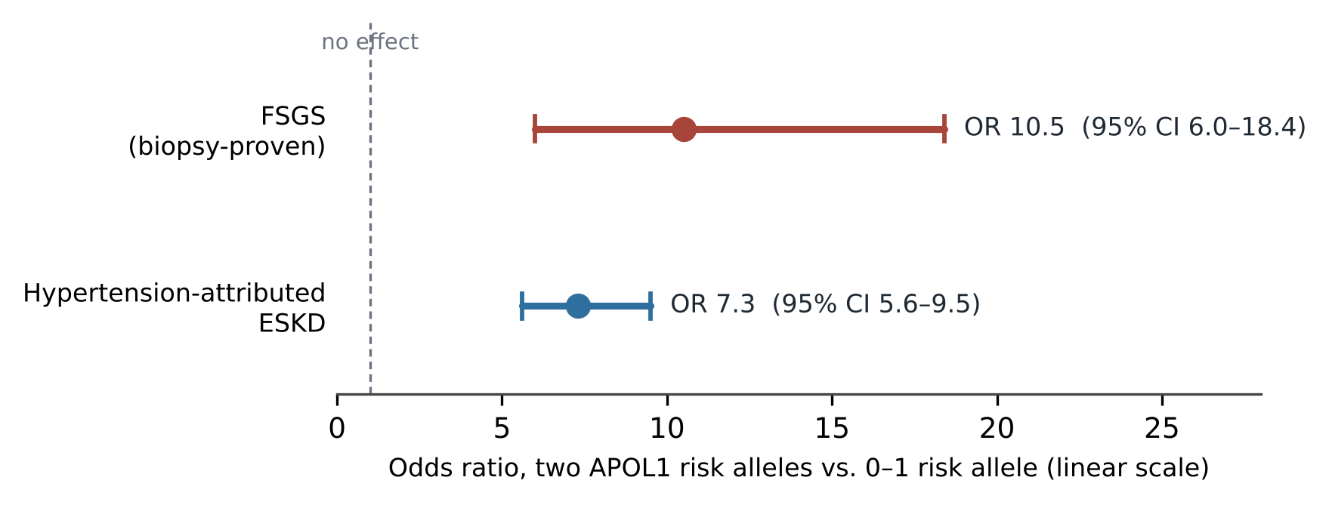
Figure 1. Effect sizes of the APOL1 high-risk genotype in the original association study. Point estimates and 95% confidence intervals redrawn from the values reported by Genovese et al., Science 2010;329:841–845 [1]. Odds ratios of this magnitude are exceptional for common variants in complex disease.

2.2 Selection, and the shape of the trade-off
Both risk haplotypes sit on extended haplotypes carrying signatures of recent positive selection, and both are confined to chromosomes of African origin [1]. The inferred history is straightforward in outline: sleeping sickness exerted strong mortality pressure in sub-Saharan Africa; alleles restoring trypanolysis against the SRA-expressing parasite were favoured; and the kidney phenotype, which typically manifests in the fourth to sixth decades, was largely invisible to selection operating on reproductive success. Pays has argued that the geographic distribution is informative — G1 and G2 spread in West Africa and may have contributed to the local disappearance of T. b. rhodesiense, while T. b. gambiense persisted [2].
It is worth being precise about what the evolutionary story does and does not license. It explains allele frequency, and it reframes a health disparity as the consequence of an ancestral pathogen environment rather than of race as a biological category. It does not, by itself, establish the molecular mechanism of kidney injury, and the trypanolytic and nephrotoxic activities of the variants are in fact separable, as the N264K and APOL1Δ variants demonstrate [2, 10].

2.3 Incomplete penetrance and the N264K modifier
Roughly 13% of African Americans carry a high-risk genotype, but only a minority — on the order of 15–20% — develop overt nephropathy [10, 18]. One review places the lifetime risk of FSGS in high-risk individuals at about 4% and of end-stage kidney disease at 7–8% [21]. Something beyond genotype is therefore required, and two classes of explanation are live: environmental or infectious second hits (Section 4.6), and genetic modifiers.
The clearest modifier identified to date is the common missense variant p.N264K. Gupta and colleagues showed across multiple cohorts that when N264K is co-inherited in cis with G2, it substantially reduces the penetrance of G1/G2 and G2/G2 genotypes — effectively converting them to low-risk [10]. The finding is mechanistically illuminating as well as clinically relevant, because N264 lies in the membrane-addressing domain next to the first cholesterol recognition motif (CRAC-1), well away from the pore-forming domain, and because recent electrophysiology confirms that the N264K variant, like the drug inaxaplin, prevents APOL1-dependent calcium influx and rescues cell viability [5]. Any complete mechanistic account must explain why a substitution at that position disarms the variant protein.

3. Molecular architecture of APOL1
The APOL1 structure has not been solved in full, but biochemical and mutational work supports a three-module architecture downstream of the signal peptide [2].
The N-terminal pore-forming domain (PFD) comprises five α-helices, four of them arranged as a bundle, together with a two-helix transmembrane hairpin. Insertion of this hairpin into a bilayer requires protonation of acidic residues and therefore occurs only at acidic pH — a constraint that will become important when the podocyte mechanism is assessed. Under acidic conditions the domain supports weak anion fluxes; on subsequent neutralisation, high cation conductance follows. The pore is thus pH-gated, with gating controlled by negatively charged residues in the C-terminal domain [2].
Immediately downstream lies the membrane-addressing domain (MAD), two helices carrying rows of positively charged residues that allow association with anionic phospholipids, and containing the first cholesterol recognition amino acid consensus motif, CRAC-1, at residues 268–277. Residue N264 sits here, immediately adjacent [2].
After a long hinge, the C-terminal domain carries a second leucine zipper (LZ2) and a second hydrophobic cluster (HC2) containing CRAC-2. In the reference G0 protein, LZ2 pairs with the N-terminal LZ1 in a foldback interaction that mutually buries the two hydrophobic clusters. G1 and G2 both perturb LZ2 and therefore loosen this foldback, increasing exposure of HC2 and of CRAC-2 and raising the overall hydrophobicity of the protein [2, 3]. Essentially every proposed mechanism of variant toxicity traces back to this conformational change.
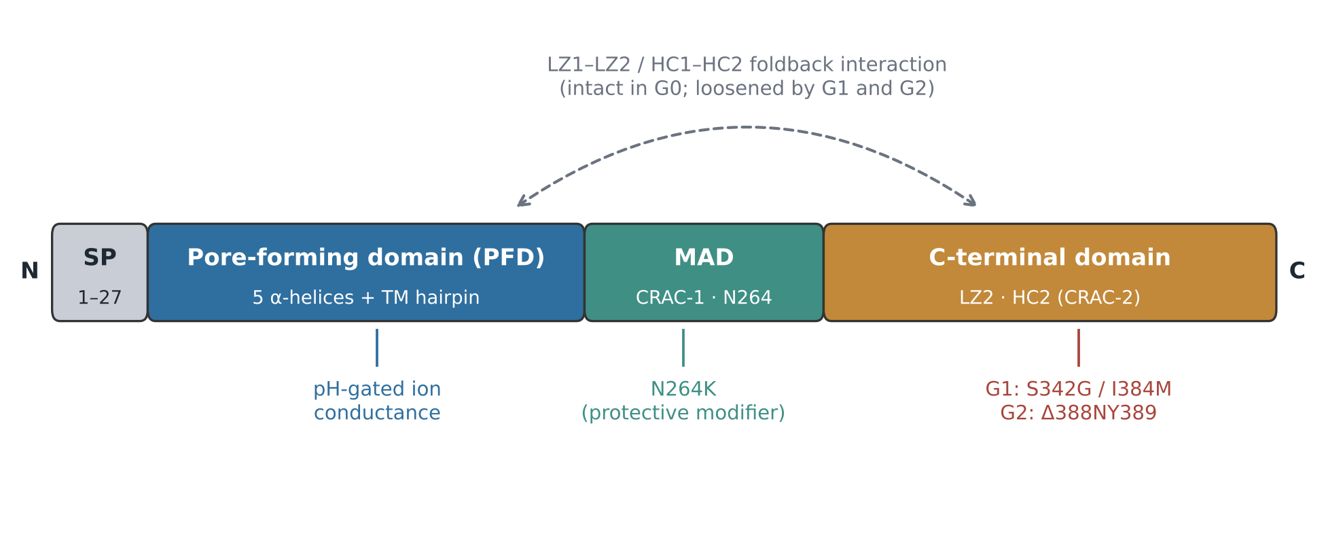
Figure 2. Domain organisation of APOL1 and the location of the disease-relevant variants. Schematic redrawn from the structural description given by Pays E, Cells 2024;13:1738 [2]; residue assignments for G1, G2 and N264K from Genovese et al. 2010 [1] and Gupta et al. 2023 [10]. SP, signal peptide; TM, transmembrane; LZ, leucine zipper; HC, hydrophobic cluster; CRAC, cholesterol recognition amino acid consensus motif; MAD, membrane-addressing domain.

4. Mechanisms of podocyte injury: four accounts and a dispute
The genetics have been settled for fifteen years; the mechanism has not. A large literature, much of it based on heterologous overexpression systems, has generated several candidate pathways that are not mutually exclusive but are weighted very differently by different groups. The disagreement is not academic: it determines which drug targets are credible.

4.1 Gain of function at the plasma membrane: cation flux
The dominant model holds that risk-variant APOL1 behaves as a toxic cation channel at the podocyte surface. Datta and colleagues, working across HEK293 cells, human urine-derived podocyte-like epithelial cells and podocytes from APOL1-G1 transgenic mice, showed that G1 drives sodium import and potassium efflux, which in turn activates G-protein-coupled receptor/IP3-mediated calcium release from the endoplasmic reticulum, impairs mitochondrial ATP production, and inhibits protein translation. Every one of these effects, up to and including podocyte injury and proteinuria in vivo, was reversed by the small-molecule APOL1 blocker VX-147 [4]. On this evidence the authors placed APOL1-mediated Na⁺/K⁺ transport as the proximal driver of disease.
More recent electrophysiology in HEK293 cells and human podocytes reinforces the channel model and refines it. Adebayo and colleagues found that APOL1 is transported in vesicle-like structures along actin filaments to the plasma membrane, where both G0 and the risk variants form voltage-dependent, non-selective cation-permeable pores active under basal conditions. In their hands the decisive ion was extracellular calcium entering through APOL1 itself, with risk variants showing greater basal channel activity than G0 and correspondingly greater cytotoxicity. Both the N264K variant and inaxaplin blocked that calcium influx and preserved viability [5].

4.2 The cholesterol counter-argument
Pays has mounted a sustained argument that the pore model cannot be right at the podocyte surface, and the objections are substantive [2, 3]. Transmembrane insertion of the pore-forming domain is strictly acid-dependent, and the extracellular face of the podocyte is not acidic. Antibody-accessibility experiments found that only the membrane-addressing domain, and not the pore-forming domain, was shielded at the podocyte surface — which is difficult to reconcile with the PFD being inserted through the bilayer. And the APOL1Δ truncation at V353, which is devoid of pore-forming activity, nonetheless produces a severe G1/G2-like podocyte phenotype, demonstrating that the phenotype can arise without a functioning pore [2].
In place of pore formation, Pays proposes that the loosened C-terminal foldback exposes CRAC-2, so that variant APOL1 binds cholesterol at the outer leaflet through two distant motifs simultaneously. Cholesterol clustering would then disturb the lipid raft microdomains in which podocin, nephrin and the mechanosensitive channels TRPC6 and BK are organised, secondarily activating those native channels and producing the observed cation fluxes without APOL1 ever forming a pore. The N264K result is marshalled as support: N264 lies beside CRAC-1 and is predicted to penetrate the outer membrane leaflet, so N264K should impair cholesterol binding — and it abolishes toxicity despite leaving the pore-forming domain intact [2, 10]. The model also accounts for why recruiting variant APOL1 to cholesterol-containing lipid droplets reduces its toxicity [7], and why toxicity requires high APOL1 with low HDL, conditions in which the protein is not sequestered.
The two models are not easily reconciled, and the field should be read with that in mind. Both predict toxic cation fluxes; both are consistent with inaxaplin working, since a compound that binds APOL1 and prevents its membrane interaction would block either mechanism. The discriminating experiments — direct demonstration of transmembrane PFD insertion at a neutral-pH cell surface, or of raft reorganisation preceding ion flux — have not yet been done decisively.

4.3 Mitochondrial dysfunction
Ma and colleagues examined primary renal tubule cells from 50 African American individuals and found that APOL1 genotype did not alter APOL1 expression globally, but that the SNP rs513349 adjacent to BAK1 acted as an expression quantitative trait locus for both BAK1 and APOL1, which were co-expressed. BAK1 knockout in podocytes diminished APOL1 protein. Functionally, mitochondria in G0/G0 tubule cells remained elongated under low-dose poly(I:C) stimulation, whereas G1/G1, G2/G2 and G1/G2 cells showed fragmentation; overexpression of G1 and G2 in HEK293 cells induced fission while G0 promoted fusion, and the fission inhibitor Mdivi-1 preserved viability and cristae structure [6].
The intracellular account developed by Pays converges on mitochondria from a different direction. Intracellular APOL1 associates with the trans-Golgi and endoplasmic reticulum and with non-muscle myosin 2A, and participates in ATG9A-vesicle traffic. Risk variants, through their increased hydrophobic-cluster exposure, bind and inactivate APOL3, which normally sequesters the phosphatidylinositol-4-kinase PI4KB at the Golgi. The resulting mislocalisation produces abortive mitochondrial fission and incomplete mitophagy even without inflammation [2, 3]. On this view mitochondrial dysfunction is downstream of a trafficking defect rather than of ion flux.

4.4 Inflammatory signalling and endoplasmic reticulum stress
Wakashin and colleagues identified an APOL1 RNA variant lacking a secretory signal sequence, encoding an isoform designated APOL1-B3 that is expressed in human podocytes in vivo. Transgenic mice carrying APOL1-B3 with the G2 risk variant showed podocyte injury, increased pro-IL-1β mRNA in isolated glomeruli, and increased IL-1β production in the remnant kidney after uninephrectomy. APOL1-B3 was found to interact with NLRP12, a regulator of Toll-like receptor signalling [8]. This places an inflammasome-adjacent pathway in the causal chain and may help explain why stress — here surgical reduction of nephron mass — unmasks the phenotype.

4.5 Lipid droplets and the recessive pattern
Chun and colleagues established APOL1 as a bona fide lipid-droplet protein. A large fraction of risk-variant APOL1 localises to the endoplasmic reticulum, while a significant proportion of G0 localises to lipid droplets. Loading cells with oleic acid to promote droplet formation shifted G1 and G2 from the ER to droplets, with reduced autophagic flux and reduced cytotoxicity. Strikingly, co-expression of G0 with risk-variant APOL1 recruited G1 and G2 from the ER to droplets and reduced cell death — which offers a plausible molecular explanation for why the disease is recessive, since a single G0 allele would suffice to sequester variant protein [7].

4.6 The second hit
No account of APOL1 disease is complete without the trigger. APOL1 is an interferon-inducible gene, and the most potent known susceptibility modifier is uncontrolled HIV-1 infection. APOL1 variants are associated with HIV-associated nephropathy (HIVAN), a podocyte disease, but not with HIV immune-complex disease, which is primarily mesangial — a specificity that argues for a genuine mechanistic interaction rather than a general effect of illness [11]. Two non-exclusive mechanisms have been proposed: HIV accessory proteins and APOL1 variants converging on the same intracellular pathways in podocytes, with roles suggested for IL-1β and transcription factor EB; and circulating interferon driving APOL1 transcription to levels at which the variant protein becomes toxic [11, 12]. Downregulation of miR-193a, a repressor of APOL1, has also been implicated [12].
The same logic extends beyond HIV to other viral infections and to interferon therapy, and it is the reason transgenic models typically require an interferon challenge to produce disease (Section 6). It also carries a clinical implication that is sometimes overlooked: if ongoing APOL1 expression is not driving injury in a given patient — for example in slowly progressive disease attributable to reduced nephron endowment rather than active podocyte toxicity — then an APOL1-directed drug may have little to act on [22].
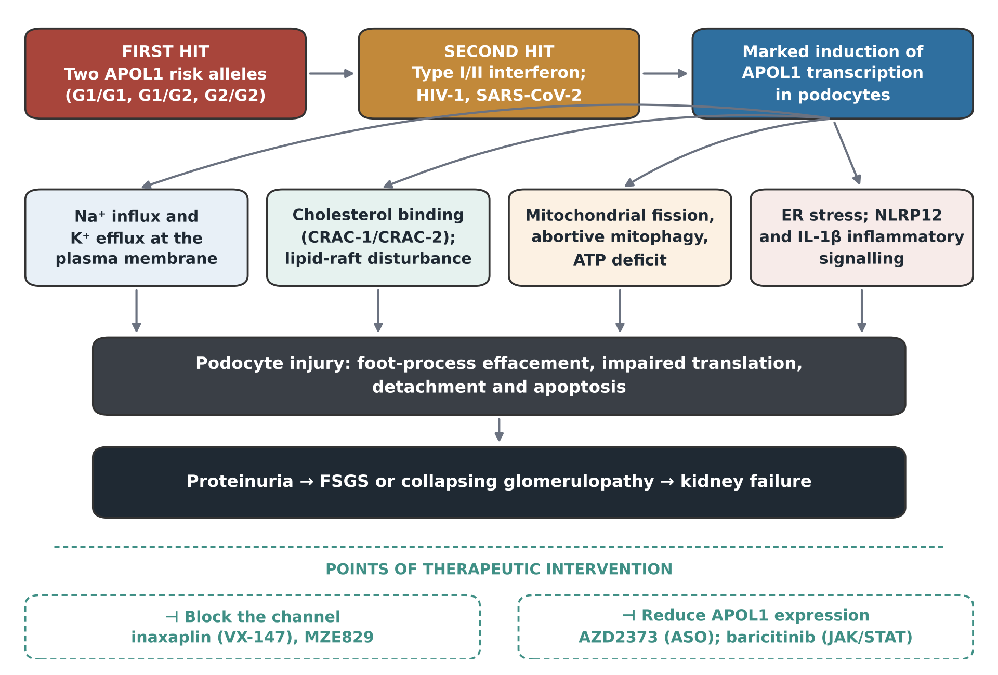
Figure 3. The two-hit model of APOL1 kidney disease and the mechanisms proposed to lie downstream of it. The four mechanistic boxes are candidate pathways reported by different groups, not an agreed sequence; Sections 4.1–4.4 set out where they conflict. Synthesised from Pays 2024 [2], Datta et al. 2024 [4], Adebayo et al. 2026 [5], Ma et al. 2020 [6], Wakashin et al. 2020 [8], and Kopp et al. 2017 [11]; therapeutic agents from the trial records listed in Table 4.
Proposed mechanism | Principal experimental evidence | Model system | Key source
Na⁺/K⁺ channel gain of function | G1 drives Na⁺ import and K⁺ efflux → GPCR/IP3 Ca²⁺ release → impaired mitochondrial ATP and translation; all reversed by VX-147 | HEK293; human urine-derived podocyte-like cells; G1 transgenic mouse podocytes | Datta et al., J Clin Invest 2024 [4]
Voltage-dependent cation pore with Ca²⁺ influx | APOL1 forms non-selective cation pores at the plasma membrane; risk variants show higher basal activity; blocked by N264K and by inaxaplin | HEK293 and human podocytes; patch clamp and microscopy | Adebayo et al., J Am Soc Nephrol 2026 [5]
Cholesterol binding and lipid-raft disturbance (no pore) | PFD insertion requires acidic pH absent extracellularly; PFD remains antibody-accessible at the cell surface; pore-dead APOL1Δ still produces the phenotype | Human podocytes; synthetic membranes; antibody accessibility | Pays, Cells 2024 [2]; J Am Soc Nephrol 2020 [3]
Mitochondrial fission | G1/G2 induce fragmentation where G0 promotes fusion; rescued by Mdivi-1; BAK1 eQTL co-regulates APOL1 | Primary renal tubule cells from 50 donors; HEK293 Tet-on | Ma et al., Kidney Int Rep 2020 [6]
Abortive mitophagy via APOL3 inactivation | Variant HC exposure sequesters APOL3, releasing PI4KB from the Golgi; mimics APOL3 knockout phenotype | Human podocytes; APOL1/APOL3 knockouts | Pays, Cells 2024 [2]
NLRP12 / IL-1β inflammatory signalling | APOL1-B3-G2 transgenic mice show podocyte injury and raised glomerular pro-IL-1β after uninephrectomy; APOL1-B3 binds NLRP12 | BAC-transgenic mice; human kidney | Wakashin et al., BMC Nephrol 2020 [8]
Lipid-droplet sequestration (protective) | Oleic acid shifts G1/G2 from ER to droplets, reducing toxicity; G0 recruits variant protein to droplets, suggesting why risk is recessive | HEK293; podocytes | Chun et al., PNAS 2019 [7]
Table 2. Competing and complementary mechanistic accounts of APOL1-mediated podocyte injury, with the experimental basis and model system for each. Note that most of these data come from overexpression systems, a limitation emphasised by Bruggeman et al. [9] and by Dogra et al. [18].

5. Clinical spectrum, pathology and transplantation

5.1 Phenotypes associated with the high-risk genotype
APOL1 kidney disease is not one clinical picture. At one extreme is a rapid, heavily proteinuric presentation, often triggered by viral infection and classified pathologically as collapsing FSGS — the lesion of classical HIVAN. At the other is an insidious, slowly progressive disease with modest proteinuria, loss of glomerular filtration rate over years, and varied histology [22]. The association with the high-risk genotype is robust and reproducible for FSGS, HIVAN and hypertension-attributed kidney failure, and remains inconsistent for diabetic kidney disease [18].
FSGS itself accounts for roughly 40% of adult and 20% of paediatric nephrotic syndrome globally, and APOL1 variants are a major contributor to the subset occurring in people of African ancestry [21]. Because genetic FSGS does not respond to the immunosuppression used for primary disease, and because an APOL1-directed therapy may become available, genotyping has moved from research tool toward clinical test — though current expert opinion holds that genotype-guided risk stratification is reasonable rather than proven, and that population-level screening is not yet supported [18].

5.2 Transplantation and living donation
The transplant setting isolates the donor kidney's genotype from the recipient's systemic environment, and the evidence there has been among the most consistent in the field. Kidneys from deceased donors of recent African ancestry show shorter allograft survival, and African American living donors more often progress to end-stage kidney disease. The NIH-sponsored APOLLO network was designed to test this prospectively, assessing allograft survival in some 2,614 deceased donor–recipient pairs plus living-donor pairs, as a function of donor and recipient APOL1 genotype, with participation from essentially all US transplant programmes and organ procurement organisations and with a community advisory council of African American individuals affected by kidney disease involved from inception [24].
Long-term outcome data in living donors have since been reported. Hsu and colleagues recontacted US living kidney donors who donated between 2000 and 2008 and conducted home-based research visits a median of 18.5 years after donation. Among 445 Black donors, 68 (15.3%) carried a high-risk genotype. Those donors had a higher risk of reaching an estimated GFR below 45 mL/min/1.73 m² than Black donors without a high-risk genotype (relative risk 2.31, 95% CI 1.16–4.61, P = 0.02), although after adjustment for pre-donation eGFR the association was attenuated and no longer statistically significant (RR 1.91, 95% CI 0.90–4.03, P = 0.09). The authors concluded that all Black living-donor candidates in the US should be offered APOL1 genotyping for risk stratification [23].

5.3 An alternative route to disease: nephron endowment
A hypothesis worth flagging because it cuts across the mechanistic debate concerns development rather than ongoing toxicity. APOL1 risk variants are associated not only with kidney disease but with pre-eclampsia and other conditions of placental insufficiency; these pregnancy complications frequently result in prematurity and low birth weight, both established risk factors for later hypertension and chronic kidney disease through reduced nephron endowment. Azhibekov and Bruggeman argue that some cases — particularly the insidious, slowly progressive forms that are hard to distinguish from the sequelae of prematurity — may reflect a developmental deficit laid down before birth rather than continuing APOL1-driven podocyte loss [22]. If so, those patients would not be expected to benefit from APOL1 inhibition, which has direct implications for how trials are enriched and interpreted.

6. Animal models and preclinical pharmacology
Many mechanisms have been reported in cell culture; comparatively few have been demonstrated in animals, and the gap is the single largest methodological weakness in the field [13]. Models span flies, zebrafish and mice, and the most informative have been bacterial artificial chromosome (BAC) transgenic mice carrying the human APOL1 locus with its native regulatory elements. These animals are typically healthy at baseline and require an interferon challenge — or crossing onto an HIV-transgenic background — to develop disease, which is itself a strong confirmation of the two-hit requirement [13, 14].
Yoshida and colleagues characterised two such models and found exacerbated glomerular disease in APOL1-G1 compared with APOL1-G0 mice in both. Transcriptomic profiling identified synergistic podocyte-damaging pathways activated by the G1 allele together with HIV transgenes, and revealed that the eukaryotic initiation factor 2 pathway was the most activated pathway in the interferon-γ model but the most deactivated in the HIVAN model — a reminder that the two clinical settings are not simply the same disease at different speeds. Podocyte expression profiles from the mouse models showed appreciable similarity to human FSGS data, and the transcription factor Nr4a1 was downregulated in podocytes and endothelial cells in both models, which the authors suggest may contribute to glucocorticoid resistance [14].
The most directly clinically relevant preclinical result concerns standard-of-care drugs. Sula Karreci and colleagues randomised proteinuric, plasmid-injected BAC-transgenic mice to lisinopril, dapagliflozin, hydralazine or no treatment [15]. The results, summarised in Table 3, were strikingly allele-specific.
Intervention | APOL1-G1/G1 mice | APOL1-G2/G2 mice | Interpretation
Lisinopril (ACE inhibitor), standard dose | Proteinuria reduced ~90-fold; glomerulosclerosis reduced; effect independent of blood pressure | Little benefit at standard dose | RAAS blockade is far more effective against G1- than G2-mediated disease in this model
Lisinopril, double dose | — | Proteinuria and glomerulosclerosis reduced, but benefit much smaller than in G1/G1 | G2 disease is relatively ACE-inhibitor resistant
Dapagliflozin (SGLT2 inhibitor) | No alteration in disease progression | No alteration in disease progression | No evidence of benefit in this model, despite SGLT2 inhibitors' broad efficacy in CKD generally
Hydralazine (blood-pressure control without RAAS blockade) | No protection despite comparable blood-pressure reduction | No protection | The lisinopril effect is not explained by blood pressure lowering
Table 3. Response of APOL1 BAC-transgenic mice to standard-of-care agents. Data from Sula Karreci E, Jacas S, Donovan O, et al., Kidney International 2024;106:1072–1085 [15]. The authors note it remains to be determined whether a similar G1/G2 difference in ACE-inhibitor responsiveness occurs in patients.
If this allele-specific difference holds in humans it would be consequential, because it implies that the two risk haplotypes are not interchangeable for treatment purposes even though they confer similar genetic risk — and that trials pooling G1 and G2 carriers may dilute or distort an effect.

7. Therapeutic development

7.1 Inaxaplin: proof of concept
Inaxaplin (VX-147) is a small molecule identified as an inhibitor of APOL1 channel function. Egbuna and colleagues reported the full translational sequence in a single paper: selective inhibition of APOL1 channel function in tetracycline-inducible HEK293 cells, reduction of proteinuria in an APOL1-G2-homologous transgenic mouse model, and then a single-group, open-label phase 2a study [16].
Sixteen participants with two APOL1 risk variants, biopsy-proven FSGS, a urinary protein-to-creatinine ratio between 0.7 and 10, and an estimated GFR of at least 27 mL/min/1.73 m² received inaxaplin daily for 13 weeks (15 mg for two weeks, then 45 mg for eleven) alongside standard care. Among the 13 participants meeting the 80% adherence threshold, the mean change from baseline in the urinary protein-to-creatinine ratio at week 13 was −47.6% (95% CI −60.0 to −31.3); similar reductions were seen in all but one participant when adherence was disregarded. Adverse events were mild or moderate and none led to discontinuation [16].
The accompanying correspondence was appropriately sceptical, and the caveats are worth stating plainly: the study was single-arm and open-label, with sixteen participants and thirteen weeks of follow-up, and proteinuria is a surrogate endpoint [17, 18]. A 47.6% reduction in UPCR is encouraging and consistent with the preclinical mechanism, but it is not evidence of preserved kidney function.
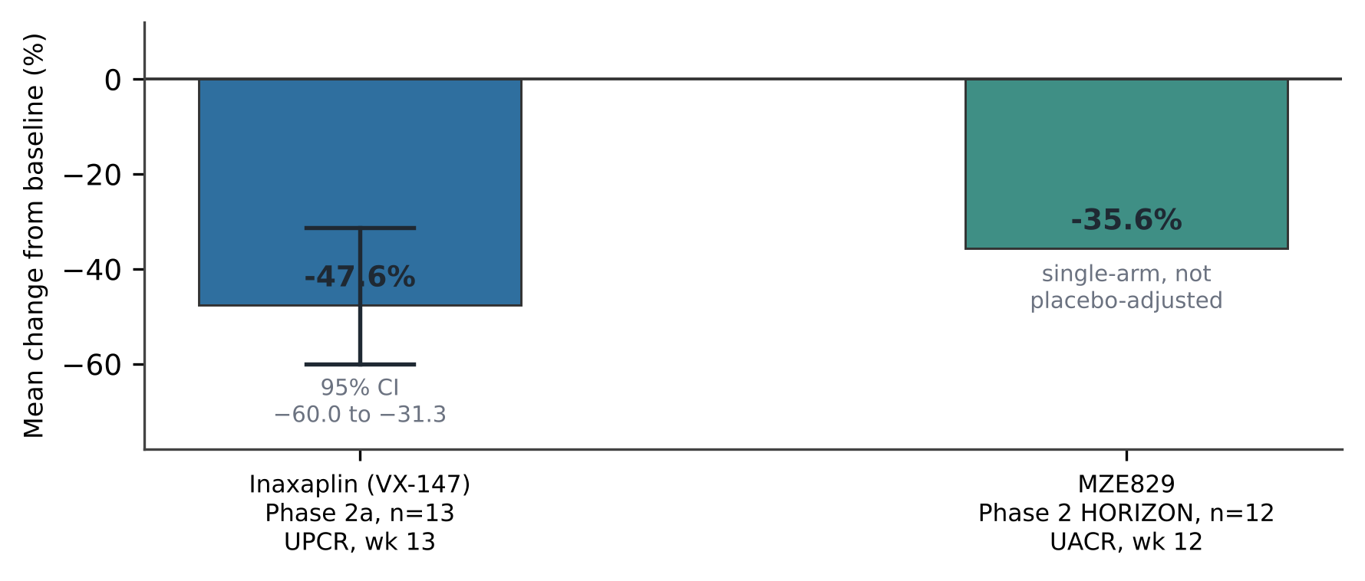
Figure 4. Reported surrogate-endpoint effects of the two APOL1-directed small molecules with published phase 2 data. Inaxaplin data from Egbuna et al., N Engl J Med 2023;388:969–979 [16]. MZE829 HORIZON data as reported in the narrative review by Dogra et al., Int Urol Nephrol 2026 [18]; HORIZON was a small open-label single-arm basket study whose primary endpoints were safety and tolerability, so its figure is neither placebo-adjusted nor the product of a formal efficacy test. Neither agent has yet shown benefit on a hard kidney endpoint.

7.2 The current trial landscape
Four mechanistically distinct strategies are now in clinical testing: direct channel blockade, antisense knockdown of APOL1 transcript, interruption of the interferon signalling that induces APOL1, and genotyping assays to identify the treatable population. Table 4 lists the registered studies retrieved from ClinicalTrials.gov.
Agent / study | NCT number | Phase, sponsor | Status | Design and current position
Inaxaplin (VX-147)  phase 2a | NCT04340362 | Phase 2  Vertex | Completed | Open-label, single-arm, 16 adults with APOL1-mediated FSGS; UPCR −47.6% at week 13 [16].
Inaxaplin  AMPLITUDE | NCT05312879 | Phase 2/3  Vertex | Recruiting | Adaptive, double-blind, placebo-controlled, 466 adult and paediatric participants with APOL1-mediated proteinuric kidney disease; started March 2022, primary completion listed for June 2028. A pre-specified week-48 interim analysis is anticipated in early 2027 [18].
Inaxaplin  phase 2b | NCT06794996 | Phase 2  Vertex | Completed | Open-label, 42 participants with proteinuric APOL1-mediated kidney disease with or without comorbidities that may independently contribute to CKD.
VX-840 | NCT05324410 | Phase 1  Vertex | Completed | Randomised, double-blind, placebo-controlled single- and multiple-ascending-dose study in 88 healthy subjects.
MZE829  HORIZON | NCT06830629 | Phase 2  Maze Therapeutics | Recruiting | Open-label, planned 74 adults with proteinuric CKD and the APOL1 high-risk genotype; safety, tolerability and effect on albuminuria.
AZD2373  APPRECIATE | NCT06824987 | Phase 2b  AstraZeneca | Active, not recruiting | Antisense oligonucleotide. Randomised, double-blind, placebo-controlled dose-ranging study, 57 participants with APOL1-mediated kidney disease.
Baricitinib | NCT05237388 | Phase 2  Duke University | Completed | JAK–STAT inhibition to reduce APOL1-associated kidney disease; randomised against placebo, 8 participants — a mechanistic rather than efficacy study.
APOL1 genotyping assay | NCT06839833 | N/A  Almac Diagnostic Services | Recruiting | Prospective study of a companion genotyping assay in 2,000 participants; a prerequisite for deploying genotype-directed therapy at scale.
Table 4. Registered clinical studies of APOL1-directed interventions. Study identifiers, phase, sponsor, status, enrolment and dates retrieved from ClinicalTrials.gov (accessed 5 October 2026); outcome data for NCT04340362 from Egbuna et al. [16]; AMPLITUDE interim-analysis timing as reported by Dogra et al. [18].

7.3 Standard of care in the meantime
Management remains supportive and non-specific: renin–angiotensin system blockade, blood-pressure control, and the general CKD armamentarium. The mouse data discussed in Section 6 raise the possibility that ACE inhibition is substantially more effective in G1 than in G2 disease, and that SGLT2 inhibition — which has transformed outcomes in CKD broadly — may not add benefit in this particular pathology [15]. Neither inference has been tested in patients, and neither should change practice yet.

8. Open questions
Five problems stand between the current state of the field and a mature precision therapy.
What is the proximal injury mechanism? The channel and cholesterol models make different predictions and imply different second-generation drug targets. Settling this requires experiments at physiological expression levels in authentic podocytes, not in overexpression systems — a limitation that Bruggeman and colleagues identified years ago and that has still not been fully overcome [9, 2, 5].
What determines penetrance? N264K explains part of the variance in G2-containing genotypes, and interferon-inducing infections explain another part, but most high-risk individuals never develop nephropathy and we cannot currently tell which ones will [10, 18].
Is there a validated progression biomarker? There is not. Proteinuria is the operative surrogate, and the relationship between early proteinuria reduction and preserved GFR in this specific disease is assumed rather than demonstrated [18].
Can the common slowly progressive phenotype be modelled? Existing animal models produce acute, interferon-driven, heavily proteinuric disease. No model reproduces the insidious form that probably accounts for most of the population burden [13, 18, 22].
What are the consequences of chronic APOL1 inhibition? Natural APOL1-null individuals appear broadly healthy apart from susceptibility to trypanosomes, which is reassuring. But APOL1 has a role in inflammation-induced mitophagy, and its loss in renal carcinoma cells causes severe mitochondrial dysfunction; the effect of years of pharmacological inhibition on responses to viral infection is unknown [2].

9. Conclusion
APOL1 is the field's best demonstration that a health disparity can have a tractable molecular explanation. A gene that made humans resistant to a lethal parasite was pushed to high frequency by that advantage, and the same structural change that defeats the parasite's countermeasure destabilises the protein in a way that, under inflammatory stress, kills podocytes. The genetics are unambiguous, the evolutionary account is coherent, and within fifteen years of the association being reported a drug designed against the inferred mechanism reduced proteinuria in the right patients.
The caution is equally clear. Most of the mechanistic literature rests on overexpression, the two leading models of proximal injury contradict each other on a basic point of membrane biochemistry, penetrance is unexplained, and every APOL1-directed agent so far is supported only by short-term surrogate data in small, single-arm studies. AMPLITUDE, with 466 participants, placebo control and a week-48 interim analysis expected in 2027, is the trial that will determine whether this becomes the first genotype-directed therapy in glomerular disease or a well-reasoned mechanism that failed at the only endpoint that matters.

References
Bibliographic records for references 1–24 were retrieved from PubMed and PubMed Central; references 25–32 are study records retrieved from ClinicalTrials.gov.
1. Genovese G, Friedman DJ, Ross MD, et al. Association of trypanolytic ApoL1 variants with kidney disease in African Americans. Science. 2010;329(5993):841–845. doi:10.1126/science.1193032. PMID: 20647424.
2. Pays E. Apolipoprotein-L1 (APOL1): From Sleeping Sickness to Kidney Disease. Cells. 2024;13(20):1738. doi:10.3390/cells13201738. PMID: 39451256.
3. Pays E. The Mechanism of Kidney Disease Due to APOL1 Risk Variants. J Am Soc Nephrol. 2020;31(11):2502–2505. doi:10.1681/ASN.2020070954. PMID: 32943491.
4. Datta S, Antonio BM, Zahler NH, et al. APOL1-mediated monovalent cation transport contributes to APOL1-mediated podocytopathy in kidney disease. J Clin Invest. 2024;134(5):e172262. doi:10.1172/JCI172262. PMID: 38227370.
5. Adebayo OC, Dallali I, Kerselaers S, et al. Expression of Apolipoprotein L1 Risk Variants at the Plasma Membrane and Haplotype-Dependent Cytotoxicity. J Am Soc Nephrol. Published online 15 June 2026. doi:10.1681/ASN.0000001159. PMID: 42295851.
6. Ma L, Ainsworth HC, Snipes JA, et al. APOL1 Kidney-Risk Variants Induce Mitochondrial Fission. Kidney Int Rep. 2020;5(6):891–904. doi:10.1016/j.ekir.2020.03.020. PMID: 32518871.
7. Chun J, Zhang J-Y, Wilkins MS, et al. Recruitment of APOL1 kidney disease risk variants to lipid droplets attenuates cell toxicity. Proc Natl Acad Sci U S A. 2019;116(9):3712–3721. doi:10.1073/pnas.1820414116. PMID: 30733285.
8. Wakashin H, Heymann J, Roshanravan H, et al. APOL1 renal risk variants exacerbate podocyte injury by increasing inflammatory stress. BMC Nephrol. 2020;21(1):371. doi:10.1186/s12882-020-01995-3. PMID: 32854642.
9. Bruggeman LA, O'Toole JF, Sedor JR. APOL1 polymorphisms and kidney disease: loss-of-function or gain-of-function? Am J Physiol Renal Physiol. 2019;316(1):F1–F8. doi:10.1152/ajprenal.00426.2018. PMID: 30332315.
10. Gupta Y, Friedman DJ, McNulty MT, et al. Strong protective effect of the APOL1 p.N264K variant against G2-associated focal segmental glomerulosclerosis and kidney disease. Nat Commun. 2023;14(1):7836. doi:10.1038/s41467-023-43020-9. PMID: 38036523.
11. Kopp JB, Heymann J, Winkler CA. APOL1 Renal Risk Variants: Fertile Soil for HIV-Associated Nephropathy. Semin Nephrol. 2017;37(6):514–519. doi:10.1016/j.semnephrol.2017.07.004. PMID: 29110758.
12. Goyal R, Singhal PC. APOL1 risk variants and the development of HIV-associated nephropathy. FEBS J. 2021;288(19):5586–5597. doi:10.1111/febs.15677. PMID: 33340240.
13. Yoshida T, Latt KZ, Heymann J, Kopp JB. Lessons From APOL1 Animal Models. Front Med (Lausanne). 2021;8:762901. doi:10.3389/fmed.2021.762901. PMID: 34765626.
14. Yoshida T, Latt KZ, Santo BA, et al. APOL1 kidney risk variants in glomerular diseases modeled in transgenic mice. bioRxiv. Preprint posted 27 March 2023. doi:10.1101/2023.03.27.534273. PMID: 37090576. [Preprint — not peer reviewed at the time of posting.]
15. Sula Karreci E, Jacas S, Donovan O, et al. Differing sensitivities to angiotensin converting enzyme inhibition of kidney disease mediated by APOL1 high-risk variants G1 and G2. Kidney Int. 2024;106(6):1072–1085. doi:10.1016/j.kint.2024.07.026. PMID: 39181397.
16. Egbuna O, Zimmerman B, Manos G, et al. Inaxaplin for Proteinuric Kidney Disease in Persons with Two APOL1 Variants. N Engl J Med. 2023;388(11):969–979. doi:10.1056/NEJMoa2202396. PMID: 36920755.
17. Soler MJ, Glassock RJ, Fervenza FC. Inaxaplin for Proteinuric Kidney Disease in Persons with Two APOL1 Variants [letter]. N Engl J Med. 2023;388(26):2490. doi:10.1056/NEJMc2304780. PMID: 37379147. [See also the authors' reply: Egbuna O, Chertow GM. N Engl J Med. 2023;388(26):2491. PMID: 37379148.]
18. Dogra N, Baranwal M, Ahmad S, Kumar P, Ashawat MS. APOL1 kidney disease: a critical narrative review of molecular mechanisms, clinical heterogeneity, and the emerging therapeutic landscape. Int Urol Nephrol. Published online 8 September 2026. doi:10.1007/s11255-026-05380-1. PMID: 42709370.
19. Srinivasan V, So PN, Kwakyi EPK, Lerma EV, Wiegley N. APOL1-Mediated Kidney Disease: A Review and Look Toward the Future. Kidney Med. 2025;7(9):101062. doi:10.1016/j.xkme.2025.101062. PMID: 40837248.
20. Bonilla M, Efe O, Selvaskandan H, Lerma EV, Wiegley N. A Review of Focal Segmental Glomerulosclerosis Classification With a Focus on Genetic Associations. Kidney Med. 2024;6(6):100826. doi:10.1016/j.xkme.2024.100826. PMID: 38765809.
21. Waheed A, Gul MH, Naeem R, et al. Clinical implications of apolipoprotein L1 testing in patients with focal segmental glomerulosclerosis: a review of diagnostic and prognostic implications. Ann Med Surg (Lond). 2025;87(3):1543–1551. doi:10.1097/MS9.0000000000003051. PMID: 40213244.
22. Azhibekov T, Bruggeman LA. Insidious APOL1 Kidney Disease: A Manifestation of APOL1-Associated Pregnancy Complications on Nephron Endowment? Cells. 2025;14(17):1373. doi:10.3390/cells14171373. PMID: 40940784.
23. Hsu C-Y, Gao Y, Freedman BI, et al. Apolipoprotein L1 Gene Genotype and Kidney Outcomes After Living Kidney Donation. JAMA Intern Med. 2026;186(8):943–950. doi:10.1001/jamainternmed.2026.0996. PMID: 42329639.
24. Freedman BI, Moxey-Mims MM, Alexander AA, et al. APOL1 Long-term Kidney Transplantation Outcomes Network (APOLLO): Design and Rationale. Kidney Int Rep. 2019;5(3):278–288. doi:10.1016/j.ekir.2019.11.022. PMID: 32154449.
25. ClinicalTrials.gov. NCT04340362 — A Phase 2a, Open-label, Single-arm, 2-Part Study to Evaluate the Efficacy, Safety, and Pharmacokinetics of VX-147 in Adults With APOL1-mediated Focal Segmental Glomerulosclerosis. Vertex Pharmaceuticals. Accessed 5 October 2026.
26. ClinicalTrials.gov. NCT05312879 — A Phase 2/3 Adaptive, Double-blind, Placebo-Controlled Study to Evaluate the Efficacy and Safety of VX-147 in Adult and Pediatric Subjects With APOL1-mediated Proteinuric Kidney Disease (AMPLITUDE). Vertex Pharmaceuticals. Accessed 5 October 2026.
27. ClinicalTrials.gov. NCT06794996 — A Phase 2b, Open-label Study to Evaluate the Efficacy and Safety of Inaxaplin in Subjects With Proteinuric APOL1-mediated Kidney Disease With or Without Comorbidities. Vertex Pharmaceuticals. Accessed 5 October 2026.
28. ClinicalTrials.gov. NCT05324410 — A Phase I, Randomized, Double-blind, Placebo-controlled Study Evaluating the Safety and Pharmacokinetics of Single and Multiple Ascending Doses of VX-840 in Healthy Subjects. Vertex Pharmaceuticals. Accessed 5 October 2026.
29. ClinicalTrials.gov. NCT06830629 — An Open-Label Phase 2 Study to Evaluate the Safety, Tolerability, and Effect on Albuminuria of MZE829 in Adults With Proteinuric Chronic Kidney Disease and the APOL1 High Risk Genotype. Maze Therapeutics. Accessed 5 October 2026.
30. ClinicalTrials.gov. NCT06824987 — Phase 2b Multicentre, Randomized, Double-Blind, Placebo-Controlled, Parallel Group Dose-Ranging Study to Assess the Efficacy, Safety, and Tolerability of AZD2373 in Participants With APOL1-Mediated Kidney Disease (APPRECIATE). AstraZeneca. Accessed 5 October 2026.
31. ClinicalTrials.gov. NCT05237388 — Janus Kinase-STAT Inhibition to Reduce APOL1 Associated Kidney Disease. Duke University. Accessed 5 October 2026.
32. ClinicalTrials.gov. NCT06839833 — A Prospective, Interventional Study to Assess the Clinical Performance of the APOL1 Genotyping Clinical Trial Assay in the Intended Use Population and Environment. Almac Diagnostic Services. Accessed 5 October 2026.

