The Latent HIV-1 Reservoir: Molecular Architecture of Proviral Silencing, Clonal Persistence, and the Path to a Cure
A Review of Current Evidence in Virology and Translational HIV Cure Research

Weekly Science Review
Subfield: Virology / Infectious Disease Immunology
14 September 2026

Abstract
Antiretroviral therapy (ART) suppresses HIV-1 replication to below the limit of clinical detection but does not eliminate the virus. A small, durable population of CD4+ T cells carrying integrated, replication-competent proviral DNA — the latent reservoir — survives indefinitely on therapy and drives rebound viraemia within weeks of treatment interruption. Over the past decade, the conceptual model of this reservoir has shifted substantially. Assays that discriminate intact from defective proviruses have shown that the overwhelming majority of integrated genomes are irreparably damaged, and that the clinically relevant intact fraction decays with multiphasic kinetics that slow markedly after roughly seven years of suppression. In parallel, integration-site mapping has revealed that intact proviruses are not randomly distributed: those that survive longest on ART are disproportionately located in heterochromatic compartments, including centromeric satellite DNA and KRAB-domain zinc-finger genes on chromosome 19, a configuration that is especially pronounced in elite controllers. Persistence is sustained less by ongoing replication than by antigen-driven and homeostatic proliferation of infected memory CD4+ T cells, which copies proviruses without exposing them to the mutational pressure of reverse transcription.
This review synthesises the molecular and clinical evidence underpinning this revised model. We outline the virological background and the assays that define reservoir size; examine the epigenetic and genomic determinants of proviral silencing; analyse clonal expansion as the dominant maintenance mechanism; and evaluate the four principal therapeutic strategies now in clinical development — shock-and-kill, block-and-lock, immune-based remission with long-acting broadly neutralising antibodies, and cell or gene therapy targeting CCR5. Latency-reversing agents have reliably induced viral transcription in clinical studies but have not meaningfully reduced reservoir size, whereas combination broadly neutralising antibodies have maintained ART-free virological suppression for up to 43 weeks in carefully selected participants. Documented cures following CCR5Δ32/Δ32 allogeneic haematopoietic stem-cell transplantation establish proof of principle but are not scalable. We conclude by identifying the open questions most likely to determine whether a scalable functional cure is achievable: the anatomical and phenotypic distribution of the rebound-competent reservoir, the biological basis of the decay inflection, and the absence of a validated surrogate endpoint that can replace analytical treatment interruption.
Keywords: HIV-1; latent reservoir; proviral latency; chromatin; clonal expansion; intact proviral DNA assay; broadly neutralising antibodies; HIV cure; analytical treatment interruption; CCR5Δ32

Contents

1. Introduction
Combination antiretroviral therapy has transformed HIV-1 infection from a uniformly fatal illness into a manageable chronic condition. Contemporary regimens suppress plasma viraemia below 50 copies per millilitre in the great majority of adherent individuals, restore CD4+ T cell counts, and reduce the risk of onward sexual transmission to effectively zero. What ART does not do is cure. When treatment is stopped, plasma virus almost invariably returns within two to four weeks, drawn from a source that has been replenished neither by drug-resistant replication nor by continuous rounds of new infection.
The existence of that source was demonstrated in 1997, when replication-competent virus was recovered from resting CD4+ T cells of individuals who had been virologically suppressed for up to thirty months. The frequency of such cells was low — between 0.2 and 16.4 per million resting CD4+ T cells — and, critically, it did not decline with increasing time on therapy, and the recovered viruses did not carry the resistance mutations that ongoing replication under drug pressure would have produced (Finzi et al., 1997). Longer follow-up quantified the problem: across individuals with no detectable viraemia for as long as seven years, the reservoir decayed with a half-life of approximately 44 months, implying that eradication by ART alone would require more than six decades of uninterrupted treatment (Siliciano et al., 2003).
Those two papers defined the central obstacle in HIV medicine and set the research agenda for the following twenty-five years. What has changed since is not the conclusion but the resolution at which the reservoir can be interrogated. Near-full-length proviral sequencing, integration-site mapping, single-provirus transcriptional profiling, and assays that separately quantify intact and defective genomes have collectively replaced a black-box "reservoir" with a structured and heterogeneous population of infected cells whose survival is governed by identifiable genomic, epigenetic, and immunological rules. This review examines that structure and asks what it implies for cure strategies now entering clinical testing.

2. Biological Background

2.1 The HIV-1 replication cycle and the origin of latency
HIV-1 is an enveloped lentivirus with a positive-sense, single-stranded RNA genome of roughly 9.7 kilobases. Entry into a target cell requires sequential engagement of CD4 by the viral envelope glycoprotein gp120 and of a chemokine co-receptor, most commonly CCR5 in transmitted founder viruses and CXCR4 in some later-emerging variants. Fusion delivers the viral core into the cytoplasm, where reverse transcriptase converts the RNA genome into double-stranded DNA. The resulting pre-integration complex traffics to the nucleus, and the viral integrase enzyme covalently inserts the proviral DNA into host chromatin.
Integration is not random. Lens epithelium-derived growth factor (LEDGF/p75) tethers the integrase complex to the bodies of actively transcribed genes, so that the initial integration-site distribution is strongly biased toward transcriptionally permissive euchromatin. Once integrated, the provirus is a permanent feature of the host cell genome and is replicated with it at every cell division.
Latency arises when an infected cell survives the productive phase of infection and reverts to a quiescent memory state, or when a resting cell is infected directly. In that state the proviral long terminal repeat is transcriptionally inactive — silenced by nucleosome positioning, repressive histone modifications, DNA methylation, sequestration of host transcription factors such as NF-κB in the cytoplasm, and the absence of the viral transactivator Tat needed to break transcriptional elongation blocks. The infected cell expresses no viral antigen, presents no target for cytotoxic T lymphocytes or antibodies, and is entirely invisible to antiretroviral drugs, which act only on steps of the replication cycle that a silent provirus does not perform.

2.2 Intact versus defective proviruses
A crucial complication is that most integrated proviruses cannot produce infectious virus. Error-prone reverse transcription, template switching, and the antiviral cytidine deaminase APOBEC3G generate large internal deletions, packaging-signal losses, and G-to-A hypermutation. The practical consequence is that simple polymerase chain reaction assays for proviral DNA overestimate the clinically relevant reservoir by one to two orders of magnitude, while quantitative viral outgrowth assays — which score only proviruses induced to produce virus after a single round of T cell activation — underestimate it, because a single stimulation does not induce every intact provirus.
The intact proviral DNA assay (IPDA) resolved this discrepancy by using multiplexed droplet digital PCR at two independent genomic positions to distinguish intact from defective genomes at scale (Bruner et al., 2019). The assay demonstrated that cells carrying intact and defective proviruses have distinct dynamics both in vitro and in vivo — the first direct evidence that the two populations are under different selective pressures — and it has since become the standard readout for interventional cure trials.
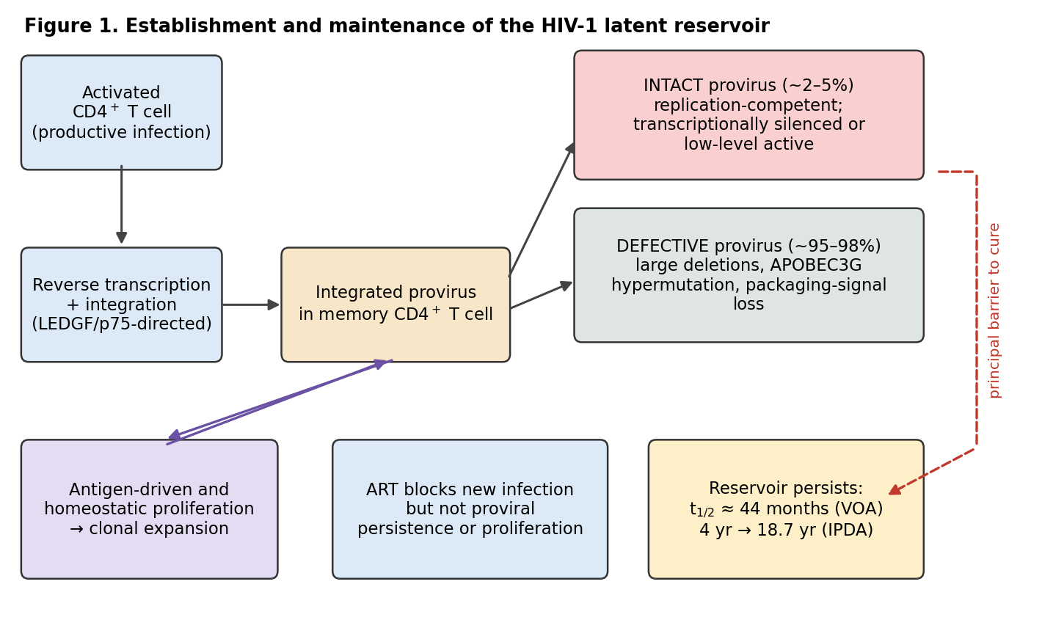
Figure 1. Establishment and maintenance of the HIV-1 latent reservoir. Schematic prepared by the authors from data reported in Finzi et al. (1997), Siliciano et al. (2003), Bruner et al. (2019), and Peluso et al. (2020). Following reverse transcription and LEDGF/p75-directed integration, the provirus persists in a memory CD4+ T cell. The great majority of integrated genomes are defective; the small intact fraction is replication-competent and constitutes the principal barrier to cure. Antiretroviral therapy blocks new rounds of infection but does not prevent survival or proliferation of already-infected cells.
Table 1. Assays used to quantify the HIV-1 reservoir, with their characteristic biases.
Assay | What it measures | Direction of bias | Principal source
Quantitative viral outgrowth assay (QVOA) | Resting CD4+ T cells releasing infectious virus after one round of T cell activation | Underestimates — a single stimulation does not induce every intact provirus | Finzi et al. 1997; Siliciano et al. 2003
Total HIV-1 DNA by PCR | All integrated proviral genomes regardless of transcriptional or genetic status | Overestimates by 1–2 orders of magnitude — most proviruses are defective | Bruner et al. 2019
Intact proviral DNA assay (IPDA) | Intact versus defective proviruses, by multiplexed droplet digital PCR at two genomic positions | Closest available approximation; cannot determine inducibility | Bruner et al. 2019
Near-full-length sequencing with integration-site mapping | Proviral sequence plus chromosomal position and chromatin context | Low throughput; requires large cell inputs | Jiang et al. 2020; Einkauf et al. 2022
Analytical treatment interruption (ATI) | Time to plasma viral rebound after stopping ART | Definitive readout of ART-free control, but carries clinical and transmission risk | Sneller et al. 2022; Lee et al. 2022
Compiled from Finzi et al. (1997), Siliciano et al. (2003), and Bruner et al. (2019).

3. Reservoir Dynamics on Suppressive Therapy

3.1 Multiphasic decay of intact proviruses
Applying the IPDA to a cohort of 81 adults followed for a median of 7.3 years produced a decay profile that differed sharply from the flat, single-exponential picture inherited from the outgrowth-assay era. Intact proviruses declined by 15.7% per year (95% CI −22.8% to −8.0%) from the point of initial suppression through year seven, corresponding to a half-life of 4.0 years; after year seven the decline slowed to 3.6% per year (95% CI −8.1% to +1.1%), a half-life of 18.7 years whose confidence interval includes no decay at all. Intact proviruses declined significantly faster than defective ones (P < 0.001), and the rate of early decline was greater in individuals with higher CD4+ T cell nadirs (Peluso et al., 2020).
The inflection is the most consequential feature of this curve. Early decay is compatible with immune clearance of infected cells that express viral antigen, but the near-plateau after year seven implies that whatever population remains is either immunologically invisible or is being replaced as fast as it is lost. Comparable kinetics were observed in a controlled non-human primate model: intact simian immunodeficiency virus genomes in macaques starting ART approximately one year after infection showed triphasic decay, reaching a stable third phase after 1.6 to 2.9 years, while hypermutated proviruses decayed with bi- or mono-phasic kinetics, consistent with the two populations facing different selective pressures. That study also showed that cells continue to enter the reservoir throughout untreated infection, rather than being seeded only at a single early time point (Fray et al., 2023).
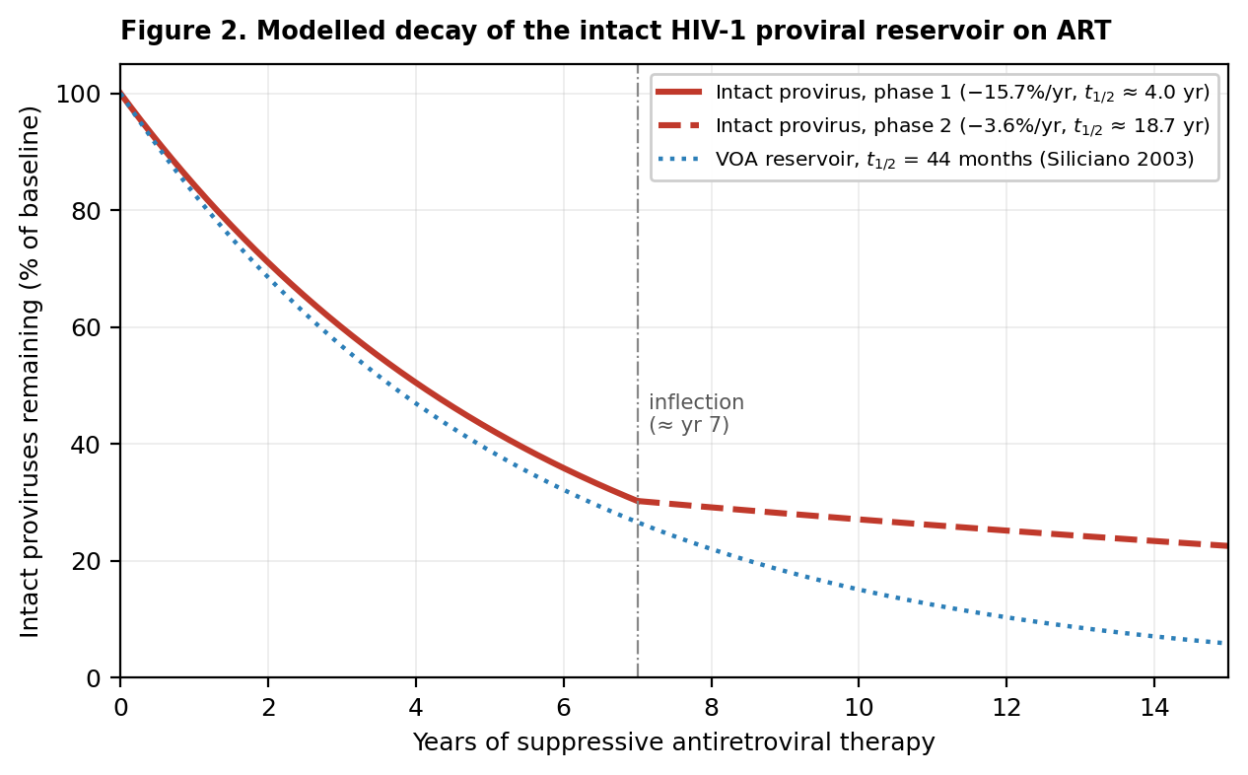
Figure 2. Modelled decay of the intact HIV-1 proviral reservoir during suppressive antiretroviral therapy. Curves were computed by the authors from the published decay parameters of Peluso et al. (2020) — 15.7% per year to year 7, 3.6% per year thereafter — and from the 44-month reservoir half-life reported by Siliciano et al. (2003) using the quantitative viral outgrowth assay. The plateau after the year-7 inflection indicates that the residual intact reservoir is largely refractory to ongoing immune clearance.

3.2 Clonal proliferation as the engine of persistence
If the reservoir is not replenished by ongoing replication, what maintains it? The answer is cell division. Memory CD4+ T cells are long-lived and divide in response to cognate antigen and to homeostatic cytokines. When such a cell carries an integrated provirus, division produces two infected daughter cells, each with the provirus at the identical chromosomal position. Because this route of replication uses host DNA polymerase rather than reverse transcriptase, it copies the provirus with high fidelity and without exposing it to antiretroviral drugs.
Longitudinal analysis of 661 near-full-length proviral sequences from eight individuals sampled seven years apart found slow decay of intact proviruses with no change in the proportional representation of the various classes of defective provirus. Intact proviruses were found in expanded clones at a frequency similar to that of defective proviruses, and — contrary to expectation — intact proviruses in clones did not show more escape from cytotoxic T lymphocyte epitopes than intact proviruses found as singletons. Three natural controllers on ART, included precisely because they mount strong HIV-specific CTL responses, had a smaller proportion of intact proviruses but an otherwise similar distribution of defect types and epitope escape. The authors concluded that CTL selection does not substantially restrain clonal proliferation or reshape the proviral landscape in treated individuals (Antar et al., 2020).
A barcoded-virus system in humanised mice allowed this process to be tracked directly. Recovery of 890 viral RNA barcodes and 504 proviral barcodes linked to 15,305 integration sites showed that the proviral reservoir retains genetic diversity despite clonal proliferation, that proviruses associated with transcriptional activity and viraemia are preferentially eliminated among non-proliferated clones, and that this elimination is much less effective among proliferated clones. Proliferated — but not massively expanded — clones made the dominant contribution to proviral expansion and viraemia (Zhang et al., 2025).

4. The Genomic and Epigenetic Architecture of Latency

4.1 Integration site as a determinant of proviral fate
Because integration is LEDGF/p75-directed toward active genes, the proviruses present shortly after infection sit predominantly in euchromatin. The proviruses that survive years of therapy do not. This divergence between the initial and the persisting integration-site distribution is now one of the best-supported findings in the field, and it implies an active selection process operating over the course of treated infection.
The clearest demonstration came from elite controllers — the fewer than 0.5% of infected individuals who maintain undetectable viraemia without therapy. Near-full-length single-genome sequencing with matched chromosomal integration-site analysis showed that their proviral reservoirs frequently consist of oligoclonal to near-monoclonal clusters of intact sequences integrated at highly distinct genomic positions: preferentially in centromeric satellite DNA or in KRAB-domain-containing zinc-finger genes on chromosome 19, both heterochromatic. Intact proviruses in controllers lay further from transcription start sites and from accessible chromatin than those in ART-treated individuals and were enriched for repressive chromatin marks. In one controller, no intact provirus could be detected despite analysis of more than 1.5 billion peripheral blood mononuclear cells (Jiang et al., 2020).
The same architectural signature appears, less completely, in treated individuals. Analysis of integration sites of near-full-length genomes from people on long-term ART whose reservoirs are highly clonal found that intact proviruses in expanded CD4+ T cell clones were preferentially integrated within KRAB-ZNF genes. These genes are associated with heterochromatin in memory CD4+ T cells yet are expressed under steady-state conditions; notably, ZNF genes carrying clonal intact integrations were down-regulated upon cellular activation, whereas genes carrying unique integrations were not. Certain genomic sites therefore appear especially permissive for maintaining latency through rounds of memory T cell expansion (Huang et al., 2021).

4.2 Transcriptional activity and selection against expression
The word "latent" implies complete transcriptional silence, but this is an oversimplification. An assay profiling the transcriptional activity and chromosomal location of individual proviruses in parallel produced a genome-wide map of transcriptionally active and silent proviral species and followed their evolution during suppressive ART. Proviral transcriptional activity tracked with activating epigenetic features both in linear proximity to the integration site and in its inter- and intrachromosomal contact regions. Transcriptionally active proviruses were actively selected against over prolonged therapy — but this pattern was violated by large clones of infected cells, which appear able to outcompete negative selection through elevated intrinsic proliferative activity (Einkauf et al., 2022).
This reconciles several otherwise-puzzling observations. Selection against expression explains the drift of surviving intact proviruses into heterochromatin and the early phase of reservoir decay; the ability of large clones to escape that selection explains the plateau. Consistent with this, a study of immune-selection signatures found that in elite controllers defective proviruses were commonly located in permissive genic euchromatin while autologous intact proviruses were frequently in heterochromatin — indicating differential immune pressure on the two populations. Both intact and defective proviruses from controllers showed reduced frequencies of escape mutations in CTL epitopes and antibody contact regions relative to ART-treated individuals, plausibly because a small and poorly inducible reservoir generates too little antigen to drive escape. Approximately 15% of controllers harboured deletions in intact proviruses (Lian et al., 2021).
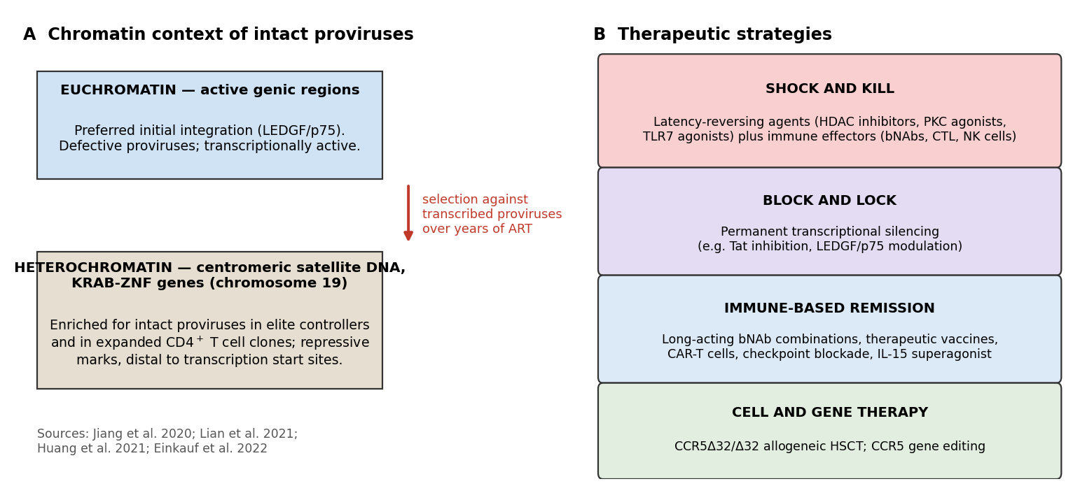
Figure 3. Chromatin context of persisting intact proviruses (A) and the four principal classes of therapeutic strategy under clinical investigation (B). Panel A summarises findings reported in Jiang et al. (2020), Lian et al. (2021), Huang et al. (2021), and Einkauf et al. (2022); panel B summarises the strategy classes discussed in Section 5. Figure prepared by the authors.
A complementary line of work has examined whether integration-site selection itself is a tractable drug target. Because LEDGF/p75 is the principal determinant of integration-site choice, agents that redirect integration away from active genes — or that stabilise a repressive chromatin state around existing proviruses — could in principle convert a reactivatable reservoir into a permanently silenced one, the logic underlying block-and-lock approaches (Janssens et al., 2021).

5. Therapeutic Strategies

5.1 Shock and kill
The oldest and most intuitive strategy is to reverse latency pharmacologically so that infected cells express viral antigen and become visible to immune effectors or die from viral cytopathic effects, while ART prevents the released virus from infecting new cells. Latency-reversing agents (LRAs) tested clinically include histone deacetylase inhibitors (vorinostat, romidepsin, panobinostat, chidamide), protein kinase C agonists, bromodomain inhibitors, Toll-like receptor agonists, and immune checkpoint inhibitors.
The clinical record is a sobering one. A systematic review screening 5,182 publications and including 45 studies — 26 interventional and 16 randomised — found that detectable reactivation, measured as cell-associated unspliced HIV-1 RNA, occurred in 78% of studies and typically within 24 hours of dosing. Chromatin modulators accounted for 24 of the studies. Combination LRA strategies were infrequently studied and showed no synergistic reactivation. Adverse events, though mostly low-grade, were frequent, and seven studies reported participants discontinuing for related toxicity. Only three studies — involving immune checkpoint inhibitors and the HDAC inhibitors romidepsin and chidamide — showed any decrease in reservoir size, and no clear effect on the duration of ART-free control was observed. Risk of bias was assessed as high and participants were overwhelmingly male (90.1%) (Debrabander et al., 2023). A recent medicinal-chemistry review of HDAC inhibitors as LRAs reached the same conclusion: no single agent has achieved statistically significant reservoir reduction in clinical trials, indicating that the "shock" phase alone is inadequate and that a complementary "kill" component is required (Almolhim, 2026).
Innate-immune activation has produced more encouraging, if still modest, results. In a randomised, double-blind, placebo-controlled phase 1b trial, the oral TLR7 agonist vesatolimod was given every other week for ten doses to HIV controllers on ART (n = 17 active, n = 8 placebo) before analytical treatment interruption. Vesatolimod induced immune cell activation, decreased intact proviral DNA during the on-ART period, and produced a modest increase in time to rebound. Delayed rebound was predicted by lower intact proviral DNA at the end of dosing, and pathway analysis suggested increased dendritic cell–natural killer cell cross-talk and enhanced cytotoxic potential (SenGupta et al., 2021).
Table 4. Clinical performance of latency-reversing agent classes.
Agent class | Latency reversal (cell-associated unspliced HIV-1 RNA) | Effect on reservoir size and ART-free control
Histone deacetylase inhibitors (vorinostat, romidepsin, panobinostat, chidamide) | Reactivation observed with nearly all chromatin modulators, typically within 24 h of dosing; 24 of 45 included studies used this class | Small decreases reported only for romidepsin and chidamide; no agent achieved statistically significant reservoir reduction; no clear effect on ATI duration
Immune checkpoint inhibitors | Reactivation reported | Among the three studies showing any decrease in reservoir size
Protein kinase C agonists, bromodomain inhibitors | Reactivation reported in a minority of clinical studies | No demonstrated reservoir reduction
TLR7 agonists (vesatolimod) | Innate immune activation rather than direct chromatin-mediated reversal | Decreased intact proviral DNA on ART; modest delay in rebound (SenGupta et al. 2021)
Combination LRA regimens | Infrequently studied; no synergistic reactivation observed | Insufficient data; identified as a priority for well-designed studies
Summarised from the systematic review of Debrabander et al. (2023), which screened 5,182 publications and included 45 studies (26 interventional, 16 randomised), and from Almolhim (2026).

5.2 Block and lock
The inverse strategy accepts that the reservoir cannot be eliminated and seeks instead to lock it permanently into transcriptional silence, producing a state resembling that of elite controllers. The rationale draws directly on the observation that controllers harbour intact proviruses in deep heterochromatin and that their reservoirs are poorly inducible. Approaches include Tat inhibition to prevent the positive feedback loop required for efficient elongation from the viral LTR, and modulation of LEDGF/p75 to alter integration-site selection or the chromatin environment of established proviruses (Janssens et al., 2021). No block-and-lock agent has yet completed a randomised efficacy trial, and the strategy faces an unresolved conceptual difficulty: demonstrating durable silencing requires either treatment interruption or a validated surrogate for inducibility, and neither is currently available at the scale needed.

5.3 Immune-based remission with broadly neutralising antibodies
The most clinically advanced non-ART approach uses combinations of broadly neutralising monoclonal antibodies (bNAbs) that target conserved envelope epitopes. Beyond direct neutralisation, bNAbs can engage Fc receptors on effector cells, clear infected cells expressing surface envelope, and act as immune complexes that enhance host antiviral responses.
A two-component clinical trial provided the strongest evidence to date. The first component was a randomised, double-blind, placebo-controlled study in participants who had started ART during acute or early infection; the second was an open-label single-arm study in ART-naive individuals with viraemic control. Up to eight infusions of 3BNC117 (CD4-binding site) and 10-1074 (V3 glycan supersite) over 24 weeks were well tolerated with no serious infusion-related adverse events. Compared with placebo, the antibody combination maintained complete suppression of plasma viraemia for up to 43 weeks after analytical treatment interruption — provided that no antibody-resistant virus was detected at baseline. Potent suppression was likewise seen in ART-naive participants carrying sensitive virus (Sneller et al., 2022).
The baseline-sensitivity caveat is the central limitation and shapes current trial design. The RIO trial, a two-stage randomised phase II study, enrols individuals who began ART within three months of primary infection and whose virus appears sensitive to both antibodies, randomising 72 participants to long-acting LS-variant 3BNC117-LS and 10-1074-LS or placebo followed by monitored treatment interruption, with time to viral rebound within 36 weeks as the primary endpoint. Its design tests explicitly whether bNAbs can drive sustained control beyond the period of detectable antibody concentrations, and its two-stage structure — allowing all participants eventual access to active antibody — was developed with community representatives (Lee et al., 2022).
Paediatric work has extended the approach to children who started ART near birth and therefore have unusually small reservoirs. In the Tatelo study in Botswana, nearly half of unscreened children aged two to five maintained viral suppression on dual bNAbs (VRC01LS and 10-1074) alone; IMPAACT 2008 identified a possible dose-dependent effect of VRC01, with higher plasma concentrations associated with lower HIV-1 DNA (Shapiro et al., 2025).

5.4 Cell and gene therapy targeting CCR5
Homozygosity for the CCR5Δ32 deletion confers near-complete resistance to infection by R5-tropic HIV-1. Allogeneic haematopoietic stem-cell transplantation from a CCR5Δ32/Δ32 donor, performed for a haematological malignancy, has now produced several documented cases of long-term ART-free remission with no recoverable replication-competent virus (Table 2). These cases are unambiguous proof that cure is biologically attainable, and they have delineated the correlates: complete donor chimerism, loss of HIV-specific humoral and cellular immune responses reflecting the absence of ongoing antigen production, and pre-transplant absence of X4-tropic variants that would escape the CCR5 block.
They are not, however, a scalable therapy. Allogeneic transplantation with myeloablative or reduced-intensity conditioning carries substantial mortality and is justifiable only when an independent oncological indication exists. The relevant translational question is whether the mechanism can be reproduced without transplantation — for example by ex vivo CCR5 gene editing of autologous haematopoietic stem cells — and that remains at an early stage.
Table 2. Reported cases of HIV-1 remission or cure following CCR5Δ32/Δ32 allogeneic haematopoietic stem-cell transplantation.
Case | Underlying malignancy | Transplant / conditioning | Reported virological outcome | Source
London | Hodgkin lymphoma | Single allogeneic CCR5Δ32/Δ32 HSCT; reduced-intensity conditioning, no irradiation; mild gut GvHD | ART stopped 16 months post-transplant; remission maintained a further 18 months; plasma HIV-1 RNA <1 copy/mL; no reactivatable virus from 24 million resting CD4+ T cells | Gupta et al. 2019, Nature
Düsseldorf | Acute myeloid leukaemia | Allogeneic CCR5Δ32/Δ32 HSCT; monitored >9 years | No rebound 4 years after treatment interruption; sporadic HIV-1 DNA traces in T cell subsets and tissue, but no replication-competent virus by ex vivo or humanised-mouse outgrowth; waning HIV-specific immunity | Jensen et al. 2023, Nature Medicine
New York | Acute myeloid leukaemia | CCR5Δ32/Δ32 haplo-cord transplant (cord blood plus haploidentical adult stem cells) | 100% CCR5Δ32/Δ32 cord-blood chimerism by week 14, sustained through 4.8 years; 18 months of aviraemia off ART from month 37; loss of detectable replication-competent reservoir and of HIV-specific immune responses | Hsu et al. 2023, Cell
Assembled by the authors from the primary case reports cited in the final column. Durations are those reported at the time of publication.

6. Discussion and Open Questions

6.1 What the decay inflection means
The shift from a four-year to an eighteen-year half-life at approximately year seven is, on current evidence, the single most informative unexplained observation in the field. Two broad explanations are consistent with the data. The first is selection: proviruses in transcriptionally permissive sites are progressively eliminated by immune recognition, leaving behind a residuum in deep heterochromatin that is effectively invisible, which fits both the integration-site drift and the direct demonstration that transcriptionally active proviruses are selected against (Einkauf et al., 2022). The second is demographic: the reservoir shifts over time into long-lived, slowly dividing memory subsets, or into clones large enough that their intrinsic proliferative advantage offsets any loss (Zhang et al., 2025). These are not mutually exclusive, and distinguishing their relative contributions matters practically — the first implies that intensifying the "kill" arm could resume decay, while the second implies that decay will not resume regardless of immune augmentation.

6.2 The measurement problem
Cure research is constrained by the absence of a validated surrogate endpoint. The IPDA quantifies genetically intact proviruses but cannot determine which are inducible; outgrowth assays measure inducibility but underestimate the reservoir because one round of stimulation does not activate every intact provirus (Bruner et al., 2019). Neither predicts time to rebound with sufficient precision to replace analytical treatment interruption, which remains the only definitive readout of ART-free control and carries real risks: rebound viraemia, transmission to partners, and the possibility of an acute retroviral-like syndrome. Community involvement in protocol design — as in the RIO trial, where representatives shaped criteria for restarting ART, monitoring frequency, and transmission-risk mitigation (Lee et al., 2022) — has become a standard and appropriate feature of this work.

6.3 Anatomical compartments and generalisability
Almost everything described in this review derives from peripheral blood, which contains an estimated 2% of the body's lymphocytes. Lymph nodes, gut-associated lymphoid tissue, and the central nervous system may harbour reservoirs with different dynamics, different drug exposure, and different immune surveillance. The Düsseldorf case is instructive here: sporadic traces of HIV-1 DNA were detected by droplet digital PCR and in situ hybridisation in peripheral T cell subsets and in tissue-derived samples, yet repeated ex vivo quantitative and in vivo outgrowth assays in humanised mice recovered no replication-competent virus, and there was no rebound four years after treatment interruption (Jensen et al., 2023). Residual proviral DNA in tissue is therefore not by itself evidence of a rebound-competent reservoir — a distinction with direct implications for how cure is defined and adjudicated.
Generalisability is a further concern. Participants in LRA studies have been overwhelmingly male and predominantly infected with subtype B virus (Debrabander et al., 2023). Whether reservoir architecture, decay kinetics, and responses to intervention are equivalent across sexes, HIV-1 subtypes, and ancestries is largely untested; the report of remission in a mixed-race woman after CCR5Δ32/Δ32 haplo-cord transplantation was explicitly framed as extending proof of principle beyond the previously reported male cases (Hsu et al., 2023).

6.4 Where the field is heading
Current clinical activity concentrates on long-acting antibody combinations, increasingly paired with long-acting small molecules such as the capsid inhibitor lenacapavir, and on combination approaches that pair reservoir-directed agents with immune effectors (Table 3). Two conclusions are reasonably firm. First, no single-agent strategy has reduced the reservoir meaningfully in humans, and the combination logic — reduce the reservoir, then augment the effector arm, then test with interruption — is now the dominant design. Second, the most durable ART-free control observed outside transplantation has come from individuals with small reservoirs seeded during early treatment and from those whose virus is sensitive to the administered antibodies. This suggests that the achievable near-term goal for most people with HIV is durable remission rather than eradication, and that the population most likely to benefit is defined at the point of ART initiation, years before any cure intervention is offered.
Table 3. Selected interventional studies of reservoir-directed and immune-based strategies.
Identifier | Intervention | Phase | Status | Key reported finding or endpoint
Published trial (SenGupta et al. 2021) | Vesatolimod (oral TLR7 agonist), 10 doses q2w, then ATI | Phase 1b | Completed | Immune activation; decreased intact proviral DNA on ART; modest delay in rebound predicted by lower end-of-dosing intact proviral DNA (n = 17 active / 8 placebo)
Published trial (Sneller et al. 2022) | 3BNC117 + 10-1074, up to 8 infusions over 24 weeks, then ATI | Randomised, placebo-controlled + open-label | Completed | Complete suppression of plasma viraemia for up to 43 weeks after ATI in participants without baseline antibody-resistant virus
NCT05300035 (RIO) | 3BNC117-LS + 10-1074-LS vs placebo during primary infection, then ATI | Phase 2 | Recruiting | Primary endpoint: time to viral rebound within 36 weeks of ATI; n = 69–72; two-stage design giving all participants eventual bNAb access
NCT04340596 | N-803 (IL-15 superagonist) ± VRC07-523LS + 10-1074, with ATI | Phase 1 | Active, not recruiting | Safety, tolerability and efficacy for inducing HIV-1 control during analytical treatment interruption; n = 118
NCT06205602 (ACACIA) | 3BNC117-LS + 10-1074-LS vs placebo at ART initiation, sub-Saharan Africa | Phase 2 | Active, not recruiting | Randomised, double-blind evaluation of long-acting dual bNAbs given at ART start; n = 135
NCT05729568 | Teropavimab + zinlirvimab with lenacapavir, dosed every 6 months | Phase 2 | Active, not recruiting | Safety and efficacy of bNAbs plus capsid inhibitor as long-acting treatment in virologically suppressed adults; n = 83
NCT07053384 | VH3810109 ± fostemsavir with INSTI-based ART | Phase 1b | Active, not recruiting | Impact of bNAb administration on the viral reservoir in adults living with HIV-1; n = 130
Registered trial data retrieved from ClinicalTrials.gov; completed-study results are attributed to the corresponding peer-reviewed publication. Status as recorded at retrieval.

7. Conclusion
Twenty-eight years after the latent reservoir was identified, its molecular architecture is far better understood than its therapeutic tractability. The reservoir is now known to be small, overwhelmingly defective, maintained principally by proliferation of infected memory CD4+ T cells rather than by ongoing replication, and progressively enriched — through selection against transcription — for intact proviruses residing in heterochromatic genomic compartments that render them both invisible to immunity and difficult to reactivate deliberately. Elite controllers demonstrate that this configuration is compatible with lifelong drug-free control, and CCR5Δ32/Δ32 transplantation demonstrates that complete eradication is biologically possible.
Translating either observation into a scalable therapy remains unsolved. Latency-reversing agents reliably induce transcription but do not shrink the reservoir; broadly neutralising antibodies achieve extended ART-free suppression but only in participants whose virus is antibody-sensitive at baseline; transplantation cures but cannot be offered to people without an oncological indication. The most important near-term advances are likely to be methodological rather than pharmacological: a surrogate endpoint that predicts time to rebound and can displace treatment interruption, an assay that measures inducibility rather than genetic intactness, and systematic characterisation of tissue reservoirs in populations that current trials underrepresent. Those tools would let the field distinguish between interventions that alter the biology of persistence and those that merely perturb its most accessible readout.

Acknowledgements and Scope
This review was prepared from peer-reviewed primary literature and registered trial records retrieved through PubMed, Consensus, and ClinicalTrials.gov. All figures are original schematics and models constructed by the authors from parameters reported in the cited sources; no figure has been reproduced from a copyrighted publication. All tables were assembled from data reported in the cited papers and trial registrations. Statements of fact are attributed to the specific source from which they derive.

References
Peer-reviewed sources were retrieved through PubMed and Consensus; trial records through ClinicalTrials.gov. Digital object identifiers and PubMed identifiers are given for every source.
Almolhim, H. (2026). Histone deacetylase inhibitors (HDACis) as latency-reversing agents in HIV cure strategies: chemistry, selectivity, and clinical perspective. Viruses. Retrieved via Consensus: https://consensus.app/papers/details/3a172fba15c8501d87f647e960a795a1/
Antar, A. A. R., Jenike, K. M., Jang, S., Rigau, D. N., Reeves, D. B., Hoh, R., Krone, M. R., Keruly, J. C., Moore, R. D., Schiffer, J. T., Nonyane, B. A. S., Hecht, F. M., Deeks, S. G., Siliciano, J. D., Ho, Y.-C., & Siliciano, R. F. (2020). Longitudinal study reveals HIV-1-infected CD4+ T cell dynamics during long-term antiretroviral therapy. The Journal of Clinical Investigation, 130(7), 3543–3559. https://doi.org/10.1172/JCI135953 (PMID 32191639)
Bruner, K. M., Wang, Z., Simonetti, F. R., Bender, A. M., Kwon, K. J., Sengupta, S., Fray, E. J., Beg, S. A., Antar, A. A. R., Jenike, K. M., Bertagnolli, L. N., Capoferri, A. A., Kufera, J. T., Timmons, A., Nobles, C., Gregg, J., Wada, N., Ho, Y.-C., Zhang, H., … Siliciano, R. F. (2019). A quantitative approach for measuring the reservoir of latent HIV-1 proviruses. Nature, 566(7742), 120–125. https://doi.org/10.1038/s41586-019-0898-8 (PMID 30700913)
Debrabander, Q., Hensley, K. S., Psomas, C. K., Bramer, W., Mahmoudi, T., van Welzen, B. J., Verbon, A., & Rokx, C. (2023). The efficacy and tolerability of latency-reversing agents in reactivating the HIV-1 reservoir in clinical studies: a systematic review. Journal of Virus Eradication, 9(3), 100342. https://doi.org/10.1016/j.jve.2023.100342 (PMID 37663575)
Einkauf, K. B., Osborn, M. R., Gao, C., Sun, W., Sun, X., Lian, X., Parsons, E. M., Gladkov, G. T., Seiger, K. W., Blackmer, J. E., Jiang, C., Yukl, S. A., Rosenberg, E. S., Yu, X. G., & Lichterfeld, M. (2022). Parallel analysis of transcription, integration, and sequence of single HIV-1 proviruses. Cell, 185(2), 266–282.e15. https://doi.org/10.1016/j.cell.2021.12.011 (PMID 35026153)
Finzi, D., Hermankova, M., Pierson, T., Carruth, L. M., Buck, C., Chaisson, R. E., Quinn, T. C., Chadwick, K., Margolick, J., Brookmeyer, R., Gallant, J., Markowitz, M., Ho, D. D., Richman, D. D., & Siliciano, R. F. (1997). Identification of a reservoir for HIV-1 in patients on highly active antiretroviral therapy. Science, 278(5341), 1295–1300. https://doi.org/10.1126/science.278.5341.1295 (PMID 9360927)
Fray, E. J., Wu, F., Simonetti, F. R., Zitzmann, C., Sambaturu, N., Molina-Paris, C., Bender, A. M., Liu, P.-T., Ventura, J. D., Wiseman, R. W., O'Connor, D. H., Geleziunas, R., Leitner, T., Ribeiro, R. M., Perelson, A. S., Barouch, D. H., Siliciano, J. D., & Siliciano, R. F. (2023). Antiretroviral therapy reveals triphasic decay of intact SIV genomes and persistence of ancestral variants. Cell Host & Microbe, 31(3), 356–372.e5. https://doi.org/10.1016/j.chom.2023.01.016 (PMID 36809762)
Gupta, R. K., Abdul-Jawad, S., McCoy, L. E., Mok, H. P., Peppa, D., Salgado, M., Martinez-Picado, J., Nijhuis, M., Wensing, A. M. J., Lee, H., Grant, P., Nastouli, E., Lambert, J., Pace, M., Salasc, F., Monit, C., Innes, A. J., Muir, L., Waters, L., … Olavarria, E. (2019). HIV-1 remission following CCR5Δ32/Δ32 haematopoietic stem-cell transplantation. Nature, 568(7751), 244–248. https://doi.org/10.1038/s41586-019-1027-4 (PMID 30836379)
Hsu, J., Van Besien, K., Glesby, M. J., Pahwa, S., Coletti, A., Warshaw, M. G., Petz, L., Moore, T. B., Chen, Y. H., Pallikkuth, S., Dhummakupt, A., Cortado, R., Golner, A., Bone, F., Baldo, M., Riches, M., Mellors, J. W., Tobin, N. H., Browning, R., Persaud, D., & Bryson, Y. (2023). HIV-1 remission and possible cure in a woman after haplo-cord blood transplant. Cell, 186(6), 1115–1126.e8. https://doi.org/10.1016/j.cell.2023.02.030 (PMID 36931242)
Huang, A. S., Ramos, V., Oliveira, T. Y., Gaebler, C., Jankovic, M., Nussenzweig, M. C., & Cohn, L. B. (2021). Integration features of intact latent HIV-1 in CD4+ T cell clones contribute to viral persistence. The Journal of Experimental Medicine, 218(12), e20211427. https://doi.org/10.1084/jem.20211427 (PMID 34636876)
Janssens, J., Bruggemans, A., Christ, F., & Debyser, Z. (2021). Towards a functional cure of HIV-1: insight into the chromatin landscape of the provirus. Frontiers in Microbiology, 12, 636642. https://doi.org/10.3389/fmicb.2021.636642 (PMID 33868195)
Jensen, B.-E. O., Knops, E., Cords, L., Lübke, N., Salgado, M., Busman-Sahay, K., Estes, J. D., Huyveneers, L. E. P., Perdomo-Celis, F., Wittner, M., Gálvez, C., Mummert, C., Passaes, C., Eberhard, J. M., Münk, C., Hauber, I., Hauber, J., Heger, E., De Clercq, J., … Kobbe, G. (2023). In-depth virological and immunological characterization of HIV-1 cure after CCR5Δ32/Δ32 allogeneic hematopoietic stem cell transplantation. Nature Medicine, 29(3), 583–587. https://doi.org/10.1038/s41591-023-02213-x (PMID 36807684)
Jiang, C., Lian, X., Gao, C., Sun, X., Einkauf, K. B., Chevalier, J. M., Chen, S. M. Y., Hua, S., Rhee, B., Chang, K., Blackmer, J. E., Osborn, M., Peluso, M. J., Hoh, R., Somsouk, M., Milush, J., Bertagnolli, L. N., Sweet, S. E., Varriale, J. A., … Yu, X. G. (2020). Distinct viral reservoirs in individuals with spontaneous control of HIV-1. Nature, 585(7824), 261–267. https://doi.org/10.1038/s41586-020-2651-8 (PMID 32848246)
Lee, M. J., Collins, S., Babalis, D., Johnson, N., Falaschetti, E., Prevost, A. T., Ashraf, A., Jacob, M., Cole, T., Hurley, L., Pace, M., Ogbe, A., Khan, M., Zacharopoulou, P., Brown, H., Sutherland, E., Box, H., Fox, J., Deeks, S., … Fidler, S. (2022). The RIO trial: rationale, design, and the role of community involvement in a randomised placebo-controlled trial of antiretroviral therapy plus dual long-acting HIV-specific broadly neutralising antibodies (bNAbs) in participants diagnosed with recent HIV infection — study protocol for a two-stage randomised phase II trial. Trials, 23(1), 263. https://doi.org/10.1186/s13063-022-06151-w (PMID 35382844)
Lian, X., Gao, C., Sun, X., Jiang, C., Einkauf, K. B., Seiger, K. W., Chevalier, J. M., Yuki, Y., Martin, M., Hoh, R., Peluso, M. J., Carrington, M., Ruiz-Mateos, E., Deeks, S. G., Rosenberg, E. S., Walker, B. D., Lichterfeld, M., & Yu, X. G. (2021). Signatures of immune selection in intact and defective proviruses distinguish HIV-1 elite controllers. Science Translational Medicine, 13(624), eabl4097. https://doi.org/10.1126/scitranslmed.abl4097 (PMID 34910552)
Peluso, M. J., Bacchetti, P., Ritter, K. D., Beg, S., Lai, J., Martin, J. N., Hunt, P. W., Henrich, T. J., Siliciano, J. D., Siliciano, R. F., Laird, G. M., & Deeks, S. G. (2020). Differential decay of intact and defective proviral DNA in HIV-1-infected individuals on suppressive antiretroviral therapy. JCI Insight, 5(4), e132997. https://doi.org/10.1172/jci.insight.132997 (PMID 32045386)
SenGupta, D., Brinson, C., DeJesus, E., Mills, A., Shalit, P., Guo, S., Cai, Y., Wallin, J. J., Zhang, L., Humeniuk, R., Begley, R., Geleziunas, R., Mellors, J., Wrin, T., Jones, N., Milush, J., Ferre, A. L., Shacklett, B. L., Laird, G. M., … Deeks, S. G. (2021). The TLR7 agonist vesatolimod induced a modest delay in viral rebound in HIV controllers after cessation of antiretroviral therapy. Science Translational Medicine, 13(599), eabg3071. https://doi.org/10.1126/scitranslmed.abg3071 (PMID 34162752)
Shapiro, R. L., Masheto, G., & Ajibola, G. (2025). Use of broadly neutralizing antibodies in pediatric HIV for treatment and remission. Current Opinion in HIV and AIDS, 20(3), 279–286. https://doi.org/10.1097/COH.0000000000000927 (PMID 40048578)
Siliciano, J. D., Kajdas, J., Finzi, D., Quinn, T. C., Chadwick, K., Margolick, J. B., Kovacs, C., Gange, S. J., & Siliciano, R. F. (2003). Long-term follow-up studies confirm the stability of the latent reservoir for HIV-1 in resting CD4+ T cells. Nature Medicine, 9(6), 727–728. https://doi.org/10.1038/nm880 (PMID 12754504)
Sneller, M. C., Blazkova, J., Justement, J. S., Shi, V., Kennedy, B. D., Gittens, K., Tolstenko, J., McCormack, G., Whitehead, E. J., Schneck, R. F., Proschan, M. A., Benko, E., Kovacs, C., Oguz, C., Seaman, M. S., Caskey, M., Nussenzweig, M. C., Fauci, A. S., Moir, S., & Chun, T.-W. (2022). Combination anti-HIV antibodies provide sustained virological suppression. Nature, 606(7913), 375–381. https://doi.org/10.1038/s41586-022-04797-9 (PMID 35650437)
Tibebe, H., et al. (2025). Targeting latent HIV reservoirs: effectiveness of combination therapy with HDAC and PARP inhibitors. Viruses. Retrieved via Consensus: https://consensus.app/papers/details/999493e0a4135b6aacc060d092bf9dca/
Zhang, T.-H., Shi, Y., Komarova, N. L., Wodarz, D., Kostelny, M., Gonzales, A., Abbaali, I., Chen, H., Bresson-Tan, G., Dimapasoc, M., Harvey, W., Oh, C., Carmona, C., Seet, C., Du, Y., Sun, R., Zack, J. A., & Kim, J. T. (2025). Barcoded HIV-1 reveals viral persistence driven by clonal proliferation and distinct epigenetic patterns. Nature Communications, 16(1), 1641. https://doi.org/10.1038/s41467-025-56771-4 (PMID 39952916)
U.S. National Library of Medicine. ClinicalTrials.gov registry records NCT05300035, NCT04340596, NCT06205602, NCT05729568, and NCT07053384. https://clinicaltrials.gov

