Clonal Haematopoiesis of Indeterminate Potential as a Cardiovascular Risk Factor: Somatic Mutations, Inflammasome Biology and the Case for Mutation-Guided Anti-Inflammatory Therapy
A review of the molecular mechanisms, clinical epidemiology and therapeutic implications
Review article · Cardiovascular genomics and inflammation · 26 October 2026

Abstract
Haematopoietic stem cells accumulate somatic mutations throughout life. When one of those mutations falls in a gene that confers a self-renewal advantage, the mutant cell can outgrow its neighbours and come to supply a measurable fraction of circulating blood cells. In a person with no cytopenia and no diagnosed haematological malignancy, the resulting state is called clonal haematopoiesis of indeterminate potential (CHIP), conventionally defined by a leukaemia-associated variant at a variant allele fraction of at least 2%. CHIP is uncommon before the age of 40 and is found in roughly one in ten adults in their seventies when assayed by whole-exome sequencing, and in a far larger fraction when deeper, targeted assays are used. Its clinical importance turned out to lie less in the small annual risk of progression to myeloid malignancy than in an unexpected place: the blood vessels and the heart. Carriers have roughly twice the risk of incident coronary heart disease and ischaemic stroke, a fourfold risk of early-onset myocardial infarction, and elevated risk of incident and progressive heart failure, aortic valve disease, myocarditis and pericarditis, and acute kidney injury. Mouse models have converted this association into a causal, mechanistic account: mutant monocytes and macrophages carrying loss of TET2 or the JAK2 V617F allele are hyperinflammatory, and the excess inflammation runs through the inflammasome and interleukin-1β, with gene-specific wiring — NLRP3 activation downstream of JNK1 and BRCC3 in TET2 deficiency, AIM2 activation downstream of DNA replication stress in JAK2 V617F. This review traces the arc from population genomics to mechanism to therapy. It summarises the quantitative human evidence, dissects the mutation-specific pathways, examines why atherosclerosis itself accelerates clonal expansion in a feed-forward loop, and assesses the central translational claim arising from an exploratory analysis of the CANTOS trial: that carriers of TET2 mutations may derive disproportionate benefit from interleukin-1β blockade. CHIP is the clearest contemporary example of a somatic genotype that predicts response to an anti-inflammatory drug, and the trials now testing that hypothesis prospectively will determine whether CHIP becomes the first routinely actionable somatic biomarker in cardiovascular medicine.
Keywords: clonal haematopoiesis; CHIP; TET2; DNMT3A; JAK2 V617F; NLRP3 and AIM2 inflammasomes; interleukin-1β; interleukin-6; atherosclerosis; heart failure; canakinumab; ziltivekimab

1. Introduction and biological background

1.1 A somatic condition hiding in plain sight
For most of the twentieth century, cardiovascular risk was understood in terms of inherited germline variation and acquired environmental exposure: a family history here, a lipid profile and a cigarette habit there. Somatic mutation — the mutation a cell acquires after conception, present in some tissues and not others — belonged to oncology. That boundary dissolved in 2014, when three groups sequencing blood DNA from large population cohorts for entirely unrelated reasons noticed the same unexpected signal. A substantial minority of older adults with normal blood counts carried, in their peripheral blood cells, the canonical somatic mutations of myeloid malignancy.
In the largest of these analyses, whole-exome sequences from 17,182 participants unselected for haematological phenotype were screened for known somatic variants in 160 genes recurrently mutated in blood cancers [1]. Detectable clones were rare below age 40 but rose steeply thereafter: 9.5% of those aged 70 to 79, 11.7% of those aged 80 to 89, and 18.4% of those aged 90 to 108. Three genes accounted for the majority of variants — DNMT3A, TET2 and ASXL1 — a trio so consistent that the field now refers to them collectively as the 'DTA' drivers. Carriers had, as expected, an elevated risk of subsequently developing a haematological cancer (hazard ratio 11.1). What was not expected was the rest of the signal: all-cause mortality was increased (hazard ratio 1.4), and so were incident coronary heart disease (hazard ratio 2.0) and ischaemic stroke (hazard ratio 2.6) [1]. The excess mortality was not being driven by leukaemia, which remained rare. It was being driven by the heart.
The condition acquired a name — clonal haematopoiesis of indeterminate potential, or CHIP — and an operational definition: a somatic variant in a gene recurrently mutated in myeloid neoplasia, present at a variant allele fraction (VAF) of at least 2% in peripheral blood, in a person without cytopenia and without a diagnosed haematological disorder [24,30]. The VAF threshold is a technical convention rather than a biological boundary; at a VAF of 2% roughly 4% of blood cells carry the heterozygous variant. Deeper sequencing finds smaller clones in a much larger fraction of the ageing population, and the choice of assay therefore determines the apparent prevalence — a point of considerable practical importance when comparing studies (Figure 1). The condition and its cardiovascular consequences have been reviewed from haematological, mechanistic and clinical perspectives elsewhere [22,23,31,32,35].

1.2 The cells and pathways involved
Understanding why a mutation in a blood stem cell should affect an artery requires three pieces of background biology: the architecture of haematopoiesis, the function of the commonly mutated genes, and the role of myeloid cells in the atherosclerotic plaque.
Haematopoiesis. The entire blood system is maintained by a pool of haematopoietic stem cells (HSCs) in the bone marrow. Each HSC must balance self-renewal against differentiation into the myeloid lineage (monocytes, macrophages, neutrophils, platelets, erythrocytes) and the lymphoid lineage (T cells, B cells, natural killer cells). Every cell division carries a small risk of replication error, so mutations accumulate with age in proportion to divisional history. Most are silent passengers. A mutation that tilts the self-renewal-versus-differentiation balance even slightly in favour of self-renewal, however, acts as a driver: over decades of competition among tens of thousands of HSC clones, a fractional per-division advantage compounds into clonal dominance. Crucially, a mutation in an HSC is inherited by every mature cell descended from it, so a clonal HSC produces a clonal, mutant population of circulating monocytes and neutrophils for the rest of the person's life.
The driver genes. DNMT3A is a de novo DNA methyltransferase that writes 5-methylcytosine marks; TET2 is a dioxygenase that initiates their removal by oxidising 5-methylcytosine to 5-hydroxymethylcytosine. The two therefore sit on opposite arms of the same epigenetic cycle, and loss of either perturbs the methylation landscape at enhancers and promoters, including those controlling inflammatory genes. ASXL1 participates in polycomb-mediated chromatin modification. JAK2 encodes a tyrosine kinase downstream of cytokine receptors; the recurrent V617F substitution renders it constitutively active, driving ligand-independent JAK-STAT signalling. PPM1D and TP53 belong to the DNA-damage response and are especially enriched after cytotoxic chemotherapy, while SF3B1, SRSF2 and U2AF1 are components of the spliceosome [10,30].
Myeloid cells and the plaque. Atherosclerosis begins when apolipoprotein-B-containing lipoproteins are retained in the arterial intima and modified. Monocytes recruited from the circulation differentiate into macrophages, ingest the modified lipid and become foam cells. The lesion that results is not a passive lipid deposit but a chronic inflammatory structure whose stability depends on a dynamic balance: macrophage proliferation and death expand a necrotic core, while smooth muscle cells and fibroblasts deposit the collagenous fibrous cap that separates the thrombogenic core from flowing blood [33]. Rupture or erosion of that cap causes myocardial infarction and stroke. Because the macrophage is both the dominant inflammatory cell of the plaque and a direct descendant of the HSC, any mutation that makes HSC-derived macrophages more inflammatory has a plausible, short mechanistic path to plaque instability. That is precisely the path the experimental literature has traced.

2. Human epidemiology: from association to independent risk factor
The 2014 observation was a hazard ratio in search of a mechanism, and it carried an obvious alternative explanation: CHIP and cardiovascular disease are both functions of age and of shared exposures such as smoking, so confounding was a live concern. The 2017 follow-up study was designed to address this [2]. Using whole-exome sequencing across four case-control studies totalling 4,726 participants with coronary heart disease and 3,529 controls, carriers of CHIP had a 1.9-fold risk of coronary heart disease (95% CI 1.4–2.7) in nested analyses from prospective cohorts, and a 4.0-fold risk of myocardial infarction (95% CI 2.4–6.7) in two retrospective cohorts assembled specifically to study early-onset disease. Mutations in DNMT3A, TET2, ASXL1 and JAK2 were each individually associated with coronary heart disease, and carriers had greater coronary-artery calcification, an anatomical correlate of atherosclerotic burden that is not susceptible to reverse causation through symptom-driven ascertainment [2].
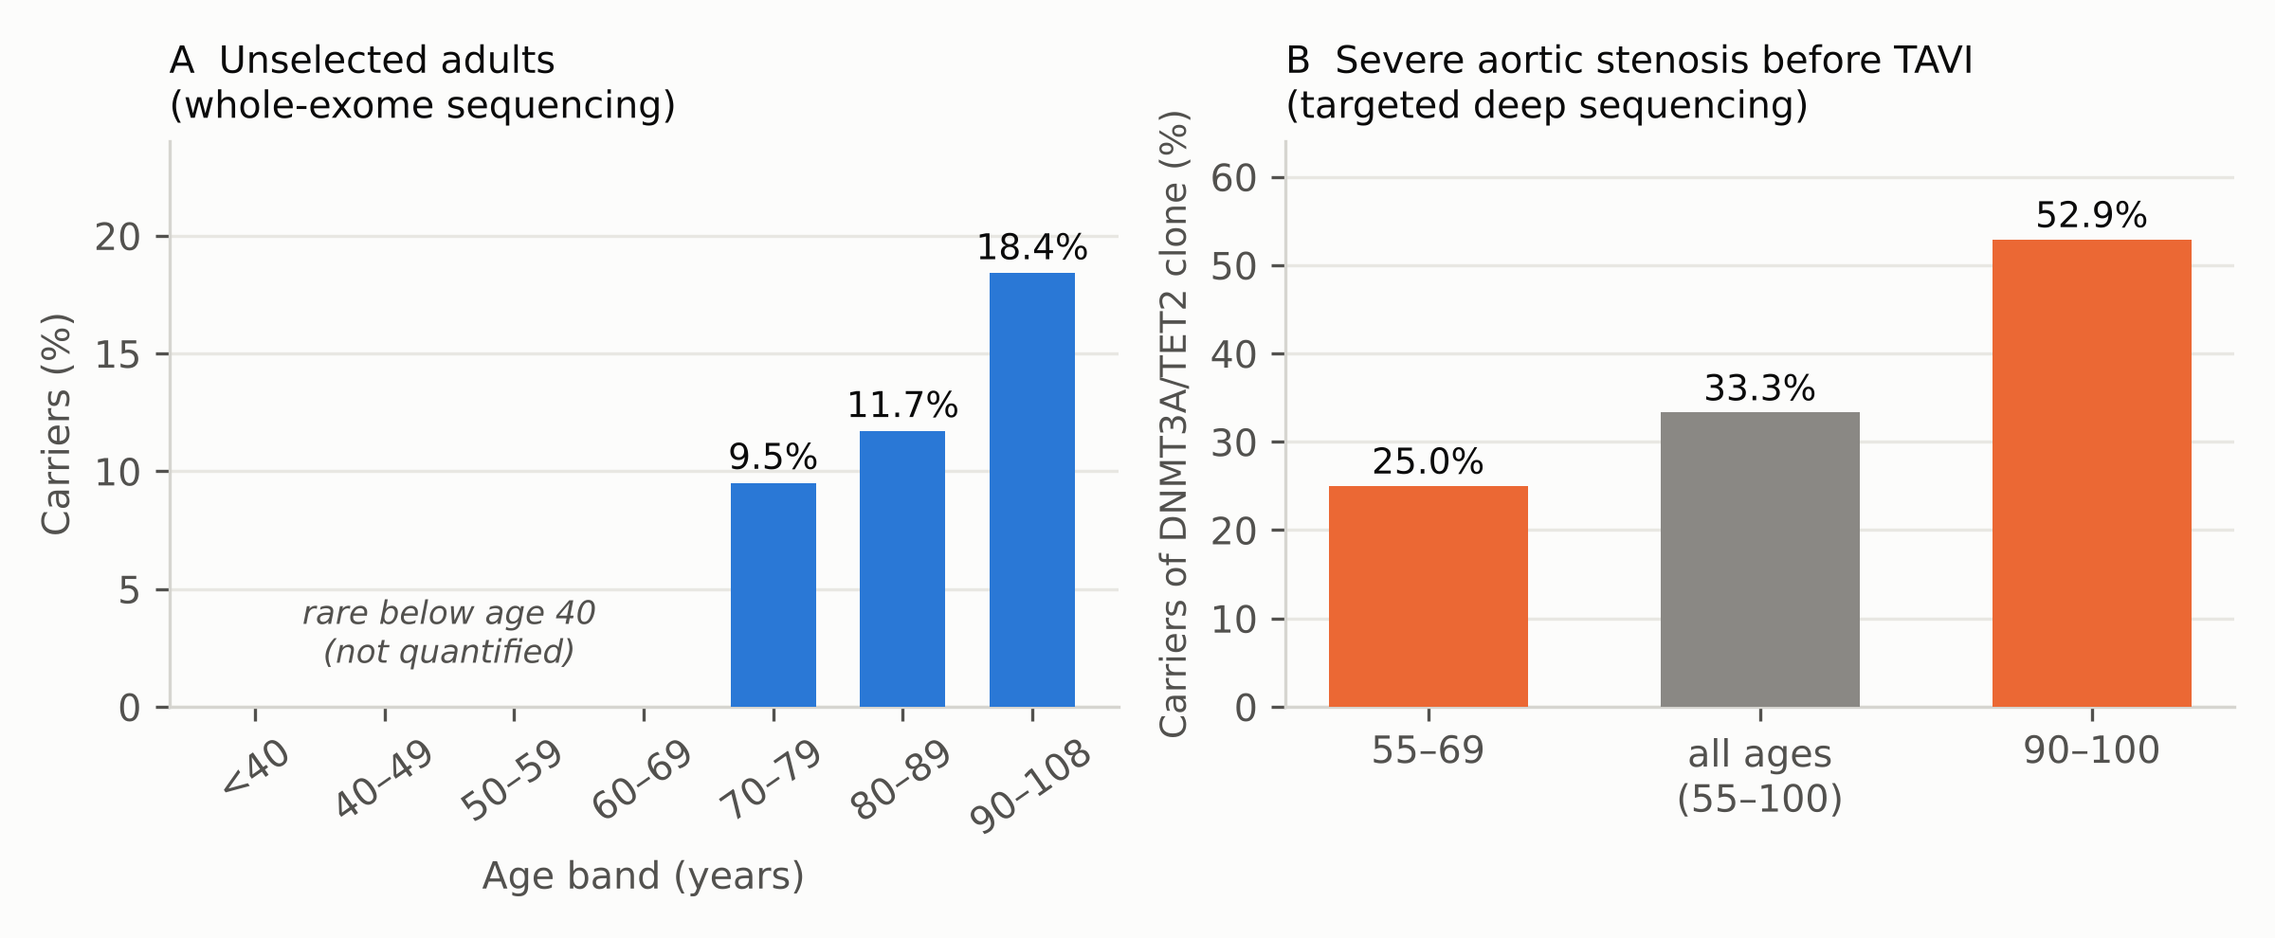
Figure 1. Prevalence of clonal haematopoiesis rises steeply with age, and the figure obtained depends strongly on sequencing depth. (A) Proportion of participants with a detectable somatic clone in 17,182 adults unselected for haematological phenotype, assayed by whole-exome sequencing; clones were rare below age 40 and were not quantified in that band. Data from Jaiswal et al., N Engl J Med 2014 [1]. (B) Proportion of patients carrying a DNMT3A or TET2 clone at a variant allele fraction ≥2% among 279 patients with severe degenerative aortic stenosis undergoing transcatheter aortic valve implantation, assayed by targeted amplicon sequencing of only those two genes. Data from Mas-Peiro et al., Eur Heart J 2020 [14]. The roughly threefold higher prevalence in panel B reflects deeper sequencing of a smaller gene panel in an older, vascular-disease-enriched population, and illustrates why prevalence estimates are not directly comparable across studies.
Three features of the subsequent epidemiology deserve emphasis. First, the association survives adjustment for conventional risk factors and persists in people who already have established disease. In 13,129 UK Biobank participants aged 40 to 70 with prevalent atherosclerotic cardiovascular disease followed for a median of 10.8 years, any CHIP carried an adjusted hazard ratio of 1.23 for the composite of recurrent events and death, large clones (VAF ≥10%) a hazard ratio of 1.34 [10]. CHIP is therefore not only a predictor of first events but a marker of residual risk in secondary prevention — the population in which anti-inflammatory therapy is most often considered.
Second, risk is gene-specific and clone-size-dependent, and the gradient is steep. In the same secondary-prevention cohort, large TET2 clones carried a hazard ratio of 1.89 and large spliceosome-gene clones a hazard ratio of 3.02, against 1.23 for CHIP considered as a single undifferentiated exposure [10]. In 417,616 participants free of heart failure and of CHIP-associated comorbidities at baseline, CHIP was associated with incident heart failure (adjusted hazard ratio 1.27), but the association was driven almost entirely by non-DNMT3A drivers (1.52) with a far weaker signal for DNMT3A (1.15) [11]. Treating 'CHIP' as a binary exposure therefore systematically dilutes the effect, because the most common driver, DNMT3A, is among the least cardiotoxic.
Third, mediation analysis suggests that the heart failure association is largely direct. When the development of coronary artery disease, atrial fibrillation, type 2 diabetes and chronic kidney disease were modelled as mediators, they collectively accounted for only 28.2% of the association between non-DNMT3A CHIP and incident heart failure [11]. Roughly seven tenths of the effect runs through some other route — most plausibly, on the evidence reviewed below, direct myocardial inflammation and fibrosis.
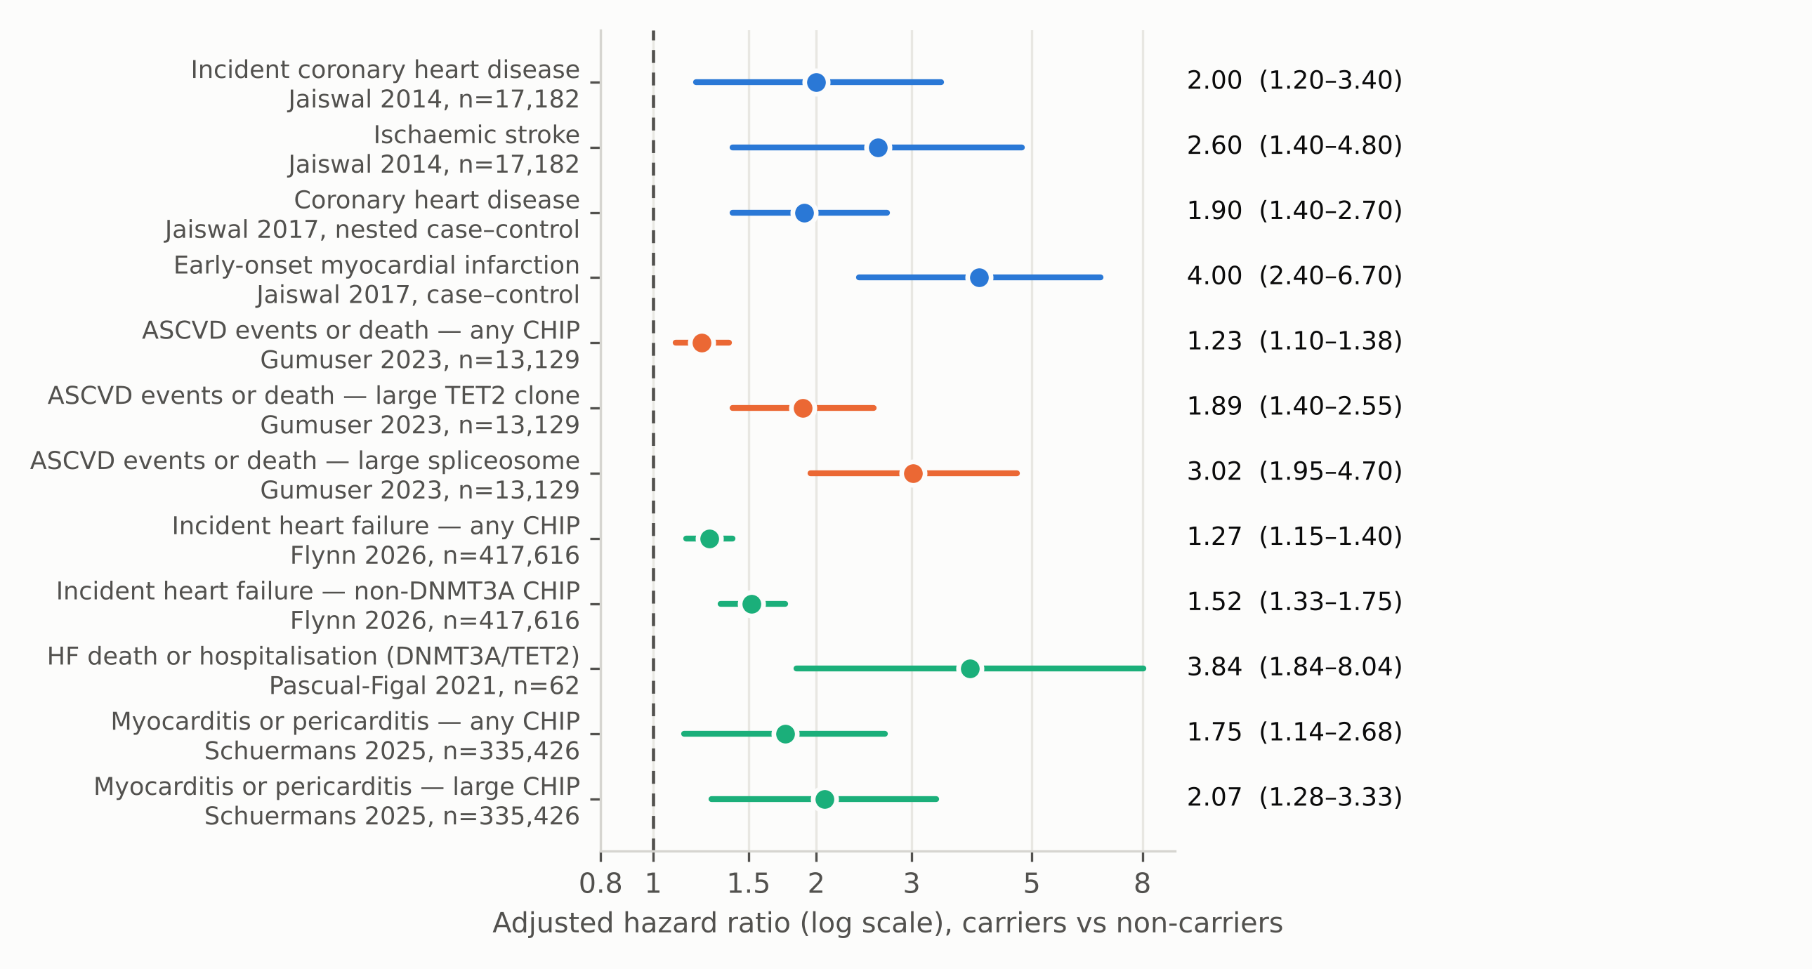
Figure 2. Adjusted hazard ratios for cardiovascular outcomes in carriers of clonal haematopoiesis across six human studies. Markers show point estimates, horizontal bars the 95% confidence interval; the dashed line marks the null. Blue, foundational discovery cohorts [1,2]; orange, secondary prevention in established atherosclerotic disease [10]; green, myocardial and pericardial outcomes [11,12,15]. Note the log scale and the consistent gradient from 'any CHIP' to large clones and to specific driver genes. Estimates are not pooled, because the studies differ in design, sequencing depth, outcome definition and covariate adjustment; the figure is a visual synthesis of separately reported adjusted models, not a meta-analysis. The early-onset myocardial infarction estimate derives from a case–control design and is a risk ratio rather than a hazard ratio.
The phenotypic reach of CHIP has since widened well beyond the coronary tree. In 335,426 UK Biobank participants, CHIP was associated with incident myocarditis and pericarditis (hazard ratio 1.75 for any CHIP, 2.07 for large clones) more strongly than with coronary artery disease or heart failure, and also with the later development of non-cardiac immune-mediated inflammatory disease (hazard ratio 1.27) without evidence of reverse causation [15]. In three population cohorts, CHIP was associated with incident acute kidney injury, with the effect concentrated in non-DNMT3A drivers; Mendelian randomisation supported causality, and mouse models of Tet2 and Jak2 clonal haematopoiesis showed more severe injury, greater proinflammatory macrophage infiltration and more post-injury fibrosis [16]. Carriers of DNMT3A or TET2 clones undergoing transcatheter aortic valve implantation had markedly higher medium-term mortality after a technically successful procedure, in the absence of any difference in blood counts, inflammatory markers or procedural characteristics [14]. The emerging picture is of a systemic, myeloid-driven inflammatory state whose cardiac manifestations are simply the most consequential.
Table 1 summarises the principal human studies underlying these conclusions.
Table 1. Landmark human studies linking clonal haematopoiesis to cardiovascular outcomes. VAF, variant allele fraction; ASCVD, atherosclerotic cardiovascular disease; HF, heart failure; HR, hazard ratio; TAVI, transcatheter aortic valve implantation.
Study | Design and population | Exposure | Principal outcome | Effect estimate
Jaiswal 2014 [1] | Whole-exome sequencing, 17,182 unselected adults | Any somatic clone in 160 myeloid genes | Incident coronary heart disease; ischaemic stroke; all-cause mortality | HR 2.0 (1.2–3.4); HR 2.6 (1.4–4.8); HR 1.4 (1.1–1.8)
Jaiswal 2017 [2] | Four case–control studies; 4,726 cases, 3,529 controls | CHIP by whole-exome sequencing | Coronary heart disease; early-onset myocardial infarction; coronary calcium | HR 1.9 (1.4–2.7); 4.0-fold risk (2.4–6.7); calcium score increased
Mas-Peiro 2020 [14] | 279 patients with severe aortic stenosis before TAVI | DNMT3A or TET2 clone, VAF ≥2%, targeted deep sequencing | All-cause mortality after successful TAVI | Prevalence 33.3%; markedly increased medium-term mortality
Pascual-Figal 2021 [12] | 62 patients, HF with LVEF <45%, 54-gene panel | DNMT3A or TET2 clone, VAF >2% | Death or HF hospitalisation over ≥3.5 years | HR 3.84 (1.84–8.04); HF death or hospitalisation HR 4.41 (2.15–9.03)
Gumuser 2023 [10] | 13,129 UK Biobank participants with established ASCVD | Any CHIP; large CHIP (VAF ≥10%); gene-specific | ASCVD events plus all-cause mortality, median 10.8 years | Any 1.23 (1.10–1.38); large 1.34 (1.17–1.53); large TET2 1.89; large spliceosome 3.02
Schuermans 2025 [15] | 335,426 UK Biobank participants, median 13.6 years | Any CHIP; large CHIP | Incident myocarditis or pericarditis | Any 1.75 (1.14–2.68); large 2.07 (1.28–3.33)
Flynn 2026 [11] | 417,616 UK Biobank participants free of HF and comorbidity | Any CHIP; DNMT3A vs non-DNMT3A | Incident heart failure, median 11.1 years | Any 1.27 (1.15–1.40); non-DNMT3A 1.52 (1.33–1.75); DNMT3A 1.15 (1.00–1.31)
Vlasschaert 2024 [16] | Three population cohorts plus mouse models and Mendelian randomisation | CHIP, especially non-DNMT3A | Incident acute kidney injury; non-resolving injury pattern | Increased risk, greatest for dialysis-requiring injury; causality supported

3. Mechanism: how a mutation in a stem cell inflames an artery
Epidemiology alone could not establish causality, and the decisive evidence came from competitive bone marrow transplantation in atherosclerosis-prone mice. The experimental design deliberately mimics the human condition rather than modelling a leukaemia: a small fraction of mutant bone marrow is transplanted alongside wild-type marrow into a hyperlipidaemic recipient, the mutant cells expand over weeks as they would over decades in a person, and the consequences for plaque are measured.
In Ldlr-deficient mice, partial reconstitution with Tet2-deficient marrow was sufficient for clonal expansion and produced a marked increase in atherosclerotic plaque size [3]. The phenotype was traced to the macrophage: Tet2-deficient macrophages showed increased NLRP3 inflammasome-mediated secretion of interleukin-1β, and an NLRP3 inhibitor was more atheroprotective in chimeric mice carrying the mutant clone than in non-chimeric controls — a pharmacological interaction that is the mechanistic ancestor of the entire mutation-guided therapeutic hypothesis [3]. An independent study transplanting homozygous or heterozygous Tet2-knockout marrow into hypercholesterolaemic mice found larger lesions in the aortic root and aorta, with elevated expression of multiple chemokine and cytokine genes in mutant macrophages [2].
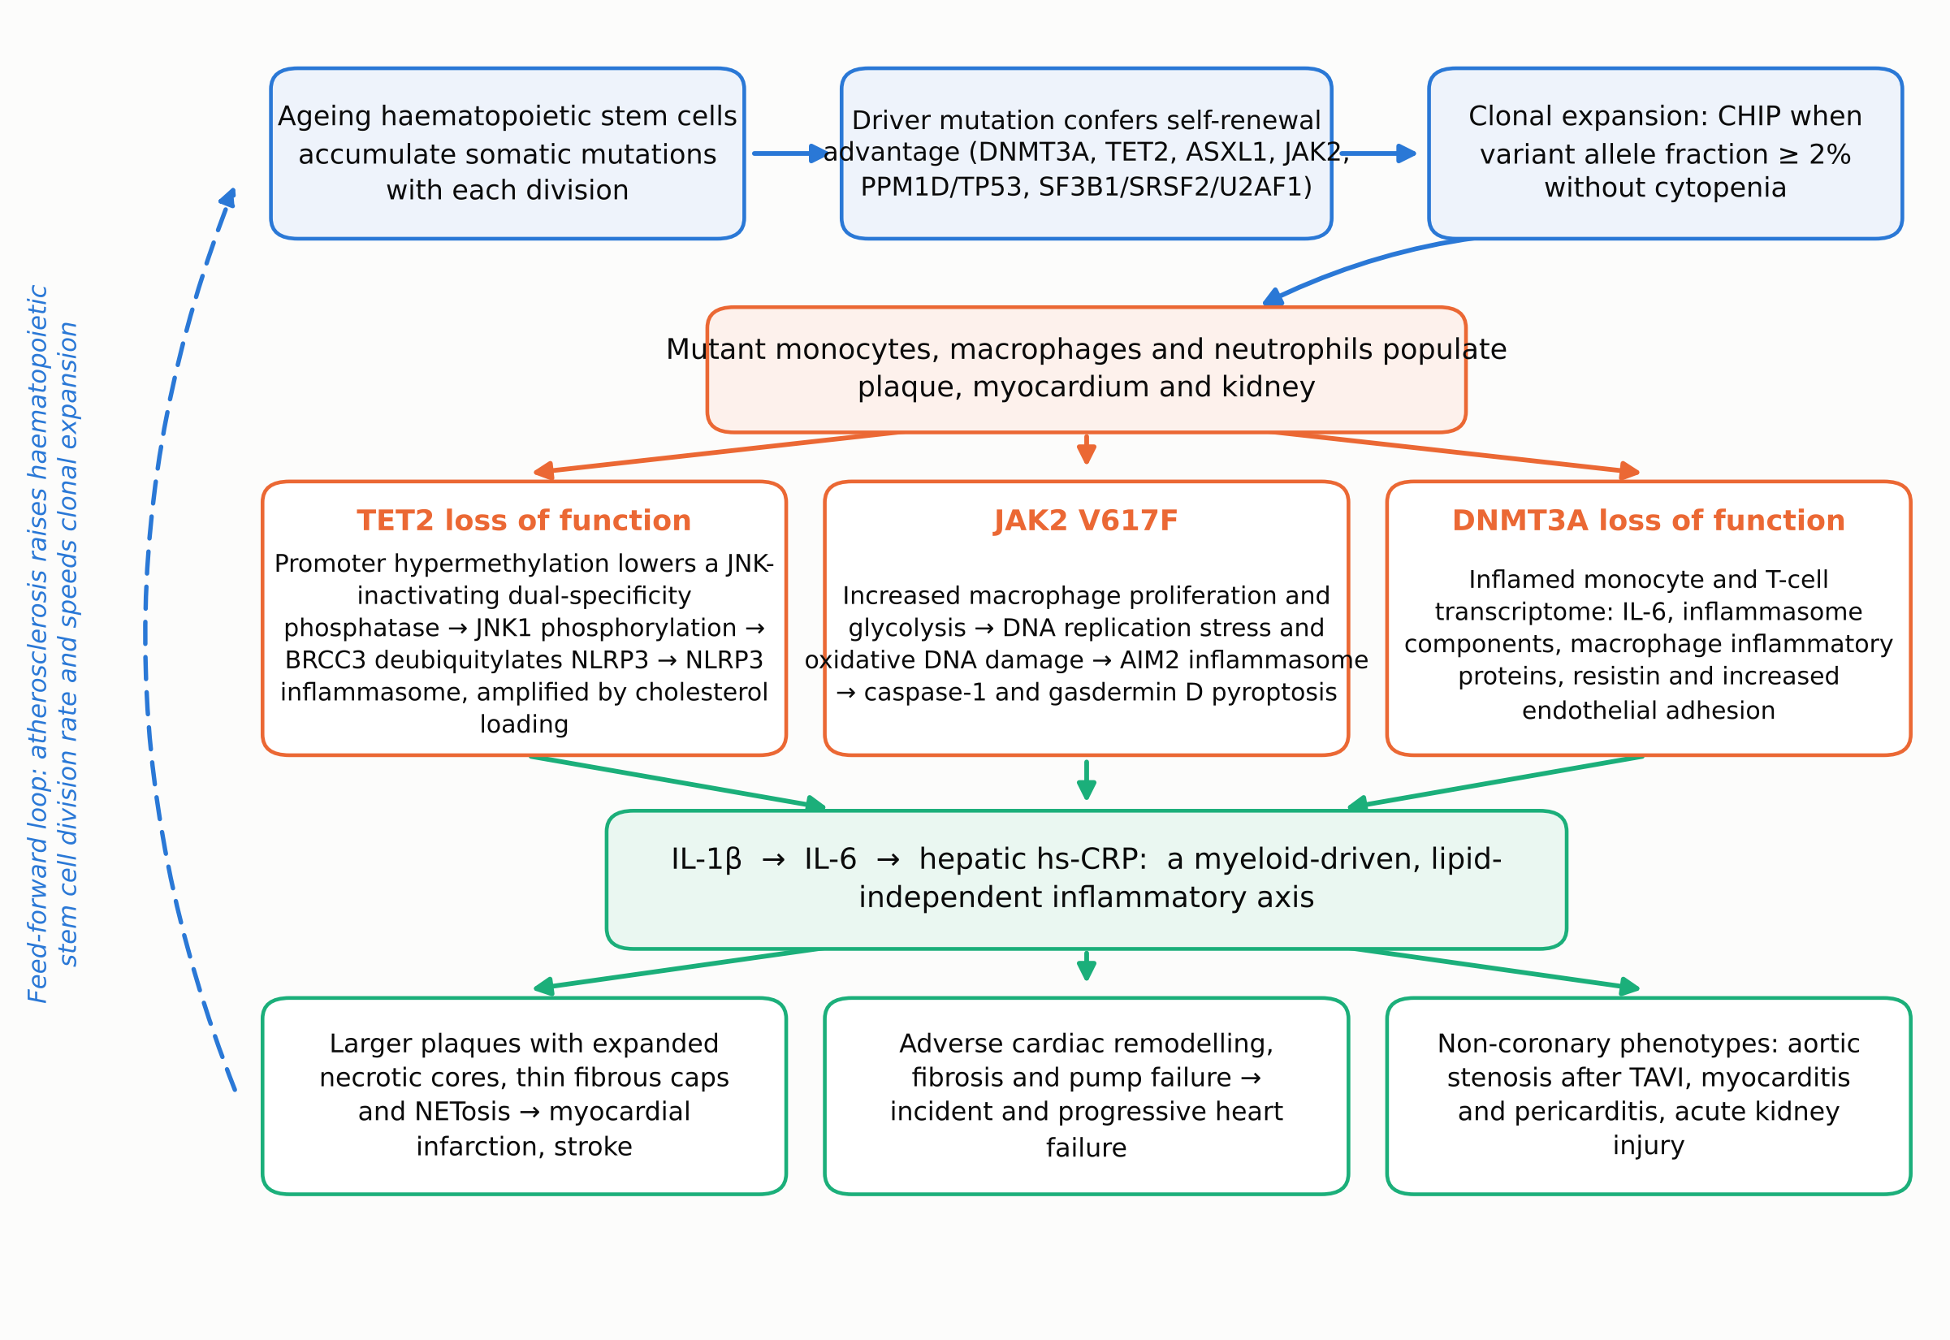
Figure 3. Schematic of the pathway from somatic mutation in a haematopoietic stem cell to cardiovascular and renal disease, with gene-specific inflammasome wiring. Original diagram assembled by the author from mechanisms reported in the cited primary literature: clonal expansion and definition [1,2,24]; TET2–JNK1–BRCC3–NLRP3 axis [3,6]; JAK2 V617F replication stress and AIM2 activation [5]; DNMT3A inflammatory transcriptome in human monocytes and T cells [13]; fibrous cap and fibroblast biology under interleukin-1β blockade [7]; feed-forward acceleration of clonal expansion by atherosclerosis [8]; renal and pericardial phenotypes [15,16].

3.1 TET2: epigenetic de-repression and a deubiquitylase switch on NLRP3
The TET2 pathway is the best resolved, and its elucidation is a useful illustration of how an epigenetic lesion becomes an inflammatory one. TET2 normally promotes demethylation at target promoters. Its loss leads to promoter hypermethylation and reduced expression of a JNK-inactivating dual-specificity phosphatase, which releases c-Jun N-terminal kinase 1 (JNK1) from restraint. Phosphorylated JNK1 in turn licenses the deubiquitinase BRCC3 to strip inhibitory ubiquitin from NLRP3, converting the sensor to its activatable state [6]. The consequence is a macrophage primed to assemble the NLRP3 inflammasome, cleave pro-interleukin-1β via caspase-1, and secrete mature interleukin-1β.
Two details of this pathway matter clinically. The first is synergy with cholesterol: TET2 deficiency and cholesterol loading act together, both in cell culture and in hypercholesterolaemic mice, so the inflammatory penalty of the mutation is contingent on the lipid environment rather than fixed [6]. The second is druggability at several nodes. Targeted editing of promoter methylation using a Tet1–dead-Cas9 fusion abolished cholesterol-induced inflammasome activation in TET2-deficient macrophages, confirming the epigenetic link directly; and pharmacological inhibition of BRCC3 with holomycin, or haematopoietic deficiency of the scaffolding protein Abro1, reversed both accelerated atherosclerosis and neutrophil extracellular trap formation in mice modelling TET2 clonal haematopoiesis. Human embryonic-stem-cell-derived isogenic TET2-deficient macrophages recapitulated the increased JNK1 and NLRP3 activation and its reversal by holomycin, establishing that the pathway is not a mouse idiosyncrasy [6].

3.2 JAK2 V617F: replication stress and the AIM2 inflammasome
JAK2 V617F is the least common of the major drivers but confers the strongest risk of premature coronary disease, and it arrives at inflammation by a different route [5]. Mice expressing Jak2 V617F selectively in macrophages, and chimeric mice modelling JAK2 clonal haematopoiesis, developed lesions with increased macrophage proliferation and prominent necrotic cores. Deletion of caspase-1 and caspase-11, or of the pyroptosis executioner gasdermin D, reversed these adverse features. The sensor responsible was not NLRP3 but AIM2, which detects cytosolic double-stranded DNA: lesions showed increased AIM2 expression together with oxidative DNA damage and DNA replication stress, and Aim2 deficiency reduced atherosclerosis. Single-cell RNA sequencing of mutant lesions revealed an inflammatory myeloid landscape that was suppressed by deletion of Gsdmd. The proposed sequence is that constitutive JAK-STAT signalling drives macrophage proliferation and glycolysis, which generates replication stress and cytosolic DNA, which activates AIM2 [5].
The therapeutic corollary was tested in the same system: inhibition of interleukin-1β reduced macrophage proliferation and necrotic core formation while increasing fibrous cap thickness — in other words, it stabilised plaques [5]. A later study clarified how. Single-cell analysis of human carotid plaques showed that inflammasome components are enriched in macrophages while the interleukin-1 receptor is enriched in fibroblasts and smooth muscle cells. Interleukin-1β antibody treatment of mice modelling TET2 or JAK2 clonal haematopoiesis did not substantially alter smooth muscle cell differentiation, as had been assumed; instead it produced a prominent expansion of fibroblast-like cells, and depleting those fibroblasts abolished the cap-thickening benefit [7]. Cytokine blockade therefore stabilises the plaque through a cell type that was not the expected target.

3.3 DNMT3A: the common driver with the subtler phenotype
DNMT3A is the most frequently mutated gene in clonal haematopoiesis yet carries a weaker cardiovascular signal, a dissociation that remains only partly explained. Human evidence nonetheless shows that DNMT3A clones are not inert. Single-cell RNA sequencing of peripheral blood mononuclear cells from patients with chronic heart failure found that monocytes from DNMT3A mutation carriers had a markedly more inflammatory transcriptome than monocytes from non-carriers with the same clinical syndrome, with upregulation of inflammasome components, macrophage inflammatory proteins and resistin; silencing DNMT3A in monocytes induced paracrine proinflammatory activation and increased adhesion to endothelial cells. Carriers also showed altered T-helper, cytotoxic and regulatory T-cell signatures, suggesting that the adaptive compartment is drawn in [13]. Consistent with a broader tissue reach, Dnmt3a-mutant clonal haematopoiesis promotes osteoporosis in mice through altered osteoclast biology [28] — a reminder that the mutant myeloid output acts wherever macrophage-lineage cells do work.

3.4 Other drivers, and the special case of mosaic loss of Y
Spliceosome-gene clones (SF3B1, SRSF2, U2AF1) are relatively uncommon but carry the highest observed hazard in secondary prevention [10], and their mechanism is largely unexplored — an obvious gap given the effect size; the broader set of candidate mechanisms proposed but not yet confirmed for the less-studied drivers has been catalogued elsewhere [34]. PPM1D and TP53 clones, enriched after cytotoxic therapy, link the cardiovascular risk of clonal haematopoiesis to cancer survivorship. Beyond point mutations, mosaic loss of the Y chromosome in leukocytes of older men has been associated with cardiac fibrosis and heart failure, with circulating macrophages proposed as the mechanistic intermediary [29]; whether it should be grouped with CHIP or treated as a parallel phenomenon is unsettled.
Table 2 collates the driver-specific evidence.
Table 2. Driver genes of clonal haematopoiesis: normal function, proposed inflammatory mechanism and associated cardiovascular phenotype. Mechanistic column reflects the experimental literature cited; absence of an entry denotes a genuine gap rather than a negative finding.
Gene | Normal function | Proposed mechanism in myeloid progeny | Cardiovascular association
DNMT3A | De novo DNA methyltransferase | Inflamed monocyte and T-cell transcriptome; IL-6, inflammasome components, resistin; increased monocyte–endothelial adhesion [13] | Most common driver; modest HF signal (HR 1.15) [11]; increased mortality after TAVI [14]; HF progression with TET2 [12]
TET2 | 5-methylcytosine dioxygenase; initiates demethylation | Promoter hypermethylation lowers a JNK-inactivating phosphatase → JNK1 → BRCC3 deubiquitylates NLRP3 → IL-1β; synergy with cholesterol loading [3,6] | Accelerated atherosclerosis and heart failure in mice [3,4]; large clones HR 1.89 in established ASCVD [10]; candidate predictor of canakinumab benefit [18]
ASXL1 | Polycomb-associated chromatin regulator | Not well defined; associated with inflammatory phenotypes | Associated with coronary heart disease [2] and incident heart failure [11]
JAK2 (V617F) | Tyrosine kinase in cytokine signalling; V617F is constitutively active | Macrophage proliferation and glycolysis → DNA replication stress and oxidative DNA damage → AIM2 inflammasome → caspase-1/gasdermin D pyroptosis [5] | Strongest risk of premature coronary disease; necrotic core expansion and plaque destabilisation [5]; severe acute kidney injury in mice [16]
PPM1D, TP53 | DNA-damage response | Under investigation; enriched after cytotoxic chemotherapy | Associated with adverse outcomes in established ASCVD [10]
SF3B1, SRSF2, U2AF1 | Core spliceosome components | Largely unexplored | Highest reported hazard in secondary prevention: large clones HR 3.02 [10]; associated with incident HF [11]
Mosaic loss of Y | Not a point mutation; whole-chromosome loss in leukocytes | Circulating macrophages proposed as the link to profibrotic signalling [29] | Cardiac fibrosis and heart failure in older men [29]

3.5 Reverse causality: atherosclerosis feeds the clone
One of the most consequential findings in the field complicates the simple arrow from mutation to disease. Haematopoietic stem cell division rates are increased in both mice and humans with atherosclerosis, and mathematical modelling shows that faster division accelerates somatic evolution: the elevated division rate measured in patients with atherosclerosis is sufficient, on its own, to produce a 3.5-fold increased risk of clonal haematopoiesis by age 70 [8]. The prediction was confirmed experimentally — expansion of competitively transplanted Tet2-mutant cells was accelerated in mouse models of atherosclerosis and of sleep fragmentation, both conditions of chronically elevated haematopoietic activity [8].
The relationship is therefore bidirectional and self-reinforcing: the clone inflames the artery, and the inflamed artery drives the haematopoietic proliferation that expands the clone. For epidemiology this means that part of the observed association reflects disease acting on clone rather than clone acting on disease, and that cross-sectional associations will overstate the forward effect. For therapy it suggests a less obvious target — interventions that quiet haematopoietic output may slow clonal expansion itself, independently of what they do to the cytokines. It also offers a partial explanation for why CHIP is so enriched in cohorts selected for cardiovascular disease (Figure 1B).

4. Therapeutic implications: the first somatic biomarker of drug response in cardiology

4.1 CANTOS and the TET2 signal
The inflammatory hypothesis of atherothrombosis was tested definitively in CANTOS, which randomised 10,061 patients with previous myocardial infarction and a high-sensitivity C-reactive protein (hs-CRP) of at least 2 mg/L to one of three doses of canakinumab, a monoclonal antibody against interleukin-1β, or placebo [17]. Canakinumab lowered hs-CRP in a dose-dependent manner without altering lipid levels, and the 150 mg dose reduced the primary composite endpoint of non-fatal myocardial infarction, non-fatal stroke or cardiovascular death (hazard ratio 0.85, 95% CI 0.74–0.98). The absolute benefit was modest, fatal infection was more common, and the drug was not approved for this indication. The trial nonetheless proved the principle that lowering inflammation without touching lipids reduces cardiovascular events.
An exploratory genetic analysis of CANTOS then asked whether that modest average benefit concealed a large benefit in a genetically defined subgroup [18]. Targeted deep sequencing of baseline samples identified 338 participants (8.6%) with clonal haematopoiesis. Notably, in this population selected for elevated hs-CRP, TET2 variants were more common than DNMT3A variants — the reverse of the usual population ordering, and itself suggestive of a relationship between TET2 clones and systemic inflammation. Among placebo-treated participants, CHIP carriers showed a non-significant increase in major adverse cardiovascular events (hazard ratio 1.32, 95% CI 0.86–2.04). Among those with TET2 variants, canakinumab was associated with a hazard ratio of 0.38 (95% CI 0.15–0.96) — a far larger effect than in the trial overall, although the interaction test was not significant (P = 0.14) and the subgroup was small [18]. A companion proteogenomic analysis of 4,595 CANTOS participants found that incident anaemia was more common in carriers of clonal haematopoiesis and was reduced by canakinumab, with greater haemoglobin gains and greater normalisation of inflammatory, myeloid-activation and complement pathways in carriers [19].
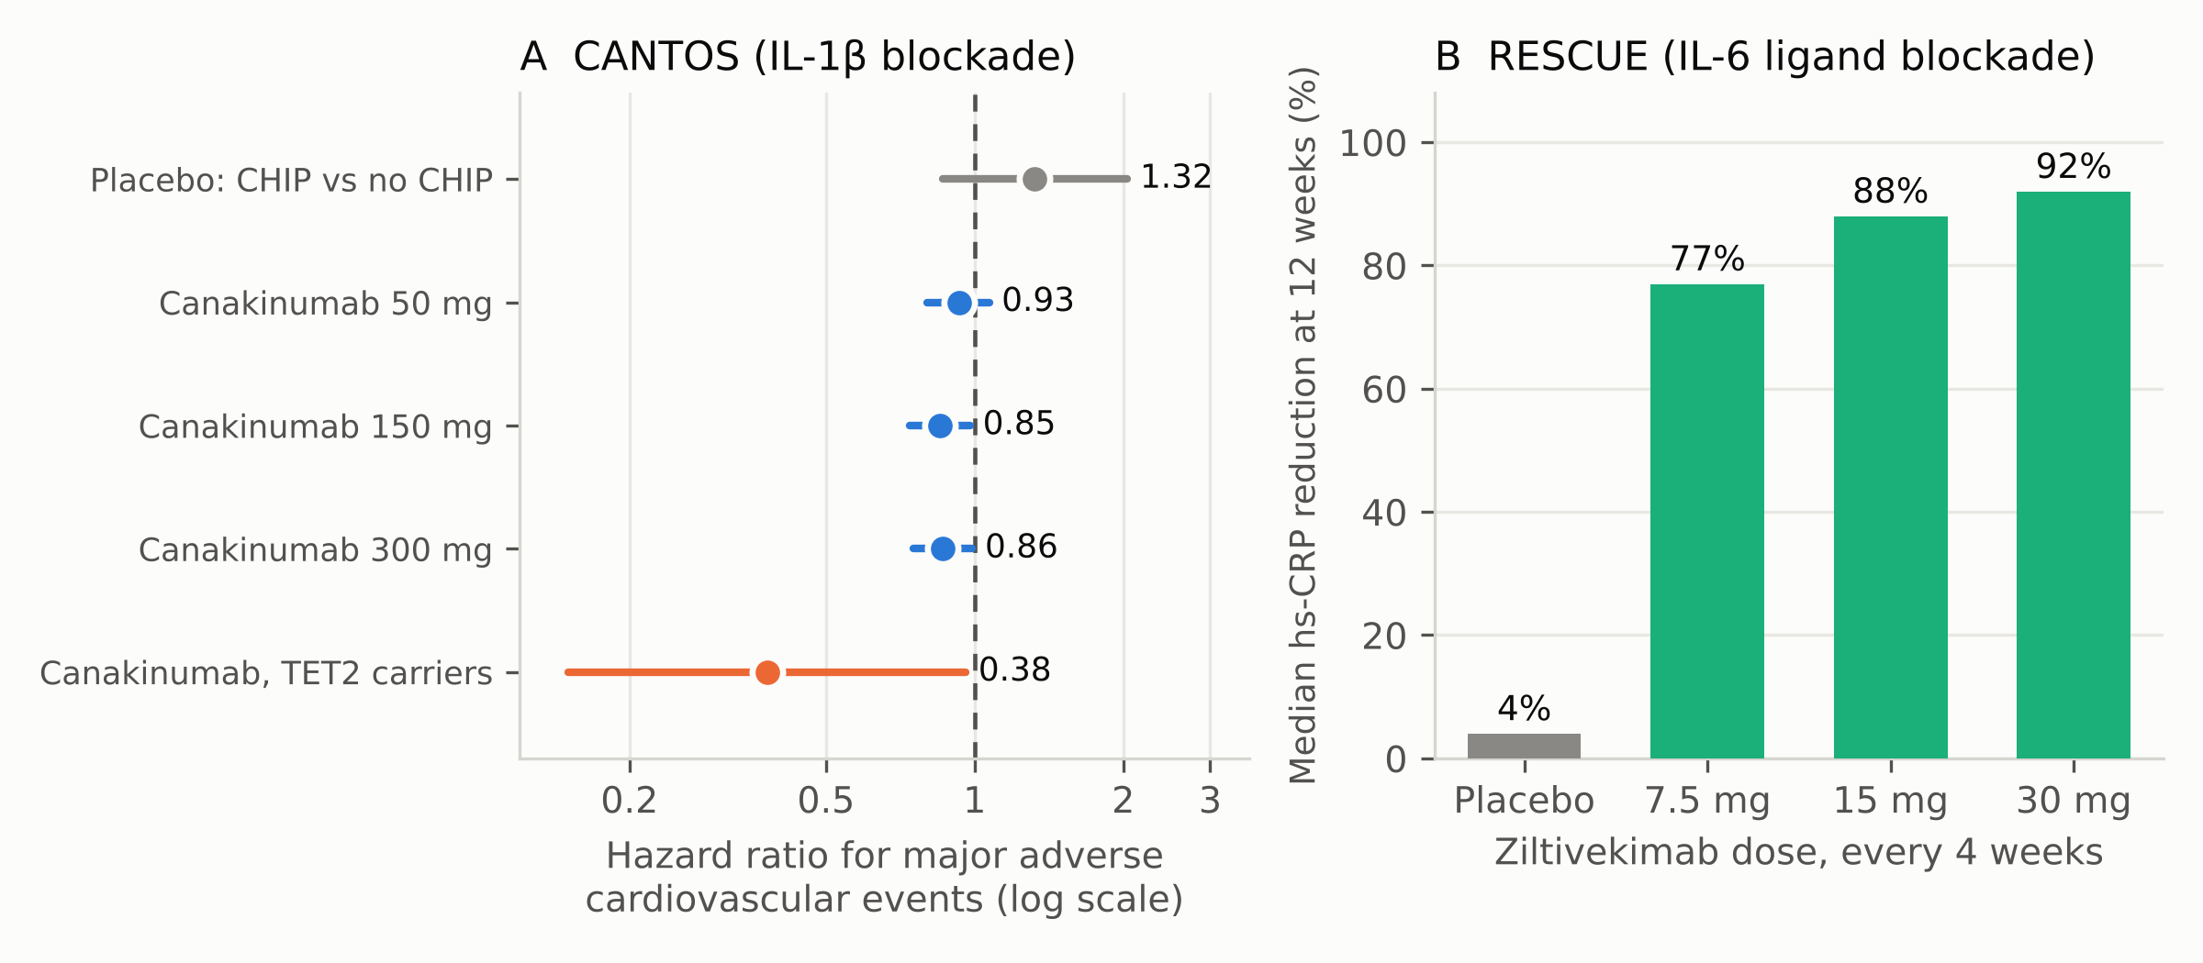
Figure 4. Anti-inflammatory therapy in atherosclerosis, and the clonal haematopoiesis signal. (A) Hazard ratios for major adverse cardiovascular events in CANTOS. Blue, the three randomised canakinumab doses versus placebo in the full trial of 10,061 patients [17]; grey, CHIP carriers versus non-carriers among placebo-treated participants in the sequenced subset; orange, canakinumab versus placebo restricted to carriers of TET2 variants [18]. The TET2 estimate derives from an exploratory subgroup of a trial not designed to test it, and the interaction test was not significant; it is hypothesis-generating. (B) Median reduction in high-sensitivity C-reactive protein at 12 weeks by ziltivekimab dose in the phase 2 RESCUE trial of 264 patients with chronic kidney disease and hs-CRP ≥2 mg/L [20]. Confidence intervals are omitted in panel B because the source reports medians with pairwise differences rather than symmetric intervals.

4.2 Moving downstream: the interleukin-6 axis
Interleukin-1β exerts much of its systemic effect by inducing interleukin-6, which in turn drives hepatic production of C-reactive protein and other acute-phase reactants. Targeting the interleukin-6 ligand directly is therefore an attractive alternative, and ziltivekimab was developed for patients with chronic kidney disease, a population with high residual inflammatory risk. In the phase 2 RESCUE trial, 264 patients were randomised to placebo or ziltivekimab at 7.5, 15 or 30 mg every four weeks; median hs-CRP fell by 77%, 88% and 92% respectively against 4% on placebo, with dose-dependent reductions in fibrinogen, serum amyloid A, haptoglobin, secretory phospholipase A2 and lipoprotein(a), and no adverse effect on the total-to-HDL cholesterol ratio [20]. The ZEUS cardiovascular outcomes trial has since randomised 6,376 participants with atherosclerotic cardiovascular disease, chronic kidney disease and hs-CRP ≥2 mg/L to ziltivekimab 15 mg monthly or placebo, with three-point major adverse cardiovascular events as the primary outcome and a composite kidney endpoint among the secondary outcomes [21]. Whether CHIP status modifies the effect of interleukin-6 blockade is a question the field is well placed to answer from stored samples, and the germline evidence makes it plausible: genome-wide analysis of 97,691 whole genomes identified germline determinants of CHIP and gene-specific associations with inflammatory traits, and a causal variant disrupting a distal TET2 enhancer that increases haematopoietic stem cell self-renewal [9].

4.3 Lipid lowering and other non-biological interventions
Because TET2-driven inflammasome activation is synergistic with cholesterol loading [6], and because JAK2-driven AIM2 activation depends on a proliferative, metabolically stressed macrophage state, aggressive lipid lowering is a mechanistically rational intervention in carriers rather than merely a default. A recent preprint reports that in mice modelling JAK2 V617F clonal haematopoiesis and myeloproliferative neoplasm, moderate cholesterol lowering left lesion resolution impaired relative to controls, whereas marked lowering halted progression, reversed AIM2 inflammasome activation and increased TREM2-expressing pro-resolving macrophages, normalising the regression deficit [27]. As a preprint this result awaits peer review, but it sharpens a clinically testable prediction: that the excess risk conferred by a JAK2 clone may be substantially abrogated by sufficiently intensive LDL reduction. A parallel line of reasoning applies to colchicine, an inexpensive and widely available anti-inflammatory agent whose actions include inhibition of NLRP3 inflammasome assembly; the PRECISE pilot trial is now testing it specifically in carriers of TET2 clonal haematopoiesis with coronary atherosclerosis [36].
Table 3 summarises the interventional landscape.
Table 3. Completed and ongoing interventional studies relevant to clonal haematopoiesis. Trial registration numbers are from ClinicalTrials.gov; status and enrolment as registered. CH, clonal haematopoiesis; hs-CRP, high-sensitivity C-reactive protein; MACE, major adverse cardiovascular events; THU, tetrahydrouridine.
Trial | Intervention | Registration | Status | Relevance to clonal haematopoiesis
CANTOS | Canakinumab (anti-IL-1β), 50/150/300 mg quarterly | NCT01327846 | Completed | MACE reduced at 150 mg (HR 0.85) without lipid change [17]; exploratory analysis suggested greater benefit in TET2 carriers (HR 0.38) [18] and reduced anaemia in carriers [19]
RESCUE | Ziltivekimab (anti-IL-6 ligand), 7.5/15/30 mg monthly | NCT03926117 | Completed, phase 2 | Established 77–92% median hs-CRP reduction, supporting the downstream limb of the CHIP inflammatory axis [20]
ZEUS | Ziltivekimab 15 mg monthly vs placebo, n=6,376 | NCT05021835 | Ongoing, outcomes trial | Will test whether IL-6 blockade reduces events in a high-inflammation population; CHIP-stratified analyses anticipated [21]
IL-1β blockade in TET2 CH | Canakinumab vs saline placebo, n=120 | NCT06691217 | Recruiting, phase 2 | First trial to prospectively select participants by TET2 clonal haematopoiesis status; endpoint is vascular inflammation
PRECISE | Colchicine 0.5 mg daily for 12 months, n=120 | NCT07362966 | Recruiting, phase 4 | Tests a widely available anti-inflammatory agent specifically in TET2 clonal haematopoiesis with coronary atherosclerosis
Ropeginterferon in JAK2 V617F CH | Ropeginterferon alfa-2b, n=12 | NCT07249840 | Recruiting, phase 1 | Pilot study of clone-directed rather than cytokine-directed therapy in the highest-risk driver
Decitabine plus THU | Low-dose oral decitabine with tetrahydrouridine (THU) vs placebo, n=80 | NCT07435636 | Not yet recruiting, phase 2 | Tests whether hypomethylating therapy can modify high-risk clonal haematopoiesis itself
CHIVE registry | Observational registry and biorepository, n=800 | NCT06701214 | Recruiting | Dedicated clonal haematopoiesis and vascular inflammation cohort to define natural history and outcomes

5. Open questions
Is the TET2–canakinumab interaction real? This is the central unresolved question, because an affirmative answer would make CHIP the first somatic biomarker to guide anti-inflammatory therapy in cardiology. The existing evidence is an exploratory subgroup of 103 patients within a trial that was not designed to test it, with a non-significant interaction term [18]. Mouse pharmacology supports the hypothesis — NLRP3 inhibition was selectively more protective in TET2-chimeric animals [3] — but subgroup effects of this magnitude frequently fail to replicate. NCT06691217 is the first trial to select participants prospectively on TET2 status, though its endpoint is vascular inflammation rather than clinical events; an adequately powered outcomes trial remains some distance away.
What should be measured, and when? Clone size at a single time point is a weak summary of a dynamic process. Integrating three longitudinal ageing cohorts (713 individuals, 2,341 observations), one analysis found that pathway-specific fitness advantage, clonal composition and — critically — the timing of mutation acquisition jointly determine how far a clone expands within a lifetime, and proposed a composite metric combining mutation context, timing and variant fitness that outperformed variant allele fraction in predicting clinical outcomes [26]. This work is a preprint and awaits peer review, but it frames the right question: a 3% clone acquired at 45 and a 3% clone acquired at 75 are not the same exposure. Prospective risk stratification will probably require serial sampling rather than a single measurement.
Why is DNMT3A different? DNMT3A is the commonest driver and the weakest cardiovascular risk factor, yet DNMT3A-mutant monocytes from patients with heart failure are transcriptionally inflamed [13] and DNMT3A clones predict mortality after aortic valve replacement [14]. Whether the discrepancy reflects a genuinely milder inflammatory phenotype, a different tissue distribution, confounding by clone size, or heterogeneity among DNMT3A variants is unresolved — and it matters, because DNMT3A carriers would dominate any population screening programme.
Should anyone be screened? There is at present no evidence that knowing CHIP status improves outcomes, no approved CHIP-directed therapy, and a real prospect of harm from incidental detection: a finding that confers a small annual risk of leukaemia, substantial anxiety, and no validated management pathway. Dedicated clonal haematopoiesis clinics and registries are being established to define natural history and the psychological and clinical consequences of diagnosis, and that evidence should precede any screening recommendation.
How much of the association is reverse causation? Because atherosclerosis accelerates clonal expansion [8], observational estimates of forward effect are inflated to an unknown degree. Mendelian randomisation has supported causality for acute kidney injury [16], and the mouse transplantation experiments establish a forward effect for atherosclerosis and heart failure [3,4], but quantifying the division of effect in humans will require either genetic instruments for CHIP itself or serial sampling in large cohorts.
Can the clone be targeted directly? Every therapy discussed above targets the consequences of the clone rather than the clone itself. Clone-directed approaches — interferon in JAK2 V617F, hypomethylating agents in high-risk clonal haematopoiesis — are entering early-phase testing, but the risk-benefit calculus is unforgiving in people who are, by definition, asymptomatic. The feed-forward loop offers a third option: interventions that reduce haematopoietic proliferation (improving sleep, treating the underlying atherosclerosis) may slow clonal expansion without exposing anyone to a cytotoxic drug [8].

6. Conclusion
Clonal haematopoiesis of indeterminate potential has moved in little over a decade from an incidental finding in sequencing data to a recognised, mechanistically grounded cardiovascular risk factor. The evidence is unusually complete for a risk factor of recent discovery: consistent associations across large prospective cohorts with gene-specific and dose-dependent gradients; causal demonstrations in competitive transplantation models that recapitulate the human condition rather than a leukaemia; a resolved molecular pathway from epigenetic lesion to inflammasome to cytokine, with distinct wiring for different drivers; and a randomised trial showing that blocking the terminal cytokine reduces cardiovascular events.
What remains missing is the piece that would change practice. The claim that TET2 carriers derive disproportionate benefit from interleukin-1β blockade rests on an exploratory subgroup with a non-significant interaction term, and it has not yet been tested prospectively against clinical endpoints. If it survives that test, CHIP will become the first somatic genotype used to allocate anti-inflammatory therapy in cardiovascular medicine, and a diagnostic category defined by what it might become will have found its clinical use in what it already does. If it does not, CHIP will remain what it is today: a powerful marker of inflammatory risk, an unusually tractable model of how ageing produces chronic disease, and a reminder that the mutations we acquire over a lifetime shape far more than our risk of cancer.

References
1. Jaiswal S, Fontanillas P, Flannick J, et al. Age-related clonal hematopoiesis associated with adverse outcomes. N Engl J Med. 2014. doi:10.1056/NEJMoa1408617. PMID 25426837.
2. Jaiswal S, Natarajan P, Silver AJ, et al. Clonal hematopoiesis and risk of atherosclerotic cardiovascular disease. N Engl J Med. 2017. doi:10.1056/NEJMoa1701719. PMID 28636844.
3. Fuster JJ, MacLauchlan S, Zuriaga MA, et al. Clonal hematopoiesis associated with TET2 deficiency accelerates atherosclerosis development in mice. Science. 2017. doi:10.1126/science.aag1381. PMID 28104796.
4. Sano S, Oshima K, Wang Y, et al. Tet2-mediated clonal hematopoiesis accelerates heart failure through a mechanism involving the IL-1β/NLRP3 inflammasome. J Am Coll Cardiol. 2018. doi:10.1016/j.jacc.2017.12.037. PMID 29471939.
5. Fidler TP, Xue C, Yalcinkaya M, et al. The AIM2 inflammasome exacerbates atherosclerosis in clonal haematopoiesis. Nature. 2021. doi:10.1038/s41586-021-03341-5. PMID 33731931.
6. Yalcinkaya M, Liu W, Thomas LA, et al. BRCC3-mediated NLRP3 deubiquitylation promotes inflammasome activation and atherosclerosis in TET2 clonal hematopoiesis. Circulation. 2023. doi:10.1161/CIRCULATIONAHA.123.065344. PMID 37781816.
7. Fidler TP, Dunbar A, Kim E, et al. Suppression of IL-1β promotes beneficial accumulation of fibroblast-like cells in atherosclerotic plaques in clonal hematopoiesis. Nat Cardiovasc Res. 2024. doi:10.1038/s44161-023-00405-9. PMID 38362011.
8. Heyde A, Rohde D, McAlpine CS, et al. Increased stem cell proliferation in atherosclerosis accelerates clonal hematopoiesis. Cell. 2021. doi:10.1016/j.cell.2021.01.049. PMID 33636128.
9. Bick AG, Weinstock JS, Nandakumar SK, et al. Inherited causes of clonal haematopoiesis in 97,691 whole genomes. Nature. 2020. doi:10.1038/s41586-020-2819-2. PMID 33057201.
10. Gumuser ED, Schuermans A, Cho SMJ, et al. Clonal hematopoiesis of indeterminate potential predicts adverse outcomes in patients with atherosclerotic cardiovascular disease. J Am Coll Cardiol. 2023. doi:10.1016/j.jacc.2023.03.401. PMID 37197843.
11. Flynn S, Schuermans A, Uddin MM, et al. Clonal hematopoiesis and incident heart failure. JAMA Cardiol. 2026. doi:10.1001/jamacardio.2025.4603. PMID 41206888.
12. Pascual-Figal DA, Bayes-Genis A, Díez-Díez M, et al. Clonal hematopoiesis and risk of progression of heart failure with reduced left ventricular ejection fraction. J Am Coll Cardiol. 2021. doi:10.1016/j.jacc.2021.02.028. PMID 33832602.
13. Abplanalp WT, Cremer S, John D, et al. Clonal hematopoiesis-driver DNMT3A mutations alter immune cells in heart failure. Circ Res. 2020. doi:10.1161/CIRCRESAHA.120.317104. PMID 33155517.
14. Mas-Peiro S, Hoffmann J, Fichtlscherer S, et al. Clonal haematopoiesis in patients with degenerative aortic valve stenosis undergoing transcatheter aortic valve implantation. Eur Heart J. 2020. doi:10.1093/eurheartj/ehz591. PMID 31504400.
15. Schuermans A, Flynn S, Niroula A, et al. Clonal hematopoiesis and risk of new-onset myocarditis and pericarditis. JAMA Cardiol. 2025. doi:10.1001/jamacardio.2025.3369. PMID 40884495.
16. Vlasschaert C, Robinson-Cohen C, Chen J, et al. Clonal hematopoiesis of indeterminate potential is associated with acute kidney injury. Nat Med. 2024. doi:10.1038/s41591-024-02854-6. PMID 38454125.
17. Ridker PM, Everett BM, Thuren T, et al. Antiinflammatory therapy with canakinumab for atherosclerotic disease. N Engl J Med. 2017. doi:10.1056/NEJMoa1707914. PMID 28845751.
18. Svensson EC, Madar A, Campbell CD, et al. TET2-driven clonal hematopoiesis and response to canakinumab: an exploratory analysis of the CANTOS randomized clinical trial. JAMA Cardiol. 2022. doi:10.1001/jamacardio.2022.0386. PMID 35385050.
19. Woo J, Lu D, Lewandowski A, et al. Effects of IL-1β inhibition on anemia and clonal hematopoiesis in the randomized CANTOS trial. Blood Adv. 2023. doi:10.1182/bloodadvances.2023011578. PMID 37934948.
20. Ridker PM, Devalaraja M, Baeres FMM, et al. IL-6 inhibition with ziltivekimab in patients at high atherosclerotic risk (RESCUE): a double-blind, randomised, placebo-controlled, phase 2 trial. Lancet. 2021. doi:10.1016/S0140-6736(21)00520-1. PMID 34015342.
21. Ridker PM, Baeres FMM, Hveplund A, et al. Rationale, design, and baseline clinical characteristics of the Ziltivekimab Cardiovascular Outcomes Trial (ZEUS). JAMA Cardiol. 2026. doi:10.1001/jamacardio.2025.4491. PMID 41369941.
22. Marnell CS, Bick A, Natarajan P. Clonal hematopoiesis of indeterminate potential (CHIP): linking somatic mutations, hematopoiesis, chronic inflammation and cardiovascular disease. J Mol Cell Cardiol. 2021. doi:10.1016/j.yjmcc.2021.07.004. PMID 34298011.
23. Stein A, Metzeler K, Kubasch AS, et al. Clonal hematopoiesis and cardiovascular disease: deciphering interconnections. Basic Res Cardiol. 2022. doi:10.1007/s00395-022-00969-w. PMID 36355225.
24. Jaiswal S. Clonal hematopoiesis and nonhematologic disorders. Blood. 2020. doi:10.1182/blood.2019000989. PMID 32736379.
25. Yalcinkaya M, Tall AR. Genetic and epigenetic regulation of inflammasomes: role in atherosclerosis. Atherosclerosis. 2024. doi:10.1016/j.atherosclerosis.2024.118541. PMID 39111028.
26. Latorre-Crespo E, Robertson NA, Kosebent EG, et al. Clinical progression of clonal hematopoiesis is determined by a combination of mutation timing, fitness, and clonal structure. bioRxiv. 2025 [preprint, not peer reviewed]. doi:10.1101/2025.02.28.640879. PMID 40093158.
27. Hardaway BD, Fidler TP, Tavallaie M, et al. Aggressive cholesterol lowering normalizes atherosclerosis regression in Jak2 V617F mice. bioRxiv. 2025 [preprint, not peer reviewed]. doi:10.1101/2025.07.23.666334. PMID 40766664.
28. Kim PG, Niroula A, Shkolnik V, et al. Dnmt3a-mutated clonal hematopoiesis promotes osteoporosis. J Exp Med. 2021. doi:10.1084/jem.20211872. PMID 34698806.
29. Xu X, Zhou R, Duan Q, et al. Circulating macrophages as the mechanistic link between mosaic loss of Y-chromosome and cardiac disease. Cell Biosci. 2023. doi:10.1186/s13578-023-01075-7. PMID 37488646.
30. Malkots B, Stamatiou I, Panagiotopoulos E, et al. Clonal hematopoiesis of indeterminate potential (CHIP): a model of mutation-driven thromboinflammation. Cancers (Basel). 2026. doi:10.3390/cancers18091326. PMID 42122123.
31. Saadatagah S, Ballantyne CM. Clonal hematopoiesis of indeterminate potential and cardiovascular disease. Transl Res. 2022. doi:10.1016/j.trsl.2022.08.013. PMID 36067904.
32. Bhattacharya R, Bick AG. Clonal hematopoiesis of indeterminate potential: an expanding genetic cause of cardiovascular disease. Curr Atheroscler Rep. 2021. doi:10.1007/s11883-021-00966-9. PMID 34468876.
33. Björkegren JLM, Lusis AJ. Atherosclerosis: recent developments. Cell. 2022. doi:10.1016/j.cell.2022.04.004. PMID 35504280.
34. Burns SS, Kapur R. Putative mechanisms underlying cardiovascular disease associated with clonal hematopoiesis of indeterminate potential. Stem Cell Reports. 2020. doi:10.1016/j.stemcr.2020.06.021. PMID 32735822.
35. Gajagowni S, Hopkins S, Qadeer Y, et al. Clonal hematopoiesis of indeterminate potential and cardiovascular disease: pathogenesis, clinical presentation, and future directions. Prog Cardiovasc Dis. 2024. doi:10.1016/j.pcad.2024.09.001. PMID 39278303.
36. ClinicalTrials.gov. Trial records NCT01327846, NCT03926117, NCT05021835, NCT06691217, NCT07362966, NCT07249840, NCT07435636 and NCT06701214. US National Library of Medicine. Accessed 26 October 2026.
Source note: all literature in this review was retrieved from PubMed and PubMed Central and from ClinicalTrials.gov. Figures 1, 2 and 4 were constructed from numerical results reported in the cited papers; Figure 3 is an original schematic synthesising mechanisms from the cited primary literature. No figure has been reproduced from a copyrighted publication.

