REVIEW · NEUROGENETICS
The Repeat That Keeps Growing: Somatic CAG Expansion and DNA Mismatch Repair as the Engine of Huntington's Disease
A mechanistic and therapeutic review of MSH3, PMS1, MLH1, MLH3 and FAN1 as modifiers of repeat instability
Prepared 29 September 2026 · Literature retrieved from PubMed / PubMed Central, bioRxiv and ClinicalTrials.gov
Abstract
For three decades Huntington's disease (HD) was understood as a polyglutamine disorder: an inherited CAG expansion in HTT encodes an abnormally long glutamine tract, the mutant protein misfolds, and striatal neurons die. Human genetics has now overturned the temporal logic of that model. Genome-wide association studies of age at onset repeatedly implicate DNA maintenance genes — MSH3, MSH2, MLH1, MLH3, PMS1, PMS2 and FAN1 — and not genes governing protein handling; the number of pure CAG triplets, rather than the length of the encoded polyglutamine tract, predicts when symptoms begin. The unifying explanation is that the inherited repeat is only a starting point. In post-mitotic neurons the tract continues to expand throughout life, driven by an error-prone mismatch repair (MMR) reaction initiated by the MutSβ (MSH2–MSH3) heterodimer, and it is this somatic expansion that sets the clock. Single-nucleus measurements in human post-mortem brain have since shown that striatal projection neurons inheriting 40–45 CAGs accumulate 100–500 or more, that expansion below roughly 150 CAGs is biologically silent, and that neurons cross a shared toxicity threshold near 150 CAGs after which they lose neuronal identity and die within a comparatively short window. Mouse genetics converts this into a rate problem: modal repeat length in Q140 medium spiny neurons grows linearly at about 8.8 CAGs per month, a rate cut to 2.3 and 0.3 CAGs per month by heterozygous and homozygous Msh3 deletion respectively, with corresponding rescue of aggregation, transcriptional dysregulation and locomotor deficits. This review sets out the molecular background, the human and model-organism evidence, and the resulting therapeutic programme — antisense oligonucleotides, divalent siRNA, and orally available splice modulators, one of which (SKY-0515, which lowers both HTT and PMS1) has reached randomised Phase 2/3 testing. It closes with the unresolved questions that determine whether ‘slow the repeat’ becomes a disease-modifying therapy: how early treatment must begin, how expansion is to be measured in a living brain, and how much MMR can safely be removed from a human genome for decades.

1. Introduction

1.1 The disease and its founding mutation
Huntington's disease is an autosomal dominant neurodegenerative disorder characterised by chorea and other movement abnormalities, progressive cognitive decline, and psychiatric disturbance, with death typically 15–20 years after motor onset. Its cause has been known since 1993: an expanded CAG trinucleotide repeat in exon 1 of HTT, the gene encoding huntingtin. Alleles below about 27 repeats are stable and normal; 36–39 repeats confer reduced penetrance; 40 or more repeats are fully penetrant. Longer inherited repeats produce earlier onset, and the relationship is steep enough that repeat length in blood explains roughly half the variance in age at motor onset.
The remaining variance is the subject of this review. It is substantially heritable and, critically, it is not distributed randomly across the genome. When the Genetic Modifiers of Huntington's Disease (GeM-HD) Consortium and allied groups searched for loci altering onset independently of inherited repeat length, they recovered a conspicuously coherent set of genes: components of the DNA mismatch repair machinery and the interstrand-crosslink nuclease FAN1 [3, 5, 7]. Nothing about a polyglutamine-toxicity model predicts that result.

1.2 A change in the unit of analysis
The consequence is a shift from the gene to the cell, and from a fixed genotype to a moving one. If the repeat expands somatically, then the genotype relevant to a neuron's fate is not the one measured in that patient's blood at birth but the one present in that particular neuron at that particular moment. Two neurons in the same putamen, with the same inherited allele, may carry tracts differing by hundreds of repeats. Pathogenesis becomes a race between a slowly lengthening DNA tract and the lifespan of the cell carrying it — and a therapy that slows the tract is, in principle, a therapy that postpones the disease.
This review covers: the molecular biology of the repeat and of mismatch repair (Section 2); the human genetic evidence that somatic expansion is the rate-limiting step (Section 3); the mechanism by which a repair pathway causes mutation rather than preventing it (Section 4); the quantitative link between repeat length and neuronal death (Section 5); the therapeutic programme now in the clinic (Section 6); and the open questions (Section 7). The intended reader is scientifically literate but not a specialist in repeat biology.

2. Biological background

2.1 The CAG tract is a structural, not merely a coding, element
A (CAG)n·(CTG)n duplex is unusual DNA. Single strands of CAG and CTG both fold into imperfect hairpins stabilised by G·C base pairs with A·A or T·T mismatches at every third position. Whenever the duplex is transiently opened — during transcription, during repair synthesis, or at an R-loop — the displaced strand can fold back on itself and re-anneal out of register. The result is a slipped-strand intermediate: a correctly paired duplex flanked on one side by an extrahelical loop of repeat units, known as a slip-out. Slipped intermediates of this kind have been detected in DNA from patient tissues, and the size and junction conformation of the slip-out determine which repair factors engage it [16].
Two features of the tract matter clinically. First, interruptions stabilise it. Many HTT alleles carry glutamine-encoding CAA codons embedded in or adjacent to the CAG run; because CAA breaks the repeat's structural periodicity without changing the encoded protein, an allele's behaviour is governed by the length of its longest uninterrupted CAG run rather than by total polyglutamine [3, 6]. Second, length begets length: longer uninterrupted tracts form larger and more persistent slip-outs, so the expansion rate accelerates as the tract grows — a positive feedback that is central to the threshold behaviour described in Section 5.

2.2 Mismatch repair: the machinery, in brief
Post-replicative mismatch repair exists to correct base–base mismatches and small insertion–deletion loops left behind by DNA polymerase. It operates in two steps. Recognition is performed by MutS homologue heterodimers: MutSα (MSH2–MSH6) handles base–base mismatches and single-nucleotide loops, while MutSβ (MSH2–MSH3) specialises in larger insertion–deletion loops — exactly the lesion a CAG slip-out presents. On binding, and on exchanging ADP for ATP, MutSβ converts from a DNA-bending recognition complex into a sliding clamp that can diffuse along the duplex; cryo-electron microscopy of human MutSβ has now resolved the DNA-free, (CAG)2-bound, sliding-clamp and ATP-bound conformations, confirming that nucleotide state and heteroduplex recognition are allosterically coupled [18].
Licensing and incision are performed by MutL homologue heterodimers, each a latent endonuclease that is activated by the loaded MutS complex: MutLα (MLH1–PMS2), MutLγ (MLH1–MLH3), and MLH1–PMS1, whose canonical repair role in humans has long been obscure. The incision permits excision and resynthesis of the nascent strand. In canonical MMR this restores the correct sequence. At a repeat tract it does not — for reasons taken up in Section 4.

2.3 Why neurons are the vulnerable compartment
Repeat expansion is often assumed to be a replication error, but the cells that matter in HD do not divide. Medium spiny neurons of the striatum are post-mitotic for the whole of adult life, and it is precisely in them that the HTT tract expands fastest. Expansion in non-dividing cells must therefore be driven by repair-associated, not replication-associated, DNA synthesis — a short resynthesis patch templated on a slipped intermediate. This explains why MMR gene dosage, rather than proliferation rate, governs the process, and why the phenomenon is shared across the CAG·CTG, CGG·CCG and GAA·TTC repeat disorders [16].

3. The human genetic case for somatic expansion

3.1 Modifier loci converge on DNA maintenance
The decisive evidence is human and unbiased. Association studies of HD age at onset, conducted independently of any mechanistic hypothesis, returned DNA repair genes. FAN1 at chromosome 15 gave a bidirectional signal, with increased expression associated with delayed onset and slower progression [2]. The same variants behaved consistently across the polyglutamine spinocerebellar ataxias: in a cohort of 1,462 individuals with HD or polyQ SCA, DNA repair genes as a group associated with onset at p = 1.43 × 10⁻⁵, with FAN1 rs3512 and PMS2 rs1805323 significant individually and in the same direction as in HD [1]. A modifier mechanism shared by diseases whose only common feature is an expanded CAG tract is difficult to explain by protein toxicity and easy to explain by repeat instability.

3.2 CAG repeat length, not polyglutamine length
The GeM-HD Consortium tested this directly by exploiting naturally occurring CAA interruptions, which alter the uninterrupted CAG run while leaving the polyglutamine tract unchanged. Onset tracked the DNA sequence, not the protein: the uninterrupted CAG repeat determines the rate at which HD develops, and onset showed no significant association with HTT cis-eQTLs, but was influenced — sometimes sex-specifically — by variation at multiple DNA maintenance genes [3]. The authors' conclusion was blunt: the finding "question[s] the fundamental premise that polyglutamine length determines the rate of pathogenesis in the 'polyglutamine disorders'". Sequencing-based work in TRACK-HD and Enroll-HD reached the same endpoint independently, showing that HD outcomes are best predicted by the number of pure CAGs rather than by total encoded glutamines [6].

3.3 Measured somatic expansion predicts clinical outcome
If somatic expansion is the mechanism, then individuals who expand faster should do worse. They do. Using ultra-deep sequencing of the glutamine-encoding repeat in blood DNA from 203 TRACK-HD and 531 Enroll-HD participants carrying 40–50 repeats, Ciosi and colleagues derived a per-individual somatic expansion score and found a one-unit increase associated with a Cox hazard ratio for motor onset of 3.05 (95% CI 1.94–4.80) [6]. Those same expansion scores were themselves associated with variants in FAN1 (pFDR = 4.8 × 10⁻⁹), MLH3, MLH1 and MSH3 — closing the loop from genotype, through a measurable molecular intermediate, to clinical outcome.
The MSH3 signal has an unusually clean molecular explanation. The top progression-associated variant from an earlier GWAS turned out to be an alignment artefact; resequencing showed that the real signal is a polymorphic 9-base-pair tandem repeat in MSH3 exon 1. The three-repeat allele is associated with a reduced rate of somatic CAG·CTG expansion (p = 0.004), delayed onset (p = 0.003) and slower progression (p = 3.86 × 10⁻⁷) — in both HD and myotonic dystrophy type 1, and with a corresponding effect on MSH3 expression [4]. A common human allele that lowers MSH3 activity is, in effect, a natural experiment in the therapy proposed in Section 6.

3.4 Modifiers act with tissue and domain specificity
The picture is not uniform. Predicting disease landmarks from integrated motor and cognitive measures revealed that individual modifiers act preferentially in one clinical domain: common variants at MSH3 and FAN1 differ in their relative weight on motor versus cognitive decline, and additional effects were identified at PMS1 and PMS2 [5]. A 2025 study comparing GWAS of somatic expansion measured in blood with GWAS of expansion-driven clinical phenotypes went further, reporting shared modifiers (MSH3, PMS2, FAN1) alongside cell-type-specific and trans-acting effects, plus two instructive dissociations: a synonymous CAG-adjacent variant in HTT that markedly hastens motor onset without increasing somatic expansion, and a cis-acting 5′-UTR variant that promotes blood repeat expansion without influencing clinical HD [8]. Somatic expansion is the dominant driver; it is not the only one, and expansion in blood is an imperfect surrogate for expansion in neurons.
Table 1. Principal DNA-maintenance modifiers of Huntington's disease identified in human genetic studies, with the direction of effect on somatic expansion and clinical onset.
Gene | Complex / role | Direction of effect | Key human evidence
MSH3 | MutSβ (with MSH2); recognises extrahelical loops | Higher activity → faster expansion, earlier onset, faster progression | Exon-1 9-bp repeat variant: slower expansion, delayed onset (p = 0.003), slower progression (p = 3.9 × 10⁻⁷) in HD and DM1 [4]; expansion-score association [6]
MSH2 | MutSβ / MutSα obligate partner | Required for expansion | Modifier signal in GWAS [3]; strongest CRISPRi effect ex vivo [12]
MLH1 | MutLα / MutLγ obligate partner | Higher activity → faster expansion | Expansion-score association [6]; onset modifier [3]
MLH3 | MutLγ (with MLH1) | Promotes expansion | Expansion-score association pFDR = 8.0 × 10⁻⁵ [6]
PMS1 | MLH1–PMS1 heterodimer | Promotes expansion | Modifier locus in landmark-phenotype GWAS [5]; now a clinical target [Table 4]
PMS2 | MutLα (with MLH1) | Promotes expansion | rs1805323 modifies onset across HD and polyQ SCAs, p = 3.1 × 10⁻⁵ [1]; shared modifier [8]
FAN1 | Structure-specific nuclease; MLH1-binding | Protective — higher expression → later onset, slower progression | Bidirectional chr15 signal; expression–onset association [2]; rs3512 across polyQ diseases [1]
Table 1. Compiled by the authors of this review from the cited primary literature; effect directions are as reported in the source studies.

4. Mechanism: how a repair pathway becomes a mutator

4.1 MutSβ initiates rather than prevents expansion
The central irony of repeat biology is that MMR, whose function elsewhere is anti-mutagenic, drives expansion at disease-associated repeats [16]. The prevailing model runs as follows. A slip-out forms in the tract. MutSβ recognises it as an insertion–deletion loop and loads. But instead of directing excision of the extra repeat units, the repair reaction removes and resynthesises the opposite strand, using the looped strand as template — so the loop is not excised but fixed into the duplex. Each completed cycle adds a small number of repeats, typically one to three. Because the substrate regenerates itself, the reaction iterates for the life of the cell (Figure 1).
Two lines of evidence tie this specifically to MutSβ rather than to MMR generally. Structurally, human MutSβ adopts distinct conformations on (CAG)2 DNA, including a sliding-clamp form, indicating genuine substrate engagement rather than incidental binding [18]. Functionally, the rate of expansion scales almost exactly with MSH3 protein abundance: in Hdh^{Q111} mice treated with divalent siRNAs across a dose range, the relationship between prevention of somatic expansion and MSH3 protein level was linear with a proportionality constant of approximately 1 — MSH3 is rate-limiting, with no threshold or reserve [13].
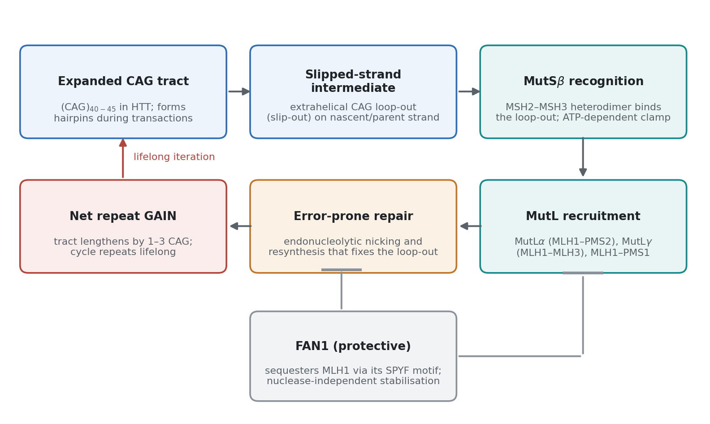
Figure 1. The iterative somatic expansion cycle in a post-mitotic neuron. A slipped-strand intermediate (extrahelical CAG loop-out) forms when the duplex is transiently opened; MutSβ (MSH2–MSH3) recognises it and, on ATP binding, converts to a sliding clamp; MutL heterodimers are recruited and nick the DNA; error-prone resynthesis incorporates rather than removes the loop, producing a net gain of one to three repeats. FAN1 opposes the cycle by sequestering MLH1 through its N-terminal SPYF motif, restricting MutL recruitment by MSH3. Original schematic prepared for this review, drawn from the mechanisms described in Schmidt & Pearson (2015) [16], Goold et al. (2021) [10], Lee et al. (2025) [18] and Ferguson et al. (2024) [12].

4.2 MutL heterodimers, and the unexpected importance of PMS1
Which MutL complex licenses the incision is not a detail — it determines which protein can be drugged. A CRISPR-interference platform in HD patient-derived induced pluripotent stem cells carrying more than 125 CAG repeats, and in iPSC-derived striatal medium spiny neuron cultures, allowed each MMR factor to be knocked down individually. Reducing MSH2, MSH3 or MLH1 slowed expansion most; reducing PMS1, PMS2 or MLH3 slowed it to a lesser but real degree; and — importantly for translation — lowering expression only to levels achievable by current therapeutic modalities was sufficient to slow expansion measurably [12].
Mouse genetics sharpened the ranking and produced a surprise. Nine HD GWAS/MMR genes were knocked out in Q140 Htt knock-in mice. Loss of Msh3 or Pms1 strongly rescued the triad of striatal phenotypes — somatic expansion, transcriptional dysregulation, and mutant huntingtin aggregation — while Msh2 and Mlh1 loss rescued them moderately [9]. That Pms1, whose canonical MMR function in humans is poorly defined, should rank alongside Msh3 was unexpected, and it is the direct origin of the clinical compound discussed in Section 6.3.

4.3 FAN1 sets the brake
FAN1 is the one modifier that protects. Increased FAN1 expression associates with delayed onset and slower progression in patients; overexpression reduces CAG expansion in human cells, and knockdown increases it in patient-derived stem cells and differentiated medium spiny neurons, in a concentration- and repeat-length-dependent manner. Unexpectedly, FAN1's nuclease activity is dispensable for this protection [2].
The mechanism was resolved by identifying a highly conserved SPYF motif at the FAN1 N-terminus that binds MLH1. The current model gives FAN1 two separable functions: it sequesters MLH1, restricting its recruitment by MSH3 and thereby preventing assembly of the functional MMR complex that would otherwise drive expansion, and it independently promotes accurate repair through its nuclease domain [10]. FAN1 is thus a competitive inhibitor of complex assembly — which makes stabilising or mimicking the SPYF–MLH1 interaction an attractive, if undeveloped, therapeutic concept.

4.4 Context-dependent inputs
Expansion rate is also modulated by the neuronal environment. CRISPR/Cas9 knockdown of TDP-43 in the striatum of HD knock-in mice promoted CAG expansion, accompanied by increased Msh3 and Mlh1 expression; suppressing Msh3 and Mlh1 in turn diminished the expansion [17]. Because nuclear TDP-43 loss is a feature of several neurodegenerative conditions, this suggests a route by which unrelated proteinopathies could accelerate repeat instability, and a possible contribution to the cell-type specificity of expansion rate.

5. From an expanding repeat to a dying neuron

5.1 Reading repeat length one nucleus at a time
The mechanistic account above leaves the central question open: why do neurons carrying the mutation from conception remain healthy for four decades? The answer came from a method that measures the HTT CAG repeat length in a single nucleus alongside that nucleus's genome-wide RNA expression. Applied to human post-mortem striatum, it showed that the repeat expands in striatal projection neurons from an inherited 40–45 to 100–500 or more CAGs. Expansion from 40 to about 150 CAGs had no apparent cell-autonomous effect: those neurons were transcriptionally normal. Neurons carrying 150–500+ CAGs, by contrast, lost first the positive and then the negative features of neuronal identity, de-repressed senescence and apoptosis genes, and were lost [11].
The implication reframes the disease. At any one time most neurons in an HD brain carry an innocuous but unstable HTT gene; the pathogenic event is rare, abrupt and asynchronous, and HD is for almost all of a neuron's life a DNA process rather than a protein process (Figure 3). A striatum losing neurons steadily over years is therefore not a population declining in unison but a population in which individual cells cross a threshold at different times.
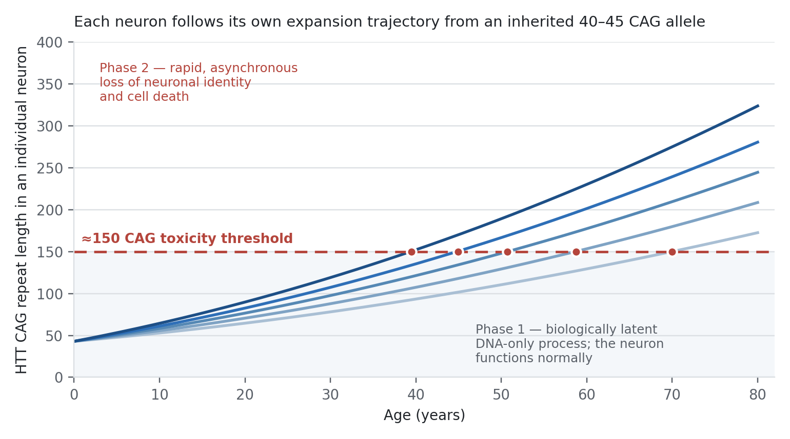
Figure 3. Two-phase model of HD pathogenesis at the level of the single neuron. Each line is an illustrative neuron whose inherited 40–45 CAG allele expands at its own rate; the dashed line marks the shared toxicity threshold of approximately 150 CAGs. Below the threshold the process is biologically latent; above it the neuron rapidly loses identity and dies. Schematic drawn for this review; the inherited range, the expansion range (to 100–500+ CAGs) and the ≈150-CAG threshold are the values reported by Handsaker et al., Cell 2025 [11]. Individual trajectories are illustrative, not measured.

5.2 The same threshold in cortex
Striatal and cortical degeneration in HD differ in timing and severity, and cortical loss has often been treated as secondary to striatal loss, or vice versa, given the dense corticostriatal projection. Analysis of more than 130,000 nuclei from 12 cortical areas of HD donors argues otherwise. Cortical and striatal neurodegeneration follow analogous, cell-autonomous sequences, each instructed by somatic expansion of that neuron's own repeat; the ≈150-CAG toxicity threshold is shared across striatal and cortical projection neurons of all types; and cortical area, layer and axonal projection act only as proxies for the true variable, which is an up to 50-fold difference between pyramidal neuron subtypes in the probability of reaching the threshold within a human lifespan [19]. This work is currently a preprint and has not completed peer review, but if it holds, containing expansion below the threshold would protect both regions by the same mechanism.

5.3 Rate, threshold and phenotype in mouse models
Mouse models convert the threshold model into measurable kinetics. In purified Q140 medium spiny neuron nuclei, modal repeat length increases with striking linearity at 8.8 repeats per month (R = 0.98). Heterozygous Msh3 deletion reduces this to 2.3 repeats per month and homozygous deletion to 0.3 — a near-complete arrest (Figure 2). Msh3- or Pms1-deficient animals keep somatic repeat length below 150 and, correspondingly, show no mutant huntingtin aggregation; Q140 mice homozygous for Msh3 knockout lack visible brain aggregates even at 20 months. Msh3 deficiency also corrects synaptic marker loss, astrogliosis and locomotor impairment, and ameliorates open-chromatin dysregulation [9, 14].
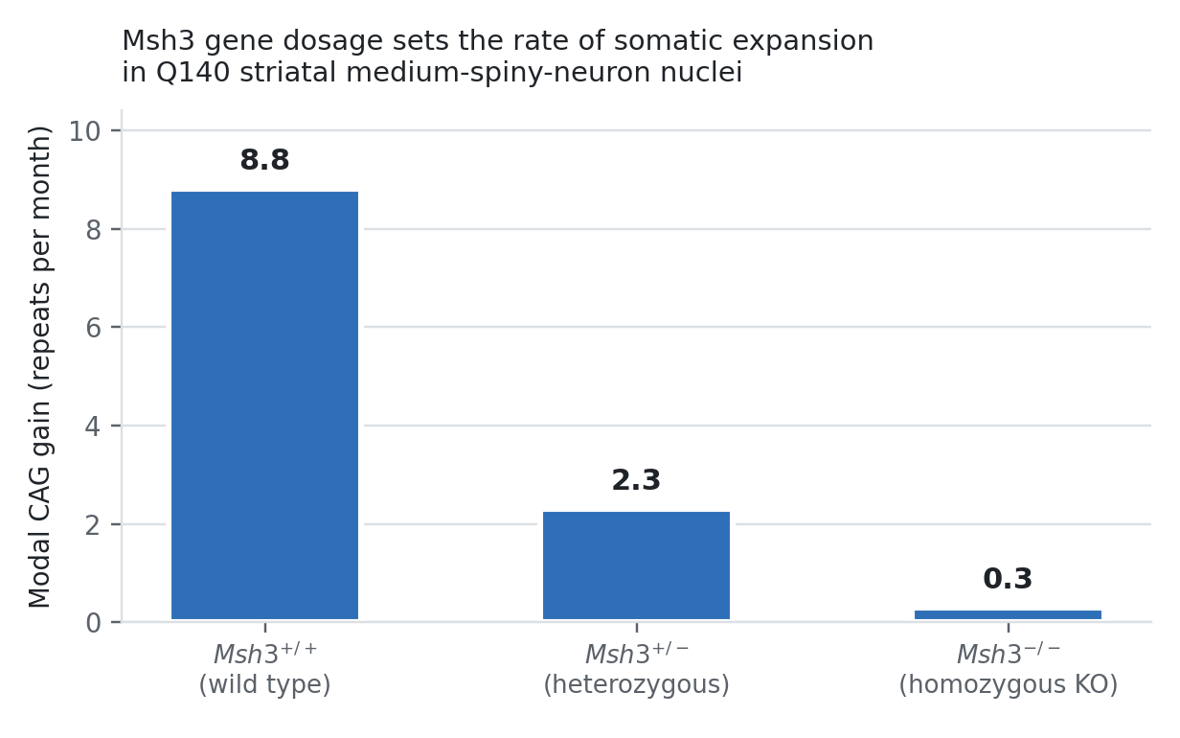
Figure 2. Msh3 gene dosage sets the somatic expansion rate. Modal CAG gain per month in purified Q140 medium spiny neuron nuclei by Msh3 genotype. Chart built for this review; values (8.8, 2.3 and 0.3 repeats per month) are those reported by Wang et al., Cell 2025 [9].
The mouse work also imposes an important caveat on model selection. The widely used zQ175 knock-in line carries approximately 185 CAGs — already above the human toxicity threshold — so somatic expansion in that model operates on a tract that has, in the terms of Section 5.1, already crossed the line. A systematic analysis of the CAG repeat threshold for therapeutics targeting somatic instability concluded that the pathogenic threshold in brain is considerably longer than the (CAG)40 measured in blood and that model choice must reflect this if candidate therapies are to be evaluated meaningfully [15].
One result usefully complicates the picture. In Hdh^{Q111} mice, a 75% reduction in MSH3 protein proportionally reduced somatic expansion yet left striatal nuclear huntingtin aggregates unchanged; the same study detected a nuclear Msh3 mRNA pool inaccessible to RNA interference, and compensatory upregulation of MSH6 protein following MSH3 knockdown [13]. Slowing expansion and reversing established pathology are not the same endpoint, and partial knockdown may not be sufficient for the latter.
Table 2. Effect of lowering individual mismatch repair factors on somatic CAG expansion, across three experimental systems.
Factor | Human iPSC / MSN (CRISPRi) [12] | Q140 mouse knockout [9] | Other evidence
MSH2 | Largest slowing of expansion | Moderate rescue of striatal triad | Obligate MutSβ partner; loss also abolishes MutSα
MSH3 | Largest slowing of expansion | Strong rescue; no aggregates at 20 months; locomotor rescue | ASO [14] and divalent siRNA [7] block expansion; MSH3 level is rate-limiting, slope ≈ 1 [13]
MLH1 | Largest slowing of expansion | Moderate rescue | Sequestered by FAN1 SPYF motif [10]
MLH3 | Lesser but significant slowing | Not among strong rescuers | Expansion-score modifier in patients [6]
PMS1 | Lesser but significant slowing | Strong rescue, comparable to Msh3 | Target of SKY-0515 in Phase 2/3 [Table 4]
PMS2 | Lesser but significant slowing | Not among strong rescuers | rs1805323 modifies onset across polyQ diseases [1]
FAN1 (loss) | Not applicable — protective factor | Not applicable | Knockdown increases expansion; overexpression reduces it; nuclease-independent [2, 10]
Table 2. Compiled for this review from the cited studies. Entries summarise the qualitative ranking reported by each source; the three systems differ in repeat length, cell type and knockdown depth, so magnitudes are not directly comparable across columns.

6. Therapeutic implications

6.1 The target rationale, and why MSH3 came first
The therapeutic logic follows directly from Sections 3–5. If onset timing is set by the rate at which a neuron's repeat approaches a toxicity threshold, then reducing that rate should postpone onset, and doing so before the threshold is approached should be more valuable than doing so afterwards. This is a fundamentally different proposition from huntingtin lowering, which addresses the protein consequence; the two are complementary rather than competing.
Among the modifiers, MSH3 has attracted most attention for a specific safety reason. Suppressing a mismatch repair gene for decades raises an obvious concern about microsatellite instability and cancer risk. But MSH3 is relatively tolerant of loss-of-function variation in humans, and unlike other MMR genes, nullizygosity for MSH3 does not cause the malignancies associated with mismatch repair deficiency [14, 15]. The clinical genetics literature is consistent with this: heterozygous MSH3 defects alone do not produce a Lynch syndrome phenotype, although biallelic defects have been reported in adenomatous polyposis and heterozygous variants may aggravate an MSH6 phenotype in affected families [20]. The margin is real but not unlimited, and chronic partial reduction in adults is a different exposure from germline nullizygosity. Reassuringly, divalent siRNA silencing of Msh3 in two HD mouse models blocked striatal CAG expansion without affecting tumour-associated microsatellite instability or the mRNA expression of other MMR genes [7], and bulk RNA sequencing of MSH3-targeting antisense oligonucleotide-treated neurons showed a safe transcriptional profile even at greater than 95% knockdown [14].

6.2 Nucleic acid modalities: antisense oligonucleotides and divalent siRNA
An MSH3-targeting antisense oligonucleotide engaged its RNA target in iPSC-derived striatal neurons from a patient carrying 125 CAG repeats, producing dose-dependent MSH3 reduction and stalling CAG expansion. Maximal knockdown also slowed expansion in striatal neurons engineered for an accelerated expansion rate by CRISPR-Cas9 FAN1 knockout in the same line — a stringent test, since removing the protective brake maximises the rate the drug must overcome. A knock-in mouse expressing the human MSH3 gene confirmed effective in vivo reduction after ASO treatment [14].
In parallel, a fully chemically modified siRNA silencing Msh3, synthesised in a divalent scaffold that improves distribution in the central nervous system, blocked CAG expansion in the striatum of two HD mouse models [7]. Dose–response work with the same chemistry established the near-linear MSH3–expansion relationship described earlier, and flagged the two practical caveats — an RNAi-inaccessible nuclear mRNA pool and MSH6 upregulation — that a clinical programme will need to address [13].

6.3 Small molecules and the first clinical test of the hypothesis
Nucleic acid therapeutics for the brain require intrathecal or intraparenchymal delivery. An orally available small molecule would be preferable, particularly for a treatment likely to be started in pre-manifest carriers and continued for decades. SKY-0515, an oral small-molecule mRNA splicing modulator, is the first agent to bring the somatic expansion hypothesis into randomised clinical testing. It lowers HTT mRNA, and thus both wild-type and mutant huntingtin, and additionally lowers PMS1 — the protein identified as a strong expansion driver in the Q140 knockout series [9]. The sponsor reports dose-dependent reduction of HTT and PMS1 mRNA in healthy volunteers with acceptable tolerability. Falcon-HD (NCT06873334), a randomised, double-blind, placebo-controlled Phase 2/3 dose-ranging study, enrolled 120 participants aged 25 or older with genetically confirmed HD (CAG ≥ 40) across sites in Australia and New Zealand, with co-primary endpoints of change in blood mutant huntingtin, MRI brain volume, and UHDRS over 12 months; a larger 400-participant study (NCT07378644) began in January 2026.
Two points deserve emphasis. First, because SKY-0515 lowers both HTT and PMS1, a positive result will not by itself isolate the contribution of expansion suppression. Second, none of the primary endpoints directly measures somatic expansion in brain; the field's central quantity remains, for now, clinically unobservable.

6.4 Structure-guided discovery
Direct inhibition of MutSβ — rather than reduction of MSH3 abundance — would allow acute, reversible and dose-titratable control, which is attractive given the chronic exposure envisaged. The cryo-EM structures of human MutSβ in its DNA-free, (CAG)2-bound, sliding-clamp and ATP-bound states provide the necessary foundation, identifying conformational transitions that a small molecule could trap or block [18]. An inhibitor that prevented the recognition-to-clamp transition, or that blocked MutL recruitment without disabling MutSα-dependent repair, would be the most selective intervention yet proposed.
Table 3. Therapeutic modalities directed at somatic CAG repeat expansion.
Modality | Target | Stage of evidence | Principal finding and limitation
Antisense oligonucleotide | MSH3 mRNA | Patient iPSC-derived striatal neurons; humanised mouse | Dose-dependent MSH3 reduction stalls expansion, including in FAN1-null accelerated cells; safe transcriptome at >95% knockdown; requires intrathecal delivery [14]
Divalent siRNA | Msh3 mRNA | Two HD mouse models, dose–response | Blocks striatal expansion without altering tumour-associated microsatellite instability; nuclear mRNA pool partly inaccessible; MSH6 upregulation observed [7, 13]
Oral splice modulator | HTT and PMS1 mRNA | Randomised Phase 2/3 (see Table 4) | First clinical test of expansion suppression; dual mechanism means a positive result will not isolate the expansion contribution
MutSβ small-molecule inhibitor | MSH2–MSH3 protein | Structure-enabled; preclinical | Cryo-EM states define druggable conformational transitions; no disclosed clinical candidate [18]
FAN1 pathway stabilisation | FAN1–MLH1 (SPYF) interaction | Concept; mechanism defined | Protection is nuclease-independent and acts by restricting MutL recruitment; no reported chemical matter [2, 10]
Gene-editing / CRISPRi | Any MMR factor | Human ex vivo validation platform | Establishes target ranking and the knockdown depth required; delivery to human brain unsolved [12]
Table 3. Compiled for this review from the cited sources. Stage of evidence reflects the highest level reported in the retrieved literature as of September 2026.
Table 4. Selected interventional trials relevant to the somatic expansion and huntingtin-lowering strategies.
NCT number | Agent | Sponsor | Phase | Design and relevance
NCT06873334 (Falcon-HD) | SKY-0515 | Skyhawk Therapeutics | 2/3 | Randomised, double-blind, placebo-controlled dose-ranging; n = 120; started May 2025; lowers HTT and PMS1 mRNA; co-primary endpoints blood mutant HTT, MRI volume, UHDRS at 12 months
NCT07378644 | SKY-0515 | Skyhawk Therapeutics | 2/3 | Randomised, double-blind, placebo-controlled; n = 400; started January 2026
NCT05686551 (GENERATION HD2) | Tominersen | Hoffmann-La Roche | 2 | HTT-lowering antisense oligonucleotide; n = 301; prodromal and early manifest HD; dose-finding after the halted Phase 3
NCT04120493 / NCT05243017 | AMT-130 (rAAV5-miHTT) | uniQure | 1/2 | One-time intrastriatal gene therapy lowering total HTT; n = 43 and n = 14
NCT06585449 | ALN-HTT02 | Alnylam | 1 | Intrathecal siRNA against HTT; single ascending dose; n = 66
NCT03761849 (GENERATION HD1) | Tominersen | Hoffmann-La Roche | 3 | Completed; n = 899; the trial whose outcome prompted the current re-evaluation of dose and disease stage
Table 4. Data retrieved from ClinicalTrials.gov (NIH/NLM registry), September 2026. No trial in the registry currently uses somatic repeat expansion in brain as a primary endpoint.

7. Current research and open questions
Five questions determine whether this mechanism becomes a medicine.

7.1 How early must treatment begin?
If the threshold model is right, then a therapy started after motor onset is acting on a population in which a substantial fraction of vulnerable neurons have already crossed 150 CAGs, and in which the surviving neurons are the ones nearest the threshold. The value of expansion suppression should therefore be greatest in pre-manifest carriers and should fall as the disease advances. This makes the pivotal trial expensive, long, and dependent on a surrogate endpoint — and it means a null result in manifest patients would not refute the hypothesis.

7.2 How will expansion be measured in a living brain?
Somatic expansion in blood is measurable, predicts outcome [6], and is already used as a modifier phenotype in GWAS [8]. But the same 2025 analysis identified a variant that promotes blood expansion without influencing clinical HD [8], and expansion rates differ markedly between cell types [19]. Blood is therefore a pharmacodynamic readout of target engagement, not a biomarker of the process that kills neurons. Whether a cerebrospinal fluid measure — for example, repeat-length distributions in neuron-derived cell-free DNA — can bridge this gap is, on the evidence retrieved here, unresolved.

7.3 What is the safe depth and duration of MMR suppression?
The MSH3 safety argument rests on human loss-of-function tolerance and on mouse data showing no change in tumour-associated microsatellite instability [7, 14]. Both are reassuring for MSH3 specifically. They do not transfer automatically to PMS1, MLH1 or MSH2, where MMR deficiency is unambiguously oncogenic, and they say little about decades of continuous exposure beginning in a person's thirties. The compensatory MSH6 upregulation seen after MSH3 knockdown [13] is a reminder that the network adapts.

7.4 Does slowing expansion reverse anything?
The most sobering datum in this literature is that a 75% MSH3 reduction, which proportionally slowed expansion, left existing striatal huntingtin aggregates unchanged [13]. Expansion suppression is plausibly preventive rather than restorative. Whether neurons that have crossed the threshold but not yet died can be rescued, and whether the transcriptional collapse described by single-nucleus analysis [11] is reversible, are open.

7.5 How far does this generalise?
Mismatch repair drives expansion at CAG·CTG, CGG·CCG and GAA·TTC repeats [16]; DNA repair variants modify onset across HD and the polyglutamine spinocerebellar ataxias [1]; and the MSH3 exon-1 variant modifies both HD and myotonic dystrophy type 1 [4]. More than forty human disorders are caused by expanded tandem repeats. If expansion rate is the common clock, a single mechanism-based therapy could in principle address a large group of otherwise unrelated diseases — the most consequential implication of this work, and the least tested.

8. Conclusion
Huntington's disease has been reinterpreted. The inherited CAG repeat is not the disease genotype but its seed; the genotype that matters is the one a given neuron has reached, and the disease is for most of a neuron's life an ongoing mutational process rather than a proteinopathy. Human genetics pointed to this conclusion first, through the improbable convergence of onset modifiers on mismatch repair and the demonstration that pure CAG length, not polyglutamine length, sets the clock. Single-cell measurement in human brain supplied the missing quantitative link: a shared toxicity threshold near 150 repeats, approached at cell-type-specific rates, crossed asynchronously, and followed by rapid loss of neuronal identity. Mouse genetics supplied the tractable variable: expansion rate, which scales with MSH3 dosage and collapses when Msh3 or Pms1 is removed.
What follows is a therapeutic hypothesis of unusual clarity — hold the repeat below the threshold and the neuron survives — attached to a set of unusually difficult trial problems: the treatment should be given before symptoms, the mechanism cannot yet be measured where it matters, and the first compound in randomised testing perturbs two targets at once. The hypothesis is, at last, in the clinic. Whether the brake can be applied early enough, deeply enough and safely enough to change a person's trajectory is the question the next decade will answer.

References
All sources below were retrieved from PubMed / PubMed Central, bioRxiv or ClinicalTrials.gov. According to PubMed, the bibliographic details are as listed; DOIs are given where available.
1. Bettencourt C, Hensman-Moss D, Flower M, Wiethoff S, Brice A, Goizet C, et al. DNA repair pathways underlie a common genetic mechanism modulating onset in polyglutamine diseases. Ann Neurol. 2016;79(6):983–990. DOI: 10.1002/ana.24656. PMID: 27044000.
2. Goold R, Flower M, Moss DH, Medway C, Wood-Kaczmar A, Andre R, et al. FAN1 modifies Huntington's disease progression by stabilizing the expanded HTT CAG repeat. Hum Mol Genet. 2019;28(4):650–661. DOI: 10.1093/hmg/ddy375. PMID: 30358836.
3. Genetic Modifiers of Huntington's Disease (GeM-HD) Consortium (consortium authorship). CAG Repeat Not Polyglutamine Length Determines Timing of Huntington's Disease Onset. Cell. 2019;178(4):887–900.e14. DOI: 10.1016/j.cell.2019.06.036. PMID: 31398342.
4. Flower M, Lomeikaite V, Ciosi M, Cumming S, Morales F, Lo K, et al. MSH3 modifies somatic instability and disease severity in Huntington's and myotonic dystrophy type 1. Brain. 2019;142(7):1876–1886. DOI: 10.1093/brain/awz115. PMID: 31216018.
5. Lee J-M, Huang Y, Orth M, Gillis T, Siciliano J, Hong E, et al. Genetic modifiers of Huntington disease differentially influence motor and cognitive domains. Am J Hum Genet. 2022;109(5):885–899. DOI: 10.1016/j.ajhg.2022.03.004. PMID: 35325614.
6. Ciosi M, Maxwell A, Cumming SA, Hensman Moss DJ, Alshammari AM, Flower MD, et al. A genetic association study of glutamine-encoding DNA sequence structures, somatic CAG expansion, and DNA repair gene variants, with Huntington disease clinical outcomes. EBioMedicine. 2019;48:568–580. DOI: 10.1016/j.ebiom.2019.09.020. PMID: 31607598.
7. O'Reilly D, Belgrad J, Ferguson C, Summers A, Sapp E, McHugh N, et al. Di-valent siRNA-mediated silencing of MSH3 blocks somatic repeat expansion in mouse models of Huntington's disease. Mol Ther. 2023;31(6):1661–1674. DOI: 10.1016/j.ymthe.2023.05.006. PMID: 37177784.
8. Consortium authorship (see publication). Genetic modifiers of somatic expansion and clinical phenotypes in Huntington's disease highlight shared and tissue-specific effects. Nat Genet. 2025;57(6):1426–1436. DOI: 10.1038/s41588-025-02191-5. PMID: 40490511.
9. Wang N, Zhang S, Langfelder P, Ramanathan L, Plascencia M, Gao F, et al. Distinct mismatch-repair complex genes set neuronal CAG-repeat expansion rate to drive selective pathogenesis in HD mice. Cell. 2025;188(6):1524–1544.e22. DOI: 10.1016/j.cell.2025.01.031. PMID: 39938516.
10. Goold R, Hamilton J, Menneteau T, Flower M, Bunting EL, Aldous SG, et al. FAN1 controls mismatch repair complex assembly via MLH1 retention to stabilize CAG repeat expansion in Huntington's disease. Cell Rep. 2021;36(9):109649. DOI: 10.1016/j.celrep.2021.109649. PMID: 34469738.
11. Handsaker RE, Kashin S, Reed NM, Tan S, Lee W-S, McDonald TM, et al. Long somatic DNA-repeat expansion drives neurodegeneration in Huntington's disease. Cell. 2025;188(3):623–639.e19. DOI: 10.1016/j.cell.2024.11.038. PMID: 39824182.
12. Ferguson R, Goold R, Coupland L, Flower M, Tabrizi SJ. Therapeutic validation of MMR-associated genetic modifiers in a human ex vivo model of Huntington disease. Am J Hum Genet. 2024;111(6):1165–1183. DOI: 10.1016/j.ajhg.2024.04.015. PMID: 38749429.
13. Driscoll R, Hampton L, Abraham NA, Larigan JD, Joseph NF, Hernandez-Vega JC, et al. Dose-dependent reduction of somatic expansions but not Htt aggregates by di-valent siRNA-mediated silencing of MSH3 in HdhQ111 mice. Sci Rep. 2024;14(1):2061. DOI: 10.1038/s41598-024-52667-3. PMID: 38267530.
14. Bunting EL, Donaldson J, Cumming SA, Olive J, Broom E, Micăuș M, et al. Antisense oligonucleotide-mediated MSH3 suppression reduces somatic CAG repeat expansion in Huntington's disease iPSC-derived striatal neurons. Sci Transl Med. 2025;17(785):eadn4600. DOI: 10.1126/scitranslmed.adn4600. PMID: 39937881.
15. Aldous SG, Smith EJ, Landles C, Osborne GF, Cañibano-Pico M, Nita IM, et al. A CAG repeat threshold for therapeutics targeting somatic instability in Huntington's disease. Brain. 2024;147(5):1784–1798. DOI: 10.1093/brain/awae063. PMID: 38387080.
16. Schmidt MHM, Pearson CE. Disease-associated repeat instability and mismatch repair. DNA Repair (Amst). 2015;38:117–126. DOI: 10.1016/j.dnarep.2015.11.008. PMID: 26774442.
17. Bai D, Zhu L, Jia Q, Duan X, Chen L, Wang X, et al. Loss of TDP-43 promotes somatic CAG repeat expansion in Huntington's disease knock-in mice. Prog Neurobiol. 2023;227:102484. DOI: 10.1016/j.pneurobio.2023.102484. PMID: 37315918.
18. Lee JH, Thomsen M, Daub H, Thieulin-Pardo G, Frank F, Kaltenbach L, et al. Elucidation of multiple high-resolution states of human MutSβ by cryo-EM reveals interplay between ATP/ADP binding and heteroduplex DNA recognition. Nucleic Acids Res. 2025;53(12):gkaf604. DOI: 10.1093/nar/gkaf604. PMID: 40613711.
19. Kashin S, Lee W-S, McDonald TM, Morris K, Handsaker RE, Mello C, et al. A shared DNA-repeat toxicity threshold, reached somatically at cell-type-specific rates, unites cortical and striatal neurodegeneration in Huntington's disease. bioRxiv [preprint]. 2025. DOI: 10.64898/2025.12.09.688862. PMID: 41427302. Not peer reviewed.
20. Morak M, Käsbauer S, Kerscher M, Laner A, Nissen AM, Benet-Pagès A, et al. Loss of MSH2 and MSH6 due to heterozygous germline defects in MSH3 and MSH6. Fam Cancer. 2017;16(4):491–500. DOI: 10.1007/s10689-017-9975-z. PMID: 28528517.
21. Wang N, Zhang S, Langfelder P, Ramanathan L, et al. Msh3 and Pms1 Set Neuronal CAG-repeat Migration Rate to Drive Selective Striatal and Cortical Pathogenesis in HD Mice. bioRxiv [preprint]. 2024. DOI: 10.1101/2024.07.09.602815. PMID: 39026894. Preprint of reference 9.
22. Maiuri T, Hung CLK, Suart C, Begeja N, Barba-Bazan C, Peng Y, et al. DNA Repair in Huntington's Disease and Spinocerebellar Ataxias: Somatic Instability and Alternative Hypotheses. J Huntingtons Dis. 2021;10(1):165–173. DOI: 10.3233/JHD-200414. PMID: 33579859.
23. ClinicalTrials.gov (NIH/NLM). Falcon-HD: Study of SKY-0515 for Safety, Efficacy, and Pharmacodynamics in Participants With Huntington's Disease. NCT06873334. https://clinicaltrials.gov/study/NCT06873334
24. ClinicalTrials.gov (NIH/NLM). A Phase 2/3 Dose Ranging Study of SKY-0515 in Participants With Huntington's Disease. NCT07378644. https://clinicaltrials.gov/study/NCT07378644
25. ClinicalTrials.gov (NIH/NLM). Additional registry records consulted: NCT05686551 (tominersen, Phase 2); NCT04120493 and NCT05243017 (AMT-130); NCT06585449 (ALN-HTT02); NCT03761849 (GENERATION HD1).
Note on sources and figures. Every factual claim in this review traces to one of the numbered references, all of which were retrieved through PubMed/PubMed Central, bioRxiv or the ClinicalTrials.gov registry. Figures 1–3 and Tables 1–4 were constructed for this review; no copyrighted figure has been reproduced. Where a figure displays numerical values (Figure 2) those values are quoted from the cited source and the source is named in the caption; where a figure is illustrative (Figures 1 and 3) the caption states so explicitly. Reference 19 is a preprint and has not completed peer review.

