Artistree: iOS Location Based Marketing Application for Music Retail

Chapter 2: Literature Review

Nicolas Roldos

Background and Literature Review

A brief literature review was done to articulate relevant concepts that are key to understanding the Artistree LBS application. Since Artistree uses LBS for its core functionalities, LBS is discussed along with relevant technologies location based application design, privacy and adaptation in chapter 2.1. In order to define areas where participating users should be notified on store events a virtual perimeter or geo-fence is created. The concept of a geo-fence and its use in other location-aware mobile applications is described in section 2.2. Finally, Esri’s Geotrigger service efficiency, accuracy and user benefits are described section 2.3.

Location Based Services
Location based services or LBSs have been around since at least 1996 in the United States when the Federal Communications Commission issued the E911 mandate allowing emergency response services to determine a 911 wireless caller’s latitude and longitude via information from U.S. cellular providers (Junglass, 2008). LBS in a general sense have two major functions, which most experts on the subject will agree on. The first major function of LBS is obtaining the location of a user, via their device, associated networks and positioning systems, and second, utilizing this information to provide a service (Kyamakya, 2004). While the use of location for 911 services exemplifies the earliest widespread adoption of LBS, location information has become an important component of an array of services available to businesses and individuals today.
According to the Association for Computer Machinery, or ACM, LBS is any service that utilizes the geographic location of an entity to provide either a location-tracking service or location-aware service (Junglass, 2008). ACM’s distinction between these two services lies in who requests location information to provide the service. A location-tracking service provides information on a user’s location to an entity other than the user, such when a 911 service locates a caller, or when delivery truck-tracking systems are used to increase efficiency of a fleet. A location-aware service on the other hand supplies the user with location information based on a user-defined query. Examples of location-aware services could include requesting directions to point B from user’s current location A, or finding the cheapest gasoline at gas stations no more than 5 miles from a passenger’s location in a moving car.
While ACM provides a distinction to between location-tracking and location-aware services, other definitions of LBS describe the service as it relates to the technologies it utilizes. It is widely recognized that LBS exists at an intersection of technologies including GIS, the Internet and new information technologies or NCITs (Brimicombe, 2002). The figure below adapted from Brimicombe shows how these three technology categories ultimately influence LBS.

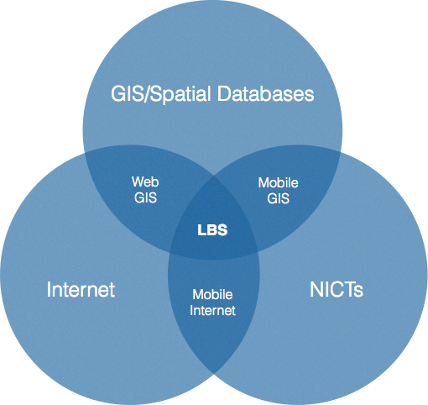

Figure 2.1: Intersection of technologies contributing to LBS (Adapted from Brimicombe 2002).

The following sections describe components, classifications, user actions, design and adaption, and last but not least positioning technologies involved in LBS applications.

Components of a LBS
Throughout most of academic literature it is a common assertion that LBSs are made up of or require at least five technological components. These include but are not limited to: mobile devices, positioning systems, communication networks, service and application providers, and the data or content provider, with a sixth human component known as the LBS user (Buczkowski, 2012). The four components in the top portion of the diagram all communicate with the mobile device that in effect relays location based information to the user of the service.

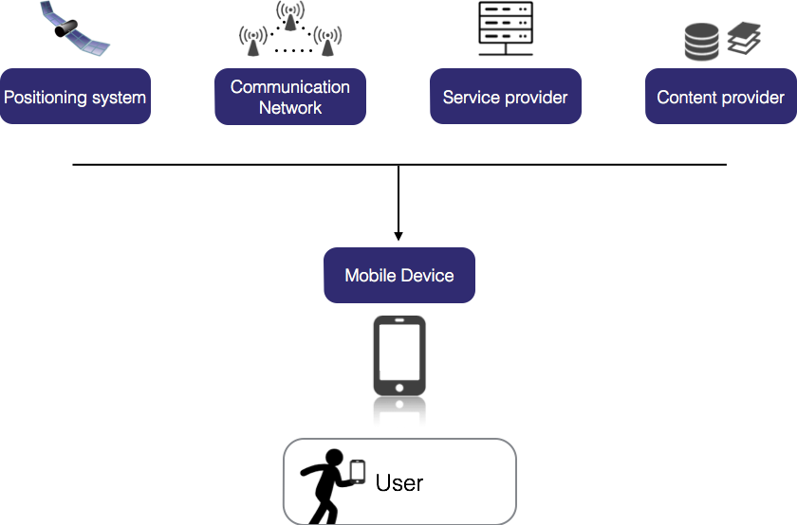

Figure 2.2: Six main components in structure of LBS (adapted from description by Buczkowski 2012).

Classifications of LBS
Just as the location-tracking and location-aware distinctions were made at the beginning of this chapter other taxonomy can describe different types of LBSs. Another way to describe LBS is by categorizing it as a “push” or “pull” service in regard to how information is delivered with respect to the LBS user (Steiniger et al. 2004). If a mobile device user requests delivery of location based information then this is a pull service; such as requesting locations of the cheapest gas stations within 5 miles of the users location. On the other hand when location based information is delivered to the user, triggered by a timer or location based event, then the service is a push service.
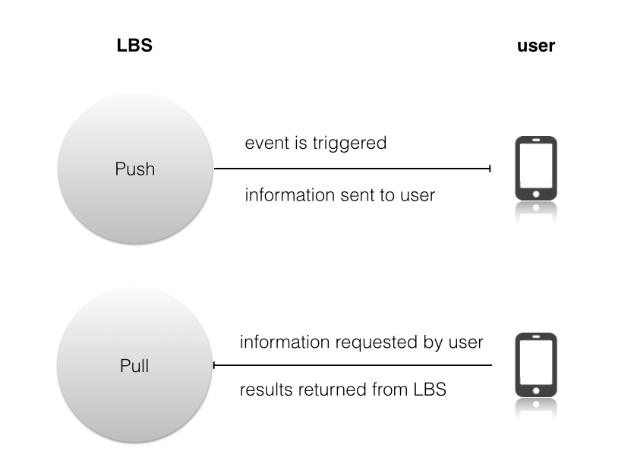
Figure 2.3: Push and Pull Location Based Services

Another important consideration in classifying LBS is whom the user is sharing location with and what is driving the user to their share location (Tang et al. 2010). A user may share their location with the service provider in order to receive value-added personalized location information or services; this is known as purpose driven. Alternatively the user may share their location with a social network driven by unique incentives provided by that social network (Buczkowski, 2012). Understanding incentives and drives is important when working on an application that utilizes LBS in order to tailor the interface and component to fit user requirements and expectations.

Finally whether or not a user will be indoors or outdoors can dictate the positioning component of LBS and is an important distinction to classify a LBS application. In the case of indoor services Wi-Fi infrastructure may be necessary to pinpoint users inside stores or shopping malls. Google for example has incorporated indoor navigation into its mapping services as of a November 2011 announcement (Buczkowski, 2012). While this is a more recent development it is worth noting, as a type of LBS that reaches users in a spatial context that is important for Location-Based Marketing applications.

Typical User Actions for LBS
After classifying LBS it is important to define what actions our users will take while using a mobile LBS application. LBS applications typically involve five elementary geo-location based mobile actions: locating, navigating, searching, identifying and checking (Reichenbacher, 2004). These can be identified as pull-services since the user is the one requesting the information. The figure below, adapted from Reichenbacher, describes these five actions or activities in more detail with regards to what questions a user typically asks and what operations are necessary by the LBS to answer the question.

Associated Symbol | Action | Questions | Operations
 | Orientation and localization  Locating | Where am I? Where is {person/object/destination}? | Positioning, geocoding
 | Navigation  Navigation through space and/or planning a route. | How do I get to {place name/address/x, y}? | Positioning, geocoding, routing
 | Search  Searching for people or objects. | Where is the  {nearest/most relevant} {person or object} | Positioning, geocoding, calculating distance and area, finding relationships
 | Identification  Identifying and recognizing persons or objects. | {who/what/how much} is {here/there} | Directory, selection, thematic classification/ spatial query/ search
 | Event Check  Checking foe events; Determining the state of objects. | What happens {here/there}? | Spatial query/ non-spatial query, finding relationships

Figure 2.4: LBS user activities (adapted from Reichenbacher 2004).

It is interesting to note here that the information required for searching, identifying and checking actions includes a greater variety of information while the information required for navigating and localization consists of primarily geospatial information (Steiniger et al, 2012). This is important because a LBS application that intends to serve these user-requested actions must include the appropriate information to fulfill the tasks of searching, identifying and or checking. Design and adaption to user requirements and actions for a LBS application are described in the following section.

Adaptation of LBS to user requests, context and privacy
Since LBS is inherently a context-aware service, context as it relate to user experience and actions is an important consideration. The main types of context a LBS deals with in almost any application include where the user is (location), when they are using the service (temporal), what they are using the service for (task); also known as location, time and task (Steiniger et al, 2012). These are the most general and common considerations, however there are various categories of context that an LBS application developer should consider. Experts on mobile location-based services have come up with nine types of context important to consider in LBS development: mobile map user, location, time, purpose of use, social and cultural situation, physical surroundings, orientation, navigation history, system properties (Nivala, 2003).
Navigation history in particular raises the question of privacy for the user. While enhancing user experience and precisely catering to a customer’s preferences, LBS business or marketing applications often raise user fears of privacy (Steiniger et al. 2012). In order to avoid scaring potential users away there are techniques of assuring users that their information is secure and only used for core application functions. It is best practice for LBS applications today to alert the user about location and other types of information that is collected by the application and secure data transfer; additionally LBS users should have the option to decide if context based features, that collect this type of information, are enabled or disabled (Steiniger et al. 2012).
Adaptation to the nine categories described above can take place at different levels of a LBS application and is often represented by the mobile cartography of such an application. LBS adaptation is seen at four different levels according to experts on the topic: information level, technology level, user interface level and presentation level (Reichenbacher, 2004). These four levels will be described with examples in the following.
At the information level, information content adapts to user actions or changes in a user’s location. For example, when a user zooms into a mobile map greater detail on surroundings at a users current location (Timpf et al 2003). At the technological level an applications capabilities adapt to data available from positioning components and services depending on the users surroundings. For example in a city a LBS application will take location information provided by assisted GPS and available Wi-Fi networks and adjust location accuracy based on these available positioning technology and data. Outside of the city, where there is a scarcity of Wi-Fi networks, the LBS will adapt to only using GPS and assisted GPS if available to calculate location.
When it comes to user interface this is the most noticeable adaptive component of a LBS app to a user. A fairly common example of user interface adaption in LBS applications is the auto-panning or readjusting of mobile map extents when a user moves from one position to another. At presentation level mobile-map cartography is typically involved in crafting a visualization of information based on user preferences or application settings. For example, retail stores more relevant to a user’s price and location preferences may be presented as larger pinpoints on a mobile map than less relevant search results (Steiniger 2012). The following diagram shows how user activities influence adaptation at different levels for a LBS application.

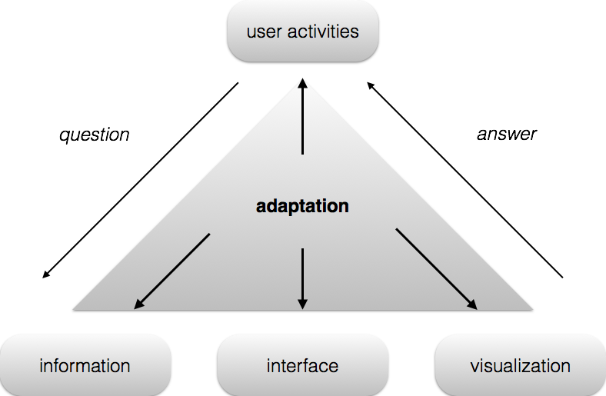

Figure 2.5: Levels of adaptation to user query/activity (adapted from Reichenbacher 2004)

Mobile device positioning methods
Positioning is probably the most important component of LBS since location of a user’s device is the key to providing the majority of LBS services. If manual input of position is not considered as a location method then network-based positioning and terminal-based positioning are the two main categories for positioning methods (Steiniger, 2012). Network-based positioning systems work within cellular providers’ network infrastructure. In this case an infrastructure comprised of cellular provider base stations, which already relay service to devices, sense devices sending signals back to them and location is calculated by a control station (Steiniger, 2012). There are various methods to calculate location of a device in a network-based positioning system however a few stood out in this literature review. In a broad scope positioning calculation methods include Angle-of-Arrival (AOA), Received Signal Strength Indicator (RSSI), Cell Identity (ID), Round Trip Delay (RTD) and Enhanced Observed Time Difference (EOTD) (Kyamakya, 2004). The most common network positioning strategies according to available literature today use Cell ID with the nearest base transceiver station (BTS).
Cell ID as a positioning strategy is mostly useful within urban areas. According to experts, while Cell ID (or Cell of Origin) is the simplest form of device localization available in cellular networks Cell ID’s accuracy ranges from a hundred to two hundred meters at best in urban areas to several kilometers in rural areas (Labrador et. al., 2011). This makes sense because cellular providers tend to have more base stations in urban areas to accommodate a higher volume of mobile device users. In such urban environments with many cellular provider BTSs positional accuracy can be enhanced by use of the multiple stations and also additional calculation parameters, which use signal angles or temporal characteristics of a signal; some examples of these parameters are AOA (Angle of Arrival), TDOA (Time Difference of Arrival) and TOA (Time of Arrival) (Trevisani et al., 2004). Cell ID positioning accuracy depends on not only the amount of BTSs but also calculation parameters chosen by providers at control stations.

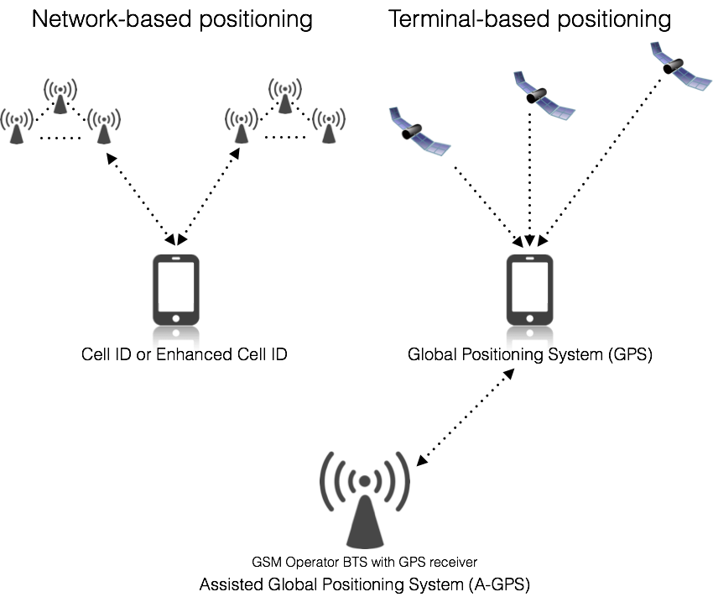

Figure 2.6: Network and Terminal based positioning systems (Adapted from Reichenbacher 2004).

Terminal-based positioning systems, such as Global Positioning Systems (GPS), and Assisted GPS are great in when used with a clear view of the sky and rely on a group of satellites orbiting the earth to send out signals to mobile device users to reach the overall goal device localization. In other words a GPS determines the position of a receiver (mobile device user) by calculating differences in time for signals from at least three satellites to reach a receiver (Trevisani et al., 2004); differences in time that are later combined for use with a mathematical method called trilateration that determines not only location but speed and elevation (Ferraro et al., 2011). GPS is overall more accurate than network-based positioning systems however it has its complications. Some of the disadvantages of GPS include slow set-up times, its consumption of battery power on mobile devices, dependency on many satellites to obtain an accurate position (more than the minimum of three) and inoperability indoors (Trevisani et al., 2004). While GPS can have its complications it is still the preferred positioning system for LBS location-tracking services or precise location-aware applications like navigation services.
Assisted GPS (A-GPS) can help overcome some of the complications mentioned above. A-GPS uses satellites that communicate with Global System for Mobile, or GSM, operator and BTS stations to improves accuracy, reduces battery consumption and speeds up initial location tracking or Time To First Fix (TTFF) (Trevisani et al., 2004; Ferraro et al., 2011). There are a lot of ways this combination of GPS, provider network and BTS can be configured to provide better accuracy in some areas or better accuracy and less battery consumption for specific types of application however these various configurations will not be discussed in the literature review as LBS configuration for Artistree will be discussed in the implementation section of this report.
The latest frontier in positioning systems for LBS includes Wi-Fi, or Wireless-Fidelity, and Bluetooth technologies. Additionally these systems do not drain as much battery as GPS or cellular network positioning. New location based services take advantage of existing indoor Wi-Fi networks to deploy services indoors and at storefronts using an energy saving positioning method which does not require exploitation of precise user locations; the service uses the location of the Wi-Fi network instead a users device to pinpoint service features and data transfers (Namoit, 2013). Wi-Fi positioning systems require mobile devices that have Wi-Fi detection enabled and pre-existing local Wi-Fi hotspots or networks. Wi-Fi positioning typically works in the following manner: a mobile device detects a nearby Wi-Fi signal, then preinstalled positioning software scans the detected network against a network reference database, finally, based on detected-network signal strength, the location of a user’s device can be calculated (Buczkowski, 2012). The Wi-Fi network has a signal that often radiates from a router whose strength can be strongly correlated to proximity. This allows us to create geographic zones where a user’s location can be estimated based on network signal strength.
Accuracy for Wi-Fi positioning methods can be quite precise in comparison to cellular networks or GPS based on current data and literature. Wi-Fi has been observed as having a three to ten meter indoor positioning accuracy and a ten to thirty meter accuracy outdoors (Gao et al., 2011; Ferraro et al., 2011). Bluetooth technology uses radio waves to allow information exchange between devices while having the capability to provide location information for mobile devices. According to Bluetooth Special Interest Group, Bluetooth technology exchanges data and information over short distances using radio transmissions and operates in the unlicensed, industrial, scientific and medical (ISM) frequency band at 2.4 to 2.485 GHz (Bluetooth ISG, 2014). The radio transmission methods Bluetooth uses can achieve a high level of positional accuracy. Using RSSI and multiple nodes, Bluetooth can determine the position of a device within 2 meters of accuracy according to a study done by Feldman et al. (Almaula, 2006). Both Wi-Fi and Bluetooth have great potential for indoor advertisement services with a high level of accuracy and best used for close proximity use cases.

 | Indoor | Outdoor | Accuracy
Network Based | Cell ID  Enhanced Cell ID | Cell ID  Enhanced Cell ID | 200 to 5000 meters  50 to 1000 meters
Handset Based |  | GPS | 30 to 100 meters
Hybrid |  | A-GPS | 20 to 30 meters
Infrastructure Based | Wi-Fi  Bluetooth | Wi-Fi | 3 to 10/10 to 20 meters (indoor/outdoor)  2 to 10 meters
Figure 2.7: Accuracy for positioning technologies used by LBSs (Adapted from Reichenbacher 2004)
Whether it is providing navigation, increasing accuracy of localization of 911 caller, or finding cheap gasoline that is nearby, LBS have improved and expanded in recent years improving existing services and providing geographic information to solve problems and provide services that were once never imagined. The following discussed LBS for spatially targeted advertising.

LBS in spatially targeted advertising for mobile
LBS are very prevalent in todays marketing and advertising world in the form of mobile phone applications and online spatially targeted advertisement. As opposed to reaching customers passively through television, radio, magazine, newspaper or other print-based advertisement, the mobile device, via mobile software applications, has become the most direct way to reach consumers today (Martin, 2013). Spatially targeted advertisement on mobile devices can be referred to as part of Location-Based Marketing (LBM) and started out with spatially targeted online advertising. Marketing strategy and analytical value are the main components that differentiate LBM for analytics and LBM for spatially targeted advertising (Buczkowski, 2012). For the scope of this project location-based advertising is the focus however, this type of advertising inherently collects data that may later be used for location-based analytics.

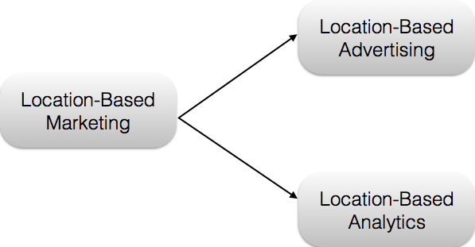

Figure 2.8: Taxonomy of Location-Based Marketing (Adapted from Buczkowski 2012)

Spatially based online advertising includes two basic types of spatial data: a business location or point of interest (POI) that a user is interested in and an area a user wishes to search within which can be determined by directly or indirectly (Fu, 2011). Now it is well known that user locations can be determined through address field completion and subsequent geo-coding with sometimes as little information as a zip code. This is a direct way of obtaining a user location, however as discussed in prior sections on LBS it is possible to obtain a user’s location using receiver technology on a user’s device. Spatially targeted online advertising entities can elicit a user’s current location on web pages by determining the IP address of a user if he/she is on a computer, a GPS unit if the user is on a mobile device and often from previously filled out and readily available location information from social networks a user has registered for (Fu, 2011). Once an advertising entity knows where a user is in relation to POIs or area users wish to search then the entity can send or display a spatially relevant advertisement via the web.
This process is fairly similar on mobile devices; the only major difference is mobile applications as opposed to web browsers are to relay the advertisement or marketing message. Location-triggered advertisement is one of many forms of location-based advertisement and uses a users location to push alerts of sales events or promotions of businesses near the user either in the form of text message or app notifications on a users mobile device (Buczkowski, 2012). Thanks to the many positioning technologies available on smartphones (mobile phones) location-triggered advertisement has been found to be quite effective in attracting users to the physical locations of POIs or businesses of interest that are nearby.

Geofencing
An advantage that mobile location based advertising has over online or browser location-based advertising can be found in specifically in location-triggered advertisement for physical business venues and the use of a method known as geofencing. The most popular method used in location-triggered advertisement is geofencing; which sets up a virtual perimeter around a physical venue such as a store, restaurant or recreational park (Buczkowski, 2012). Triggering a geofence requires a change in location or location monitoring which most online or browser location-based advertisement services do not provide. Geofencing, when included as part of an LBS application, sets up a virtual perimeter around a geographic with the intention of generating a notification or action after detecting when a user enters or exits the virtual geographic area (Fu, 2011). Geofences create an environment for many uses and activities to occur because of presence at a specific predefined virtual geographic area.
While a geofence can trigger many actions, activities and apply to many user notification(s) is typically the most common activity or action triggered within a geofence and is very useful in location-based advertisement. It is generally agreed upon by experts on the subject that geofences are used in order to check for user presence inside the geo-fenced area (true or false) in order to trigger a predefined action (Ferraro et al., 2011). Triggered actions often result in a notification on a users device which can be linked to a web page or provide a user direct access to useful information and data. These notifications can convey an advertisement promotion or sales event that is spatially relevant and attractive to a user. Geofencing in LBS meets the needs of users that are interested in receiving local alerts and special offers or promotions from nearby stores and other retailers (deGaravilla, 2009). These needs are becoming more and more prevalent in todays LBS market as recent popular mobile phone applications.

Popular Spatially Targeted Advertising Apps on the Market Today
Opt-in services like Shop Alerts, Groupon, Loopt and others have grabbed the attention of millions of mobile phone users. Loopt a Location-Based Social Network application allows users, that have opted in, to discover venues (businesses, restaurants attractions) that are near the user’s current location, allows users to broadcast their location to friends that may join them in discovering venues, and also allows advertisements or promotions from nearby venues to appear on the apps interface (Loopt, 2011). Another example of LBS for advertising is Groupon. While users may purchase any coupon via a mobile device, Groupon deals are pushed as notifications to customers that have opted in to the service and are nearby the location of a deal or business offering a Groupon coupon (Buczkowski 2012). These two applications have reached millions of users and benefitted thousands of businesses nationally and worldwide.
Another recent example of location-triggered advertisement application that has received a lot of attention and praise in the LBS and marketing community is Placecast’s Shop Alerts. Shop Alerts is another opt-in service, however users opt-in only to brands that they are interested in with programs set up that send text messages or push notifications with information, coupons and offers from places of interest nearest to the user (Buczkowski, 2012). In this way users only receive content they desire and do not feel that their privacy is compromised. With such a marketing and advertising strategy for brands and users Placecast has been quite successful in recent years. In October 2010 Placecast collaborated with O2, second-largest mobile operator in the UK, and brands like Starbucks and L’Oreal in a project where users opt-in to receive promotional messages relevant to their location, age, gender and interests; the project reaped huge success as it reached 6 million subscribed customers by October 2011 (Placecast, 2011). Here is a great example of a successful LBS application that uses spatially targeted advertising but maintains integrity by being context aware on many fronts in addition to being spatially aware and delivering content when relevant.

Esri’s Geotrigger LBS
Esri’s Geotrigger service is a cloud-based service that can be built into location aware apps to facilitate LBS functions. The Geotriggers cloud-service is commercial off-the-shelf (COTS) software as-a service (SaaS) available through an Esri’s online portal and web GIS platform ArcGIS Online (AGO). The Software Development Kit (SDK) available for Geotriggers allows developers to customize how a location-aware application, on either iOS or Android platforms, sends notifications to users when they are in predefined geofences or geo-trigger boundaries.
Boundaries can be circular with a trigger radius, which is most common, or polygonal often wrapping around buildings or areas in a city where a location-triggered actions or notifications will take place (ArcGIS Online, 2014). These boundaries can be created through the AGO for developers portal on a simple web-map interface called Geotrigger Editor that allows drawing of geotriggers right on the web-map itself with an attribute editor to edit and manage existing triggers. According to the official documentation for Esri’s Geotriggers service, there are two main trigger conditions along with one pre-condition: the precondition is a shared tag, or unique identifier, between the device and the trigger, the first condition is the trigger geometry and the second condition is the trigger direction (ArcGIS Online, 2014). While trigger geometry was just described as editable in the Geotriggers Editor direction is another editable attribute in this editor. Direction describes a device’s movement when crossing the trigger boundary and when it will cause a trigger to fire (ArcGIS Online, 2014). Specifying an “enter” direction means that the device must move from outside a trigger boundary to inside a trigger boundary for the trigger to be fired. Specifying a “leave” boundary means that a device must have registered its location inside the trigger before moving outside the trigger boundary before it causes the trigger to fire. In this way a retailer, for example, can set an “enter” trigger around their store to that welcomes a user, perhaps along with some current sales information as incentive to visit and make a purchase; then the retailer may set “leave” direction trigger that thanks the user for visiting the store promptly after the user has left the stores vicinity. The same type of “enter” and “leave” triggers can be set by vigilant parents to track when children are entering and leaving the boundaries of a residence or small neighborhood. As the second required parameter it also ensures developers or app users are firing triggers at the right time and place as opposed to just place.

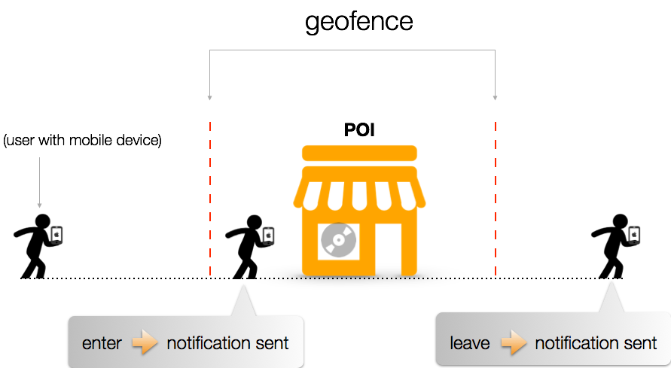
Figure 2.9: Geofence direction condition and notification using Geotrigger service.

The Geotriggers service is not only useful to LBS app developers because of its customization but also because of it’s tracking profiles, analytics and notification templates it makes available as actions upon firing a trigger. When creating a trigger a developer can set a trigger to execute one or more actions including: setting a callback URL to provide analytics or alert a server of a user’s action, customizing a notification to be sent when a user steps in or out of a trigger boundary, and last but not least changing the tracking profile of the device to enhance positioning accuracy or ramp positioning accuracy down depending on the circumstance (ArcGIS Online, 2014). An advertiser can customize a notification to reflect current sales at their retail store or venue, a marketing analyst can set a callback URL to his/her server so they can track how many people are visiting a venue or store and at what time of day for example. A developer on the other hand can change a tracking profile on a trigger so that when a user causes a trigger to fire their device can be put in a more accurate tracking profile to for example get turn by turn directions to a special event or when the user “leaves” a trigger the tracking profile can be preset to ramp down accuracy so the LBS application does not unnecessarily drain the battery life of the mobile device.
As discussed in previous sections different positioning technologies require different infrastructure, consume more or less battery on mobile devices and provide different levels of accuracy. The Geotriggers service offers three tracking profiles, which are known as fine, rough and adaptive. Fine primarily uses GPS and the most battery power, however it provides the best positional accuracy for say turn by turn directions or pinpointing a user in an area less than 10 to 20 meters in diameter. Rough uses the least amount of battery power but also has poor positional accuracy, which makes it a good mode to set after a user has fired a trigger or is very far away from any trigger boundaries.

Adaptive is the hallmark of the Geotrigger service as it adapts positional accuracy, technology and resources used for location tracking based on where a user is in relation to trigger boundaries or POIs (ArcGIS Online, 2014). This is a default setting yet a very useful tracking profile since it ramps down positional accuracy when the app does not need it and brings the accuracy back up when the app does need it to deliver fast messaging or notification when a user enters or leaves a trigger. This saves a user battery life and improves the precision of the service.
The Geotrigger service has already been successful in providing location-aware solutions to an array of clients and users. For example in a popular retail application, the Geotriggers service and SDK was applied to an application built by Taqtile for 7 Eleven targeting its sales of AMP energy drinks. Taqtile found the Geotrigger service easy to develop with and deliver the client results as the marketing application drove distribution and sales of AMP Energy Orange up 70 percent at participating stores during the promotion (Weis, 2014). This service has also provided a solution to parents worried about the whereabouts of their children. A leading provider of parental intelligence systems uKnow teamed up with Esri to create and app called uKnowLocate. The app uses geofencing and the Geotriggers service to allow parents to create and customize geofences around their home, school, and children’s friends homes along with alerts that tell them when their child arrives at or departs from a geofenced location (Weis, 2014). These two applications only touch on the tip of the iceberg of possible applications for the Geotrigger service and SDK. Many more applications have been built and are still being built using this new Esri service, which just came out of Beta this February (Weis, 2014).

2.5 Summary
In summary location-based services or LBS have been around for a while now with prevalence increasing in 1996 due to the United States FCC mandate and recently with improvements in positioning technology and GPS technology of mobile phones. The taxonomy of LBS is diverse and context-aware systems can fall under many categories which require different levels of positioning technology, user interface, information display, visualization and adaptations based on a user’s needs and/or actions. Positioning technologies, level of accuracy measured in meters and required infrastructure has been discussed in enough detail in order to understand their application for different LBS use case scenarios. The concept of Location-Based Marketing or LBM and location-based advertising, their origins in web based technology and transcendence into mobile device applications have been discussed along with the concept of geofencing that creates a virtual perimeter around points of interest or POIs to a user, advertiser, developer or venue-marketing manager. Geofencing allows LBS applications to send notifications to users that step inside or out of geofenced areas in order to deliver messages both when and where they are relevant; something that is important to both the user and client as exemplified by the Placecast program in the UK. Finally Esri’s Geotrigger service was described and identified as both a cloud-based server geofencing platform and software development kit or SDK that has some significant features that allow ample customization and creation of different types of geofenced areas, customization and analytics of actions within a geofence, and management of tracking profiles. It was emphasized how the Geotriggers service can be applied to an array of use cases and how managing tracking profiles can really save a user battery power and increase positional accuracy when relevant.

