GitHub Repository: github.com/username/repo

Sprint #0 Report

Instructions

Objectives
- Make decisions on the Solitaire software development project.
- Learn unit testing and GUI programming in the language of your choice.

Deliverables and Grading Policy
Read the “CS 449 Homework Overview” document carefully and make the key decisions for the software development. Use the following template to complete your report.

- Key Decisions of the Solitaire Project (2 points)

Topic | Decision
Object-oriented programming language (if not using OOP, then justify the use of the language) | Java
GUI library (strongly encouraged) | JavaFX
IDE (Integrated Development Environment) | VS Code
xUnit framework (e.g., JUnit for Java) | JUnit
Programming style guide (must read it carefully)
Project hosting site | Github.com
Other decisions if applicable

Sample programming style guides:
- Google Java Style Guide: https://google.github.io/styleguide/javaguide.html
- Google C++ Style Guide: https://google.github.io/styleguide/cppguide.html
- Google Python Style Guide: https://google.github.io/styleguide/pyguide.html

- Unit testing (4 points)

Find a tutorial on the unit test framework you have chosen and write at least two xUnit tests of a program you have written or found elsewhere. Attach here (1) the screenshot of your program execution and (2) the source code of your program.

For example, Junit5 user guide: https://docs.junit.org/5.10.3/user-guide/index.html
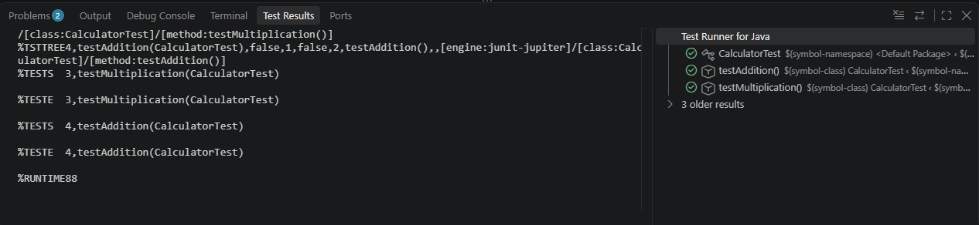
Calculator:

public class Calculator {

public int add(int a, int b) {
return a + b;
}

public int multiply(int a, int b) {
return a * b;
}
}

Calculator Test:

import static org.junit.jupiter.api.Assertions.assertEquals;
import org.junit.jupiter.api.Test;

public class CalculatorTest {

@Test
void testAddition() {
Calculator calculator = new Calculator();
assertEquals(8, calculator.add(5, 3));
}

@Test
void testMultiplication() {
Calculator calculator = new Calculator();
assertEquals(15, calculator.multiply(5, 3));
}
}

- GUI programming (4 points)

Write a GUI program in the language you have chosen for your Solitaire project. The GUI of your program must include text, lines, a check box, and radio buttons. In this assignment, any GUI program of your own work is acceptable.

Attach here (1) the screenshot of your program execution and (2) the source code of your program.

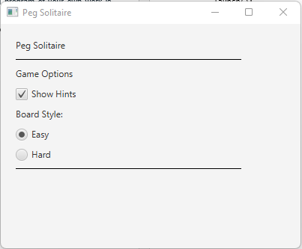

package com.example;

import javafx.application.Application;
import javafx.geometry.Insets;
import javafx.scene.Scene;
import javafx.scene.control.CheckBox;
import javafx.scene.control.Label;
import javafx.scene.control.RadioButton;
import javafx.scene.control.ToggleGroup;
import javafx.scene.layout.VBox;
import javafx.scene.shape.Line;
import javafx.stage.Stage;

public class Main extends Application {

@Override
public void start(Stage stage) {
Label title = new Label("Peg Solitaire");
Label options = new Label("Game Options");
Label boardStyle = new Label("Board Style:");

CheckBox hints = new CheckBox("Show Hints");

RadioButton easy = new RadioButton("Easy");
RadioButton hard = new RadioButton("Hard");

ToggleGroup boardGroup = new ToggleGroup();
easy.setToggleGroup(boardGroup);
hard.setToggleGroup(boardGroup);
easy.setSelected(true);

Line line1 = new Line(0, 0, 300, 0);
Line line2 = new Line(0, 0, 300, 0);

VBox layout = new VBox(10);
layout.setPadding(new Insets(20));

layout.getChildren().addAll(
title,
line1,
options,
hints,
boardStyle,
easy,
hard,
line2
);

Scene scene = new Scene(layout, 400, 300);

stage.setTitle("Peg Solitaire");
stage.setScene(scene);
stage.show();
}

public static void main(String[] args) {
launch();
}
}

