A PROJECT REPORT
ON
LEAVE MANAGEMENT SYSTEM
Submitted in partial fulfillment of the
Requirements for the award of the degree of
Bachelor of Vocation
In
Software Development

Submitted By:
VANSH MALHOTRA SACHIN SHARMA
B. VOC (SD) 6th Semester B.VOC (SD) 6thSemester
04724818116 04624818116


AMBEDKAR INSTITUTE OF TECHNOLOGY
GOVT. OF NCT OF DELHI
Affiliated to
Guru Gobind Singh Indraprastha University
Dwarka, Sector 16, New Delhi
2018-2019

CERTIFICATE

This is to certify that VANSH MALHOTRA and SACHIN SHARMA , students of Bachelor’s of Vocation in Software Development , 6th Semester have successfully completed their major project on Leave Management System under the guidance of Mr. RAHUL SACHDEVA.

ACKNOWLEDGEMENT

I would like to express my special thanks of gratitude to my teacher and project guide Mr. Rahul Sachdeva who gave me the golden opportunity to do this wonderful project on the Leave Management System. This project helped me in doing a lot of Research and I came to know about so many new things I am really thankful to everyone who helped me.
Secondly I would also like to thank my parents and friends who helped me a lot in finalizing this project within the limited time frame.

This project that I undertook was truly a very rewarding experience for me in more than one way. It has given a big thrust to my technical knowledge as prospective Software professional. It has also helped me enhance my skills on the personal front.
And I feel extremely satisfied by the fact that I have managed to develop the project of course with equal contribution from my team members. I think I have exploited the opportunity that came my way to the fullest extent by increasing my technical know-how and also gaining the valuable work experience apart from studying the other subjects in our curriculum.

ABSTRACT

This project is aimed at developing an online leave management system that is of importance to either an organization or a company. The Leave Management System (LMS) is an Internet based application that can be accessed throughout the organization or a specified group/Dept. This system can be used to automate the workflow of leave applications and their approvals. The periodic crediting of leave is also automated. There are features like email notifications, approval/disapprove a leave, report generators etc in this system. Leave Management application will reduce paper work and maintains record in more efficient way.

EXISTING SYSTEM:
In existing systems most companies or organizations follow manual procedure to record the leaves taken by an employee in a record book. At the end of each month Head of department will calculate leaves of every employee which is a time taking process and there are chances of losing records.

PROPOSED SYSTEM:
In proposed system chances of losing data is not possible because data is maintained in the form of database. The information about the leaves taken by the employees is updated in to database using a user friendly GUI. This will reduce work done manually. This application is an online application which makes more flexible to access information.

CONTENTS

Page Number
- List of Figures 6
- Introduction 7
- Software requirements specification 8
- Technology used-
  - Html 9
  - Css 9
  - Javascript 9
  - jQuery 10
  - Php 10
  - My Sql 11
5. System Design
5.1 Flow Chart 12
6. System Analysis
Module
  - Admin module 13
6.2 Employee Module 13

7. Conclusion 14
8. References 15
9. Appendix A (Screenshots) 19-24
10. Appendix B (Source Code) 25-52

- LIST OF FIGURES

Figure Number | Figure name | Page number
1 | SYSTEM DESIGN | 13
2 |  | 13
3 |  | 14
4 |  | 15
5 |  | 15

2. INTRODUCTION

Leave management system project is a web based system which can be accessed all over the organization or company. This system is automated system for managing leaves related information of employees and approval of leaves, payment cancellations etc are element of this system . In this system, every employee is provided with the unique user id and password for log in to the system and send request for leave. The project managers will look after the proposals and they may accept, reject or keep it in pending. Before approving the leave different department people look after the request through this system and make their decisions. This system will upgrade the process of leave management inside the company or an organization by saving time and money. It help the employees to view leave balances, request leaves , view past leave history and managers can review and approve the leave applications. This system is very useful for the companies or organizations where there are a large number of employees. It is an online system which can be used throughout a corporate company. This system has many features such as providing notifications of approved/ disapproved leaves, pending leaves, leave cancellation, automated leave approval and report generation based on the requested data by the user.

3. SOFTWARE REQUIREMENTS SPECIFICATION

NAME OF THE COMPONENT SPECIFICATION

OPERATING SYSTEM WINDOWS 98, XP ,7, Linux

LANGUAGE PHP,HTML,CSS,JS

DATABASE MYSQL SERVER

BROWSER MOZILLA, CHROME

WEB SERVER XAMPP

SCRIPTING LANGUAGE ENABLED JAVASCRIPT

DATABASE JDBC DRIVER MY SQLJCONNECTOR

- TECHNOLOGY USED

HTML

HTML stands for Hyper Text Markup Language, which is the most widely used language on Web to develop web pages. HTML was created by Berners-Lee in late 1991 but "HTML 2.0" was the first standard HTML specification which was published in 1995. HTML 4.01 was a major version of HTML and it was published in late 1999. Though HTML 4.01 version is widely used but currently we are having HTML-5 version which is an extension to HTML 4.01, and this version was published in 2012.

CSS

Cascading Style Sheets, fondly referred to as CSS, is a simple design language intended to simplify the process of making web pages presentable.CSS handles the look and feel part of a web page. Using CSS, you can control the color of the text, the style of fonts, the spacing between paragraphs, how columns are sized and laid out, what background images or colors are used, layout designs, variations in display for different devices and screen sizes as well as a variety of other effects.CSS is easy to learn and understand but it provides powerful control over the presentation of an HTML document. Most commonly, CSS is combined with the markup languages HTML or XHTML.

  - JAVASCRIPT

JavaScript is a dynamic computer programming language. It is lightweight and most commonly used as a part of web pages, whose implementations allow client-side script to interact with the user and make dynamic pages. It is an interpreted programming language with object-oriented capabilities. JavaScript was first known as LiveScript, but Netscape changed its name to JavaScript, possibly because of the excitement being generated by Java. JavaScript made its first appearance in Netscape 2.0 in 1995 with the name LiveScript. The general-purpose core of the language has been embedded in Netscape, Internet Explorer, and other web browsers.

  - JQUERY

jQuery is a fast and concise JavaScript Library created by John Resig in 2006 with a nice motto: Write less, do more. jQuery simplifies HTML document traversing, event handling, animating, and Ajax interactions for rapid web development. jQuery is a JavaScript toolkit designed to simplify various tasks by writing less code.

  - PHP

PHP started out as a small open source project that evolved as more and more people found out how useful it was. Rasmus Lerdorf unleashed the first version of PHP way back in 1994.
PHP is a recursive acronym for "PHP: Hypertext Preprocessor".
PHP is a server side scripting language that is embedded in HTML. It is used to manage dynamic content, databases, session tracking, even build entire e-commerce sites.
It is integrated with a number of popular databases, including MySQL, PostgreSQL, Oracle, Sybase, Informix, and Microsoft SQL Server.
PHP supports a large number of major protocols such as POP3, IMAP, and LDAP. PHP4 added support for Java and distributed object architectures (COM and CORBA), making n-tier development a possibility for the first time.
PHP is forgiving: PHP language tries to be as forgiving as possible.
PHP Syntax is C-Like.

  - MY SQL

My SQL is the most popular Open Source Relational SQL Database Management System. My SQL is one of the best RDBMS being used for developing various web-based software applications. My SQL is developed, marketed and supported by My SQL AB, which is a Swedish company.

5 SYSTEM DESIGN

5.1 FLOWCHART

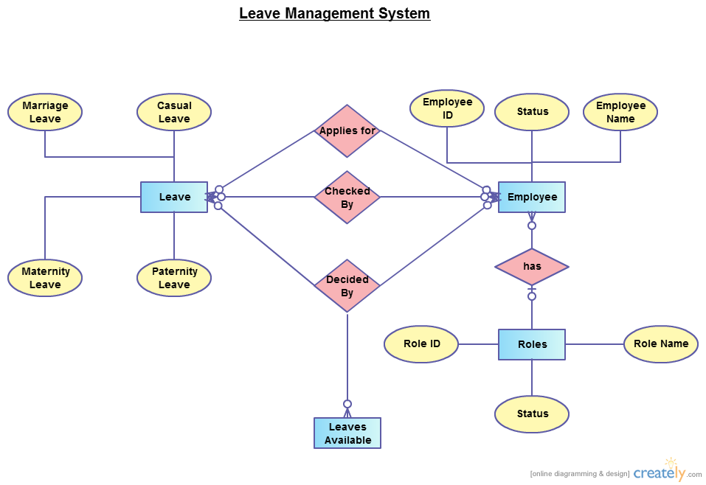

6. SYSTEM ANALYSIS (MODULE DESCRIPTION)

The project has been divided two main modules:
1 ADMIN MODULE
- EMPLOYEE MODULE

6.1 ADMIN MODULE

Admin will maintain all the employee details such as employee name, employee’s email id , employee’s contact number ,department and the employee leave record ,leave approved or disapproved details in the database.
The admin of the company will log in to the admin portal and can check the record of the employees. The admin can approve or disapprove the leave proposals of the employees. Whenever an employee registers for a leave, a notification is sent to the admin for his approval. If the admin approves his request, the employee gets the notification and can check the dashboard.

6.2
EMPLOYEE MODULE

In this module the employee will register for their leave approvals along with the type of leave they want. Members should log in to their account and update information. If there are any notifications related to their approval it is displayed in the form of pop up. Employees can check that notification to ensure that the leave is granted or not.

7
CONCLUSION

This app would be beneficial for the employees as well as the admin of the company or the organization. The admin can easily keep the record of all the data related to the leaves taken by employees , types of leaves taken, time duration of leaves taken by the employee without the risk of data loss. Both the employer and manager have access to the employee’s leave balance and leave history. This makes leave rejection or leave approval more transparent. You can access more accurate details about an employee’s leaves, leave trends, the number of leaves and balance leaves instantly. It becomes a single step procedure versus manually flipping through records and registers and putting information together. It improves accuracy and encourages discipline in a company. Better employee attendance rates can also be expected because they will be aware of the consequences of not following company policy.

8 REFERENCES USED

- Tutorialspoint.com
- W3s school
- Html.com

9 APPENDIX – A (SCREENSHOTS)

Employee

employee login page
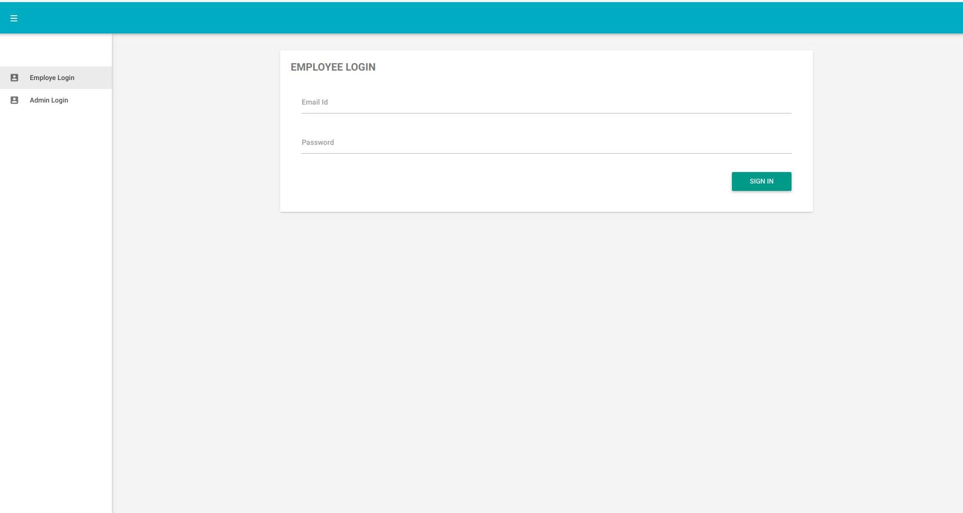

update employee information

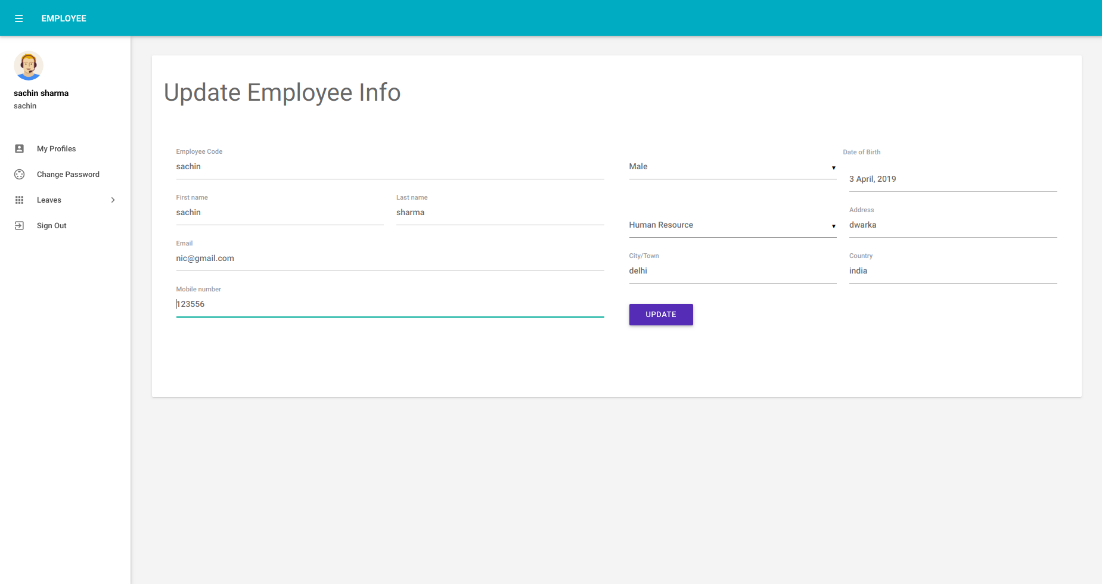
apply for leave
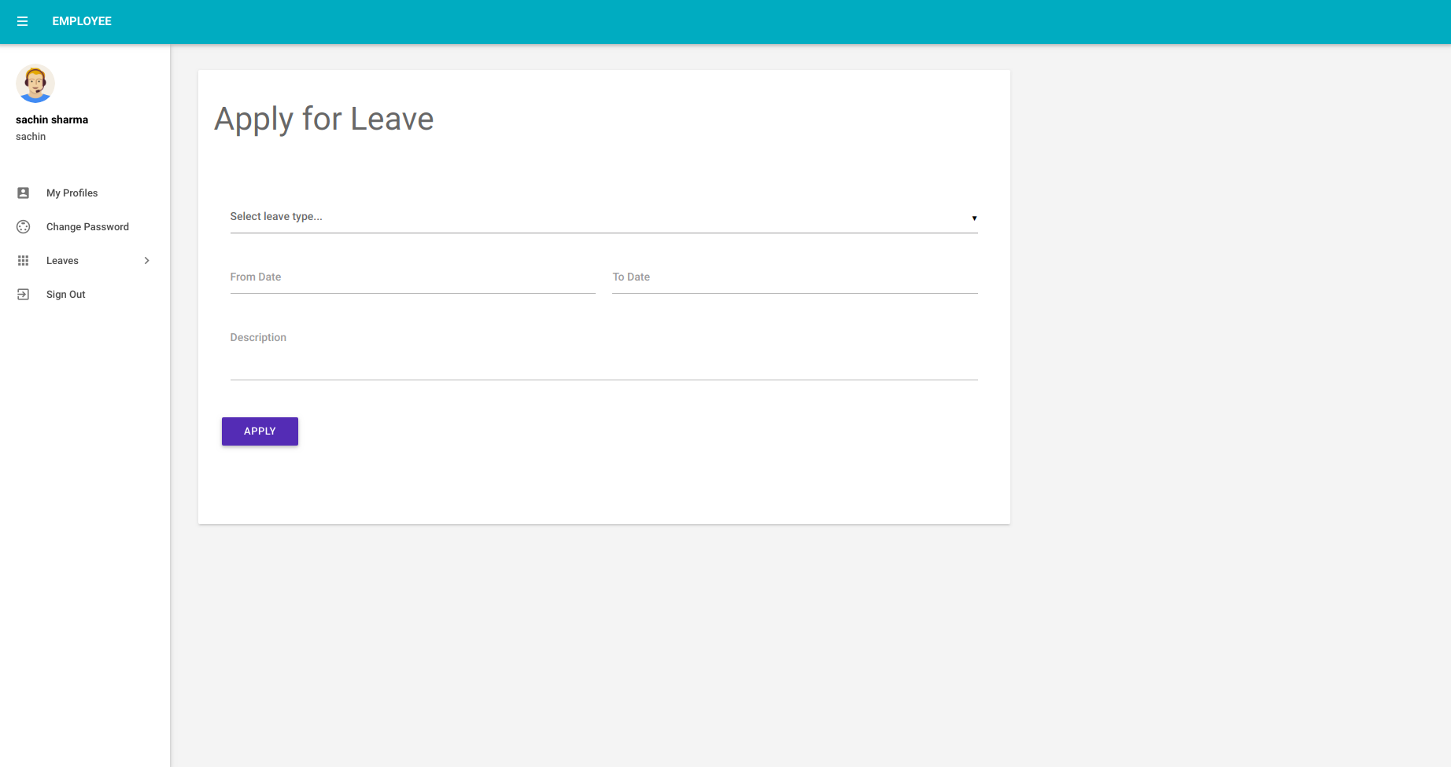

leave history

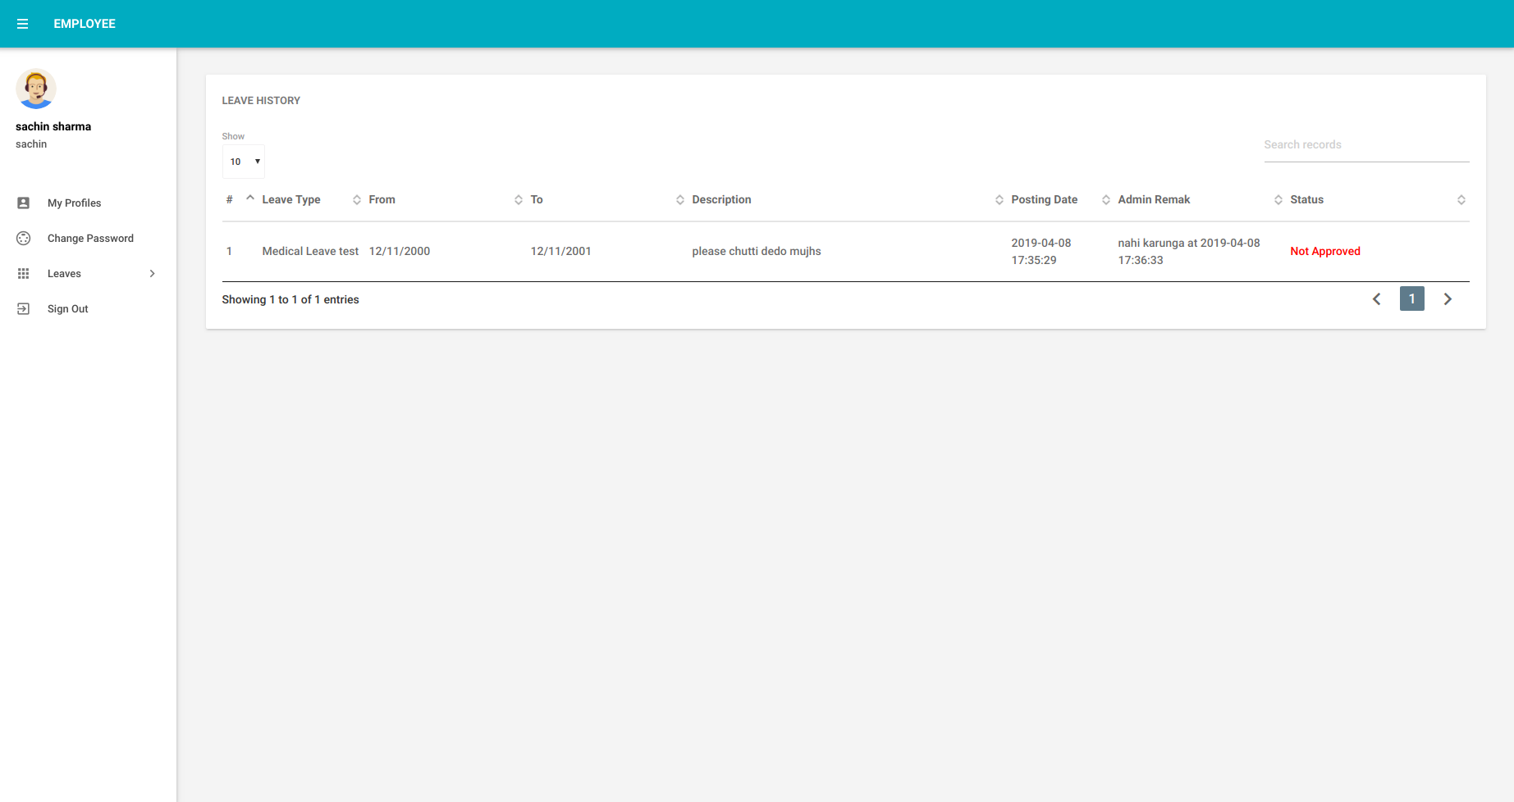
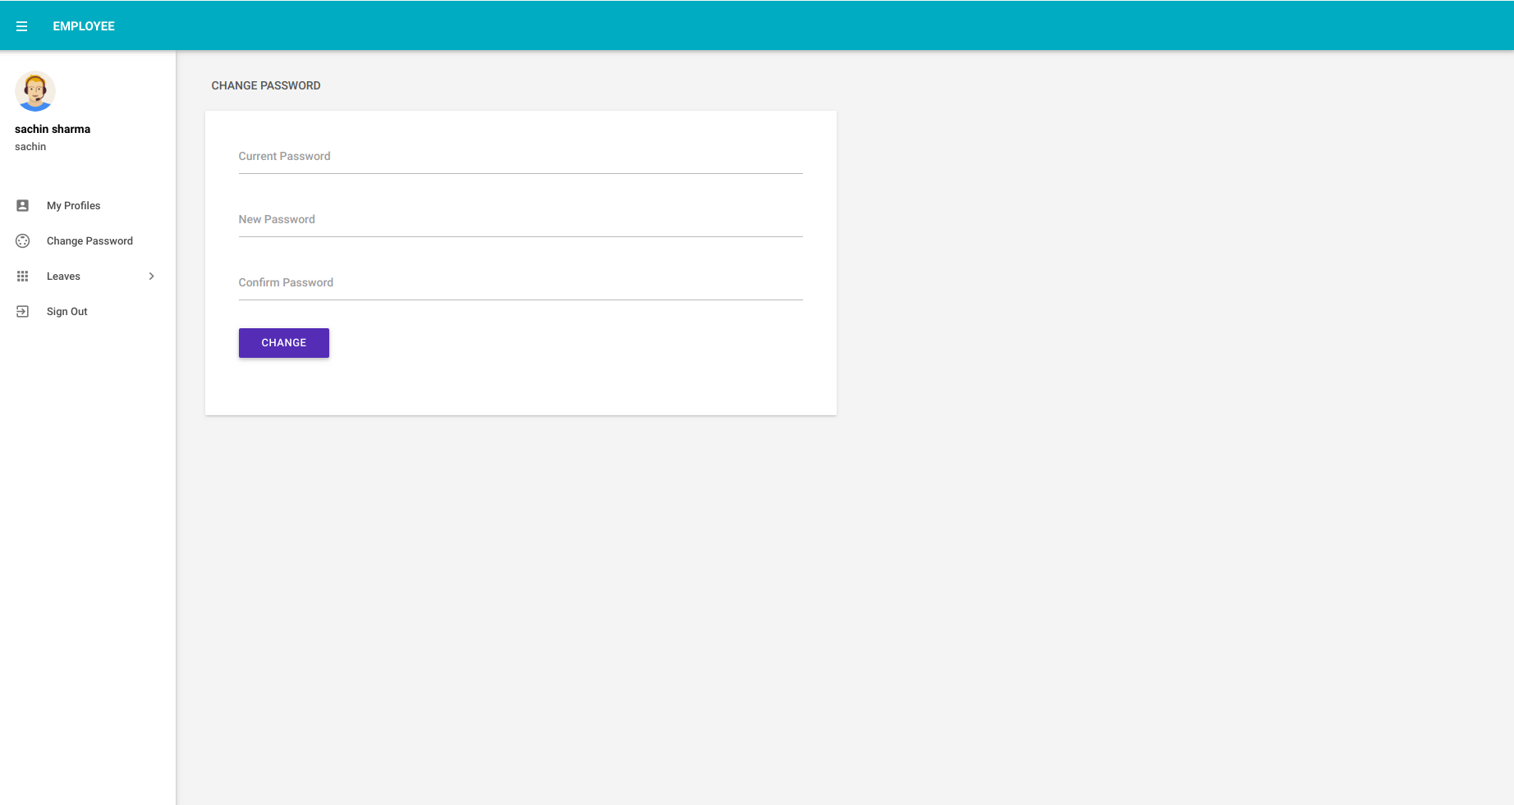
employee change password page

ADMIN MODULE

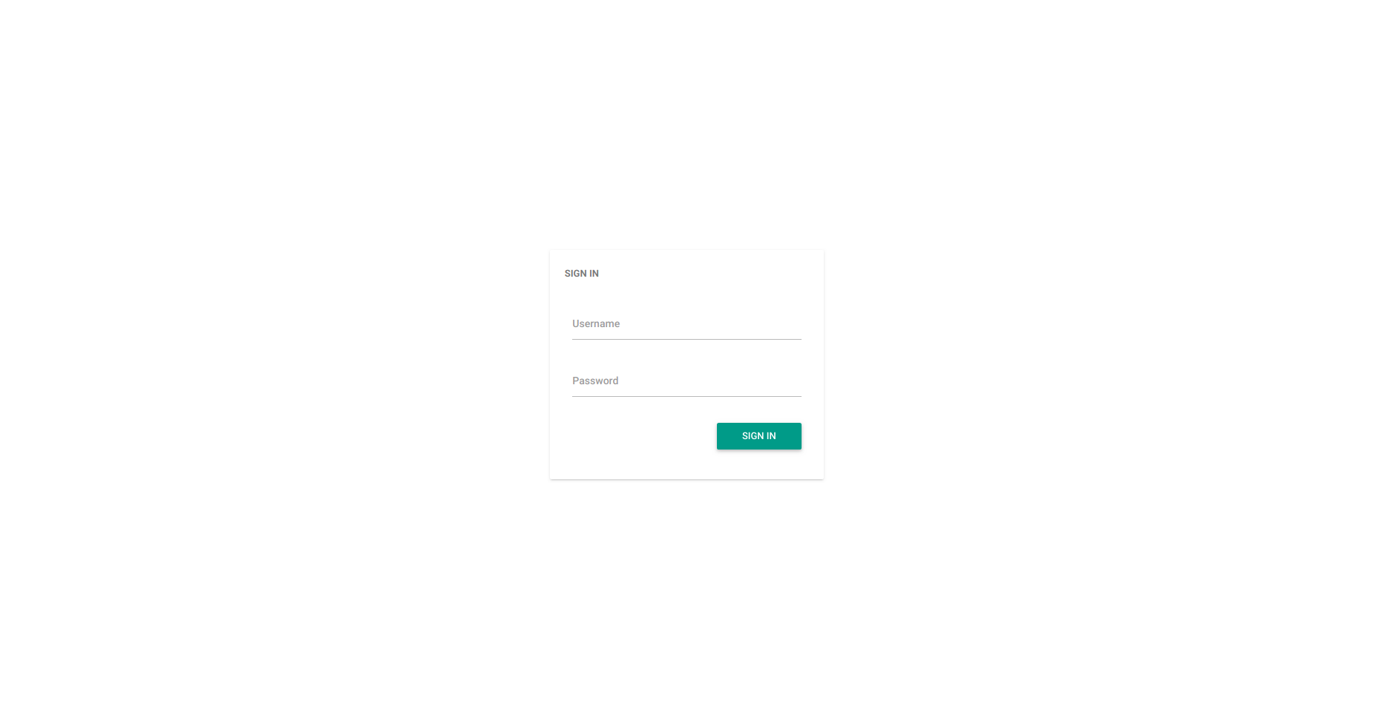
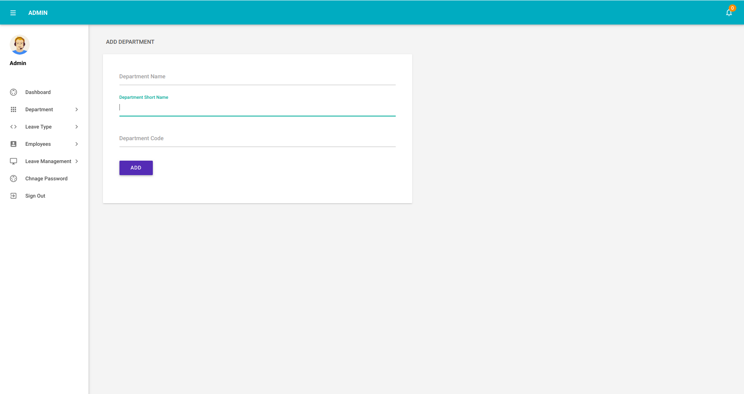
admin login page

add department page

manage department page
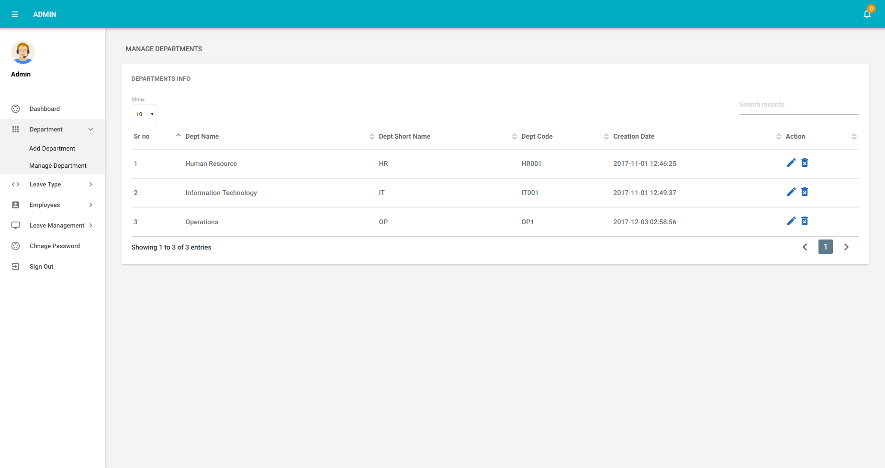
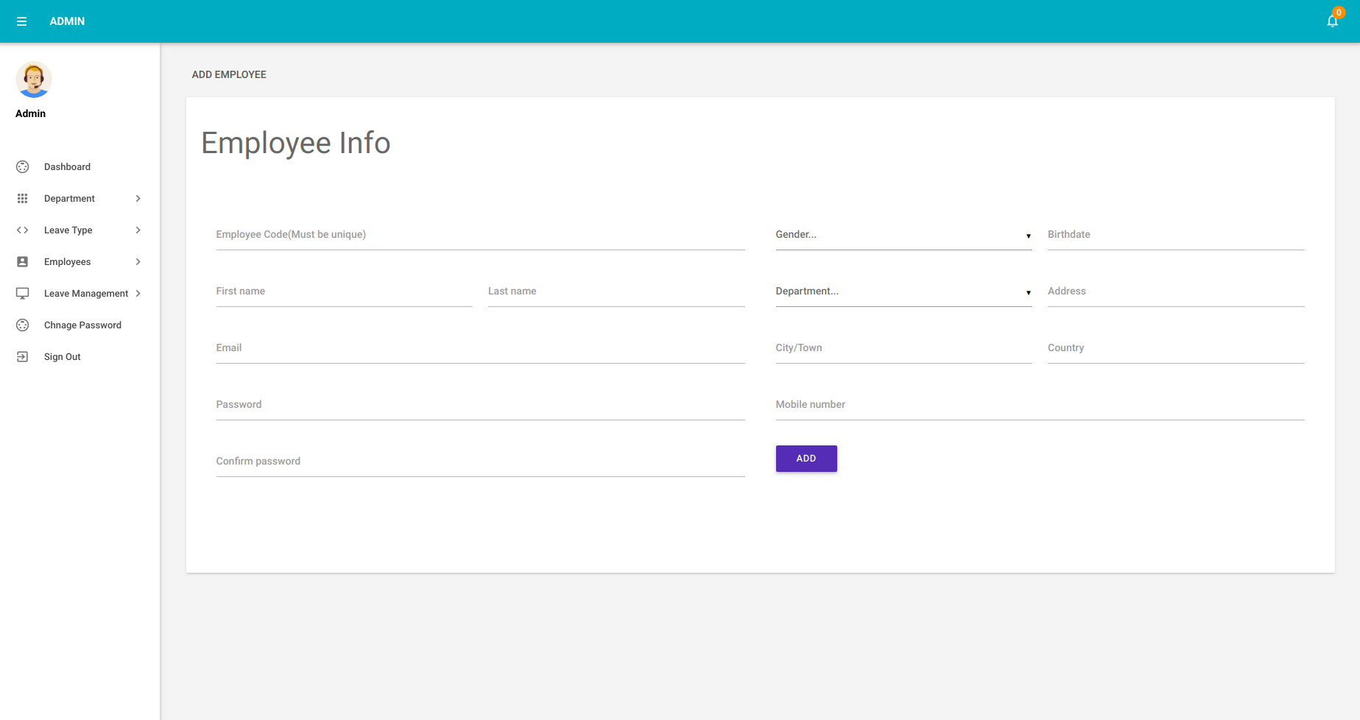
add employee page
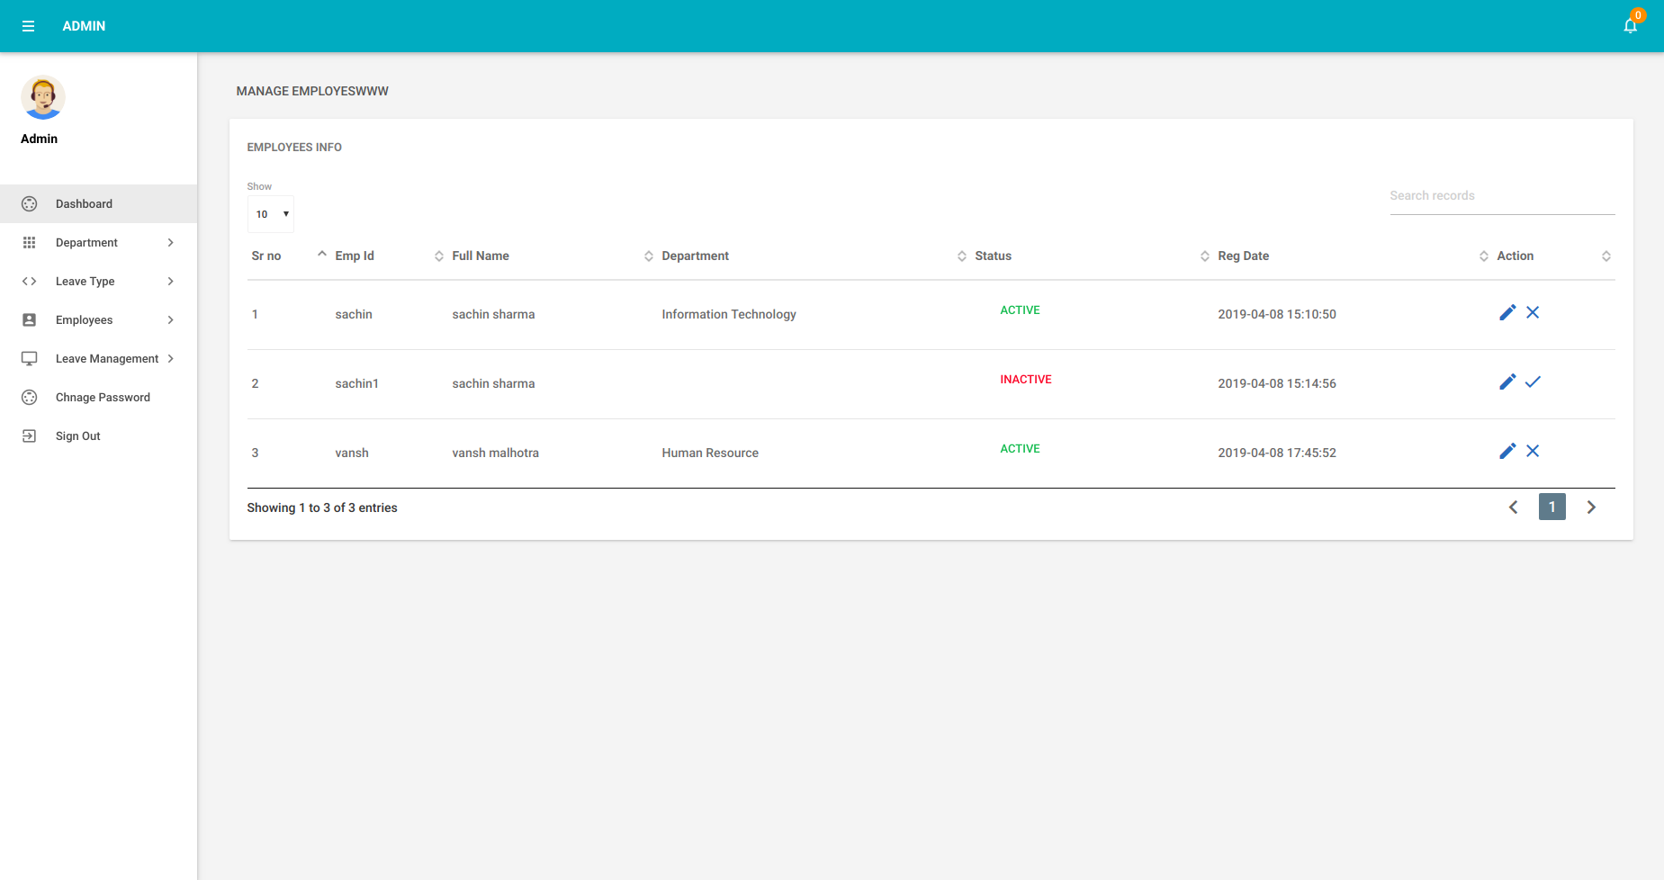
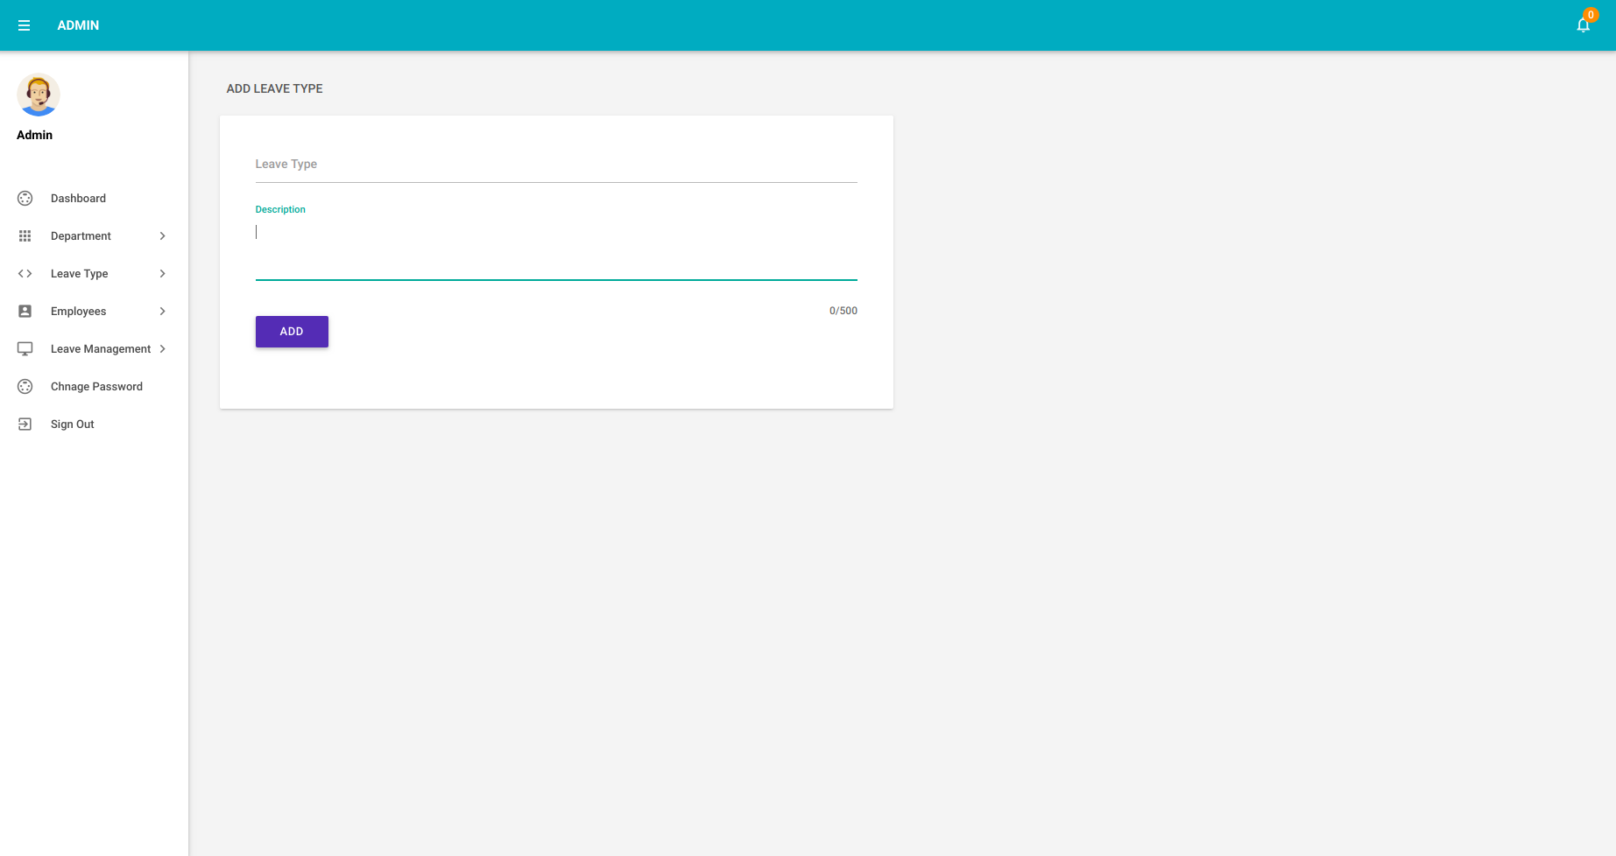
manage employee page
add leave page
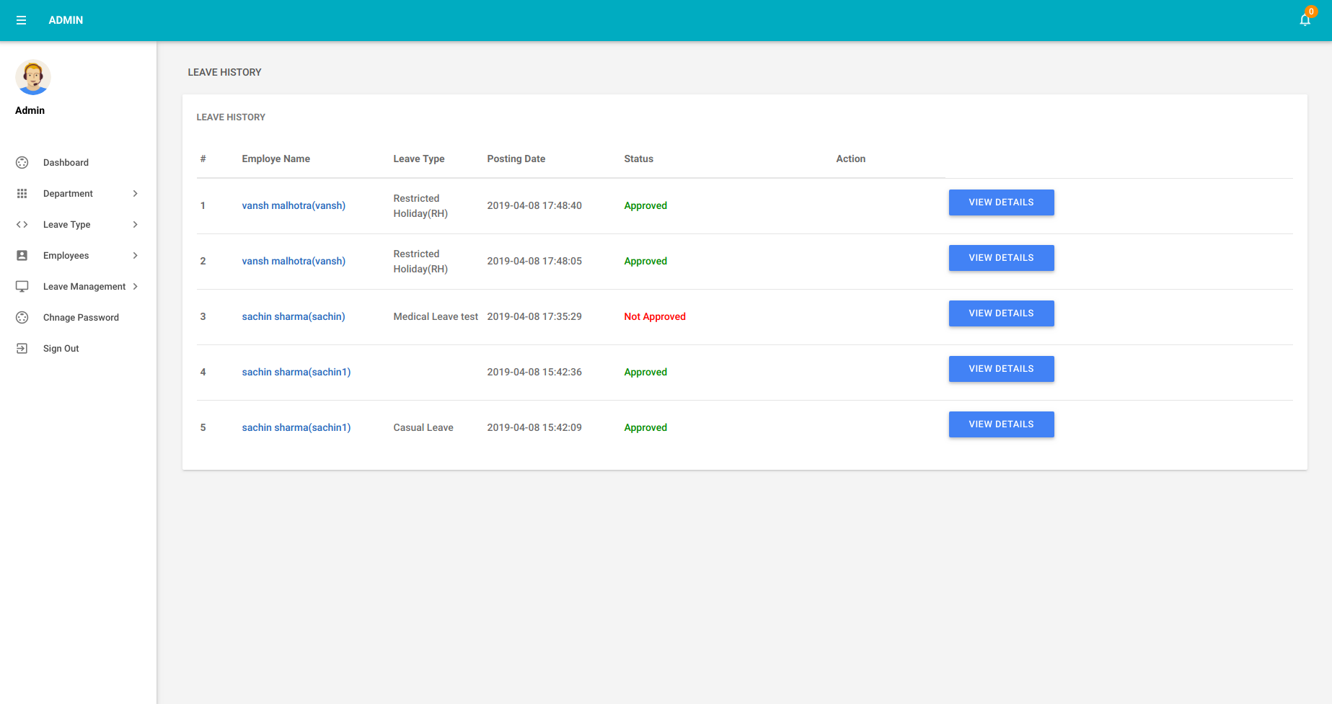
all leaves page
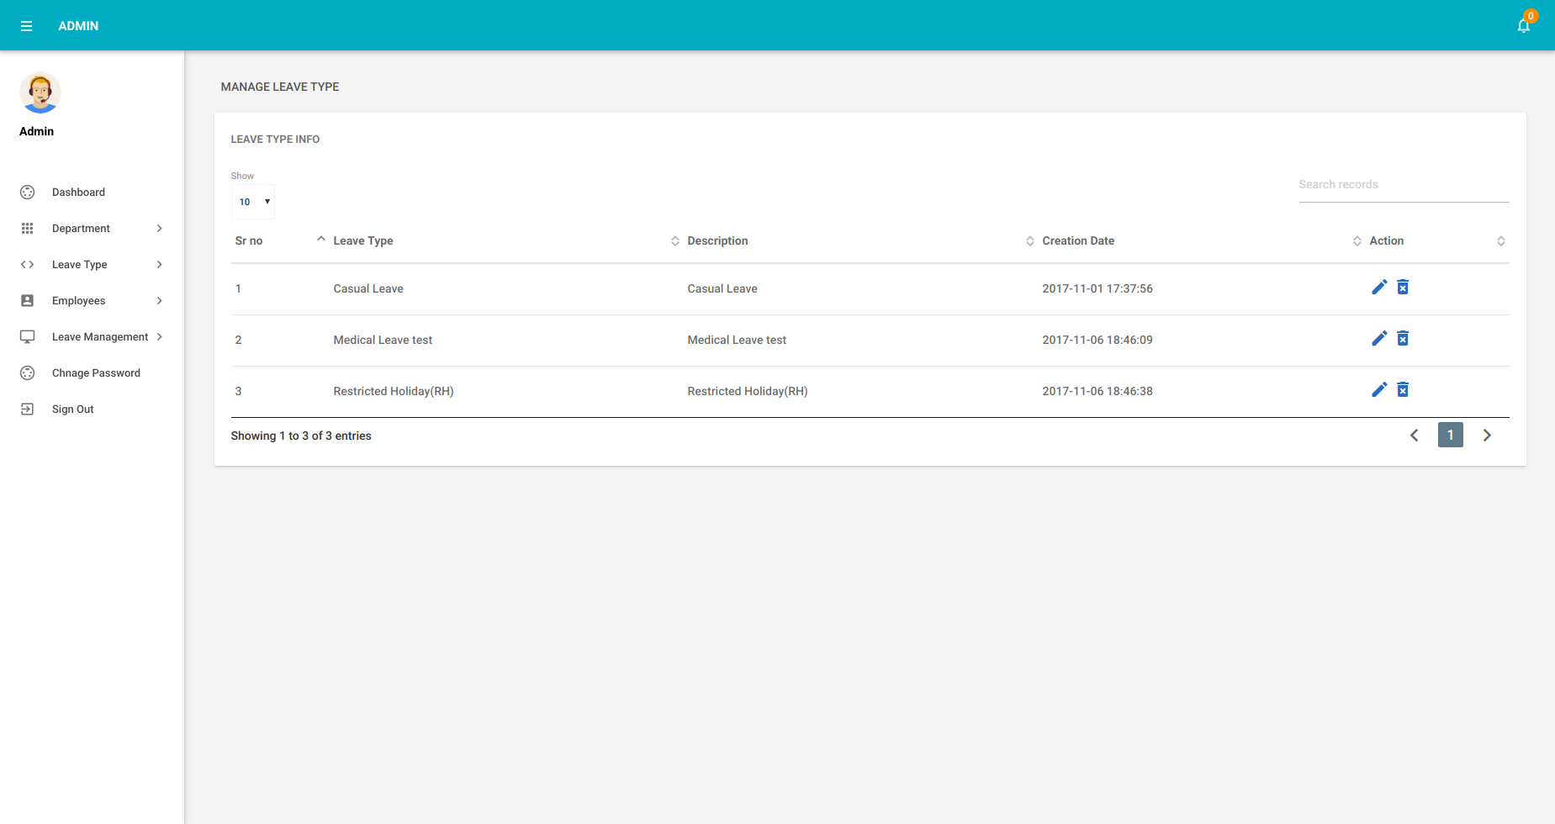
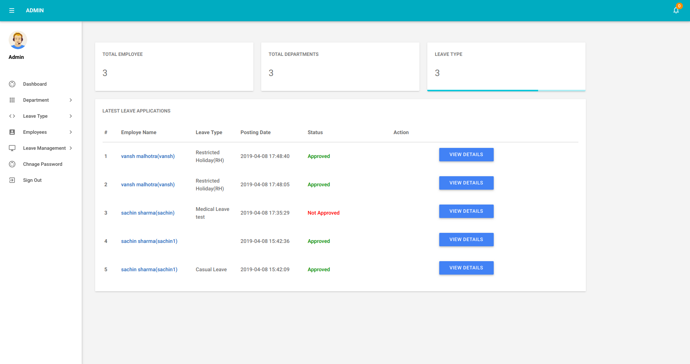
manage leaves page
admin dashboard pageAPPENDIX – B ( SOURCE CODE)

index.php

<?php
session_start();
error_reporting(0);
include('includes/config.php');
if(isset($_POST['signin']))
{
$uname=$_POST['username'];
$password=md5($_POST['password']);
$sql ="SELECT EmailId,Password,Status,id FROM tblemployees WHERE EmailId=:uname and Password=:password";
$query= $dbh -> prepare($sql);
$query-> bindParam(':uname', $uname, PDO::PARAM_STR);
$query-> bindParam(':password', $password, PDO::PARAM_STR);
$query-> execute();
$results=$query->fetchAll(PDO::FETCH_OBJ);
if($query->rowCount() > 0)
{
foreach ($results as $result) {
$status=$result->Status;
$_SESSION['eid']=$result->id;
}
if($status==0)
{
$msg="Your account is Inactive. Please contact admin";
} else{
$_SESSION['emplogin']=$_POST['username'];
echo "<script type='text/javascript'> document.location = 'emp-changepassword.php'; </script>";
} }

else{

echo "<script>alert('Invalid Details');</script>";

}

}

?><!DOCTYPE html>
<html lang="en">
<head>

<!-- Title -->
<title>Home Page</title>

<meta name="viewport" content="width=device-width, initial-scale=1.0, maximum-scale=1.0, user-scalable=no"/>
<meta charset="UTF-8">
<meta name="description" content="Responsive Admin Dashboard Template" />
<meta name="keywords" content="admin,dashboard" />
<meta name="author" content="Steelcoders" />

<!-- Styles -->
<link type="text/css" rel="stylesheet" href="assets/plugins/materialize/css/materialize.min.css"/>
<link href="assets/css/materialdesign.css" rel="stylesheet">
<link href="assets/plugins/material-preloader/css/materialPreloader.min.css" rel="stylesheet">

<!-- Theme Styles -->
<link href="assets/css/alpha.min.css" rel="stylesheet" type="text/css"/>
<link href="assets/css/custom.css" rel="stylesheet" type="text/css"/>

<!-- HTML5 shim and Respond.js for IE8 support of HTML5 elements and media queries -->
<!-- WARNING: Respond.js doesn't work if you view the page via file:// -->
<!--[if lt IE 9]>
<script src="http://oss.maxcdn.com/html5shiv/3.7.2/html5shiv.min.js"></script>
<script src="http://oss.maxcdn.com/respond/1.4.2/respond.min.js"></script>
<![endif]-->

</head>
<body>
<div class="loader-bg"></div>
<div class="loader">
<div class="preloader-wrapper big active">
<div class="spinner-layer spinner-blue">
<div class="circle-clipper left">
<div class="circle"></div>
</div><div class="gap-patch">
<div class="circle"></div>
</div><div class="circle-clipper right">
<div class="circle"></div>
</div>
</div>
<div class="spinner-layer spinner-spinner-teal lighten-1">
<div class="circle-clipper left">
<div class="circle"></div>
</div><div class="gap-patch">
<div class="circle"></div>
</div><div class="circle-clipper right">
<div class="circle"></div>
</div>
</div>
<div class="spinner-layer spinner-yellow">
<div class="circle-clipper left">
<div class="circle"></div>
</div><div class="gap-patch">
<div class="circle"></div>
</div><div class="circle-clipper right">
<div class="circle"></div>
</div>
</div>
<div class="spinner-layer spinner-green">
<div class="circle-clipper left">
<div class="circle"></div>
</div><div class="gap-patch">
<div class="circle"></div>
</div><div class="circle-clipper right">
<div class="circle"></div>
</div>
</div>
</div>
</div>
<div class="mn-content fixed-sidebar">
<header class="mn-header navbar-fixed">
<nav class="cyan darken-1">
<div class="nav-wrapper row">
<section class="material-design-hamburger navigation-toggle">
<a href="#" data-activates="slide-out" class="button-collapse show-on-large material-design-hamburger__icon">
<span class="material-design-hamburger__layer"></span>
</a>
</section>
<div class="header-title col s3">
<span class="chapter-title"></span>
</div>

</form>

</div>
</nav>
</header>

<aside id="slide-out" class="side-nav white fixed">
<div class="side-nav-wrapper">

<ul class="sidebar-menu collapsible collapsible-accordion" data-collapsible="accordion" style="">
<li>&nbsp;</li>
<li class="no-padding"><a class="waves-effect waves-grey" href="index.php"><i class="material-icons">account_box</i>Employe Login</a></li>
<!-- <li class="no-padding"><a class="waves-effect waves-grey" href="forgot-password.php"><i class="material-icons">account_box</i>Emp Password Recovery</a></li> -->

<li class="no-padding"><a class="waves-effect waves-grey" href="admin/"><i class="material-icons">account_box</i>Admin Login</a></li>

</ul>

</div>
</aside>
<main class="mn-inner">
<div class="row">
<div class="col s12">
<div class="page-title"><h4></h4></div>

<div class="col s12 m6 l8 offset-l2 offset-m3">
<div class="card white darken-1">

<div class="card-content ">
<span class="card-title" style="font-size:20px;">Employee Login</span>
<?php if($msg){?><div class="errorWrap"><strong>Error</strong> : <?php echo htmlentities($msg); ?> </div><?php }?>
<div class="row">
<form class="col s12" name="signin" method="post">
<div class="input-field col s12">
<input id="username" type="text" name="username" class="validate" autocomplete="off" required >
<label for="email">Email Id</label>
</div>
<div class="input-field col s12">
<input id="password" type="password" class="validate" name="password" autocomplete="off" required>
<label for="password">Password</label>
</div>
<div class="col s12 right-align m-t-sm">

<input type="submit" name="signin" value="Sign in" class="waves-effect waves-light btn teal">
</div>
</form>
</div>
</div>
</div>
</div>
</div>
</div>
</main>

</div>
<div class="left-sidebar-hover"></div>

<!-- Javascripts -->
<script src="assets/plugins/jquery/jquery-2.2.0.min.js"></script>
<script src="assets/plugins/materialize/js/materialize.min.js"></script>
<script src="assets/plugins/material-preloader/js/materialPreloader.min.js"></script>
<script src="assets/plugins/jquery-blockui/jquery.blockui.js"></script>
<script src="assets/js/alpha.min.js"></script>

</body>
</html>
apply leave
<?php
session_start();
error_reporting(0);
include('includes/config.php');
if(strlen($_SESSION['emplogin'])==0)
{
header('location:index.php');
}
else{
if(isset($_POST['apply']))
{
$empid=$_SESSION['eid'];
$leavetype=$_POST['leavetype'];
$fromdate=$_POST['fromdate'];
$todate=$_POST['todate'];
$description=$_POST['description'];
$status=0;
$isread=0;
if($fromdate > $todate){
$error=" ToDate should be greater than FromDate ";
}
$sql="INSERT INTO tblleaves(LeaveType,ToDate,FromDate,Description,Status,IsRead,empid) VALUES(:leavetype,:todate,:fromdate,:description,:status,:isread,:empid)";
$query = $dbh->prepare($sql);
$query->bindParam(':leavetype',$leavetype,PDO::PARAM_STR);
$query->bindParam(':fromdate',$fromdate,PDO::PARAM_STR);
$query->bindParam(':todate',$todate,PDO::PARAM_STR);
$query->bindParam(':description',$description,PDO::PARAM_STR);
$query->bindParam(':status',$status,PDO::PARAM_STR);
$query->bindParam(':isread',$isread,PDO::PARAM_STR);
$query->bindParam(':empid',$empid,PDO::PARAM_STR);
$query->execute();
$lastInsertId = $dbh->lastInsertId();
if($lastInsertId)
{
$msg="Leave applied successfully";
}
else
{
$error="Something went wrong. Please try again";
}

}

?>

<!DOCTYPE html>
<html lang="en">
<head>

<!-- Title -->
<title>Employee | Apply Leave</title>

<meta name="viewport" content="width=device-width, initial-scale=1.0, maximum-scale=1.0, user-scalable=no"/>
<meta charset="UTF-8">
<meta name="description" content="Responsive Admin Dashboard Template" />
<meta name="keywords" content="admin,dashboard" />
<meta name="author" content="Steelcoders" />

<!-- Styles -->
<link type="text/css" rel="stylesheet" href="assets/plugins/materialize/css/materialize.min.css"/>
<link href="http://fonts.googleapis.com/icon?family=Material+Icons" rel="stylesheet">
<link href="assets/plugins/material-preloader/css/materialPreloader.min.css" rel="stylesheet">
<link href="assets/css/alpha.min.css" rel="stylesheet" type="text/css"/>
<link href="assets/css/custom.css" rel="stylesheet" type="text/css"/>
<style>
.errorWrap {
padding: 10px;
margin: 0 0 20px 0;
background: #fff;
border-left: 4px solid #dd3d36;
-webkit-box-shadow: 0 1px 1px 0 rgba(0,0,0,.1);
box-shadow: 0 1px 1px 0 rgba(0,0,0,.1);
}
.succWrap{
padding: 10px;
margin: 0 0 20px 0;
background: #fff;
border-left: 4px solid #5cb85c;
-webkit-box-shadow: 0 1px 1px 0 rgba(0,0,0,.1);
box-shadow: 0 1px 1px 0 rgba(0,0,0,.1);
}
</style>

</head>
<body>
<?php include('includes/header.php');?>

<?php include('includes/sidebar.php');?>
<main class="mn-inner">
<div class="row">
<div class="col s12">
<!-- <div class="page-title">Apply for Leave</div> -->
</div>
<div class="col s12 m12 l8">
<div class="card">
<div class="card-content">
<form id="example-form" method="post" name="addemp">
<div>
<h3>Apply for Leave</h3>
<section>
<div class="wizard-content">
<div class="row">
<div class="col m12">
<div class="row">
<?php if($error){?><div class="errorWrap"><strong>ERROR </strong>:<?php echo htmlentities($error); ?> </div><?php }
else if($msg){?><div class="succWrap"><strong>SUCCESS</strong>:<?php echo htmlentities($msg); ?> </div><?php }?>

<div class="input-field col s12">
<select name="leavetype" autocomplete="off">
<option value="">Select leave type...</option>
<?php $sql = "SELECT LeaveType from tblleavetype";
$query = $dbh -> prepare($sql);
$query->execute();
$results=$query->fetchAll(PDO::FETCH_OBJ);
$cnt=1;
if($query->rowCount() > 0)
{
foreach($results as $result)
{ ?>
<option value="<?php echo htmlentities($result->LeaveType);?>"><?php echo htmlentities($result->LeaveType);?></option>
<?php }} ?>
</select>
</div>

<div class="input-field col m6 s12">
<label for="fromdate">From Date</label>
<input placeholder="" id="mask1" name="fromdate" class="masked" type="text" data-inputmask="'alias': 'date'" required>
</div>
<div class="input-field col m6 s12">
<label for="todate">To Date</label>
<input placeholder="" id="mask1" name="todate" class="masked" type="text" data-inputmask="'alias': 'date'" required>
</div>
<div class="input-field col m12 s12">
<label for="birthdate">Description</label>

<textarea id="textarea1" name="description" class="materialize-textarea" length="500" required></textarea>
</div>
</div>
<button type="submit" name="apply" id="apply" class="waves-effect waves-light btn indigo m-b-xs">Apply</button>

</div>
</div>
</section>

</section>
</div>
</form>
</div>
</div>
</div>
</div>
</main>
</div>
<div class="left-sidebar-hover"></div>

<!-- Javascripts -->
<script src="assets/plugins/jquery/jquery-2.2.0.min.js"></script>
<script src="assets/plugins/materialize/js/materialize.min.js"></script>
<script src="assets/plugins/material-preloader/js/materialPreloader.min.js"></script>
<script src="assets/plugins/jquery-blockui/jquery.blockui.js"></script>
<script src="assets/js/alpha.min.js"></script>
<script src="assets/js/pages/form_elements.js"></script>
<script src="assets/js/pages/form-input-mask.js"></script>
<script src="assets/plugins/jquery-inputmask/jquery.inputmask.bundle.js"></script>
</body>
</html>
<?php } ?>
employee change password

<?php
session_start();
error_reporting(0);
include('includes/config.php');
if(strlen($_SESSION['emplogin'])==0)
{
header('location:index.php');
}
else{
// Code for change password
if(isset($_POST['change']))
{
$password=md5($_POST['password']);
$newpassword=md5($_POST['newpassword']);
$username=$_SESSION['emplogin'];
$sql ="SELECT Password FROM tblemployees WHERE EmailId=:username and Password=:password";
$query= $dbh -> prepare($sql);
$query-> bindParam(':username', $username, PDO::PARAM_STR);
$query-> bindParam(':password', $password, PDO::PARAM_STR);
$query-> execute();
$results = $query -> fetchAll(PDO::FETCH_OBJ);
if($query -> rowCount() > 0)
{
$con="update tblemployees set Password=:newpassword where EmailId=:username";
$chngpwd1 = $dbh->prepare($con);
$chngpwd1-> bindParam(':username', $username, PDO::PARAM_STR);
$chngpwd1-> bindParam(':newpassword', $newpassword, PDO::PARAM_STR);
$chngpwd1->execute();
$msg="Your Password succesfully changed";
}
else {
$error="Your current password is wrong";
}
}
?>

<!DOCTYPE html>
<html lang="en">
<head>

<!-- Title -->
<title>Employee | Change Password</title>

<meta name="viewport" content="width=device-width, initial-scale=1.0, maximum-scale=1.0, user-scalable=no"/>
<meta charset="UTF-8">
<meta name="description" content="Responsive Admin Dashboard Template" />
<meta name="keywords" content="admin,dashboard" />
<meta name="author" content="Steelcoders" />

<!-- Styles -->
<link type="text/css" rel="stylesheet" href="assets/plugins/materialize/css/materialize.min.css"/>
<link href="http://fonts.googleapis.com/icon?family=Material+Icons" rel="stylesheet">
<link href="assets/plugins/material-preloader/css/materialPreloader.min.css" rel="stylesheet">
<link href="assets/css/alpha.min.css" rel="stylesheet" type="text/css"/>
<link href="assets/css/custom.css" rel="stylesheet" type="text/css"/>
<style>
.errorWrap {
padding: 10px;
margin: 0 0 20px 0;
background: #fff;
border-left: 4px solid #dd3d36;
-webkit-box-shadow: 0 1px 1px 0 rgba(0,0,0,.1);
box-shadow: 0 1px 1px 0 rgba(0,0,0,.1);
}
.succWrap{
padding: 10px;
margin: 0 0 20px 0;
background: #fff;
border-left: 4px solid #5cb85c;
-webkit-box-shadow: 0 1px 1px 0 rgba(0,0,0,.1);
box-shadow: 0 1px 1px 0 rgba(0,0,0,.1);
}
</style>
</head>
<body>
<?php include('includes/header.php');?>

<?php include('includes/sidebar.php');?>
<main class="mn-inner">
<div class="row">
<div class="col s12">
<div class="page-title">Change Password</div>
</div>
<div class="col s12 m12 l6">
<div class="card">
<div class="card-content">

<div class="row">
<form class="col s12" name="chngpwd" method="post">
<?php if($error){?><div class="errorWrap"><strong>ERROR</strong>:<?php echo htmlentities($error); ?> </div><?php }
else if($msg){?><div class="succWrap"><strong>SUCCESS</strong>:<?php echo htmlentities($msg); ?> </div><?php }?>
<div class="row">
<div class="input-field col s12">
<input id="password" type="password" class="validate" autocomplete="off" name="password" required>
<label for="password">Current Password</label>
</div>

<div class="input-field col s12">
<input id="password" type="password" name="newpassword" class="validate" autocomplete="off" required>
<label for="password">New Password</label>
</div>

<div class="input-field col s12">
<input id="password" type="password" name="confirmpassword" class="validate" autocomplete="off" required>
<label for="password">Confirm Password</label>
</div>

<div class="input-field col s12">
<button type="submit" name="change" class="waves-effect waves-light btn indigo m-b-xs" onclick="return valid();">Change</button>

</div>

</div>

</form>
</div>
</div>
</div>

</div>

</div>
</main>

</div>
<div class="left-sidebar-hover"></div>

<!-- Javascripts -->
<script src="assets/plugins/jquery/jquery-2.2.0.min.js"></script>
<script src="assets/plugins/materialize/js/materialize.min.js"></script>
<script src="assets/plugins/material-preloader/js/materialPreloader.min.js"></script>
<script src="assets/plugins/jquery-blockui/jquery.blockui.js"></script>
<script src="assets/js/alpha.min.js"></script>
<script src="assets/js/pages/form_elements.js"></script>

</body>
</html>
<?php } ?>

leave history

MainActivity.java

package com.example.thispc.healthcareapp;

import android.content.Intent;
import android.support.v7.app.AppCompatActivity;
import android.os.Bundle;
import android.view.View;
import android.widget.AdapterView;
import android.widget.ArrayAdapter;
import android.widget.GridView;
import android.widget.TextView;
import android.widget.Toast;

public class MainActivity extends AppCompatActivity {
GridView gridView;
TextView textView;
String[] Problems={"Acidity",
"Anaemia",
"Back Ache",
"Burns",
"Cough",
"Dehydration",
"Fever",
"Flu",
"Gastric",
"Head Ache",
"Joint Pain",
"Mumps",
"Stroke",
"Sun Burn"};

@Override
protected void onCreate(Bundle savedInstanceState) {
super.onCreate(savedInstanceState);
setContentView(R.layout.activity_main);
gridView=findViewById(R.id.gridView);
textView=findViewById(R.id.textView);
final ArrayAdapter adapter=new ArrayAdapter(this,R.layout.griditem,R.id.textView,Problems);
gridView.setAdapter(adapter);
gridView.setOnItemClickListener(new AdapterView.OnItemClickListener(){

@Override
public void onItemClick(AdapterView<?> adapterView, View view, int i, long l) {

String value=""+adapter.getItem(i);
if (value.equalsIgnoreCase("Acidity")){
Intent intent=new Intent(MainActivity.this,Acidity.class);
startActivity(intent);
}
if (value.equalsIgnoreCase("Anaemia")){
Intent intent=new Intent(MainActivity.this,Anaemia.class);
startActivity(intent);
}

if (value.equalsIgnoreCase("Back Ache")){
Intent intent=new Intent(MainActivity.this,BackAche.class);
startActivity(intent);
}
if (value.equalsIgnoreCase("Burns")){
Intent intent=new Intent(MainActivity.this,Burns.class);
startActivity(intent);
}
if (value.equalsIgnoreCase("Cough")){
Intent intent=new Intent(MainActivity.this,Cough.class);
startActivity(intent);
}
if (value.equalsIgnoreCase("Dehydration")){
Intent intent=new Intent(MainActivity.this,Dehydration.class);
startActivity(intent);
}
if (value.equalsIgnoreCase("Fever")){
Intent intent=new Intent(MainActivity.this,Fever.class);
startActivity(intent);
}
if (value.equalsIgnoreCase("Flu")){
Intent intent=new Intent(MainActivity.this,Flu.class);
startActivity(intent);
}
if (value.equalsIgnoreCase("Gastric")){
Intent intent=new Intent(MainActivity.this,Gastric.class);
startActivity(intent);
}
if (value.equalsIgnoreCase("Head Ache")){
Intent intent=new Intent(MainActivity.this,HeadAche.class);
startActivity(intent);
}
if (value.equalsIgnoreCase("Joint Pain")){
Intent intent=new Intent(MainActivity.this,JointPain.class);
startActivity(intent);
}
if (value.equalsIgnoreCase("Mumps")){
Intent intent=new Intent(MainActivity.this,Mumps.class);
startActivity(intent);
}
if (value.equalsIgnoreCase("Stroke")){
Intent intent=new Intent(MainActivity.this,Stroke.class);
startActivity(intent);
}
if (value.equalsIgnoreCase("Sun Burn")){
Intent intent=new Intent(MainActivity.this,SunBurn.class);
startActivity(intent);
}
}
});
}
}

Main2Activity.java

package com.example.thispc.healthcareapp;

import android.content.Intent;
import android.support.v7.app.AppCompatActivity;
import android.os.Bundle;
import android.view.View;
import android.widget.AdapterView;
import android.widget.ArrayAdapter;
import android.widget.GridView;
import android.widget.ListView;
import android.widget.TextView;
import android.widget.Toast;

public class Main2Activity extends AppCompatActivity {
ListView lv;
TextView tv;
String[] yoga={
"Natarajasana",
"Dhanurasana",
"Garudasana",
"Kumbhakasana",
"Ustrasana",
"Parsvottanasana",
"Virabhadrasana",
"Uttanpadasana",
"Vasistha",

};
@Override
protected void onCreate(Bundle savedInstanceState) {
super.onCreate(savedInstanceState);
setContentView(R.layout.activity_main2);
lv=findViewById(R.id.listview);
tv=findViewById(R.id.textView23);
final ArrayAdapter adapter=new ArrayAdapter(this,R.layout.abc,R.id.textView23,yoga);
lv.setAdapter(adapter);
lv.setOnItemClickListener(new AdapterView.OnItemClickListener() {
@Override
public void onItemClick(AdapterView<?> parent, View view, int position, long id){
String value=""+adapter.getItem(position);
if (value.equalsIgnoreCase("Natarajasana")){
Intent i=new Intent(Main2Activity.this,Natarajasana.class);
startActivity(i);
}
if (value.equalsIgnoreCase("Dhanurasana")){
Intent i1=new Intent(Main2Activity.this,Dhanurasana.class);
startActivity(i1);
}
if (value.equalsIgnoreCase("Garudasana")){
Intent i2=new Intent(Main2Activity.this,Garudasana.class);
startActivity(i2);
}
if (value.equalsIgnoreCase("Kumbhakasana")){
Intent i3=new Intent(Main2Activity.this,Kumbhakasana.class);
startActivity(i3);
}
if (value.equalsIgnoreCase("Ustrasana")){
Intent i4=new Intent(Main2Activity.this,Ustrasana.class);
startActivity(i4);
}
if (value.equalsIgnoreCase("Parsvottanasana")){
Intent i5=new Intent(Main2Activity.this,Parsvottanasana.class);
startActivity(i5);
}
if (value.equalsIgnoreCase("Virabhadrasana")){
Intent i6=new Intent(Main2Activity.this,Virabhadrasana.class);
startActivity(i6);
}
if (value.equalsIgnoreCase("Uttanpadasana")){
Intent i7=new Intent(Main2Activity.this,Uttanpadasana.class);
startActivity(i7);
}
if (value.equalsIgnoreCase("Vasistha")){
Intent i8=new Intent(Main2Activity.this,Vasistha.class);
startActivity(i8);
}

}
});
}
}

Homepage.java

package com.example.thispc.healthcareapp;

import android.content.Intent;
import android.database.Cursor;
import android.provider.MediaStore;
import android.support.v7.app.AlertDialog;
import android.support.v7.app.AppCompatActivity;
import android.os.Bundle;
import android.view.View;
import android.widget.Button;
import android.widget.RadioButton;
import android.widget.RadioGroup;
import android.widget.TextView;
import android.widget.Toast;

public class HomePage extends AppCompatActivity {

TextView tv1,tv2,nyr;
RadioGroup rg;
RadioButton rb_d,rb_p;
String who;

Button click;

TextView registerdoctor,registerpatient;

DoctorDatabase dbh;

@Override
protected void onCreate(Bundle savedInstanceState) {
super.onCreate(savedInstanceState);
setContentView(R.layout.activity_home_page);

tv1 = findViewById(R.id.textView2);
tv2 = findViewById(R.id.textView6);
nyr = findViewById(R.id.textView5);

registerdoctor = findViewById(R.id.textView);
registerpatient = findViewById(R.id.textView3);

registerpatient.setVisibility(View.INVISIBLE);
registerdoctor.setVisibility(View.INVISIBLE);

dbh=new DoctorDatabase(this);

rg = findViewById(R.id.radiogroup);
rb_d = findViewById(R.id.radioButton);
rb_p = findViewById(R.id.radioButton2);

nyr.setOnClickListener(new View.OnClickListener() {
@Override
public void onClick(View view) {
registerdoctor.setVisibility(View.VISIBLE);
registerpatient.setVisibility(View.VISIBLE);
}
});

registerdoctor.setOnClickListener(new View.OnClickListener() {
@Override
public void onClick(View view) {
Intent regdocIntent = new Intent(HomePage.this, DoctorLogin.class);
startActivity(regdocIntent);
}
});

registerpatient.setOnClickListener(new View.OnClickListener() {
@Override
public void onClick(View view) {
Intent regPatIntent = new Intent(HomePage.this, PatientRegister.class);
startActivity(regPatIntent);
}
});

rb_d.setOnClickListener(new View.OnClickListener() {
@Override
public void onClick(View view) {
Intent doct_log = new Intent(HomePage.this, LoginDoctor.class);
startActivity(doct_log);

// Toast.makeText(HomePage.this, "doctor", Toast.LENGTH_SHORT).show();
}
});

rb_p.setOnClickListener(new View.OnClickListener() {
@Override
public void onClick(View view) {

Intent pat_log = new Intent(HomePage.this, PatientLogin.class);
startActivity(pat_log);
// Toast.makeText(HomePage.this, "patient", Toast.LENGTH_SHORT).show();
}
});

}

}

Different activities ( java files ) have been created for some common problems.
For different problems different activities have been created one of them have been shown below.

Headache.java

package com.example.thispc.healthcareapp;

import android.support.v7.app.AppCompatActivity;
import android.os.Bundle;
import android.widget.ImageView;

public class HeadAche extends AppCompatActivity {
ImageView imageView;

@Override
protected void onCreate(Bundle savedInstanceState) {
super.onCreate(savedInstanceState);
setContentView(R.layout.activity_head_ache);
imageView=findViewById(R.id.imageView10);
}
}

For yoga asanas also we have several different activities.

Kumbhakasana.java

package com.example.thispc.healthcareapp;

import android.Manifest;
import android.content.pm.PackageManager;
import android.support.v4.app.ActivityCompat;
import android.support.v4.content.ContextCompat;
import android.support.v7.app.AppCompatActivity;
import android.os.Bundle;
import android.webkit.WebSettings;
import android.webkit.WebView;
import android.webkit.WebViewClient;

public class Kumbhakasana extends AppCompatActivity {
WebView wv3;

@Override
protected void onCreate(Bundle savedInstanceState) {
super.onCreate(savedInstanceState);
setContentView(R.layout.activity_kumbhakasana);
wv3=findViewById(R.id.webview3);
wv3.setWebViewClient(new CustomWebViewClient());
WebSettings webSetting=wv3.getSettings();
webSetting.setJavaScriptEnabled(true);
webSetting.setDisplayZoomControls(true);
wv3.loadUrl("https://m.youtube.com/watch?v=CE1H0g-1UB8");
if (ContextCompat.checkSelfPermission(Kumbhakasana.this, Manifest.permission.INTERNET)!=
PackageManager.PERMISSION_GRANTED)
{
ActivityCompat.requestPermissions(Kumbhakasana.this,new String[]{Manifest.permission.INTERNET},1);

}
}
private class CustomWebViewClient extends WebViewClient {
@Override
public boolean shouldOverrideUrlLoading(WebView view, String request) {
super.shouldOverrideUrlLoading(view, request);
view.loadUrl(request);
return true;

}
}
}

PatientDatabase.java

Jjjlj

package com.example.thispc.healthcareapp;

import android.content.ContentValues;
import android.content.Context;
import android.database.Cursor;
import android.database.sqlite.SQLiteDatabase;
import android.database.sqlite.SQLiteOpenHelper;

public class PatientDatabase extends SQLiteOpenHelper {

public static final String Database_Name = "PatientDb.db";
public static final String Patient_table = "Patient_Records";
public static final String Col_1 = "P_Email";
public static final String Col_2 = "P_Name";
public static final String Col_3 = "P_Phone_Num";
public static final String Col_4 = "P_Password";

final String createTablePatient = "create table " + Patient_table + "( P_Email text , P_Name text, P_Phone_Num text,P_Password text)";

static SQLiteDatabase db;

public PatientDatabase(Context context)
{

super(context,Database_Name,null,1);
}

@Override
public void onCreate(SQLiteDatabase sqLiteDatabase) {
sqLiteDatabase.execSQL(createTablePatient);

}

@Override
public void onUpgrade(SQLiteDatabase sqLiteDatabase, int i, int i1) {
db.execSQL("DROP TABLE IF EXISTS "+ Patient_table);
onCreate(db);

}

public boolean insertDataPat(String P_Email,String P_Name,String P_Phone_Num,String P_Password){

db=this.getWritableDatabase();
ContentValues cvs=new ContentValues();

cvs.put(Col_1,P_Email);
cvs.put(Col_2,P_Name);
cvs.put(Col_3,P_Phone_Num);
cvs.put(Col_4,P_Password);

long result = db.insert(Patient_table,null,cvs);

if (result== 1) {
return true;
}
else {
return false;
}

}

public Cursor checklog(String P_Email, String P_Password)
{
db=this.getWritableDatabase();
String a= "Select * from " +Patient_table + " where " + Col_1 + " =? and "+Col_4 +" =?";
Cursor res=db.rawQuery(a,new String[]{P_Email,P_Password});
return res;
}

public Cursor NewFunc(String n)
{
db=this.getWritableDatabase();
String a= "select * from "+ Patient_table +" where "+Col_2 + " =?";
Cursor res=db.rawQuery(a,new String[]{n});
return res;

}

public Cursor getAllData() {
db = this.getWritableDatabase();
Cursor res = db.rawQuery("select * from " + Patient_table, null);
return res;
}

public Cursor checkEmailForPswdUpdate(String P_Email)
{
db=this.getWritableDatabase();
String a= "Select * from " +Patient_table + " where " + Col_1 +" =?";
Cursor res=db.rawQuery(a,new String[]{P_Email});
return res;
}

public boolean updatePassword( String P_Email, String P_Password)
{
db=this.getWritableDatabase();
ContentValues cv= new ContentValues();

cv.put(Col_1,P_Email);
cv.put(Col_4,P_Password);
db.update(Patient_table,cv,"P_Email=?",new String[]{P_Email});

db.close();
return true;
}
}

PatientLogin.java

package com.example.thispc.healthcareapp;

import android.content.Intent;
import android.database.Cursor;
import android.support.v7.app.AlertDialog;
import android.support.v7.app.AppCompatActivity;
import android.os.Bundle;
import android.view.View;
import android.widget.Button;
import android.widget.EditText;
import android.widget.TextView;
import android.widget.Toast;

public class PatientLogin extends AppCompatActivity {

EditText email,pswd;
Button login;
TextView tv;
TextView ForgotPasswordP;

String P_Email,P_Password;

Button ViewPatDb;

PatientDatabase pdb;

String n,e,ph,psw;

@Override
protected void onCreate(Bundle savedInstanceState) {
super.onCreate(savedInstanceState);
setContentView(R.layout.activity_patient_login);

tv=findViewById(R.id.textView13);
email=findViewById(R.id.editText9);
pswd=findViewById(R.id.editText10);
login=findViewById(R.id.button3);

ViewPatDb=findViewById(R.id.button8);

ForgotPasswordP=findViewById(R.id.textView9);
pdb=new PatientDatabase(PatientLogin.this);

ForgotPasswordP.setOnClickListener(new View.OnClickListener() {
@Override
public void onClick(View view) {
Intent i =new Intent(PatientLogin.this,ForgotPasswordPatient.class);
startActivity(i);
}
});

ViewPatDb.setOnClickListener(new View.OnClickListener() {
@Override
public void onClick(View view) {
Cursor res = pdb.getAllData();
if (res.getCount() == 0) {
showMessage("error", "nothing found");
return;
}

StringBuffer buffer = new StringBuffer();
while (res.moveToNext()) {

buffer.append("Email: " + res.getString(0) + "\n");
buffer.append("Name: " + res.getString(1) + "\n");
buffer.append("Phone: " + res.getString(2) + "\n");
buffer.append("Pswd: " + res.getString(3) + "\n");
n=res.getString(1);
}
showMessage("Patient Database", buffer.toString());
Toast.makeText(PatientLogin.this, "name "+ n, Toast.LENGTH_SHORT).show();
}
});

login.setOnClickListener(new View.OnClickListener() {
@Override
public void onClick(View view) {
Cursor res = pdb.getAllData();
while (res.moveToNext()) {
n=res.getString(1);
e = res.getString(0);
ph=res.getString(2);
psw=res.getString(3);
}

if (email.getText().toString().equalsIgnoreCase("")||pswd.getText().toString().equalsIgnoreCase(""))
Toast.makeText(PatientLogin.this, "Please enter your all details", Toast.LENGTH_SHORT).show();
else {

Cursor ischecked = pdb.checklog(email.getText().toString(), pswd.getText().toString());
if (ischecked.getCount() != 0) {
//Toast.makeText(PatientLogin.this, "Getting E-mail... "+e, Toast.LENGTH_SHORT).show();
Toast.makeText(PatientLogin.this, "Account Verified Successfully", Toast.LENGTH_LONG).show();
Intent intent = new Intent(PatientLogin.this, AfterPatientLogin.class);
intent.putExtra("n1",n);
startActivity(intent);

// Toast.makeText(PatientLogin.this, "value of e "+e, Toast.LENGTH_SHORT).show();
}

else if (!psw.equals(pswd.getText().toString()))
{
pswd.setError("Incorrect..");
//Toast.makeText(PatientLogin.this, "Incorrect Password.. Please Retry", Toast.LENGTH_SHORT).show();
}
else
{

Toast.makeText(PatientLogin.this, "Not registered on our database... Please Register", Toast.LENGTH_SHORT).show();
Intent redirectToAfterLogin = new Intent(PatientLogin.this, PatientRegister.class);
startActivity(redirectToAfterLogin);
}
}
}
});
}

public void showMessage(String title, String Message) {
AlertDialog.Builder builder = new AlertDialog.Builder(PatientLogin.this);
builder.setTitle(title);
builder.setMessage(Message);
builder.show();
}
}

PatientRegister.java

package com.example.thispc.healthcareapp;

import android.content.Intent;
import android.support.v7.app.AppCompatActivity;
import android.os.Bundle;
import android.view.View;
import android.widget.AdapterView;
import android.widget.ArrayAdapter;
import android.widget.Button;
import android.widget.EditText;
import android.widget.Spinner;
import android.widget.TextView;
import android.widget.Toast;

import java.util.ArrayList;

public class PatientRegister extends AppCompatActivity {

TextView tv;
EditText nm,email,pswd,phn;
Button register;
String Pat_Name,Pat_Email,Pat_pswd,Pat_Phn;
PatientDatabase pdb;
boolean checkret;

@Override
protected void onCreate(Bundle savedInstanceState) {
super.onCreate(savedInstanceState);
setContentView(R.layout.activity_patient_register);

tv = findViewById(R.id.textView11);
nm = findViewById(R.id.editText2);
email = findViewById(R.id.editText6);
pswd = findViewById(R.id.editText7);
phn = findViewById(R.id.editText8);
register = findViewById(R.id.button2);

Pat_Name = nm.getText().toString();
Pat_Email = email.getText().toString();
Pat_pswd = pswd.getText().toString();
Pat_Phn = phn.getText().toString();
pdb=new com.example.thispc.healthcareapp.PatientDatabase(PatientRegister.this);

add();
}

public void add() {
register.setOnClickListener(new View.OnClickListener() {
@Override
public void onClick(View view) {

if (email.getText().toString().equalsIgnoreCase("") ||nm.getText().toString().equalsIgnoreCase("") ||
phn.getText().toString().equalsIgnoreCase("")
|| pswd.getText().toString().equalsIgnoreCase("")) {

Toast.makeText(PatientRegister.this, "Please Enter Your full details ", Toast.LENGTH_LONG).show();
//checkret=isValidMobile(phn.getText().toString());
//if(checkret==false){phn.setError(" Invalid");}
}

else {

boolean abc = pdb.insertDataPat(email.getText().toString(),nm.getText().toString(), phn.getText().toString(),pswd.getText().toString());
if (abc == true) {
Toast.makeText(PatientRegister.this, "Account Registered", Toast.LENGTH_SHORT).show();
Intent pat_login = new Intent(PatientRegister.this, PatientLogin.class);
startActivity(pat_login);
}
else {
Toast.makeText(PatientRegister.this, "Failed... Some Error Occured", Toast.LENGTH_SHORT).show();
}

}
}
});
}

private boolean isValidMobile(String phone) {
boolean check=true;
if(phone.length()!=10)
check= false;
else
check= true;
return check;
}

}
AfterPatientLogin.java

package com.example.thispc.healthcareapp;

import android.content.Intent;
import android.database.Cursor;
import android.support.v7.app.AlertDialog;
import android.support.v7.app.AppCompatActivity;
import android.os.Bundle;
import android.view.View;
import android.widget.AdapterView;
import android.widget.ArrayAdapter;
import android.widget.Button;
import android.widget.EditText;
import android.widget.Spinner;
import android.widget.TextView;
import android.widget.Toast;

import java.util.ArrayList;

public class AfterPatientLogin extends AppCompatActivity implements AdapterView.OnItemSelectedListener{

Spinner problem;
TextView welcomeText;
String rcvname;

private static String prb="Select";
EditText docEnter;

DoctorDatabase dbo;
SubmitDatabase sdo;
PatientDatabase pdb;

String P_n,P_e,P_ph;
TextView showdoc;

String D_n,D_e,D_ph,D_q,D_s;
Button go,showdata;
String name1,doc_name;

@Override
protected void onCreate(Bundle savedInstanceState) {
super.onCreate(savedInstanceState);
setContentView(R.layout.activity_after_patient_login);

problem=findViewById(R.id.spinner4);
welcomeText=findViewById(R.id.textView16);
problem.setOnItemSelectedListener(AfterPatientLogin.this);
showdata=findViewById(R.id.button10);

showdoc=findViewById(R.id.textView12);

docEnter=findViewById(R.id.editText20);
go=findViewById(R.id.button9);

sdo=new SubmitDatabase(AfterPatientLogin.this);
pdb=new PatientDatabase(AfterPatientLogin.this);

Intent intent=getIntent();
rcvname=intent.getStringExtra("n1");
dbo=new DoctorDatabase(AfterPatientLogin.this);
String r=rcvname.toUpperCase();
welcomeText.setText("WELCOME " + r + "!!!");

ArrayList<String> lables = new ArrayList<>();
lables.add("Select Your Problem Here");
lables.add("Head Ache");
lables.add("Fever");
lables.add("Cold/Cough");
lables.add("Skin Problem ");
lables.add("Stomach Problems");
lables.add("Spinal Problems");
lables.add("Neurological Problems");
lables.add("Others");

// creating adapter for spinner

ArrayAdapter<String> dataAdapter = new ArrayAdapter<>(this, android.R.layout.simple_spinner_item, lables);

// attaching data adapter to spinner

problem.setAdapter(dataAdapter);

// Cursor res = pdb.getAllData();
// while (res.moveToNext()) {
// P_n=res.getString(1);
// P_e = res.getString(0);
// P_ph=res.getString(2);
//
// }
//
// Cursor resd=dbo.getAllData();
// while (resd.moveToNext()) {
// D_e=resd.getString(0);
// D_n = resd.getString(1);
// D_ph=resd.getString(3);
// D_q=resd.getString(2);
// D_s=resd.getString(5);
//
// }

neww();
showdata();
}

@Override
public void onItemSelected(AdapterView<?> adapterView, View view, int i, long l) {

prb = adapterView.getItemAtPosition(i).toString();
Toast.makeText(this, "You selected " +prb, Toast.LENGTH_SHORT).show();
if(prb.equalsIgnoreCase("select")){
Toast.makeText(this, "Please choose Your Problem", Toast.LENGTH_SHORT).show();
}
else if(prb.equalsIgnoreCase("Head Ache"))
{

Cursor r=dbo.ShowDoctor(prb);
StringBuffer buffer = new StringBuffer();
// showdoc.setText(""+r);
while(r.moveToNext()){
buffer.append(r.getString(0)+"\n");
buffer.append(r.getString(3)+"\n");
buffer.append( r.getString(1) + "\n");
//name1=r.getString(1);
//showdoc.setText("Name : "+name+"\n"+"Phone Number: "+phone+"\n"+"Email : "+email+"\n");
}
Toast.makeText(this, ""+buffer.toString(), Toast.LENGTH_SHORT).show();
showdoc.setText(buffer.toString());
}

else if(prb.equalsIgnoreCase("Cold/Cough"))
{

Cursor r=dbo.ShowDoctor(prb);
while(r.moveToNext()){
// Toast.makeText(this, "data: " + r.getString(0), Toast.LENGTH_SHORT).show();
String email=r.getString(0);
String phone=r.getString(3);
String name=r.getString(1);
showdoc.setText("Name : "+name+"\n"+"Phone Number: "+phone+"\n"+"Email : "+email+"\n");

}
}

else if(prb.equalsIgnoreCase("Fever"))
{

Cursor r=dbo.ShowDoctor(prb);
while(r.moveToNext()){
//Toast.makeText(this, "data: " + r.getString(0), Toast.LENGTH_SHORT).show();
String email=r.getString(0);
String phone=r.getString(3);
String name=r.getString(1);
showdoc.setText("Name : "+name+"\n"+"Phone Number: "+phone+"\n"+"Email : "+email+"\n");

}
}

else if(prb.equalsIgnoreCase("Skin Problem"))
{

Cursor r=dbo.ShowDoctor(prb);
while(r.moveToNext()){
//Toast.makeText(this, "data: " + r.getString(0), Toast.LENGTH_SHORT).show();

String email=r.getString(0);
String phone=r.getString(3);
String name=r.getString(1);
showdoc.setText("Name : "+name+"\n"+"Phone Number: "+phone+"\n"+"Email : "+email+"\n");
}
}

else if(prb.equalsIgnoreCase("Stomach Problems"))
{

Cursor r=dbo.ShowDoctor(prb);
while(r.moveToNext()){
// Toast.makeText(this, "data: " + r.getString(0), Toast.LENGTH_SHORT).show();

String email=r.getString(0);
String phone=r.getString(3);
String name=r.getString(1);
showdoc.setText("Name : "+name+"\n"+"Phone Number: "+phone+"\n"+"Email : "+email+"\n");

}
}

else if(prb.equalsIgnoreCase("Spinal Problems"))
{

Cursor r=dbo.ShowDoctor(prb);
while(r.moveToNext()){
//Toast.makeText(this, "data: " + r.getString(0), Toast.LENGTH_SHORT).show();
String email=r.getString(0);
String phone=r.getString(3);
String name=r.getString(1);
showdoc.setText("Name : "+name+"\n"+"Phone Number: "+phone+"\n"+"Email : "+email+"\n");
}
}

else if(prb.equalsIgnoreCase("Neurological Problems"))
{

Cursor r=dbo.ShowDoctor(prb);
while(r.moveToNext()){
//Toast.makeText(this, "data: " + r.getString(0), Toast.LENGTH_SHORT).show();
String email=r.getString(0);
String phone=r.getString(3);
String name=r.getString(1);
showdoc.setText("Name : "+name+"\n"+"Phone Number: "+phone+"\n"+"Email : "+email+"\n");
}
}

else if(prb.equalsIgnoreCase("Others"))
{

Cursor r=dbo.ShowDoctor(prb);

while(r.moveToNext()){
//Toast.makeText(this, "data: " + r.getString(0), Toast.LENGTH_SHORT).show();
//String email=r.getString(0);
//String phone=r.getString(3);
//String name=r.getString(1);
//showdoc.setText("Name : "+name+"\n"+"Phone Number: "+phone+"\n"+"Email : "+email+"\n");
}
}
}

@Override
public void onNothingSelected(AdapterView<?> adapterView) {
Toast.makeText(this, "Please select your Problem", Toast.LENGTH_SHORT).show();

}

public void neww() {
go.setOnClickListener(new View.OnClickListener() {
@Override
public void onClick(View view) {

doc_name=docEnter.getText().toString();

Cursor s=dbo.NewFunc(doc_name);

while (s.moveToNext()) {
D_n = s.getString(0);
D_e = s.getString(1);
D_ph = s.getString(3);
}

Cursor p=pdb.NewFunc(rcvname);
while(p.moveToNext()) {
P_n = p.getString(0);
P_e = p.getString(1);
P_ph = p.getString(2);
}

Toast.makeText(AfterPatientLogin.this, "doct details" +D_n+"" +D_e+""+D_ph, Toast.LENGTH_SHORT).show();

if(doc_name.equalsIgnoreCase("")){
docEnter.setError("Please enter a name");}
else
{
boolean abcd = sdo.insertDataDoc(P_e,P_n,P_ph,D_e,D_n,D_ph);
if (abcd == true) {
Toast.makeText(AfterPatientLogin.this, "Ur data sent to the selected doctor", Toast.LENGTH_SHORT).show();
}

else {
Toast.makeText(AfterPatientLogin.this, "no doctor found", Toast.LENGTH_SHORT).show();
}
}}

});
}

public void showdata()
{
showdata.setOnClickListener(new View.OnClickListener() {
@Override
public void onClick(View view) {
Cursor res = sdo.getAllData();
if (res.getCount() == 0) {
showMessage("error", "nothing found");
return;
}

StringBuffer buffer = new StringBuffer();
while (res.moveToNext()) {

buffer.append(" Patient Name: " + res.getString(0) + "\n");
buffer.append("Patient Email: " + res.getString(1) + "\n");
buffer.append("Patient Phone: " + res.getString(2) + "\n");
buffer.append("Doctor Name: " + res.getString(3) + "\n");
buffer.append("Doctor Email: " + res.getString(4) + "\n");
buffer.append("Doctor Phone: "+res.getString(5)+"\n");
}
showMessage("data", buffer.toString());
}
});
}

public void showMessage(String title, String Message) {
AlertDialog.Builder builder = new AlertDialog.Builder(AfterPatientLogin.this);
builder.setTitle(title);
builder.setMessage(Message);
builder.show();
}
}

SubmitDatabase.java

package com.example.thispc.healthcareapp;

import android.content.ContentValues;
import android.content.Context;
import android.database.Cursor;
import android.database.sqlite.SQLiteDatabase;
import android.database.sqlite.SQLiteOpenHelper;

public class SubmitDatabase extends SQLiteOpenHelper {

public static final String Database_Name = "Appointment_Database";
public static final String Submit_table = "Appointment_Records";
public static final String Col_1 = "P_Email";
public static final String Col_2 = "P_Name";
public static final String Col_3 = "P_Phone";
public static final String Col_4 = "D_Email";
public static final String Col_5 = "D_Name";
public static final String Col_6 = "D_Specification";
public static final String Col_7= "D_Qualification";
public static final String Col_8= "D_Phone";

final String createTableAppointmmt = "create table " + Submit_table + "( P_Email text, P_Name text,P_Phone text,D_Email text," +
" D_Name text,D_Specification,D_Qualification text " +
",D_Phone text)";

static SQLiteDatabase db;

public SubmitDatabase(Context context)
{

super(context,Database_Name,null,1);
}

@Override
public void onCreate(SQLiteDatabase sqLiteDatabase) {
sqLiteDatabase.execSQL(createTableAppointmmt);

}

@Override
public void onUpgrade(SQLiteDatabase sqLiteDatabase, int i, int i1) {
db.execSQL("DROP TABLE IF EXISTS "+ Submit_table);
onCreate(db);

}

public boolean insertDataDoc(String P_Email,String P_Name,String P_Phone,String D_Email,
String D_Name, String D_Phone){

db=this.getWritableDatabase();
ContentValues cvs=new ContentValues();

cvs.put(Col_1,P_Email);
cvs.put(Col_2,P_Name);
cvs.put(Col_3,P_Phone);
cvs.put(Col_4,D_Email);
cvs.put(Col_5,D_Name);
cvs.put(Col_6,D_Phone);

long result = db.insert(Submit_table,null,cvs);

if (result== 1) {
return true;
}
else {
return false;
}

}

public Cursor getAllData() {
db = this.getWritableDatabase();
Cursor res = db.rawQuery("select * from " + Submit_table, null);
return res;
}

}

