|  |  |
| --- | --- |
| The Return Of Super Stores In Nigeria | The Guardian Nigeria News - Nigeria  and World News — Business — The Guardian Nigeria News – Nigeria and World  News  **Analysis of Supermarket Data Across the Country – Company XYZ** | Abstract  These project is deployed with the use of pandas called the new excel; a built-in python libraries used for Data Science. We are to analyze the sales data information of a company XYZ supermarket with three branches across the country in three major cities – Abuja, Lagos, and Port Harcourt. To know if the supermarkets are doing well, their increase and decrease in business profit margin and to improve services and product availability.  Njoku Akujobi Samuel  **Ustacky Pandas Project** |

**INTRODUCTION**

Company XYZ owns a supermarket chain across the country. Each branch is located in three major cities across the country; recording their sales information for three months, to help the company understand sales trends and determine its growth, as the rise of supermarkets business competition is in the increase. So, customer relationship and services did to be improved, and as well as supplier’s relationship with the company XYZ.

This project is aimed at employing data science and analytical skills to collect data, explore the data, perform analysis, create visualizations, and generate insights on the data to determine how best to keep the supermarket thriving and above other competitors.

Areas of Data to be analysis is as shown below:

* There’s no direct relationship between unit price and quantity sold.
* Member customers bring more sales than normal/regular customers.
* Lagos branch has the highest record sales but not the highest gross income i.e. high sales record does not translate to a high gross income.
* Epay is the most used payment channel method and other payment Channel used by the supermarkets.

### **DATA OVERVIEW & METHOD**

Data collected from all three stores used for this project analysis includes:

**Invoice ID:** Customer Identification number

**Branch:** Supermarket Branch across the country (A, B, C)

A - Lagos Branch

B - Abuja Branch

C - Port Harcourt Branch

**City**: Supermarket Location

**Customer Type:** Type of customers, Members - Returning customer with membership card, Normal - Customer without membership (could be returning, first-time or walk-in customer)

**Gender**: Customer Gender Information

**Product line:** Product categorization groups - Electronic accessories, Fashion accessories, Food and beverages, Health and beauty, Home and lifestyle, Sports and travel

**Unit Price**: Price of each product in Naira

**Quantity**: Number of products purchased by customer

**Tax**: 5% tax fee for customer buying

**Total**: Total price including tax

**Date**: Date of purchase (Supermarket Record available from January 2019 to March 2019)

**Time**: Purchase time (Supermarket Hours - 10am to 9pm)

**Payment**: Payment used by customer for purchase (3 methods are available – Cash, Card and Epay)

**COGS**: Cost of goods sold

**Gross margin percentage**: Gross margin percentage

**Gross income:** Gross income

**Rating**: Customer Satisfaction rating on their overall shopping experience (On a scale of 1 to 10)

**ANALYSIS AND RESULT**

**Branch with the highest sale records:**

From the data collected from countplot() chat Branch A (Lagos) have the highest sales records followed by Branch B (Abuja) and Branch C (Port Harcourt) the have lowest sales record :

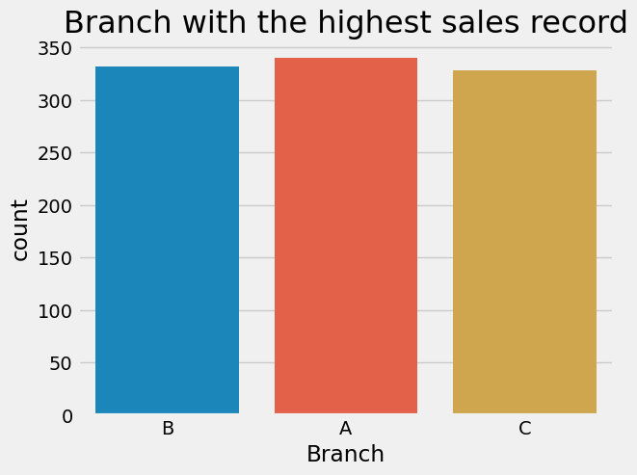

**Sales Records per City: Fig2**

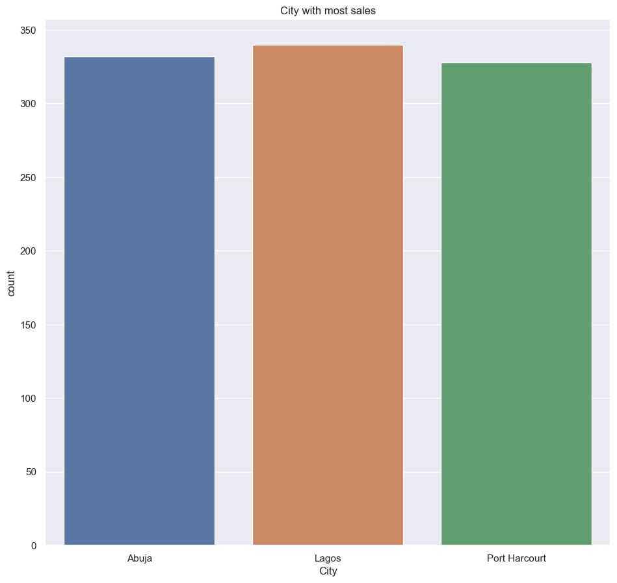

**Lagos city having the highest sales record, followed by Abuja city and Port Harcourt having little lower sales records, of that of Port Harcourt city.**

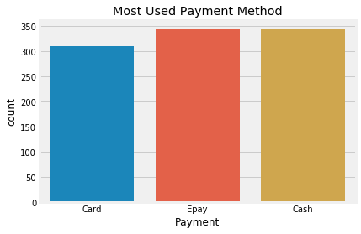**Fig -3 – Shows the most used payment method is Epay, followed closely by Cash and then Card.**

**Fig-4 The Most Payment method used among Gender across the branches in the city**

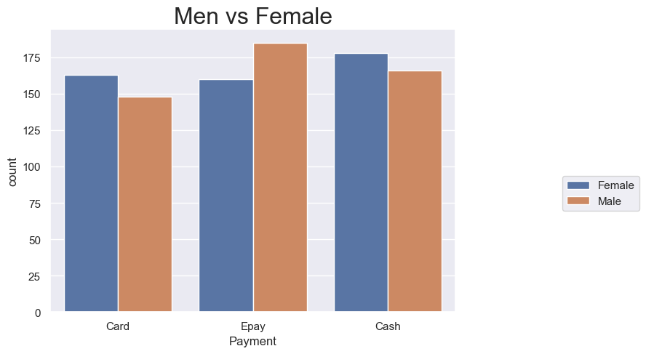

**In Branch A(Lagos) the male make use of Epay payment method than the female, while in Branch C (Port Harcourt) the females make use of cash payment method than the male. In Branch B (Abuja) the female makes use of card payment method than the male.**

**Fig.5– Shows the sales record per product line. Fashion accessories are the highest selling product line followed by Food & Beverages.**

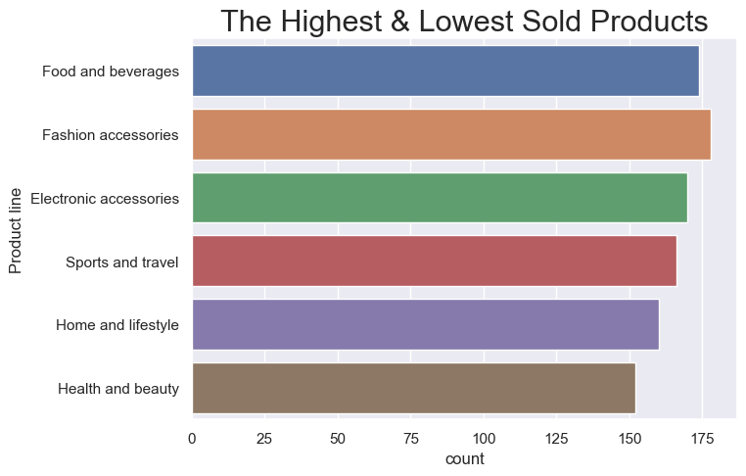

**Fig.6 – Shows the sales record per product line by payment method. This shows that people who buy Electronic accessories pay with cash than any other group. People who buy Fashion, Home and Lifestyle, and Health and Beauty Accessories pay using Epay. Those who buy Food & Beverages pay using card method more.**

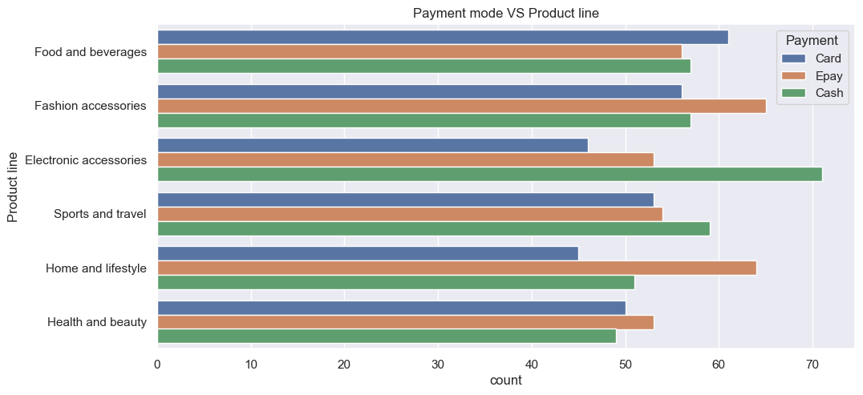

* Customers for Food and beverages: Use Card payment more than other payment channel
* Customers for Fashion accessories: Make use of Epay payment channel more than other payment channel.
* Cusomers for Electronic accessories:Make use of Cash payment channel more other payment channel
* Customers for Sport and Travel: Make use of Cash payment channel more than other payment channel.
* Customers for Home and lifestyle and Health and beauty:Make use of Epay payment channel respectively, more than any payment channel.

In general, from the data collected from the chart; customers make use of cash payment method more than any other payment method used in the branches.

**Fig -7 Determine the Payment channel for each branch.**

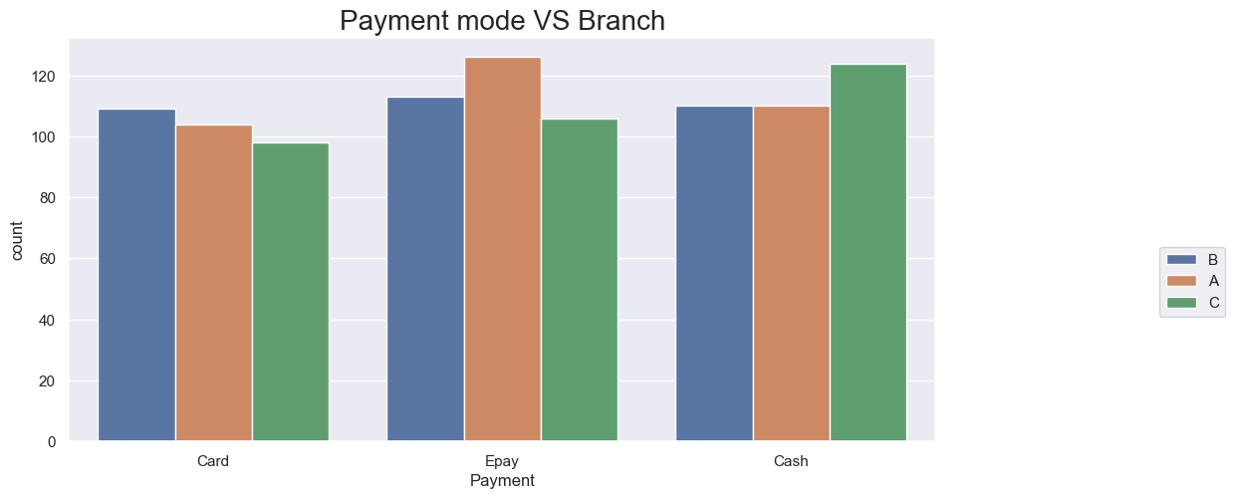

* **Branch A (Lagos) make use of Epay payment mode the more.**
* **Brabch B (Abuja) make use of Card payment mode the more.**
* **Branch C (Port Harcourt) make use of Cash payment mode the more.**

**Fig 8 - Determine the branch with the lowest rating. This you can determine using a box plot which gives a statistical summary of the plotted features, and you can pick out the branch with the lowest rating from the plot.**

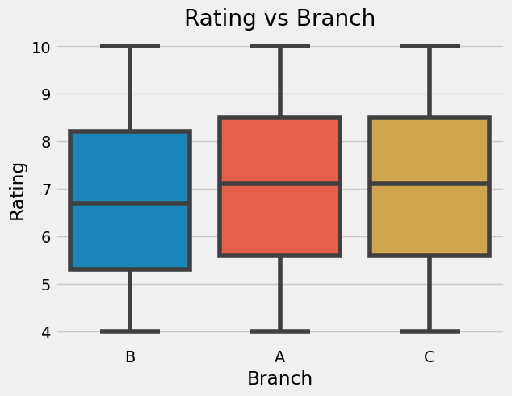

**Branch B (Abuja) have the lowest rating; with low median lower than 7.**  
**Branch A (Lagos) and Branch C (Port Harcourt) the same rating which is higher than of Branch A.**

**Fig 9**

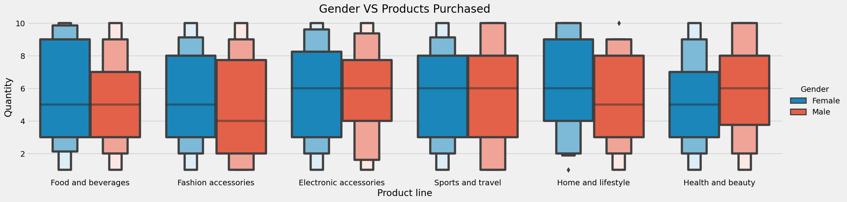

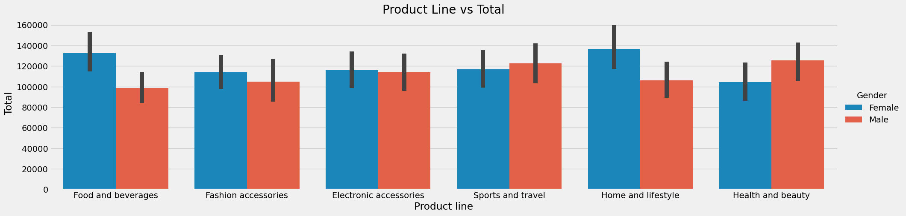

**Summary of the insights of the chart.**

* **Food and Beverages:** The Female customers bought more of the product than the men customer, as shown from the chart.
* **Fashion accessories:** The Female customers bought more of the product than men customers
* **Electronic accessories:** The Female customer just a little more than the men customers
* **Sports and Travel:** The men customer bought more of the product than the female customer
* **Home and Lifestyle:** The female customers have highest amount of products purchase than Men the customers
* **Health and Beauty:** The men customers purchase more of the product than female customers.

**Fig10 - The distribution of variables always provides valuable insight for data analysis. For instance, we can check the distribution of the total sales amount of purchases. One method is to plot a histogram which can easily be done with the plot function of pandas.**

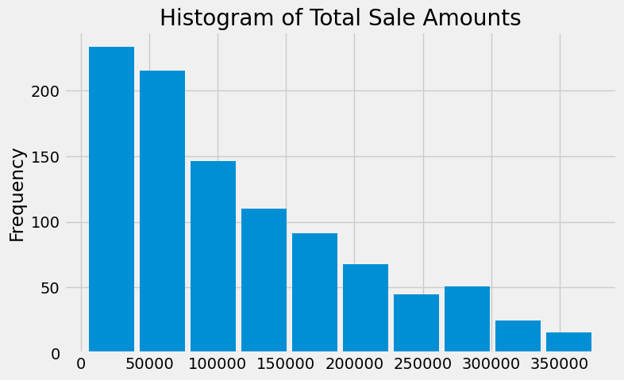

**Fig11 - We can check the product preferences of females and males. One way is to calculate the total number of items purchased in each product line. We first use the groupby function to obtain the data and then create a bar plot to make a comparison.**

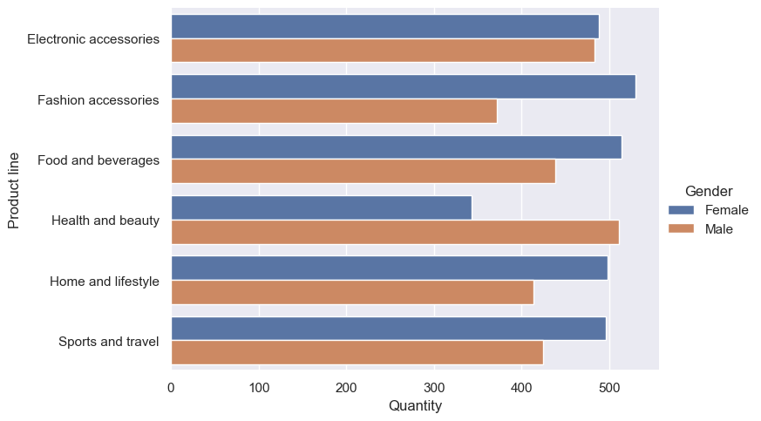

**Fig12- Using plot() function to display the distribution of the products buy by female and men customers.**

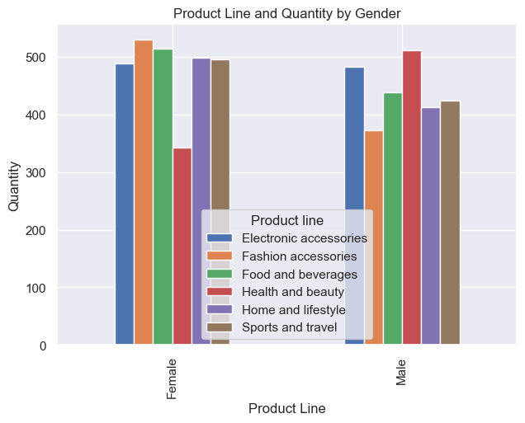

**From the distribution above shows that Female purchase more fashion accessories than men and the men purchase more health and beauty products than female. From thebar chart above the female also, purchase more food and beverages than the men.**

**Fig13 –**

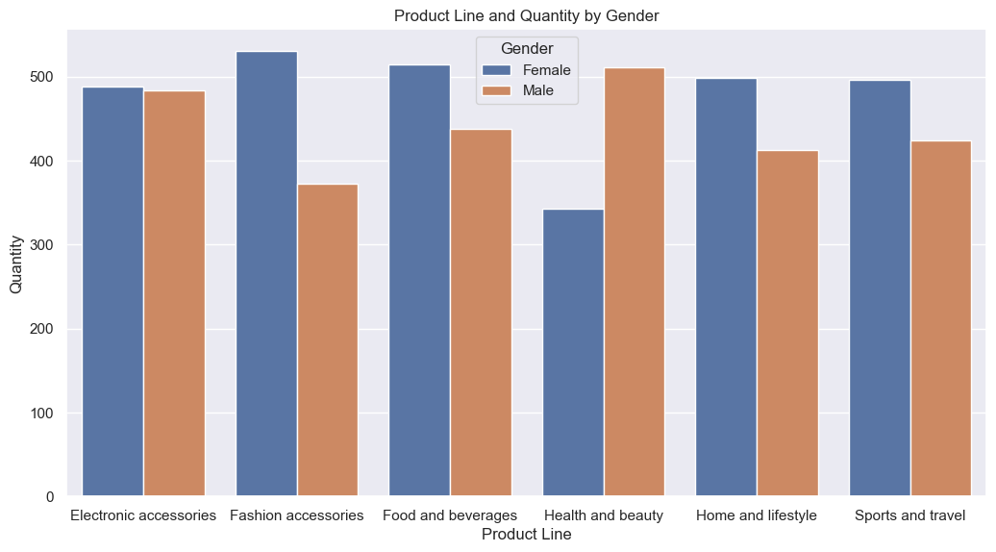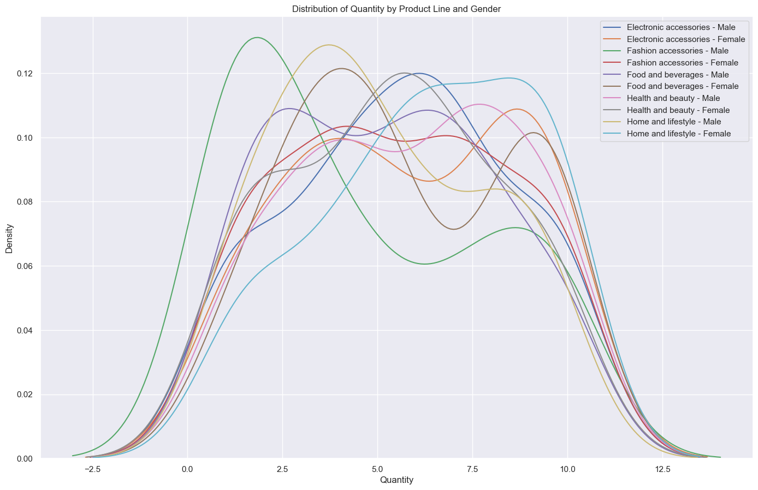

**Fig14 - Products sold per Hour a Day**

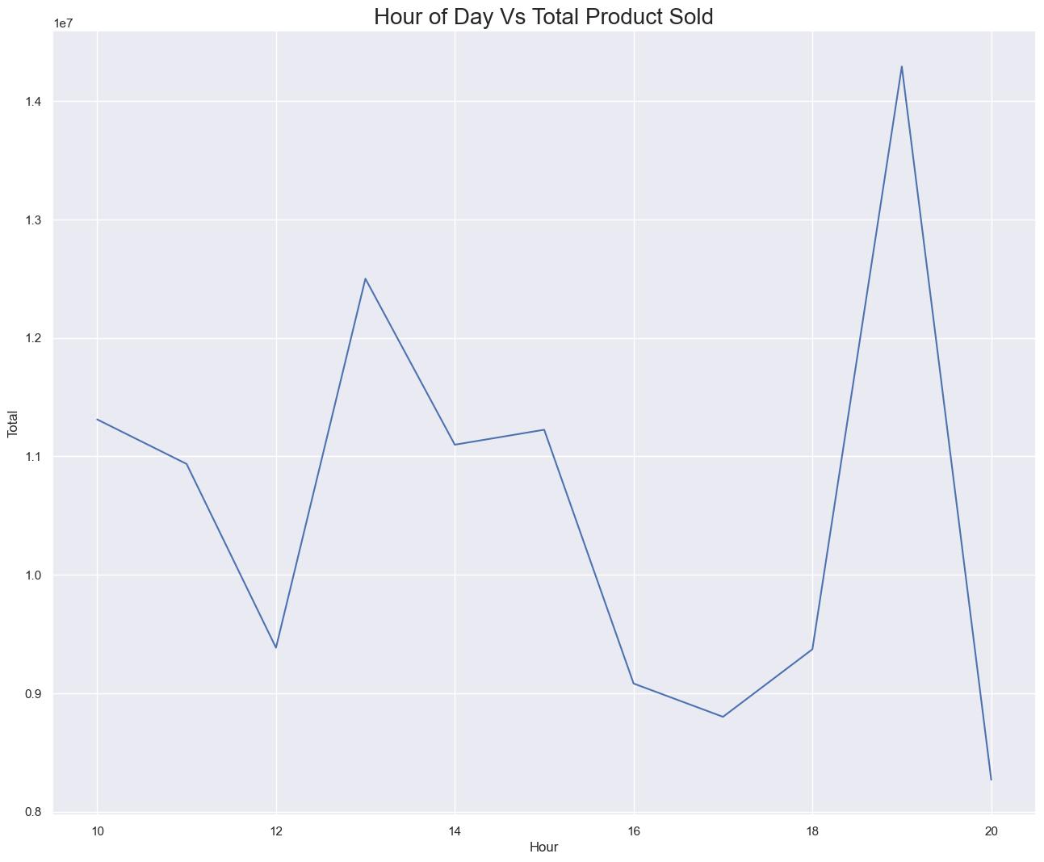

**Fig15 - Total Sales of the month**

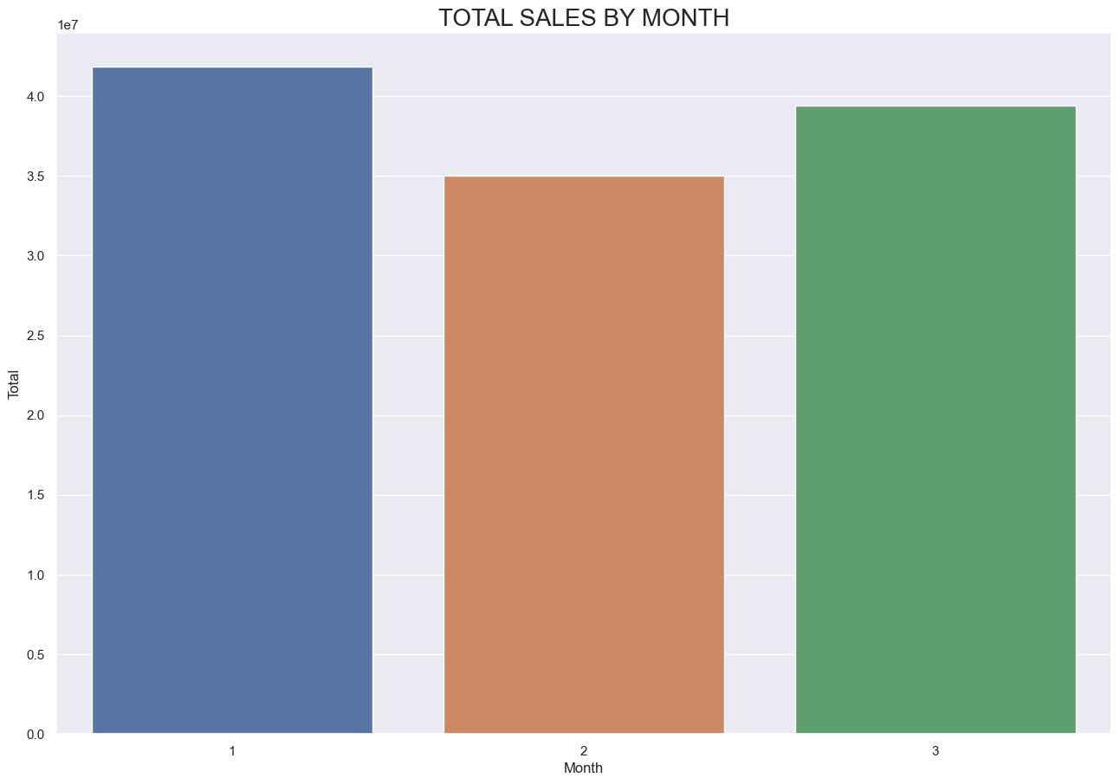

**From the data analysis there is an increase in sales at the first Month, and then at the second month there is a drop in sales, and also sales picked up at third month.**

**Fig16 - Monthly Gross Income per Product line**

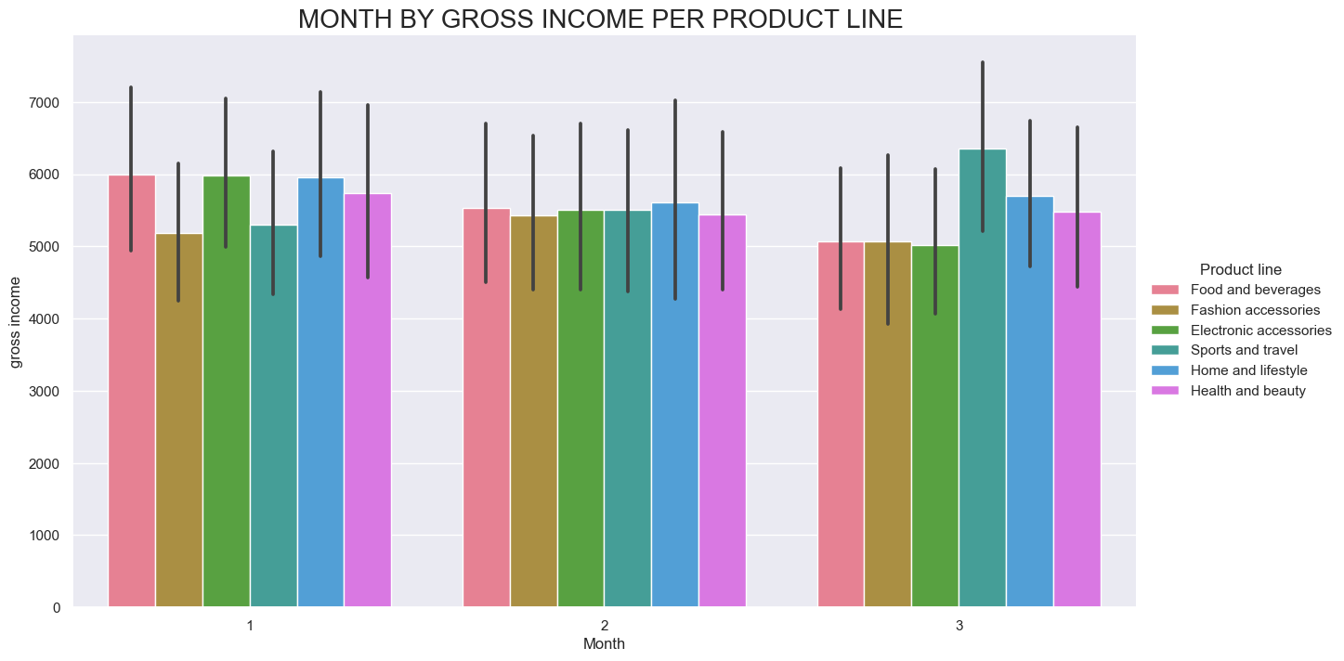

**Fig17- Product line by Gross Income**

