Introduction to Cloud Solutions Lab Report
Use this template to document your work as you complete the lab assignment in QA.

Your Information
Your Name: Nicholas M. Simpson
Lab Title: Creating AWS EC2 Instances Using Templates

Instructions
Follow the instructions to answer the questions related to the lab and add the required screenshots. Submit your completed report following the instructions in Canvas.

Section 1
1. Step 10: What do the YAML and JSON templates share in common?
YAML and JSON templates both use structured data formats that organize information with key-value pairs, lists and nested objects. They are commonly used for cloud deployments, automation, and configuration management because they allow systems to read and process data efficiently.
2. Step 10: How do the YAML and JSON templates differ from one another?
YAML is designed to be more human-readable and uses indentation instead of brackets or commas, while JSON uses braces, brackets and quotation marks for structure. JSON is generally stricter in syntax, whereas YAML is easier for users to read and edit manually.
3. Step 14 Screenshot: YAML template with URL
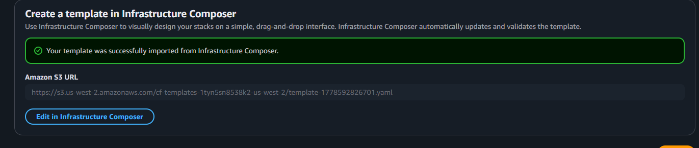
4. Step 30 screenshot: JSON template with URL
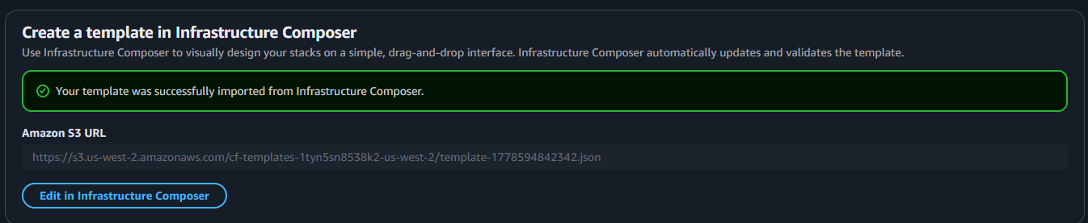

Section 2
5. Step 14: If you received a validation error, what steps did you take to resolve it?
In the template pane, add Resources and the Instance.

6. Step 14: What do validation errors indicate about the contents of template file?
Validation errors indicate that the template contains formatting, syntax or config issues that are preventing it from being processed correctly. They help identify problems such as incorrect indentation, missing characters, unsupported values or invalid resource definitions within the template

7. Step 17 screenshot: YAML template with URL
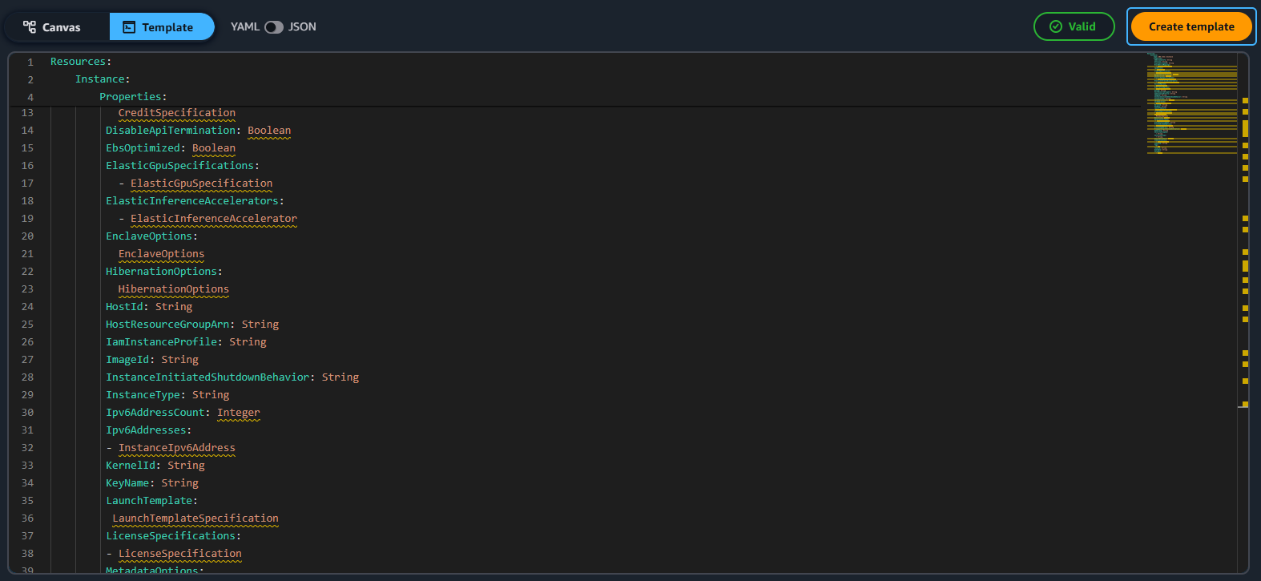

8. Step 28 screenshot: YAML template named stack (include your student ID)

