CSCU9X5 HCI – UI – UX Assignment 1
Autumn 2025

sweetspot.ph
Website Report

File name of main HTML: home.html
Student ID: 3362872

- Concept & target users

sweetspot.ph is a website dedicated to celebrating traditional Filipino desserts, offering useful information regarding various desserts, locations of dessert shops across the world, and an interactive way to learn their preparation process. It aims to support local businesses who continue to preserve these cultural delicacies and introduce the Philippines’ rich culinary heritage through its desserts to the whole world.
The website ensures that it clearly communicates its purpose in a user-centered manner. This involves ensuring consistency across colors, fonts, layouts, and spacing, while also making the site responsive across desktop, tablet, and mobile devices. Interactive elements like buttons, drag-and-drop features, and animations should be smooth and intuitive, with accessibility considerations such as readable fonts, sufficient contrast, and alt text for images. The website aims to be interactive and engaging, where it not only displays static information to the users, but also lets them feel immersed on the website and enjoy their overall experience.
The website welcomes all visitors, but it primarily targets two main audiences: food enthusiasts, or “foodies,” and both Filipino and international users who are interested in discovering traditional Filipino desserts. It aims to attract those who enjoy learning about different food cultures and experimenting with unique flavors. For Filipino users, the site evokes a sense of nostalgia by showcasing familiar, homegrown treats that connect them to their cultural roots. For international visitors, it serves as an introduction to the rich and diverse world of Filipino sweets, providing authentic visuals, names, and descriptions that make the experience both educational and engaging.
One such visitor is Mark Guelfenburg, a 30-year-old food vlogger and culinary traveler, who went on a 10-day trip to the Philippines to explore and document the country’s local cuisine. He is particularly interested in traditional Filipino desserts, seeking authentic flavors rather than modern twists. From his hotel room, he uses his laptop to browse the website, where he discovers various dessert shops and their locations. He takes note of the information, already imagining how he can feature them in his next food trip vlog.
Meanwhile, Chloe Bautista, a mother of two living in the United States, often finds that her family misses the taste of Filipino desserts, particularly halo-halo. Since there are no nearby shops that sell this traditional treat, she decides to make it herself for her family to enjoy. Using her mobile phone, Chloe accesses the website to search for inspiration and guidance. She navigates to the Desserts page, where she browses through a wide selection of Filipino sweets until she finds halo-halo. There, she checks the list of ingredients and takes note of what she will need to prepare and learns the steps of making the dessert provided in the website. Curious to learn more, Chloe proceeds to the interactive “Make-a-Dessert” page, where she builds a halo-halo. Through this experience, she learned the step-by-step process of preparing the dessert, which helped her recreate it at home, bringing a taste of the Philippines to her family.

- Design development

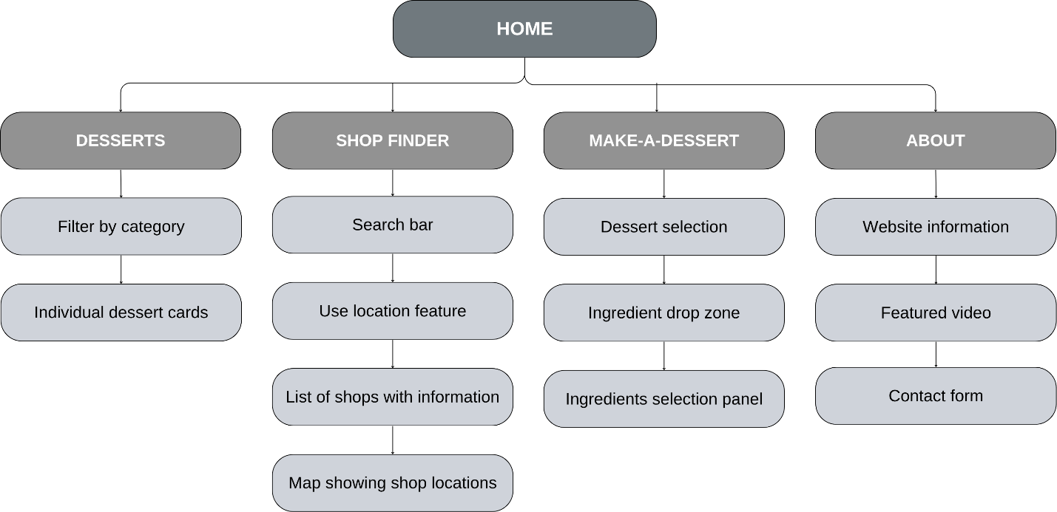
The design of sweetspot.ph aims to create an interactive and user-centered platform that showcases Filipino dessert culture while providing an intuitive browsing experience for users worldwide. Guided by established UX principles and design heuristics, the website emphasizes clarity, accessibility, and engagement through visually appealing layouts and consistent navigation.

Figure 1. Navigational map

The navigational map above provides a clear overview of the website’s structure, showing how users can access all main sections and features efficiently. It is designed to ensure smooth and seamless navigation across the website.
The homepage serves as the central hub, providing links to pages: Desserts, Shop Finder, Make-a-Dessert, and About. Each main page contains different sections and features that serve different functionalities. The Desserts page will showcase desserts, each has its own card, which can be filtered according to category. The Shop Finder page will display the nearest shop/s to whichever city given by the user on the search bar or by using user’s current location. The Make-a-Dessert page is an interactive feature that lets users create desserts step by step using drag-and-drop action. Users are first presented with a selection of desserts, after which they are taken to the main interface featuring an ingredients panel, where they can drag items and drop them into the drop zone (image of a cup) or, for mobile users, tap the ingredients instead. On the About page, information regarding the website is shown, a special featured video, and a contact form where users can send messages or give feedback.
The website is designed with Jakob Nielsen’s Usability Heuristics in mind. It provides feedback by highlighting the active navigation page, which, in this case, is indicated through bold text. This feature helps users remain aware of their current location within the site and reassures them that their actions are recognized. Moreover, when users hover on buttons, its state changes, including the color, shadow, and a minimal animation added to it, indicating to users that the element is clickable and will do something once clicked. Across the website, the navigation bar remains fixed at the top of the screen when scrolling. This sticky behavior eases seamless navigation and enhances user control and freedom over their browsing experience. The website maintains a consistent font, color scheme, and styling throughout all pages. This visual uniformity and internal consistency not only strengthen the site’s identity but also supports the user familiarity, aligning with Jakob’s Law, which states that users prefer interfaces that match patterns they are already familiar with from other websites. By using familiar design patterns and navigation structures, users can predict functionality and behavior, reducing cognitive effort and improving overall usability.
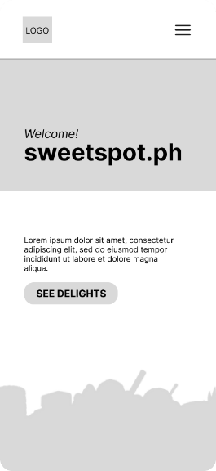
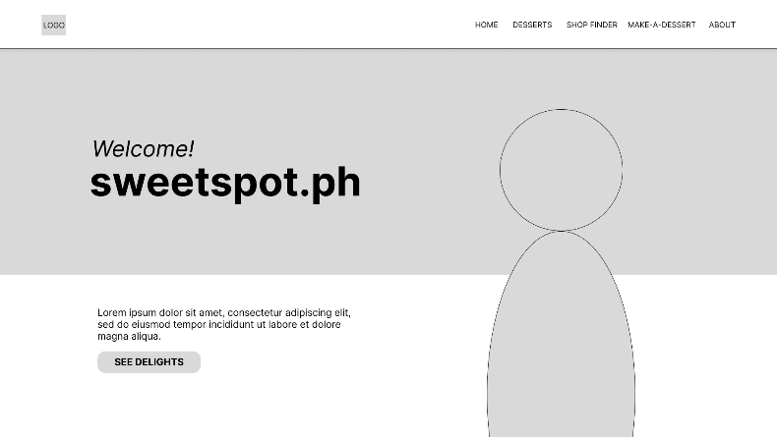
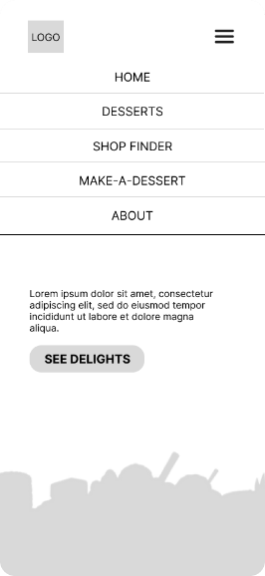
Figure 2, 3, 4. Homepage wireframes

The homepage’s layout follows the F-Layout, a common web design principle based on users’ natural reading behavior. Eye-tracking studies show that visitors typically scan web pages in an “F” shape — starting from the top left, moving horizontally, then scanning down the left side with shorter horizontal movements across the page. Hence, the heading text is placed at the top left of the page, and just below it is the subheading, and a call-to-action button. This way, users’ interest is captured immediately. This structure also demonstrates how users can easily explore the website by simply tapping or clicking on the corresponding navigation elements, ensuring an intuitive flow that minimizes cognitive effort. The layout emphasizes clarity and simplicity, aligning with Nielsen’s heuristic of “recognition rather than recall”, as users can visually identify options without memorizing navigation paths.
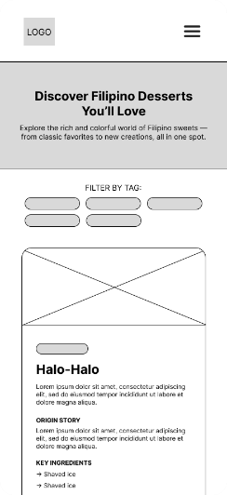
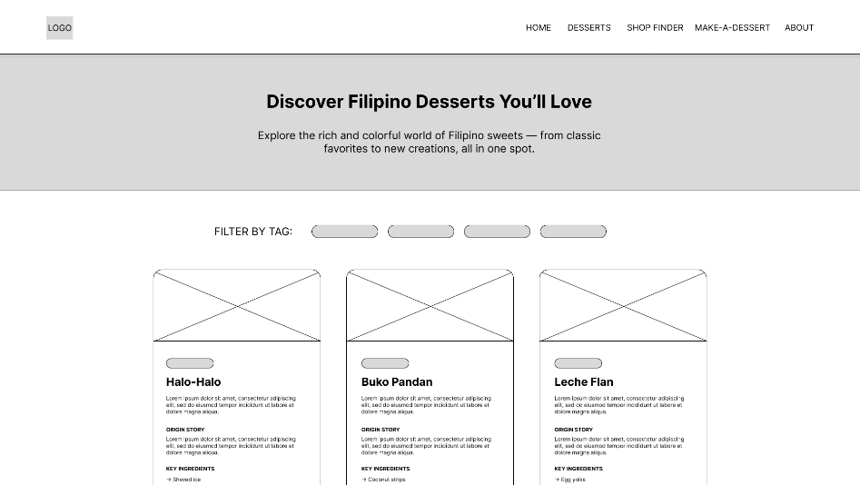
Figure 5, 6. Desserts page wireframes wireframes

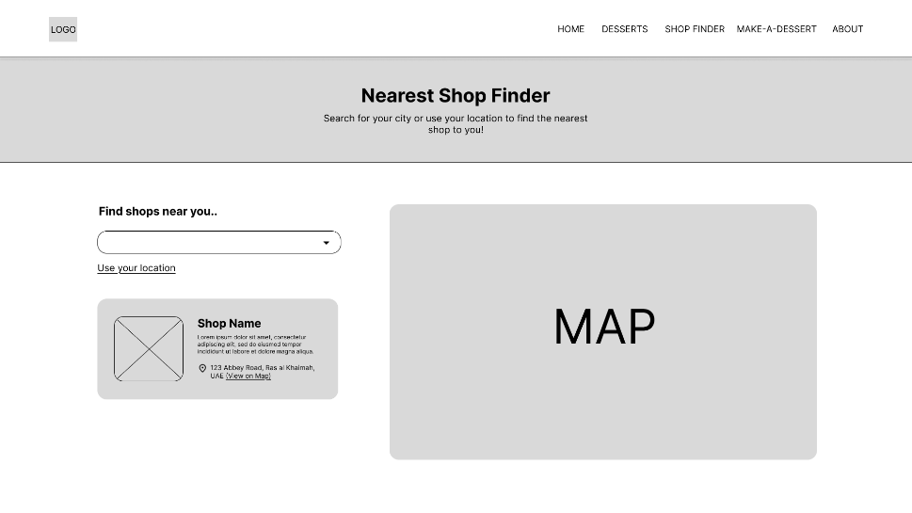
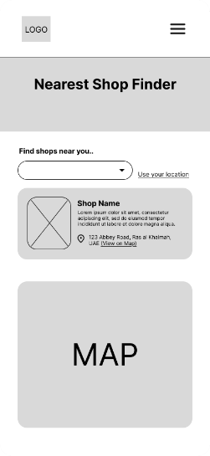
To ensure match between the system and the real world, real images and authentic names of desserts and ingredients are consistently used across this page, enabling users to connect on-screen elements with their real-life counterparts and enhancing familiarity and engagement. A filter by tag functionality is available to help users break down the catalog of desserts into categories, reducing cognitive load and decision time in accordance with Hick’s Law. Additionally, when users scroll down the “Desserts” and “Shop Finder” page, a back-to-top shortcut button appears, allowing them to quickly return to the top of the page without manually scrolling. This feature improves task efficiency, particularly for users browsing long lists of desserts or shops.
Figure 7,8. Shop Finder page wireframes

On the Shop Finder page, users are initially presented with a maximum of three nearby shops, with the option to ‘show more’ if desired. This design choice follows Miller’s Law, which suggests that people can comfortably process only about 7±2 items at a time. Limiting the initial display helps prevent cognitive overload, allowing users to quickly evaluate options before deciding whether to view more.
To enhance flexibility and efficiency of use, the search functionality includes a dropdown menu listing various cities, enabling users to easily narrow down their search and find nearby dessert shops without the need to type city names manually. Additionally, users can easily find the nearest shops to them by using their current location in one click.
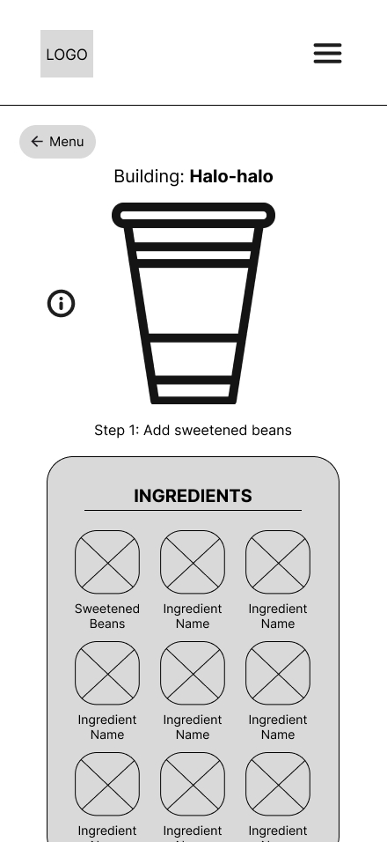
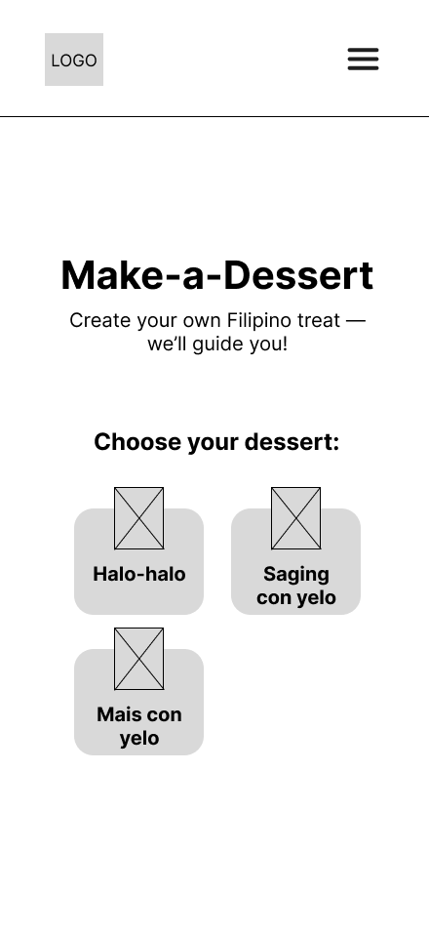
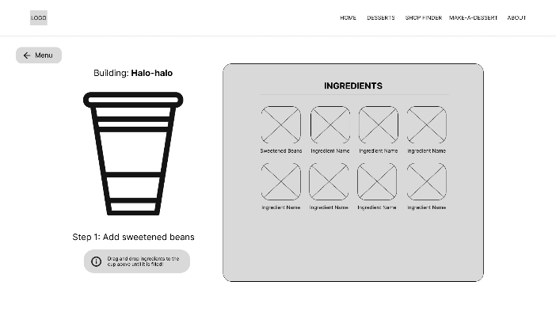
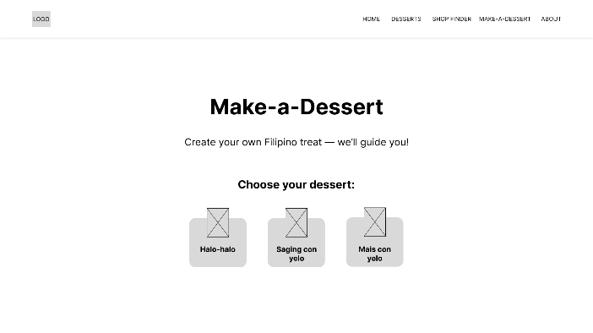
Figure 9, 10. Make-a-Dessert page wireframes

The Make-a-Dessert page uses a drag-and-drop function to perform the building process. On mobile devices, the drag-and-drop feature is replaced with a tap-based interaction to ensure ease of use and better alignment with touchscreen behavior. This design choice aligns with Nielsen’s heuristic of flexibility and efficiency of use. This change improves usability by reducing the precision required for touch input and offering a more natural interaction for mobile users.
Users are initially presented with a selection of desserts to choose from. Upon selecting a dessert, they are directed to the “building” interface. A button that says “Menu” is available on this page. This button allows users to effortlessly return to the previous interface, the dessert selection page, in various situations, such as when they unintentionally select the wrong dessert, choose to discontinue the current “building” process to create a different one, or complete a dessert and wish to start a new creation. This aligns with Nielsen’s heuristic of user control and freedom.
Textual information regarding the steps of the building process is displayed to the users. This lets users know what state they are in in the process. Accordingly, this textual feedback changes once the user completes the current step. Moreover, an image of a cup commonly used in authentic and traditional Filipino dessert shops is featured to match the system to the real world and provide users with a more organic and culturally immersive experience.
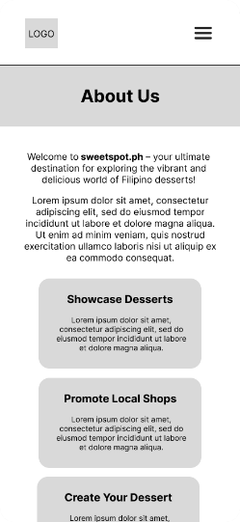
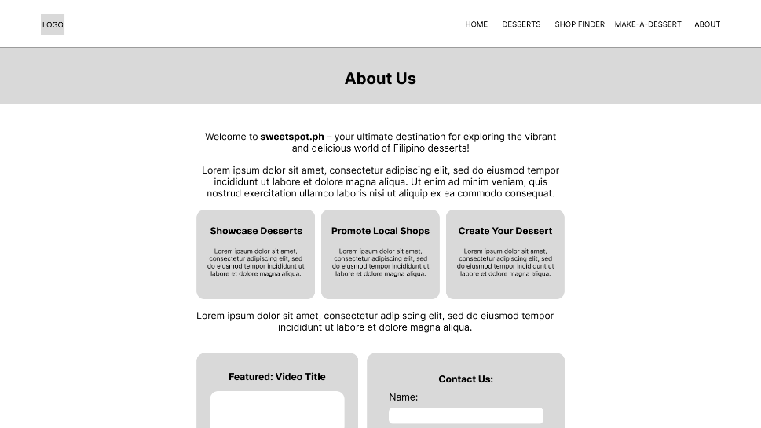
Preventing error and mistakes that could possibly be done by users is another crucial aspect of design. On the “Make-a-Dessert” page, error prevention mechanisms are integrated to guide users through a smooth and intuitive dessert-making process. Only the next required ingredient is droppable to the cup, preventing mistakes such as adding items in the wrong order. Once an ingredient has been added, it becomes grayed out, signaling completion and avoiding repetition.
Figure 11, 12. About page wireframes

The “Contact Us” form found in the “About” page, include input validation, such as email format checks to prevent submission errors. These safeguards reduce user frustration and ensure reliable interaction throughout the experience.

- Usability testing & evaluation

Usability testing is a crucial component of web design. The goal of this is to help better understand the end users’ needs. This process enables to identify design and usability flaws that a designer might miss. It measures how easily a user can accomplish their goals when using the website. This plan will cover the full lifecycle: from pre-development to during development and post-delivery.
At the early stages of development, the testing will focus on low-fidelity products such as paper sketches or wireframes. The purpose of this phase is to evaluate the structure of the content, the flow of navigation, and the overall layout. From the list of possible tasks on the website, a few representative examples – such as “Locate shops in Ras al Khaimah” or “Find main ingredients of Halo-Halo” – will be selected to assess whether users can navigate and understand the interface with ease.
A small group of participants (3–5 individuals) from the target audience will be chosen to complete these tasks. During the testing sessions, participants will be encouraged to think aloud as they work through the activities. The observer will monitor how they navigate, note any confusion or hesitation, and record recurring issues such as unclear labels, disjointed flows, or other usability challenges. The time taken to complete each task will also be documented. These observations and performance metrics will then be used to identify flaws and determine which areas need improvement before progressing to higher-fidelity design stages.
In the mid-stage testing phase, the process moves beyond sketches and wireframes to focus on an interactive prototype that closely resembles the final product. This stage involves testing a functional version of the website that includes the core features necessary for user interaction, such as real navigation and clickable buttons. The primary goal is to determine whether users can complete key tasks smoothly and without confusion, emphasizing the refinement of interactions, efficiency, and clarity.
Participants will be selected from the intended target audience, including some from the earlier testing stage, to evaluate whether previously identified issues have been resolved. Around five to eight participants will be involved to obtain meaningful feedback. Before the sessions begin, participants will be informed that the purpose of the test is to assess the usability of the prototype, not their performance, and that they should act naturally as if the observer were not present in the same room.
Similar to the earlier phase, the sessions will employ a think-aloud or moderated approach, where participants verbalize their thoughts while completing tasks. Both quantitative data (such as time on task, number of errors, and completion rates) and qualitative data (including comments, hesitations, and feedback) will be collected. These insights will help identify patterns of user frustration or satisfaction, guiding necessary design adjustments such as revising button labels or enhancing layout balance. Based on the findings, the prototype will be updated and tested iteratively with a smaller group to confirm the effectiveness of the improvements.
The post-delivery usability evaluation focuses on assessing how the final product performs under real-world conditions. This phase may involve structured testing with participants, where real or representative users complete key tasks on the live system and provide feedback. Alternatively, post-delivery testing can incorporate passive data collection, drawing insights from analytics and user feedback. To achieve a comprehensive evaluation, a dual strategy will be employed –combining both active, structured testing and passive data monitoring.
For the structured usability testing, a group of 5–10 participants will be recruited to perform realistic tasks on the live system. Participants will then provide feedback through interviews or standardized questionnaires such as the System Usability Scale (SUS) or the Net Promoter Score (NPS). This active approach will yield valuable qualitative insights alongside measurable usability metrics. Simultaneously, passive data collection through analytics will be utilized to capture unmoderated user behavior. This will include metrics such as the most and least used features, common navigation paths, and critical drop-off points where users tend to leave the site. Such data is vital for identifying recurring issues, accessibility challenges, and performance bottlenecks as they naturally occur in the user’s environment.
By synthesizing findings from both structured testing and behavioral analytics, the evaluation will produce a comprehensive overview of the product’s usability. These insights will then inform a clear roadmap for updates and improvements in future iterations of the system.
Despite the time constraint, a usability test was conducted with a group of three peers to evaluate the current prototype of the website. The results of this testing indicate that the prototype effectively meets the needs of its target users. During the observation sessions, participants navigated the website with ease, showing no signs of confusion regarding the interface or navigation structure. The assigned tasks were completed efficiently within a short period, demonstrating that the layout and interaction flow are well-optimized. Participants were also able to quickly understand the functionality of the website’s elements, confirming its intuitive design.
However, a few areas for improvement were identified. One participant suggested making the “steps” information on the Make-a-Dessert page more prominent or larger, as there was initial uncertainty about the correct sequence of ingredient selection. Another participant experienced minor confusion when first interacting with the same page but quickly adapted after brief exploration. Based on these insights, future design revisions will focus on enhancing the Make-a-Dessert page to ensure that it is more intuitive and easier to learn.

- Group activities & co-design

During tutorials and lab sessions, I actively collaborated with classmates to discuss design ideas, usability principles, and interface layouts. These interactions exposed me to a range of perspectives, highlighting how different users might interpret or interact with similar design elements. I worked closely with my peers to test and refine the website prototype. Throughout the development stages, I frequently asked them to navigate the Make-a-Dessert and Shop Finder pages while thinking aloud, which allowed me to observe their natural behavior and identify pain points.
One peer suggested adding clearer visual cues to guide users through each step of the building process. Another peer suggested adding an additional feature on the “Desserts” page that allows users to view more detailed information about each dessert. She noted that while the cards appeared clickable, they did not respond when clicked, which created a mismatch between user expectations and actual functionality. This feedback prompted me to consider implementing a modal to display dessert details, improving both interactivity and the overall user experience.
Beyond design refinement, these sessions helped me understand the importance of iterative testing and the value of incorporating real user feedback early in the process. Collaborating with others broadened my perspective by revealing usability challenges I had not anticipated and encouraging me to think more critically about accessibility and user experience. This not only improved the quality of my final submission but also strengthened my ability to justify design choices based on observed user behavior and evidence from testing.

- Prototype & resources description

This prototype represents the first interactive version of the sweetspot.ph website. This prototype version includes main features that users might look for. This version allows users to navigate seamlessly and browse through 5 different pages. Users can interact with various elements on the website, like searching for shops, filtering desserts by category, or playing the “building” game. Additionally, the visual design of the prototype is sufficiently developed to represent the final aesthetic and layout of the system. Finally, this version also optimizes and renders well on mobile screens, but further adjustments are still needed.
These components were intentionally scoped to align with the project’s timeline while still providing meaningful feedback on the overall design. They represent the key user flows that required testing to ensure a smooth and effective user experience. Using this prototype, it is possible to evaluate the navigation flow and the ease with which users locate information. The testing also enables the collection of usability feedback on aspects such as layout, visual hierarchy, clarity, and overall aesthetics.
Furthermore, this stage allows observation of how users interact with the interface in real time, helping to identify elements that may cause confusion or hesitation and to assess whether the visual design supports intuitive navigation. The insights gained from this evaluation will inform subsequent refinements to the system’s functionality, structural organization, and visual consistency in future development phases.
The final version of the website is expected to incorporate additional features and provide a more refined overall outcome. The current version is limited in terms of data/information on desserts (currently, there are only 6) and shops (5). The Make-a-Dessert page presents three dessert options, but only the Halo-Halo option has been fully implemented in this prototype. Responsiveness across different devices is also partially achieved, with further refinement to be made as development time allows.

External media used and their sources
Media | Source Link
Ube Halaya (Desserts page) | https://www.theflavorbender.com/ube-halaya-recipe
Turon (Desserts page) | https://themayakitchen.com/turon
Buko Pandan (Desserts page) | https://www.kawalingpinoy.com/buko-pandan-salad
Nanay Nidas Homemade Leche Flan (Shop Finder page) | https://wanderlog.com/place/details/9636249/nanay-nidas-homemade-leche-flan
The Original Buko Pie Shop (Shop Finder page) | https://lh3.googleusercontent.com/gps-cs-s/AG0ilSxIEpIpw4zy5L80IA-1uCVKCOjvHWc8lC-gmrqiQDFAIXhdlehdKz_IByKlEHz2Jn4VVPKBbw2A5SEvoNzDxvIkvoEzpubg_aieZMxLlrmLyH8LVLnHnvf6hIwQVVpeInKZ3vax2Q=s1360-w1360-h1020-rw
Original Digman Halo-Halo and Home Made Siopao (Shop Finder page) | https://original-digman-halohalo-and-home-made-siopao.wheree.com
Max’s Restaurant – Karama (Shop Finder page) | https://www.tripadvisor.com/LocationPhotoDirectLink-g295424-d3919857-i444072052-Max_s_Restaurant_Karama-Dubai_Emirate_of_Dubai.html
Panaderia Restaurant (Shop Finder page) | https://www.lokalee.app/recommendations/panaderia-restaurant
Background video on Shop Finder page | https://youtu.be/4P1uQkFQH0Q?si=MmhZ3C_-Fvg7a1XB
Logo | Generated by Google Gemini
Woman holding halo-halo (Homepage)
Desserts on a table (Home, mobile screens only)
Halo-Halo (Desserts page)
Leche Flan (Desserts page)
Bibingka (Desserts page)
All images on Make-a-Dessert page

External fonts used:
- Montserrat: https://fonts.google.com/specimen/Montserrat
- Lobster Two: https://fonts.google.com/specimen/Lobster+Two

All files containing code and their purpose
File Name | What does this file do?
home.html | It is the main landing page of the site. It defines the structure and content, highlighting the features of the site. It displays a call-to-action button that navigates to another section of the site, the desserts page. It also displays links to all other pages of the website.
desserts.html | It serves as the Desserts page of the website. It displays a collection of Filipino desserts and allows users to browse and filter them by category (e.g., cold, hot/warm, chilled).
shopFinder.html | It defines the Shop Finder page of the website. It allows users to locate dessert shops near their city or current location. The page integrates an interactive map powered by the Google Maps API and provides both manual search and geolocation options.
makeADessert.html | It defines the Make-a-Dessert page of the website. It allows users to create their own Filipino dessert through an interactive, guided process. The page enables users to select a dessert and view its preparation steps dynamically.
about.html | It defines the About page of the website. It provides visitors with information about the platform, its mission, and the services offered. It also features a video section that highlights a dessert-related external video from YouTube. It allows users to submit inquiries/messages/feedback through a contact form.
main.css | It provides the global and layout styling for the website. It defines the appearance and responsiveness of key components such as the navigation bar, footer, and general page layout.
home.css | It defines the homepage layout, animations, and responsive behavior for the home page. It primarily styles the main hero section, including headings, greetings, description text, call-to-action button, and a model image.
desserts.css | It contains styles specific to the Desserts page, including the layout, background, dessert cards, filter buttons, and modals. It adds hover effects, animations for scroll and card appearances, gradient text and overlays, and ensures responsive design for tablets and mobile devices.
shopFinder.css | It styles the Shop Finder page of the website, including the video background, shop cards, search bar, and map section. It features hover effects, animations for card appearances, responsive layout for smaller screens, and gradient styling for buttons and overlays.
makeADessert.css | It provides styles and animations for the Make-a-Dessert page. This includes floating and wiggle effects on dessert images, hover and tap interactions for buttons and ingredients. It ensures visually engaging animations and smooth transitions for feedback messages.
about.css | It styles the About page with a fixed background, animated fade-in elements, and gradient headings.
main.js | It contains global scripts for the website. It handles mobile menu visibility and dynamically changes the navigation bar’s appearance based on scrolling
desserts.js | It manages the interactive features of the Desserts page: it animates sections as they scroll into view using the Intersection Observer API, controls the “scroll to top” button functionality, and dynamically renders dessert cards from a dataset including their images, descriptions, origin stories, ingredients, and preparation steps. It also handles modal popups that display detailed information when a dessert card is clicked, allows closing the model via clicks or the escape key, and enables filtering desserts by type through filter buttons, updating the displayed list in real time.
shopFinder.js | It handles the interactive functionality of the Shop Finder page. It initializes a Google Map with predefined shop locations, dynamically displays shop cards with images, descriptions, addresses, and map links, and allows users to click cards to center and zoom the map on that shop. It provides search functionality by city, can detect the user’s current location to calculate and sort shops by distance, and shows the user’s position on the map with a custom marker. It also handles “Show More/Show Less” toggling for lists longer than three shops.
makeADessert.js | It powers the interactive Make-a-Dessert page, allowing users to select a dessert and virtually build it step by step by dragging or tapping ingredients. It manages the navbar shrink to maximize space, mobile “back to top” button, updates the dessert and ingredient panels, gives feedback for correct or incorrect steps, and resets the interface when returning to the selection menu.
about.js | Adds scroll-triggered fade-in animations for elements on the About page using the Intersection Observer API.

